Stage 4 – Mathematics

How can data empower us during a global health crisis?
This mathematical investigation is designed to support and empower students to consider how data can empower individuals, communities and countries to make informed decisions during a global health crisis. It may be studied alongside the Stage 4 - PDHPE learning sequence, “Connect me, include me, empower me. How do I stay connected?”

Related mathematics outcomes
This document references the Mathematics K-10 Syllabus © NSW Education Standards Authority (NESA) for and on behalf of the Crown in the right of the State of New South Wales, 2012
- communicates and connects mathematical ideas using appropriate terminology, diagrams and symbols MA4-1WM
- recognises and explains mathematical relationships using reasoning MA4-3WM
- collects, represents and interprets single sets of data, using appropriate statistical displays MA4-19SP

Learning across the curriculum

General capabilities
- Critical and creative thinking
- Ethical understanding
- Information and communication technology capability
- Intercultural understanding
- Numeracy
- Personal and social capability

Other areas of learning
- Civics and citizenship
- Difference and diversity
- Work and enterprise

Task 1 – Interpreting Australian data about coronavirus
Students are to go to the website Coronavirus data – reveals how COVID-19 is spreading in Australia. Explore the data shown on the website using the questions and prompts in this investigation to consider:
- What is the data showing us through the visual representations?
- How can the data empower or support our next steps as a country? As a local community? As a family? As an individual?

Part A: Confirmed cases – cumulative count vs daily count
Note: This is a screenshot at a particular point in time for reference purposes only. Use the live website for up-to-date data.
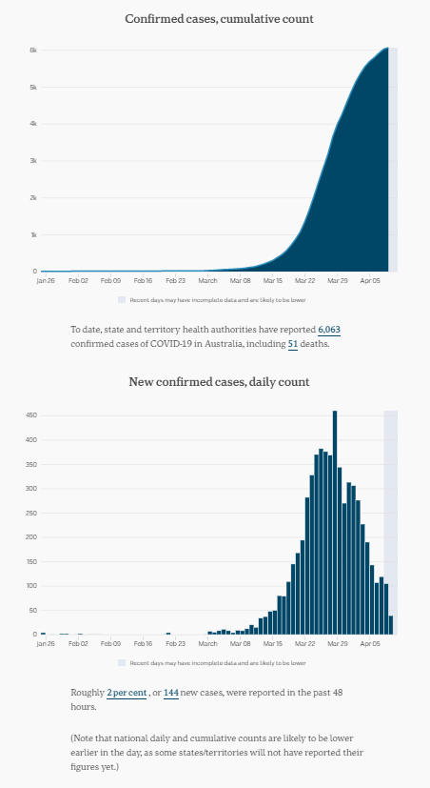

Activities and questions

‘Daily count’ graph
- What type of graph is the ‘daily count’ graph and what information is shown on it?
- Write down everything you notice about the ‘daily count’ graph.
- Write down everything you wonder about the ‘daily count’ graph.
- Label the title and axes on the ‘daily count’ graph.
- What is the vertical scale on the ‘daily count’ graph?
- Approximate the date that had the most number of new cases. How many new cases were diagnosed?
- When was the first case of coronavirus in Australia diagnosed?
- Write a short paragraph to describe the trend or patterns you see in the ‘daily count’ graph. Write down some thoughts about what factors you think could have influenced these trends and patterns.

Extension – ‘cumulative count’ graph
- These two graphs present the same information in two different ways. The first graph shows a cumulative count of confirmed cases. What does the word cumulative mean?
- In your own words, explain how the top graph is related to the bottom graph.
- What is the vertical scale on the ‘cumulative count’ graph? Explain why it is different from the scale on the ‘daily count’ graph using an example from the graphs.

Part B: Confirmed cases – by state and territory
Note: This is a screenshot at a particular point in time for reference purposes only. Use the live website for up-to-date data.
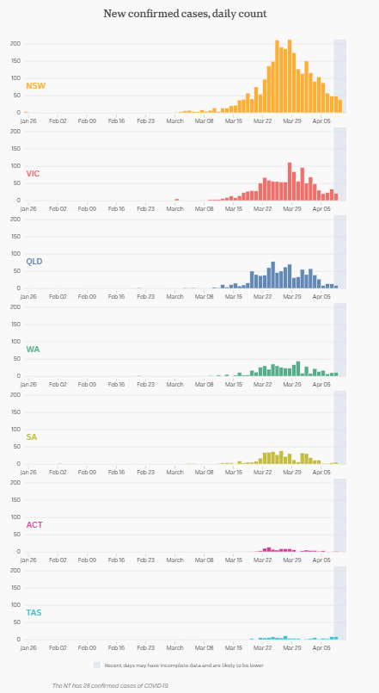

Activities and questions
- Examine the features of each graph. What information are these graphs displaying?
- What are the horizontal and vertical scales on the graphs? Are the scales the same for each state and territory?
- Write down what you notice and wonder about the graphs by state and territory.
- In NSW, describe the trends or patterns you see in the data displays. Write down some thoughts about the factors you think could have influenced these trends and patterns.
- Which state or territory has the largest number of cases? What are some possible reasons that this might this be the case?
- Which state or territory has the least numbers of cases? What are some possible reasons that this might this be the case?
- Consider the map of Australia:
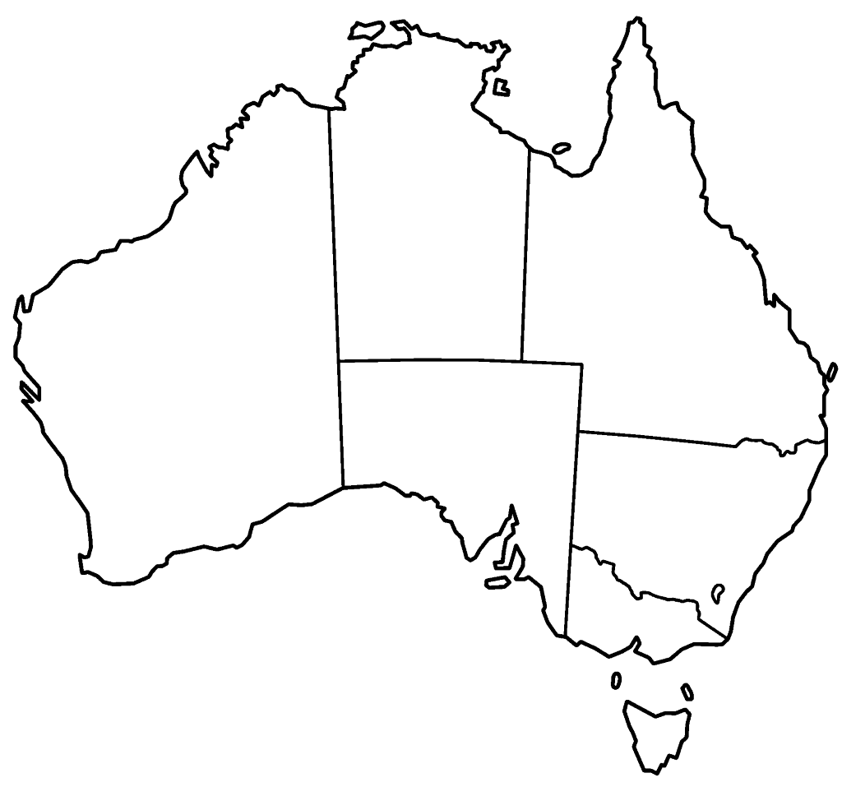
Order the states and territories from largest to smallest. Would you expect the numbers shown in the above graphs to be the case when you compare how large the different states and territories are? What other factors might impact the number of cases?
- Order the following ‘factors’ to discuss which ones you think have the most impact through to least impact:
  - Land size of the state or territory
  - Total population of the state or territory
  - Number of flights that land in the state or territory
  - Number of cruise ships that dock in the state or territory

Part C: Cases per 100 000 residents – by state and territory
Note: This is a screenshot at a particular point in time for reference purposes only. Use the live website for up-to-date data.
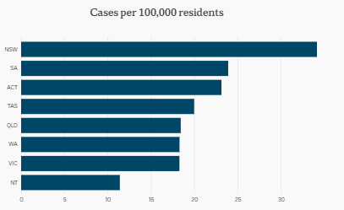

Background information
This graph has taken the raw data about the number of cases in each state and adjusted it to compare the number of cases per 100 000 people in the state. In other words, the graph shows how the states would compare if every state had the same number of people.

Activities and questions
- Examine the features of the graph. What information is it displaying? What labels is it missing along the axes?
- What is the scale along the horizontal axis?
- Examine the statements below. Decide if they are true or false and write a reason to justify your thinking:
  - There are only 20 cases of coronavirus in Tasmania.
  - For every 100 000 residents in NSW, there are approximately 35 cases of coronavirus.
  - There are three states that have the same rate of cases per 100 000 residents.
- Compare this graph with the graphs in Part B about the confirmed number of cases of coronavirus. Are the states ranked in the same order? What are some possible reasons for any differences?

Part D: Statistics by gender
Note: This is a screenshot at a particular point in time for reference purposes only. Use the live website for up-to-date data.
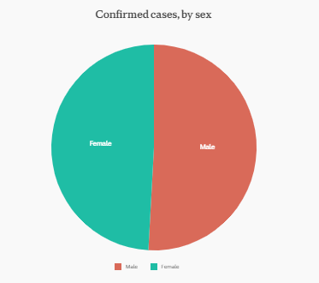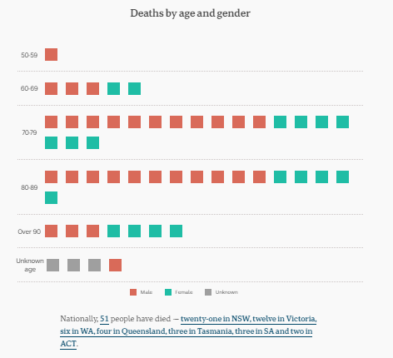

Activities and questions
- Examine the features of the first graph. What type of graph is it? What information is it displaying? What do you notice and wonder about the graph?
- The picture graph on the right-hand side uses one square for each death and the colours are used to display the gender of those who have died. Represent the data in the picture graph using a side-by-side column graph.
- What age groups have been most severely affected by coronavirus?
- What age groups are missing from the picture graph? What does this mean?
- A picture graph can use one picture to represent more than one person or item. Construct a different picture graph ignoring the gender data and using the age data only, using one symbol to represent two people. You may use a square but you may also use another type of symbol or picture instead.
- Construct two separate dot plots for the data in the picture graph, one for males and one for females. What do you notice and wonder the data shown in the dot plots?
- How does the data in the sector graph compare to the data in the picture graph? Are the proportions similar or different? Why might this be the case?

Part E: Cases by age group
Note: This is a screenshot at a particular point in time for reference purposes only. Use the live website for up-to-date data.
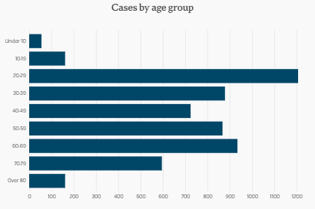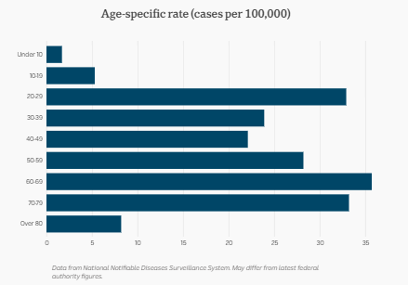

Background information
The second graph has taken the raw data from the first graph and adjusted it to compare the age groups for cases per 100 000 people. In other words, the graph shows how the age groups would compare if every age group had the same number of people.

Activities and questions
- Which age group has the modal or highest number of cases?
- Which age group has the lowest number of cases?
- Why do you think the age groups ‘under 10’ and ‘over 80’ have lower numbers?

- Use the table below to order the age group data from each graph from highest to lowest. Write a paragraph to summarise and explain any interesting findings from this comparison.
Cases by age group | Age-specific rates  (cases per 100 000)

- What other factors might you consider when deciding how dangerous this virus is for different age groups? Hint: You may also like to consider your age-related findings in Part D.

Part F: Sources of infection
Note: This is a screenshot at a particular point in time for reference purposes only. Use the live website for up-to-date data.
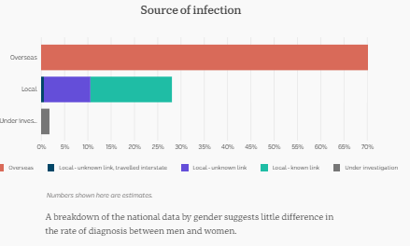

Background information
This is an interesting data display! The above graph is a bar chart but the middle bar is also a divided bar graph. This is because the local infections have been further categorised and this bar shows the proportion of each category of local infection.

Activities and questions
- What is the source of most infections? What percentage of cases does this represent?
- What are the categories within the local infections? Order these sources from most to least.
- Choose an appropriate scale and represent all of the data from the ‘Source of infection’ graph in one divided bar graph.
- Convert your divided bar graph into a sector graph.
- What specific measures have the Australian or State Governments put in place to address these sources of infection?

Part G: Using data to make empowered decisions
Use the information you have found in your investigation to answer the driving question, “How can data empower us during a global health crisis?”
Use all of the information available to you from your research to write your response.

