Dividing negative numbers

Background
Traditionally we think of dividing as sharing objects amongst people or into groups.
Consider 15 ÷ 3

Method 1
We can think of this as taking fifteen objects and dividing them into three groups.
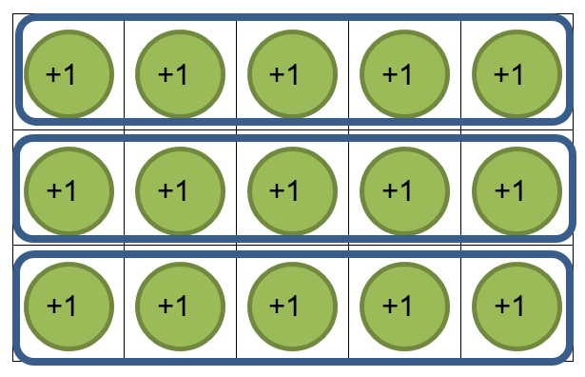
Which gives us five objects in each group.
So, 15 ÷ 3 = 5

Method 2
We can also think of 15 ÷ 3 as taking fifteen objects and dividing it into groups with three objects in each group.
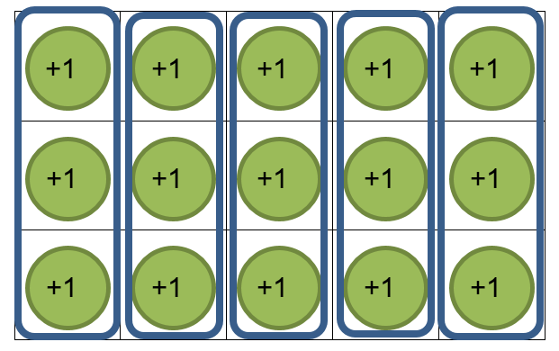
This gives us five groups.
So 15 ÷ 3 = 5

Method 3
We can turn our division sum into a multiplication problem.
15 ÷ 3 is the same as “how many groups of three do a need to make 15?”
3 x ? = 15
3 x 5 = 15, so I need five groups

Sharing with negatives
Consider now, (-15) ÷ 3
Using Method 1, we can think of this as taking fifteen, (-1) counters and dividing them into three groups.
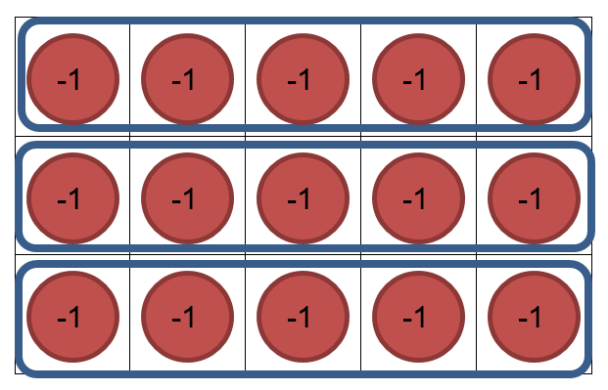
Which gives us (-5) in each group.
So, (-15) ÷ 3 = (-5)
What about, (-15) ÷ (-3)?
It doesn’t make sense to divide into (-3) groups, but we could make groups of (-3) counters, as in Method 2.
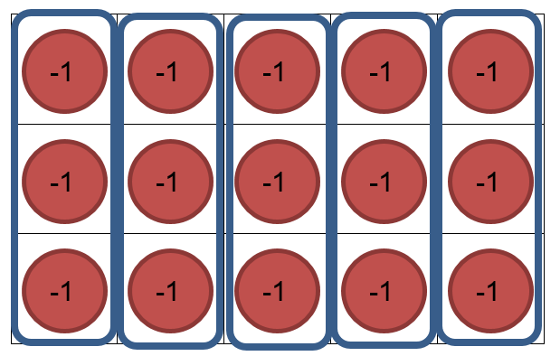
This would give us five groups of (-3) counters.
So, (-15) ÷ (-3) = 5

Task 1
- Represent these questions with counters before writing your final answer.
- (-12) ÷ 4
- (-20) ÷ 2
- (-16) ÷ 4
- (-21) ÷ (-7)
- (-18) ÷ (-6)
- How could you write each of the sums above in a different way?
- How many sums can you find with an answer of (-2)?
- What do you notice? What do you wonder?

Even more negatives
What about 15 ÷ (-3)?
How can we divide fifteen, +1 counters into groups of (-3)?
The best way to tackle this problem is to turn it into a multiplication problem.
(-3) x ? = 15
When we did multiplication, we learnt that (-3) rows meant that we had to remove three rows.
What do we need to remove three rows of, to leave us with fifteen +1 counters?
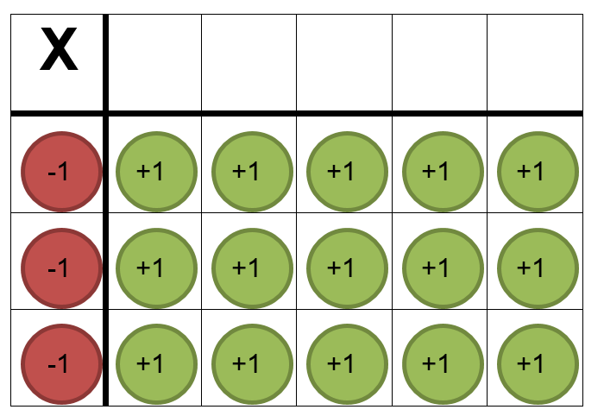

If we created fifteen zero pairs, we could then remove three rows of (-1) counters, to leave us with fifteen +1 counters.

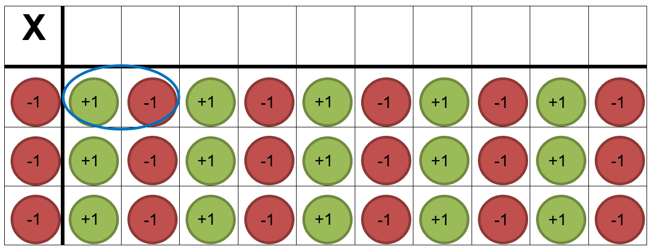

So we can remove (-5) counters out of each row, to leave us with fifteen +1 counters.
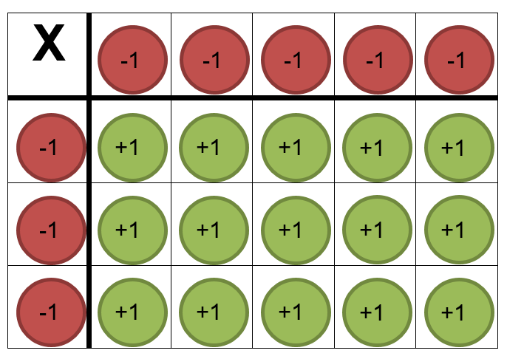
So, (-3) x (-5) = 15
Or
15 ÷ (-3) = (-5)

Task 2
- Represent these questions with counters before writing your final answer.
- 12 ÷ (-4)
- 20 ÷ (-2)
- 16 ÷ (-4)
- 21 ÷ (-7)
- 18 ÷ (-6)
- How could you write each of the sums above in a different way?
- How do your answers compare to those in Task 1?
- How many sums can you find now, with an answer of (-2)?
- What do you notice? What do you wonder?

Task 3
Make a summary of how to divide with negative numbers (with or without counters). It should be in your own words and can use pictures of diagrams to assist you.

Outcomes
- MA4-4NA compares, orders and calculates with integers, applying a range of strategies to aid computation

Note to teacher
Questions could be completed with online algebra tiles
s3-us-west-2.amazonaws.com/oervm/chipmodel/ChipModelOps.html
support.mathies.ca/en/mainSpace/AlgebraTiles.php

Interactive practice
thewessens.net/ClassroomApps/Models/Tiles/muldivtiles.html?topic=models&id=3

