Buying in bulk

Background
Companies like Mega Savers and Costco are famous for selling items in bulk.
Is this always cheapest? Is it always the best buy?

Part A: Exploring different sizes

Task 1- Coca cola
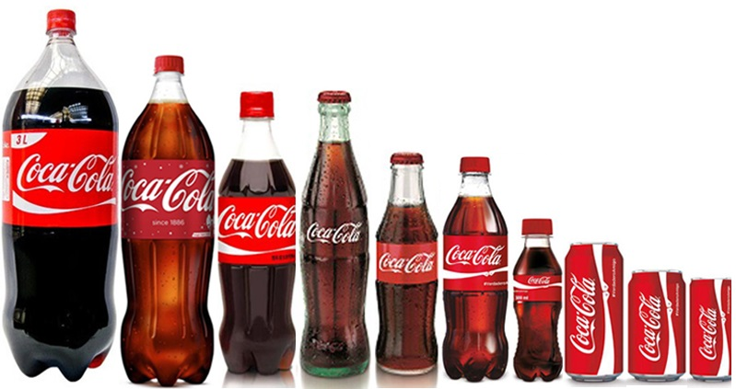
Coca-Cola sell their products in a variety of different sizes and forms. Your task is to investigate the cheapest option.
- Visit your nearest supermarket and record the different ways you can purchase Coca-Cola and record your results in a table similar to the one below.
Item | Size | Price | Price per 100mL
Bottle | 600 mL | $3.60
Can | 10 x 375 mL | $6.50
- Convert your prices to a price per 100mL. You must show your working for at least 3 of your calculations. Record your answers in your table.
- Which is the cheapest way to purchase Coca-Cola? Is there any disadvantage to purchasing Coca-Cola in this manner?

Task 2 – Toilet paper
During COVID19 people were restricted to buying only one packet of toilet paper at a time due to hoarding. Which packet would you buy?
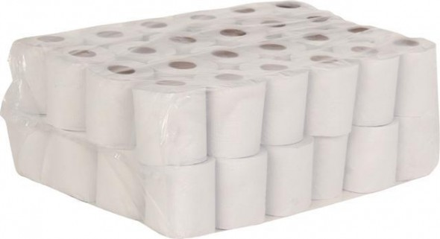
- Visit your nearest supermarket and record the different sizes and prices of toilet paper. Make sure you include the same size in different brands. Record your results in a table similar to the one below.

Brand | Number of rolls | Number of sheets per roll | Price | Price per roll | Price per sheet
Quilton | 36 | 180 | $14.00
Coles - So soft | 8 | 190 | $3.70
Coles - toilet tissue | 18 | 260 | $5.50

- Convert your prices to a price per roll. You must show your working for at least 3 of your calculations. Record your answers in our table.

- Different packs of toilet paper have different numbers of sheets per roll. Convert your prices to a price per sheet. You must show your working for at least 3 of your calculations. Record your answers in your table.

- Which is the cheapest way to buy toilet paper?

- Which packet of toilet paper would you buy? Justify your answer. What factors did you consider?

Part B – No name
No-name generic brands are notorious for being cheaper than their well-advertised brand name opponents.
How much money could you save by using purely generic brands?

Task - Planning a meal
Find a recipe and compare the cost of making it using purely generic brands vs using brand name products.
- Record your ingredients in two tables similar to the ones below.
- Calculate the cost per quantity needed
- Find the total cost of making your recipe in each scenario.
- Would you use the generic ingredients to make your recipe? Justify your decision by discussing the factors that you considered.

Some facts that may help you (these have been simplified slightly):
1 cup = 250 ml = 250g
¼ cup = 60 ml = 60g
1/3 cup = 80 ml = 80 g
1 teaspoon (tsp) = 5 ml = 5g
1 tablespoon (tbsp.) = 20 ml = 20g
If you have access to the internet, you might like to use the more accurate measurements found at https://www.taste.com.au/healthy/articles/weights-measurement-charts/vnepuhic
Table 1 – Generic brand products
Item | Brand | Size | Price | Quantity needed | Price per quantity
Sugar | Coles | 1 kg | $1.00 | 1 cup | $0.25
Table 2 – Brand name products
Item | Brand | Size | Price | Quantity needed | Price per quantity
Sugar | CSR | 1 kg | $1.75 | 1 cup | $0.44

Outcomes
- MA4-1WM communicates and connects mathematical ideas using appropriate terminology, diagrams and symbols
- MA4-2WM applies appropriate mathematical techniques to solve problems
- MA4-3WM recognises and explains mathematical relationships using reasoning
- MA4-6NA solves financial problems involving purchasing goods

