Mathematics workbook Stage 3
Name:
Class:

Overview
For the next 2 weeks, we hope you will be having some fun with mathematics – getting sweaty brains, thinking hard and feeling successful when you solve a problem, develop more confidence or understand something better. Many of these activities are games and investigations that you can play with your family, friends and classmates. Have fun and think deeply!
Most of these tasks have a video and some have downloadable resources to support your learning. You can find these using the digital student resource link on the Learning from home, Teaching and learning resources, K-6 resources page.

Day 1
Today we have 4 tasks. These tasks are designed to get us talking about different ways we can think about numbers, have some fun whilst working with the operations and make some squares we will need later in the week.
Resources – colour pencils/ markers, device to view videos, 5 pieces of A4 or A5 paper, dice or numeral cards 1-6, 0-9 spinner (appendix)

Imagining fractions 1
View Imagining fractions 1 video
What’s a different way you could have imagined the fractional slices of lemon moving? Draw pictures to capture your thinking.
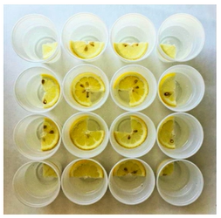
(Image from Adam Hillman)

Dicey addition
(Adapted from NRICH maths)
View Dicey addition video
How to play?
Find a partner and a 0-9 dice or spinner. Draw your game board so you each have one. (We used this one to start with: _ _ _ + _ _ _ + _ _ _ = ________ You can start with something different if you like). Each player takes a turn to spin the spinner and decide where to play that digit in your number sentence (equation). Spin the spinner 9 times each. The person whose sum is closest to 1000 is the winner!
Enjoy playing dicey addition with your family members. Record your games.

How to make a square
View video – How to make a square
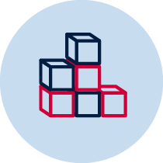Follow the steps in the video to make 5 squares and keep them ready for Day 2!

101 and you’re out
View 101 and you’re out video
How to play?
This game comes from Marilyn Burns.
Make a game board by drawing a 6 x 4 table. Label the first column as ‘tens’, the second column as ‘ones’, the third column as number and forth column as total. Each time you roll the dice (or flip a card) you have to decide whether the number is representing ‘ones’ or ‘tens’. For example, if I roll a 3, I could use it as 3 ones (3) or 3 tens (which we rename as 30). If you choose to use your 3 as 3 ones, record the number in the ones column. If you choose to use your 3 as 3 tens (30), record your number in the left column. Continue to play for six rolls. Once you write a number, you can’t change it. The winner is the player with the sum that is closest to 100 without going over!
Draw up 4 new game boards. Using the same numbers you rolled, use the game boards to get closer to 100 than you did in your first game.
Play again with someone at home!
Other ways to play:
- Increase the challenge by using numbers from 0-9. You can also use playing cards, make cards or make a spinner at home.
- Roll the dice 4 times and only use four lines on the game board.
This game can be played individually, competitively or collaboratively.
Play, explore and record your ideas for 101 and you’re out.

Reflection
Share or record your thinking about:
- What made you think hard when you played Dicey Addition?
- What advice would you give to someone playing this game for the first time?
- What will you do differently next time?

Day 2
Today we have 3 tasks. Today we have 3 tasks. We are going to spend some time talking about different ways we could solve the same problem...and then you’re going to have to think about how you could apply those strategies to a different context. We also have a puzzling problem for you using the squares you made in Day 1.
Resources – device to view videos, coloured pencils/ markers, 5 paper squares0-119 bottoms up hundreds chart (game board), 2 spinners, 2 counters, 1 or 2 paperclips, pencil or pen

Let’s talk 1 – Stage 3
View video Let’s talk 1 – Stage 3 video
What are 5 ways you can solve the problem? Remember you can use the blue (strong man), green (robot) or purple (flamingo) strategies, but you also need to think of 2 more!
How could you use the strategies shared by the blue team‘s thinking (strong man), green team‘s thinking (robot) and purple team’s thinking (flamingo) to solve your problem?

Pentominoes 1
Find all the unique shapes you can make using all 5 squares. Remember, the edges of each square must join other squares perfectly and of the shapes you make must be different. That means that two shapes are considered the same if one can be fitted exactly on top of the other, even if you have to turn it around or turn it over.
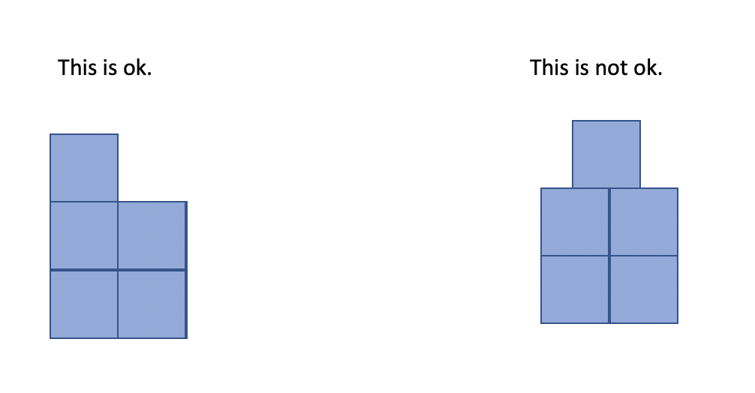
Record your thinking on this grid paper.

Super shapes
View Super shapes video
(From NRICH maths)
Each of the following shapes has a value:
 | =7 |  | =17
The value of the red shapes changes in each of the following problems.
Can you discover its value in each problem, if the values of the shapes are being added together?
(a) |  | =25
(b) |  | =51
(c) |  | =136
(d) |  | =48
(e) |  | =100

Reflection
You might have had a sweaty brain today looking at a strategy we could use to solve 2.3 – 1.9. Your brain might also have felt excited! Draw a picture to show what your brain was thinking as we investigated strategies for solving 2.3 – 1.9.

Day 3
Today we have 3 tasks. We are going to deeply consider one of the strategies we spoke about yesterday, explore the role of structure in helping us determine how many there are in a collection, and, keep puzzling with pentominoes!
Resources – device to view videos, scissors, colour pencils, pencil

Dot card talk 3
View Dot card talk 3 video

Let’s investigate 1 – S3
View video on Let’s investigate 1 – S3
Have a go at adjusting both numbers so we keep a constant difference. How could you use this strategy to solve 7 and 3-tenths - 2 and 9-tenths (for example)? What about with 3-tenths - 12-hundredths (0.3 - 0.12)? Record your thinking in your student workbook.

Pentominoes 2
(Adapted from Pentominoes zoo)
What other shapes can you make by joining your pentominoes together? Show your thinking on the grid paper.
- Can you make a rectangle?
- Can you make more than one rectangle?
- Form a rectangle with the smallest possible perimeter.
- Form a rectangle with the largest possible perimeter.

Can you make some of these animals from Abaroth’s World? After making them, you may like to colour them in to match your pentominoes.
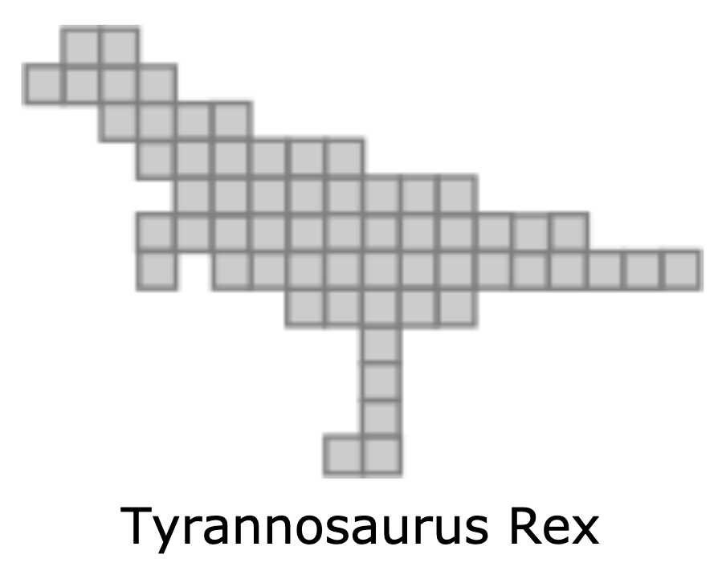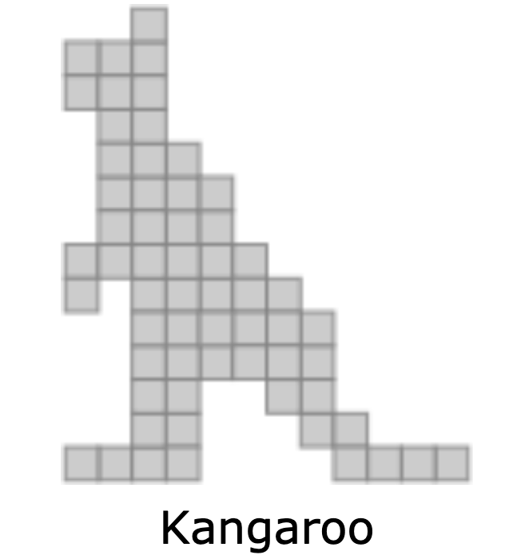
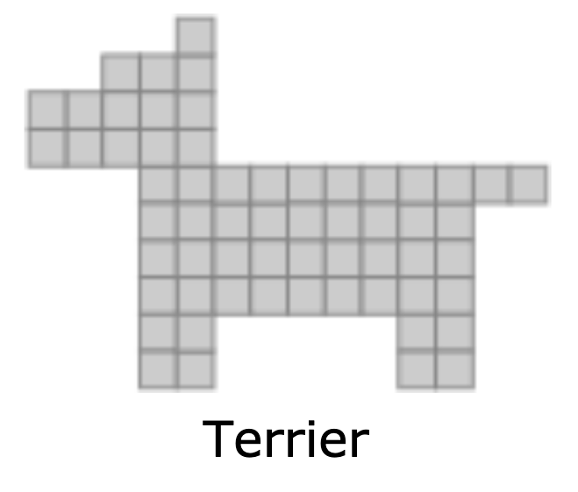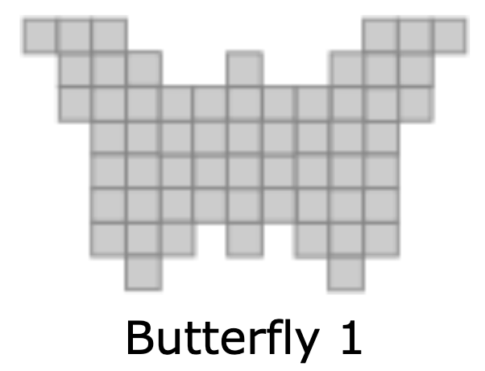
- If you need some clues take a peep in the appendix.
- What else can you create?

Reflection
Draw a picture to show what your brain was thinking as we explored the strategy of ’constant difference’ today.

Write another problem where you might use this strategy to help you find a solution.

Day 4
Today we have 3 tasks. We are going to continue working on our mathematical reasoning as we explore similarities and differences between different mental computation strategies, and develop various mathematical arguments. We will also have some fun making origami cubes!
Resources – device to view videos, pencil, 6 paper squares

Which one doesn’t belong? 2
(From Which one doesn’t belong?)
View video Which one doesn’t belong? 2.
What’s your initial thinking for which one doesn’t belong? Why?

Now, make a case for why each number doesn’t belong.

Record 3 other reasons for why 25, 16 and 43 don’t belong? (We might have found 3 for 43 but you’ll need to check… is it the only number with an even number of factors?)
Collaborate with others to discuss and record, which one doesn’t belong using the image above. Challenge yourselves to come up with an argument for each image.
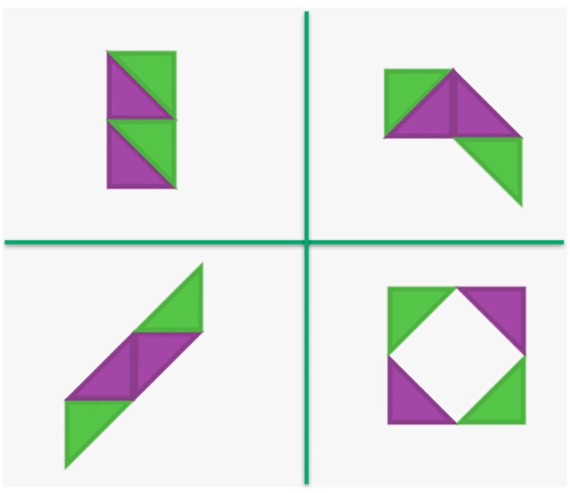

Let’s explore 1
View Let’s explore 1 video
Reflect on the strategies you used to solve 2.3 – 1.9 and identify the most efficient strategy you used.

How many steps did it take?

Do you think you could use the same strategy with other problems? Write 1 or 2 problems you could use this strategy with. Record your thinking.

Origami cube
View Origami cube video
Create 1 or 2 (or more if you like!) origami cubes.

Reflection
Talk about what you have discovered and learnt about today with someone at home.

Day 5
Today we have 3 tasks. We are going to continue working on our mathematical reasoning as we consider the different contexts where one strategy works...and when it doesn’t. We will also use our origami cubes to investigate some interesting things about nets!
Resources – pencils, device to view videos, pair of scissors, cube made on day 4, paper

Let’s generalise 1
View the video Let’s generalise 1
What happens with addition? Can we use the same strategy we used with subtraction is the exact same way?
Use any numbers you feel comfortable working with to investigate this idea.
Record your thinking using pictures, as well as words and symbols.

Net exploration
View Net exploration video
Create the net in the video and then use your cube to explore and make the other 10 nets.

Watch Look Kool cubes episode
View episode Look Kool Series 1 cubes on ABC iview.

Reflection
Talk about what you have discovered and learnt about today with someone at home.

Day 6
Today we have 2 tasks. We are going to get creative thinking about numbers within numbers as well as explore a problem with cubes.
Resources – device to view videos, colour pencils, 5 cubes, pencil

youcubed number visuals
View youcubed number visuals video
Explore the number visuals and record the different ways you see each number visual made up of other numbers.
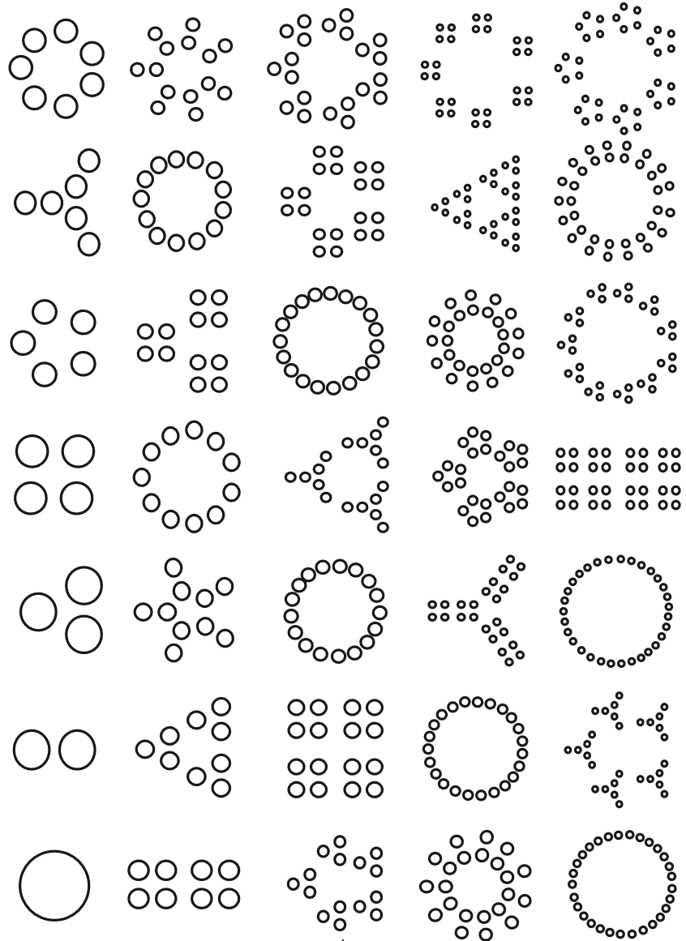
(from youcubed)

Brushloads
(from NRICH maths)
View Brushloads video page.
Can you find ways of arranging 5 cubes so that:
- you need as few BLs (brushloads) as possible?
- you need as many BLs (brushloads) as possible?
Record your thinking.

Reflection
Draw a picture or write about 1 or 2 things that made your brain think hard today (that made your brain get sweaty).

Draw a picture or write about 1 or 2 things that you realised today about numbers or maths that you may never have really thought about before.

Day 7
Today we have 3 tasks. We are going to continue exploring different ways of representing (and thinking about) numbers as well as explore some big ideas around how something can look quite different and still share some important commonalities.
Resources – device to view videos, pencil, colour pencils

Same...and different
(Using youcubed and mathforlove)
View Same...and different video
What do you notice?
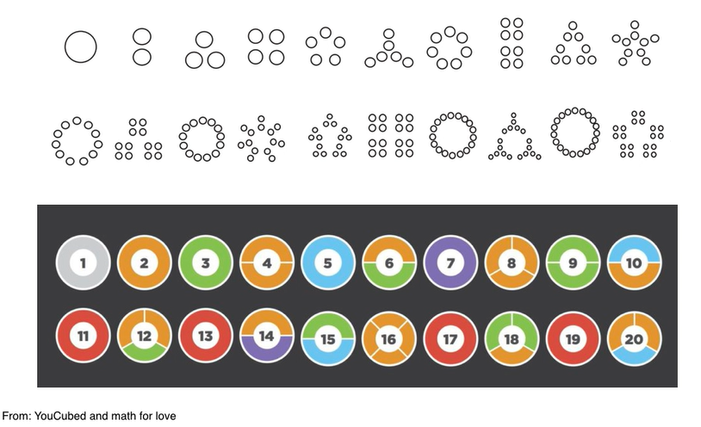What’s the same in these visual representations of the numbers 1- 20?

What’s different?

What are some things you find cool and/or curious?

Area vs perimeter
Area vs perimeter page
Remember our pentomino challenge from Day 3? We asked you to make some rectangles – one with the smallest possible perimeter and one with the largest possible perimeter. Looking at numbers in different ways has reminded us of this challenge! We’re realising that numbers can have the same value but look quite different. Look at these two rectangles:
Here’s one rectangle I could have made using all 12 pentomino pieces.
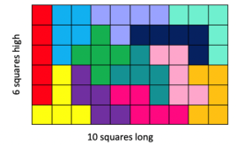
It forms a rectangle with boundaries of 6+10+6+10 making the perimeter 32 squares long. The area inside the rectangle is 60 squares.
Here’s a different rectangle I could have made using all 12 pentomino pieces.
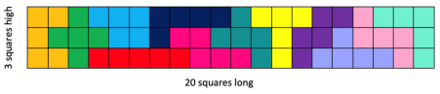
They look pretty different...and they still have the same area!
View episode MathXplosion –area vs perimeter on ABC splash.
https://education.abc.net.au/home#!/media/2971335/area-vs-perimeter

What rectangles can you make that have an area of 24 squares? Find as many rectangles as possible and record their perimeter and area.

Let’s talk 2 – S3
View Lets talk 2 – S3 video.
We found 3 different strategies we could use to solve the same problem… Can you think of another 2 strategies to solve the problem 15 nines (15 x 9)?

How could you use any of the strategies shared in the video to solve 16 x 25 nines (16 twenty-fives)?

Reflection
What 2 things made you think: ”Oh! that‘s cool/interesting!‘ today?

Day 8
Today we have 3 tasks. We are going to try to get inside other people’s thinking and play around with arrays and problems involving multiplicative thinking.
Resources – device to view videos, 0-9 dice or spinner (appendix) and 3 counters for each player (of the same colour), cut out youcubed math cards downloadable, scissors, paper, colour pencils/markers, pencil

Let’s investigate 2 S3
View Let’s investigate 2 S3 video
Use diagrams, drawings and/ or materials to represent how you might use these strategies to think about for 16 twenty-fives (16×25)?

reSolve bakery – part 1
View reSolve bakery - part 1 video and pause it as the questions are presented to record your ideas and mathematical thinking.
Charlie bakes eight trays of different flavoured cakes each day. How many cupcakes does Charlie bake each day?
Create a poster to show how you solved the problem. You might like to use a copy of the cupcake array to help explain how your strategy works.
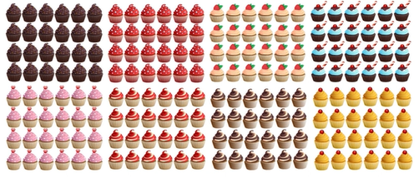

youcubed math cards
(from youcubed)
youcubed math cards page
How to play?
This game is like Memory or Concentration. Using the youcubed math cards, you are aiming to match cards with the same value shown through different representations. Lay all the cards down on a table and then take turns to pick them up, looking for a match.
For example 9 fours can be shown with an area model, a set of objects such as dominoes, and the number sentence (equation) as well as the product, 36. When players match the cards they should explain how they know that the different cards are equivalent in value.
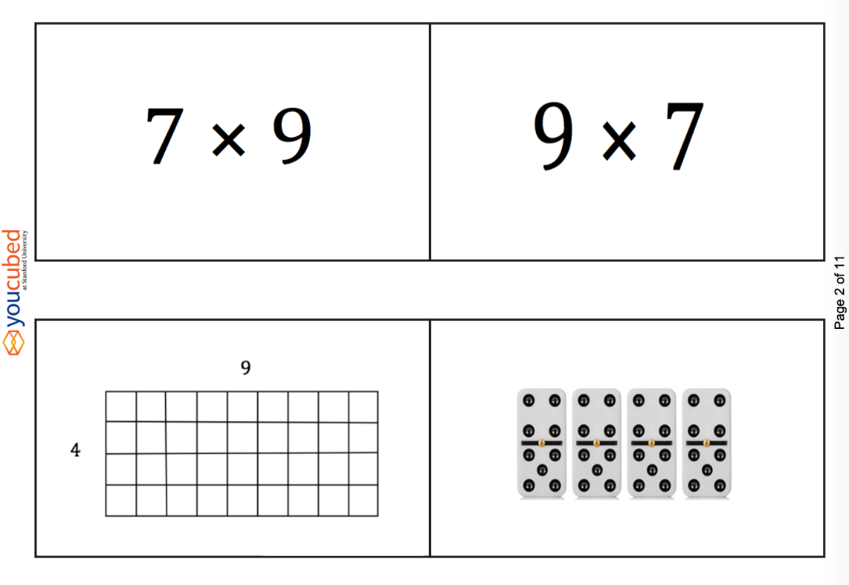
Play youcubed math cards. You can play this by yourself, with family members, friends or your classmates.
Explain how you knew that one set of different cards are equivalent in value.

Reflection
Imagine yourself feeling good about mathematics. Draw a picture to show what you‘re doing when you feel good about mathematics.

Day 9
Today we have 4 tasks. We are going to warm up our brain with a task from Math for Love, continue our problem with the reSolve bakery task and return to a maths game and give it a new twist.
Resources – device to view videos, pencil, paper, 0-9 spinner (appendix), paper clip, pen

Broken calculator
View Broken calculator video
(Adapted from mathforlove)
What are some other ways we can get to a total of 33 on this broken calculator?
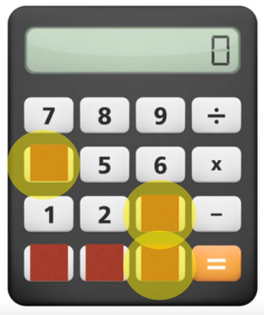

Write some of your own challenges for your family, classmates or teachers!

reSolve bakery task– part 2
View reSolve bakery task - part 2
How are these two strategies similar and how are they different?
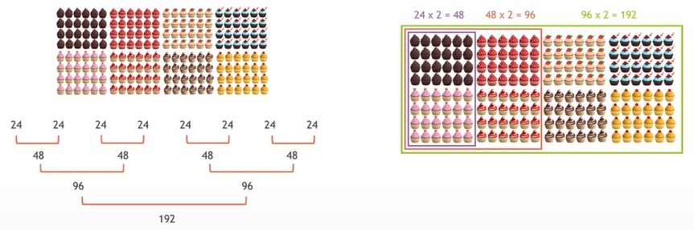

How many cakes does Charlie need to bake? Create a poster to show how you solved the problem. You might like to use a copy of the grid array on the next page to help explain how your strategy works.
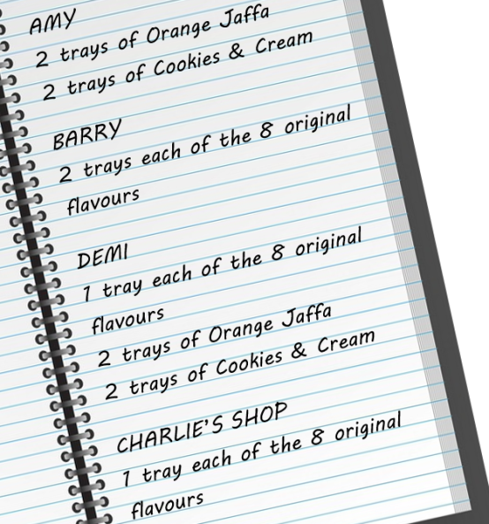
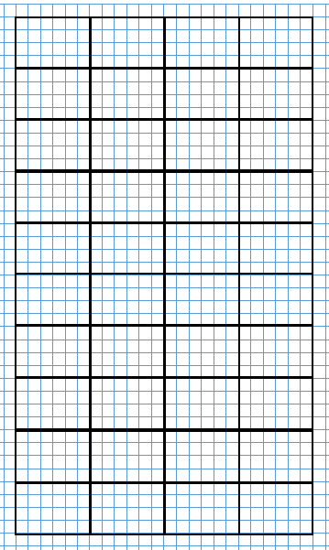

Dicey addition
(Adapted from NRICH maths)
View Dicey addition video
Play Dicey addition again – but this time, create a game board using multiplication or division.

Reflection
Draw a picture or write about 1 or 2 things that made your brain think hard today (that made your brain get sweaty).

Day 10
Today we have 2 tasks. You will use your number knowledge and skills and knowledge in reasoning and multiplication and division! Have fun playing!
Resources – device to view videos, 0-9 spinner (appendix), colour pencils or markers, paperclip, pen

reSolve bakery task – part 3
View reSolve bakery task – part 3 video.

Do you think the trays have the same area? If not, which tray do you predict has the biggest area? Select an efficient strategy to determine which area is larger.

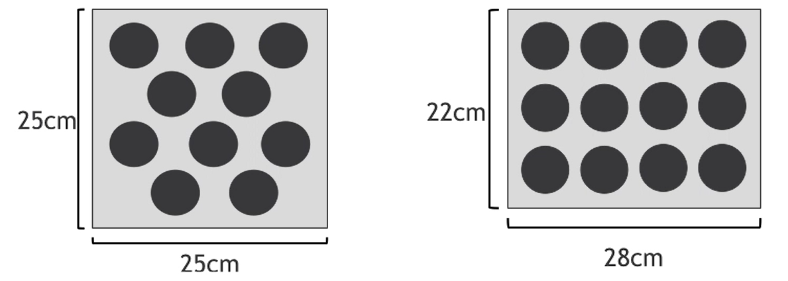

Work out which tray has the largest area. Use diagrams to share your thinking.

Multiplication toss
(From Dianne Siemon, RMIT University)
Video on multiplication toss page.
How to play?
You can play this by yourself or players take turns to spin the spinners. If a 3 and 6 are spun, players can enclose either block out 3 rows of 6 (3 sixes) or 6 rows of 3 (6 threes). The game continues with no overlapping areas. The winner is the player with the largest area blocked out after 10 spins. Eventually the space on the grid paper gets really small.
Then, you have to think:
What if my 3 sixes won’t fit as 3 sixes or as 6 threes?
Players can partition to help them! So, for example, I can rename 3 sixes as 2 sixes and 1 six (if that helps me fit the block into my game board).
Play multiplication toss.
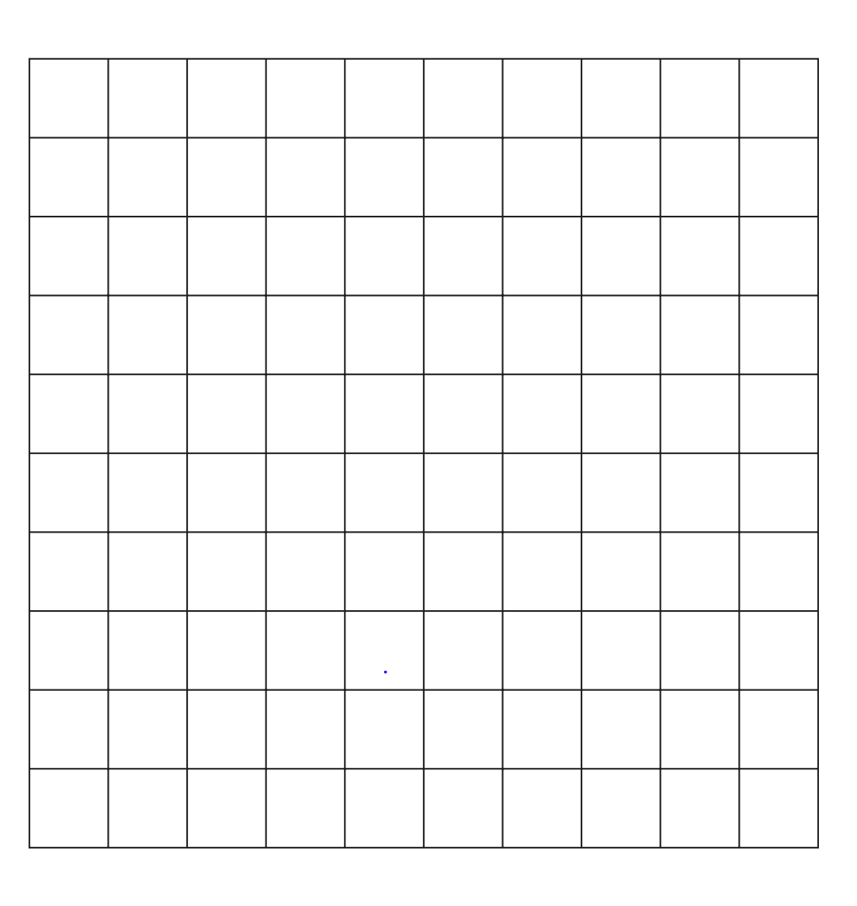

Day 3 pentominoes 2
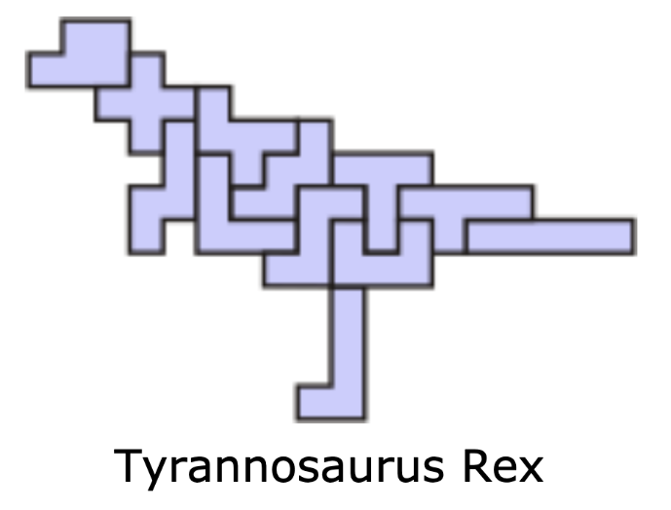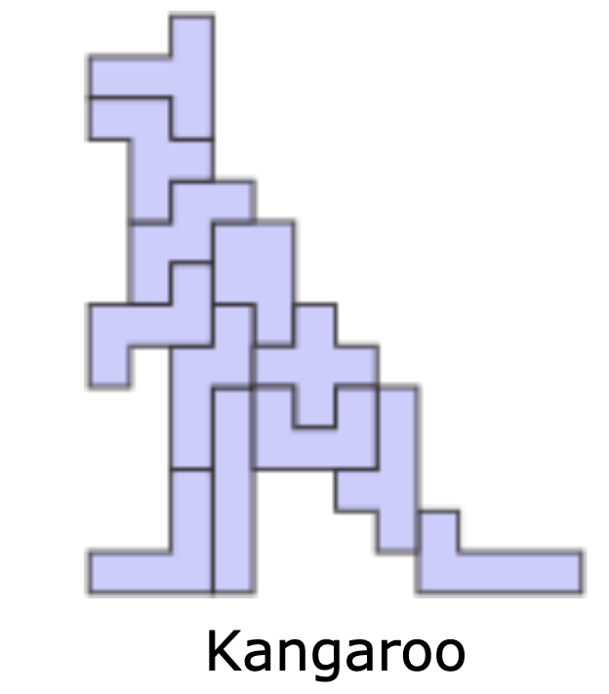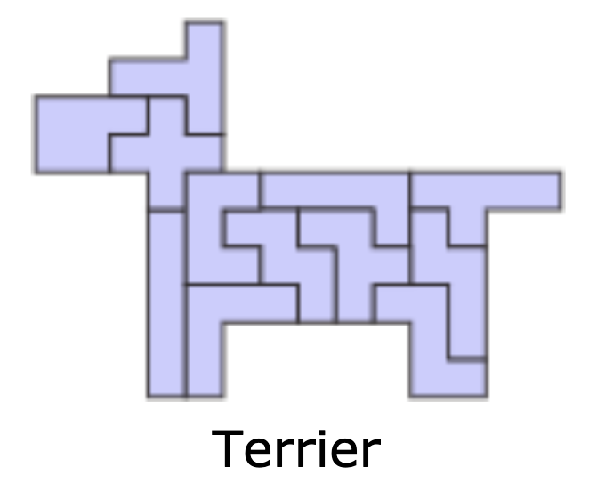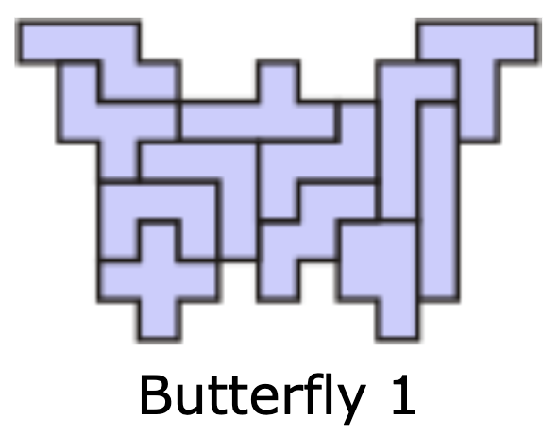

Spinner for day 1 and 9 dicey addition and day 10 multipliation toss
