Name:
Class:

Overview
For the next 2 weeks, you will be having lots of fun with maths, especially number! Most of these lessons are games that you can play with your family. Have fun and think deeply!

These activities do not require the use of a device. However, if you’re interested in seeing videos related to these activities, you can find the link on the Learning from home, Teaching and learning resources, K-6 resources page. https://education.nsw.gov.au/teaching-and-learning/curriculum/learning-from-home/teaching-and-learning-resources/k-6-resources

Activity 1
During this activity you will explore addition and subtraction and place value in order to get as close as possible to 100.
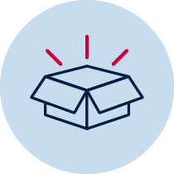 Resources – Playing cards from Ace to 9 (where Ace = 1) or a 4 sets of 1-9 cards you’ve made at home.

Closest to 100
Play this game with a partner in your workbook or on paper. If you can, it is even better to play 2 versus 2.

Players shuffle the cards and put them in a central pile. One person takes 6 cards and places them face up for everyone to see.

The goal is to use addition and subtraction to get as close to a total of 100 as possible.

Each card can only be used once. It can be used to form a 1- or 2-digit number.
Imagine a 2, 4, 5, 1, 8 and 5 have been flipped over.

A team of players could:
- Use 8 and 5 and make 8 represent 8 tens to create the 2-digit number 85
- Use 1 and 5 and make 1 represent 1 ten to create the 2-digit number 15
- Add 85 and 15 together to make 100

If a player had flipped over 6, 3, 9, 9, 1, 2, they could:
- Make 91 and 9, adding them together to make 100
- Make 99 and 1, adding them together to make 100
- Make 63 and 29, adding them together to make 92.
- Then, add 9 more to make 101. Subtract 1 from 101 to make 100.

If a player had flipped over 3, 3, 6, 8, 1, 2, they could:
- Make 83 + 23 = 106. 106 - 6 = 100
- Make 86 + 13 + 3 = 102. 102 - 2 = 100

Players score 0 points if they are able to reach exactly 100. Otherwise, they work out their points based on the difference between their total and 100. For example, if a player created a total of 98, they would score 2 points.

Keep a cumulative total of your difference to 100. The winner is the player to have the lowest points score at the end.

Variations:
- The first 3 cards are ‘small numbers’ (single digits) and the next 3 cards are ‘multiples of 10’ (the face value multiplied by 10). E.g. I flip over cards showing 3, 6, 1, 9, 3 and 4 and have to use the numbers 3, 6, 1, 90, 30 and 40
- Change the target number, for example, to 50

Reflection
Think about what you have learnt in this activity. Use the two stars and a wish structure to guide your reflection.
Star  Something that went well! | Star  Something that went well! | Wish  A goal for next time…

Activity 2
During this activity you will be exploring area. You should also look for patterns and think of strategies to beat your opponent.
Resources –1cm grid paper from your mathematics book, different coloured pencils or markers, 2 spinners (you will need the decagon outlines in the resources page and 2 paper clips), and a pen.

Multiplication toss
This is a variation of a game from Professor Dianne Siemon and the Victorian Department of Education (https://www.education.vic.gov.au/Documents/school/teachers/teachingresources/discipline/maths/assessment/lafzone2intro.pdf). A version of this game can also be found here
(https://www.youcubed.org/tasks/how-close-to-100/)
Play this game with a partner.

Players take turns to spin the spinners. If a 3 and 6 are spun, players can enclose either a block out of 3 row s of 6 (3 sixes) or 6 rows of 3 (6 threes).
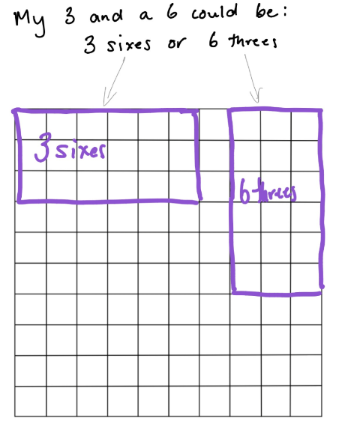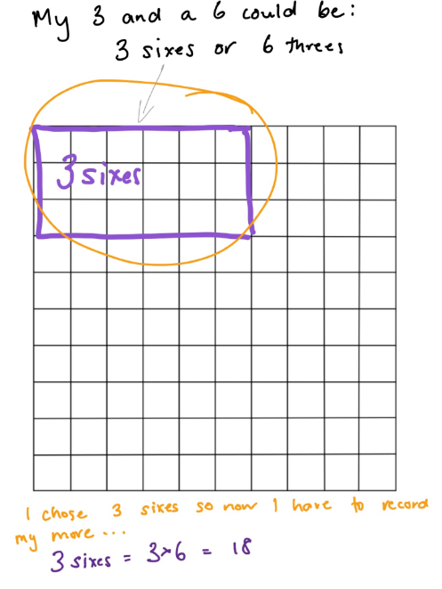
The game continues with no overlapping areas. The winner is the player with the largest area blocked out after 10 spins.
Eventually the space on the grid paper gets really small. Then, you have to think:
- What if my 3 sixes won’t fit as 3 sixes or as 6 threes? Players can partition to help them! So, for example, I can rename 3 sixes as 2 sixes and 1 six (if that helps me fit the block into my game board).
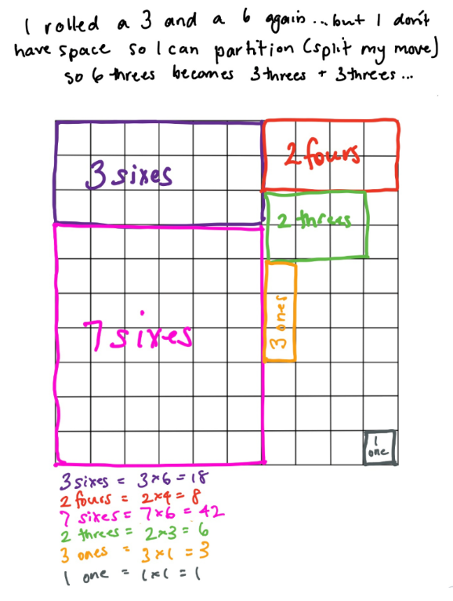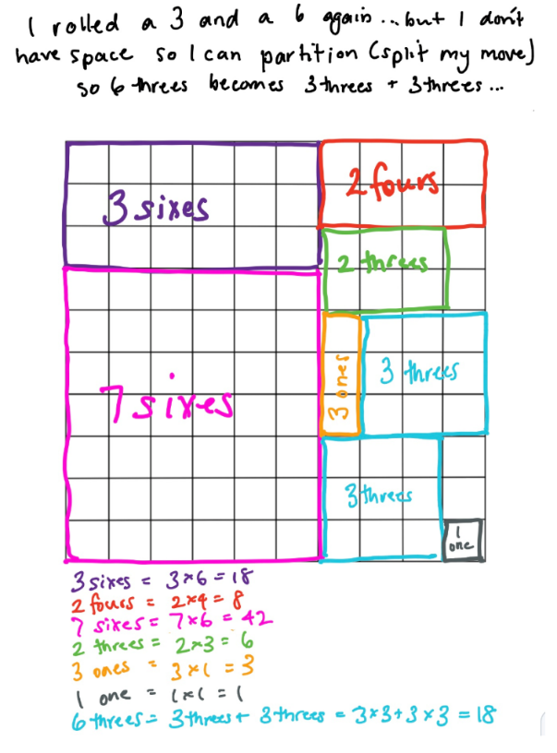

Reflection
Now that you’ve played this game once, what could you do differently next time to increase your chances of filling in 100 squares?

Activity 3
During this activity you will continue to explore multiplication, division and equivalent areas. In the same way mathematicians can see 8 and think about it as 4 and 4 more, we can do the same with multiplicative situations and area!
Resources – colour pencils, grid paper, two spinners, a paperclip and a pen.

Multiplication toss Part 2
Explore these ideas and write them in your workbook.

After playing Multiplication toss, select an outlined area from your game board, for example, here is a game board.
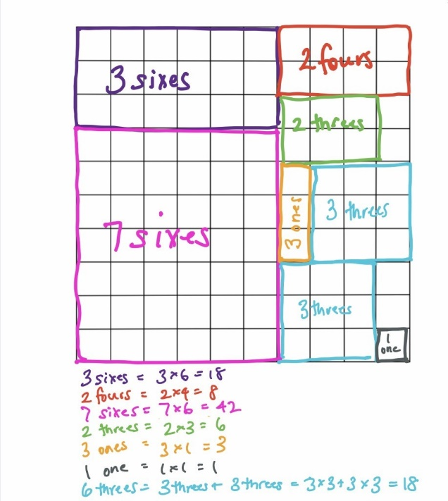
You might choose this section:
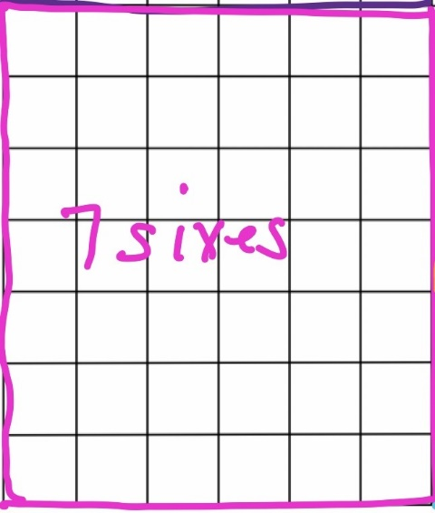
Draw and label all of the different ways that area can be partitioned and renamed.
For example (Here are 2 ideas)
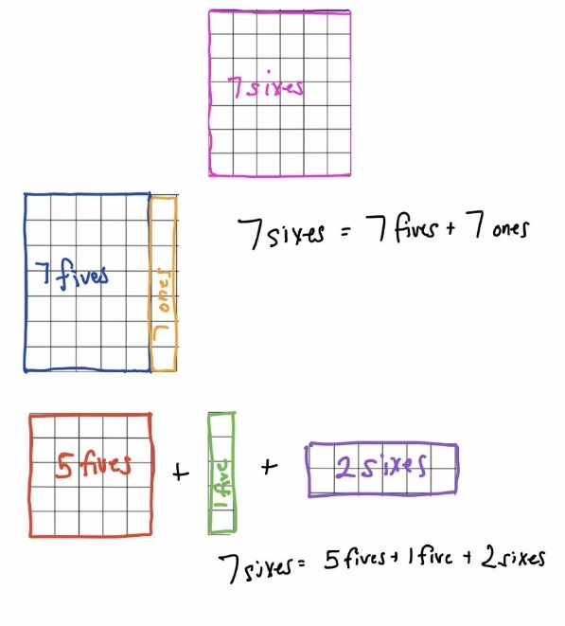

Reflection
Think about what you have learnt in this activity.
How many different ways did you find to partition your selected area?

What does this reveal to you about how flexibly mathematicians can think about situations involving area, multiplication and division?

How could you use this knowledge to help you in the future?

Activity 4
- During this activity you will be exploring fractions. You should also look for patterns and think of strategies to beat your opponent.
Colour in Fractions game board (in resources at the back of this workbook), lots of different coloured pencils and markets, fraction spinners (in resources).

Colour in fractions
(From: D. Clarke and A. Roche, Engaging Maths: 25 Favourite Maths Lessons, 2014)
Play this game with a partner. If you can, the best way to play is 2 versus 2 so you can develop winning strategies together.

Players take turns spin both fraction spinners to make a fraction. The first spinner tells you how many and the second spinner tells you what fraction you are working with.
Colour the equivalent of the fraction shown. For example, if a player spins 2 and quarters then they can colour in $\frac{2}{4}$of one line, or $\frac{4}{8}$ of one line, or $\frac{1}{4}$ of one line and $\frac{2}{8}$ of another, or any other combination that is the same as $\frac{2}{4}$.
Each time you spin, you should use a different colour pencil or marker.
If a player is unable to use their turn, they “pass.”
Players take it in turns to spin and make fractions, marking them on their fraction wall. If the fraction rolled or its equivalence cannot be shaded, they miss a turn. This becomes more frequent later in the game.
You are not allowed to break up a “brick.”
In finishing off the game, you must have had 18 turns or have filled in your wall. A larger fraction is not acceptable to finish.
The first player who colours in their whole wall is the winner. If after 18 turns, neither player colours in their whole wall, the player with the greatest number of wholes wins.
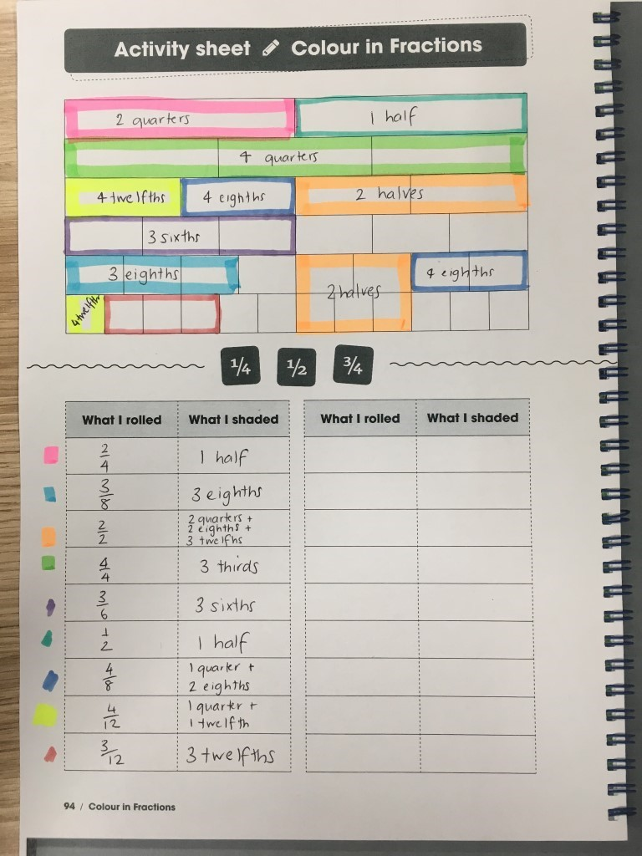

Reflection
Reflection questions. Think about these questions and write your thinking in your workbook.
1. If you played the game tomorrow, what would you do differently?
2. If you were giving some hints to a younger brother or sister who was about to play the game, what would you say to him or her to help them win?

Activity 5
During this activity you will be exploring equivalent fractions and the renaming of fractions.
Resources: Colour in fractions game board (in resources at the back of this workbook), lots of different coloured pencils and markets, fraction spinners (in resources).

Colour in fractions Part 2
(From: D. Clarke and A. Roche, Engaging Maths: 25 Favourite Maths Lessons, 2014)
Play this game with a partner.

Play the fractions game again.
Look at Michelle’s game board.
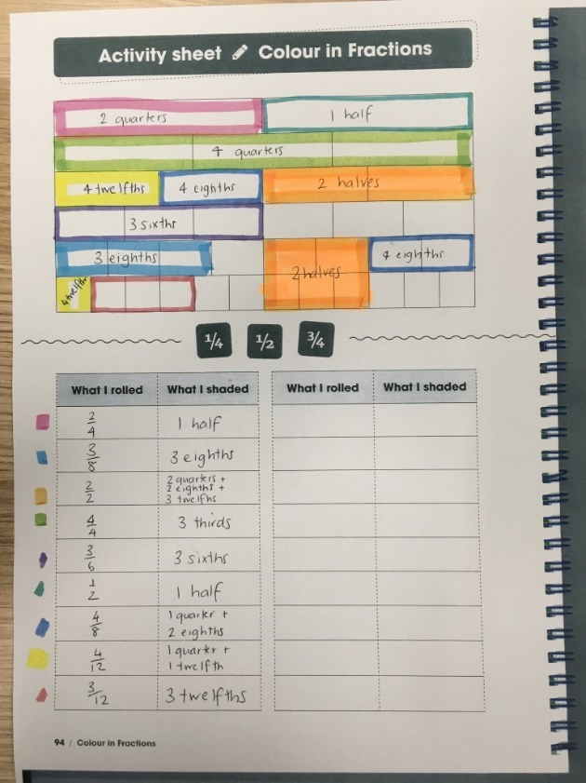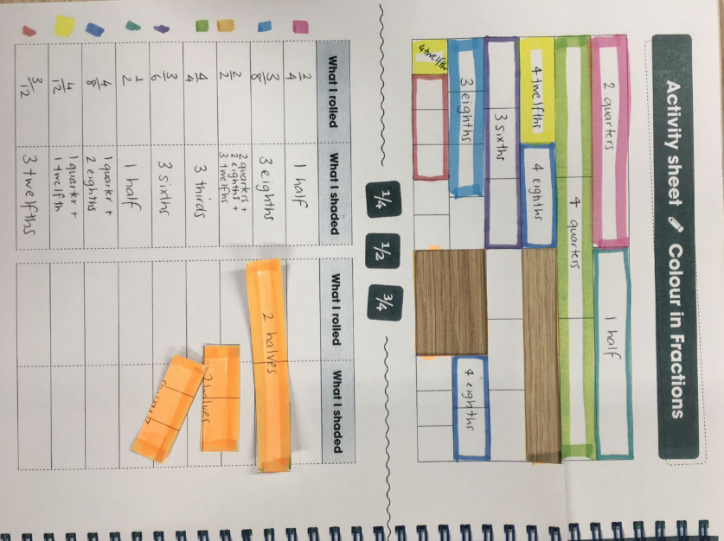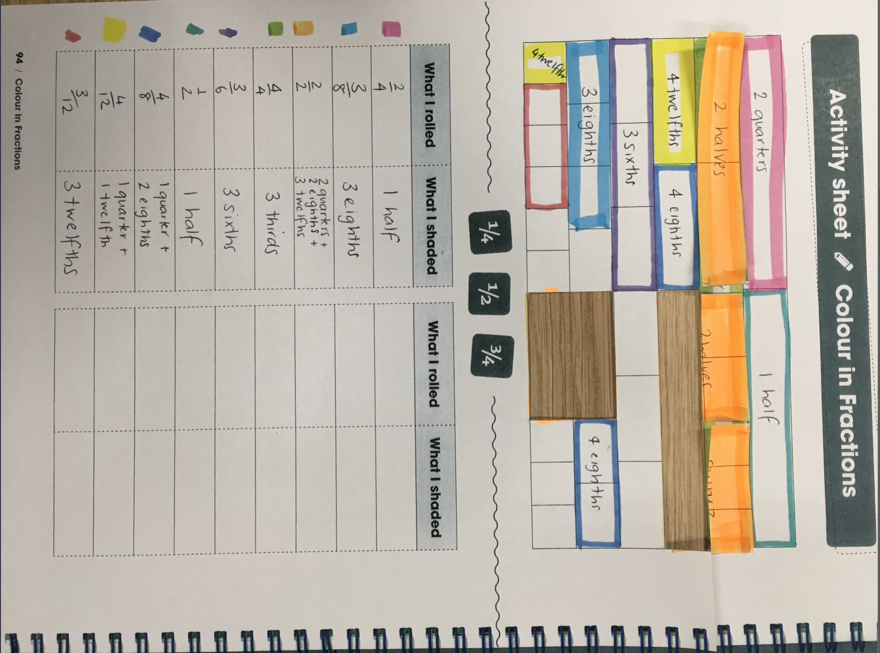
She recorded $\frac{2}{2}$as 2 quarters + 2 eighths + 3 twelfths. She wondered...how many other ways can she rename $\frac{2}{2}$ ?
Use the game board to explore these questions:
- 2 halves is...
- 2 quarters + 2 eighths + 3 twelfths
- 4 eighths + 1 half
- 4 eighths + 6 twelfths
- 3 sixths + 6 twelfths
- 3 thirds is….
Now, explore your own game boards to investigate equivalent fractions. What equivalent fractions can you investigate using your gameboard?

Reflection
Reflection questions. Think about this question and write your thinking in your workbook.
1.What is something interesting that you discovered when exploring equivalent fractions today?

Activity 6
During this task, you will collect data on your success shooting baskets.
Resources: a basket, socks, paper, pencils, and a clear space.

Basketball Toss
You can play this game alone or with a partner. Have fun!

Your challenge: See how many times you can successfully shoot your rolled up socks into the basket.
Mark a clear ‘starting line’ for your Basketball Toss
Take 3 big steps from your starting line and place a basket or container at the end.
Stand at your starting line and throw your socks. Throw your socks with your right hand.
Go back to your starting line and have your second throw. Repeat this until you have thrown your socks 10 times with your right hand.
Repeat the process with your left hand, with your eyes closed (using any hand you like) and trying backwards. Keep a record on each shot using tally marks in your work book.

Keep a record of your baskets and graph your results.

Reflection
Talk over these reflection questions with a family member or carer.
- Do you think that these results will change with practice?
- Do you think that they would change at the same rate?

Activity 7
During this task, you will analyse data and think about different possible answers to a problem.
Resources: workbook, pencil

Paul’s basketball challenge
This graph shows the number of baskets Paul scored when he was playing basketball toss with his sister.
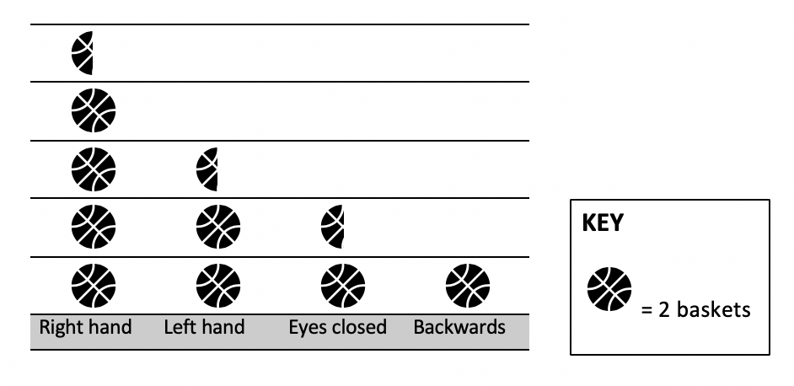
How many points did Paul score in total?
        - 9 and a half
        - 19
        - 16
        - 8
Paul decided that he wanted to improve his score and beat his sister the next time they played. He spent a lot of time practising using his left hand, playing backwards and with his eyes closed.
When he competed against his sister the next time, his efforts had worked! He had improved his score and he beat his sister! He scored 33 baskets. Paul had the same success with his right hand and improved by 1 with his eyes closed. How many baskets might he have scored with his left hand and backwards? What are all the possibilities?
Reflection
Think about what you have learnt in this activity. Use the two stars and a wish structure to guide your reflection.
Star  Something that went well! | Star  Something that went well! | Wish  A goal for next time…

Activity 8
During this task, you will be investigating number relationships through magic!
Resources: workbook, pencil

Let’s get magical

Let’s get magical (A version this can be found on NRICH maths https://nrich.maths.org/11014/note)
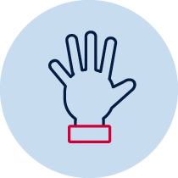
Choose a 3-digit number where the each digit is smaller than the previous one (but they don’t have to be in order. For example, 982 or 531.)
Then, reverse the digits and subtract the second number from the first one. So, if I had chosen 531 I would now work out 531 – 135. The answer is 396. (If you get 99, record your answer as 099.)
Next, reverse your new number. For example, from 396 I can make 639.
Finally, add these last two numbers together. For example, 396 + 639.
Here comes the magic...
The answer is 1089!
Try another starting number and test it out again...is the final answer is still 1089?
Explore what happens if you use the same process, starting with a 2-digit number or a 4-digit number...what do you notice about the final answer? Why do you think this might be happening?

Reflection
Think about what you have learnt in this activity. Use the two stars and a wish structure to guide your reflection.
Star  Something that went well! | Star  Something that went well! | Wish  A goal for next time…

Activity 9
During this task, you will be investigating your reaction time using the ruler drop test.
Resources: ruler, pencil, workbook

Reaction time test
- Reaction time test (adapted from reSolve: Maths by Inquiry https://www.resolve.edu.au/authentic-problems-reaction-time)
You need a partner to complete this activity.
To conduct the test, one person holds the ruler up reasonably high. The zero mark on the ruler is at the bottom.
The reacting student places finger and thumb at the bottom of the ruler, not touching but ready to grab.
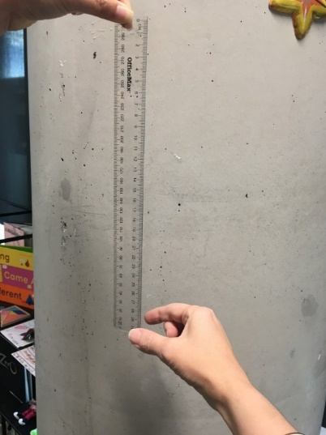
At an unpredictable time, the first person drops the ruler.
The reacting student catches it between finger and thumb, and reads the distance below the thumb.
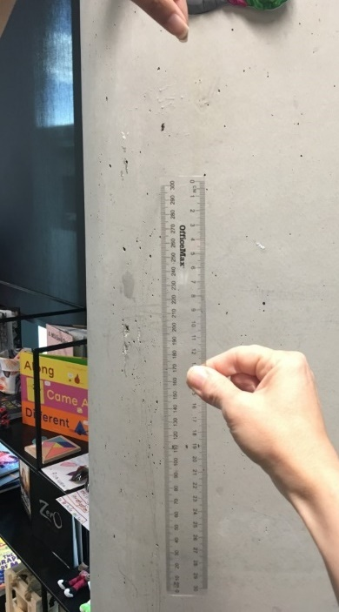
Conduct the test 5 times and record the results.
Convert the data into times using the ruler drop reaction time chart.
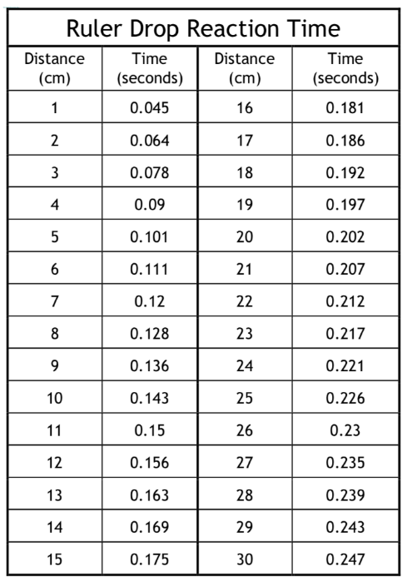
Draw a number line showing your reactions times.
Circle your fastest and slowest reaction times.
What is the difference between them?
How does your reaction time compare with other people in your family?

Reflection
Reflection questions. Think about these questions, discus them with someone and then show your thinking in your workbook.
1. Do you think that your reaction time is something that could improve with practice?
2. Who was the fastest in your family and why do you think that this was the case?

Activity 10
During this activity, you will be noticing and describing patterns using words and representations.
Resources: workbook, coloured pencils

Raindrops

1. Raindrops (from YouCubed https://www.youcubed.org/wp-content/uploads/2018/09/Raindrop-Task-final-copy.pdf)

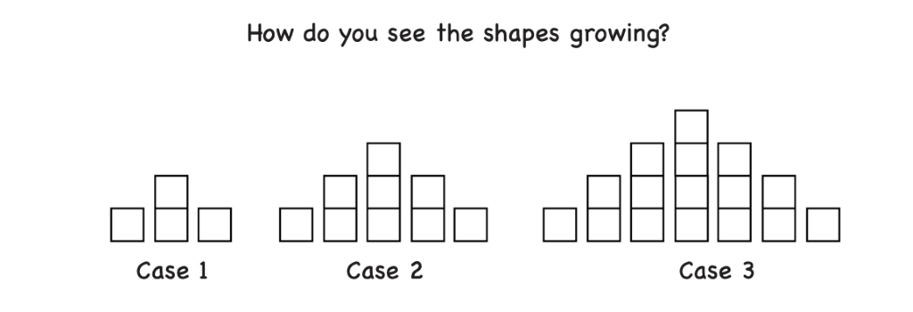
You might have noticed that in case 2 there are more cubes than in case 1, and in case 3 there are more cubes again.
Where do you see the extra cubes adding each time?
There are many ways to answer this question as people see the cases in lots of different ways. How does your class see them?
Record the way that you see it growing.

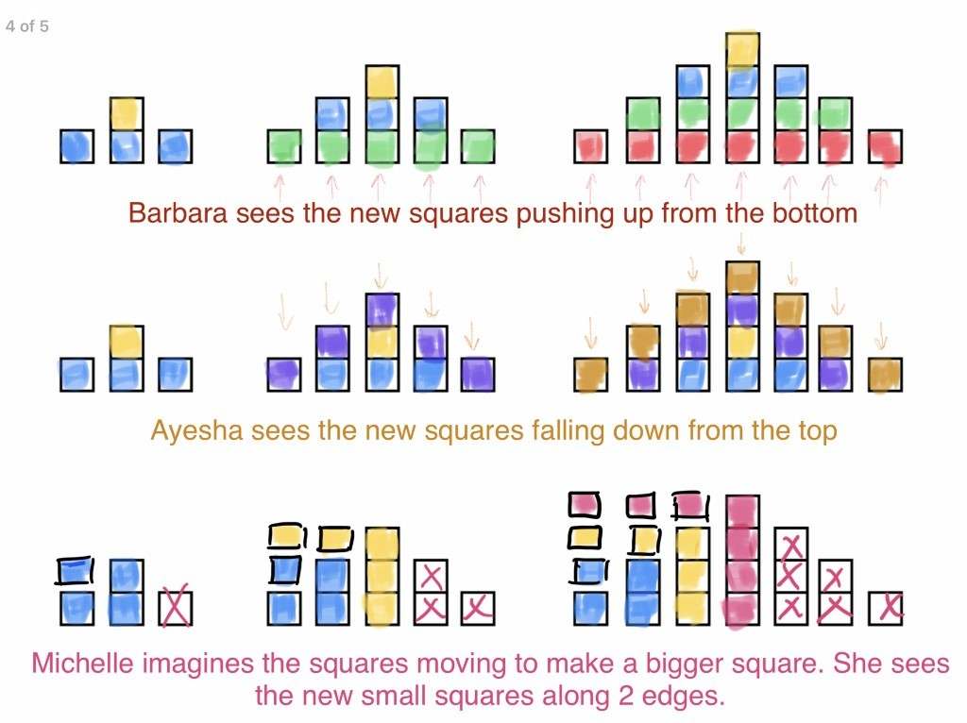
- What will the fourth case look like? Draw it in your work book.
- Mathematicians often like to draw diagrams and use tables to help them identify patterns. Can you use these strategies to help you work out what the 10th case would look like?

Resources
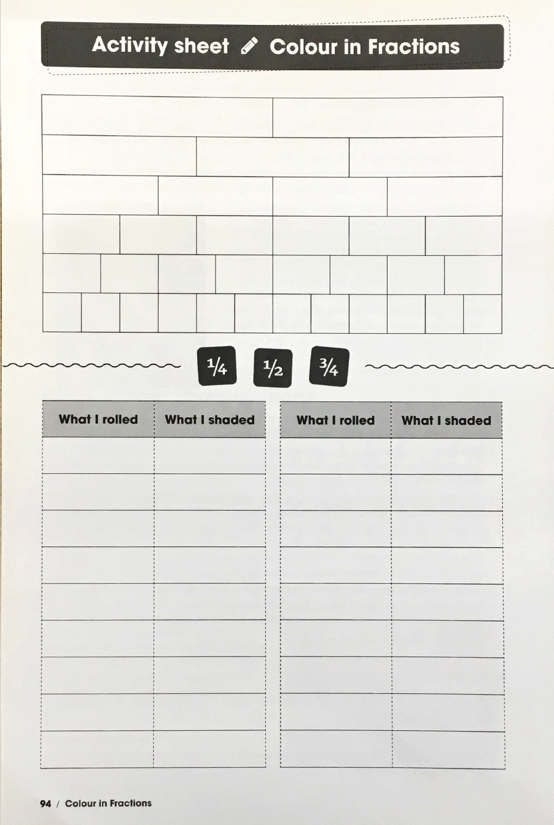

Colour in fraction spinners

