Student workbook thinking mathematically 3 Stage 2
Name:
Class:

Overview
For the next 2 weeks, we hope you will be having some fun with mathematics – getting sweaty brains, thinking hard and feeling successful when you solve a problem, develop more confidence or understand something better. Many of these activities are games and investigations that you can play with your family, friends and classmates. Have fun and think deeply!
Most of these tasks have a video and some have downloadable resources to support your learning. You can find these using the digital student resource link on the Learning from home, K-6 support – mathematics page.

Day 1
Today we will have an opportunity to deepen our understanding of patterns.
Resources – device to view videos, colour pencils/ markers

Staircase patterns 2.1
View video Staircase pattern 1 – Part 1
Draw the staircase pattern we explored, continuing it down the other side.
View video Staircase pattern 1 – part 2
If you like, you can build the model. Then draw what the staircase will look like if we continue building it up and down the other side, using twos.

View video Staircase pattern 1 – part 3
How many blocks are there altogether? Use diagrams to record the thinking you did to work out the solution.
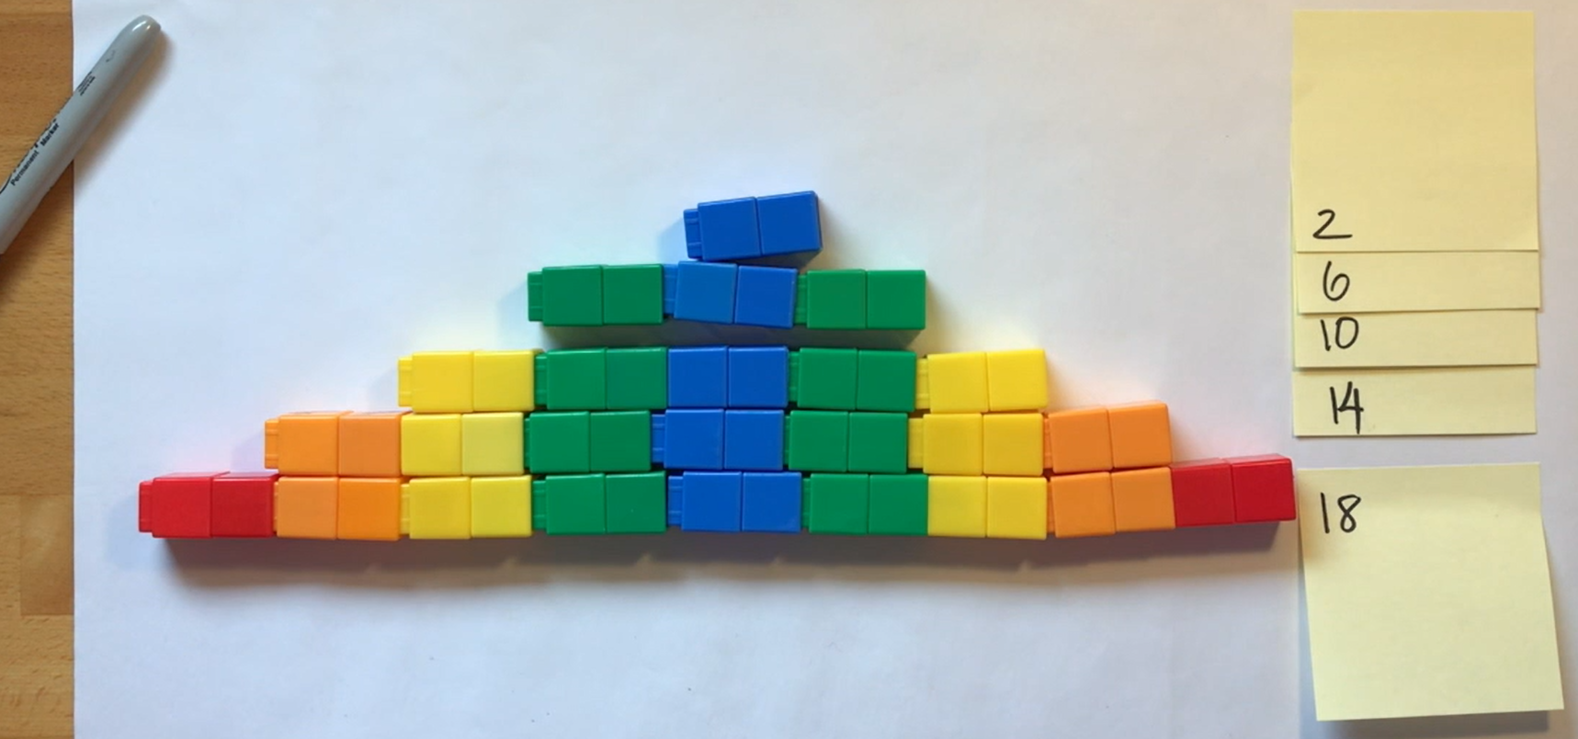

Reflection
Can you find any growing or shrinking patterns at home or at school? Draw the patterns you find.

Talk about what you have discovered and learnt about today with someone at home.

Day 2
Today we are going to have a closer look at patterns and create some.
Resources – device to view videos, colour pencils/ markers, collection of objects like blocks or unfix cubes

Staircase patterns 2.2
View video Staircase patterns 1 – part 4
Use objects, like blocks to create 2 new staircase structures.
Draw and describe the things you notice from the staircase structure you have made.

Make other staircases that form into squares.
Draw and describe the other staircases that form into squares.

Reflection
Share the drawings you created as a mathematician and talk about what your diagrams represent.

Day 3
Today we have 3 tasks. We are going to make a rekenrek (with the support of an adult), learn a new game and explore a multiplicative problem brought to us by LEGO.
Resources – device to view videos, glue (wood glue or hot glue), 4 pegs, 10 red beads and 10 blue beads (or 10 of any 2 colours you like), 2 paddle pop sticks, 2 kebab sticks, 4 wall plugs, and an adult. 48 counters (for example dried pasta, 24 for each player), 6 pieces of paper, 1-6 dice or spinner (see appendix)

Make a rekenrek
With an adult collect:
- glue (wood or hot glue)
- 4 pegs
- 10 red beads and 10 blue beads (or 10 of any 2 colours you like)
- 2 paddle pop sticks
- 2 kebab sticks
- 4 wall plugs
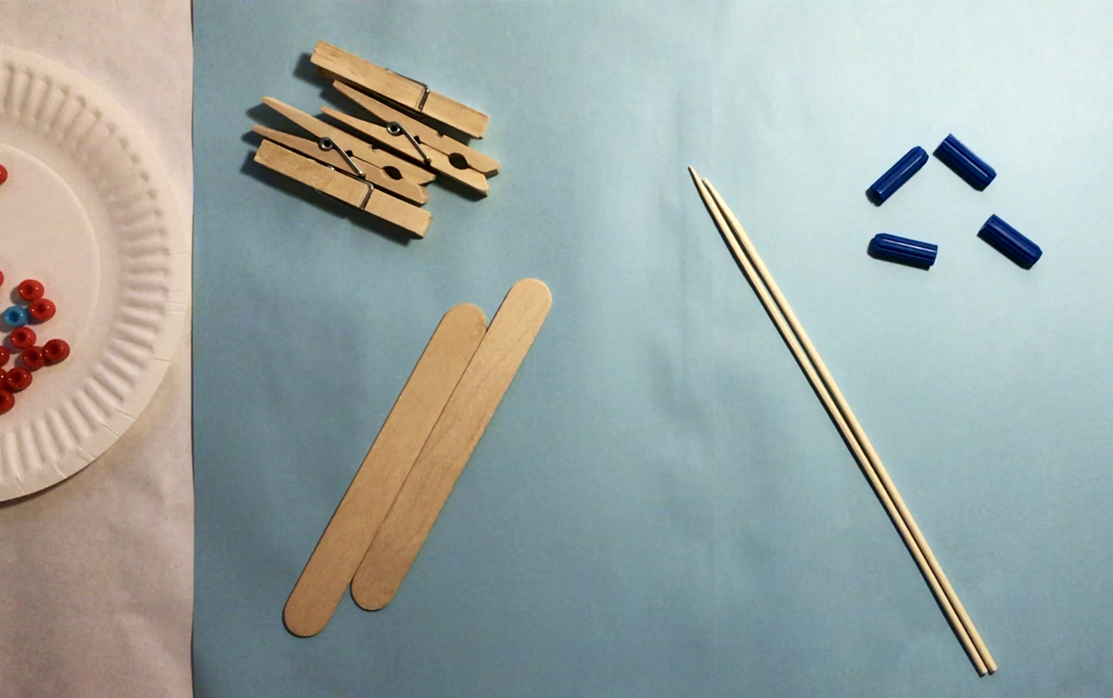
View video How to make a rekenrek with an adult and together make your own rekenrek.

Remainders game
View video Remainders game
Play Remainders game and record your game.
How to play
- Start with a collection of 24 things each.
- Players take it in turns to roll the dice to determine how many groups their collection needs to be shared into.
  - The player works out the solution to their division problem and explain their thinking to their partner who records their move.
  - If the product cannot be evenly divided, players keep the remainders, and the collection of counters they were working with is reduced.
- The player who reduces their collection to only 2 counters is declared the winner.

How many characters challenge
View video How many unique characters – part 1
How many unique mini figs can we make for our $25?

View video How many unique characters – part 2
See if the strategy shared in the video helps you think of all the different mini figs.
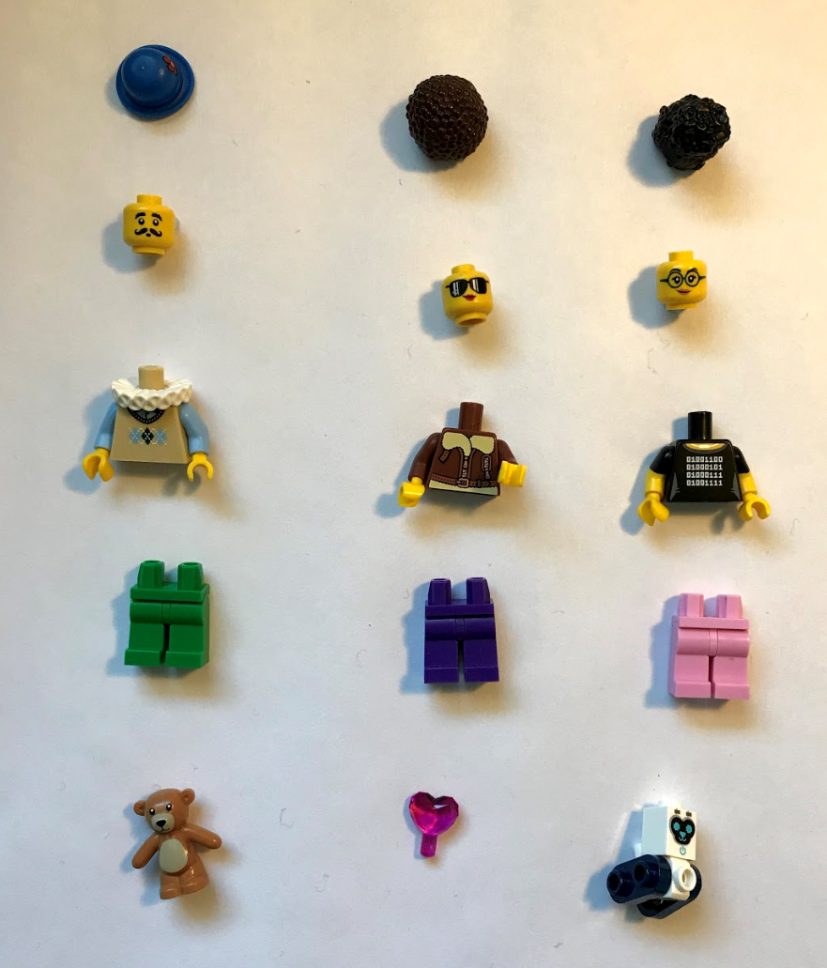

Reflection
What’s something you feel more confident with today? What’s something you found challenging today?

Day 4
Today we are going to play a game of strategy and number knowledge using our rekenreks. Then, we are going to make our own tangrams!
Resources –device to view videos, pencil, your rekenrek, set of numeral cards 0-20, colour pencils/ markers, counters for tokens (you could you use dried pasta), 1 square sheet of paper, pair of scissors

Rekenrek duel: level 2
View video Rekenrek duel: level 2.
Collect your rekenrek, a set of numeral cards 0-20, colour pencils/ markers, counters for tokens (you could you use dried pasta) and play Rekenrek duel: level 2!
Make up your own game using the rekenrek and record your rules here. What mathematical skills and understanding do you think your game will help students with?

How to make a tangram
View video How to make a tangram
With an adult collect:
- pair of scissors
- 1 square sheet of paper (View video on how to make a square)
View video How to make a tangram with an adult and together make your own tangram.

Reflection
List 2 things about your learning that made you feel good today?

Day 5
Today we are going to use our tangram to find out more about shapes... and hopefully get sweaty brains as we wonder about trapeziums!
Resources – device to view videos, pencil, tangram, colour pencils/ markers

Tangrams 2.1: exploring trapeziums
View video Tangrams –part 1
Use this adapted Frayer chart to define a trapezium.
Examples  (Draw, write or describe some examples) | Non-examples  (Draw write or describe some non- examples. Ask yourself “What isn’t it?”)

Definition and features
(Draw, write or describe a definition and some really important features.)
View video Tangrams –part 2
How many different trapeziums can you make using your tangram pieces? Make a trapezium using:
- 2 tangram pieces
- 3 tangram pieces
- 4 tangram pieces
- 5 tangram pieces
- 6 tangram pieces
- 7 tangram pieces
Record your creations.

View video Tangrams –part 3

Reflection
Revisit your Frayer chart. Using a different colour pencil/marker add any more information or revise your thinking.

Day 6
Today we will continue to explore some challenges using our tangrams.
Resources – device to view videos, colour pencils/ markers, tangram you made earlier.

Tangrams 2.2: investigating fractions
View video Tangrams 2 – part 1
What other rectangles can you make of exactly the same dimensions? Record your thinking.

View video Tangrams 2– part 2
If the rectangle is the whole, what’s the value of the square, the small triangle, the medium triangle and the parallelogram?

View video Tangrams 2– part 3
How can we prove that the medium triangle, the parallelogram and the square are all equal in area (they are all 1-half of our rectangle)?

Reflection
Draw a picture of 1 or 2 things that made your brain think hard today (that made your brain sweaty).

Day 7
Today we have 2 tasks. We are going to continue using our tangram to explore shapes and fractions, and then, we are going to learn a new game.
Resources – device to view videos, colour pencils/ markers, post-it-notes or pieces of paper, tangram, 1-9 dice or spinner (see appendix)

Order! Order! 2
(From Mike Askew)
View video Order! Order! 2
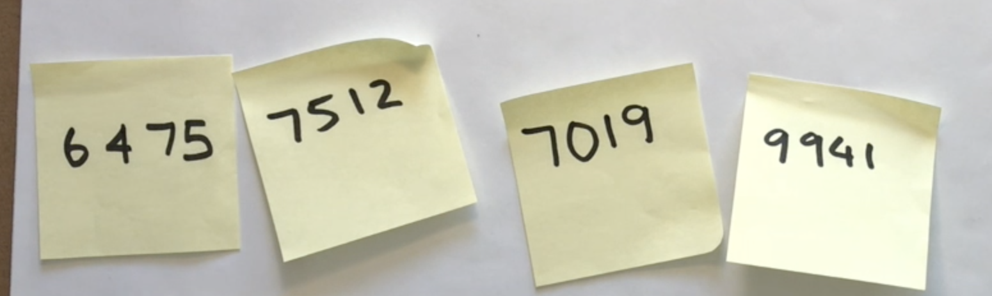
Help Michelle and Barbara order these numbers from largest to smallest to in less than 5 moves (if possible). Record how many moves it takes to order them. Remember you are aiming to use the fewest moves possible!
Play Order! Order!
How to play
- Roll the dice and create and record a 4-digit number.
- Repeat until you have 4 numbers.
- Order them from smallest to largest, and largest to smallest in the fewest moves possible, moving adjacent cards only.

Tangrams 2.3: exploring halves
View video Tangrams 2– part 4
What are all the different ways you can show half using this rectangle?
Don’t forget to prove your thinking!
Here are two ideas to get you thinking!
Over to you, mathematicians!

Reflection
Draw a picture of 1 or 2 things that made your brain think hard today (that made your brain get sweaty).

Day 8
Today we have 2 tasks. We will play two games that require strategic thinking whilst also focusing on place value and our skills in multiplicative thinking!
Resources – device to view videos, colour pencils/ markers, 8 counters (4 of one colour and 4 of a different colour), paperclip

Mastermind
View video Mastermind
Play Mastermind!
How to play
- Each player writes down a 3-digit number (with no repeating digits)
- Each player draws up their game board (a table with 3 columns: 'guess', 'digits', 'places'
- Players take turns to guess a 3-digit number
  - Their opponent tells them how many digits are correct and how many are in the correct place
  - Players record their guess, the number of digits that are correct and the number of digits that are in the right place. Players then use this information to refine their guesses.
- The first player to correctly guess their opponents' number is the winner!
- Players can choose to play using 4-digit numbers, 5-digit numbers, and 2-digit numbers. etc.

Factors fun
View video Factors fun
Create your own factors fun spinner and play Factors fun.
How to play
- Get your game board, spinner, recording sheet, counters, and pencils ready
- Take it in turn to spin the spinner and divide the number by the chosen divisor (for example, 5)
- Players work out the solution and explain their thinking to their partner.
  - The partner records their thinking and if they agree, the student is able to place one of their counters on the number on the game board, claiming that place.
  - If the number is taken, students miss a turn.
  - If there are no new counters that can be added to the game board, players have to move an existing counter to a new place.
- Students win by getting four counters in a row (in any orientation, including a square).
- If preferred, students can use 5 or 6 counters, looking for 4 in a row.
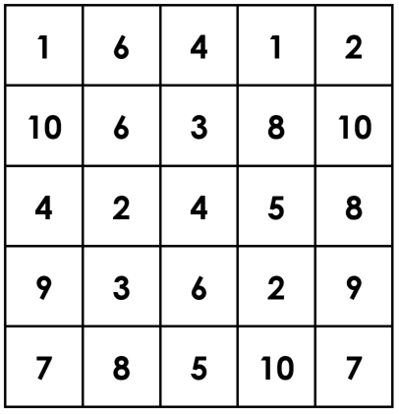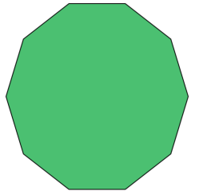
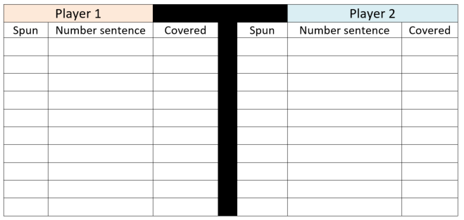

Reflection
Imagine yourself feeling good about mathematics. Draw a picture to show what you‘re doing when you feel good about mathematics.

Day 9
Today we are going to explore how different people might approach solving problems and then, we are going to play a game involving remainders.
Resources – device to view videos, colour pencils/ markers, paper, 6-sided dice or spinner (see appendix), 48 counters (for example dried pasta, 24 for each player)

Which would you do in your head 1?
(Inspired by McIntosh Reys, Reys and Hope)
View video Which would you do in your head 1? Part 1
Which of these problems would you solve using a mental strategy?

Which would you solve using a written or digital strategy?

Survey your classmates!
Is there a problem that everyone would use mental strategies for?
Is there a problem that everyone would use a written or digital strategy for?

View video Which would you do in your head 1? Part 2
How can you help someone develop confidence in solving
17 + __= 34 using a flexible mental strategy. Work together with a classmate to develop your ideas together.

Remainders game
View video Remainders game
How to play
- Start with a collection of 24 things each.
- Players take it in turns to roll the dice to determine how many groups their collection needs to be shared into.
  - The player works out the solution to their division problem and explain their thinking to their partner who records their move.
  - If the product cannot be evenly divided, players keep the remainders, and the collection of counters they were working with is reduced.
- The player who reduces their collection to only 2 counters is declared the winner.
Play Remainders game and record your game.

Reflection
What advice would you give someone who is joining you tomorrow for Remainders game?

Day 10
Today we are going to play a game from Mike Askew that helps us deepen our skills and understanding in estimating, rounding, using place value knowledge and reasoning. Have fun, mathematicians!
Resources – device to view videos, colour pencils/ markers, 9-sided dice

Hit it!
(From Mike Askew)
View video Hit it!
Play Hit it! You can play this game using 2-, 3-, 4- or 5- digit numbers and beyond. You can even play with decimal fractions!
How to play
- Draw up your game board (in this game, we were working with 3-digit numbers but you can use larger or smaller numbers if you like)
- Select a multiple of hundred between 100 and 900 to be your target number
- The person with the most letters in their surname goes first
- Take it in turns to roll the dice and use the digit somewhere in your number
- Once the digits are full, players read their number and determine how far they are away from the target number. The player who is closest to the target number wins a point.
- The winner with the most points after 3 rounds is declared the winner.

Reflection
What would you do differently if you played Hit it! Again tomorrow? Please explain your reasoning.

Appendix
