Representing weeks, months and seasons

Question 1
Draw a picture or write some words in each circle to show what you know about each season.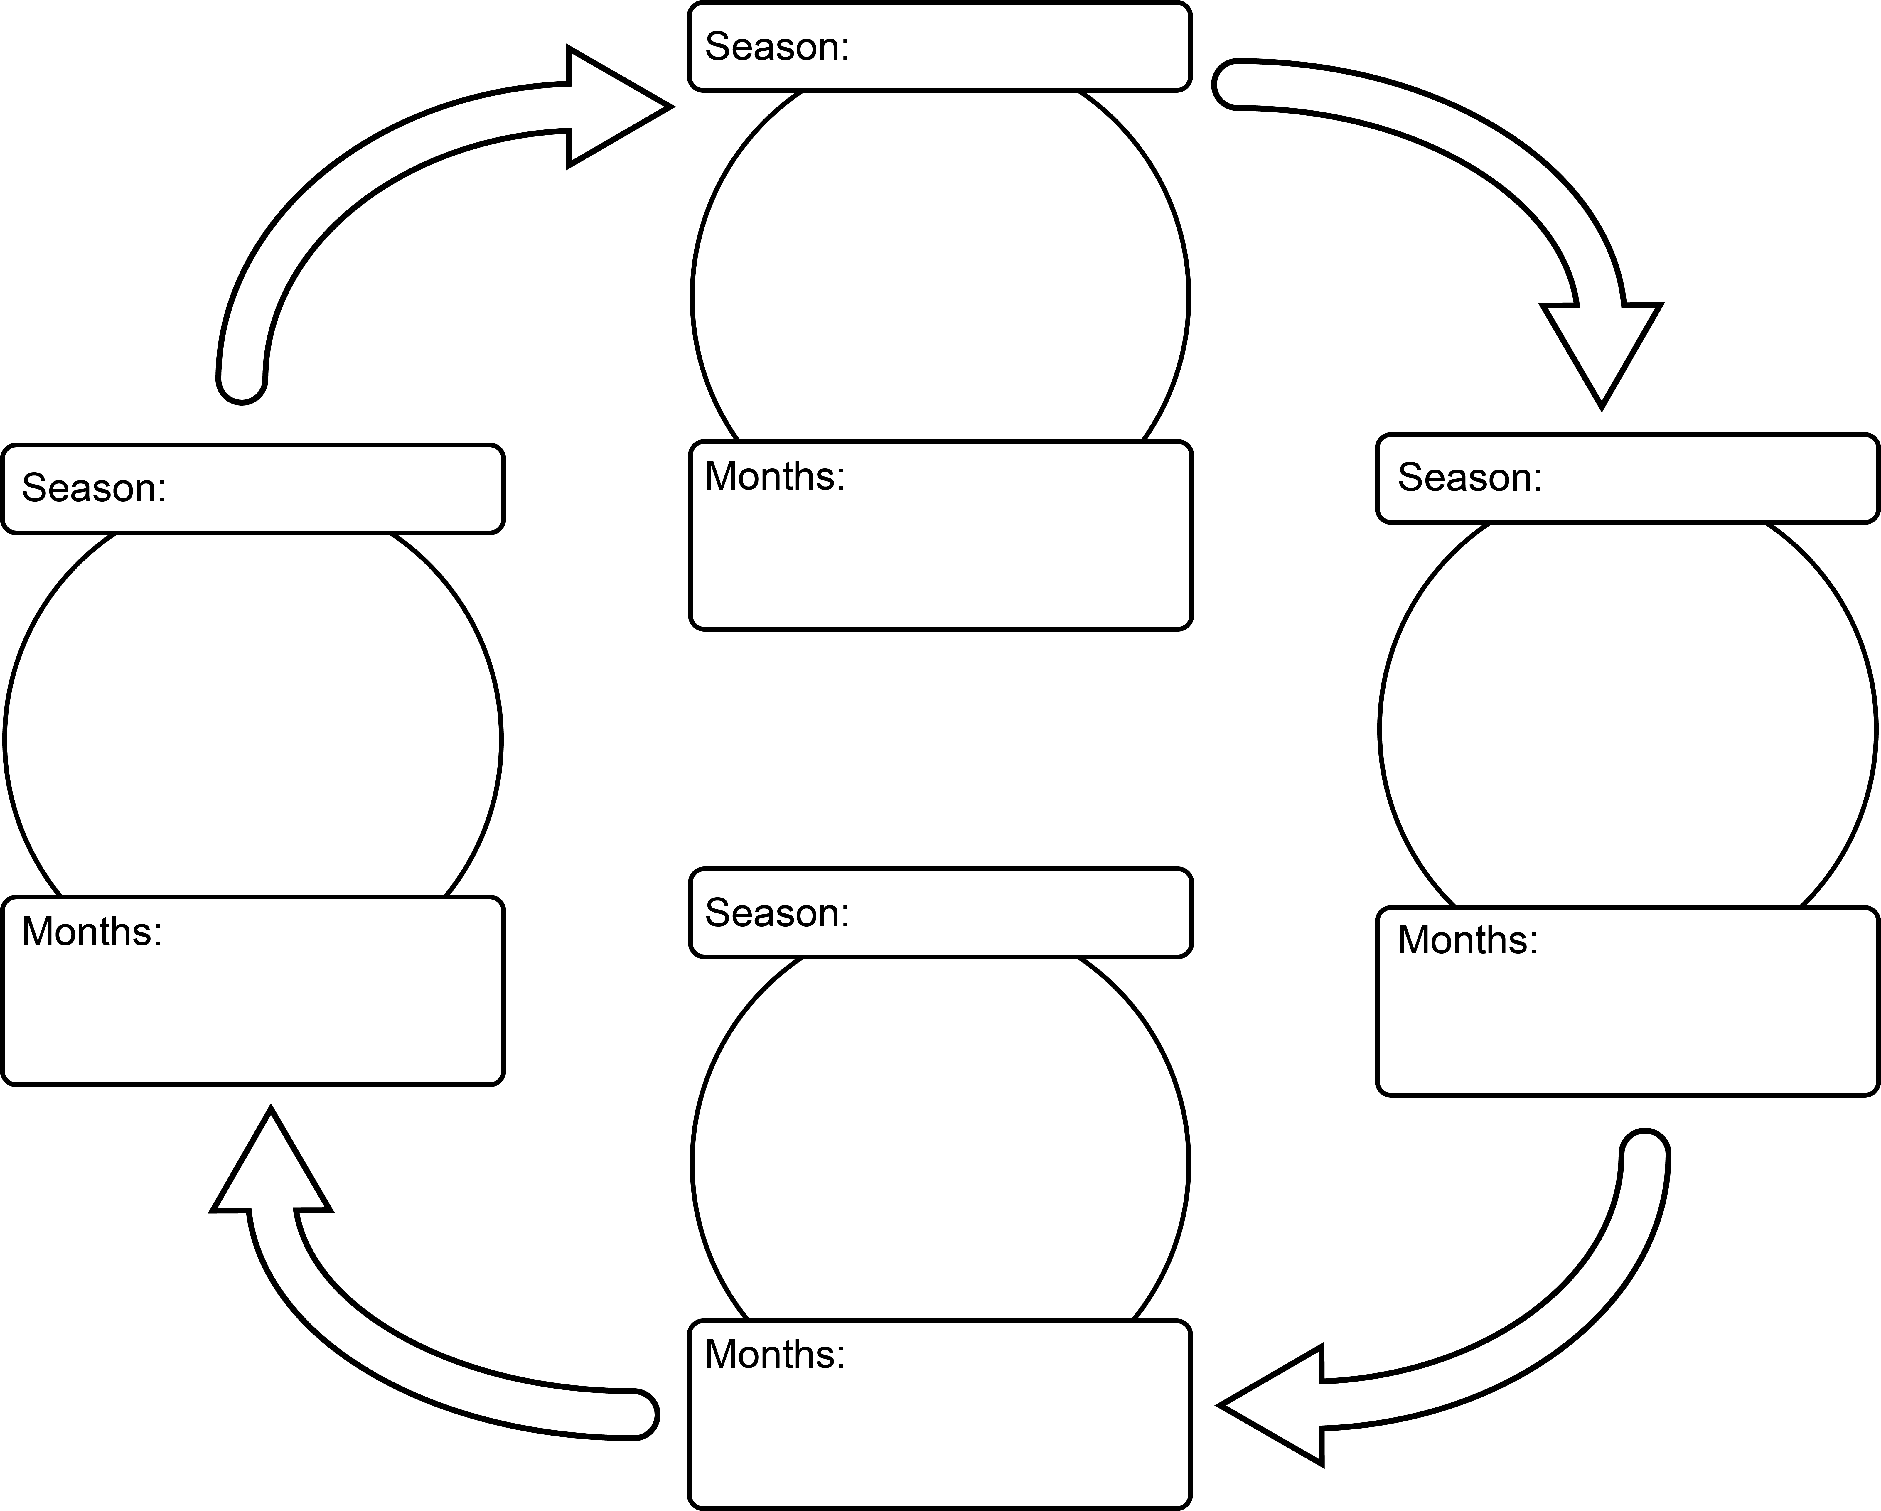

Question 2
Choose a month of the year and complete the calendar.
Month: __________________________
Sunday | Monday | Tuesday | Wednesday | Thursday | Friday | Saturday
blank | blank | blank | blank | blank | blank | blank
blank | blank | blank | blank | blank | blank | blank
blank | blank | blank | blank | blank | blank | blank
blank | blank | blank | blank | blank | blank | blank
blank | blank | blank | blank | blank | blank | blank

