Student workbook thinking mathematically 3 Stage 1
Name:
Class:

Overview
For the next 2 weeks, we hope you will be having some fun with mathematics – getting sweaty brains, thinking hard and feeling successful when you solve a problem, develop more confidence or understand something better. Many of these activities are games and investigations that you can play with your family, friends and classmates. Have fun and think deeply!
Most of these tasks have a video and some have downloadable resources to support your learning. You can find these using the digital student resource link on the Learning from home, K-6 support – mathematics page.

Day 1
Today we have 1 task. We will the opportunity to deepen our understanding of patterns, exploring growing and shrinking patterns.
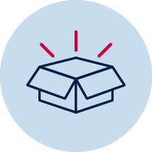 Resources – device to view videos, colour pencils/ markers

Staircase pattern
View video Staircase pattern 1 – Part 1
Draw the staircase pattern we’ve made in the video, continuing it down the other side.
View video Staircase pattern 1 – part 2
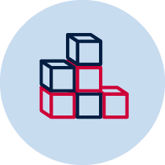If you like, build the model. Then draw what the staircase will look like if we continue building it up and down the other side, using twos.

View video Staircase pattern 1 – part 3
How many blocks are there altogether? Use diagrams to record the thinking you did to work out the solution.
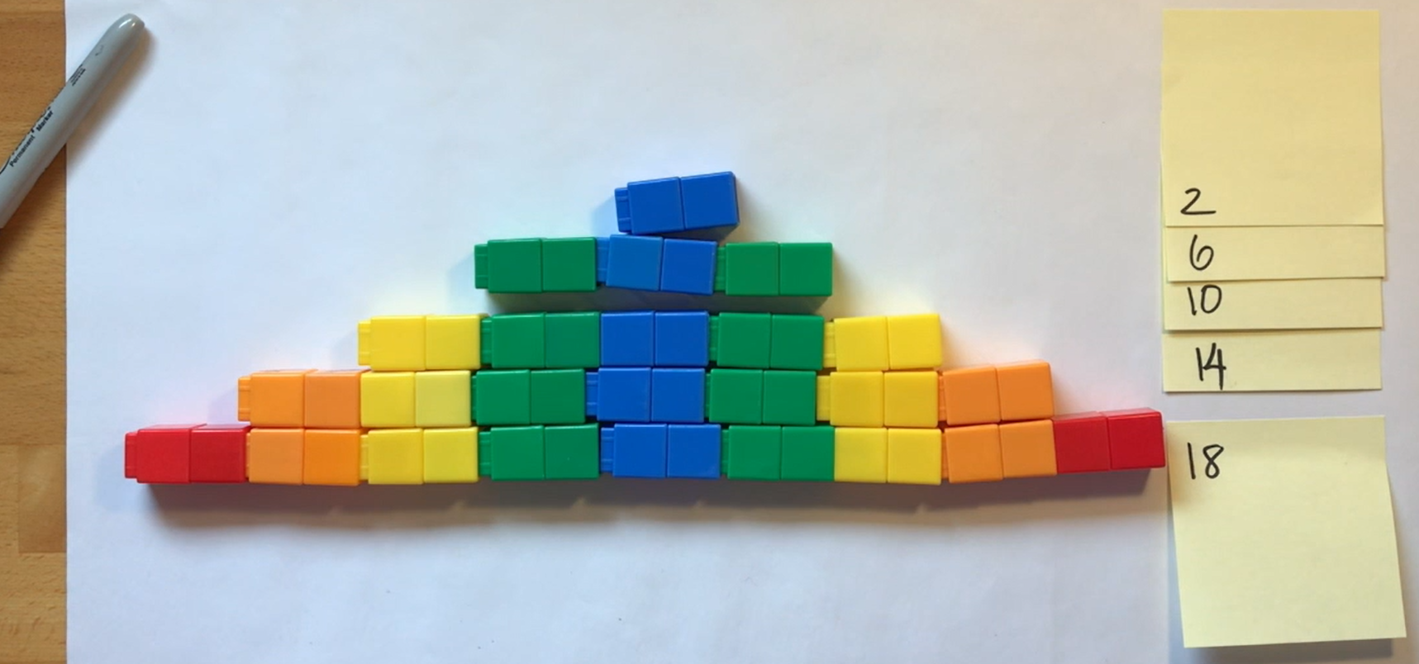

You may like to view the episode of Numberblocks step squad

Reflection
Can you find any growing or shrinking patterns at home or at school? Draw the patterns you find.

Talk about what you have discovered and learnt about today with someone at home.

Day 2
Today we have 3 tasks. We are going to explore different ways of thinking about numbers to help us better understand how numbers work. We will look at using a pan balance to investigate mass. We are also going to have a closer look at growing and shrinking patterns.
Resources – device to view videos, colour pencils/ markers, collection of objects like blocks or unfix cubes

Introducing rekenreks
View video Introducing rekenreks
Mum gave us some baby carrots for a snack. There were 8 in total. Some carrots were on my brother's plate and some carrots were on my plate.
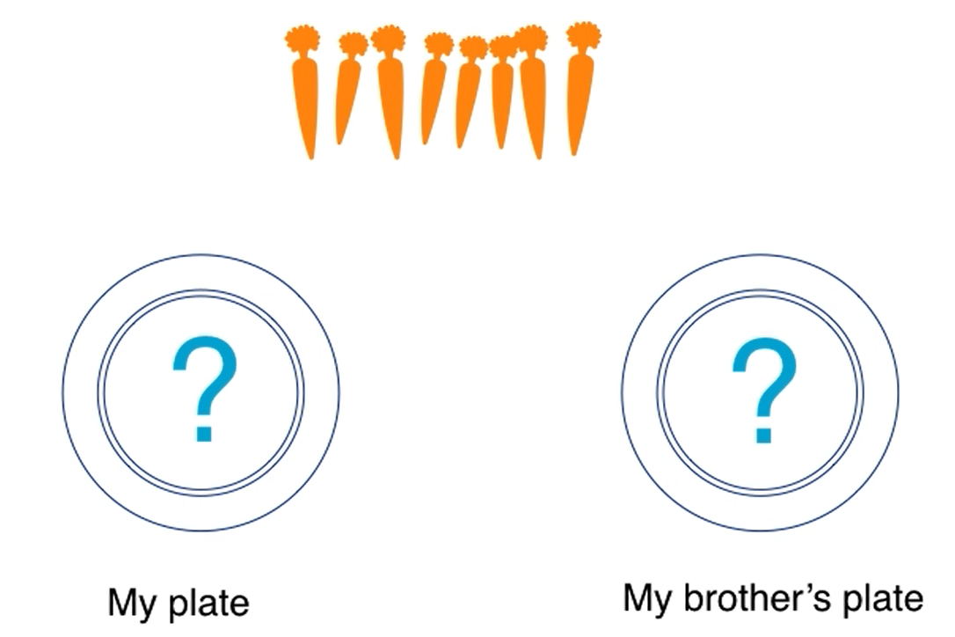
Use a rekenrek to imagine your thinking then draw pictures to record your thinking; for example:
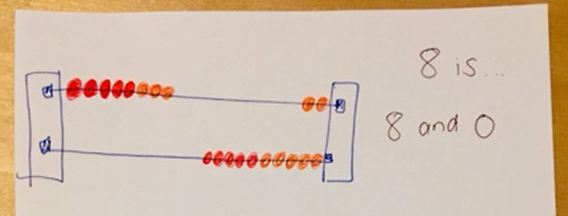
How many carrots were on my plate?
How many carrots were on my brother’s plate?
Show as many solutions as you can think of.

Balancing numbers 1
(Inspired by the work of Dan Meyer)
View video Balancing numbers 1 – part 1
What do you notice?

What do you wonder?

View video Balancing numbers 1 – part 2
How many more bears are needed to make the scale balance?
(How many bears are equivalent in mass to The Hulk?)
What’s an estimate that’s way too high?

What’s an estimate that’s way too low?

What’s an estimate that you think is reasonable?

View video Balancing numbers 1 – part 3
Create a drawing to represent the problem: How many bears are equivalent in mass to The Hulk?

Staircase pattern follow-up
View video Staircase pattern 1 part 4
Use objects, like blocks to create a new staircase structure.
Draw and describe the things you notice from the staircase structure you have made.

Explain the growing and shrinking patterns you can see inside your staircase.

Reflection
Share the drawings that you created as a mathematician. Talk to a family member or friend about the information you have shared in your mathematical drawings.

Day 3
Today we have 3 tasks. With the help of an adult we are going to create a rekenrek! The Hulk is back and we will estimate and investigate mass using a pan balance.
Resources – device to view videos, glue (wood glue or hot glue), 4 pegs, 10 red beads and 10 blue beads (or 10 of any 2 colours you like), 2 paddle pop sticks, 2 kebab sticks, 4 wall plugs, figurines like LEGO mini figs or teddy bears, and an adult.

How to make a rekenrek
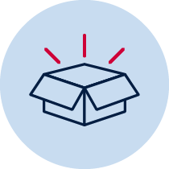With an adult collect:
- glue (wood or hot glue)
- 4 pegs
- 10 red beads and 10 blue beads (or 10 of any 2 colours you like)
- 2 paddle pop sticks
- 2 kebab sticks
- 4 wall plugs
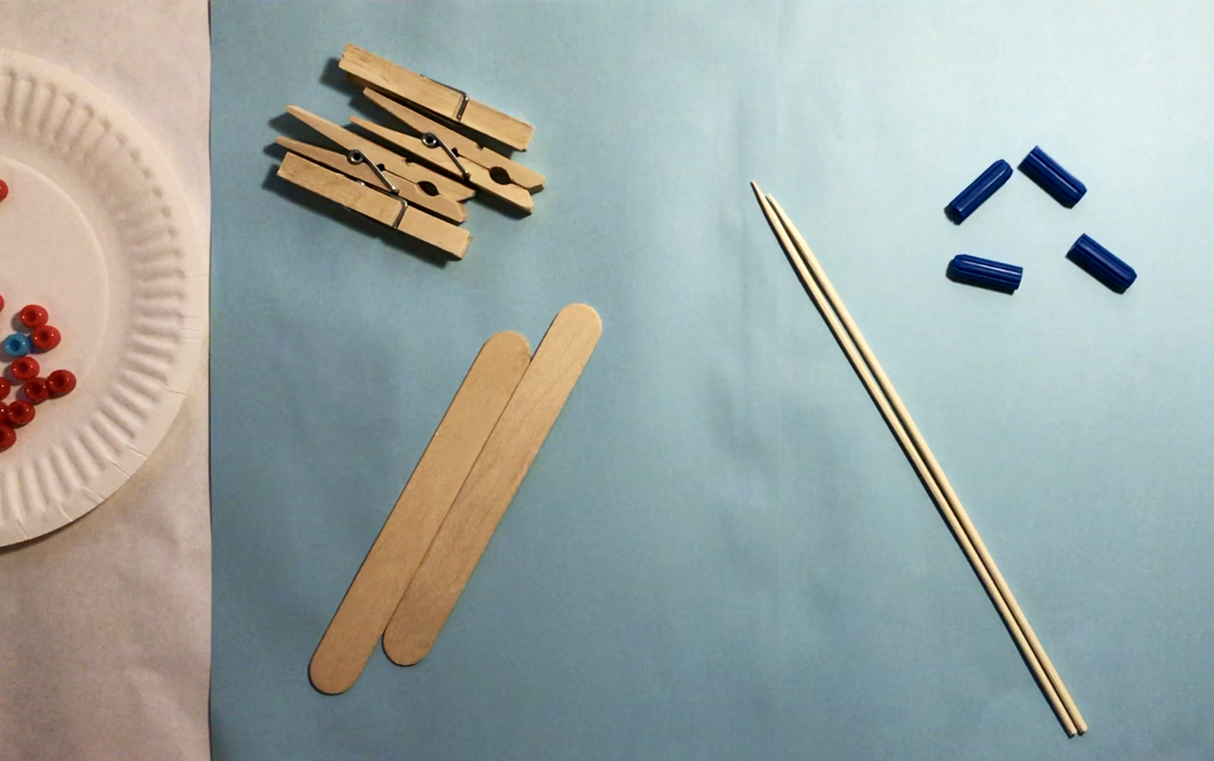
View video How to make a rekenrek with an adult and together make your own rekenrek.

Balancing numbers 2
View video Balancing numbers 2 – part 1
What’s an estimate that’s way too high?

What’s an estimate that’s way too low?

What’s a reasonable estimate?

View video Balancing numbers 2– part 2
What would you do to solve this problem? Share your thinking with a fellow mathematician or write down your ideas.

Revise your estimate: how many paddle pop sticks are needed to balance the mass of The Hulk?

View video Balancing numbers 2– part 3
What do you think will happen to the balance scale?
Draw a picture to communicate your thinking.

View video Balancing numbers 2– part 4
What can we say about the mass of The Hulk, the collection of bears and the collection of paddle pop sticks?

Handfuls: thinking multiplicatively
View video Handfuls: thinking multiplicatively
Play handfuls - thinking multiplicatively using groups of twos (with LEGO mini figs) and with fours (with bears).
Record your thinking about your games.

Reflection
What’s something you feel more confident with today?

Day 4
Today we have 3 tasks. We will use our rekenrek to imagine and explore numbers within numbers and other important number relationships. We will also make our own tangram.
Resources –device to view videos, pencil, your rekenrek, set of numeral cards 0-20, colour pencils/ markers, counters for tokens (you could you use dried pasta), 1 square sheet of paper, pair of scissors

Rekenrek 1
View video Rekenreks 1, make sure you are ready to use your mathematical imagination and you have the rekenrek you made.
Draw pictures to show how you can make 9, 6 and 13 in just 1 or 2 slides. Think of two different ways for each number. For example:
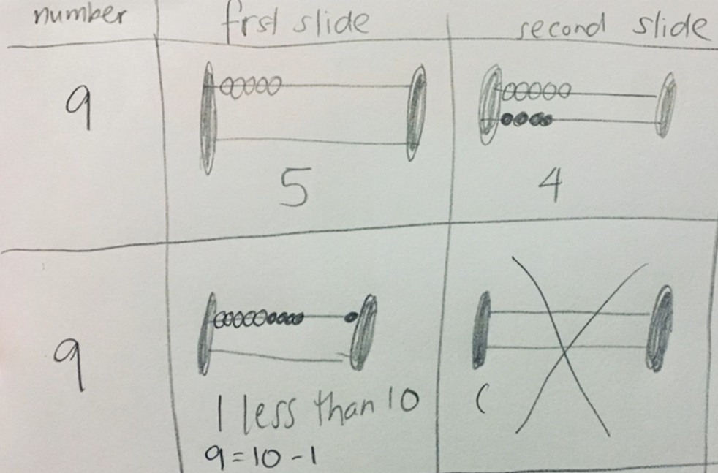
Draw your two different ways for each number.

Rekenrek duel: level 2
View video Rekenrek duel: level 2.
Collect your resources, your rekenrek, a set of numeral cards 0-20, colour pencils/ markers, counters for tokens (you could you use dried pasta) and play Rekenrek duel: level 2!
Record your games.

How to make a tangram
View video How to make a tangram
With an adult collect:
- pair of scissors
- 1 square sheet of paper (View video on how to make a square)
View video How to make a tangram with an adult and together make your own tangram.

Reflection
You might have had a sweaty brain today whilst playing Rekenrek duel: level 2. Your brain might also have felt excited! Draw a picture to show what your brain was thinking as you tried to move the beads in just 1 or 2 slides.

Day 5
Today we have 3 tasks. We will use our tangram pieces to complete puzzles, learn a new game where we think multiplicatively and explore doubles and near-doubles on our rekenreks.
Resources – device to view videos, pencil, your rekenrek, 10-frame cards cut up, spinner in appendix, paperclip, pen, counters for tokens for example dried pasta, collection of figurines with 2 legs or teddy bears.

Rekenrek noticing doubles and near doubles
View video Rekenreks 2
Collect the resources to play Rekenreks double and near doubles.
Record your game.

For each game
View video For each game
Play the For each game.
How to play
Make a spinner with 4, 6, 8, 10, 12, and 14.
Spin the spinner to determine how many legs you need in total.
Imagine and then collect the number of figurines you need to make that many legs.
The player with the most figurines each round wins a token.
The first person to win 5 tokens wins the game.
Another way to play:
Use teddy bears instead of the figurines and find out how many teddy bears are needed to have that many paws. You could also use toy cards, trains, other animal figures or pictures of animals.

Tangram puzzle challenge
Using all the pieces of your Tangram, try creating these formations!
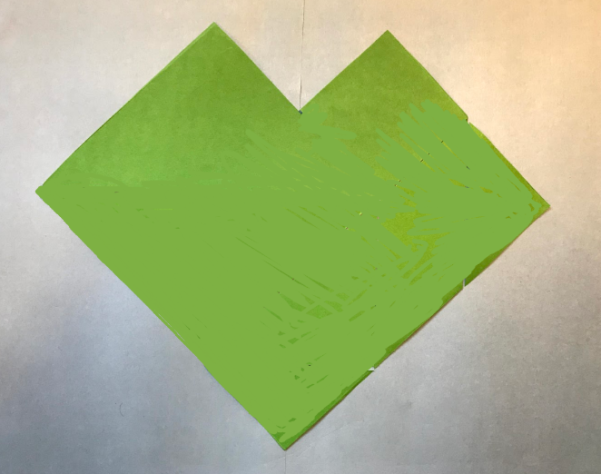 a heart
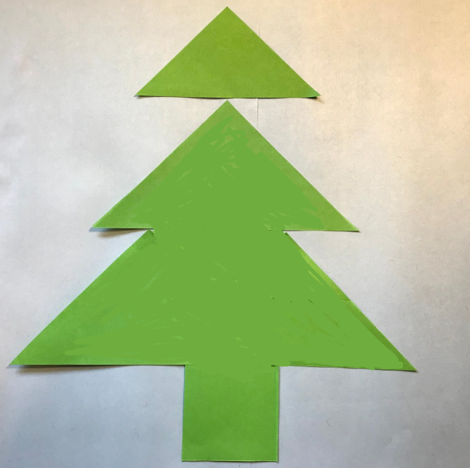 a tree
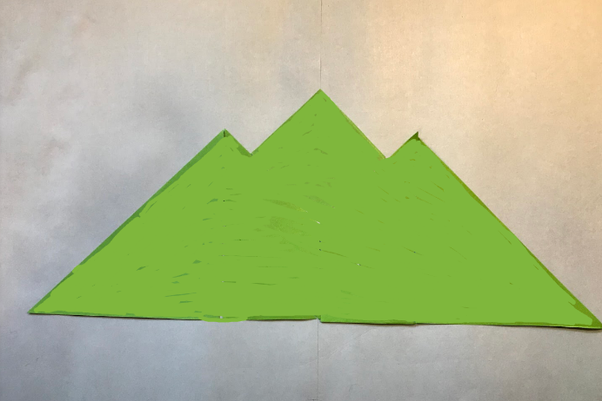a mountain
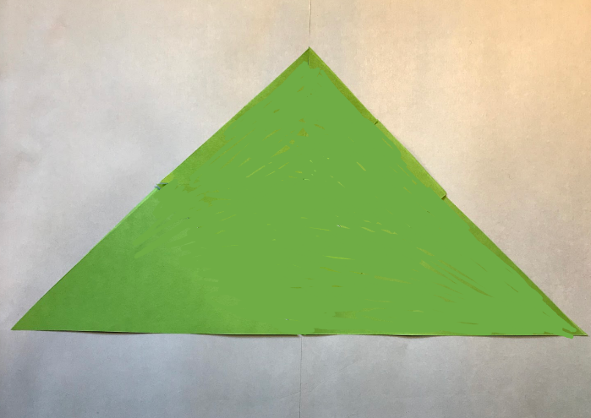a big triangle
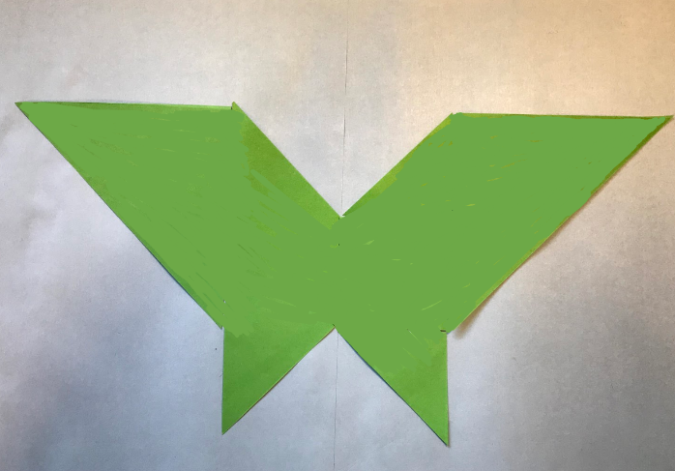 a butterfly

Reflection
List 2 things about your learning made you feel good today?

Day 6
Today we have 2 tasks. We will estimate and investigate mass using a pan balance and we will explore quadrilaterals.
Resources – device to view videos, colour pencils/ markers

Balancing numbers 3
(Inspired by the work of Dan Meyer and Graham Fletcher)
View video Balancing numbers 3 – part 1
How many trapeziums (red shapes) are needed to balance the hexagons (yellow shapes)?
Write an estimate that’s way too high.
Write an estimate that’s way too low.
Write an estimate that’s reasonable.

View video Balancing numbers 3 – part 2
How many triangles are needed to cover the area of 3 hexagons?
Michelle thinks she will need 6 trapeziums to cover the area of the 3 hexagons.
What do you think?
Draw a picture to share your thinking.

View video Balancing numbers 3 – part 3
How many triangles are needed to cover the area of 3 hexagons?
If you like build the model then draw a picture to share your thinking.

Tangrams 1.1: exploring quadrilaterals
View video on Quadrilaterals – part1
Use this adapted Frayer chart to define a quadrilateral.
Examples  (Draw, write or describe some examples | Non-examples  (Draw write or describe some non-examples. Ask yourself “What isn’t it?”

Definition and features
(Draw, write or describe a definition and some really important features.)
View video on Quadrilaterals –part 2
How many different quadrilaterals can you make using your tangram pieces? Try making at least 1 quadrilateral with…
- 1 tangram piece
- 2 tangram pieces
- 3 tangram pieces
- 4 tangram pieces
- 5 tangram pieces
- 6 tangram pieces
- 7 tangram pieces

Reflection
Revisit your Frayer chart. Using a different colour pencil/marker add any more information or revise your thinking.

Day 7
Today we have 2 tasks. Today these tasks will help us see that as mathematicians, we get to be in charge of the numbers. We will see some different ways to solve the same problem. We will also play a strategic game with 2-digit numbers, which involves us using what we know about place value.
Resources – device to view videos, colour pencils or markers

Let’s talk 4 – part 1
View video Let’s talk 4 – part 1

Order! Order!
(From Mike Askew)
View video Order! Order!
Write these numbers on post-it-notes or paper and place them in this order.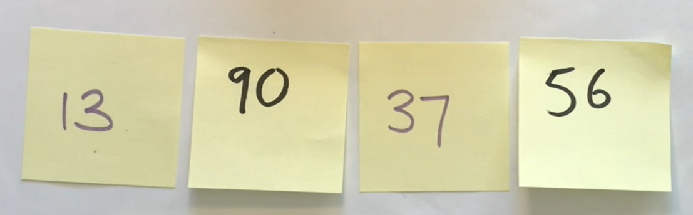
Help Michelle and Barbara order these numbers from largest to smallest. Record how many moves it takes to order them. Remember you are aiming to use the fewest moves possible!

Play Order! Order!

Reflection
Draw a picture of 1 or 2 things that made your brain think hard today (that made your brain get sweaty).

Day 8
Today we have 2 tasks. We will further investigate how we can use numbers flexibly like our mathematical pirate and pony did yesterday when they visualised dots moving from one ten-frame to another. We will also learn to play Mastermind!
Resources – device to view videos, colour pencils/markers, piece of paper

Let’s talk 4 – part 2
View video Let’s talk 4 – part 2
What other quantities can you find that are equivalent in value to 8+8+6?

Mastermind
View video Mastermind
Play mastermind!

Reflection
Imagine yourself feeling good about mathematics. Draw a picture to show what you‘re doing when you feel good about mathematics.

Day 9
Today we have 2 tasks. We will learn a new game, circles and stars. We will also talk work on our conceptual subitising as we Splat!
Resources – device to view videos, colour pencils/ markers, A4 paper to make a game board, 1-6 dice, playing cards 2, 5 and 10 cards

Splat!
(Adapted from Steve Wyborney)
View video Splat!
Make sure you have your subitising eyes ready to look for chunks that you recognise instantly so you don’t have to count!
Draw how many dots you think you saw and how you saw them?

Circles and stars
(From Marilyn Burns)
View video Circles and stars
Collect your resources and play Circles and stars from Marilyn Burns. Remember you only need to draw enough stars to help you work out the product.
How to play
- Divide your paper into eighths
- Roll a dice to determine how many circles (groups) you need to make
- Turn over a playing card (or roll the dice again) to determine how many stars to add into each circle.
- Determine how many stars there are in total. You can draw all or some of the stars in each circle - you only need to draw what you need to help you work out the product.
- Continue taking turns until each player has had 6 turns each.
- Work together to work out who has the most stars altogether.

Reflection
What advice would you give someone who is joining you tomorrow for Splat?

Day 10
Today we have 1 task. We will play a new game that helps look for combinations of ten!
Resources – device to view videos, colour pencils/markers

3 tens in a row
View video 3 tens in a row
Play 3 tens in a row.
How to play
- Draw a 3x3 grid as a game board (like noughts and crosses game board).
- Players take turns to roll the dice and write the number in one of their boxes.
- The goal is to be able to write two numbers in each box that combine to make 10.
- Players continue taking turns until a player has been the first to make 3 tens in a row.

Reflection
What are some tips you would give to a player trying to win 3 tens in a row?

Appendix

Spinners for day 5 for each game
