Mathematics workbook Stage 1
Name:
Class:

Overview
For the next 2 weeks, you will be having lots of fun with numbers. Most of these activities are games and investigations that you can play with your family and friends. Have fun and think deeply!
These activities do not require the use of a device. However, if you’re interested in seeing videos related to these activities, you can find the link on the Learning from home, Teaching and learning resources, K-6 resources page.
https://education.nsw.gov.au/teaching-and-learning/curriculum/learning-from-home/teaching-and-learning-resources/k-6-resources

Activity 1
During this activity you will have to think hard to outwit your opponent. You will need to use your knowledge of strategies for addition and subtraction as well as number facts.
Resources – three colour pencils or markers

Strike it out! Let’s play!
Draw a number line from 0 to 20 like this:
The first player chooses a number on the line and crosses it out.
The same player then chooses a second number and crosses that out too.
Finally, he or she circles the sum or difference of the two numbers and writes down the calculation.
For example, the first player's go could look like this:
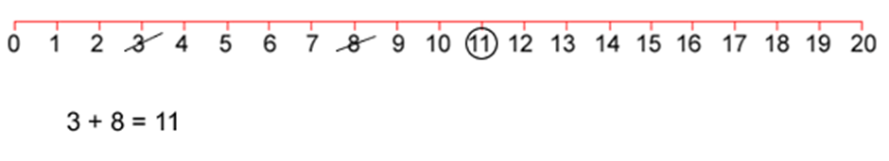
The second player must start by crossing off the number that player 1 has just circled.
He or she then chooses another number to cross out and then circles a third number which is the sum or difference of the two crossed-off numbers.
Player 2 also writes down their calculation.
For example, once the second player has had a turn, the game could look like this:
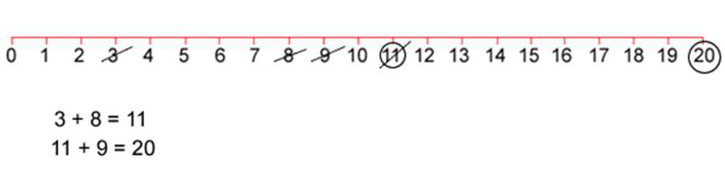
Play continues in this way with each player starting with the number that has just been circled.
For example, player one could then have a turn which left the game looking like this:
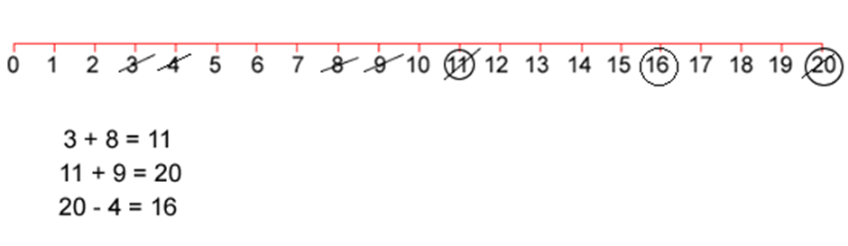
The winner of the game is the player who stops their opponent from being able to have a go.

Play this game with a partner in your workbook or on paper.

Reflection
Think about what you have learnt in this activity. Use the two stars and a wish structure to guide your reflection.
Star  Something that went well! | Star  Something that went well! | Wish  A goal for next time…
 |  | (What is something you would do differently if you were to play the game again?)

Activity 2
During this activity you will investigate, and use, what you know about numbers to help you!
Resources – three colour pencils or markers, equipment such as pasta, counters or buttons

Number busting

Select a 2-digit number, such as 26.

Get 26 items (for example, pasta pieces, counters or pencils).

Reorganise and describe your collection as many times as you can in 5 minutes (you will need to set a timer).

Draw and record all of your ways of thinking about your collection.

Play Strike it out! again with someone at home.

Reflection
Draw your favourite 3 representations of 26.

Activity 3
During this activity you will use your place value knowledge and your knowledge of addition to get as close to 100 as you can. Be careful, because at 101, you’re out!
Resources – colour pencils, paper, dice (or a set of 1-6 numeral cards)

101 and you’re out
(From https://www.hmhco.com/products/do-the-math/pdfs/WinWinGamesbyMarilynBurns.pdf)

Make a game board by drawing a 6 x 4 table. Label the first column as ‘tens’, the second column as ‘ones’, the third column as number and forth column as total.

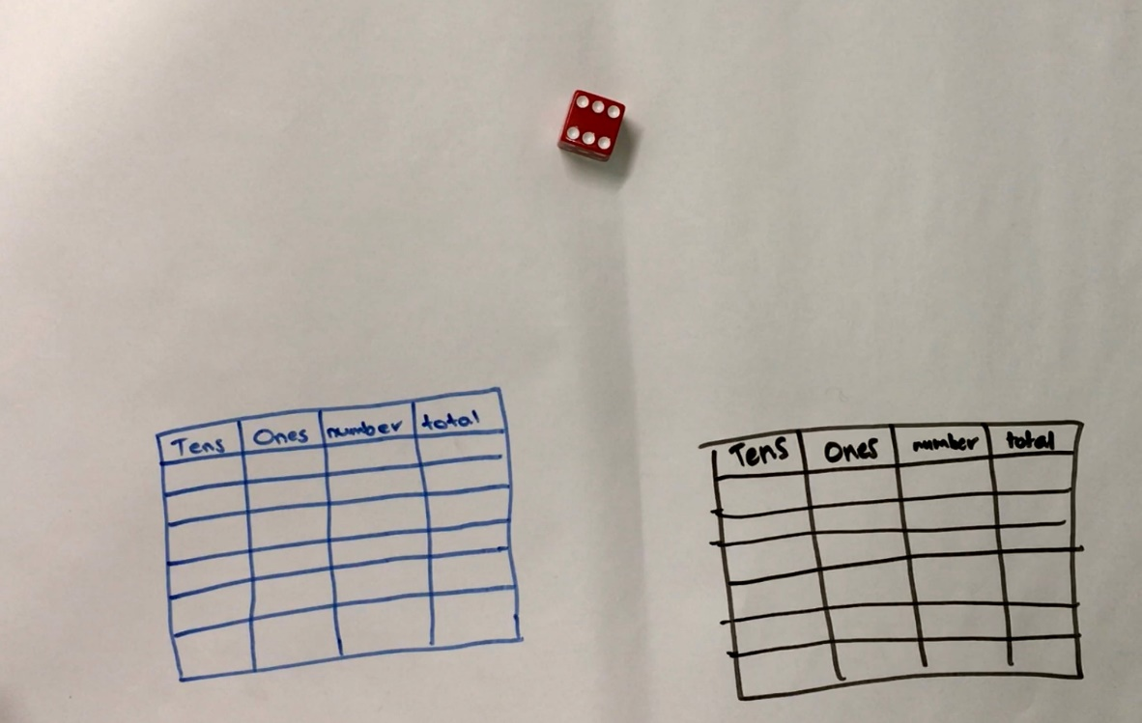

Each time you roll the dice (or flip a card) you have to decide whether the number is representing ‘ones’ or ‘tens’. For example, if I roll a 3, I could use it as 3 ones (3) or 3 tens (which we rename as 30). If you choose to use your 3 as 3 ones, record the number in the ones column. If you choose to use your 3 as 3 tens (30), record your number in the left column.

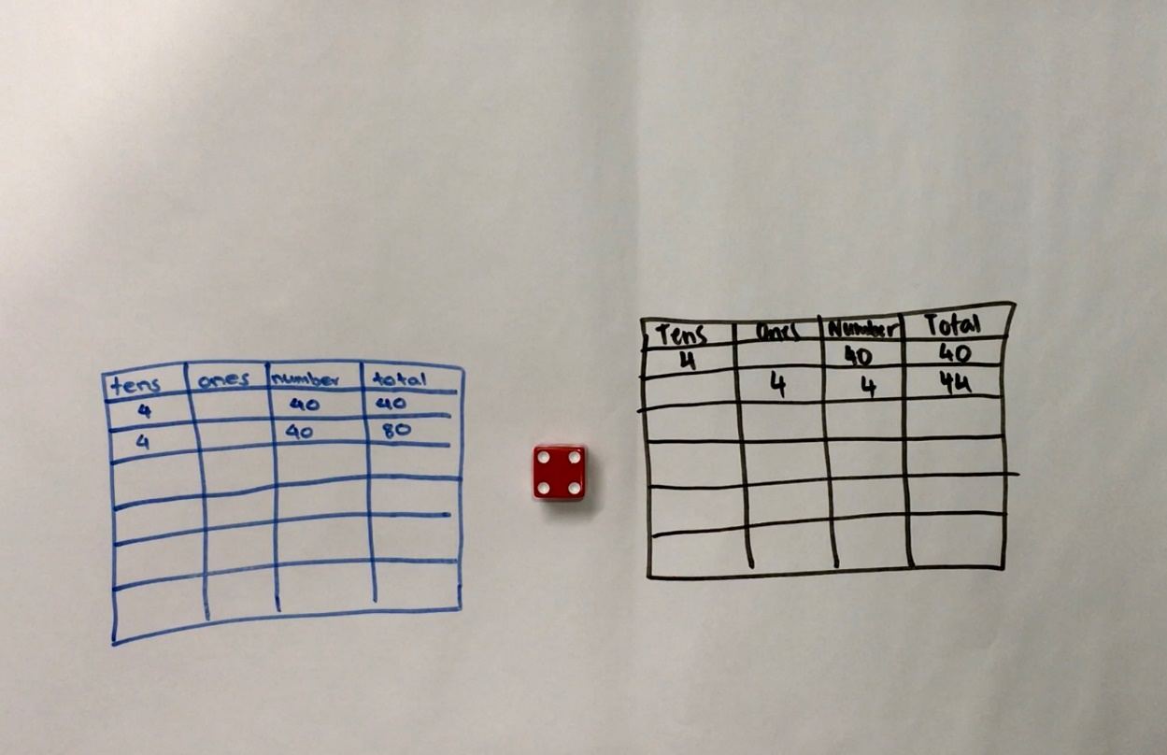

Continue to play for six rolls.

Once your write a number, you can’t change it.

The winner is the player with the sum that is closest to 100 without going over!

Draw up 4 new game boards. Using the same numbers you rolled, use the game boards to get closer to 100 than you did in your first game.

Play again with someone at home!

Variations:
- Increase the challenge by using numbers from 0-9. You can also use playing cards, make cards or make a spinner at home.
- Roll the dice 4 times and only use four lines on the game board.

This game can be played individually, competitively or collaboratively.

Explore and record your ideas in your mathematics workbook.

Reflection
Did you get closer to 100 on your second go with the same numbers?
Why do you think that was?
What advice would you give to someone playing this game for the first time?

Activity 4
During this activity you will use your knowledge of counting sequences and think strategically to beat your opponent! You should look for patterns to help you work out a winning strategy.
Resources – colour pencils or markers, workbook, 24 objects e.g. pasta

The counting game
Play this game with a partner

Collect 24 objects e.g. pasta
Using 24 as a target number, take it in turns to count on by saying the next 1, 2 or 3 number words in the sequence, placing objects into a central pile as they are counted.
You will collect a point if you say the target number.
Choose another target number and start again.

Try playing forward and backward. For example:
Target number 24
Player A: 1, 2, 3...
Player B: 4, 5...
Player A: 6, 7, 8...
Player B: 9, 10, 11...
Player A: 12, 13...
Player B: 14, 15, 16...
Player A: 17...
Player B: 18, 19...
Player A: 20, 21, 22...
Player B: 23, 24!

Another way to play: You can select a target number and a starting number. For example, you might start at 35 and try to get to 51.
You can also count in multiples. For example, you can start at 0 and aim for 85, counting by fives.

Reflection
If you were to play this game again tomorrow, what would you do differently? Why?
Is there a way to play so that you never lose?

Activity 5
During this game you will apply the strategies that you developed in the last lesson in a new context. This time your target number will be zero and you will be counting backwards. You can count back by ones, fives, tens or other multiples.
Resources – colour pencils or markers

The counting game: multiples part 2

It’s time to test your strategies!

This time staring from a given number and counting back, trying to be the person who says zero. For example,
Target number 0 (starting at 110 and counting in tens)
Player A: 100...
Player B: 90, 80...
Player A: 70...
Player B: 60...
Player A: 50, 40...
Player B: 30, 20, 10...
Player A: zero!

Reflection
Think:
What did you notice about playing the game by counting backwards? Did it make your brain work harder or was it less difficult?
Did you work out a way to play this game so that you didn’t lose? What was your strategy? Did it work?

Activity 6
During this task, you will collect data about your success at sock basketball.
Resources: a basket or container, socks, pencils, a clear space.
You can play this game alone or with a partner. Have fun!

Basketball toss
Your challenge: See how many times you can successfully shoot your rolled- up socks into the basket, using your right hand and your left hand.

Mark a clear ‘starting line’ for your basketball toss.
Take 3 big steps from your starting line and place a basket or container at the end.
Stand at your starting line and throw your socks. Throw your socks with your right hand.
Go back to your starting line and have your second throw. Repeat this until you have thrown your socks 10 times with your right hand and 10 times with your left hand.
Keep a record on each shot using tally marks then graph your results.
Keep a record your success rate in your workbook and then create a picture graph to share your results.

Reflection
What do you notice about your graph? What does it tell you about your success at playing sock basketball using your left hand compared to using your right hand?
Do you think that these results will change with practice?

Activity 7
During this activity, you will be applying your knowledge of patterns, part-whole number knowledge and problem-solving strategies to help Holly solve her problem.
Resources: pencil, some items like dried pasta, paper

Sam’s and Holly’s problem

Try to solve the following problem:

Sam and Holly were playing with combinations of numbers that make 10. They started by getting out 10 blocks
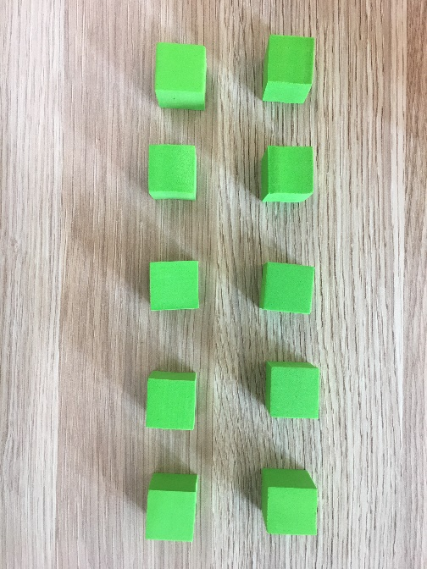
Then, Sam covered some of the blocks and Holly had to work out how many were missing.
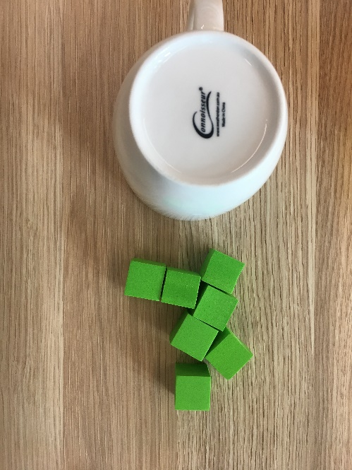
Holly decided to organise what she could see to help her work out what was missing.
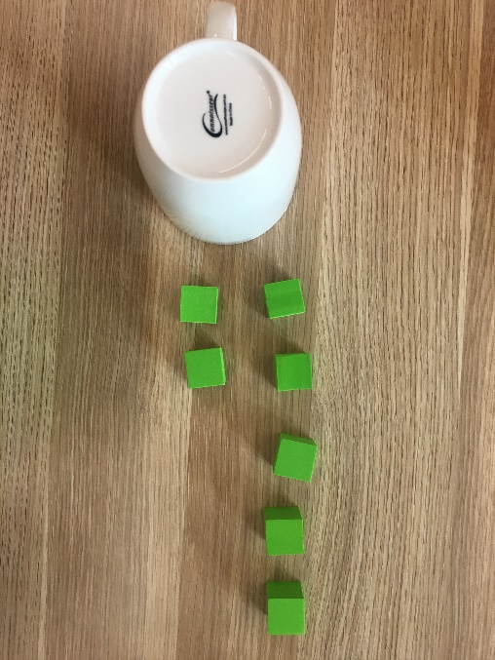
She imaged a 10-frame in her head and organised the blocks. This helped her see she needed 3 more to make 10.
Holly and Sam kept taking turns like this until Holly asked Sam if they could make it more challenging for them.

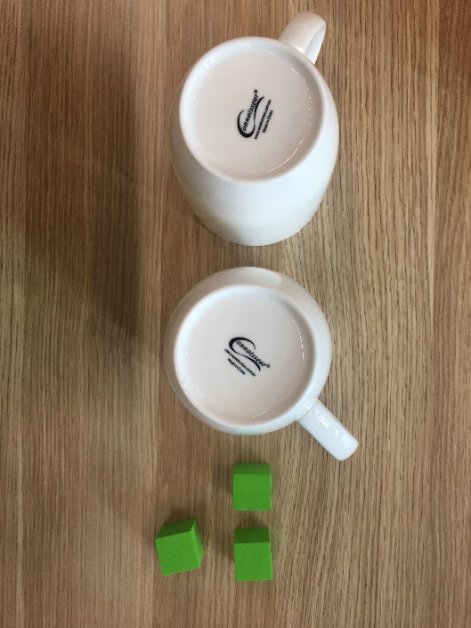
Sam made this for Holly to think about:

Record how you would solve this problem.
Can you help Holly work out how many blocks are hidden?
Can you help her work out how many of the hidden blocks might be underneath each cup?

Reflection
What possibilities did you find? Could you work out what exactly Sam put under each cup for Holly? Why? Why not?

Activity 8
During this task, you will answer the question ‘how many?’ by looking and thinking. You will need to organise your collection so that others can determine how many without needing to count everything.
Resources: pencil, pasta, counters, marbles, or dried broad beans

Handfuls
Take a handful of counters (or lima beans or pasta).

Hold the objects in your hand and imagine how many you have.

Record your estimate and draw what it might look like.

Then, organise your collection so that anyone walking by can determine how many items there are by looking and thinking.

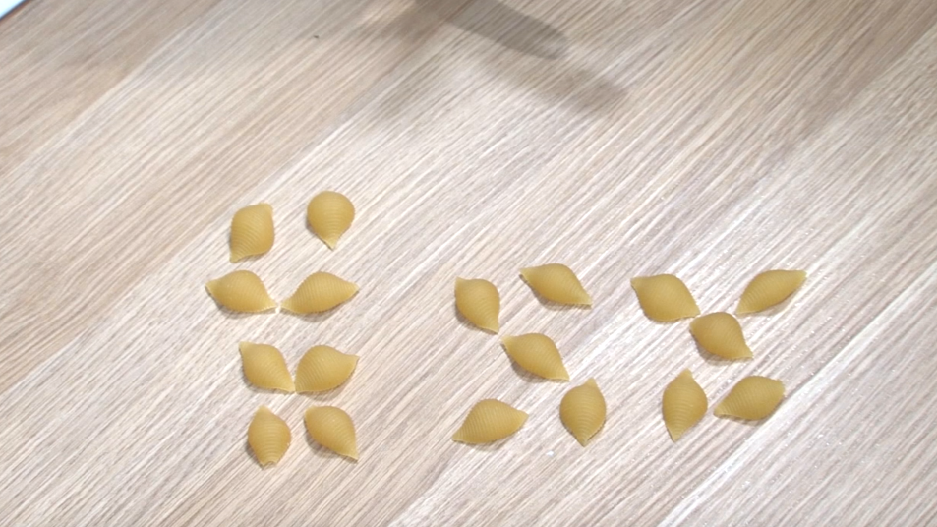

- How many do you have altogether?
- How have you organised your collection?
- Did you have more or less than your estimation?
- How many ways can you arrange your collection so you can see how many there are by looking and thinking?
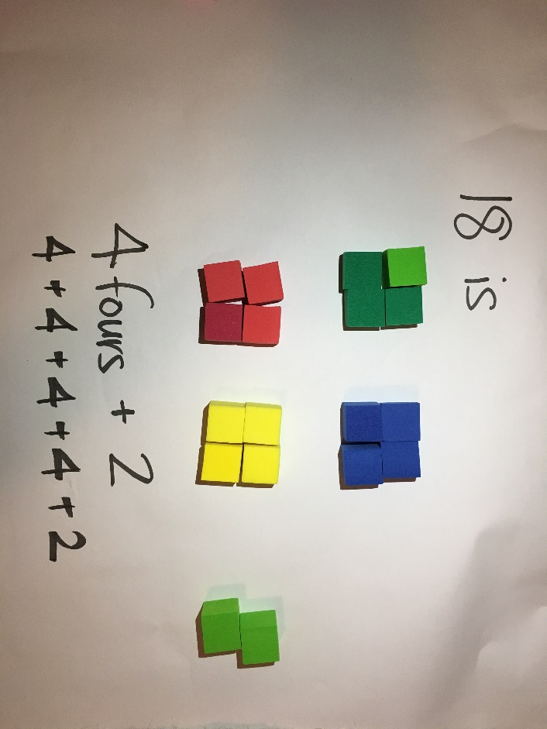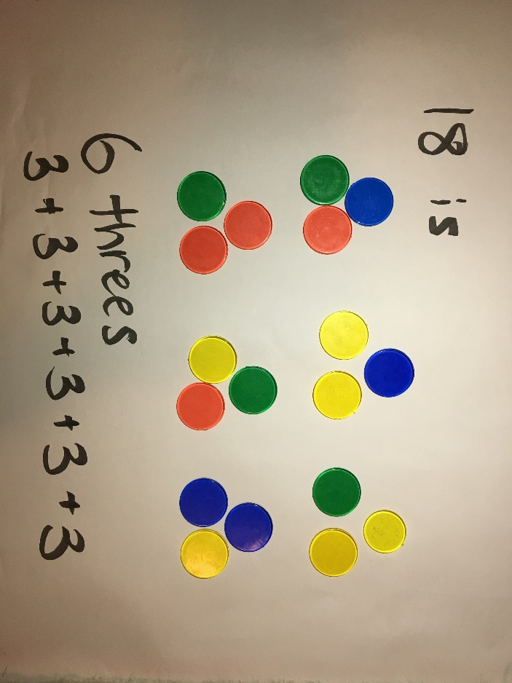
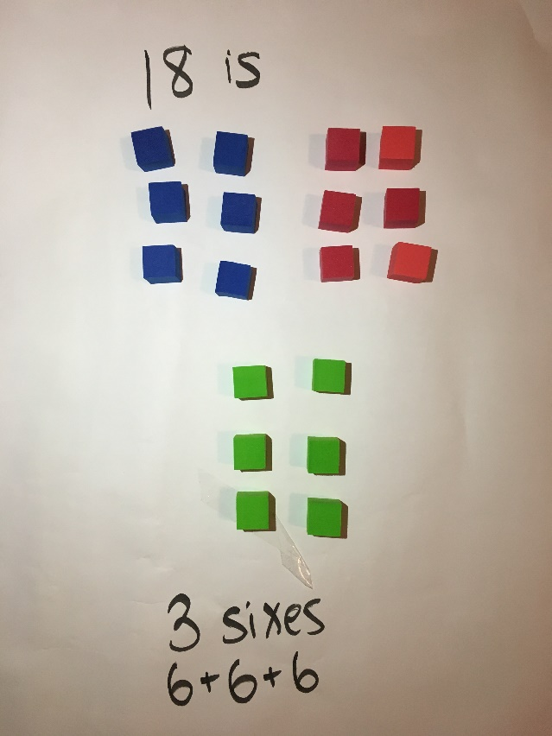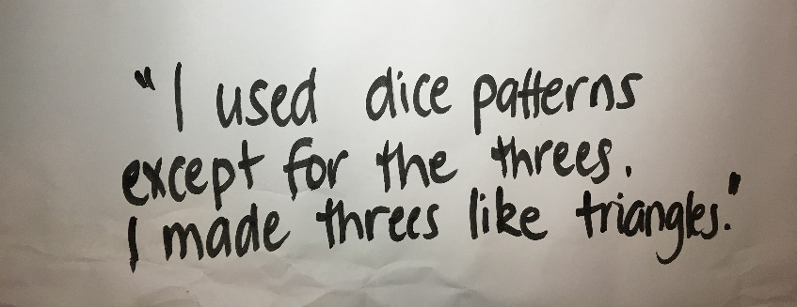
Draw your favourite way of organising your collection in your workbook.

Reflection
Compare the different ways you can arrange the collections:
  - Write down 3 things that are the same about the way you organised your collections
  - Write down 3 things that are different.

Activity 9
During this game, you will explore the smaller numbers that sit inside larger numbers.
Resources: numeral cards (post it notes or small bits of paper), dice or spinner, block for example, Lego.

Building Towers
Play this game with a partner.

Each player has 4 number cards. For the first game, you will both have 5, 7, 11 and 3.

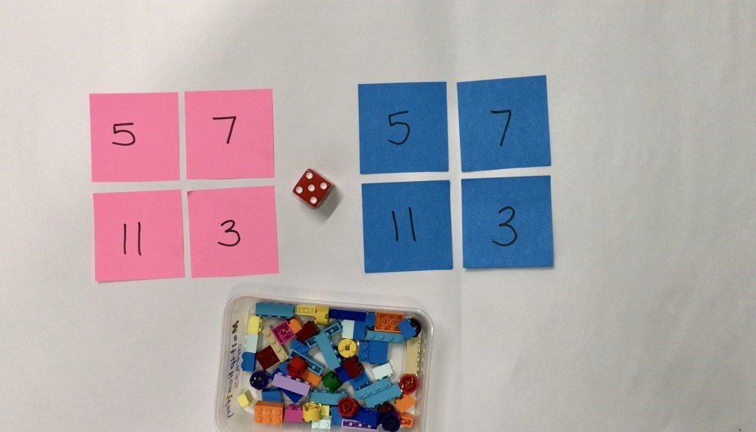

Take turns to roll a dice (or spin the spinner) and get that number of bricks to build up your towers.

Towers can be built up in any way you choose.

Take turns building up your towers until one of you gets the exact roll to complete the last tower.

Talk about how many you have, how many more you need and what strategies and knowledge you are applying.

Another way to play:
- Once you build the towers, play in reverse, taking away each time until there are no blocks left
- Change the number of towers, and, change the number of bricks needed for each tower

Reflection
If you were to play the game again tomorrow, what is one thing you would do differently? Why?

Draw a picture that shows the towers you built in order of shortest to tallest.

Activity 10
During this activity you will be exploring patterns.
Resources: decagon shapes to make spinners, pencils or markers

Let’s explore patterns

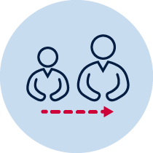
Advice for Parents
Even though this is an offline workbook, we strongly suggest you watch the patterning videos to gain an understanding of how patterns are taught at school

Gather a collection of items

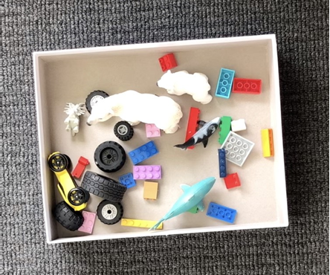

Think about the different ways you can sort and categorise your collection. Someone at home could help you record your ways of thinking.

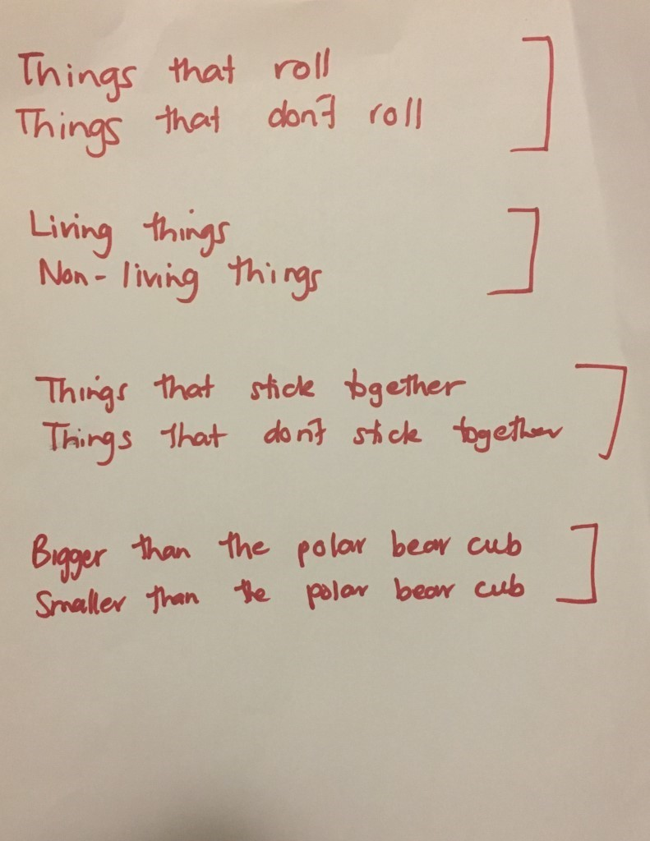
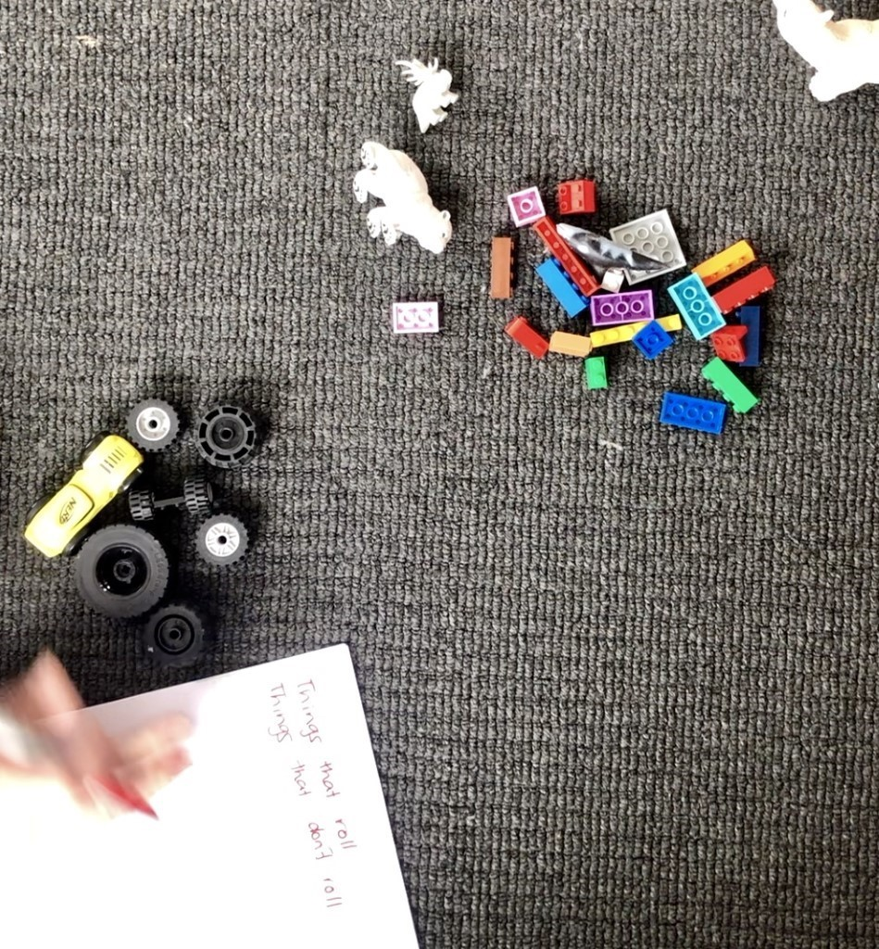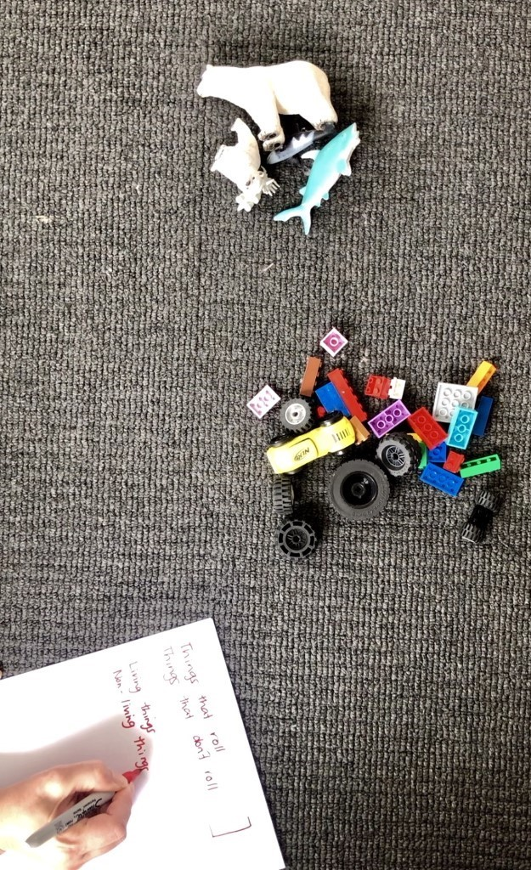

What do you think a pattern is? Talk about this with a family member and write down your thinking in your workbook.

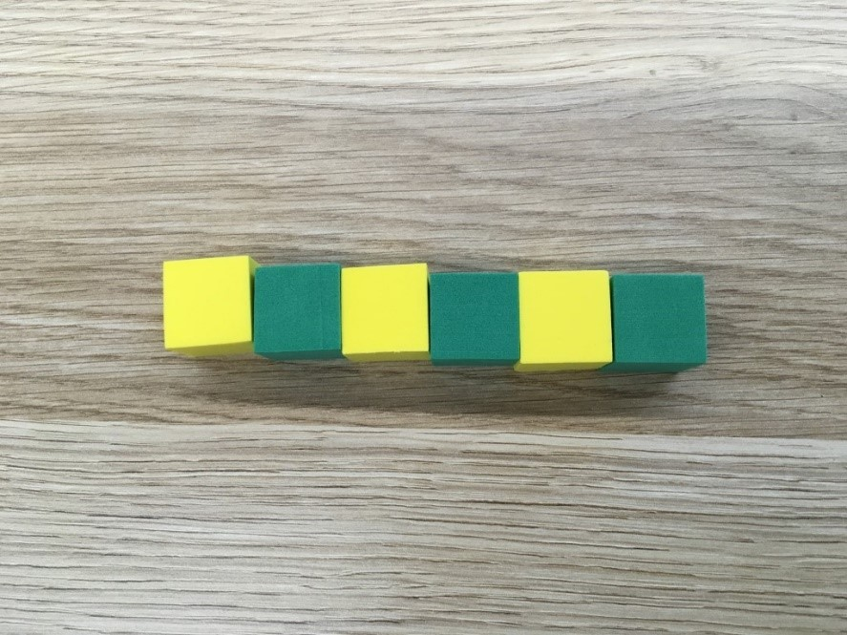

Describe this pattern.

How do you know it is a pattern and how would you describe the part that repeats?

Make an AB pattern using different equipment.

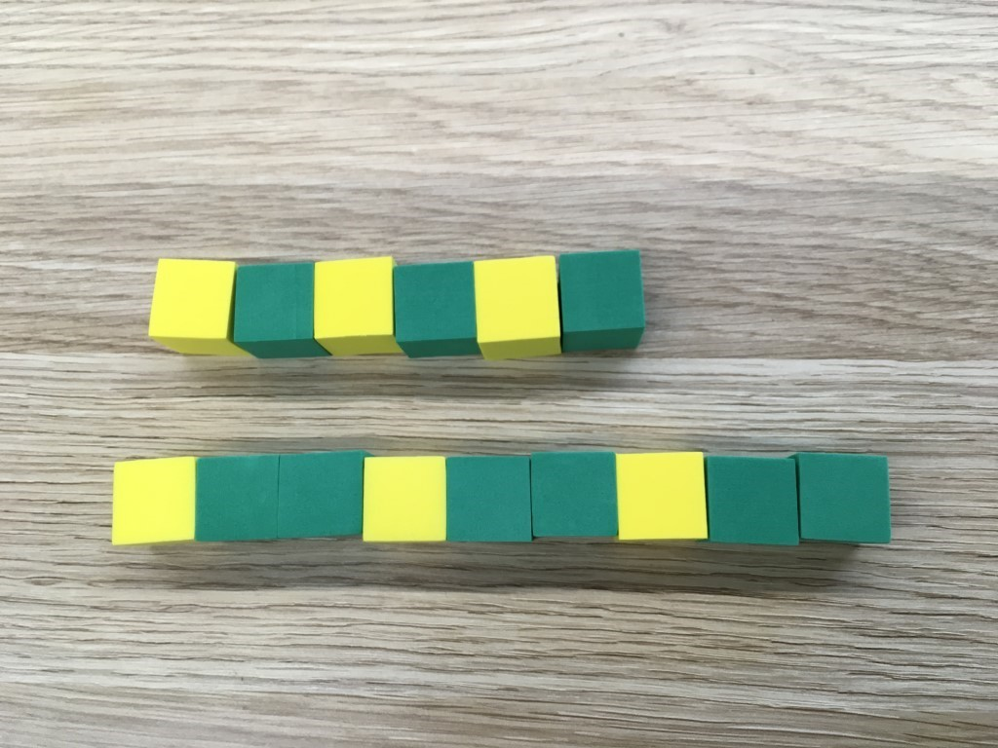

- How are these patterns the same?
- How are they different?

Construct a new pattern that follows an ABB pattern.

Reflection
Think about what you have learnt in this activity. Use the two stars and a wish structure to guide your reflection.
Star  Something that went well! | Star  Something that went well! | Wish  A goal for next time…
 |  | (What is something you would do differently if you were to play the game again?)

Resources

