Learning sequence – thinking mathematically 1 Stage 1
Learning sequence description
This sequence of lessons provides opportunities to deepen critical aspects of early number sense in the context of games and investigations. Students will explore additive situations, multiplicative situations and various forms of patterning. Teachers will be able to leverage opportunities to connect learning between aspects of Number and Algebra with learning in Measurement and Geometry, and Statistics and Probability.

Syllabus outcomes
MA1-1WM – describes mathematical situations and methods using everyday and some mathematical language, actions, materials, diagrams and symbols
MA1-2WM – uses objects, diagrams and technology to explore mathematical problems
MA1-3WM – supports conclusions by explaining or demonstrating how answers were obtained
MA1-4NA – applies place value, informally, to count, order, read and represent two- and three-digit numbers
MA1-5NA – uses a range of strategies and informal recording methods for addition and subtraction involving one- and two-digit numbers
MA1-6NA – uses a range of mental strategies and concrete materials for multiplication and division
MA1-8NA – creates, represents and continues a variety of patterns with numbers and objects
MA1-9MG – measures, records, compares and estimates lengths and distances using uniform informal units, metres and centimetres
MA1-17SP – gathers and organises data, displays data in lists, tables and picture graphs, and interprets the results
NSW Mathematics K-10 Syllabus © 2012 NSW Education Standards Authority (NESA) for and on behalf of the Crown in right of the State of New South Wales.

Resource considerations
This lesson sequence allows for continuity of student learning and could be adapted to fit in with your existing teaching and learning program. Students will be supported to meet outcomes from a Key Learning Area. Each task has a duration of 30 minutes and could be used in conjunction with your framework, designed using the K-6 template. This lesson sequence uses a balance of synchronous and asynchronous learning strategies. The tasks provide options for students with and without technology. They can be used with any online platform. Suggestions about how your school will plan students’ learning from home and ways to communicate with students can be found through the Learning at home, school planning page. Assessment strategies are included to ensure evidence of learning is monitored and collected.

Aim of lesson sequence
Teachers should look for evidence of:
- Reasoning
  - What evidence do students use when making decisions?
  - Are students thinking logically to determine winning strategies and to solve problems?
  - Do students re-think ideas based on new evidence/new understanding?
- Communicating
  - Do students use appropriate mathematical language?
  - Do students use appropriate mathematical representations including concrete materials, pictures and symbols (where appropriate)?
  - Can students record and communicate ideas using simple data representations?
- Additive strategies
  - Do students use a range of strategies when solving problems using addition and subtraction?
    - Do they use efficient counting strategies?
    - Do they use flexible strategies?
  - Do students use the commutative property?
- Multiplicative strategies
  - Do students recognise multiplicative situations?
  - Do students describe multiplicative situations?
  - What strategies do students use to solve multiplicative problems?
- Number sense
  - Do students use numbers flexibly?
  - Do students use part-part-whole knowledge to solve problems?
  - Are students able to make and describe representations of quantities?
  - Do students use operations flexibly?

Activities
Teacher notes
- These tasks are easily adaptable and can be used co-operatively, competitively, in a digital or non-digital environment.
- To access the videos in the PowerPoint, open the PowerPoint online, teachers and students may need to sign in with their school email address if prompted.

Activity 1 - Strike it out! Let’s play!
From NRICH Maths https://nrich.maths.org/8016
Strike it out! is a great context to enhance skills in reasoning, working collaboratively, and applying knowledge of additive strategies. The game is easily adaptable for a broad range of learners, also allowing you to do some deep investigations around winning strategies and using all of the numbers along the number line. Day 1 involves playing this game. Day 2 encourages some deeper investigatory work.
- Digital: Class to collaborate online. Use Activity 1 PowerPoint slides
- Non-digital: Draw a number line from 0 to 20 as shown below.
The first player chooses a number on the line and crosses it out.
The same player then chooses a second number and crosses that out too.
Finally, he or she circles the sum or difference of the two numbers and writes down the calculation.
For example, the first player's go could look like this:
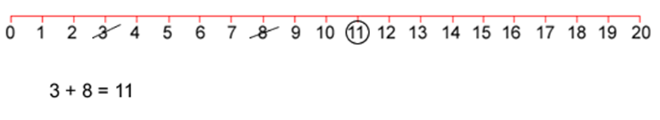
The second player must start by crossing off the number that player 1 has just circled.
He or she then chooses another number to cross out and then circles a third number which is the sum or difference of the two crossed-off numbers.
Player 2 also writes down their calculation.
For example, once the second player has had a turn, the game could look like this:
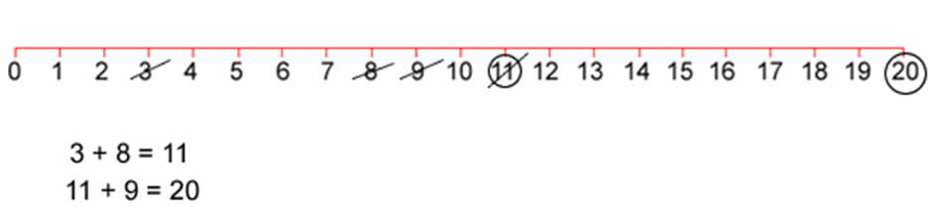
Play continues in this way with each player starting with the number that has just been circled.
For example, player one could then have a turn which left the game looking like this:
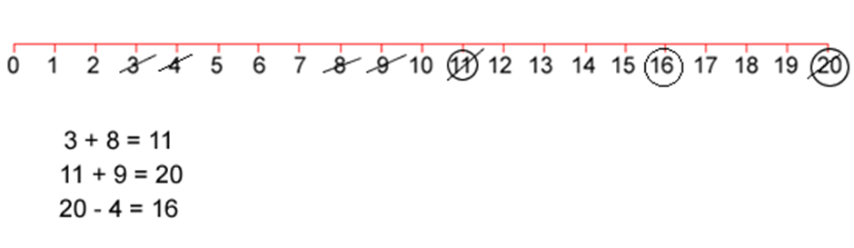
The winner of the game is the player who stops their opponent from being able to have a go.

Activity 2 - Number busting
- Digital: Class to collaborate online. Use Activity 2 PowerPoint slides
- Non-digital: Students select a 2-digit number, such as 26.
Ask students to get 26 items (for example, pasta pieces, counters or pencils). Ask students to reorganise and describe their collection as many times as they can within the next 5 minutes.
Ask students to draw and record all of their ways of thinking about their collection.
Invite students to play Strike it out! again with someone at home.

Activity 3 - 101 and you’re out
https://www.hmhco.com/products/do-the-math/pdfs/WinWinGamesbyMarilynBurns.pdf)
This game encourages reasoning, use of place value knowledge and the use of additive strategies. This game can be played individually, competitively or collaboratively.
- Digital: Class to collaborate online. Use Activity 3 PowerPoint slides
- Non-digital: Students will need to make a game board by drawing a 6 x 4 table. Label the first column as ‘tens’, the second column as ‘ones’, the third column as number and forth column as total.
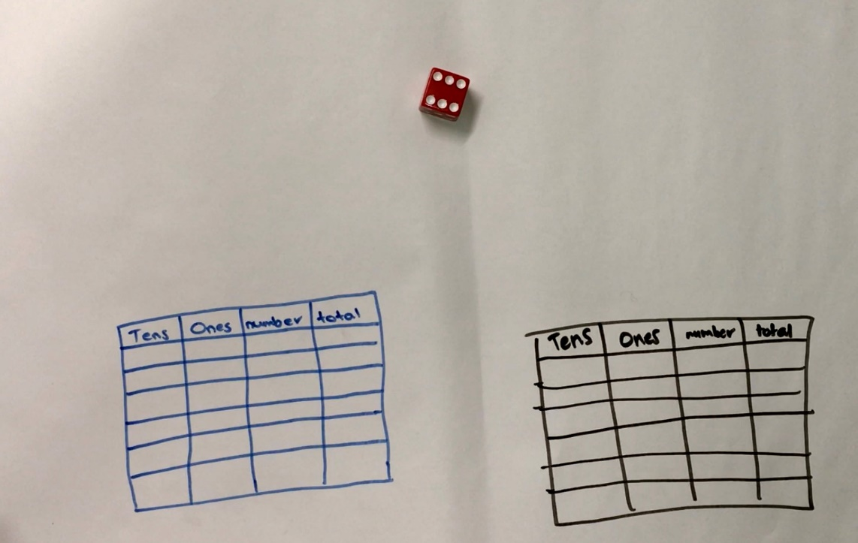
Students will need dice or they can make a set of numeral cards on paper that show 1 - 6.
Each time a player rolls the dice, they have to decide whether the number is representing ‘ones’ or ‘tens’. For example, if I roll a 3, I could use it as 3 ones (3) or 3 tens (which we rename as 30). If you choose to use your 3 as 3 ones, record the number in the ones column. If you choose to use your 3 as 3 tens (30), record your number in the left column.
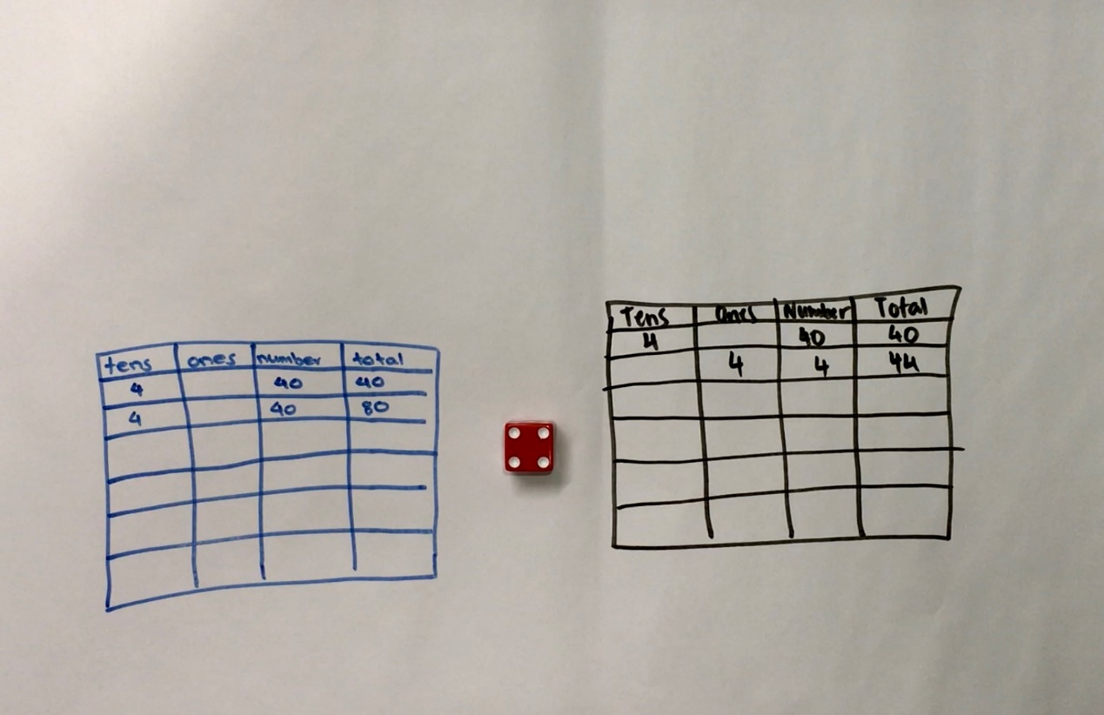
Continue to play for six rolls. Once students write a number, they can’t change it.
The winner is the player with the sum that is closest to 100 without going over!
Draw up 4 new game boards. Using the same numbers you rolled, use the game boards to get closer to 100 than you did in your first game.
Students play again with someone at home!
Variations:
- Increase the challenge by using numbers from 0-9. They can also use playing cards, make cards or make a spinner at home.
- Roll the dice 4 times and only use four lines on the game board.

Activity 4 - The counting game
This activity supports students in enhancing their reasoning skills whilst also practicing their knowledge of counting sequences. It is easily adaptable to suit a broad range of learners.
- Digital: Class to collaborate online. Use Activity 4 PowerPoint slides
- Non-digital: Students will need to collect 24 objects.
Using 24 as a target number, students take it in turns to count on by saying the next 1, 2 or 3 number words in the sequence, placing objects into a central pile as they are counted. Players collect a point if they say the target number. A new target number is chosen and players play again. Try playing forward and backward. For example:
Target number 24
Player A: 1, 2, 3...
Player B: 4, 5...
Player A: 6, 7, 8...
Player B: 9, 10, 11...
Player A: 12, 13...
Player B: 14, 15, 16...
Player A: 17...
Player B: 18, 19...
Player A: 20, 21, 22...
Player B: 23, 24!
Students to select a target number and a starting number. For example, you might start at 35 and try to get to 51.
Students can also count in multiples. For example, you can start at 0 and aim for 85, counting by fives.
Is there a way to play so that you never lose?

Activity 5 - The counting game multiples part 2
- Digital: Class to collaborate online. Use Activity 5 PowerPoint slides.
Classes play and students put their winning strategies to the test! This time start from a given number and count back, trying to be the person who says zero.
- Non-digital: It’s time for students to test their strategies!
This time starting from a given number and counting back, trying to be the person who says zero. For example,
Target number 0 (starting at 110 and counting in tens)
Player A: 100...
Player B: 90, 80...
Player A: 70...
Player B: 60...
Player A: 50, 40...
Player B: 30, 20, 10...
Player A: zero!

Activity 6 - Basketball toss
- Digital: Class to collaborate online. Use Activity 6 PowerPoint slides
- Non-digital: Students will need:
  - pair of socks
  - a clear space
  - basket, bucket or container
  - pencils or markers
  - mathematics workbook
Challenge: See how many times students can successfully shoot their rolled-up socks into the basket.
Students mark a clear ‘starting line’ for their Basketball toss
They take 3 big steps from their starting line and place a basket or container at the end.
Standing at their starting line they throw their socks. Students throw their socks with their right hand.
They go back to their starting line and have their second throw. This is repeated until they have thrown their socks 10 times with their right hand and 10 times with their left hand.
Students keep a record in their mathematics workbook.
They create a picture graph to share their results.
Ask: Do you think that these results will change with practice?

Activity 7 - Sam and Holly’s problem
- Digital: Class to collaborate online. Use Activity 7 PowerPoint slides
- Non-digital: Invite students to solve the following problem:
Sam and Holly were playing with combinations of numbers that make 10. They started by getting out 10 blocks.
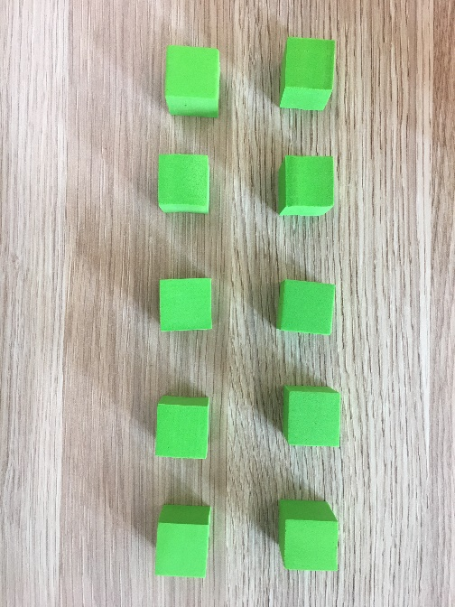
Then, Sam covered some of the blocks and Holly had to work out how many were missing.
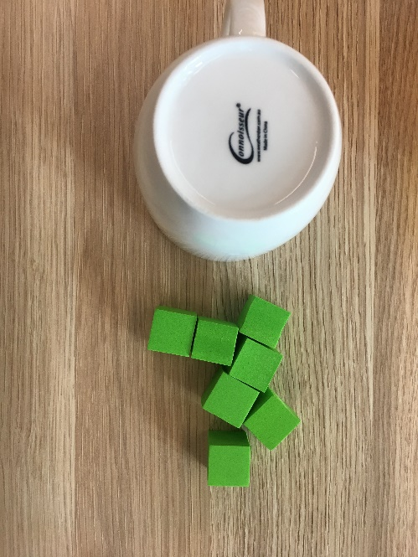
Holly decided she had to organise what she could see to help her work out what was missing.
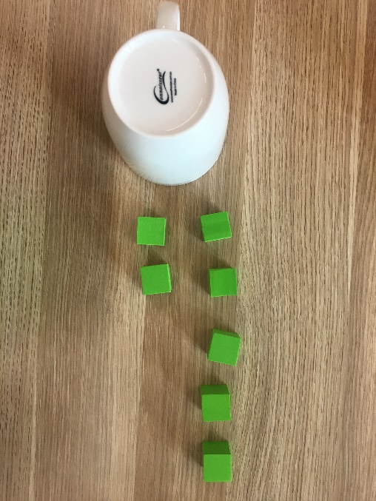
She imagined a 10-frame in her head and organised the blocks. This helped her see she needed 3 more to make 10.
Holly and Sam kept taking turns like this until Holly asked Sam if they could make it more challenging for them.
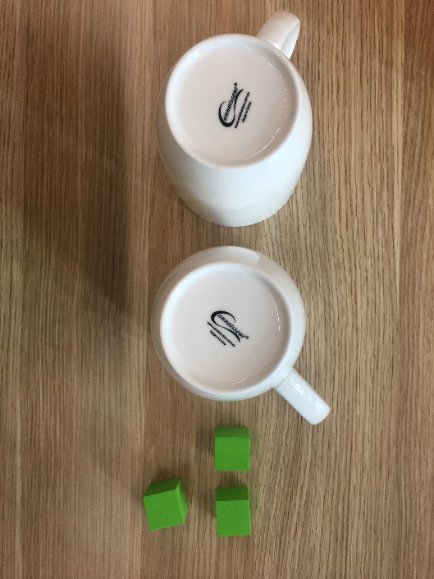
Sam made this for Holly to think about:
Can you help Holly work out how many blocks are hidden?
Can you help her work out how many of the hidden blocks might be underneath each cup?
What are all the possibilities?
Activity 8 – Handfuls
(Adapted from Ann Gervasoni, published on reSolve https://www.resolve.edu.au/counting-handfuls )
- Digital: Class to collaborate online. Use Activity 8 PowerPoint slides
- Non-digital: Invite students to take a handful of counters (or lima beans or pasta).
Ask students to hold their objects in their hand and imagine how many they have.
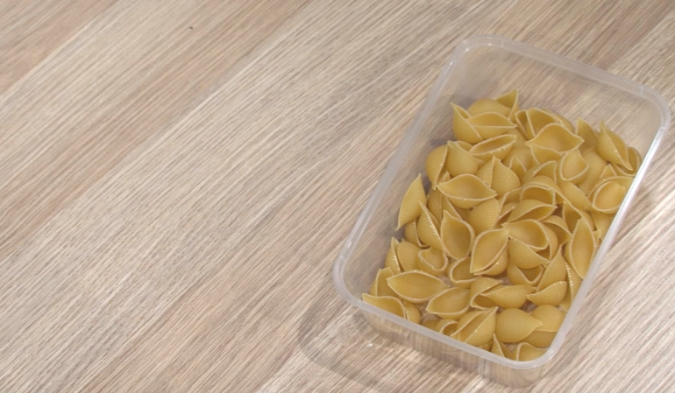
Ask students to record their estimate, and before they determine how many, you can also ask them to describe what that collection might look like, drawing on their capacity to visualise and imagine.
Invite students to organise their collection so that anyone walking by can determine how many items there are by looking and thinking.
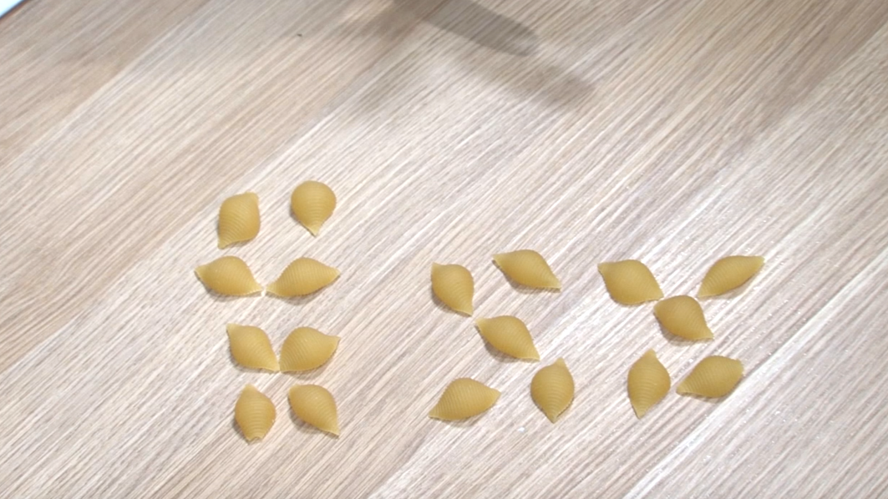
Questions to ask:
- How many do you have altogether?
- How have you organised your collection?
- Did you have more or less than your estimation?
- Can you organise them differently? Would this make them easier to work out how many you have?
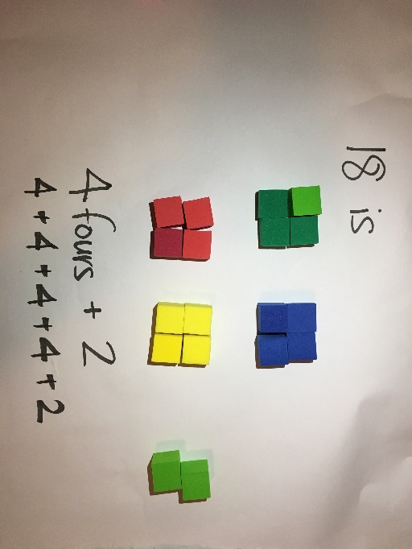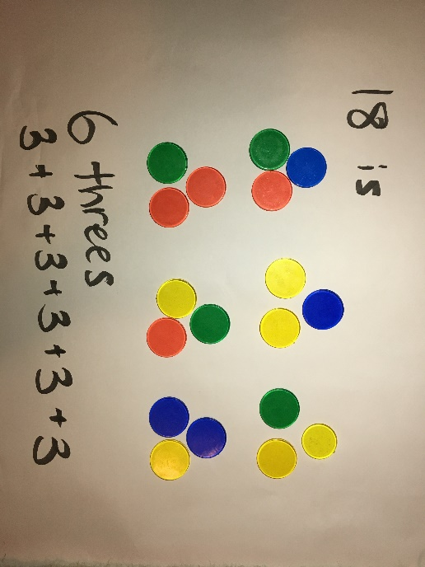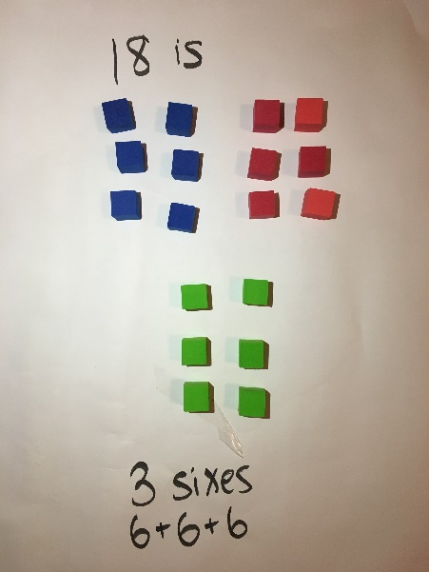
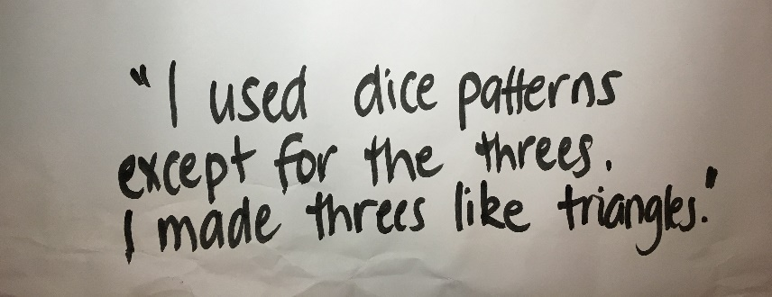
Play handfuls a few times.
Draw your favourite way of organising your collection.

Activity 9 - Building towers
This activity helps develop mathematical reasoning and communicating whilst also supporting number sense. For some students, you can emphasise one-to-one number correspondence and the use of direct comparison to describe relationships between quantities. For other students, you can use this game to support their use of part-part-whole number knowledge.
- Digital: Class to collaborate online. Use Activity 9 PowerPoint slides
- Non-digital: Give students 4 numbers to build as their towers (for example, 5, 7, 11 and 3), some blocks and a dice (or a spinner and numeral cards).
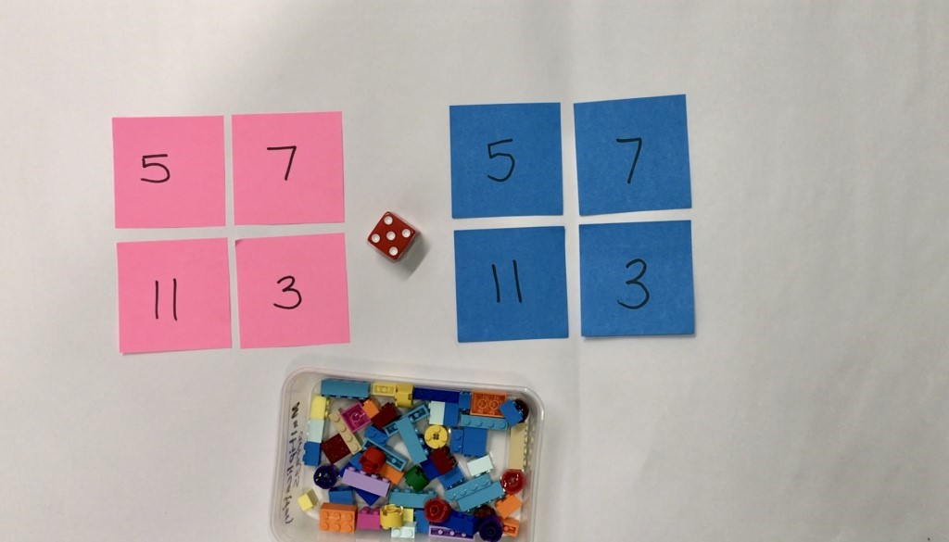
Students take turns to roll a dice and use the corresponding number of bricks to build up their towers. Towers can be built up in any way students choose. Students take turns building up their towers until one student gets the exact roll to complete the last tower.
Students can also play this in reverse.
Students should be encouraged to talk about how many they have, how many more they need and what strategies and knowledge they are applying.
Variations:
- Once students build the towers, play in reverse, taking away each time until there are no blocks left.
- Change the number of towers students build and change the number of blocks needed for each tower.
Reflection:
If you were to play the game again tomorrow, what is one thing you would do differently? Why?
Draw a picture that shows the towers you built in order of shortest to tallest.
Activity 10 - Let’s explore patterns
It is often said that patterns are at the heart of mathematics.
Mathematical patterns are those that are made up of elements that repeat over and over and over. One key concept in the early years involves students being able to identify the pattern core (e.g. a repeating pattern ABABAB). Some other important concepts involve students being able to copy, extend, create and ‘translate’ patterns.
These tasks are designed to support a very broad range of needs and understanding.
- Digital: Class to collaborate online. Use Activity 10. PowerPoint slides
- Non-digital: Ask students to gather a collection of objects.
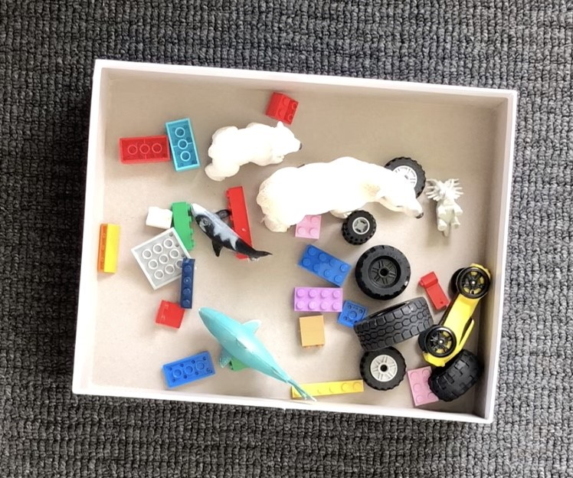
Invite students to think about the different ways they can sort and categorise their collection. Someone at home could help the student record their ways of thinking.
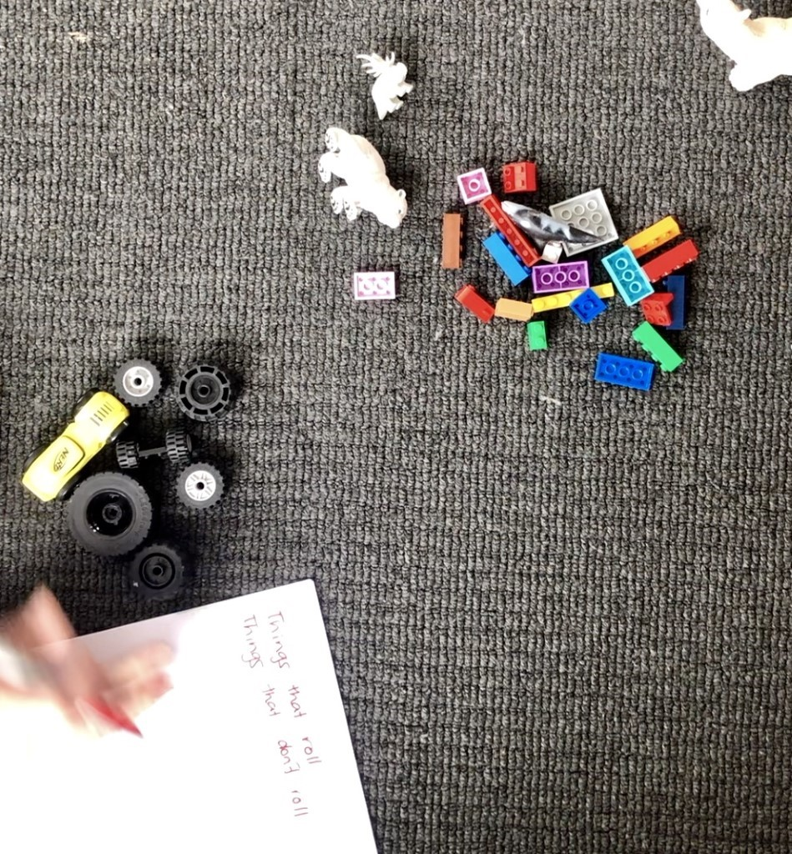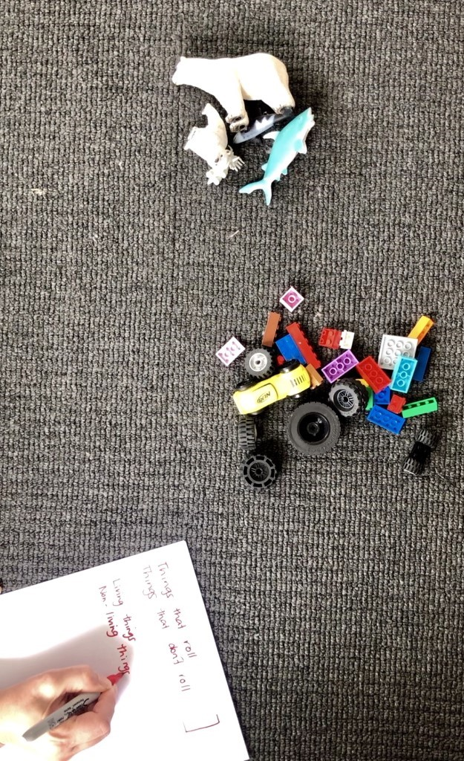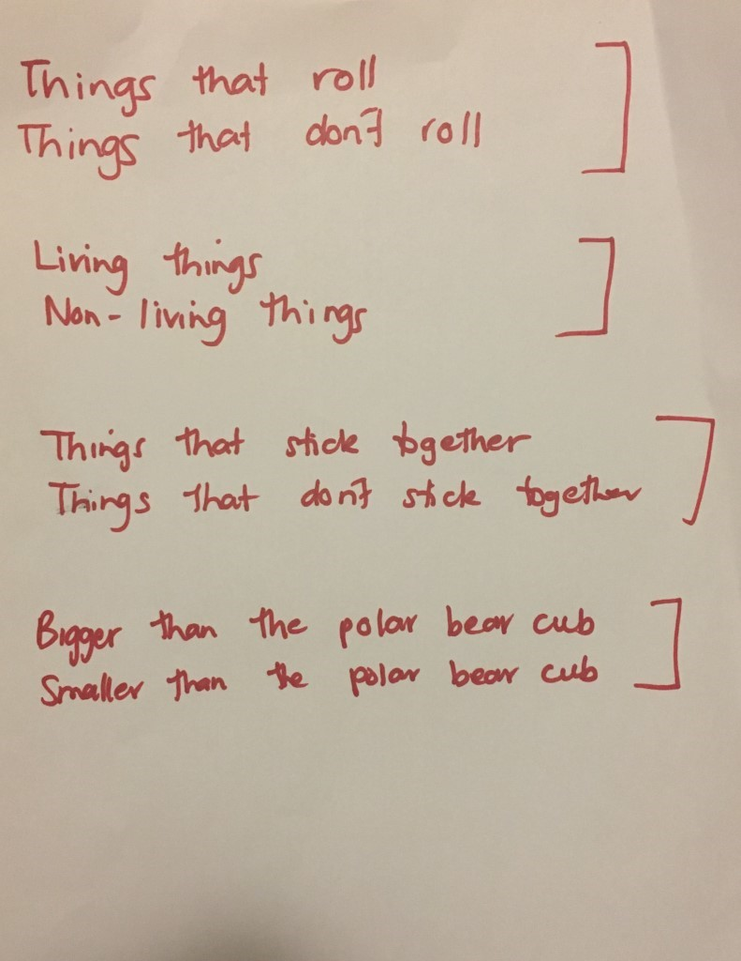
Talk to the students about what defines a pattern. Show this pattern to students.
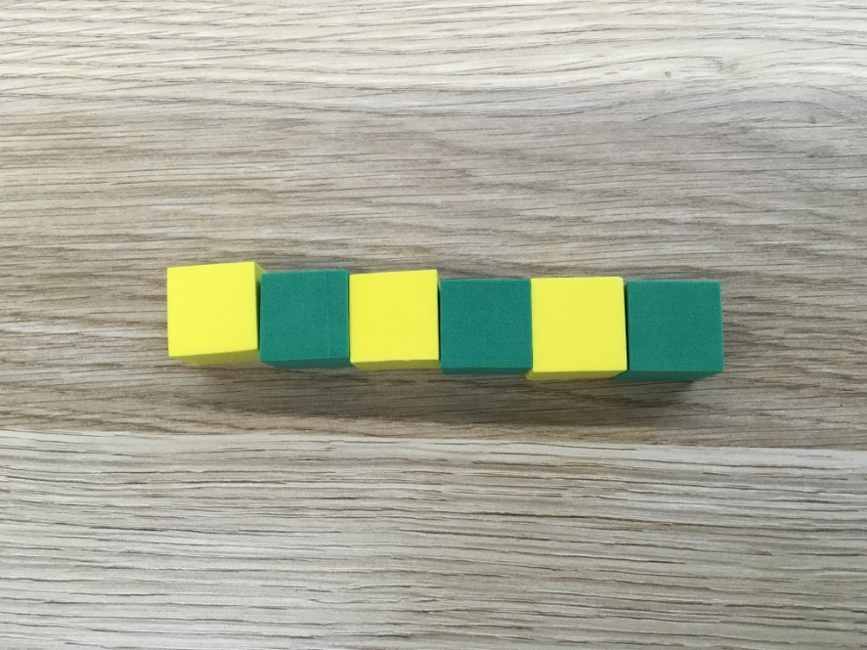
Ask them to describe the pattern. Ask students to explain how they know it is a pattern and how they would describe the part that repeats.
Ask students to make an AB pattern using different equipment.
Show students this image. Ask:
- How are these patterns the same?
- How are they different?
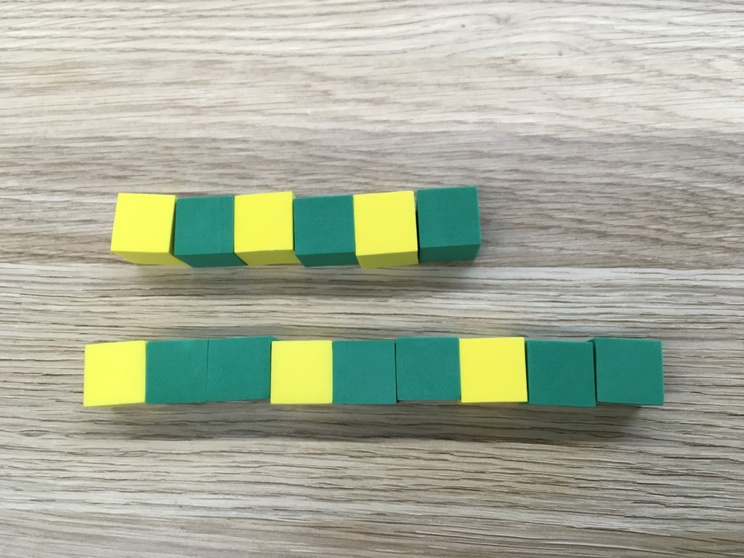
Construct, copy or extend a pattern that follows an ABB pattern.

Differentiation
Differentiation is a targeted process recognising that individuals learn at different rates and in different ways. Differentiation refers to deliberate adjustments to meet the specific learning needs of all students.
Here are some questions that you might consider when adapting the learning sequence to meet the needs of your students:
- What adjustments might you put in place for students who require additional support to access the task? For example, how will they get help when needed?
- Do you need to adjust the content to ensure it is adequately challenging and allows students to operate at their own level of thinking, skill and knowledge?
- Will you adapt the instructions so they are provided in a way that EAL/D students can easily interpret them? For example, through the use of visuals, checklists, diagrams or flow charts.
- Could you suggest ways that home language can be used as a tool to support learning? For example, bilingual dictionaries.
- Can you demonstrate that you value the Identity, culture, heritage and language of your Aboriginal students through your teaching practices?

Assessment
Using the aims of the lesson sequence as a guide, what do these tasks reveal about the knowledge, skills, understanding and interest of your students? You may like to take notes based on what you notice during conversations, student posts to digital platform and within student work samples.

Activity resources
- Online teaching resource (e.g. PowerPoint)
- Student mathematics workbooks
- Parent/carer advice: Parents may like to support their children by playing and talking to them about their experiences and their learning. It is strongly suggested they supervise their children when they are online. Teachers often find it beneficial to watch the videos like those included a few times to assist with developing confidence in noticing, wondering, talking, questioning, testing and playing like mathematicians. Feel free to play any of the games and activities more than once. These experiences are adaptable and so can be played with family and community members, who can join in on the fun!

K-6 template
Framework for delivering curriculum in case of school closure – K-6 template
Teachers may use this template to create weekly learning experiences for their class. Use the sample documents provided for ideas and to guide you.
Guiding question | Consideration and ideas
What are your students going to learn? | This framework allows for continuity of student learning and should not be considered as an ‘add on’ to your existing teaching and learning program. Use what you have. What would your students be learning if they were at school? What is scheduled in your scope and sequence? What planned activities could be used in an alternate learning environment? What syllabus outcomes and content are your students working towards?
How are they going to learn it? | What existing tools and resources are available to you? Are all students able to engage with online tools? If not, how will you accommodate different levels of access in your class? What online platforms are your students familiar with? Consider expected timeframes for task completion (as a rough guide, think about doubling the time for task completion). Where possible, include a realistic balance of synchronous and asynchronous learning strategies.  Synchronous – students learn at the same time which allows for instant feedback and clarification. An example of synchronous learning is video conferencing via Adobe Connect or Microsoft Teams that takes place in real time.  Asynchronous – students learn at different times which provides greater convenience and flexibility and allows students to work at their own pace. Examples of asynchronous learning include emails, screencasts and blog posts.
How will you ‘check in’ with students? | In consultation with parents/ caregivers establish routines that support regular communication with students. This may include using a digital platform to support a virtual lesson break or to review work completed.
Collecting evidence of student learning (Verification) | What evidence of student learning will you collect and how will you evaluate it?  How will you regularly monitor and support progress in student learning?
Feedback (Evaluation) | What existing tools and methods for providing feedback are available to you? What feedback tools and methods are your students familiar with?  How might students provide feedback to each other on their work?  How might students share their work and celebrate their success with a parent/ carer?
Communication | How will learning experiences be introduced and supported? How can students ask questions about their learning?  How will you share and display information for learning activities with your students and their parents/carers?  How will you plan for student-teacher interactions?  How will you provide opportunities for students to interact with each other through their learning?  How will you ensure students with and without online access are able to communicate effectively for learning?

 | Monday | Tuesday | Wednesday | Thursday | Friday
Morning | KLA  Task 1  Task 2  Task 3 | KLA  Task 1  Task 2  Task 3 | KLA  Task 1  Task 2  Task 3 | KLA  Task 1  Task 2  Task 3 | KLA  Task 1  Task 2  Task 3
Break
Middle | KLA  Task 1  Task 2  Task 3 | KLA  Task 1  Task 2  Task 3 | KLA  Task 1  Task 2  Task 3 | KLA  Task 1  Task 2  Task 3 | KLA  Task 1  Task 2  Task 3
Break
Afternoon | KLA  Task 1  Task 2  Task 3 | KLA  Task 1  Task 2  Task 3 | KLA  Task 1  Task 2  Task 3 | KLA  Task 1  Task 2  Task 3 | KLA  Task 1  Task 2  Task 3

