Do quadrilaterals tessellate?

Your investigation
During this activity, you will investigate whether all quadrilaterals tessellate and justify your conclusion.

Part A – Testing quadrilaterals
By drawing at least 9 duplicates for each quadrilateral below, attempt to tessellate the following quadrilaterals.

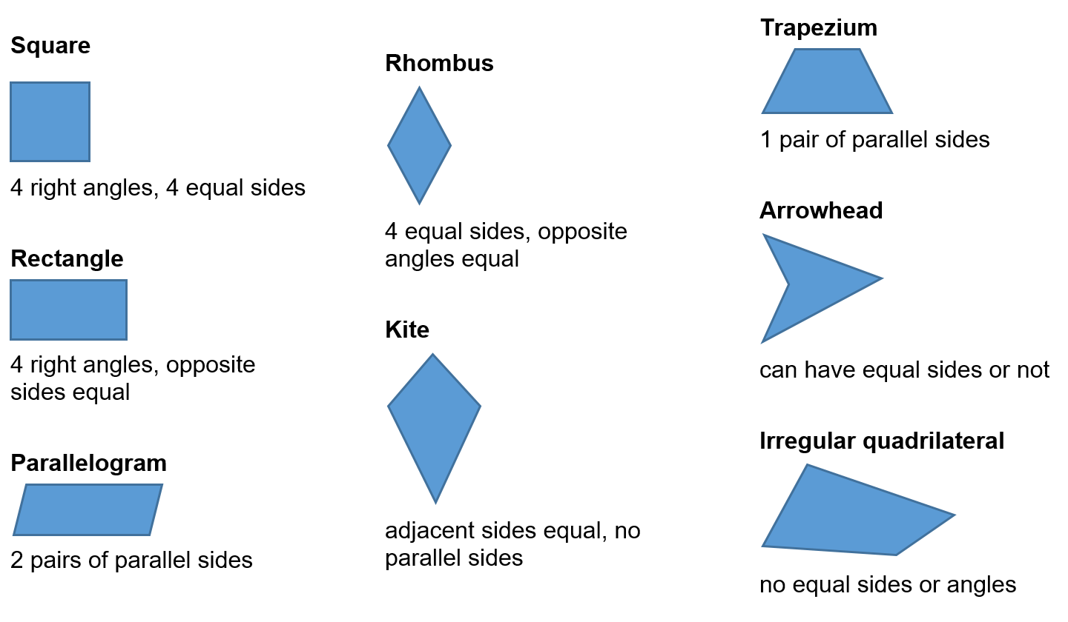

Clearly show how each shape may tessellate both vertically and horizontally across your page. You may find it easier on square dotted paper.

Part B – Testing regular polygons
Three regular polygons tessellate. On isometric paper, show which three tessellate and why?

Extension
Can you explain why the other regular polygons do not tessellate?

Part C – Testing irregular polygons
These irregular shapes tessellate. On square or isometric dotted paper, choose at least one of each type and show how they tessellate. Aim to cover half a side with your shape.

Square dotted paper

Isometric dotted paper

Extension
Some regular polygons do not tessellate perfectly; however, the gaps can be filled by another regular polygon. This is called a semi-regular tessellation.
Which regular polygons create a semi-regular tessellation? Can you create one?

Outcomes
- Classifies, describes and uses the properties of triangles and quadrilaterals, and determines congruent triangles to find unknown side lengths and angles MA4-17MG
- Identifies and uses angle relationships, including those related to transversals on sets of parallel lines MA4-18MG
All outcomes referred to in this unit come from Mathematics K-10 Syllabus © NSW Education Standards Authority (NESA) for and on behalf of the Crown in right of the State of New South Wales, 2012

Appendix 1 – Square dotted paper
You can access square dotty paper at NRich – https://nrich.maths.org/content/id/8506/dottygrid10mm.pdf

Appendix 2 – Isometric dotted paper
You can access isometric dotty paper at NRich – https://nrich.maths.org/content/id/6445/Dotty%20paper.pdf

