Mathematics workbook

Early Stage 1
Name:
Class:

Overview
For the next 2 weeks, you will be having lots of fun with numbers. Most of these activities are games and investigations that you can play with your family and friends. Have fun and think deeply!
These activities do not require the use of a device. However, if you’re interested in seeing videos related to these activities, you can find the link on the Learning from home, Teaching and learning resources page.
education.nsw.gov.au/teaching-and-learning/curriculum/learning-from-home/teaching-and-learning-resources

Activity 1
During this activity you will be making your own counting book.
Resources – 5 zip lock bags, stapler, cardboard, items to add to your book

Counting book
Instruction
Follow these steps to make a counting book
- Open the zip-lock bags.
- Lay the bags on the cardboard, like pages of a book
- Take the remaining cardboard and fold it over the bags to form the spine of the book.
- Staple it into place.
- Finally, give the book a title!
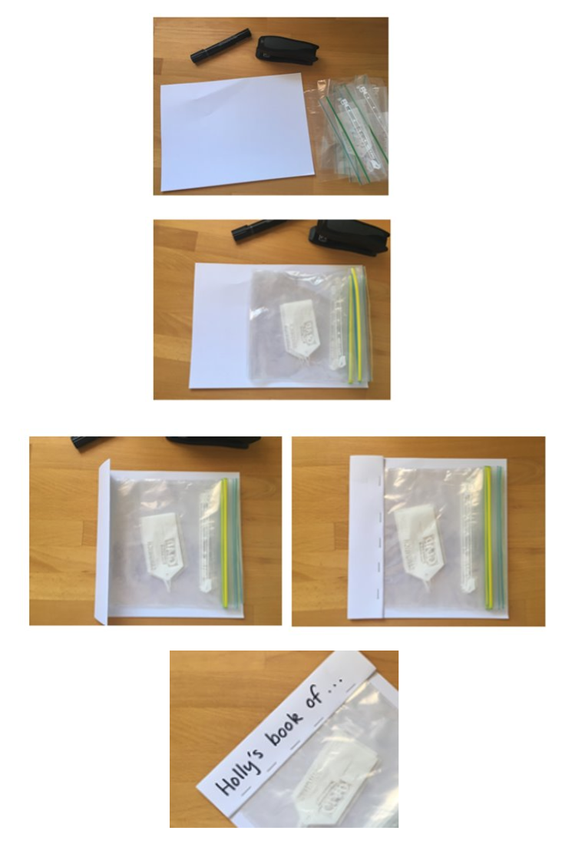
You could make a book about 5.
Go on a ‘5 hunt’ and find different ways of showing 5.

Read your book to someone in your family.

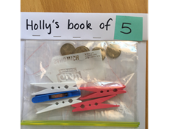

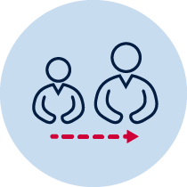
Advice for parents: Here is part of a conversation to help illustrate what it can sound like when talking to your child about their book:

Adult: You went on a hunt around the house to find different ways of representing 5. Can you read your book to me?
Holly: Yes. I have 5 pegs
Adult: How do you know that is 5?
Holly: See...it’s 2 pink and the 3. That makes 5.
Adult: I see...that’s 2 and then 3, 4, 5 (touching one object for each number word that is said)
Adult: What else have you got in your book?
Holly: This one is 5 dollars...see there’s 3 here and 2 more. That’s five.

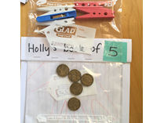

Holly: This one is my mum’s hand.

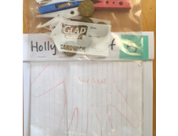

Adult: How do you know that’s five?
Holly: because she has 5 fingers on her hand
Adult: Look at all the different ways you found 5! Let’s find someone else to read it to!

Reflection
Draw your favourite page from the book below.

Activity 2
During this activity you will be exploring numbers and the smaller parts inside larger numbers.
Resources – equipment (for example, pasta shells, counters, pencils or Lego)

Number busting

You can do this activity on your own but it is better to have a partner so that you can share ideas and discuss your thinking (Parents at home might like to record their children’s thinking).

Select a number, such as 7 and get that amount of items (for example, pasta pieces, counters or pencils).

Organise your items.

Describe your collection.

What other ways can you organise your items?

Describe your other ways.

You may like to use a mathematical structure such as a ten-frame to help you.
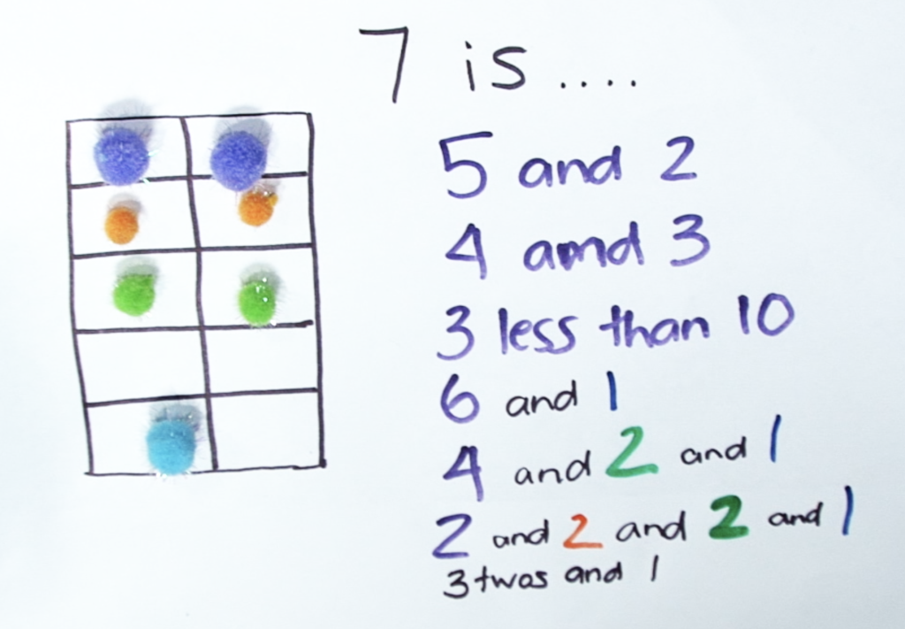
Can you try the same activity using different equipment (like LEGO, for example)?

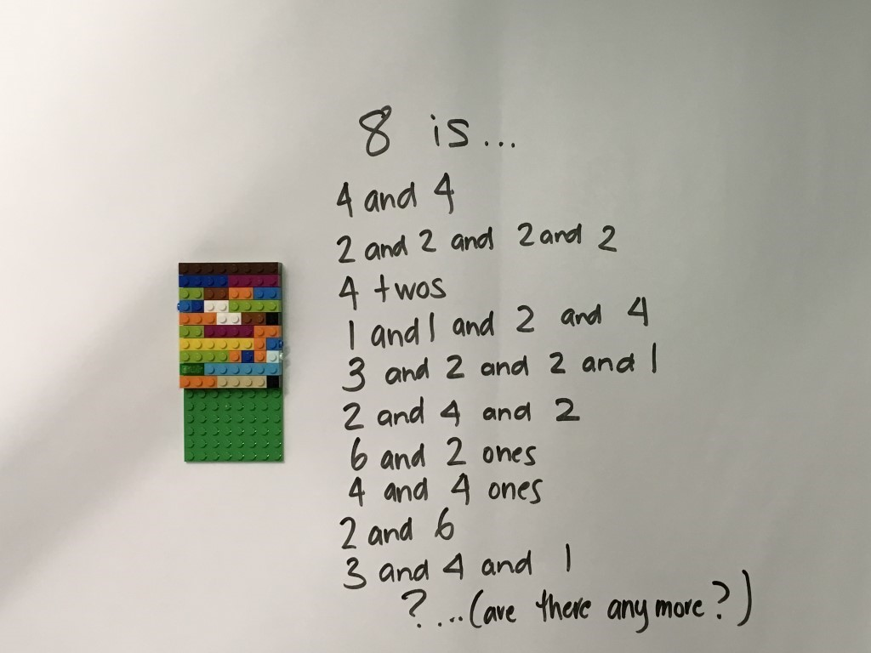
Draw and record 3 different ways you thought about your collection.

Reflection
Think about these questions and ask a family member to help you record your thinking in your workbook.
Were you surprised by all the different ways to make your number?
What did your structure help you to notice? (for example ten-frame, dice pattern)
What is something that you found interesting in today’s activity?

Activity 3
During these games, you will be comparing quantities.
Guess my number: pencils, numeral cards for example Uno cards (optional), Lego (or other blocks)
Race to write game board (in resources), 1-10 dot spinner, marker

Guess my number’ and ‘race to write’

Guess my number
Write the numbers from 1 to 10 (for example) on a piece of paper or use cards to set the number range you will be using. In this example, this student chose to use the numbers between 1 and 8.

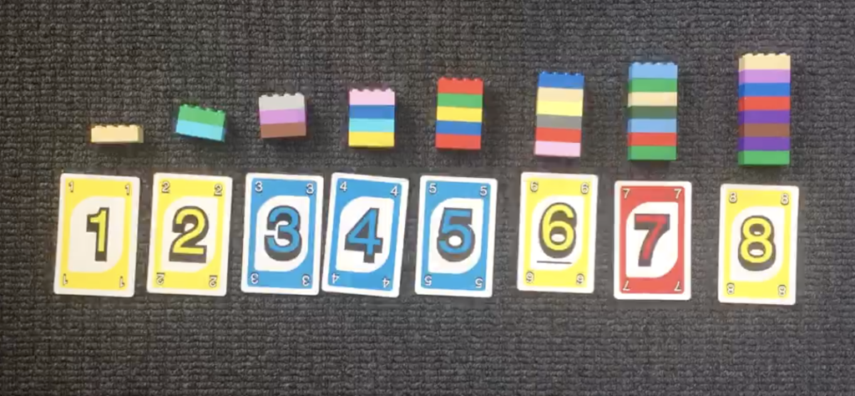
Ask someone at home (the ‘secret holder’) to choose a secret number within your given range.

Guess the secrete holder’s number.

They will tell you whether their number is greater than or less than your guess.
Try to guess the secret number in the fewest number of guesses possible, or, you must try to guess the number with only 3 guesses.

After every guess, the 'secret holder’ tells the student whether their number is greater or less than their guess.

Advice for parents:

Here is part of a conversation to help illustrate what the game can sound like. This was a game between a teacher and a student, using the number range 1-12:

Secret holder: Ok, make your first guess!
Student: 3.
Secret holder: My number is not 3.
But my number is greater than 3.
Are there any numbers you can cross off your list?
Student: It’s not 3 so I can cross that off.
Student: It’s not 2 or 1 either as they are less than 3.
Secret holder: That’s great reasoning- because my number is greater than 3, but those numbers are less than 3, they can be crossed off.
What is your next guess?
Student: 7.
Secret holder: My number is not 7, but my number is less than 7. Can you cross any more numbers off the list?
Student: Yes! 7...8, 9, 10, 11 and 12!
Secret holder: What are the options you have left?
Student: 4, 5 or 6!
Secret holder: Take some time to think about what a good number would be to guess now.
Student: Maybe 5?
Secret holder: Why do you think that?
Student: If I choose 5...it’s in the middle. So, I will know the answer whatever happens with bigger and smaller. And it could just be 5!

Reflection:

- What is an effective strategy to guess the number quickly?
- If you played the game again tomorrow, what would you do differently? Why?

Race to write
Play this game with a partner. You will need to use your ‘Race to write’ game board (at the back of this book)
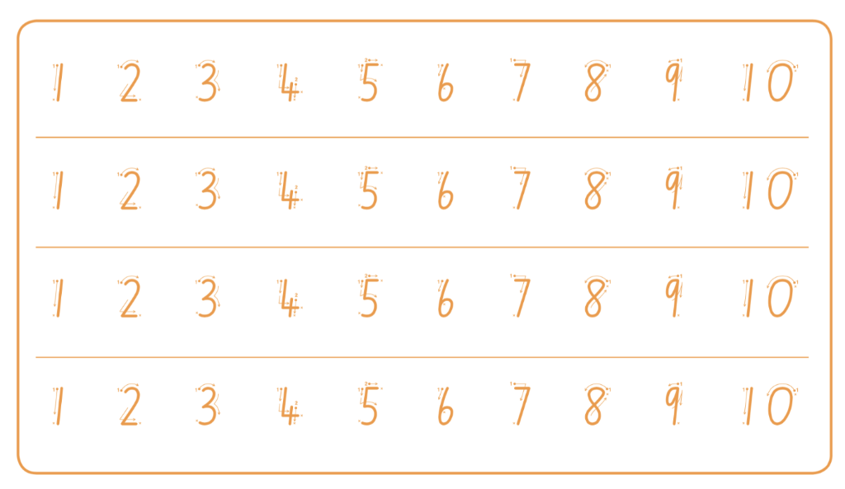
Take turns to spin the spinner and trace over the matching numeral on your game board.

The first player to complete a full row wins the race.

Advice for parents
Other ways to play:

- Provide your child with a pile of number words they flip over to determine which numeral to write (e.g. cards that say ‘one’, ‘two’ etc.)
- Have a pile of ten frames showing 1-10. Students flip over to determine which numeral to write
- Work within the range of 1-5 before progressing to 1-10
- Work with numerals 1-20 using a second game board (in resources)
Reflection
If you played tomorrow, what would you do differently and why?

Activity 4
During this activity you will count with understanding. There is a lot you have to know!
Resources –pegs or paper clips, numeral cards (you can make these using sticky-notes and a marker 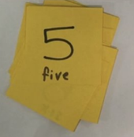, pencils or markers, your maths work- book, numeral dot cards (optional-in resources)

Counting with understanding
Use a set of number cards within an appropriate number range. For example we are using 0-6.
Shuffle the cards
Turn one card over at a time and read the numeral.
Match the number of pegs (or some other item) onto the card.
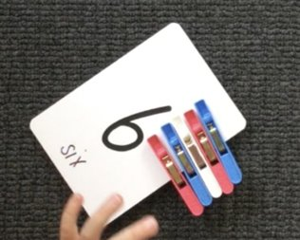
Order the cards from smallest to biggest or biggest to smallest.
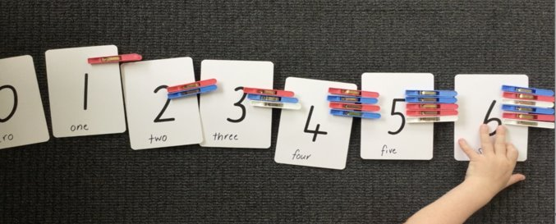
Close your eyes as someone at home removes one of your cards.

Which card is missing?
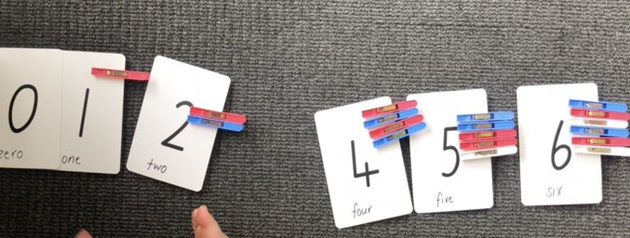
How did you work out?
Advice for parents
Choose one card, for example 5.
Ask your child to confirm how many pegs are on the card in order establish and confirm that there are 5.
Support their understanding of conservation by spreading the pegs out, bringing them in close together and swapping 1 peg for a clip.
Encourage them to use reasoning to determine there are still 5 things in the collection even if they are close together or far apart, or, when one thing is swapped for another.

An easier way to play:
Use cards that have a numeral and matching dot pattern so that you can attach one peg for each dot (in resources).

Another way to play:

Place a row of paper cups on the floor.
Count the empty cups.
Drop one counter into each cup and count the counters as they are dropped into the cups. Remove one cup at a time to practise counting backwards.

Reflection
What do you need to remember when counting?

Activity 5
During these games you will be exploring the smaller numbers that ‘live inside’ larger numbers.
Resources
10 or bust: a game board (for example use a number track, a ten-frame, a drawing of 10 fingers, a drawing of a known number combination to 10), counters (or dried beans/pasta) a dice, spinner or numeral cards from 1-6.
Counting game:10 or bust and the counting game

10 or bust or counting game

10 or bust
Have 3 turns each to roll the dice and place the matching number of counters on your game board.
You can choose to miss 1 turn, but it cannot be your last roll.
If you go over 10, you have ‘busted’ and are out of the game.
The player closest to 10 after 3 rolls is the winner.
Players can play best out of 3, playing by making up to 10 as well as backwards to 0.

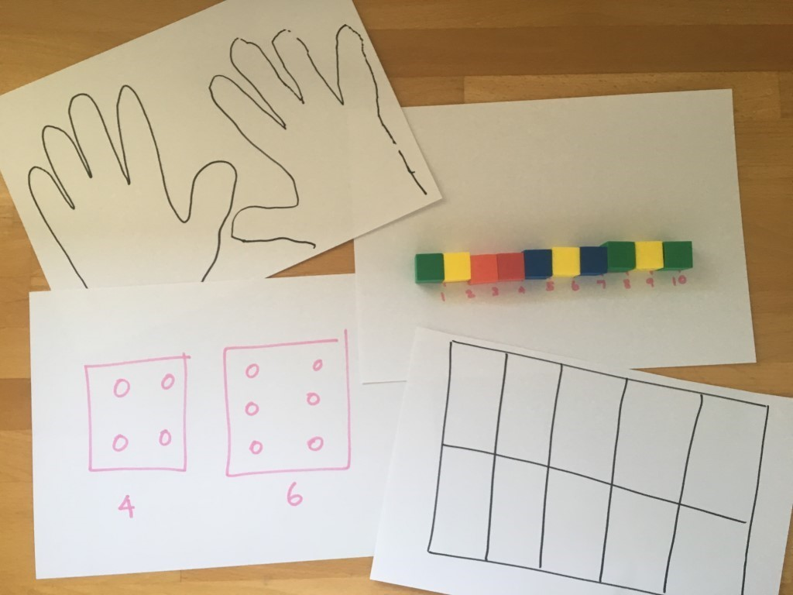

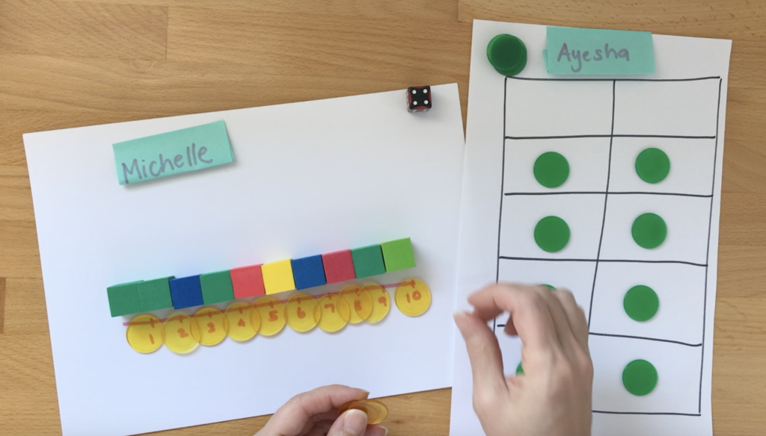
The student closest to 10 after 3 rolls each is the winner. Students can play best out of 3, playing by making up to 10 as well as backwards to 0.

Reflection

- How could we change the game to make it more/less challenging?
- Did you work out a way to play this game so that you didn’t lose? What was your strategy? Did it work?

The counting game
Collect 24 items.
Using 24 as a target number, take it in turns to count on by saying the next 1, 2 or 3 number words in the sequence, placing items into a central pile as they are counted.
Players collect a point if they say the target number.
A new target number is chosen and players play again.
Try playing forward and backward.
Advice for parents
Here is an example of a game. Target number 24.
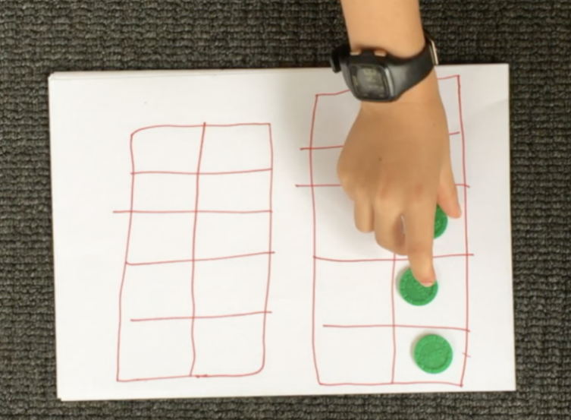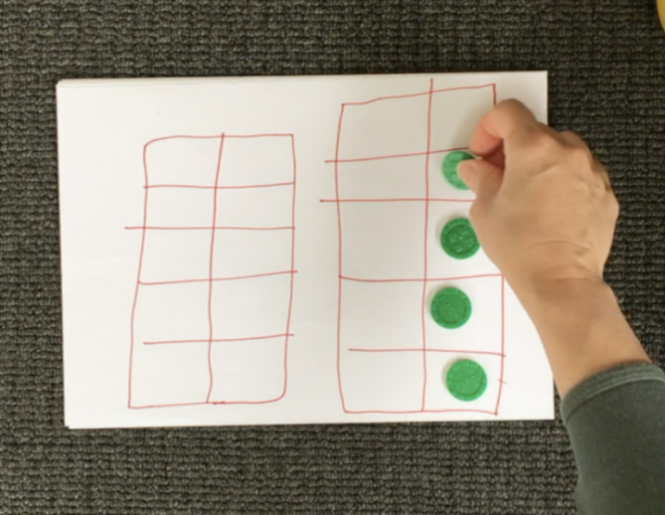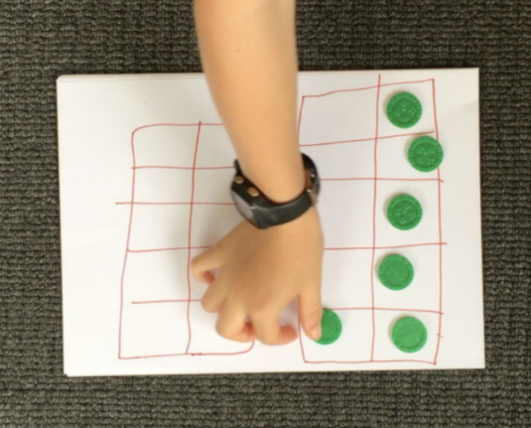

Player A: 1, 2, 3...
Player B: 4...
Player A: 5, 6...
Player B: 7, 8, 9…
Player A: 10, 11, 12...
Player B: 13…
Player A: 14...
Player B: 15, 16...
Player A: 17...
Player B: 18...
Player A: 19...
Player B: 20, 21...
Player B: 22, 23, 24!

Play again, starting at 24 and counting backwards to zero.

Another way to play
- Select a different target number, such as 12.
- You can also count in multiples. For example, you can start at 0 and aim for 20, counting by twos.

Reflection
Discuss these questions with your opponent and show your thinking in your mathematics work- book.
- What did you notice about playing the game by counting backwards? Did it make your brain work harder or was it less difficult?
- What would happen if I had said....instead of ...? (identify point in time when playing the game to pose this question)
- How could we change the game to make it more/less challenging?
- Did you work out a way to play this game so that you didn’t lose? What was your strategy? Did it work?

Activity 6
During this task, you will collect data about your success at sock basketball.
Resources: a basket or container, a pair of socks, pencils, a clear space, a piece of paper.
You can play this game alone or with a partner. Have fun!

Basketball toss
Mark a clear ‘starting line’ for your basketball toss
Take 3 big steps from your starting line and place a basket, bucket or container at the end.
Stand at your starting line and throw your socks with your right hand.
Each time you get a sock in the basket, clip a peg onto your chart.
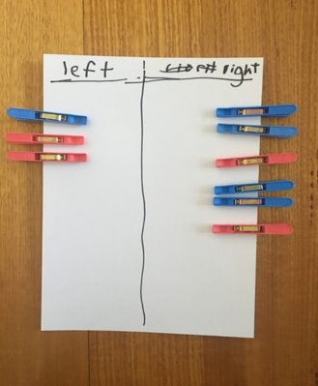
Go back to your starting line and have your second throw.
Repeat this until you have thrown your socks 10 times with your right hand and then 10 times with your left hand.
Draw a picture of your chart in your mathematics workbook.

Advice for parents
You can support your child by having them use direct comparison to help them work out/prove which one had more.
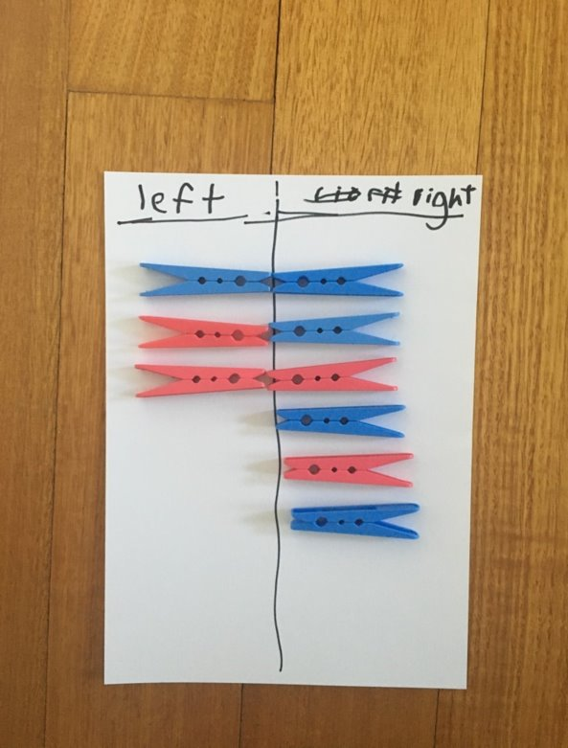
Your child can also put their pegs onto a familiar structure, like a ten-frame.
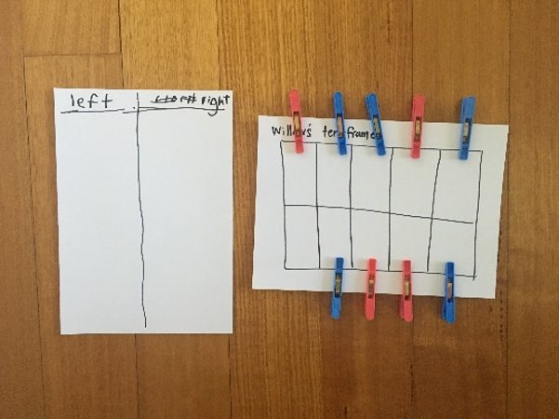
It’s important to have them use what they know about this structure to help them. So, if I see 1 box is left empty, I know I got 9 baskets because 1 less than 10 is 9.

Further investigation:
Other people in your family might have been playing basketball toss today too.​
If they’re taller than you, they might have had their baskets in a different spot.
Using some blocks or spoons, for example, work out how far you had to throw your socks and then work out how far someone else had to throw theirs.​
Draw a picture to show you measuring.​
Can you create a new game your family and friends could play at home?
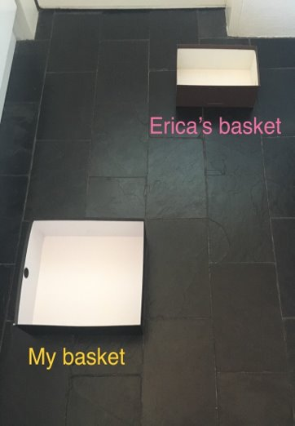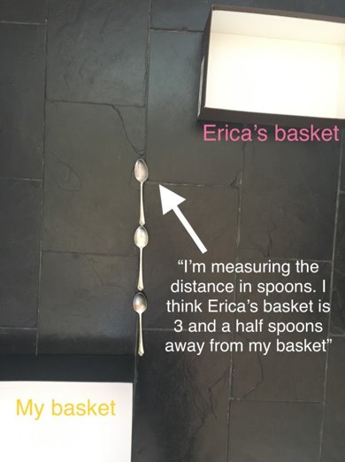

Reflection
What do you notice about your graph?
What does it tell you about your success at playing sock basketball using your left hand compared to using your right hand?
Do you think that these results will change with practice?

Activity 7
During this task, you be exploring measurement using your very own creatures.
Resources: cardboard (cut into thin strips), craft materials, pencils or markers, your mathematics workbook

Long creatures
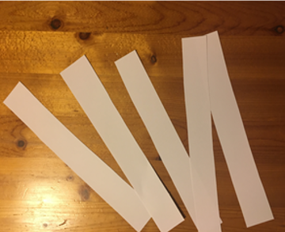

- Fold the strips into different lengths.​
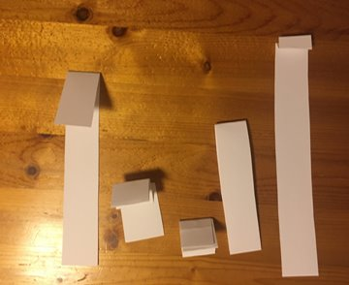
- Decorate your cardboard strips to help them come to life!
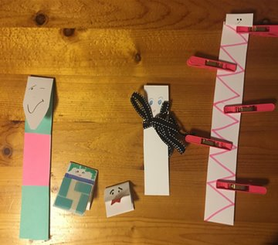
- Order your creatures from the shortest to tallest (for example).
- Draw your creatures in your mathematics workbook.

Advice for parents
Support your children in understanding that to measure accurately, we need to make sure we start measuring from the same place.
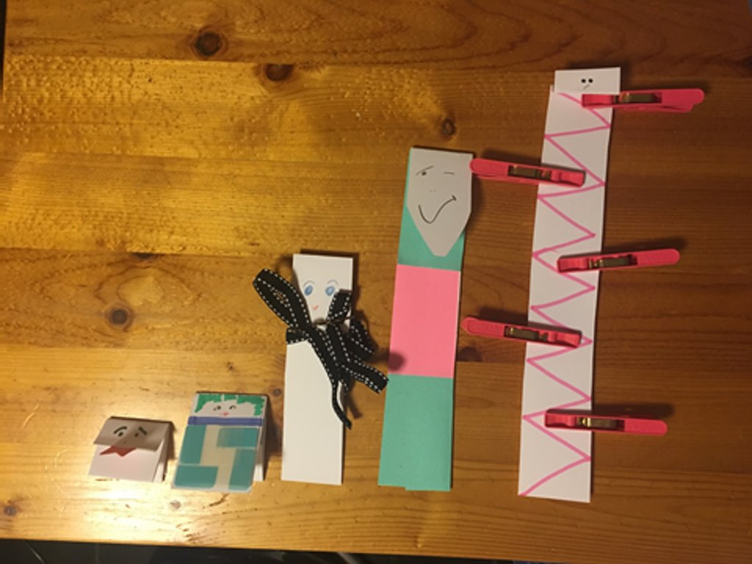

Choose your shortest creature and one of your longer creatures.
How many short creatures are needed to be the same height as the taller creature?

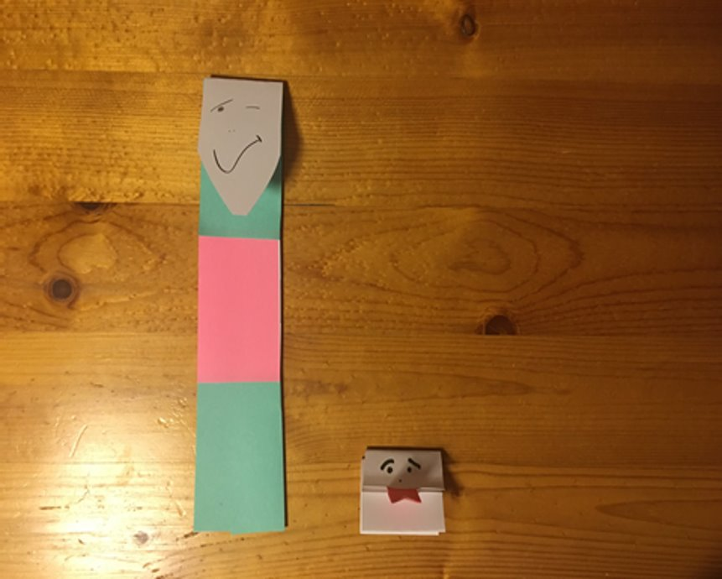

Draw a picture to show you measuring how tall the creature is that you just measured.

Reflection

Do you agree with this way of ordering from tallest to shortest?
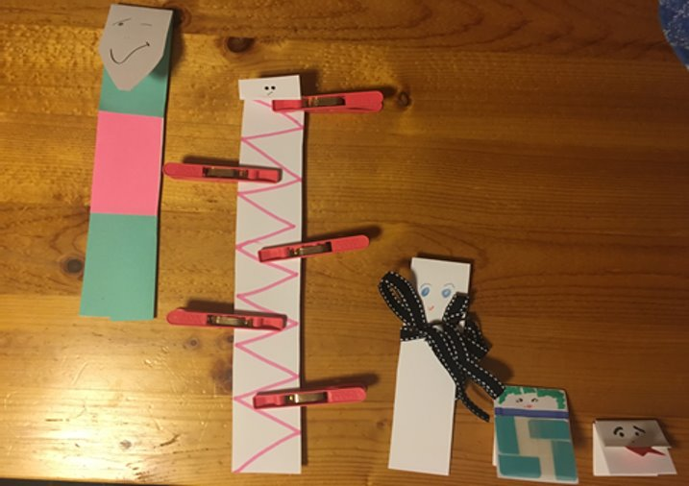
Explain why or why not.

Activity 8
During this task, you will answer the question ‘how many?’ by looking, thinking. You will need to organise your collection so that others can determine how many without needing to count everything.
Resources: small bag of dried beans or counters, pencils or markers, your mathematics workbook

Pinch a ten

Make this chart.
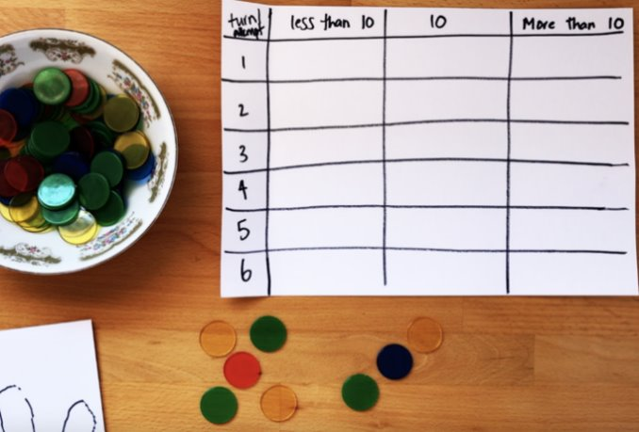
Take a pinch of dried beans and determine how many you have in your collection. Is it:​
- Less than 10​
- 10​
- More than 10​
Complete the chart as you play the game.
Use what you know about numbers and counting to help you decide whether you have more than 10, less than 10, or exactly 10.
Play again 5 more times.

Advice for parents

When playing the game on different occasions, your child should be encouraged to use different strategies for determining how many they have. ​
Using different objects (such as dried pasta, dried beans, blocks, etc.) will also be helpful in supporting students to get a feel for estimating quantities.

Reflection
How did you work out how many you pinched?
What do you notice about your chart?

Activity 9
During this game, you will explore the smaller numbers that sit inside larger numbers.
Resources: numeral cards (post it notes or small bits of paper), dice or spinner, block for example Lego,

Building towers
Play this game with a partner.

Each player has 4 number cards. For the first game, you will both have 5, 7, 11 and 3.

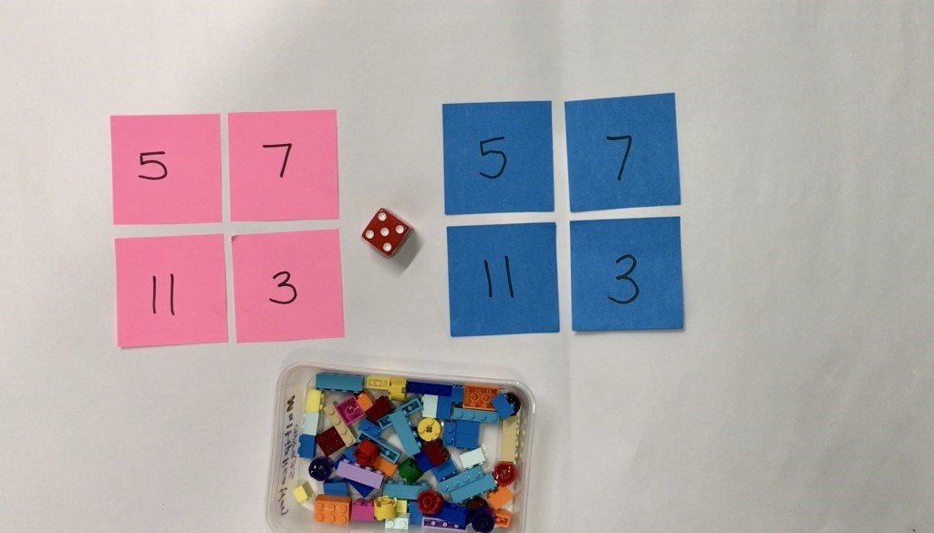

Take turns to roll a dice (or spin the spinner) and get that number of bricks to build up your towers.

Towers can be built up in any way you choose.

Take turns building up your towers until one of you gets the exact roll to complete the last tower.

Talk about how many you have, how many more you need and what strategies and knowledge you are applying.

Another way to play
- Once you build the towers, play in reverse, taking away each time until there are no blocks left
- Change the number of towers, and, change the number of bricks needed for each tower

Reflection
If you were to play the game again tomorrow, what is one thing you would do differently? Why?

Draw a picture that shows the towers you built in order of shortest to tallest.

Activity 10
During this activity you will be exploring patterns.
Resources: collection of items, pencils or markers

Let’s explore patterns
Advice for parents
Even though this is an offline workbook, we strongly suggest you watch the patterning videos to gain an understanding of how patterns are taught at school

Gather a collection of items

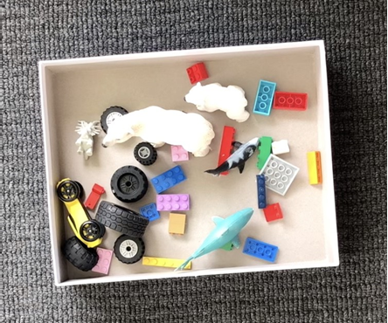

Think about the different ways you can sort and categorise your collection. Someone at home could help you record your ways of thinking.
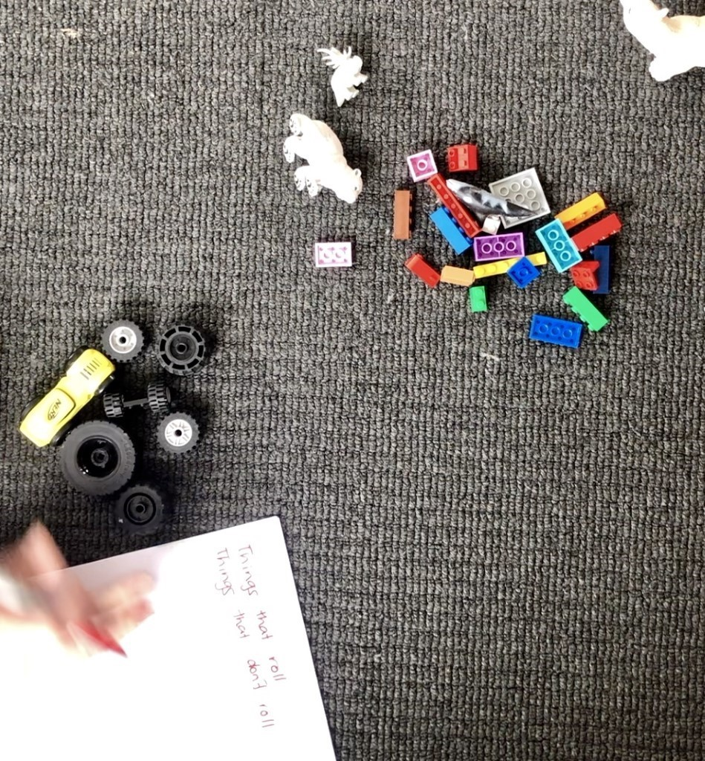
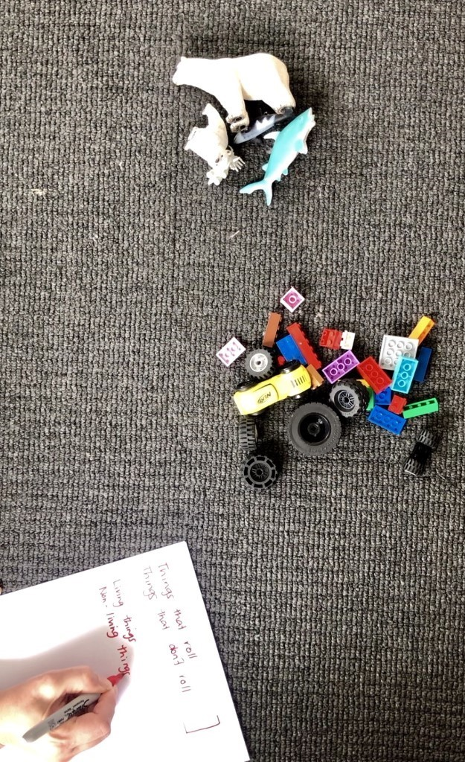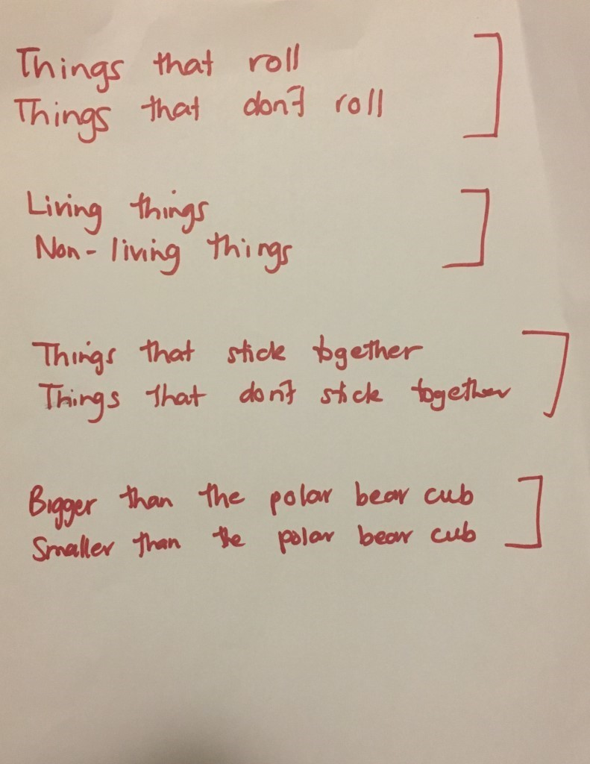

What do you think a pattern is? Talk about this with a family member and write down your thinking in your work- book.

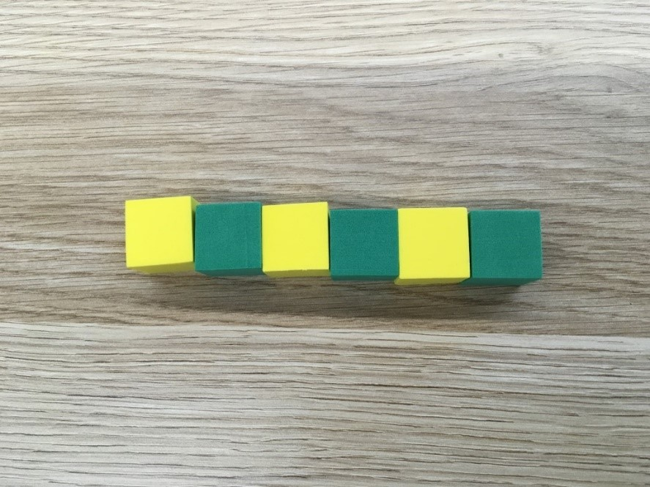

Describe this pattern.

How do you know it is a pattern and how would you describe the part that repeats.

Make an AB pattern using different equipment.

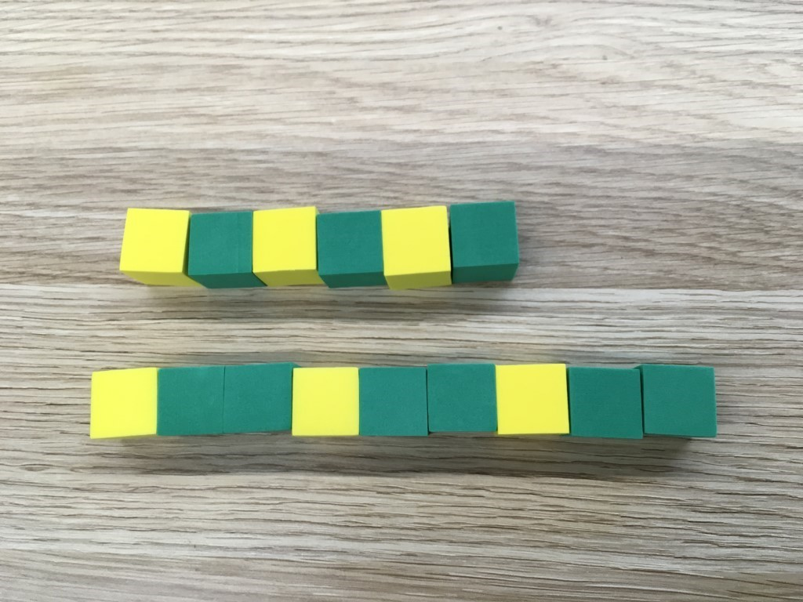

- How are these patterns the same?
- How are they different?

Construct a new pattern that follows an ABB pattern.

Reflection
Think about what you have learnt in this activity. Use the two stars and a wish structure to guide your reflection.
Star  Something that went well! | Star  Something that went well! | Wish  A goal for next time…
 |  | (What is something you would do differently if you were to play the game again?)

Resources
Race to write game boards
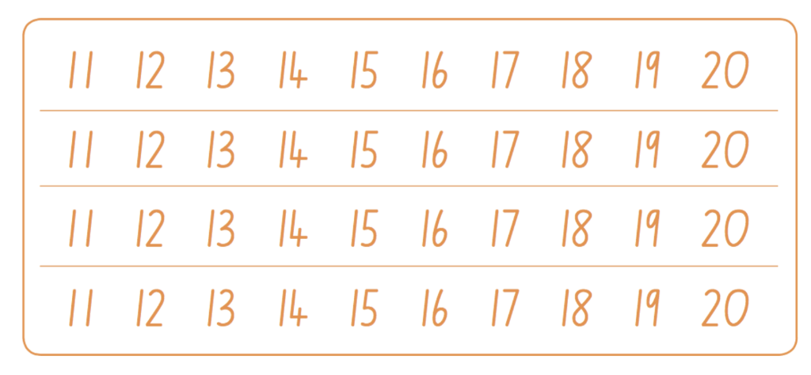
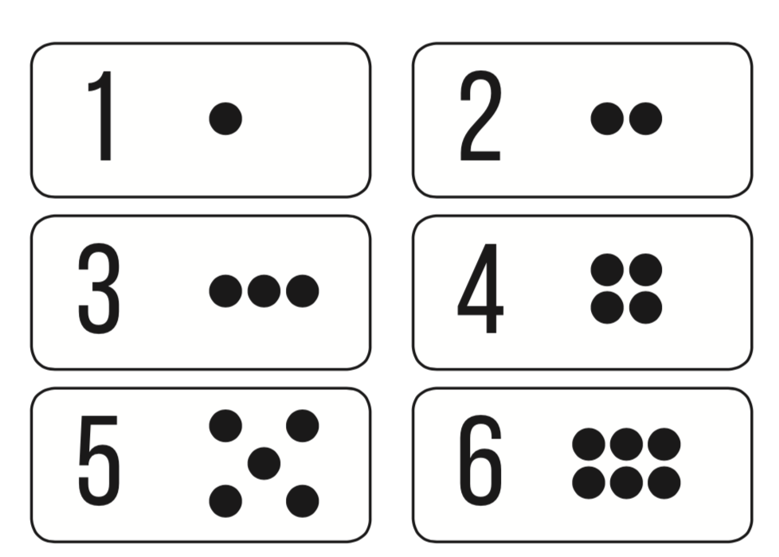
1-6 spinner
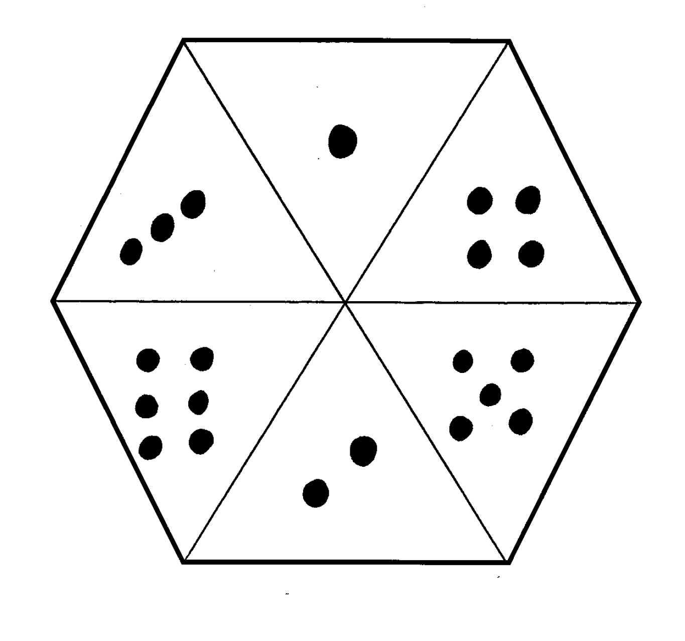

1-10 spinner
