Student workbook thinking mathematically Early Stage 1
Name:
Class:

Overview
For the next 2 weeks, we hope you will be having some fun with mathematics – getting sweaty brains, thinking hard and feeling successful when you solve a problem, develop more confidence or understand something better. You will learn about seeing numbers inside other numbers, for example, you will notice 4 and 2 inside of 6. You’ll learn strategies for estimating and working out how many things are in a collection and you’ll learn how to notice and describe patterns.
Most of these tasks have a video and some have downloadable resources to support your learning. You can find these using the digital student resource link on the Learning from home, K-6 support – mathematics page.

Day 1
Today we have 1 task. We will the opportunity to deepen our understanding of patterns, exploring growing and shrinking patterns.
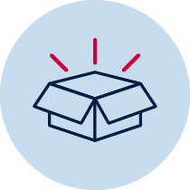 Resources – device to view videos, colour pencils/ markers,

Counting sounds 1
View Counting sounds 1 video

Staircase pattern
View video Staircase pattern K and S1 – Part 1

Draw the staircase pattern we’ve made in the video, continuing it down the other side.
View video Staircase pattern K – part 2 and be ready mathematicians, to notice some ideas and help with some counting.

How many blocks are there altogether? Draw a picture to record the thinking you did to work out the solution.
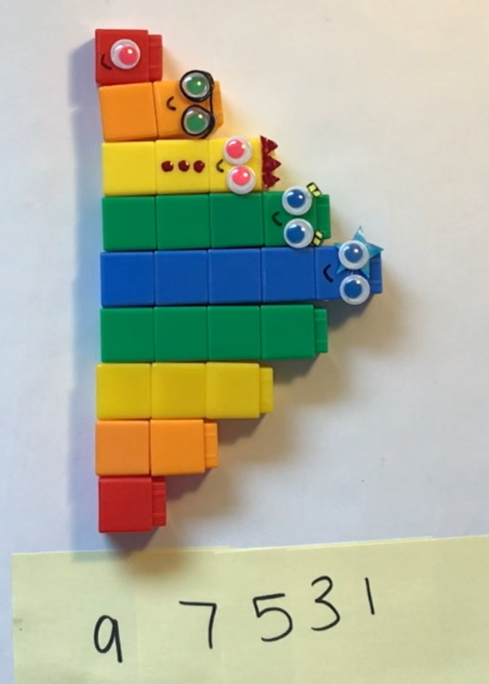

You may like to view the episode of Numberblocks step squad

Reflection
Talk about what you have discovered and learnt about today with someone at home.

Day 2
Today we have 3 tasks. We are going to explore different ways of thinking about numbers to help us better understand how numbers work. We will look at using a pan balance to investigate mass. We are also going to have a closer look at growing and shrinking patterns.
Resources – device to view videos, colour pencils/ markers, collection of objects like blocks or unfix cubes

Introducing rekenreks
View video Introducing rekenreks
Mum gave us some baby carrots for a snack. There were 8 in total. Some carrots were on my brother's plate and some carrots were on my plate.
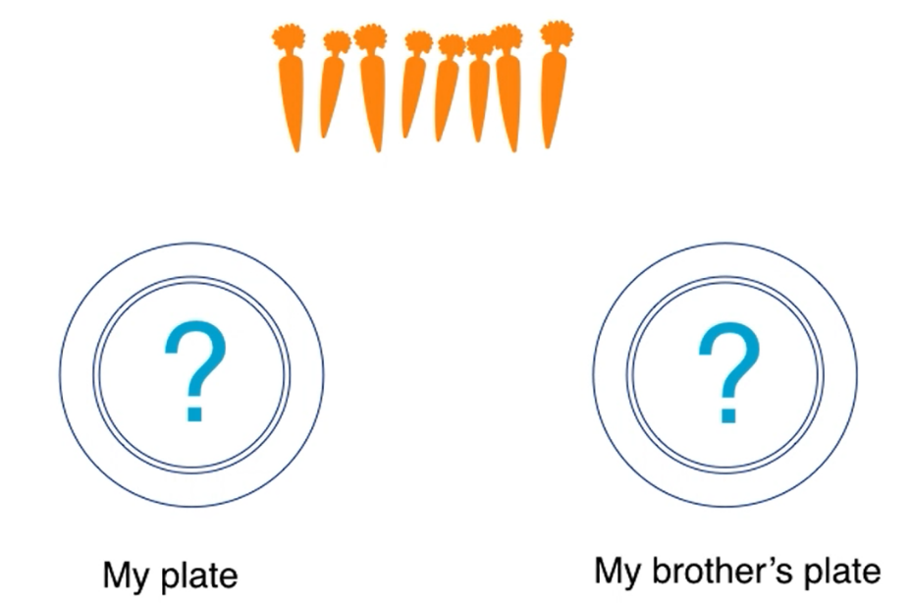
Use a rekenrek to solve the problem then draw pictures to record your thinking, for example:
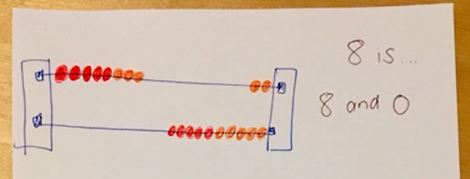
How many carrots were on my plate?
How many carrots were on my brother’s plate?
Show as many solutions as you can.

Balancing numbers 1
(Inspired by the work of Dan Meyer)
View video Balancing numbers 1 – part 1
What do you notice?

What do you wonder?

View video Balancing numbers 1 – part 2
How many more bears are needed to make the scale balance?
(How many bears are equivalent in mass to The Hulk?)
What’s an estimate that’s way too high?

What’s an estimate that’s way too low?

What’s an estimate that you think is reasonable?

View video Balancing numbers 1 – part 3
Create a drawing to represent the problem: How many bears are equivalent in mass to The Hulk?

Staircase pattern follow up
View Staircase patterns K – part 2 follow up
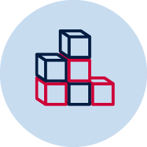Use objects, like blocks to create 2 new growing patterns and 2 new shrinking patterns.
Draw and describe them.

Reflection
Share your drawings that you created as a mathematician. Talk to a family member or friend about the information you have shared in your mathematical drawings.

Day 3
Today we have 3 tasks. With the help of an adult we are going to create our own rekenrek! The Hulk is back and we will estimate and investigate mass using a pan balance. We will also play a new version of Handfuls!
Resources – device to view videos, glue (wood glue or hot glue), 4 pegs, 10 red beads and 10 blue beads (or 10 of any 2 colours you like), 2 paddle pop sticks, 2 kebab sticks, 4 wall plugs, collection of items like bears LEGO mini figs or a similar alternative for example toy cars. You also need an adult.

Make a rekenrek
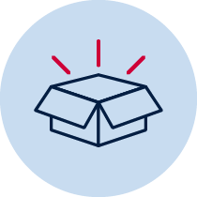With an adult collect:
- glue (wood or hot glue)
- 4 pegs
- 10 red beads and 10 blue beads (or 10 of any 2 colours you like)
- 2 paddle pop sticks
- 2 kebab sticks
- 4 wall plugs
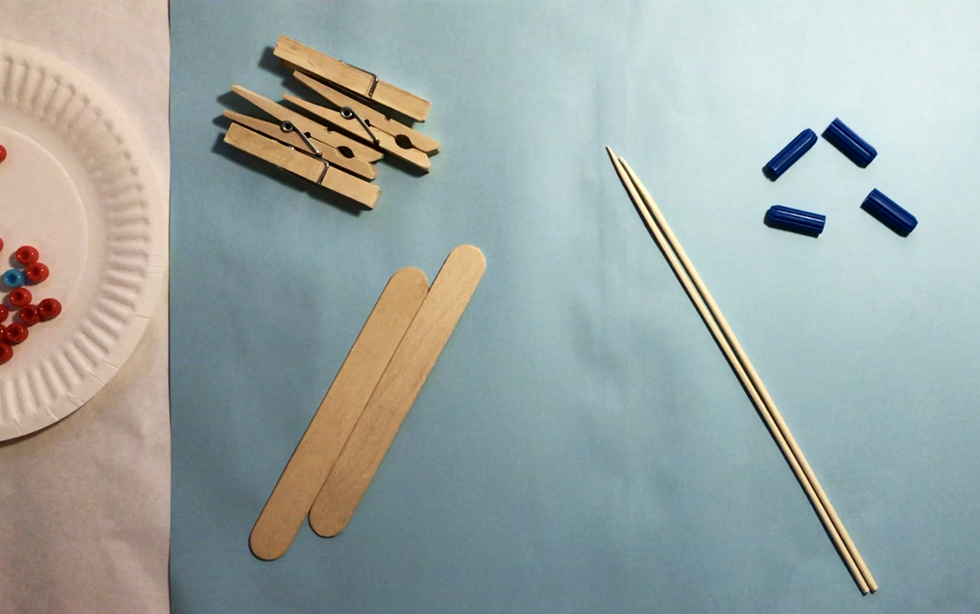
View video How to make a rekenrek with an adult and together make your own rekenrek.

Balancing numbers 2
View video Balancing numbers 2 – part 1
What’s an estimate that’s way too high?

What’s an estimate that’s way too low?

What’s a reasonable estimate?

View video Balancing numbers 2– part 2
What would you do to solve this problem? Share your thinking with a fellow mathematician or write down your ideas.

Revise your estimate: how many paddle pop sticks are needed to balance the mass of The Hulk?

View video Balancing numbers 2– part 3
What do you think will happen to the balance scale?
Draw a picture to communicate your thinking.

View video Balancing numbers 2– part 4
What can we say about the mass of The Hulk, the collection of bears and the collection of paddle pop sticks?

Handfuls: thinking multiplicatively
View video Handfuls: thinking multiplicatively
Play handfuls - thinking multiplicatively using groups of twos (with LEGO mini figs) and with fours (with bears).
Record your thinking about your last handful.

Reflection
What’s something you feel more confident with today?

Day 4
Today we have 3 tasks. We will use our rekenrek to imagine and explore numbers within numbers and other important number relationships. We will also make our own tangram!
Resources –device to view videos, pencil, your rekenrek, set of numeral cards 0-20, colour pencils/ markers, counters for tokens (you could you use dried pasta), 1 square sheet of paper, pair of scissors

Rekenrek 1
View video Rekenreks 1, make sure you are ready to use your mathematical imagination and you have the rekenrek you made.
Draw pictures to show how you can make 9, 6 and 13 in just 1 or 2 slides. Think of two different ways for each number. For example:
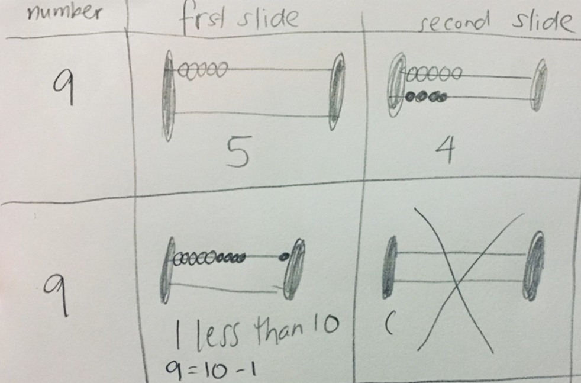
Draw your two different ways for each number.

Rekenrek duel: level 1
View video Rekenrek duel: level 1.
Collect your resources, your rekenrek, a set of numeral cards 0-20, colour pencils/ markers and play Rekenrek duel: level 1!
Record your games.

Make a tangram
View video How to make a tangram
With an adult collect:
- pair of scissors
- 1 square sheet of paper (View video on how to make a square)
View video How to make a tangram with an adult and together make your own tangram.

Reflection
You might have had a sweaty brain today whilst playing Rekenrek duel: level 2. Your brain might also have felt excited! Draw a picture to show what your brain was thinking as you tried to move the beads in just 1 or 2 slides.

Day 5
Today we have 3 tasks. We will use our tangram pieces to complete puzzles, learn a new game where we think multiplicatively and explore doubles and near-doubles on our rekenreks.
Resources – device to view videos, pencil, your rekenrek, 10-frame cards cut up,

Rekenreks noticing doubles and near doubles
View video Rekenreks 2
Collect the resources to play Rekenreks noticing doubles and near doubles.
Record your game.

Tangram puzzles
Using all the pieces of your Tangram, try creating these formations!
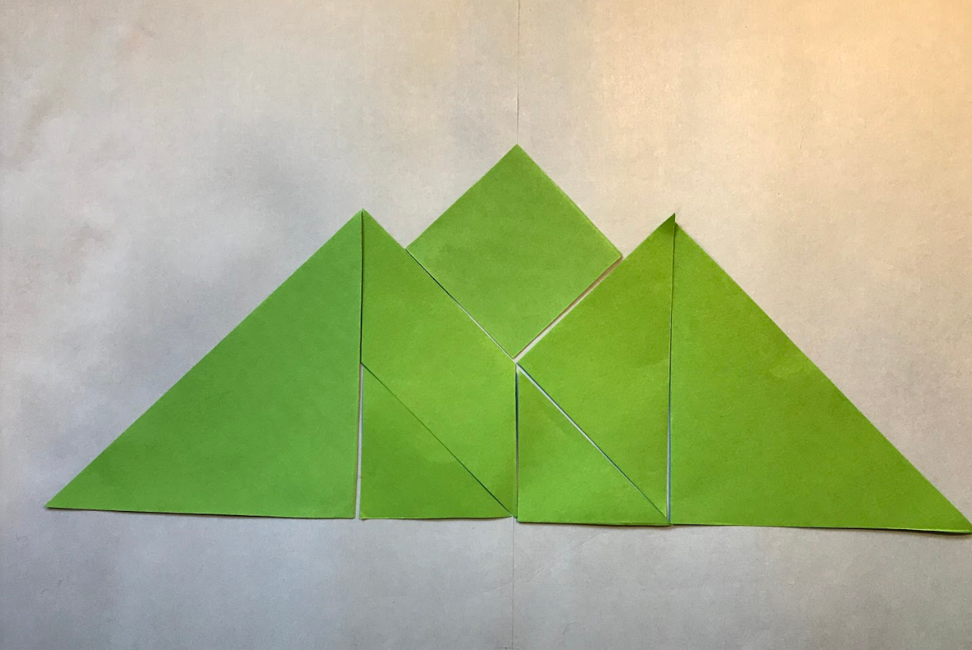 a mountain
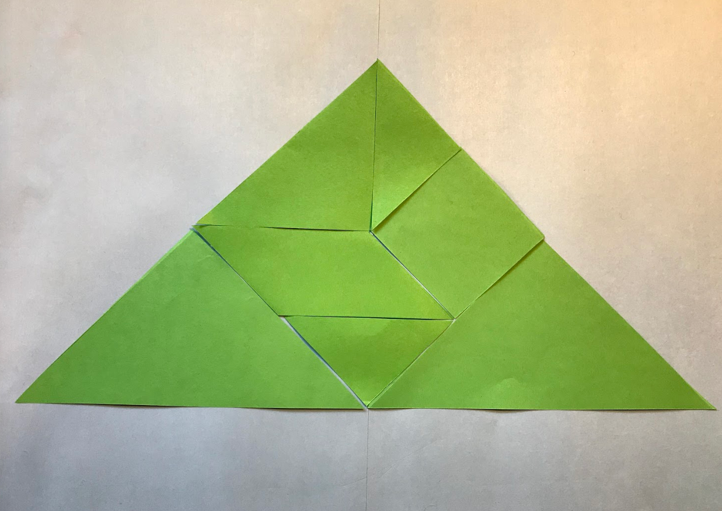 a big triangle
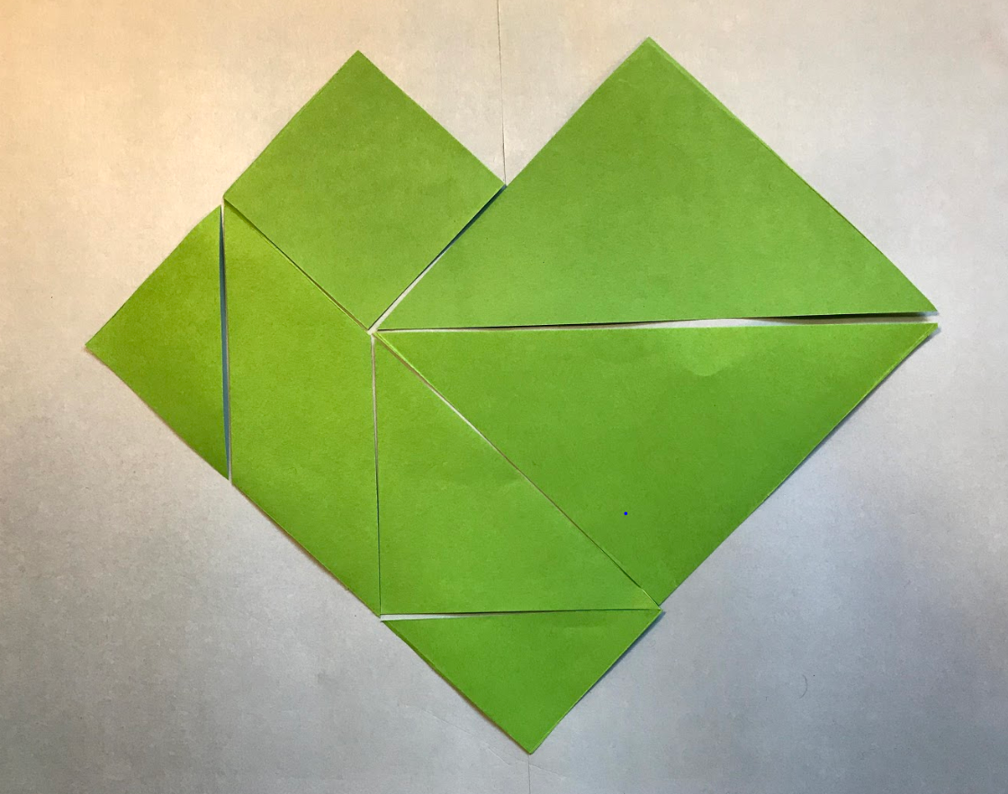 heart
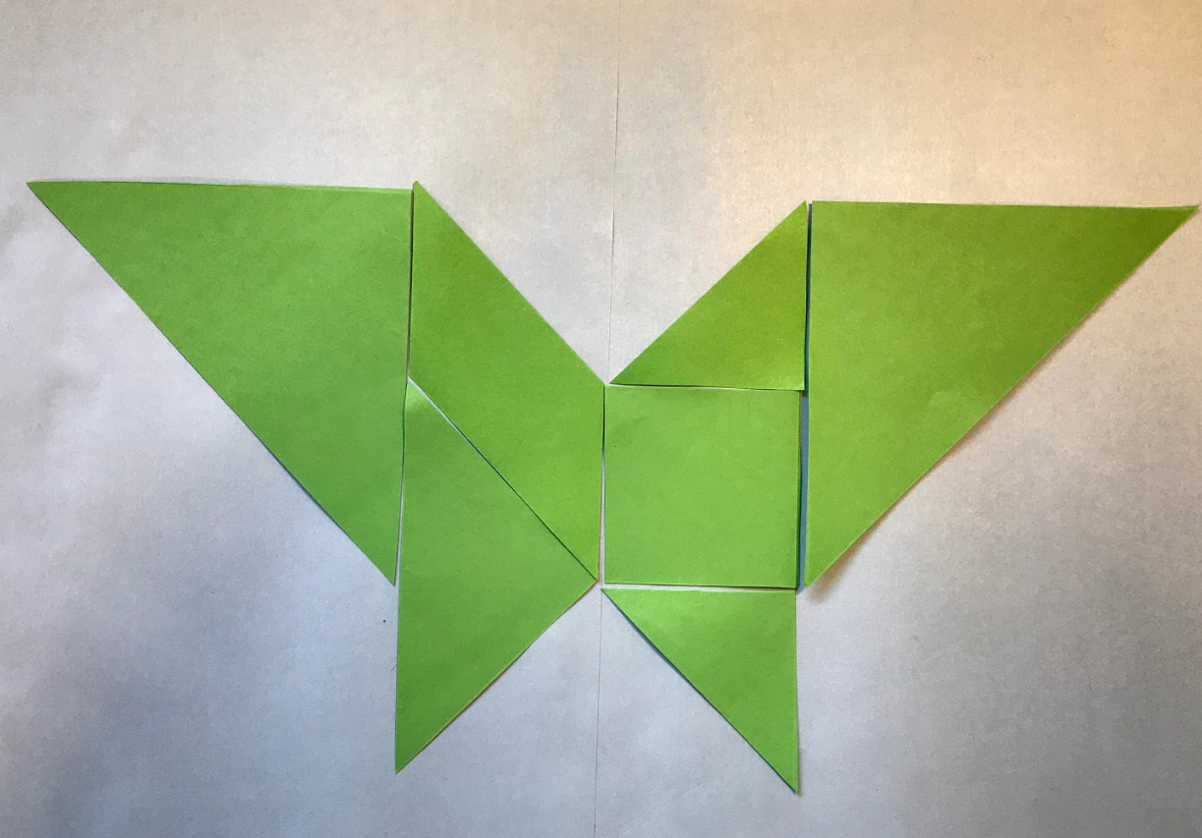a butterfly
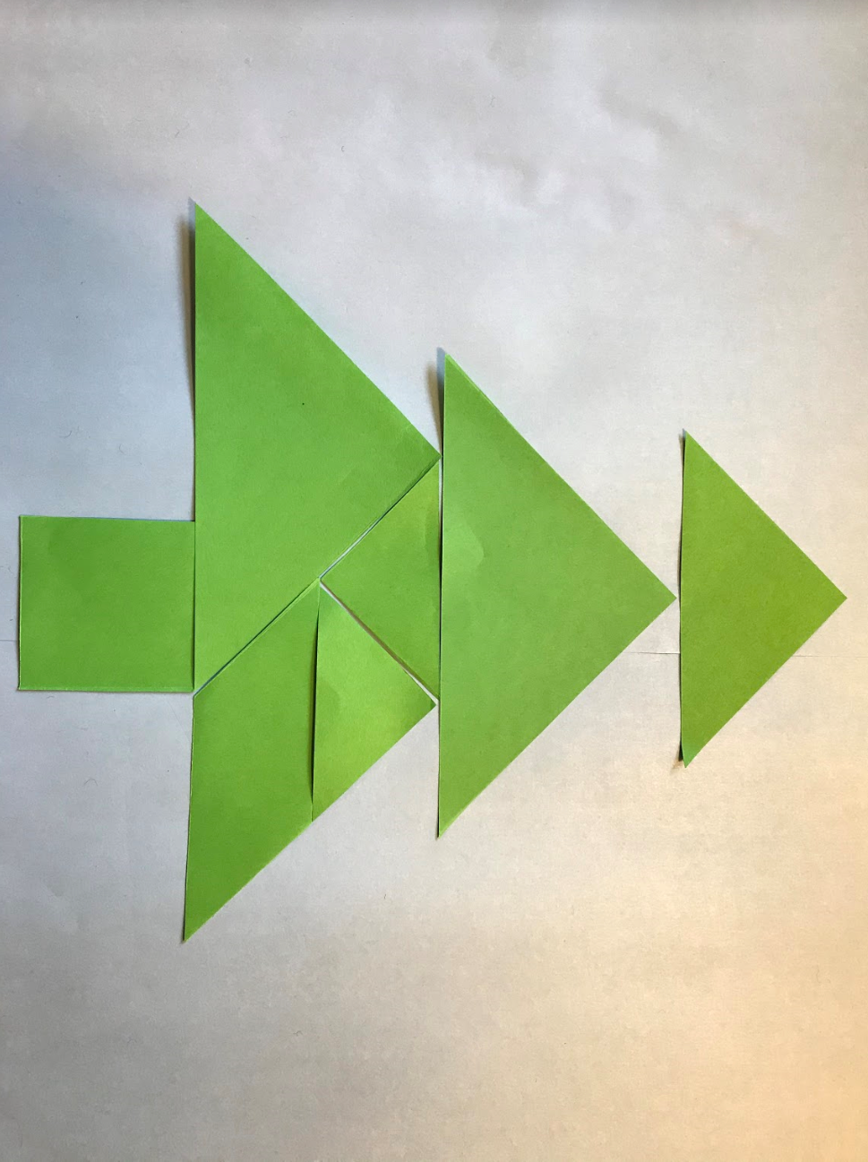a tree

Reflection
List 2 things about your learning made you feel good today?

Day 6
Today we have 2 tasks. We will estimate and investigate mass using a pan balance and we will play handfuls.
Resources – device to view videos, colour pencils/ markers, counters (or lima beans or dried pasta)

Handfuls
View video Handfuls
How to play
- Take a handful of counters (or lima beans or pasta).
- Hold the objects in your hand and imagine how many you have.
- Record your estimate.
- Describe what that collection might look like by visualising and imagining.
- Organise your collection so that someone can determine how many items there are by looking and thinking.
Record your thinking about your games.

Balancing numbers 3
(Inspired by the work of Dan Meyer and Graham Fletcher)
View video Balancing numbers 3 – part 1
How many trapeziums (red shapes) are needed to balance the hexagons (yellow shapes)?
Write an estimate that’s way too high.
Write an estimate that’s way too low.
Write an estimate that’s reasonable.

View video Balancing numbers 3 – part 2
How many triangles are needed to cover the area of 3 hexagons?
Michelle thinks she will need 6 trapeziums to cover the area of the 3 hexagons.
What do you think?
Draw a picture to share your thinking.

View video Balancing numbers 3 – part 3
How many triangles are needed to cover the area of 3 hexagons?
If you like, build the model then draw a picture to share your thinking.

Reflection
Draw a picture of 1 or 2 things that made your brain think hard today (that made your brain get sweaty).

Day 7
Today we have 2 tasks. Today these tasks will help us see that as mathematicians, we get to be in charge of the numbers. We will see some different ways to solve the same problem. We will also play a game called ‘Power dot pro’! Have fun learning and thinking today!
Resources – device to view videos, colour pencils or markers, Tiny polka dots cards

Let’s talk 3 – part 1
View video Let’s talk 3 – part 1 and get your fingers ready to show your thinking.

Tiny polka dots- power dot pro
View video Power dot pro video
Play Tiny polka dots- power dot pro

Reflection
Draw a picture of 1 or 2 things that made your brain think hard today (that made your brain get sweaty).

Day 8
Today we have 2 tasks. We will further investigate how we can use numbers flexibly like our mathematical pirate and pony did yesterday when they visualised dots moving from one ten-frame to another. We will also do some number busting.
Resources – device to view videos, colour pencils/markers, a number of the same items (for example, pasta pieces, counters, pencils or LEGO)

Let’s talk 3 – part 2
View video Let’s talk 3 – part 2

Number busting
View video Number busting
How to play
- Choose a number such as 6 or 9.
- Get the amount of items for that number. (for example pasta pieces, counters or pencils)
- Organise your items.
- Describe your collection.
- What other ways you can organise your items?
- Describe your other ways.
- You may like to use a mathematical structure such as a ten-frame to help you.

Share your thinking.

Reflection
Imagine yourself feeling good about mathematics. Draw a picture to show what you‘re doing when you feel good about mathematics.

Day 9
Today we have 2 tasks. We will play Rekenrek duel: level 1. We will also talk work on our conceptual subitising as we Splat!
Resources – device to view videos, colour pencils/ markers, your rekenrek, set of numeral cards 0-20, colour pencils/ markers, counters for tokens (you could you use dried pasta)

Splat!
View video Splat!
(Adapted from Steve Wyborney)
View video Splat! Make sure you have your subitising eyes ready to look for chunks that you recognise instantly so you don’t have to count!
Draw how many dots you think you saw and how you saw them?

Rekenrek duel: level 1
View video Rekenrek duel: level 1.
Collect your resources, your rekenrek, a set of numeral cards 0-20, colour pencils/ markers and play Rekenrek duel: level 1!
Record your games.

Reflection
What advice would you give someone who is joining you tomorrow for Splat?

Day 10
Today we have 1 task. We will play a new game that helps look for combinations of ten!
Resources – device to view videos, colour pencils

3 tens in a row
View video 3 tens in a row
Play 3 tens in a row.
How to play
- Draw a 3x3 grid as a game board (like noughts and crosses game board).
- Players take turns to roll the dice and write the number in one of their boxes.
- The goal is to be able to write two numbers in each box that combine to make 10.
- Players continue taking turns until a player has been the first to make 3 tens in a row.

Reflection
What are some tips you would give to a player trying to win 3 tens in a row?

