Thinking mathematically 2 Mathematics workbook Early Stage 1
Name:
Class:

Overview
For the next 2 weeks, we hope you will be having some fun with mathematics – getting sweaty brains, thinking hard and feeling successful when you solve a problem, develop more confidence or understand something better. You will learn about seeing numbers inside other numbers, for example, you will notice 4 and 2 inside of 6. You’ll learn strategies for estimating and working out how many things are in a collection and you’ll learn how to notice and describe patterns.
Most of these tasks have a video and some have downloadable resources to support your learning. You can find these using the digital student resource link on the Learning from home, Teaching and learning resources, K-6 resources page.

Day 1
Today we have 4 tasks. There is also a game you can play at the end if you would like to play! Today we are going to explore different ways of thinking about numbers and explore different features (attributes) we can use to organise items.
Resources – device to view videos, a collection of items (about 20 things) that can be sorted in different ways, a pencil, paper, and some things you can pinch a hold of, like dried beans.

Sorting
Visit Sorting page and view the video
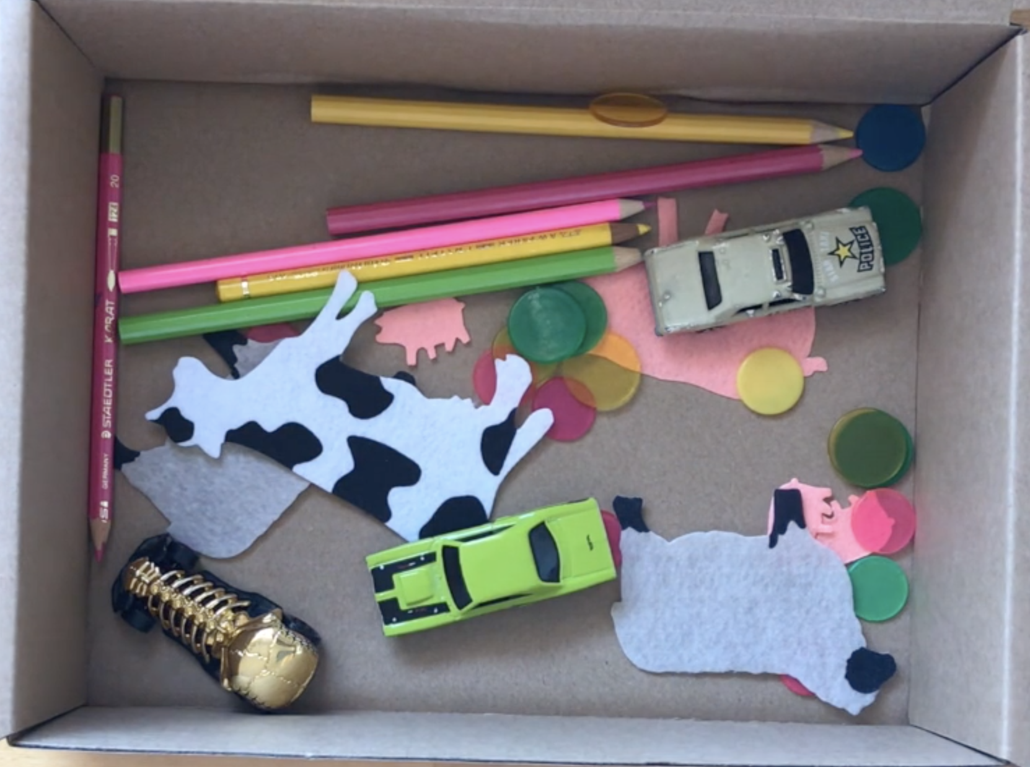

Draw pictures of the different ways you organised your own collection of items or the collection of items in the video.

Subitising dice patterns (1-6)
View video on Subitising dice patterns – 1-6 page

Ducks Away
Watch the reading of ‘Ducks Away’ by Mem Fox available on ABC iview or read the book if you have it.

Ducks Away – follow up
View the video on ‘Ducks Away follow-up’ page.

Optional: Play ‘Pinch a Ten’
View the video on ‘Pinch a Ten’ page to learn how to play the game. You could play on your own or with someone at home.

Reflection
Talk about what you have discovered and learnt today with someone at home.

Day 2
Today we have 4 tasks. These tasks are designed to help us understand numbers and think about different strategies we can use to answer the question: “How many?”
Resources – device to view videos, a collection of items (about 20 things) that can be sorted in different ways, a pencil, paper, another collection of items (about 10 things) like dried pasta or blocks and 3 sets of numeral cards showing 1-6 (we show you how to make these in the video).

Sorting – Part 2
Visit the ‘Sorting Part 2’ page and watch the video. Make sure you’ve watched Sorting 1 (Day 1) before working on this task.
Find different ways you can sort your own collection of things.

Draw pictures of the different ways you could sort your collection of items. Ask someone to help you label them.

Dice Patterns A (1-4)
View video on Dice Patterns A (1-4) page. Be ready to watch, listen, imagine, draw and write.
We have left you lots of space for your thinking here...

Subitising – match my collection
View video on ‘Subitising - match my collection’ page. Have your collection of 10 things, like dried pasta or blocks, ready.

Play ‘Dotty 6’
View video on Dotty 6 page. Have your 3 sets of numeral cards showing 1-6 (we show you how to make these in the video), ready to go.

Use the space provided to draw your game board and record one of your games.

Reflection
If you played Dotty Six again tomorrow, what’s one thing that you would do differently to help you win? Why?

Day 3
Today we have 4 tasks. We are going to enhance our skills in counting with understanding as well as continue our learning about different kinds of patterns.
Resources – device to view videos, paper, pencils, a collection of about 30 things you can use to make patterns, and the ‘matching cards’ (you can print from the PDF provided or copy and make your own).

Counting with understanding - 12
Visit Counting with understanding – up to 100 and watch the video. Be ready to help count the items.

Patterning 1
View video on Patterning 1 page and have your collection of 30 things to make some repeating patterns.
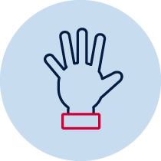 Using your collection of items, try making some repeating patterns of your own where some of the parts are missing or have someone make some patterns for you. Can you figure out what parts are missing using the strategy of looking for the repeating core?

Use the space provided to draw a repeating pattern. Take turns drawing a pattern then having another person continue it. Challenge each other by drawing some with missing parts. Can you work out which parts are missing?

Dice Patterns B (5 and 6)
View video on ‘Dice Patterns B (5 and 6)’ site and be ready to watch, listen, imagine, draw and write.
Use this space to record your thinking.

Play ‘memory’ using the matching cards. What are all the pairs you found?

Play ‘Dotty 6’
‘Play Dotty 6’ again. View the video again if you need to. Have your 3 sets of numeral cards showing 1-6 ready to go.

Use the space provided to draw your game board and record one of your games.

Reflection
Did your strategy for winning Dotty 6 work? Did you discover more today?

Day 4
Today we have 4 tasks to help us develop our number sense. We will be using our mathematical imaginations before we read one of our favourite books!
Resources – device to view videos, paper, pencils, a collection of about 30 things you can use to make patterns.

About how many rectangles?
View video on ‘Math imagination warm up 1 - about how many rectangles?’
About how many of the smaller orange rectangles are needed to fill the area of the large dark blue rectangle?

Draw a picture to share your thinking.

Patterning 2
View video on Patterning 2 page and have your collection of 30 things to make some repeating patterns.
Using your collection of items from around your home, try making as many AB patterns as you can.

Use the space provided to draw your patterns.

Patterning 3
Think about what you now know about patterns. Discuss with someone at home – ‘What is a pattern?’
View video – ‘Patterning 3’
Have a look at the patterns you made in ‘Patterning 2’. Can you make some more AB patterns where you are changing things like the shape, size, position or quantity?
Use the space provided to draw your patterns.

Day 5
Today we have 4 tasks. We are going to explore different ways of thinking about numbers which helps us discover and understand different ideas about numbers. We will also have fun with some playing with pirates!

Resources –device to view videos, paper, pencil, your drawing from ‘About how many rectangles?’ on Day 4, some counters or blocks and a dice (1-6)

About how many rectangles? Part 2
View video – ‘About how many rectangles (part 2)’ and have ready your drawing from ‘About how many rectangles?’ on Day 4.
Discuss with someone at home what you discovered about how many orange rectangles are needed to cover the larger blue rectangle. Did you notice similar things?

Counting with understanding – up to 20
View video – ‘Counting with understanding -up to 20’ and be ready to estimate and work out how many items there are.

Investigating ten-frames
View video – ‘Investigating ten-frames’ and be ready to notice some things about ten-frames.
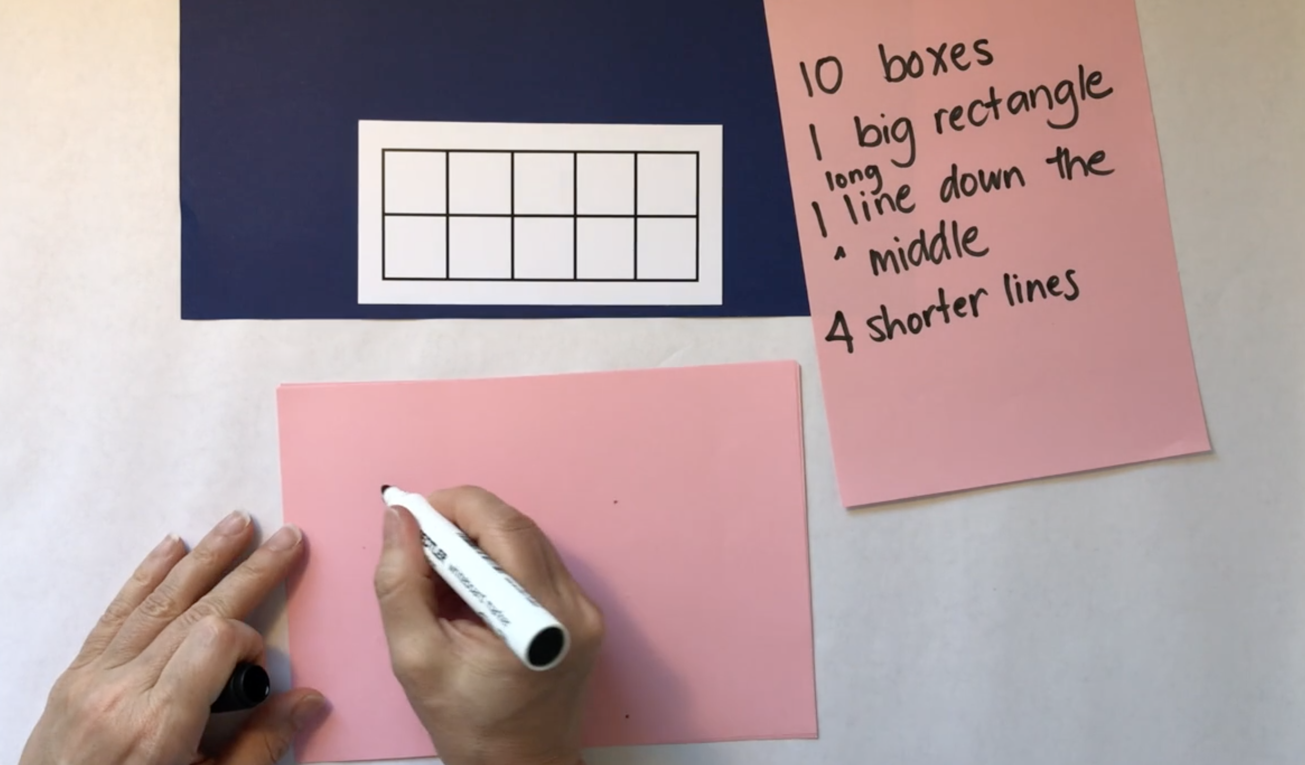

Use the space provided to have a go at drawing your own ten-frames.

Use the space provided to draw 6 on a ten-frame in as many ways as you can imagine.

Ten or bust
View video on ’10 or bust’. Be ready to play the game by having some counters, a dice, and a game board such as a number line, a ten-frame or a drawing of 10 fingers.
Play ’10 or bust’ with someone at home or you could call a friend or family member and ask them to play with you. Always ask permission before you call. Draw your gameboard in the space provided.

Reflection
Draw a picture to show us what you think about in your brain when you are working out the number before.

Day 6
Today we have 3 tasks. These tasks will help us see that as mathematicians, we get to be in charge of the numbers. We will see some different ways to think about strategies and numbers.
Resources – device to view videos, playing cards, 1-10 dot spinner, or a pile of ten-frames or number word cards showing one to ten,

Subitising 5
View video – ‘Subitising 5’. Be ready to follow on, looking and thinking about ‘how many’ you see without having to count.

youcubed - visualisations
View youcubed- visualisations video.
Explore the number visuals and record the different ways you see each number visual made up of other numbers.

Go fish: Relationships
View video – ‘Go Fish: Relationships’ and have some playing cards ready.
Play ‘Go Fish: Relationships’ with someone at home. Have fun trying some of the other game versions suggested in the video. Race to write
Visit the ‘Race to write’ page and play the game with someone at home.
If you don’t have a printer, use the space provided to write your numbers.

Day 7
Today we have 3 tasks. We are going to spend some more time investigating numbers before it’s time for a maths investigation!

Resources – device to view videos, paper, pencils, scissors

Subitising – more/less/same
View video – ‘Subitising – more, less, same’ and be ready to work out what quantities are more, less or the same.

MathXplosion
Watch this episode of MathXplosion
View video on MathXplosion: 7 feet follow-up and have a go at making your own foot as a unit of measurement.
Are you 7 feet tall?

Can you find some things that are more than your 7 feet tall? Write and draw your findings in the space provided.

Can you find somethings less than your 7 feet tall? Write and draw your findings in the space provided.

Reflection
What advice would you give someone who wants to accurately measure the length of something? When would using your feet not be a good unit of measurement?

Day 8
Today we have 4 tasks. We will investigate numbers and shapes where it will be time to get creative and crafty!
Resources – device to view the videos, colour pencils, paper, blocks or paperclips

6 is…
View video – ‘6 is…
Have some blocks (of the same size e.g. LEGO) so you can join in making your own combinations of 6.
What are all the different ways we can make 6? Investigate by using blocks or by drawing the blocks using coloured pencils. How many ways can you make 6…
- with just 1 colour?
- with 2 different colours?
- with 3 different colours?
Use the space provided to record your ideas.

Stampoline Numberblocks
View episode of ‘Numberblocks – Stampolines’ and the Numberblocks - Stampolines follow up video
What are all the different shapes Six could make playing Stampolines? See if you can come up with at least 5 different (and new) ways and draw in the space provided.

Subitising 6 – one less than
View video – ‘Subitising 6 – one less than’. Be ready to use your imagination to work out one less than how many you see.

Reflection
Do you think there are different ways of making all numbers? Discuss with someone at home.

Day 9
Today we have 2 tasks. We are going to use our mathematical imaginations to measure items before we go on a hunt around our home to find examples of ‘for each’. You’ll get to make a new counting book to read to someone today!
Resources – device to view the videos, pencil or pen, your ‘counting book’

About how many paper clips? - 1
View video – About how many paper clips? 1
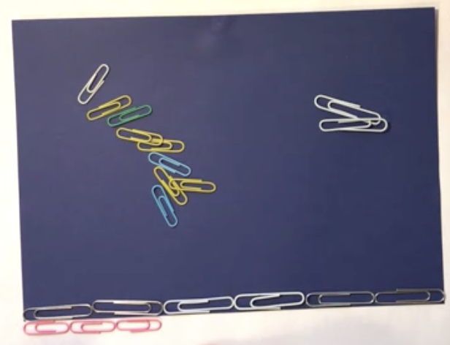

Use the space provided to draw your estimation of how many small paper clips it will take to measure the length of the paper.

About how many paper clips? - 2
View video – ‘About how many paper clips? – 2’. Have your drawing ready.
Did you notice the same things?

Numberblocks – The Zero Song
View video - ‘Numberblocks - The Zero Song’.
Have a go at making your own version of ‘The Zero Song’. You could ask someone at home to help you record it.

Reflection
How does drawing and making help you understand mathematical ideas?

