Mystery graph

Question 1
  - This graph was created by a Year 2 class. What is it about?

  - What information is displayed? How do you know?

  - What else could this graph be about?
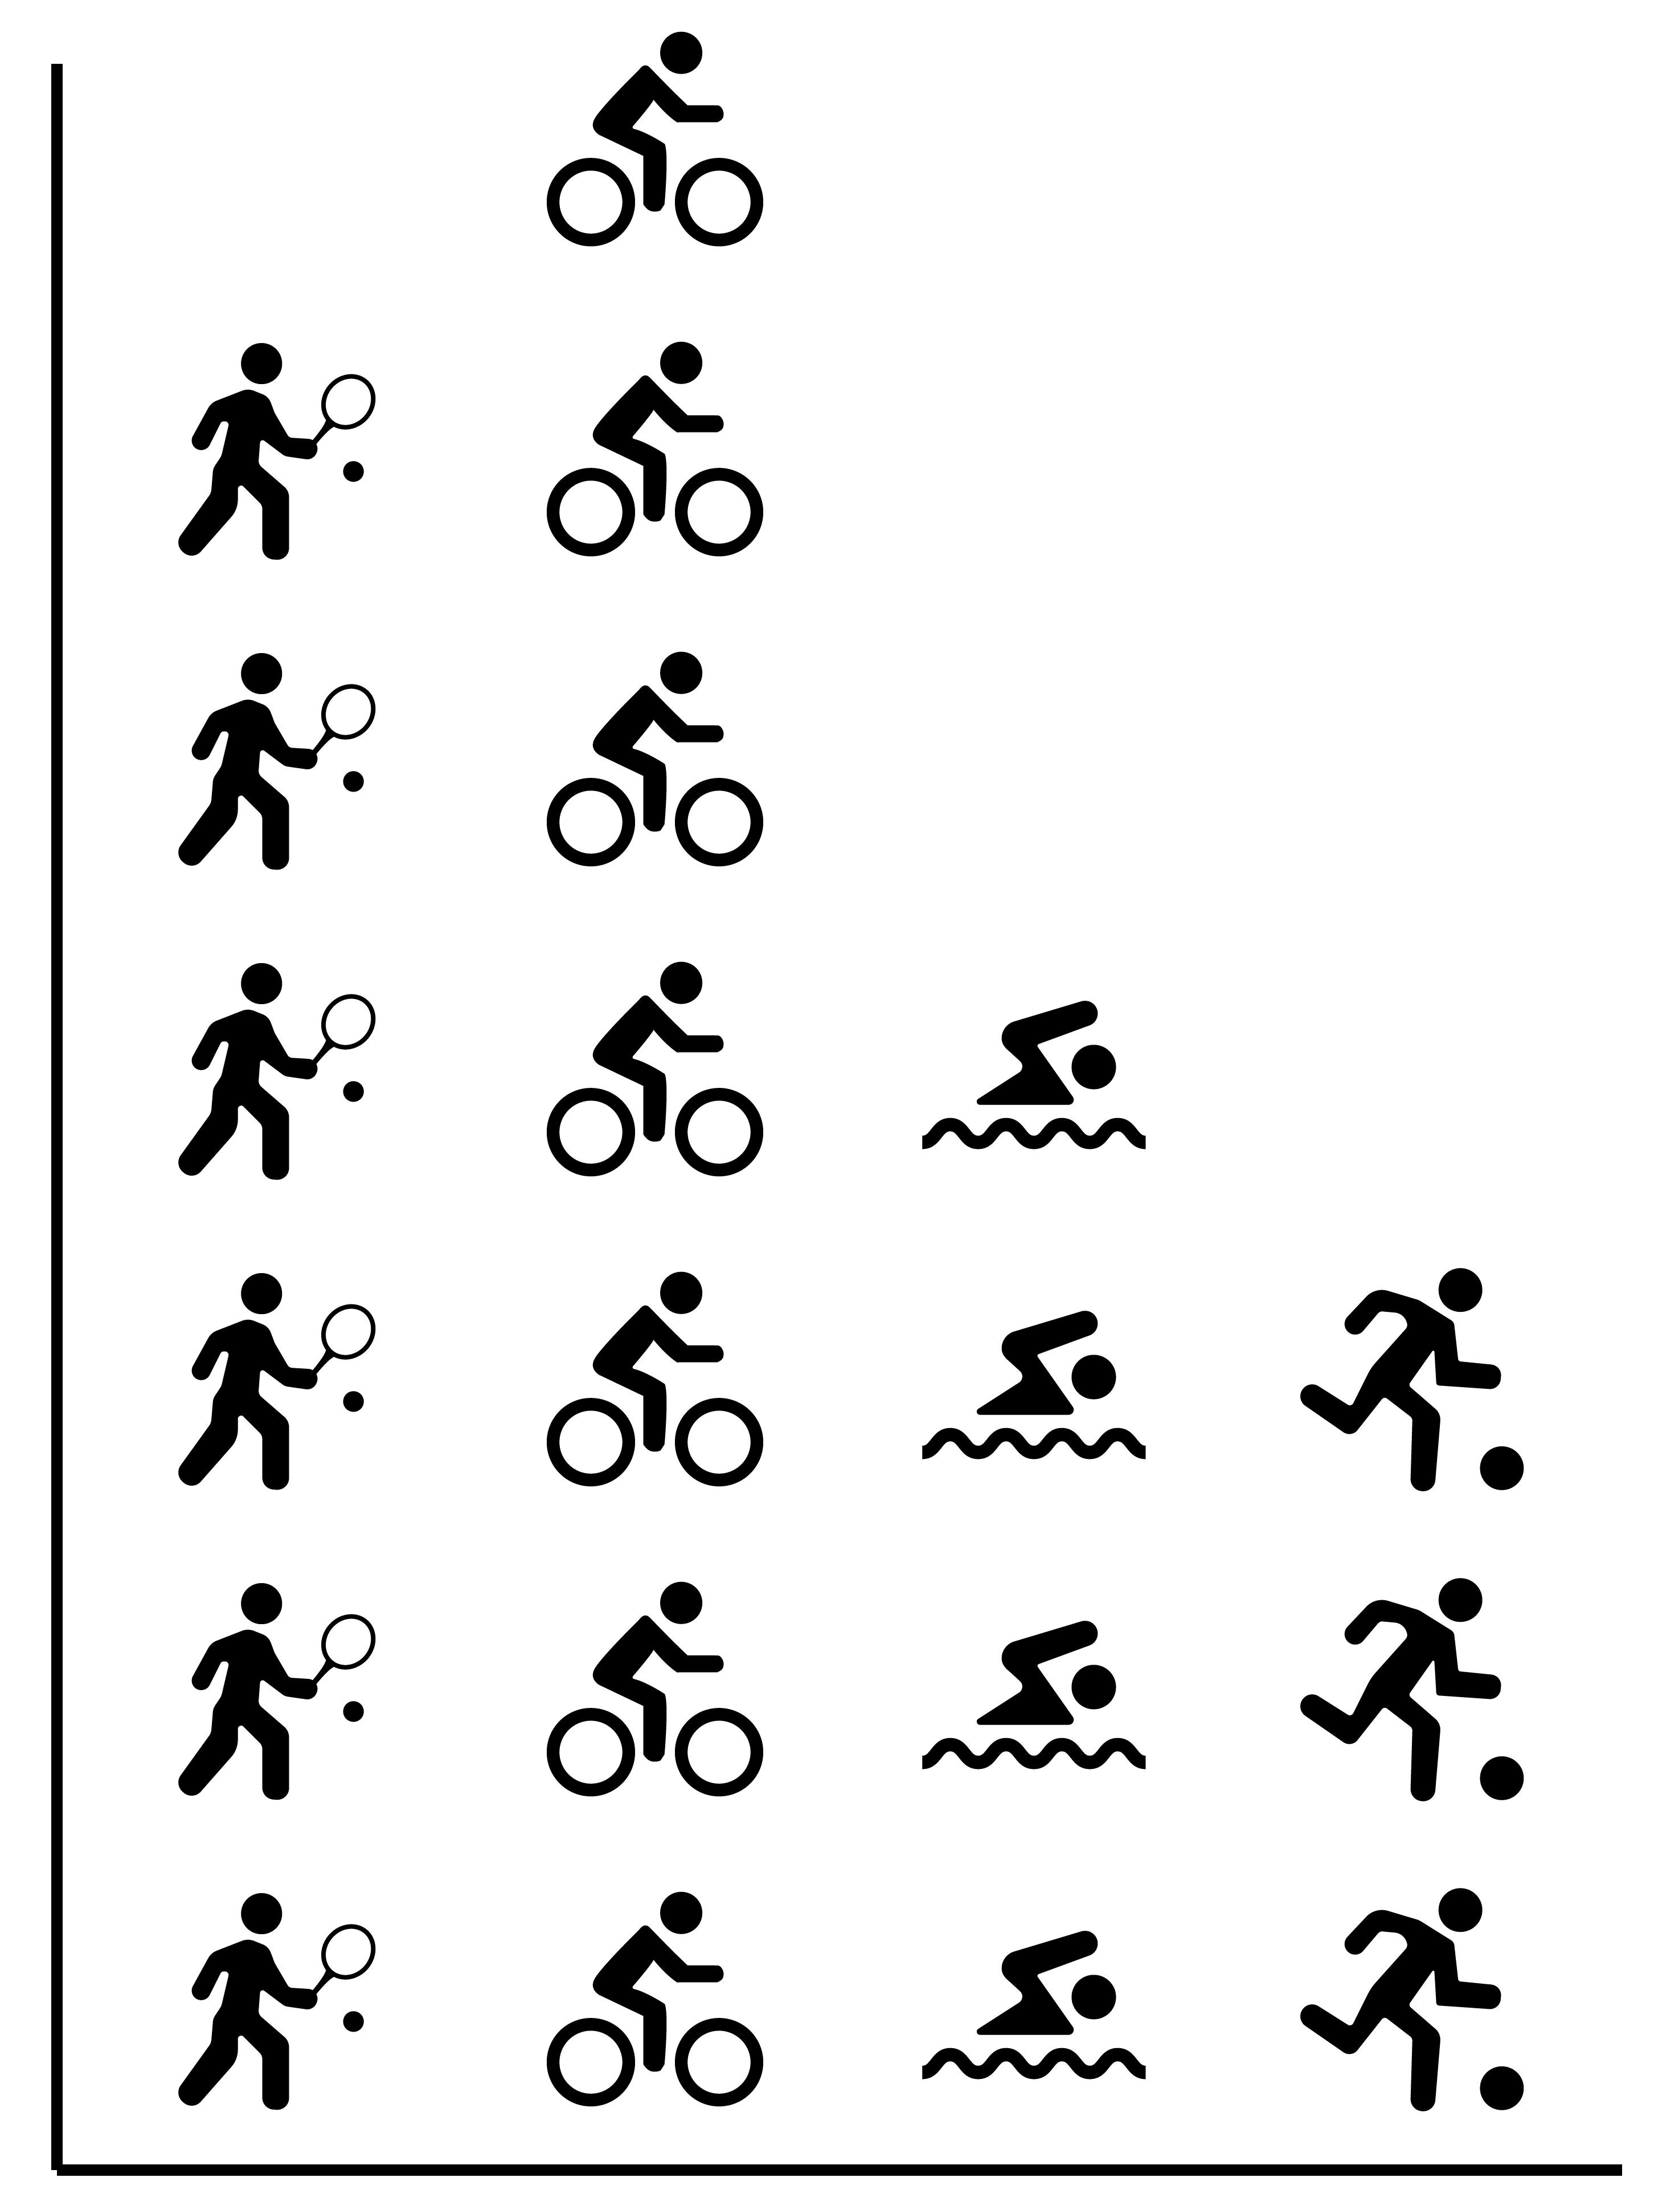

  - Why would a class use these symbols?
  - How many children could be in this class? How do you know this?
  - What would be a good title for this graph?
  - Label the parts of the graph.
  - How could you show that each symbol indicates more than one student?

