Highly likely

Question 1
Pick an event card from the pile and read what it says. Is it something that ‘might happen’, ‘will happen’ or ‘won’t happen’? Place the event card with the correct chance card.
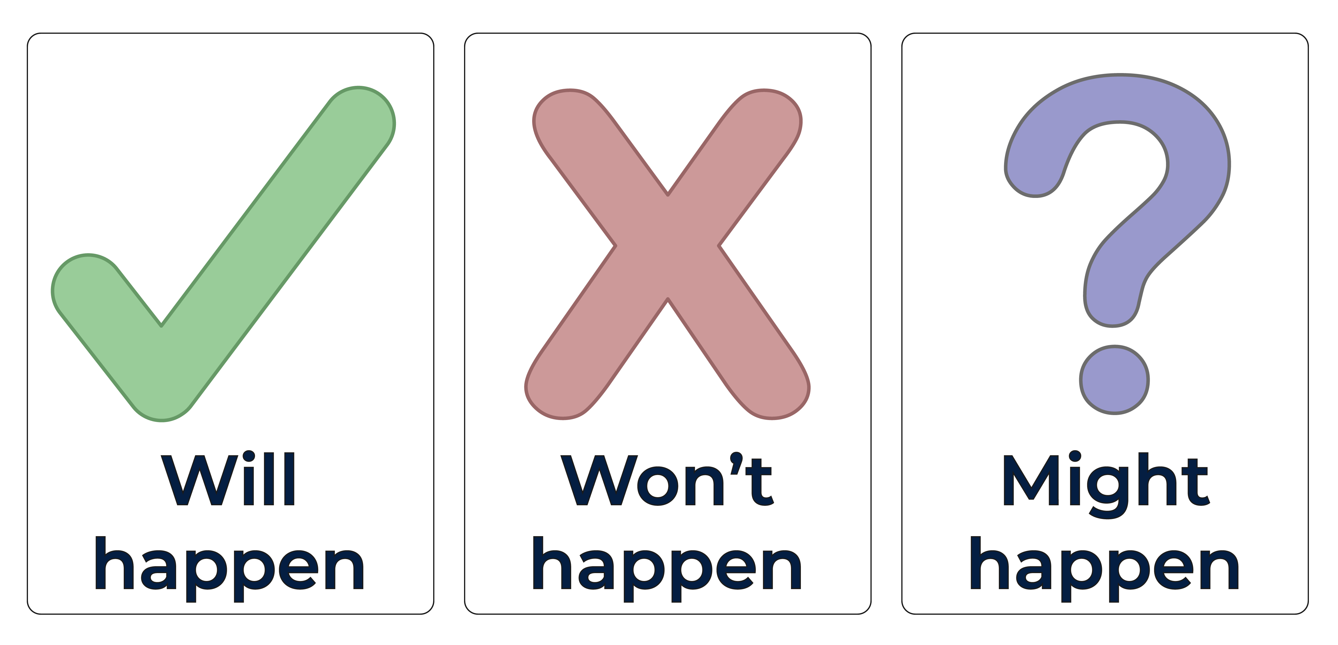

Resource - event cards
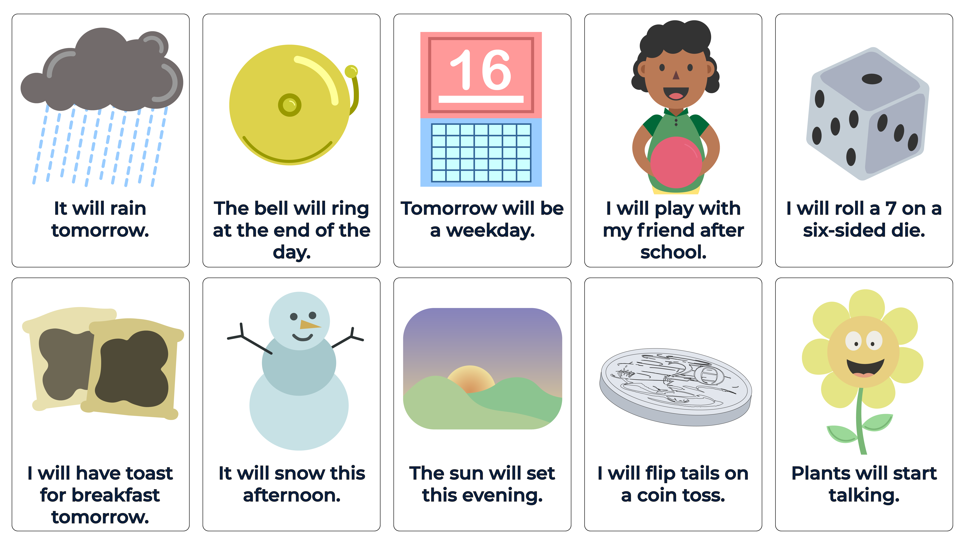

Resource - event cards
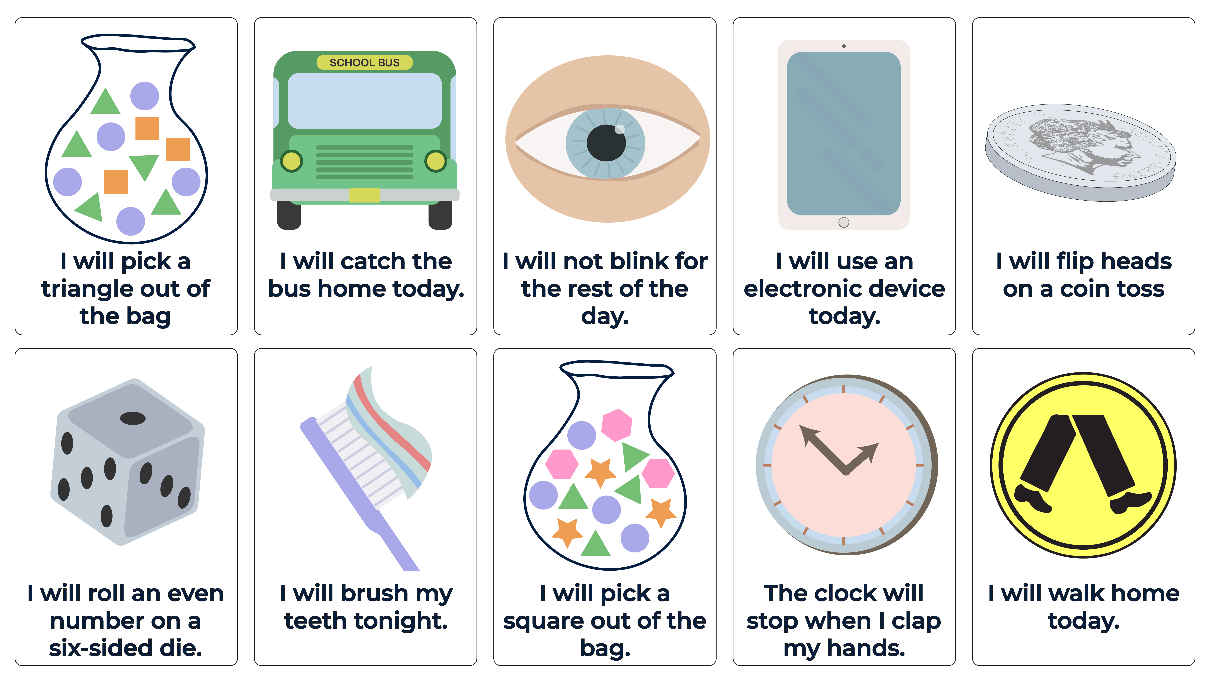

Resource – response cards (extension)

