Balance it

Question 1
Look at the picture, "I wonder which side you think is heavier and which one is lighter?"
  - Draw items on the scale to show what you mean.
  - Label each side ‘lighter’ and ‘heavier’ to match your picture.
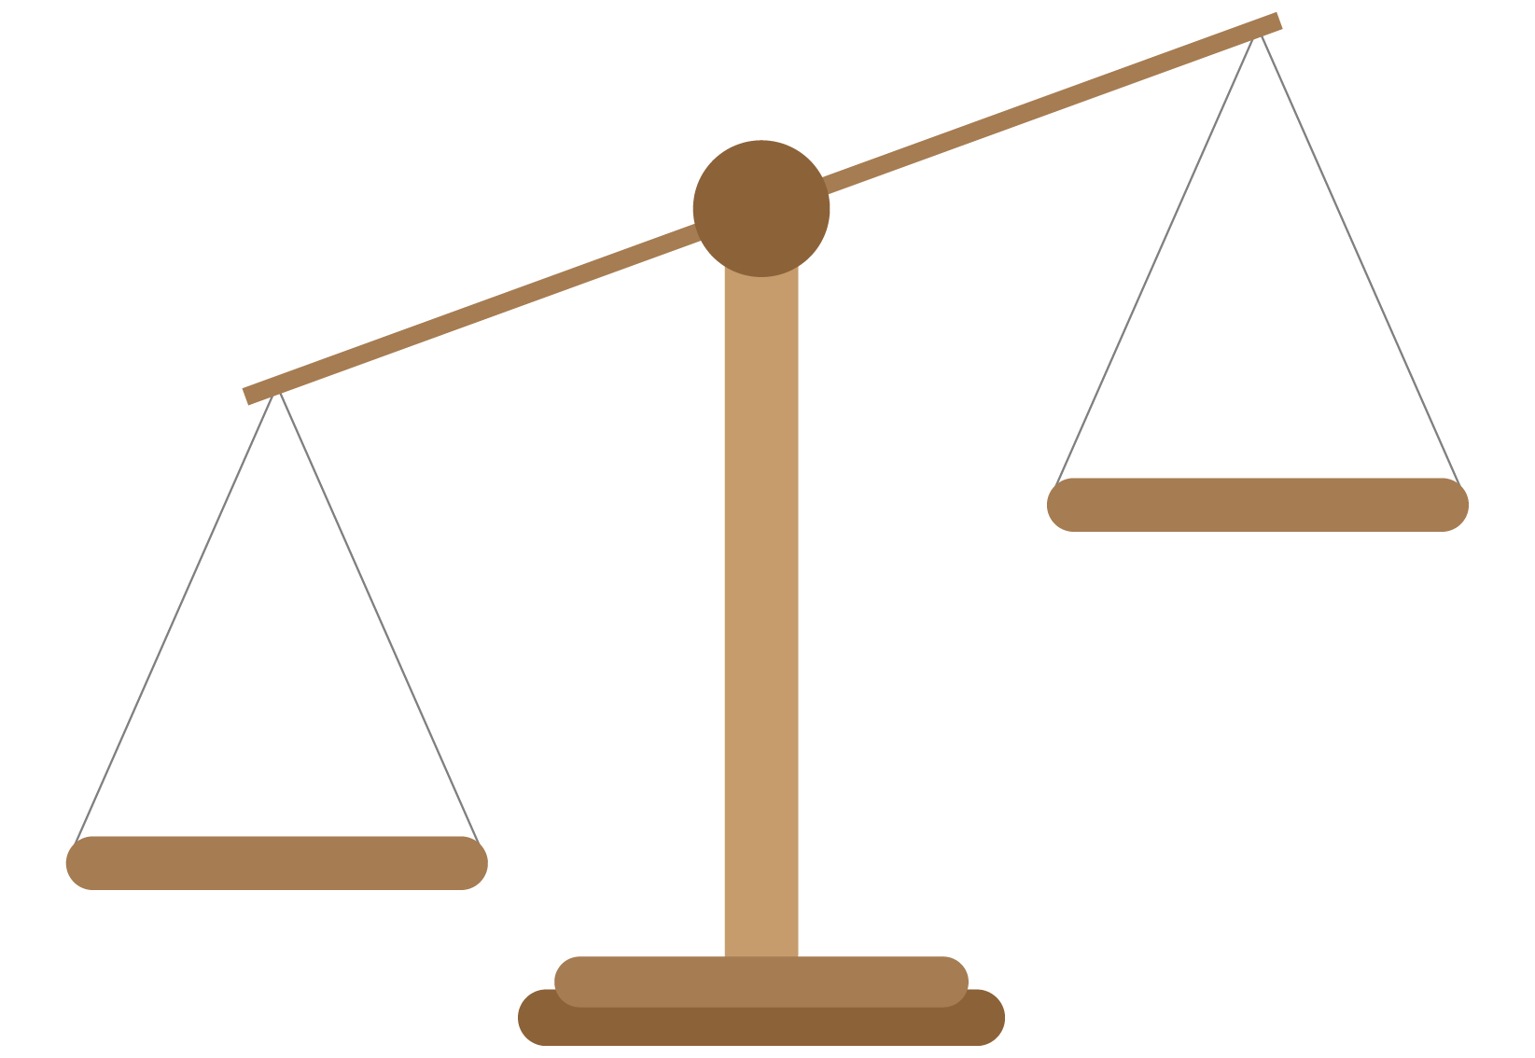

Question 2
Use a pan balance to find two collections of items that have the same mass.
  - Draw what is displayed on your pan balance.
  - Describe your pan balance, for example record amounts of items in the collections.

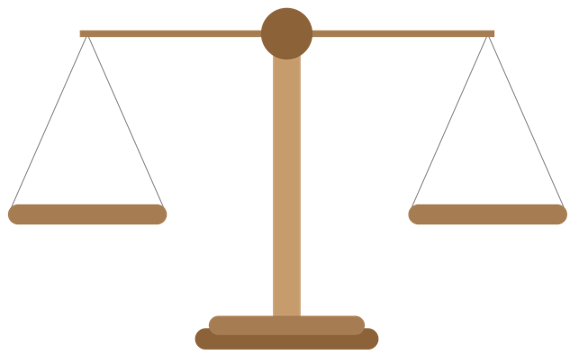

Question 3
Choose an item to measure.
  - How many of the same informal units does it take to balance this in the pan balance?
  - Draw what it looks like and write your findings.

=

Question 4
Choose another item to measure using the same informal units.
  - Estimate how many units it will take to balance this item in the pan balance. Record your estimate.
  - Investigate how many of the same informal units it takes to balance this item in the pan balance?
  - Draw what it looks like and record your findings.
  - What is the difference in mass between the two items you measured?

I estimate that it will take |  | to balance the pan balance.
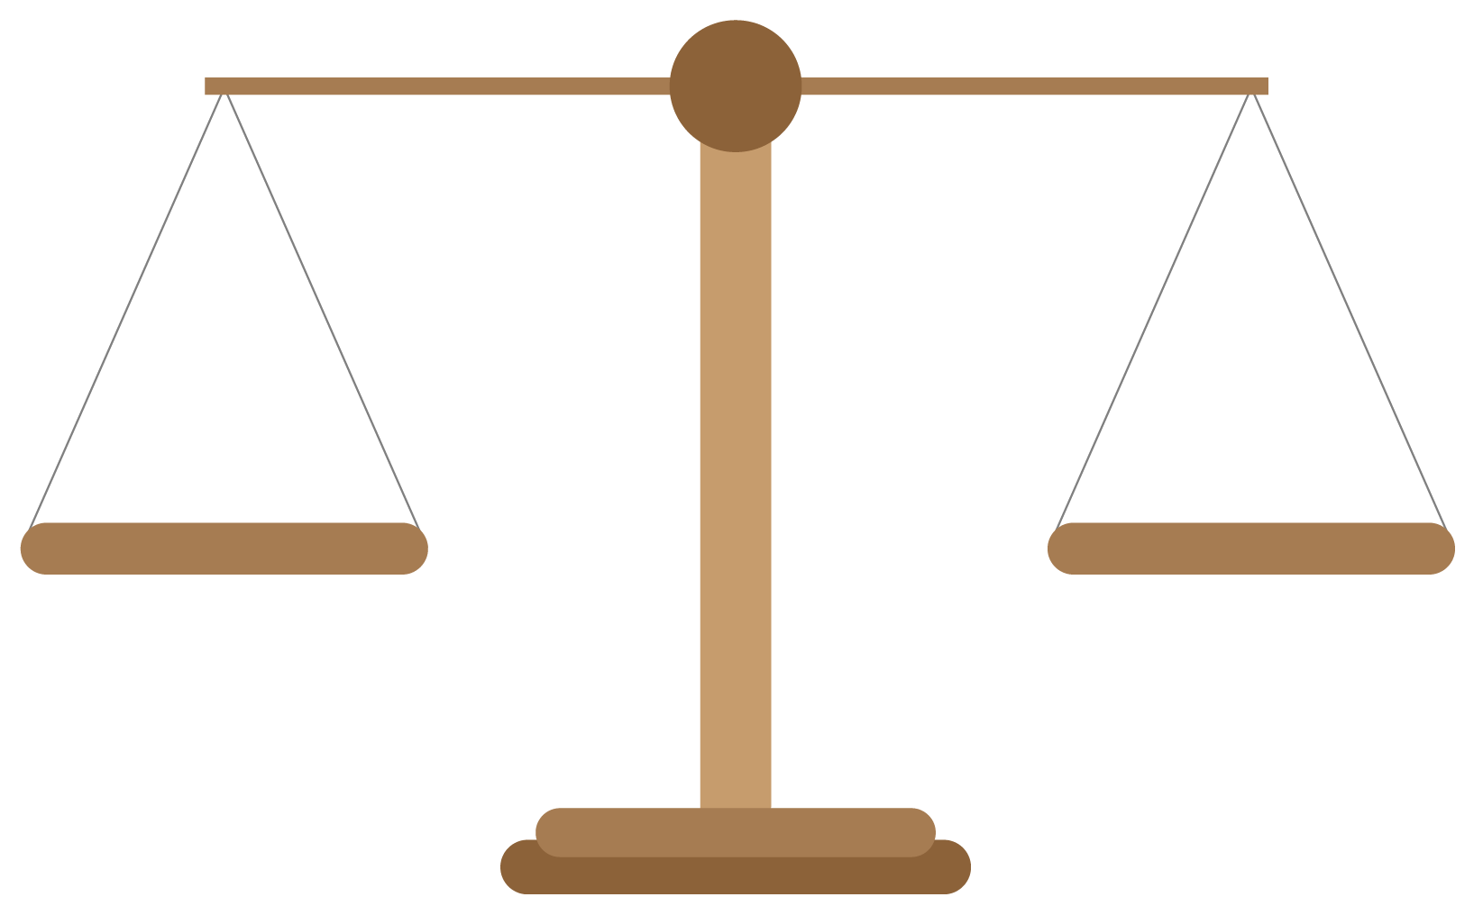
=

The difference in mass between the two objects is

