Footprints in the sand
All of the tasks and activities in this resource have been adapted from the ReSolve website at https://www.resolve.edu.au. reSolve: Maths by Inquiry is an innovative national program that promotes relevant and engaging mathematics teaching and learning from Foundation to Year 10. It is a collaboration of the Australian Academy of Science and the Australian Association of Mathematics Teachers.

The problem
Some people were playing on the beach leaving interesting patterns made from footprints in the sand. The patterns went as far as we could see.
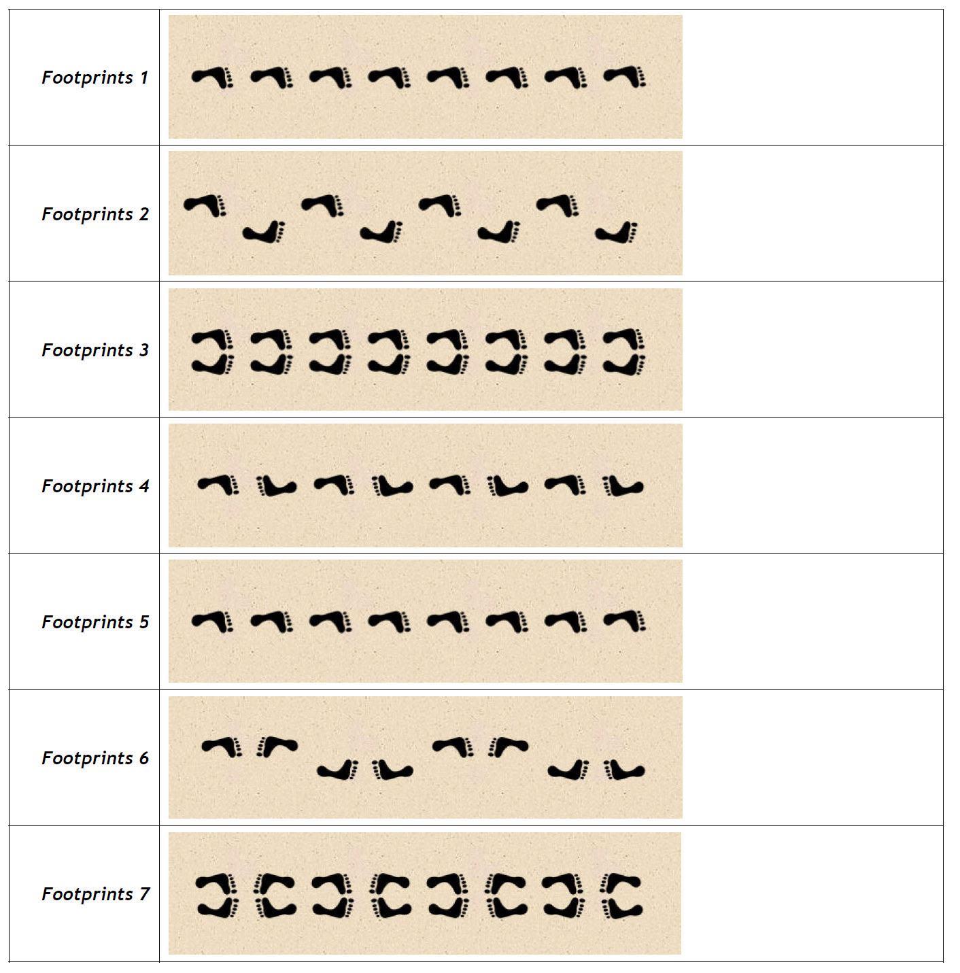
Source: ReSolve: Maths by inquiry - https://www.resolve.edu.au/transformations-frieze-patterns

Task 1
- How do you think they made these footprint patterns? Can you recreate these by performing the movements (maybe in a sandpit)
- Alter your descriptions from question 1 to use the terms ‘translations’, ‘rotations’ and ‘reflections’.
- Translation – sliding a shape without turning it or flipping it
- Rotation – a turn
- Reflection – flipping either horizontally or vertically

Task 2
What forms of symmetry can you find in each footprint pattern? Place the number of lines of symmetry and order of rotational symmetry in the table below.
- Rotational symmetry – when you can turn the object and it still looks the same
- Line symmetry – when you can fold the object in half and both sides are the same

 | Line symmetry | Rotational symmetry
Footprints 1
Footprints 2
Footprints 3
Footprints 4
Footprints 5
Footprints 6
Footprints 7

Outcomes
- MA4-1WM communicates and connects mathematical ideas using appropriate terminology, diagrams and symbols
- MA4-2WM applies appropriate mathematical techniques to solve problems
- MA4-3WM recognises and explains mathematical relationships using reasoning
- MA4-17MG classifies, describes and uses the properties of triangles and quadrilaterals, and determines congruent triangles to find unknown side lengths and angles
All outcomes referred to in this unit come from Mathematics K-10 Syllabus © NSW Education Standards Authority (NESA) for and on behalf of the Crown in right of the State of New South Wales, 2012

