Cutting congruent halves
Two shapes are congruent if one can be moved so that it fits exactly on top of the other shape.

Your investigation
There are 13 different ways to cut a 3 x 3 square array into two congruent halves by cutting along a polygonal path with vertices located on the grid. Two examples are given. Try to find the rest. Remember, don't count paths in different locations that give the same shaped halves.
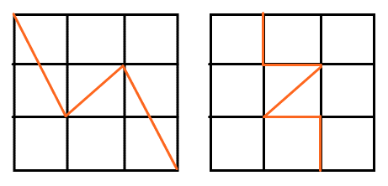

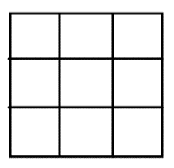

Outcomes
- MA4-1WM communicates and connects mathematical ideas using appropriate terminology, diagrams and symbols
- MA4-2WM applies appropriate mathematical techniques to solve problems
- MA4-3WM recognises and explains mathematical relationships using reasoning
- MA4-17MG classifies, describes and uses the properties of triangles and quadrilaterals, and determines congruent triangles to find unknown side lengths and angles
All outcomes referred to in this unit come from Mathematics K-10 Syllabus © NSW Education Standards Authority (NESA) for and on behalf of the Crown in right of the State of New South Wales, 2012

