Understanding place value
This demonstration and subsequent student worksheet use visuals to develop and support students learning of place value and decimals.
Thousands | Hundreds | Tens | Ones or  Units | . | Tenths | Hundredths | Thousandths
 | 1 | 2 | 1 | . | 2 | 5
 | 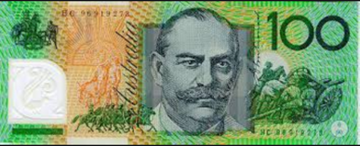 | 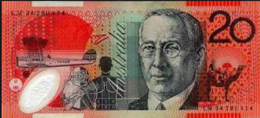 | 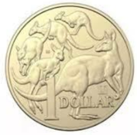 | . | 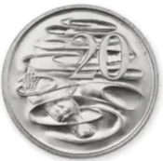 | 