Understanding place value with money
Write the value of the money in the right place value columns and answer the questions for each question.
See teacher example to help you complete the worksheet.

Write the value of the money in the right place value columns and answer the questions for each question.

See teacher example to help you complete the worksheet.

Hundreds | Tens | Ones/  Units | . | Tenths | Hundredths
 |  |  | .
 |  | 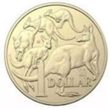 | . | 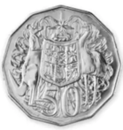 | 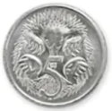

- What is the total money?
- Write the value in words
- What is the value of whole dollars ($)?
- What is the value of cents (c)?

Hundreds | Tens | Ones/  Units | . | Tenths | Hundredths
 |  |  | .
 | 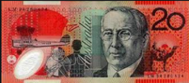 | 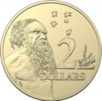 | . | 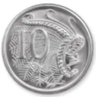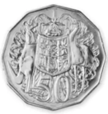

- What is the total money?
- Write the value in words
- What is the value of whole dollars ($)?
- What is the value of cents (c)?

Hundreds | Tens | Ones/  Units | . | Tenths | Hundredths
 |  |  | .
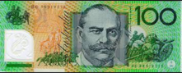 |  | 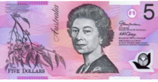 | . | 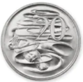 | 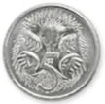

- What is the total money?
- Write the value in words
- What is the value of whole dollars ($)?
- What is the value of cents (c)?
Hundreds | Tens | Ones/  Units | . | Tenths | Hundredths
 |  |  | .
 | 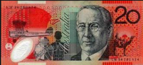 | 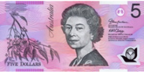  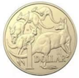 | . | 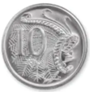

- What is the total money?
- Write the value in words
- What is the value of whole dollars ($)?
- What is the value of cents (c)?
Fill in the correct place value for the following

William has $5.00

Hundreds | Tens | Ones/  Units | . | Tenths | Hundredths
 |  |  | .

Tracey has $25.75

Hundreds | Tens | Ones/  Units | . | Tenths | Hundredths
 |  |  | .

Aaron has $115.95

Hundreds | Tens | Ones/  Units | . | Tenths | Hundredths
 |  |  | .

Josh has $275.05

Hundreds | Tens | Ones/  Units | . | Tenths | Hundredths
 |  |  | .

Tracey has $25.75

Hundreds | Tens | Ones/  Units | . | Tenths | Hundredths
 |  |  | .

