Currency converter
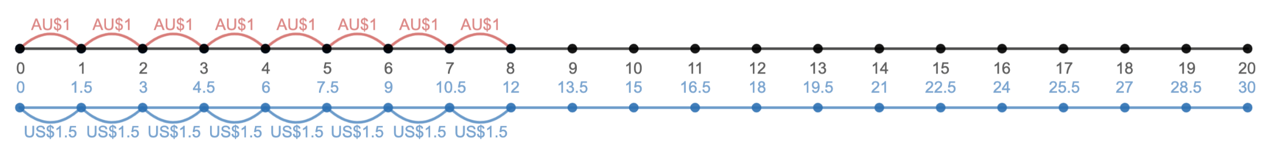Using the currency conversion tool on the computer answer the following questions:
Fill in the graph using the currency conversion tool in the web activity:
Australian Dollars ($) | American Dollars ($)
$1.00
$5.00
$7.00
$10.00
$12.00
$20.00

How much am I?
Using the currency conversion tool your task is work out what each item cost in US dollars.
Item | Cost in AU$ | How much will I be expected to pay in US dollars?
 | For my lunch I paid $6 Australian dollars.
 | I want to buy a three pack of Nike Socks from the shops and it will cost me $16 Australian dollars
 | A movie ticket is going to cost me $12
 | For my birthday I want a bucket hat. It is going to cost $10 Australian dollars
 | My iTunes gift card is $20.00 Australian dollars

