Everyday Maths Hub: Years 9 and 10 resources
Themed resources to:
- engage, inform and inspire your child/ student
- spark positive conversations about mathematics in the everyday

Building positive maths mindsets
Having a positive mindset can help improve outcomes and understanding in all aspects of your teen’s learning. Packed with profound lessons, inspiration and real-life stories about resilience, problem solving and perspective, these resources can continue to support a positive mindset towards learning and mathematics:
Grit: The Power Of Passion And Perseverance (6:01) – Leaving a successful career in consulting, Angela Lee Duckworth took a job teaching maths to Year 7. She quickly realised that IQ wasn't the only thing that mattered in supporting students to experience success with mathematics. In this TED Talk, Angela explains her theory of "grit" which might help you talk with your teen about the critical importance of perseverance and resilience when you’re learning.
Mathematics Is The Sense You Never Knew You Had (13:12) – An engaging and insightful talk for TEDxSydney by mathematics teacher Eddie Woo – explores the mathematical realities woven into the fabric of the universe – from lightning bolts to river deltas to blood vessels. Eddie makes the bold statement that we are all born to be mathematicians – Let his joy and passion for learning inspire you and your teen to consider mathematics as a whole new way to see the world.
My Invention That Made Peace With Lions (7:09) – In the community where Richard Turere lives with his family, cattle are vital to their way of life, but lion attacks can put an entire family’s herd and future at risk. In this TED Talk, learn how Richard used maths to invent and design a solar-powered solution that safely scared the lions away and continues to protect his family and their livelihood. Enjoy this story about how maths helped Richard and his community, and illustrate the power of problem solving and grit with your teen.
The Joy Of X: A Guided Tour Of Mathematics, From One To Infinity, written by Steven Strogatz – Have you ever wondered why mathematicians love maths? In each chapter of this book, Strogatz explains why maths is helpful, inspiring and lovable, with clarity and humour. This book can help your teen see the links between maths and literature, philosophy, law, medicine, art, business, even pop culture and current events. Now these are some ideas worth knowing!
Careers In Maths (2:13 to 8:06) Various speakers (developed by AMSI) – We know having a positive mindset can help improve outcomes. Let this resource inspire your teen to achieve a long-term mathematical goal. Discover the mathematics from gene mapping to zoo keeping, dancing, nursing and building… whether you’re protecting forests, fighting fires or dreaming up robots. The AMSI website has over 25 clips that highlight maths and STEM skills in a variety of career pathways.

People who used maths to help them change the world
Mathematical discoveries and achievements have shaped and improved our way of life. From GPS devices to understanding gravity and launching rockets into space - these things wouldn’t be possible if it weren’t for maths! These books will introduce your teen to some of the inspiring people and works that have contributed along the way:
Hidden Figures (Young Readers' Edition), written by Margot Lee Shetterly – Before John Glenn orbited the earth, or Neil Armstrong walked on the moon, four incredible mathematicians at NASA used pencils, slide rules, and adding machines to calculate how to launch a rocket and put astronauts into space. This true story tells the amazing and awe-inspiring tale of how mathematics, and mathematicians, came to the rescue of a very special mission!
The Man Who Loved Only Numbers, written by Paul Hoffman – Introduce your teen to the amazing Paul Erdos, a prolific mathematician and world-wandering numerical nomad. Erdos would show up on the doorstep of one mathematician or another and announce, “My brain is open.” What a guy… and what a mindset! This book shares the story of his curious mind, tenacity for problem solving and the way he helped guide some of the last century’s most startling mathematical discoveries.
Seventeen Equations That Changed The World, written by Ian Stewart and edited by John Davey – From Newton’s Law of Gravity to the Black-Scholes model used by bankers, equations have contributed too many innovations in the modern world. The book explores how Pythagoras' Theorem led to the development of GPS, how logarithms are applied in architecture and why imaginary numbers were important in the development of the digital camera. This book might help your teen wonder… how will maths be used to change the world next?
Infinite Powers, written by Steven Stogartz – Calculus has given us mobile phones, TV, GPS and ultrasound. It’s also helped us unravel DNA, discover Neptune and figure out how to put 5000 songs in your pocket. Neat, huh? Learn the interesting history of calculus and its purpose – Before your teen has the option to study this fascinating branch of mathematics more deeply in Years 11 and 12. This book might help build positive perceptions about the power of mathematics to change the world.
Ada Lovelace cracks the code, written by Rebel Girls, illustrated by Marina Muun and edited by Jestine Ware – Ada Lovelace was the inventor of the first programming language and used her incredible imagination and endless curiosity to dream up technology that jump-started the digital age nearly 200 years ago. Introduce your teen to this remarkable mathematician and let her achievements spark their curiosity.

Puzzling and wondering through maths
Using these five interactive and entertaining resources, you can help your teen discover just how maths is being used around them. From playing with maths in episodes of the Simpsons to a secret strategy to win rock-paper-scissors, your teen will be left wondering, puzzling and maybe even inspired by the impact of maths in everyday life:
Humble Pi: A Comedy Of Maths Errors, written by Matt Parker – So much of our day-to-day lives are underpinned by maths but we rarely notice it until something goes wrong! From bridges that unexpectedly wobble to billions of dollars seeming to disappear overnight... This hilarious book will show your teen how much maths surrounds us, what happens when it goes wrong, and how maths comes to the rescue with an even better solution!
Winning At Rock Paper Scissors (5:47) – Is it possible to win rock-paper-scissors every single time? This video developed by Numberphile and presented by Lily Serna will show your teen that there’s a strategy to increase your chances of winning, using mathematical thinking. Get your teen to test out the strategy, and try it with other games too - just don’t bet the tidying up on it!
The Forgotten Flexagon (12:30) – Did you know you can puzzle with maths to build curiosity, perseverance and spatial reasoning with some very simple supplies? All your teen needs to follow along with this video developed by Numberphile and presented by Matt Parker is a sheet of paper and a pair of scissors. This video demonstrates how to make the ‘forgotten flexagon’ - the tetra-flexagon - and what fun things your teen can do with these intriguing 3D objects.
The Simpsons And Their Mathematical Secrets, written by Simon Singh – If you or your teen are fans of this long-running animated comedy series, this book could be of interest to them. They may have watched hundreds of episodes without realising the maths 'inside jokes' they’ve witnessed along the way. From a brief reference in the background to key plot points or the theme of entire episodes - much like real life - the town of Springfield has maths everywhere.
Supermath: The Power Of Numbers For Good And Evil, written by Anna Weltman – This book showcases maths as a tool used to solve, and prevent, some really big problems. Archaeologists, epidemiologists and families use maths all the time to help overcome challenges. Explore how maths can be used to solve problems and the far-reaching consequences when maths is not used for good!

Unexpected places where you’ll find maths
As your teen starts thinking about careers they’d like to pursue, they may be amazed and surprised at how many professions need mathematical skills. These five resources can offer insights into how central maths is in a variety of careers:
The Maths Behind Basketball's Wildest Moves (11:59) Speaker: Rajiv Maheswaran (developed by TEDTalk) – Did you know professional athletes, like basketball players, use maths all the time to help them improve their performance? It might surprise you, but a deeper analysis of statistics helps Rajiv Maheswaran and his team to investigate movement within basketball games to improve performance. If your teen is keen on sport, they may also find ‘the science of moving dots’ fascinating.
Make Your Career Count: Guitar Making (developed by AMSI) – Your teen might be surprised to learn that maths plays a critical role in the design and building of guitars and many other instruments. This video might help your teen with a passion for music see that many creative professions are not only underpinned by maths, they simply would not exist without it.
The Science Behind The Arts: The Maths Behind Music (3:51) (developed by the University of Surrey UK) – What do guitars, pianos, singers, sound engineers and other musicians all have in common? Apart from their skills in making music, they are all using maths to help them produce sound. This video explains how maths is involved in the production of sound so if you live with a budding musician, definitely get them to tune into this video to explore maths in unexpected places.
Reaching The Stars With Maths (2:14) Speaker: Karlie Noon (developed by AMSI) – This is the inspiring story of Karlie Noon, the first Indigenous Australian in New South Wales to complete a double degree in maths and physics. She is currently researching for a Master’s in the field of Astrophysics. Her story reveals how as a mathematician, perseverance and curiosity are everything.
The Golden Ratio Colouring Book: And Other Mathematical Patterns Inspired By Nature And Art, written and illustrated by Steve Richards – Help your child relax and investigate mathematical ideas at the same time. This colouring-in book explores the ‘The Golden Ratio’ and other mathematical patterns that can be found in nature, art and architecture. The intersection of maths and art is also depicted through fractals, mandalas and tiles, all while colouring in.

Games to have fun with maths
As your teen explores complex ideas in their learning, they may enjoy taking a break and exercising their mathematical skills in different ways. These games will test their skills while keeping them entertained:
Laser Chess – Similar to chess, this game - formerly known as Khet - has one big advantage: It uses lasers! This two-player strategy board game has unique Egyptian-themed pieces equipped with mirrors. The pieces can either be moved one space or rotated in each turn. At the end of each turn the player can fire their laser, with the goal being to hit their opponent’s pharaoh piece, while protecting their own. Aside from developing their strategic skills, laser chess can enrich your teen’s understanding of angles and position.
Power Grid – If your teen enjoys strategising in Monopoly and Game of Life, they may also like Power Grid – a board game in which players compete to build an electricity empire. Power Grid players explore how money works by bidding at auction, allocating resources, recognising patterns, and maximising efficiency while retaining funds.
Cribbage – Is a classic game that can lead to some amazing battles. The game is based on scoring points by collecting particular combinations of cards. Each card is given a numerical value, with the players aiming to keep the sum of the cards at 31 or lower. The first player to reach 121 points wins. Aside from the opportunity to develop their understanding of operations and quantifying collections, cribbage can help your teen enhance their problem-solving skills and mathematical reasoning. It also requires relatively little equipment to play - just a deck of cards and a cribbage board for keeping score, which your teen can make.
Sushi! Go! – This fun card game will encourage your teen to use their understanding in probability and mathematical reasoning. In trying to create the best sushi dishes and get the highest score, players decide which cards to keep and which cards to pass to the next person. They can increase the value of their sushi pieces by dipping them in sauce but will lose points if they don’t keep room for dessert! With its addictive and delicious concept, this game can get quite competitive, making it the perfect game to play with friends or family.
Prime Climb – A colourful board game for ages 10 and up, Prime Climb combines strategy and luck as players battle to be the first to land both pawns in the 101 circle at the centre of the game board. By rolling dice and choosing which operation you’d like to use, players can bump their opponent’s pawns off the board in this exciting race to 101!

Books to build understanding
As your teenager’s mathematical understanding continues to grow, they may be curious to learn even more about different mathematical concepts, tools and strategies. These five compelling books offer insights into various ideas and reveal the ways that maths surrounds us in our lives:
Why Do Buses Come In Threes? - The Hidden Mathematics In Everyday Life, written by Rob Eastaway and Jeremy Wyndham – Ever wondered where and how maths exists in our everyday lives? This book explores the maths inherent in dating, buying a lottery ticket, cooking, and saving lives.
Here's Looking At Euclid: From Counting Ants To Games Of Chance - An Awe-Inspiring Journey Through The World Of Numbers, written by Alex Bellos – From Japan, to Manhattan, to the Amazon Rainforest, this book takes your teen on a journey of mathematical accomplishments through history. Sharing stories about some of the most influential mathematicians, this book explores origami, puzzles, pi, and different ways of counting.
Curious: Life Hacks Through Maths, written by Lily Serna – This book can show your teen how to kick goals and win arguments and games using maths. It explores some of the mathematics in magic tricks, sport and mastering the perfect pancake. If you’ve ever complained about being stuck in a queue at the supermarket, reading this book might help you avoid such a situation ever again!
Genius: The Game, written and illustrated by Leopoldo Gout – This young adult novel may be of interest to any teens who love an intriguing read. In a competition set up by the world’s youngest CEO, three online friends - a coder, a self-taught engineer and a girl with a talent for sniffing out corruption - are faced with difficult ethical choices in a world under surveillance.
Mathematics: The Science Of Patterns; The Search For Order In Life, Mind And The Universe, written by Keith Devlin – Our brains are great at detecting patterns - sometimes without us even realising! This book can help show your teen how we all have this innate human ability… and show them how this skill can help them with other mathematical ideas.

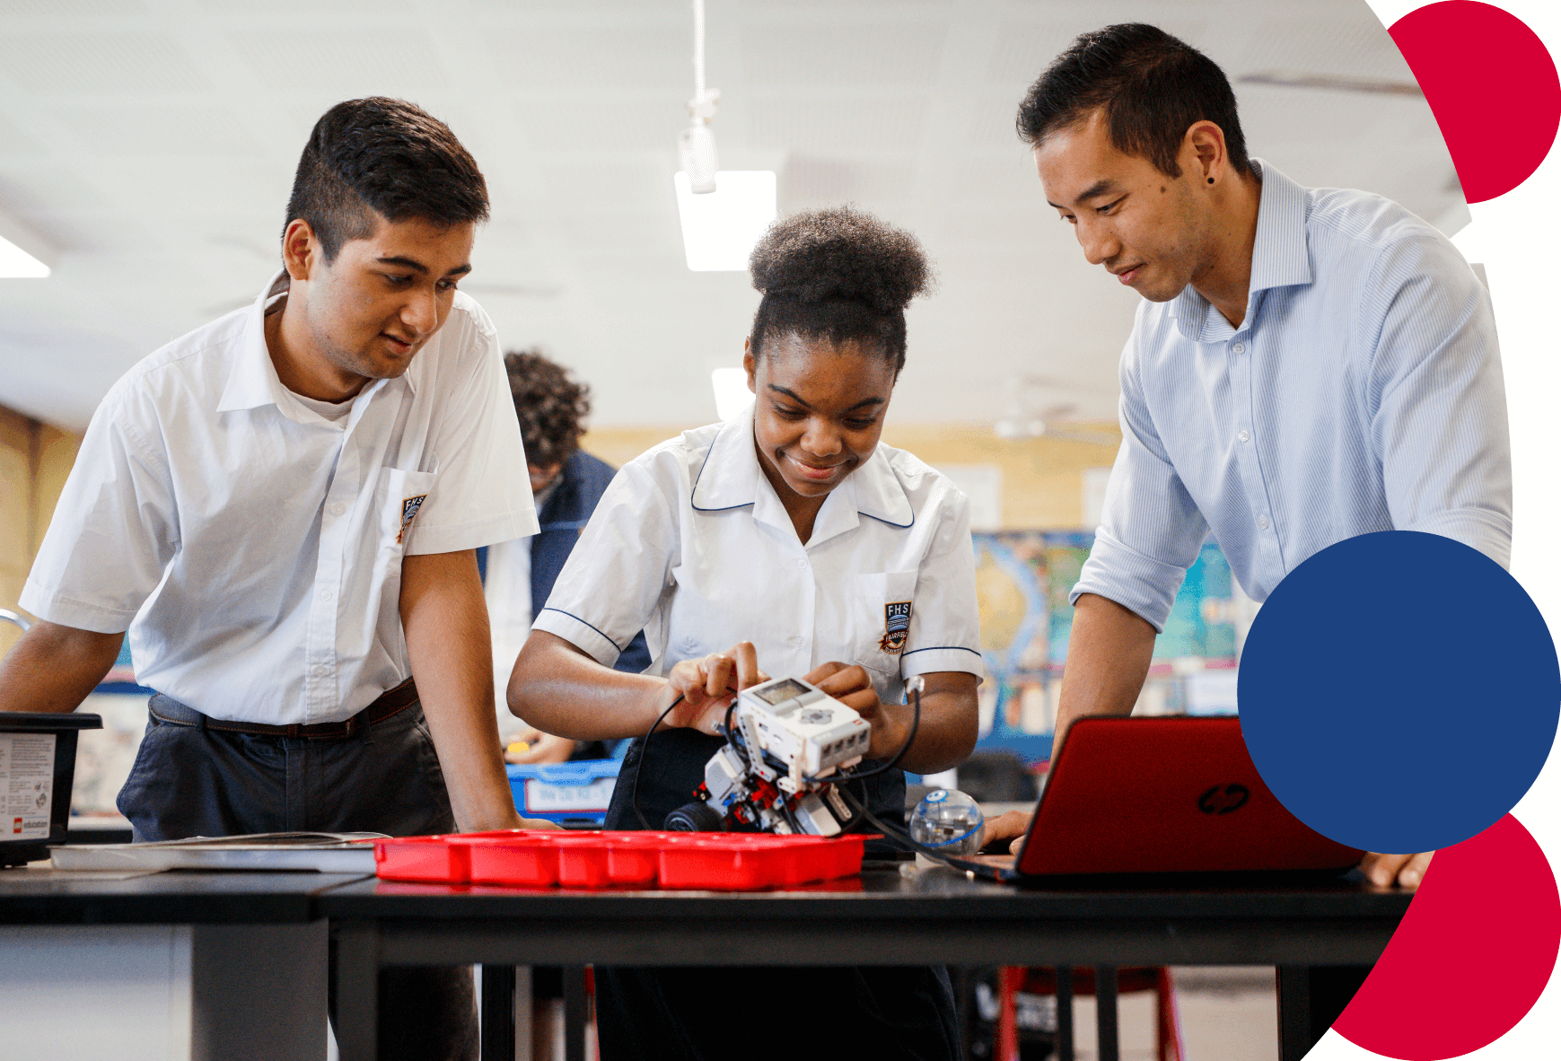
For more information contact: nswms@det.nsw.edu.au

