Everyday Maths Hub: Year 7 and 8 resources
Themed resources to:
- engage, inform and inspire your child/ student
- spark positive conversations about mathematics in the everyday

Building positive maths mindsets
Inspiration and real-life stories about resilience, problem solving and perspective to support your teen’s positive mindset towards learning and mathematics:
3 Tips To Boost Your Confidence (4:15) – When faced with challenges, you’ve probably heard the advice, “Be more confident.” But where does confidence come from and how can you get more of it? This animated video by TED-Ed in partnership with the Always #LikeAGirl campaign provides some lessons to boost your confidence so you can face learning head on.
Boosting Math (8:35) – Professor Jo Boaler from Stanford University and her students explain why everyone can master maths. They use the latest brain research as well as examples and stories of the mathematicians in history who’ve encountered setbacks and spent years working on problems. This video can help us realise that maths isn’t about speed – it’s about growing our brains, creativity, and finding and solving problems.
Mathematics Is The Sense You Never Knew You Had (13:12) – An engaging and insightful talk for TEDxSydney by mathematics teacher Eddie Woo – explores the mathematical realities woven into the fabric of the universe – from lightning bolts to river deltas to blood vessels. Eddie makes the bold statement that we are all born to be mathematicians – Let his joy and passion for learning inspire you and your teen to consider mathematics as a whole new way to see the world.
My Invention That Made Peace With Lions (7:09) – In the community where Richard Turere lives with his family, cattle are vital to their way of life, but lion attacks can put an entire family’s herd and future at risk. In this TED Talk, learn how Richard used maths to invent and design a solar-powered solution that safely scared the lions away and continues to protect his family and their livelihood. Enjoy this story about how maths helped Richard and his community, and illustrate the power of problem solving and grit with your teen.
Why I Fell In Love With Monster Prime Numbers (14:13) is a TED Talk by mathematician, comedian and self-appointed lifelong lover of maths, Adam Spencer. Your child will learn about monster prime numbers - those massive odd numbers that can only be divisible by one and themselves! They can be millions of digits long and mathematicians go hunting for them. Explained with his trademark humour and wit, let Adam inspire and broaden your teen’s view of how mathematicians persevere through tough challenges and work together to solve some really awesome problems.

People who used maths to help them change the world
The stories of inventors, innovators and trailblazers often inspire us to try new things or offer us a new perspective. Introduce your teen to the world of inspiring people who used maths to help them change the world:
Seventeen Equations That Changed The World, written by Ian Stewart and edited by John Davey – From Newton’s Law of Gravity to the Black-Scholes model used by bankers, equations have contributed to many innovations in the modern world. The book explores how Pythagoras' theorem led to the development of GPS, how logarithms are applied in architecture and why imaginary numbers were important in the development of the digital camera. This book might help your teen wonder… how will maths be used to change the world next?
Blockhead: The Life of Fibonacci, written by Joseph D'Agnese and illustrated by John O'Brien – This book tells the story of Leonardo Fibonacci - a man whose attention to detail, passion for numbers and endless wonder helped him notice the recurring patterns in nature, and led to his discovery of what has come to be known as the Fibonacci sequence. Next time you’re walking outdoors, this book might inspire you to notice and wonder about the world around you.
Hidden Figures (Young Readers' Edition), written by Margot Lee Shetterly – Before John Glenn orbited the earth, or Neil Armstrong walked on the moon, four incredible mathematicians at NASA used pencils, slide rules, and adding machines to calculate how to launch a rocket and put astronauts into space. This true story tells the amazing and awe-inspiring tale of how mathematics, and mathematicians, came to the rescue of a very special mission!
Alex's Adventure In Numberland, written by Alex Bellos – In this book, Alex Bellos travels across the globe in search of weird and wonderful mathematical phenomena. On his travels, he meets with people with incredible mathematical skills and understanding… and also a startlingly mathematical chimpanzee. Help inspire your child to think of maths in a multitude of ways with this page-turning book and its rich collection of stories of some people who used, and developed, mathematics that changed our world.
Women In Science: 50 Fearless Pioneers Who Changed The World, written and illustrated by Rachel Ignotofsky – A great collection of stories about 50 famous scientists from ancient to modern times. Profiles include renowned biologist Rachel Carson and primatologist Jane Goodall, as well as less famous pioneers, such as Dr. Patricia Bath and Barbara McClintock, a Nobel Prize-winning cytogeneticist. Fuel your child’s passion for maths by telling them the stories of the remarkable figures that have gone before and show them how maths has been used to change our world.

Puzzling and wondering through maths
Help your teen embrace the playfulness of maths. Packed with quizzes, puzzles and even colouring in, these books will help enhance your teen’s problem-solving skills as they play, puzzle and get creative with mathematical ideas:
Things To Make And Do In The Fourth Dimension, written by Matt Parker – This interactive book helps us see that maths is so much more than we sometimes give it credit for. When your teen learns that maths can help them cut pizza in a new and fairer way or make a working computer out of dominoes, they’ll realise maths isn’t only exceptionally useful - it’s also incredibly fun!
Visions Of Numberland: A Colouring Journey Through The Mysteries Of Maths, written by Alex Bellos and Edmund Harriss – Use this colouring-in book as a way to talk with your teen about some fascinating mathematical ideas. From geometry to networks, this book gives them the chance to puzzle over patterns as they colour in!
Can You Solve My Problems? A Casebook Of Ingenious, Perplexing and Totally Satisfying Puzzles, written by Alex Bellos – If your child fancies themselves as a puzzle master, this book is a worthy challenge! It contains brain-teasers and some amazing background information on the history of puzzles. Your teen might be inspired to learn that many of our ground-breaking historical mathematical figures were also keen puzzlers who loved playing with maths.
The Number Games, written by Adam Spencer – This book is filled with compelling maths questions and curiosities for teens, such as, “How much does it cost to stop a computer virus?” and, “Will you become a billionaire by age 31?” It is also packed with brain-teasing puzzles and number-based trivia bound to set off many light bulbs in your teen’s mind.
This Is Not A Maths Book: A Smart Art Activity Book, written by Anna Weltman – It might surprise you and your child that art and maths have a lot in common. This hands-on art activity book will guide your teen through how to make patterns including fractals and even Celtic knots. By putting it into practice, they’ll see just how interconnected design and maths really are.

Unexpected places where you’ll find maths
As your child’s maths learning continues in high school, they may wonder how they can use what they’re learning in their future. These five resources will help them appreciate the part maths plays in coding, magic tricks, music and the natural sciences:
Coding Up A Revolution (3:21) Speaker: Ally Watson (developed by AMSI) – Since maths underpins so much of our lives, it makes sense that having fun with coding reveals some hidden, and not so hidden, mathematical ideas and skills. This inspirational video about Ally Watson – the co-founder of Code like a girl – can take your teen on a mathematical journey into the tech world.
Beethoven Math And Music (4:19) Speaker: Natalya St. Clair (developed by TED-Ed) – How did a musician who was losing his hearing write some of the most amazing music? By using maths! This fascinating video examines the patterns in Beethoven’s Moonlight Sonata and how he used mathematics to construct his many, moving pieces of musical work.
Reaching The Stars With Maths (2:14) Speaker: Karlie Noon (developed by AMSI) – This is the inspiring story of Karlie Noon, the first Indigenous Australian in New South Wales to complete a double degree in maths and physics. She is currently researching for a Master’s in the field of Astrophysics. Her story reveals how as a mathematician, perseverance and curiosity are everything.
Magical Mathematics: The Mathematical Ideas That Animate Great Magic Tricks, written by Persi Diaconis and Ron Graham, and foreword by Martin Gardner – Magic powered by maths? Of course! Your child can learn a collection of card tricks from this book - and the mathematical ideas behind them. It has step-by-step instructions and ideas around enhancing their performance skills. There’s also an explanation of shuffling, the “Three-card-Monte” trick, and information about some magicians in history who have used maths. A magician might never reveal the secrets behind his or her tricks, but here’s a hint: there’s often maths involved!
The Golden Ratio Coloring Book: And Other Mathematical Patterns Inspired By Nature And Art, written and illustrated by Steve Richards – Help your child relax and investigate mathematical ideas at the same time. This colouring-in book explores the ‘The Golden Ratio’ and other mathematical patterns that can be found in nature, art and architecture. The intersection of maths and art is also depicted through fractals, mandalas and tiles, all while colouring in.

Games to have fun with maths
These games will help enrich your child's reasoning and problem-solving skills as they enhance their knowledge of how numbers work, quantifying collections, patterning, algebra and probability. Help your child expand their mathematical skills using these five fun games:
Prime Climb – A colourful board game for ages 10 and up, Prime Climb combines strategy and luck as players battle to be the first to land both pawns in the 101 circle at the centre of the game board. By rolling dice and choosing which operation you’d like to use, players can bump their opponent’s pawns off the board in this exciting race to 101!
Chess – A classic game, chess is steeped in opportunities to deepen mathematical skills and understanding. Players take turns moving one chess piece at a time until one player is able to capture their opponent's king. A great game to develop mathematical reasoning and patient problem solving, chess promotes your child’s understanding of concepts such as position, angles and probability.
Mastermind – Does your child like codebreaking? They may enjoy Mastermind, where they can pit themselves against an opponent and use deduction to unlock a secret code recorded in coloured pegs on a board. Fun fact: Mastermind lends itself to strategy, mathematical reasoning and algebra, with mathematicians studying the game since the late 1970s to come up with elegant and efficient solutions.
Monopoly – Monopoly isn’t just a great family board game, it can also be a great experience to enrich an understanding of working with money. Players have to budget, invest and explore the value of acquiring assets - in a fun, risk-free way! By applying skills and understanding in position, probability and patterning, players can give themselves a competitive edge.
Cribbage – Cribbage is a classic game that can lead to some amazing battles. The game is based on scoring points by collecting particular combinations of cards. Each card is given a numerical value, with the players aiming to keep the sum of the cards at 31 or lower. The first player to reach 121 points wins. Aside from the opportunity to develop their understanding of operations and quantifying collections, cribbage can help your teen enhance their problem-solving skills and mathematical reasoning. It also requires relatively little equipment to play - just a deck of cards and a cribbage board for keeping score, which your teen can make.

Books to build understanding
These five books are a great way to show your child that our world is full of maths - and in places they might not expect. They’re a great way to continue to support your child’s mathematical imagination and understanding:
If: A Mind-Bending Way Of Looking At Big Ideas And Numbers, written by David J. Smith and illustrated by Steve Adams – Numbers help us describe the world around us. To do that, sometimes we need really big numbers, which may be challenging for young minds to understand. But what if your child could think about those numbers in relation to things we can readily see, feel and touch? If your child has ever wondered 'how big is that?' this incredible book is for them.
Adam Spencer's World Of Numbers, written by Adam Spencer – This book explains how the world around us is filled with maths. Maths plays a vital role in sports, cooking, astronomy and even moving a sofa into a house. Your child will learn about maths in everyday life through various famous faces from history - from the Wright Brothers to Jimi Hendrix.
Weird Maths: At The Edge Of Infinity And Beyond, written by David Darling and Agnijo Banerjee – Exploring the connection between maths and life, this book presents a collection of interesting maths facts in intriguing ways. It tackles questions like, “How would a four-dimensional being view our world?” and also investigates game theory, Turing machines, logical paradoxes and transfinite numbers. Interesting stuff!
Mind-Boggling Numbers, written by Michael J. Rosen and illustrated by Julia Patton – “If everyone on Earth owned exactly the same amount of land, how big would your yard be?” This book poses some curious questions and uses maths to help us answer them. This is a fun read that encourages noticing and wondering whilst also exploring aspects of measurement and numbers.
How Many Socks Make A Pair? Surprisingly Interesting Everyday Maths, written by Rob Eastaway – This book uses everyday things, such as newspapers, cards, Sudoku puzzles and even socks to reveal the beauty of mathematics in the world around us. It explores mathematical ideas in practical and unique ways.

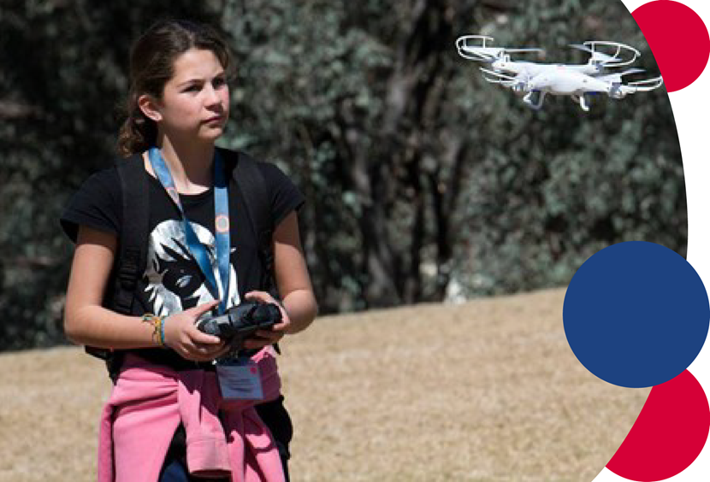
For more information contact: nswms@det.nsw.edu.au

