Everyday Maths Hub: Years 3 and 4 Resources
Looking for ideas to spark positive conversations about mathematics in the everyday?
Take a look at these themed resources to engage, inform and inspire your child/student:
- Building positive maths mindsets
- People who used maths to help them change the world
- Puzzling and wondering through maths
- Maths in surprising places
- Having fun when using maths
- Books to build understanding

Building positive maths mindsets
Having a positive mindset can help improve outcomes and understanding in all aspects of your child’s learning, including maths. Learning new things is challenging. You can support your child by helping them embrace challenges as a necessary part of learning and help them build resilience, perseverance and a positive mindset towards challenges.
Salt In His Shoes: Michael Jordan In Pursuit Of A Dream, written by Deloris Jordan and Roslyn M. Jordan and illustrated by Kadir Nelson – When Michael Jordan was a child, he almost gave up on being a basketball player because he feared he would never be tall enough. Then his parents taught him about patience, determination and hard work. This inspirational illustrated story is about how a family can work together to help a child achieve their dreams – true for almost all things when you want to feel more confident.
What Do You Do With A Problem? written by Kobi Yamada – This picture book is about a persistent problem that follows a child around. The longer the problem is avoided, the larger it seems to get – isn’t that always the way? When the child finally musters up the courage to face the problem, it turns out to be something quite different all together. This profound story might just help your child uncover how brave they can be and how important it is to embrace challenges, no matter what format they come in.
Your Fantastic Elastic Brain: Stretch It, Shape It, written by JoAnn Deak PhD and illustrated by Sarah Ackerley – Another excellent picture book for teaching your child that making mistakes can, in fact, be a great thing! Mistakes not only help your child grow their brain, they can be helpful for overcoming fears and helping to build courage – essential ingredients for working like a mathematician.
Last To Finish: A Story About The Smartest Boy In Math Class, written by Barbara Esham and illustrated by Mike Gordon – This heartfelt story follows Max who’s in Year 3. He used to think he was good at maths, now he’s convinced he’ll never memorise his multiplication facts and is always the last to finish his test. Packed with rich life lessons about learning and individuality, this book will help your child realise that we all have different skills and the true test of ‘being smart’ isn’t memorising or speed, but rather persevering, building understanding and solving problems.
Rosie Revere, Engineer, written by Andrea Beaty and illustrated by David Roberts – Let Rosie’s story and mission help your child see failure as an important stepping stone towards success. This triumphant book shares an important lesson: You only really fail when you quit. Like some of the most famous mathematicians of all time, you’re in great company when you need to keep persisting to achieve your goals. “Failure is simply the opportunity to begin again, this time more wisely.” - Henry Ford

People who used maths to help them change the world
Spark your child’s imagination with these incredible stories of trailblazers in architecture, space, and computer science… all of whom needed to use maths to help them change the world. In these five books you’ll find positive lessons about determination, collaboration, and the importance of working hard when going after your dreams.
The Boy Who Loved Math: The Improbable Life Of Paul Erdos, written by Deborah Heiligman and illustrated by LeUyen Pham – If your child’s always asking questions and likes to spend time pondering and imagining, they’ll likely find a kindred spirit in Paul Erdos. Curious about everything, including working out how many seconds someone has been alive, Paul travelled the globe and collaborated on a large number of problems, helping people around him better understand the world.
Grace Hopper: Queen Of Computer Code, written by Laurie Wallmark and illustrated by Katy Wu – As far as revolutionary people go, Grace Hopper is definitely an inspiring one. Digital illustrations and an easy-to-read story bring this picture book biography to life. Grace was an inventor, software tester, avid reader, naval leader, mentor, rule breaker and chance taker - and served an almost 50-year career in the navy where she used mathematics to shape computer science as we know it today.
On A Beam Of Light: A Story Of Albert Einstein, written by Jennifer Berne and illustrated by Vladimir Radunsky – Einstein reportedly said, “Imagination is more important than knowledge”. This sweet and inspiring picture book tells his story: A young boy with an endless fascination for the world around him, who overcomes challenges and refuses to give up on problems. The story of Einstein reminds us that sometimes, when you persevere with maths, you can use it to help change the world.
Counting On Katherine: How Katherine Johnson Saved Apollo 13, written by Helaine Becker and illustrated by Dow Phumiruk – Maths can help save lives, at least that’s part of Katherine Johnson’s story. The prominent NASA mathematician not only calculated the course of moon landings but averted many disasters using her skills and understanding. This powerful book will give your child a glimpse at Katherine’s love for the mathematics she used to change the world.
The World Is Not A Rectangle: A Portrait Of Architect Zaha Hadid, written and illustrated by Jeanette Winter – Imagine having a hand in creating buildings all over the world? This triumphant story of famed architect Zaha Hadid, details her childhood where she dreamt of one day designing her own cities, using her mathematical skills and knowledge to overcome obstacles to help her achieve her goals.

Puzzling and wondering through maths
Puzzling, wondering and playing with ideas are key qualities in the pursuit of mathematical thinking and problem solving. In these five interactive resources, you can help your child enrich their mathematical skills with everything from codebreaking to programming.
Frank Einstein And The Antimatter Motor, written by Jon Scieszka and illustrated by Brian Biggs – Science inventions, funny jokes, robot adventures and maths facts make this an entertaining and memorable story for your child. Frank Einstein loves building and experimenting in his garage lab. When the robot he builds gets stolen, fun and puzzling times unfold!

Unexpected places where you’ll find maths
Whether your child likes sports, colouring in, animals, or solving mysteries - each of these five books has something maths-related for them to think about. In this reading list, your child will discover that if we pay attention, maths can be found everywhere!
Ada Lace, On The Case, written by Tamson Weston and Emily Calandrelli, and Illustrated by Renee Kurill – Ada Lace is a resourceful eight-year-old with a knack for using science and maths to help her solve mysteries! In this fictional instalment of her adventures, Ada and her neighbour have to work together to solve a dognapping incident in New York. You can use this novel - and the other stories in the series - to inspire your child to find maths in surprising places.
Secret Coders, written by Gene Luen Yang and illustrated by Mike Holmes – This graphic novel series incorporates coding and logic puzzles into its clever plots concerning mysteries at a school. If your child is interested in learning to code and problem solving, these books and their related activities may be a fun way for them to continue developing their mathematical skills.
Football School Season 1: Where Football Explains the World, written by Alex Bellos and Ben Lyttleton and illustrated by Spike Gerrell – Do you live with a budding soccer superstar? Or are they just a massive fan of the sport? Then this series will be right up their alley! It’ll also help support mathematical skills and understanding at the same time. These true stories explore maths, science and history, accompanied by funny drawings and jokes that are bound to get your child thinking differently.
Wild Fibonacci, written by Joy N. Hulme and illustrated by Carol Schwartz – Your child can find the most amazing patterns in nature… if they know where to look! Using this book, they’ll learn about the Fibonacci sequence and how it appears in the petals of flowers and how a bird’s beak grows - two things that seemingly have no connection. This book will help you hunt for Fibonacci at the beach, in the paddock, in the garden and on your way to the shops!
Patterns of the Universe: A Coloring Adventure in Math and Beauty, written by Alex Bellos and Edmund Harriss, and illustrated by Edmund Harriss – Do you live with a budding artist? Did you know you can use colouring-in to explore the beauty of mathematical patterns? This colouring-in book includes ready-made patterns and instructions for your child to make patterns of their own.

Games to have fun with maths
Games are a fun way to get your child thinking, communicating and reasoning like a mathematician. Here are five games for you to play together.
Yahtzee – Yahtzee is a great way for your child to enhance their skills in quantifying collections, understanding how numbers work and using operations. Combining both skills and luck, there’s a chance that probability might enter the conversation too! The object of the game is to get the highest score. Players take turns rolling dice and meeting specific criteria to grow their score. Good luck rolling a Yahtzee!
Finska – This game takes maths outdoors. Players take turns to throw a wooden log - the Finska - at a set of numbered pins. Similar to lawn bowls or bowling, the aim of the game is to score exactly 50 points. Playing Finska involves working with the operations, quantifying collections and using what we know about how numbers work. It also requires mathematical reasoning, problem solving and spatial awareness to hit your target. You can use this game to explore velocity and risk because they are also underpinned by maths!
The Game Of Life – Does your child wish they were a grown-up already? Here’s a chance for them to give adulthood - and some maths - a trial run. This board game helps enrich our understanding of working with money by exploring ideas like earning a wage, paying taxes and exploring debt - all whilst using an understanding of the operations and how numbers work. It’ll give your child a glimpse of how maths is used in our daily lives.
Sequence – Sequence is a game of strategy! Helping your child enrich their understanding of position and probability, the aim of the game is to be the first person to make two collections of five tokens in a row. Aside from exploring position and probability, this game is rich in mathematical reasoning.
Chess – A classic game, chess is steeped in opportunities to deepen mathematical skills and understanding. Players take turns moving one chess piece at a time until one player is able to capture their opponent's king. A great game to develop mathematical reasoning and patient problem solving, chess promotes your child’s understanding of concepts such as position, angles and probability.

Books to build understanding
Now that your child is developing richer mathematical skills and understanding, it’s a great time to broaden their knowledge with these enjoyable and thought-provoking books.
Animals By The Numbers, written and illustrated by Steve Jenkins – If your child loves asking questions and has a passion for animals, then this book is a great way to explore statistics, infographics and develop other mathematical ideas about measurement and how numbers work. This book is full of fascinating facts and incredible visuals!
How Many Jelly Beans? A Giant Book Of Giant Numbers, written by Andrea Menotti and illustrated by Yancey Labat – This picture book investigates concepts of time and how numbers work through a delicious problem involving jelly beans! How many jelly beans are enough for Aiden and Emma, and how long will it take them to eat them all?
Place Value, written by David A. Adler and illustrated by Edward Miller – Your child can follow this story about monkeys making cupcakes to learn about place value, how numbers work and measurement. It also explores the differences and similarities in how numbers, letters and words work.
Uno’s Garden, written and illustrated by Graeme Base – Dealing with themes of environmental conservation and the protection of wildlife, Uno’s Garden comes with problems to solve and a gentle introduction into algebra. Full of beautiful illustrations and challenges to find unique creatures, this book helps build many mathematical ideas.
Really Big Numbers, written by Richard Evan Schwartz – Can you imagine how big a quinquatrigintillion is? This book helps us investigate our amazing number system. It also helps us understand how numbers work as it explores some small numbers and some really big numbers with bright and engaging illustrations.
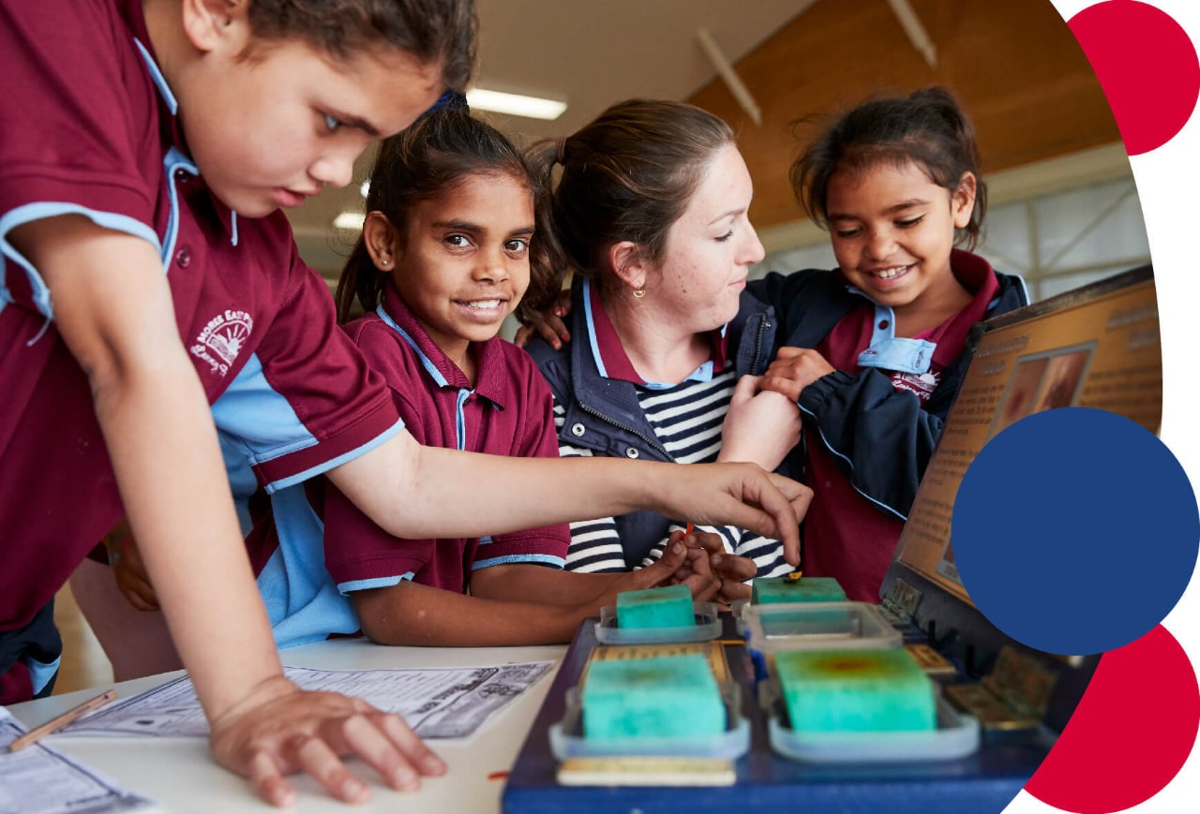
For more information contact: nswms@det.nsw.edu.au

