Best buys
You will not need to have access to any digital devices in order to complete the following activities. You will be required to keep a record of your learning and check in with your teacher at the end of the week via telephone. You may need a parent/carer to help facilitate some of the activities.

Lesson 1: Explicit learning
You are to read through the ‘Best buys’ section on pages 3 and 4 with a parent/carer. You are to then complete the ‘Best buys worksheet’ on page 5.

Lesson 2: Enrichment task
You are to complete the attached enrichment task entitled ‘Buying in bulk’. All instructions are included within the document. You are required to provide evidence of the completion of the task to your classroom teacher. This could be done by dropping off a hard copy to your school or discussing the completed task with your teacher over the phone.

Lesson 3: Activity based consolidation
You are to now complete as many of the activities listed in below. Copies of each of the activities are attached.
- Deals with percentages
- Which would you rather?
- Card game: Who got the better deal?
- Best buys word search
- Problem map
- Best buys acrostic poem

You often see businesses advertising buying items in bulk to save money. How do you know if you are actually saving money though? How do you calculate how much money you are saving? The answer is the ‘unitary method’.
The unitary method is used to find the value of one ‘unit’. By finding the value of one unit you are able to compare items of varying quantities and make informed decisions about which deal is the best value for money.
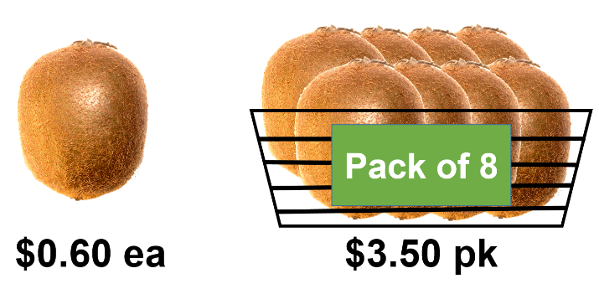

Example 1
You can buy kiwi fruits individually or in packs of 8. Individually they cost $0.60 each, however a pack of 8 costs $3.50. Are you better off buying 8 individual kiwi fruits or a packet or 8?

Method 1
Calculate how much 8 kiwi fruit would cost if you bought them individually for $0.60 each.
$$8 kiwi fruit=8×\$0.60$$
$$8 kiwi fruit=\$4.80$$
$∴$ Buying 8 individual kiwi fruits is more expensive than buying a pack of 8.

Method 2
You know that 8 kiwi fruit can be bought as a pack for $3.50. Calculate how much an individual kiwi fruit in that packet costs.
$$1 kiwi fruit=\$3.50 ÷8$$
$=\$0.44$ (correct to the nearest cent)
$∴$ One kiwi fruit out of a pack of 8 is cheaper than one individual kiwi fruit.
In terms of value for money the best buy would be the pack of 8 kiwi fruit.
In saying this, if you only want one kiwi fruit and the other 7 would go to waste, perhaps spending $0.60 on one would be better than spending $3.50 and still only eating one.

Example 2

Washing powder is sold in a variety of weights. In this example you can buy an 800g packet of washing powder for $10.00 or a 500g packet of washing powder for $6.00. There are many ways you could mathematically determine which one is the best value for money. Are you better off buying the 800g packet or the 500g packet?
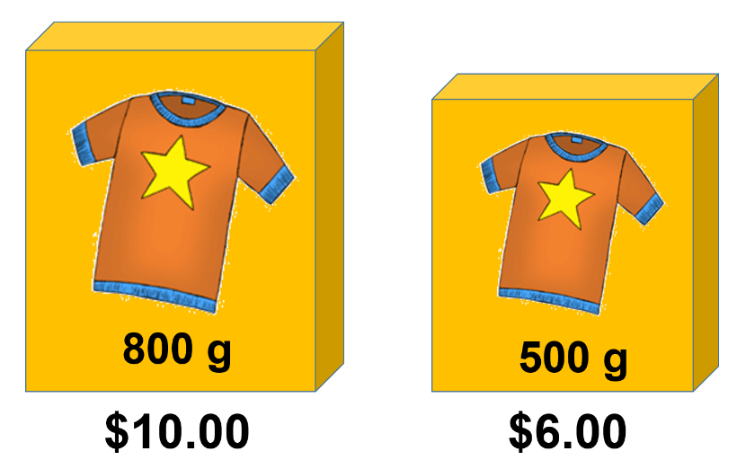

Method 1
Calculate how much washing powder you get for $1.
800g packet | 500g packet
$$\$1 of the 800g packet=800÷\$10$$  $$\$1 of the 800g packet=80g$$ | $$\$1 of the 500g packet=500÷\$6$$  $\$1 of the 500g packet=83.3g$ (correct to one decimal place
$∴$This means that you get more washing powder for $\$1$ if you buy the 500g packet

Method 2
Calculate how much it costs for the same quantity of washing powder. It is easier to calculate if you choose a quantity that can divide evenly into both quantities. For this example we will compare the price per 100g.

800g packet | 500g packet
$$800g ÷100g=8$$  $$100g of the 800g packet=\$10÷8$$  $$100g of the 800g packet=\$1.25$$ | $$500g÷100g=5$$  $$100g of the 500g packet=\$6÷5$$  $$100g of the 500g packet=\$1.20$$
$∴$ 100g is cheaper in the 500g packet than it is in the 800g packet of washing powder.
The above calculations would also have determined that the 500g packet of washing powder was the best buy if you had calculated the price per 50g, 10g or even 1g.
In terms of value for money the best buy would be the 500g packet of washing powder.

Best buys worksheet
Consider each of the following scenarios and decide which is the best value for money.

Scenario | Solution
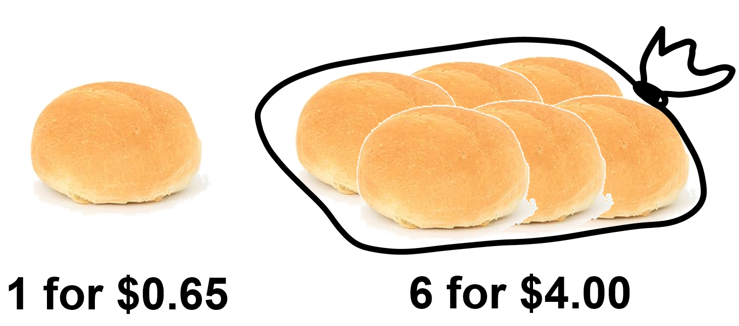
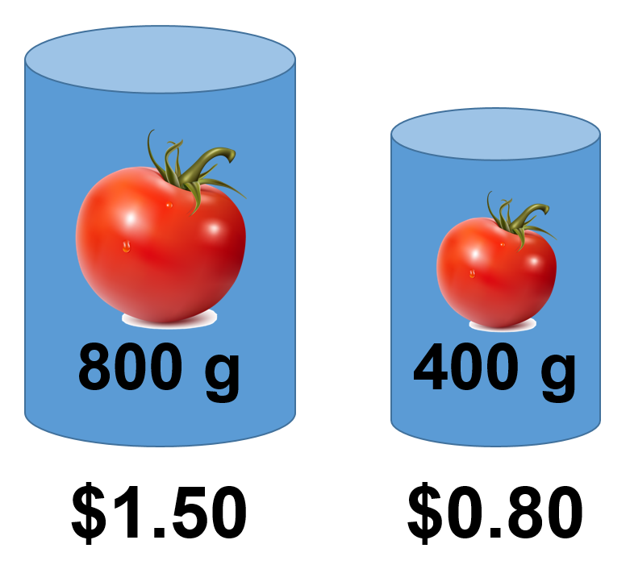
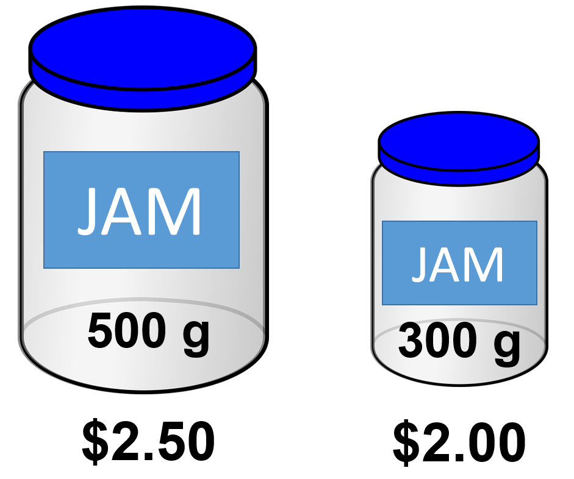
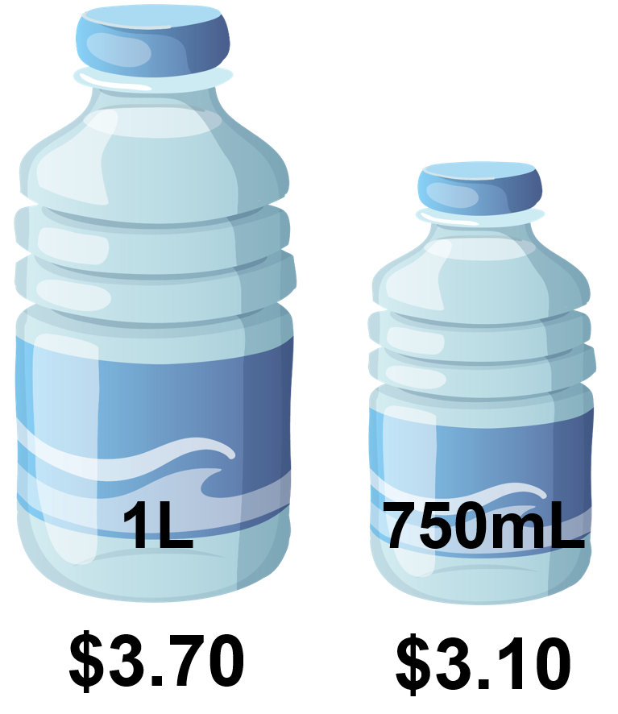

Buying in bulk

Background
Companies like Mega Savers and Costco are famous for selling items in bulk.
Is this always cheapest? Is it always the best buy?

Part A: Exploring different sizes

Task 1- Coca cola
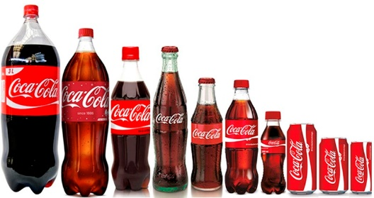

Coca-Cola sell their products in a variety of different sizes and forms. Your task is to investigate the cheapest option.

- Visit your nearest supermarket and record the different ways you can purchase Coca-Cola and record your results in a table similar to the one below.

Item | Size | Price | Price per 100mL
Bottle | 600 mL | $3.60
Can | 10 x 375 mL | $6.50

- Convert your prices to a price per 100mL. You must show your working for at least 3 of your calculations. Record your answers in your table.
- Which is the cheapest way to purchase Coca-Cola? Is there any disadvantage to purchasing Coca-Cola in this manner?

Task 2 – Toilet paper
During COVID19 people were restricted to buying only one packet of toilet paper at a time due to hoarding. Which packet would you buy?
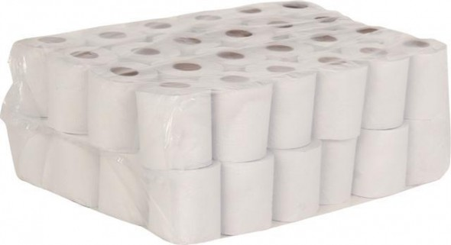
- Visit your nearest supermarket and record the different sizes and prices of toilet paper. Make sure you include the same size in different brands. Record your results in a table similar to the one below.

Brand | Number of rolls | Number of sheets per roll | Price | Price per roll | Price per sheet
Quilton | 36 | 180 | $14.00
Coles - So soft | 8 | 190 | $3.70
Coles - toilet tissue | 18 | 260 | $5.50

- Convert your prices to a price per roll. You must show your working for at least 3 of your calculations. Record your answers in our table.

- Different packs of toilet paper, have different numbers of sheets per roll. Convert your prices to a price per sheet. You must show your working for at least 3 of your calculations. Record your answers in your table.

- Which is the cheapest way to buy toilet paper?

- Which packet of toilet paper would you buy? Justify your answer. What factors did you consider?

Part B – No name
No-name generic brands are notorious for being cheaper than their well-advertised brand name opponents.
How much money could you save by using purely generic brands?

Task - Planning a meal
Find a recipe and compare the cost of making it using purely generic brands vs using brand name products.
- Record your ingredients in two tables similar to the ones below.
- Calculate the cost per quantity needed
- Find the total cost of making your recipe in each scenario.
- Would you use the generic ingredients to make your recipe? Justify your decision by discussing the factors that you considered.
Some facts that may help you (these have been simplified slightly):
1 cup = 250 ml = 250g
¼ cup = 60 ml = 60g
1/3 cup = 80 ml = 80 g
1 teaspoon (tsp) = 5 ml = 5g
1 tablespoon (tbsp.) = 20 ml = 20g
If you have access to the internet, you might like to use the more accurate measurements found at Weight measurement chart

Table 1 – Generic brand products

Item | Brand | Size | Price | Quantity needed | Price per quantity
Sugar | Coles | 1 kg | $1.00 | 1 cup | $0.25

Table 2 – Brand name products

Item | Brand | Size | Price | Quantity needed | Price per quantity
Sugar | CSR | 1 kg | $1.75 | 1 cup | $0.44

Deals with percentages
Compare the deals below and decide in each case which would give you the better buy. Justify your choice in each case.

Questions | Calculations | Which would you choose?
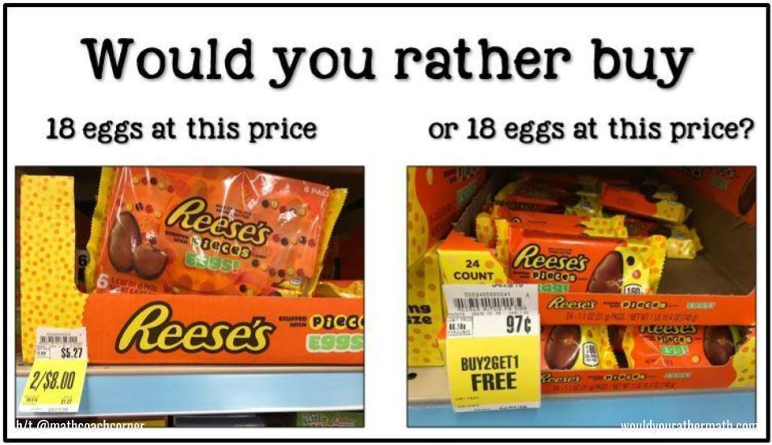
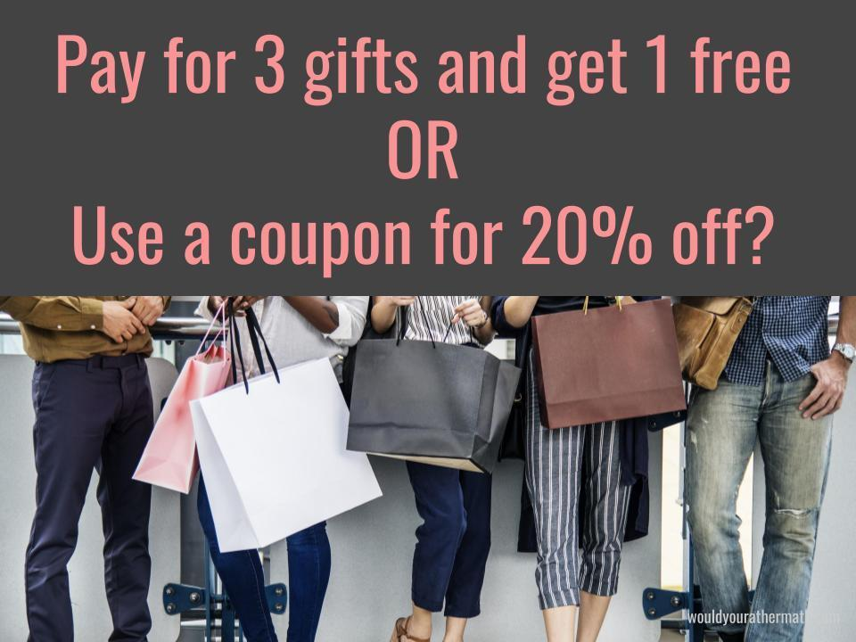
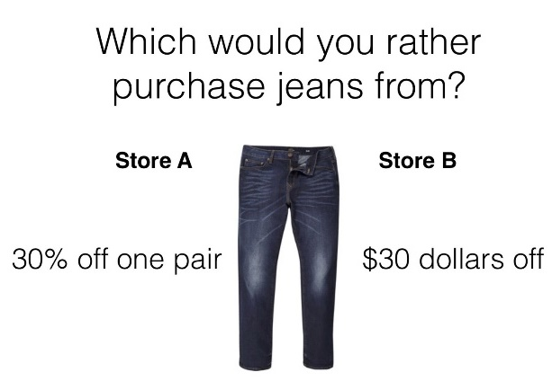
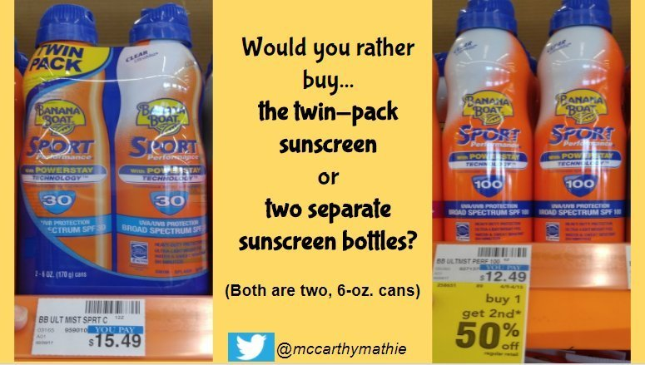
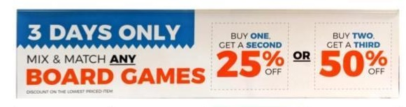
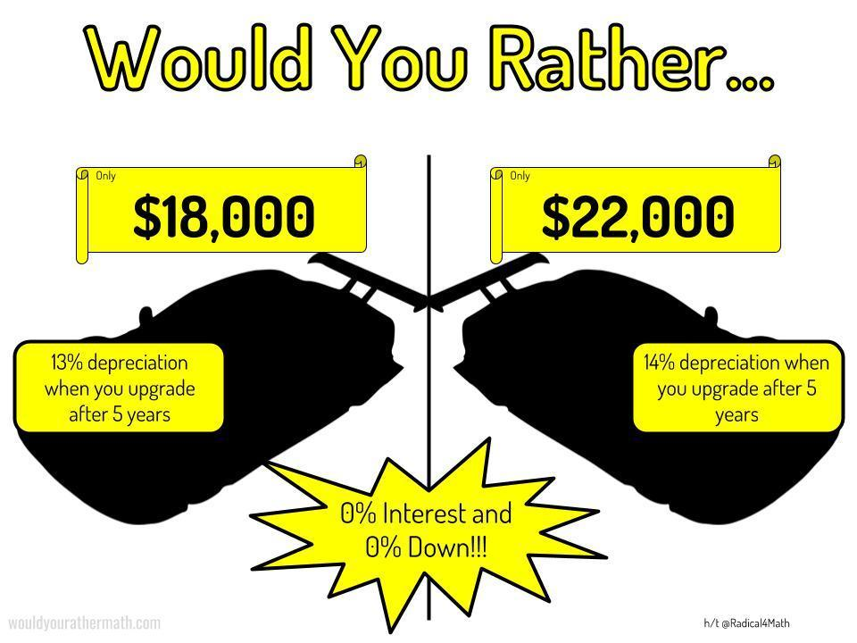
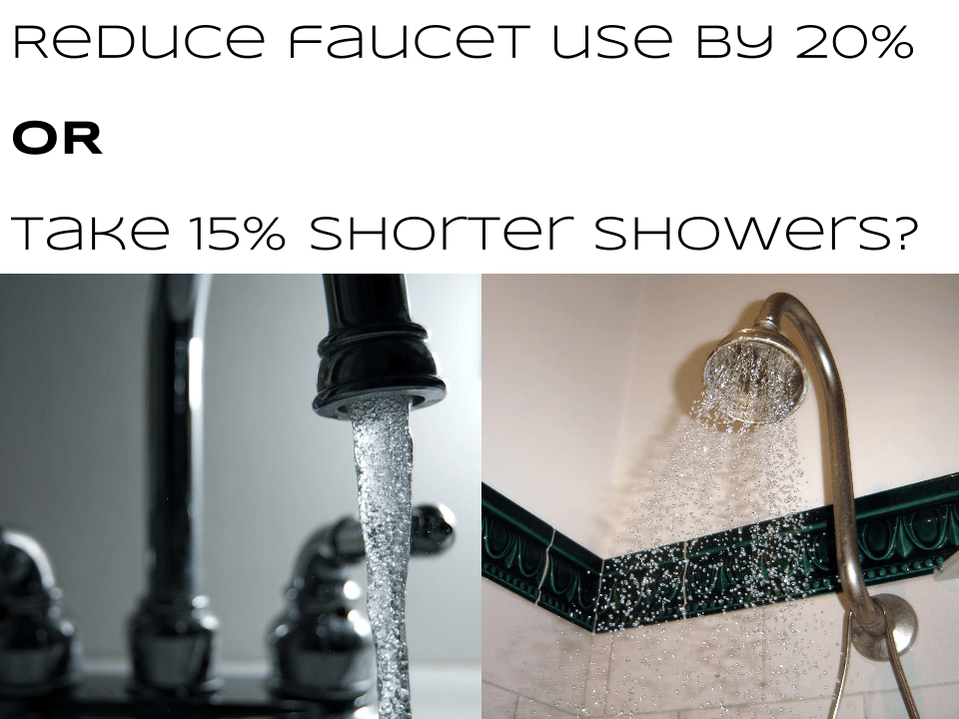
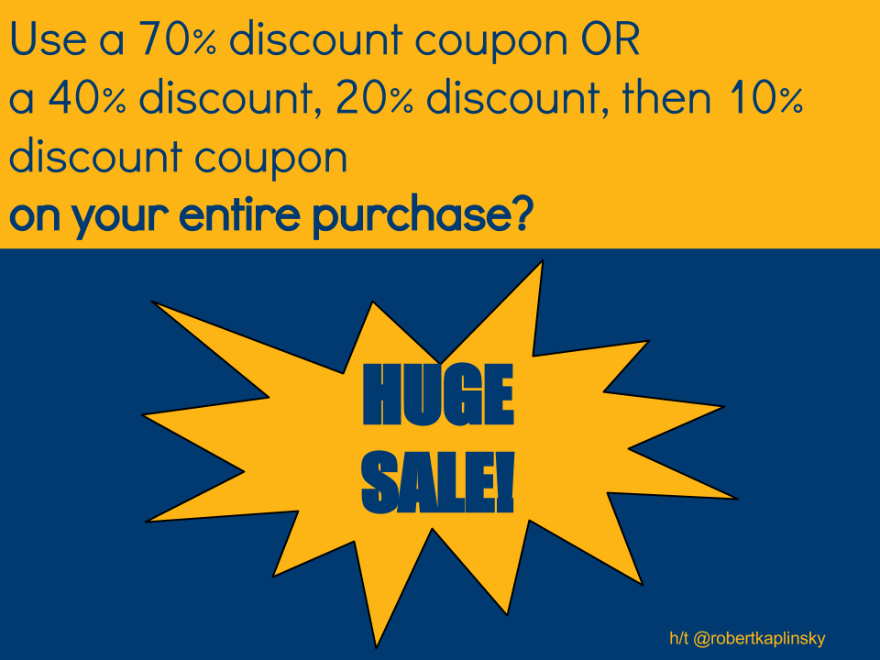
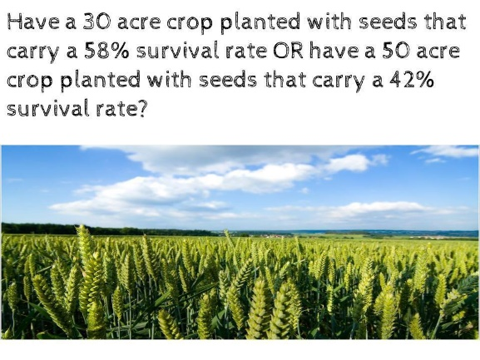

Which would you rather?
Time to go shopping! As a savvy shopper you are determined to get the best value for money on the following items. You are going to buy a DVD, book, jigsaw puzzle, recipe magazine AND you are going to choose what job you would like to pay for it all.
Complete each of the following tables by determining the unit price for each of the items and then pick which item is the best value for money.
DVD
Name | Price | Running time | Price per minute
Onward | $20.00 | 1hr 42 mins
Harry Potter and the prisoner of Azkaban | $16.00 | 2hrs 22 mins
The Lord of the Rings: The two towers | $22.00 | 3hrs 43 mins
Which DVD is the best value for money?

Book
Name | Price | Number of pages | Price per page
Indian in the cupboard | $12.99 | 192
My Place | $24.95 | 444
To kill a mocking bird | $22.99 | 296
Which book is the best value for money?

Jigsaw
Name | Price | Number of pieces | Price per piece
Tree of life | $39.90 | 1000
Disney – Beauty and the beast | $15.90 | 750
Ludicrous lighthouse | $32.90 | 995
Which jigsaw is the best value for money?

Recipe magazine
Name | Price | Number of recipes | Price per recipe
Healthy food | $6.70 | 18
Taste | $4.50 | 16
Food ideas | $3.60 | 12
Which recipe magazine is the best value for money?

Job
Name | Pay | Number of hours | Pay per hour
Bricklayer | $901.25 | 35
Beautician | $1095.60 | 40
Baker | $932.40 | 42
Which job has the best hourly rate?

Card game: Who got the better deal?
Aim: Test your skills at determining the best buy and collect as many deals as you can!
Players: You will need at least 2 players
How to play: Cut out each of the cards below and shuffle the pack. Distribute the cards evenly amongst all players. Each player puts a card down, face up, and if your card is the best deal you keep the cards. Player with the most cards at the end of the game wins!

125g for $3.00 | 100g for $2.80
250g for $6.50 | 300g for $7.00
150g for $3.20 | 50g for $1.50
75g for $1.70 | 25g for $0.70
40g for $1.30 | 120g for $2.80
80g for $1.80 | 1kg for $25.00
1.25kg for $30.00 | $1.5kg for $35.00
110g for $2.90 | 30g for $1.20
45g for $1.40 | 1.2kg for $27.50
750g for $16.00 | 800g for $17.00
500g for $13.00 | 600g for $15.00
450g for $14.50 | 800g for $19.00

Best buys word search
Find each of the words listed in the word search below.
Note: this word search was created using word search maker
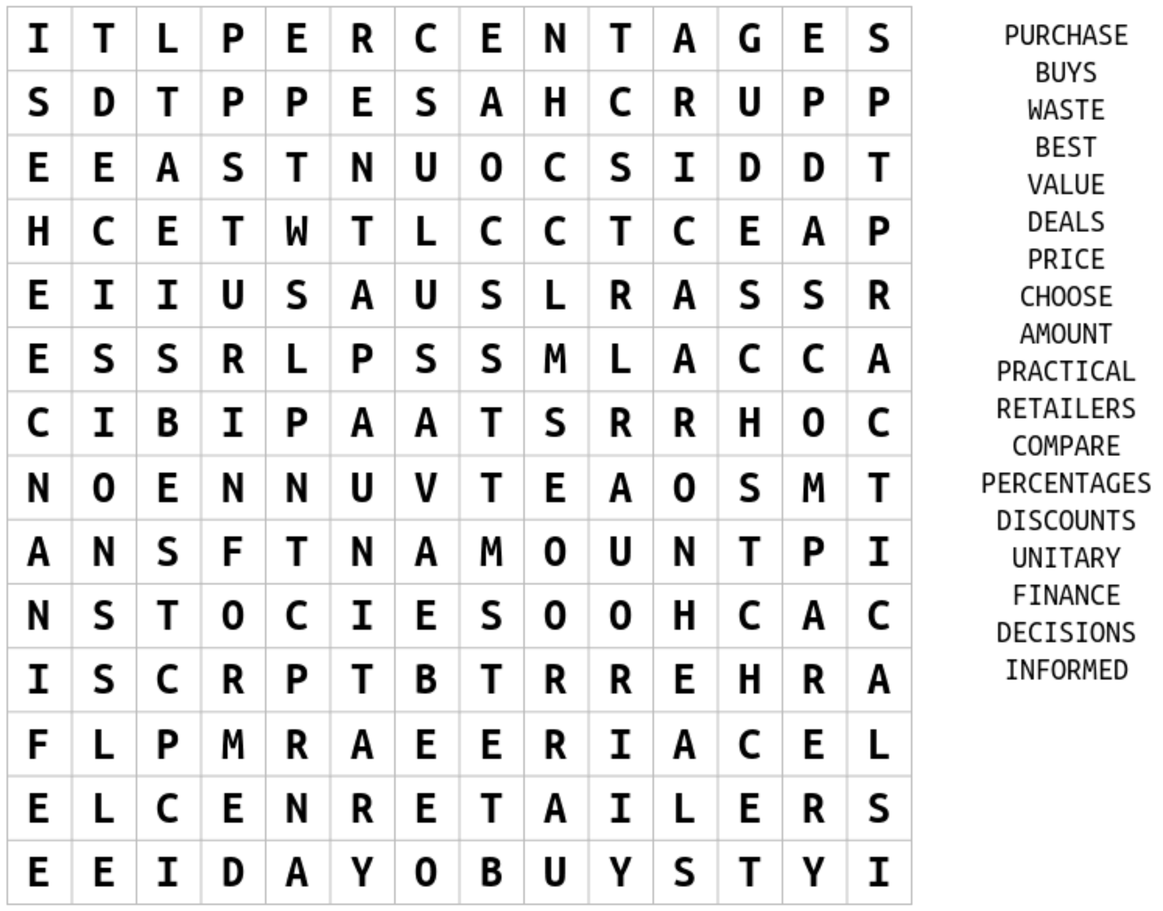

Problem map
Students are to write down a problem in the rhombus at the centre of the map. They are to then represent this problem in the four different sections of the map.

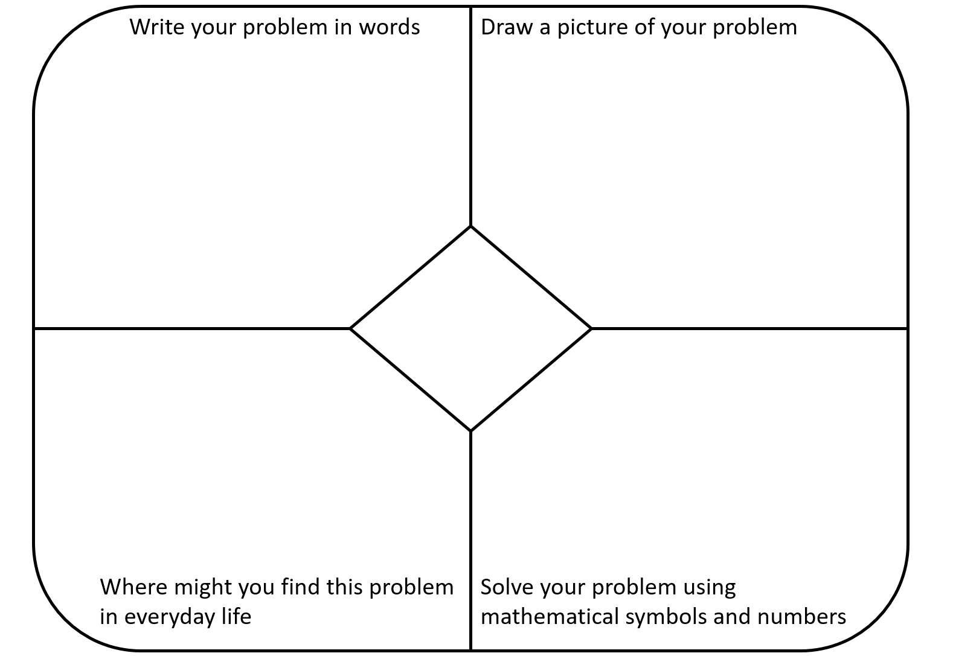

Best buys acrostic poem
Write down a word related to mathematics that starts with each of the letters of the word BEST BUYS. Provide a definition for each of your words.

Percentages | Word | Definition
B
E
S
T
B
U
Y
S

