Solve Me Mobiles

Introduction
All of the tasks and activities in this resource have been adapted from the Solve Me Mobiles website. The website has a variety of puzzles to solve, which build the skills to understand and solve equations conceptually. If teachers are providing for students who do not have internet access, please contact mathematics7-12@det.nsw.edu.au for an offline version.

Task 1 – Have a play
Go to https://solveme.edc.org/mobiles/ and explore some of the puzzles on the website. Solve puzzles 1 – 10 and write your solutions below:

Puzzle | Working out and solutions
1
2
3
4
5
6
7
8
9
10

Task 2 – Explaining your thinking (reasoning)
For each puzzle below, you will need to show your thinking! Take as much space as you need for each problem. You can use diagrams or sentences to help explain your thinking.

- Explain how you would calculate the value of the HEART in Puzzle 11. You may copy the diagram into the space below to help you with your explanation.
- Choose one puzzle from Puzzle 12 or Puzzle 13. Without using a diagram, explain the technique you used to calculate the missing values on the mobile.
- Go to Puzzle 15. Write down everything you know about this mobile and make sure you give reasons for your answer.
- Solve Puzzle 21. Write down how you calculated this answer.
- Go to Puzzle 23. Which shape would you determine the value of first? Explain why and find its value.
- Choose any puzzle to solve between Puzzles 24 and 35. Write down all the reasoning you used to solve this puzzle.
- Go to Puzzle 50. Solve it, showing all your working out.

Task 3 – Building mobiles
- Design three different mobile puzzles for someone else to solve, using the shapes below:
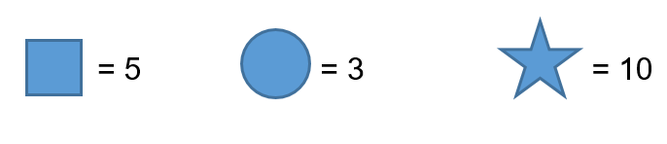
Draw your mobiles on the left-hand side of the page and write down how to solve each of them on the right hand side of the page. Try to be creative and make at least one of the problems as challenging as you can.

- Create and solve your own mobile puzzle of the following form, using any shapes and values:

Task 4 – Solving equations
- Use the mobile below to create an equation to determine the value of the star. Let:

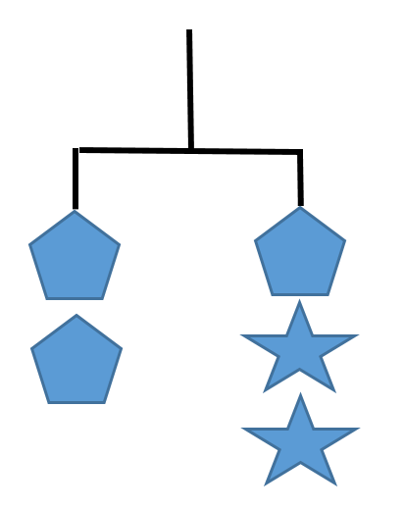

- Use the mobile below to create an equation to determine the value of the pentagon and then develop a second equation to solve for the value of the star. Let:
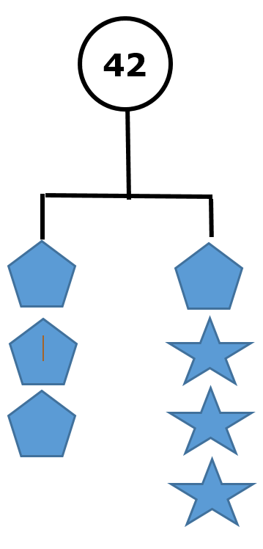

- Use equations to solve Puzzle 128.

Outcomes
- Uses algebraic techniques to solve simple linear and quadratic equations MA4-10NA
- communicates and connects mathematical ideas using appropriate terminology, diagrams and symbols MA4-1WM
- applies appropriate mathematical techniques to solve problems MA4-2WM
- recognises and explains mathematical relationships using reasoning MA4-3WM
All outcomes referred to in this unit come from Mathematics K-10 Syllabus © NSW Education Standards Authority (NESA) for and on behalf of the Crown in right of the State of New South Wales, 2012

