Maximising seating arrangements

Driving question
How can you maximise seating arrangements?

Your investigation
A restaurant has 50 tables and 300 chairs. The manager can arrange the tables and chairs to suit a variety of banquets and parties depending on the number of guests.
Six chairs can fit around a single table as shown below.
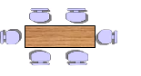

Part A: Standard tables
When there is 1 table, we can fit 6 chairs. 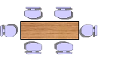
When there are 2 tables, we can fit 12 chairs. 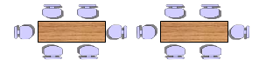
When there are 3 tables, we can fit 18 chairs. 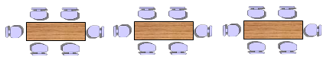
The table below shows the numbers of chairs depending how many tables we have. Complete the table, showing the number of chairs for 4, 5 and 6 tables.

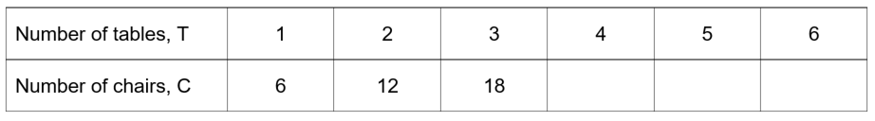

Part B: End to end
When we put the tables end to end, we get a different pattern.
When there is one table, it is still 6 chairs. 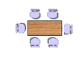
When there are 2 tables end to end, we have 10 chairs. 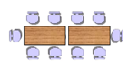
When there are 3 tables end to end, we have 14 chairs. 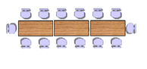

The table below shows the numbers of chairs depending how many tables we have end to end. Complete the table, showing the number of chairs for 4, 5 and 6 tables.

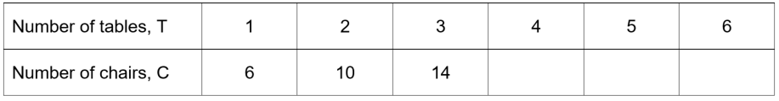

Part C: Side by side
When we put the tables side by side as in the diagram below, we get a third pattern.

When there is one table, it is still 6 chairs. 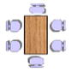
When there are 2 tables end to end, we have 8 chairs. 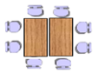

When there are 3 tables end to end, we have 10 chairs. 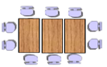

The table below shows the numbers of chairs depending how many tables we have end to end. Complete the table, showing the number of chairs for 4, 5 and 6 tables.

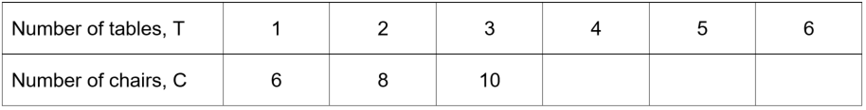

Part D – Modelling the arrangements
Plot each of the different types of table arrangements on the same Cartesian plane. You can do this by hand or using an online graphing tool like DESMOS or GeoGebra. Make sure you use a title, clearly label your axes and use an appropriate scale.

Part E – Making decisions
The table below shows groups of people who have booked in to come to our restaurant. No group is allowed to be split up.
Complete the table, making decisions about the arrangement of the tables for each group, either “Standard”, “End to end” or “Side by side” with the number of tables.
The first one is done for you.

Number of People | Arrangement | Number of tables?
10 | End to end | 2
14
6
22
16
18
30
50
25
17
29
60

Part F – Critical reflection
“For every group, there is more than one way to arrange their tables.” Explain what this means, by using examples from the list above, and showing more than one way of arranging their tables.
Your discussions should include which method is better and why?

What to submit
- Evidence of an authentic modelling. This may take the form of pictures of activities, screenshots of models with annotations.
- All data collected and initial conditions obtained.
- All formula, working and calculations required, either written by hand or typed. If screenshots have been provided, the formulas used need to be clearly annotated.
- All reasoning and justification, either written by hand or typed.

Success criteria

Criteria | Working towards developing | Developing | Developed | Well developed | Highly developed
Parts A to C  Completing patterns and generalising  MA4-2WM,  MA4-10NA,  MA4-11NA | Attempts to compete the tables in task 1 and 2. | Completes all elements of tables of values in task 1 accurately with minimal errors  OR  Makes at least one arrangement in task 2 accurately with enough chairs for each group and not needlessly over. | Completes number patterns in tables with minimal errors.  Gives clear answers to at least half of the groups of people in the table in task 2, with at least enough chairs to seat the people, and not going needlessly over | Completes number patterns expertly with at mot one careless error.  Gives clear answers to each of the groups of people in the table in task 2, with most having the no needless tables and at least enough seating. | Completes all number patterns expertly without mistakes.  Gives precise answers to the arrangements in task 2 and optimizes the number of chairs and tables.
Parts D to F  Analysing the mathematical model  MA4-2WM,  MA4-3WM | Makes a very limited attempt to discuss the comment. | Attempts to show that there could be two arrangements for the same group. | Explains competently that using End to End or Side by Side allows two different arrangements for each group.  Attempts to use an example and a basic decision as to which is better. | Explains in detail why there are two different arrangements for each group.  Uses at least one example with calculations to show the same number of people, and makes a judgement about which is better, explaining why. | Explains expertly why there are two different arrangements for each group.  Uses multiple examples and demonstrating via calculations.  Decides which method is better and uses their calculations to explain why in a convincing argument.

Outcomes
- MA4-2WM Applies appropriate mathematical techniques to solve problems
- MA4-3WM Recognises and explains mathematical relationships using reasoning
- MA4-10NA Uses algebraic techniques to solve simple linear equations
- MA4-11NA Creates and displays number patterns; graphs and analyses linear relationships; and performs transformations on the Cartesian plane
All outcomes referred to in this unit come from Mathematics K-10 Syllabus © NSW Education Standards Authority (NESA) for and on behalf of the Crown in right of the State of New South Wales, 2012

Learning across the curriculum

General capabilities
- Critical and creative thinking
- Ethical understanding
- Information and communication technology capability
- Literacy
- Numeracy
- Work and enterprise

