Eric the sheep

Your investigation
A line of sheep are waiting to be shorn. Eric is last in the line and too impatient to wait his turn, so every time the shearer takes a sheep from the head of the line, Eric jumps forward two sheep. The question is:
Given that you know how many sheep are in the line in front of Eric at the start, how many will be shorn before Eric gets to the head of the line?

Understanding the problem
Explain to a family member or friend the story of Eric the Sheep in your own words and what you need to find.

Planning your solution
List the problem-solving strategies you will use to solve this problem. Explain how you will use the ones you have chosen. Some are listed below to help you.
- Do I know a similar problem?
- Guess, check and improve.
- Try a simpler problem.
- Make a list or table.
- Work backwards.
- Act it out.
- Draw a picture or graph.
- Make a model.
- Look for a pattern.
- Try all possibilities.
- Break the problem into smaller parts.

Finding a solution
- Copy the following table onto your assignment. Fill in the table by using whichever method you listed in your plan. Fill in some numbers of your own to complete the rest of the table.
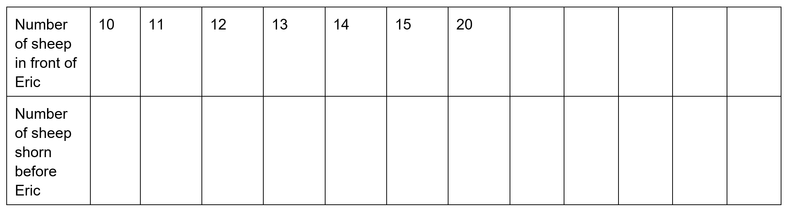

- Draw a column graph or pictograph to show how many sheep are in the line and how many are shorn before Eric. Remember to make sure your graph has a title, axes, scale and appropriate labels.

- Try to find a pattern in your table or graph. Is there anything interesting you can find about the numbers?

- Write a rule to explain how many sheep will be shorn if you know how many sheep are in the line?

- Use your rule to find how many sheep will be shorn if there are:
  - 50 sheep in the line before Eric
  - 93 sheep in the line before Eric.
Make sure you show your working out, don’t just give an answer!

Reflecting and generalising
- Explain what you did to find your answers. For example, did your strategy work as planned or did you have to change to a different strategy?

- If Eric jumps 3 sheep at a time instead of 2, what strategies would you use to find the pattern?

- What other rules did you try before you found one that worked?

Possible extension
- What if Eric was even more impatient and moved past 3 sheep at a time? Now can you predict the answers?

- What about sneaking past 4 or 5 or any other number of sheep? Explain the pattern and establish a rule.

- What if there were 2 shearers taking a sheep each and then Eric jumped over 2? Explain the pattern and establish a rule.

- Choose your own number of shearers and your own passing rule and work out the pattern.

Outcomes
- MA4-1WM communicates and connects mathematical ideas using appropriate terminology, diagrams and symbols
- MA4-3WM recognises and explains mathematical relationships using reasoning
- MA4-8NA generalises number properties to operate with algebraic expressions
All outcomes referred to in this unit come from Mathematics K-10 Syllabus © NSW Education Standards Authority (NESA) for and on behalf of the Crown in right of the State of New South Wales, 2012

