A question of time
Teacher note:. A PDF of the timetable can be downloaded and enlarged for legibility at Sydney Metro North West.

This timetable shows service information in 24-hour time (e.g. 5am = 05:00, 5pm = 17:00). Sydney Metro North West: Chatswood to Tallawong.
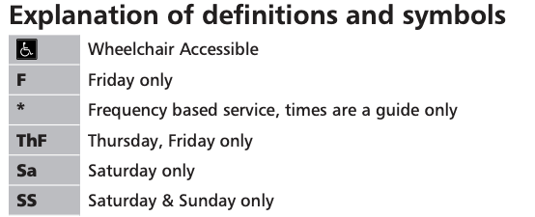
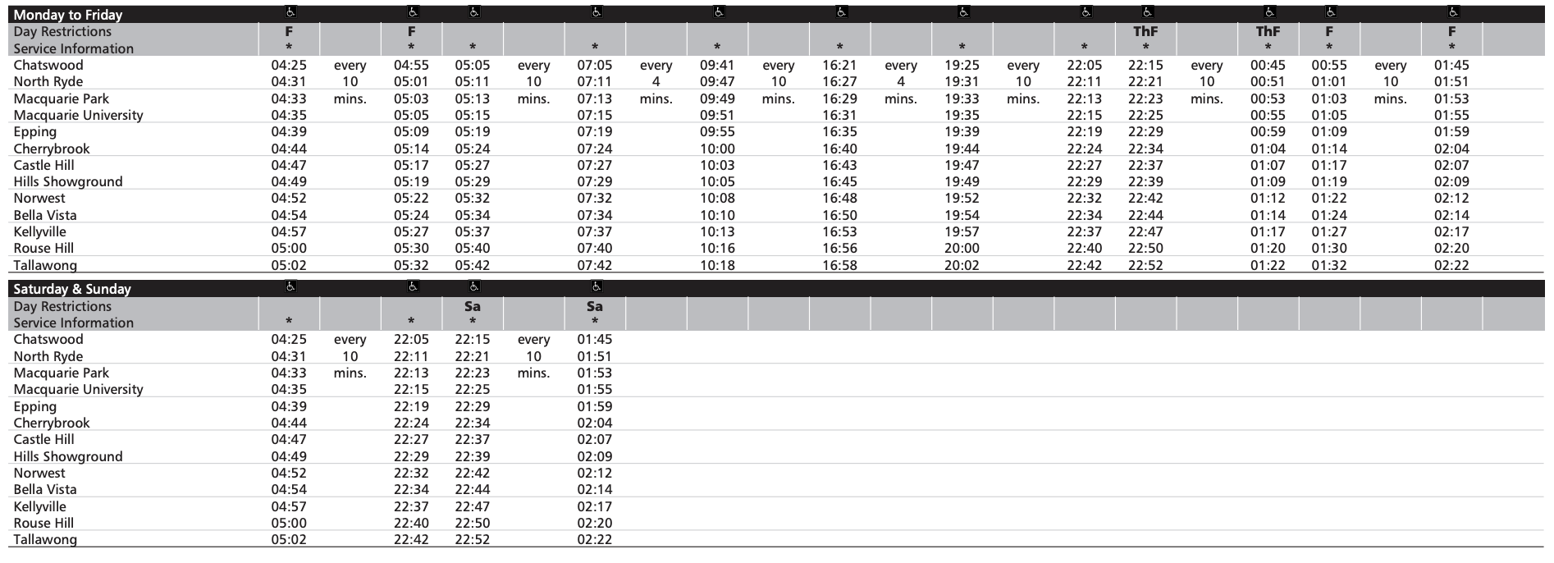

- You want to travel on the Sydney Metro early on a Friday morning from North Ryde to Epping. The current time is shown at the right.
Using the Metro timetable, what time is the next train due and what time will it arrive at Epping?

- You want to travel on the Sydney Metro on a Thursday morning from North Ryde to Epping. The current time is shown at the right.
Using the Metro timetable, what time is the next train due and what time will it arrive at Epping?

- You arrive at Castle Hill station on Saturday. The current time is shown at the right. Using the Metro timetable, at what time will the next train arrive?

- Create 3 questions (and answers) that demonstrate your understanding of reading the timetable.

