A Lifetime
The life span of a person born in Australia has been increasing gradually for many years; 80.4 years was the life expectancy for a boy born in 2016 and 84.6 years for a girl.
Over the decade since 2006, the overall life expectancy at birth increased slowly – by 1.7 years for males and 1.1 years for females.
Taking an optimistic view, for this task we will start with a general expectation of a life span of 90 years. If your life span is 90 years, you could represent it in years like this.
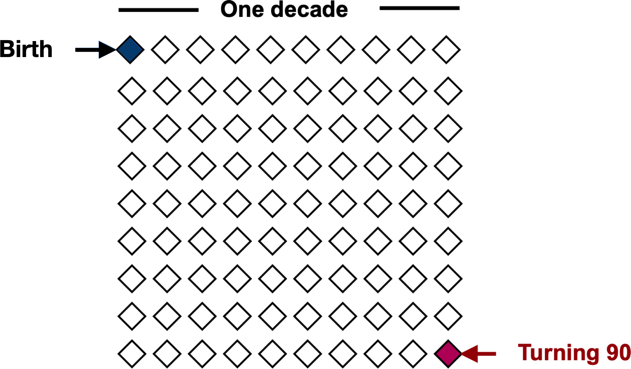

- How many years are in one decade?
- On this simple chart, mark when you started school, started high school and your current age.
- Find out at what age people retire and mark that on the chart as well. Why do you think the age pension age is rising?
- Estimate how old you will be when you start full-time work and mark that year. How long do you expect to work?
- Why do you think the last year is marked as ‘turning 90’ rather than just ‘90’?

When you were a baby your age wasn’t measured by years. Instead, the key milestones were referred to in months. Many important things often occur before your first birthday. Between 5 and 7 months you might have been able to sit up, by 6 months you might have had your first tooth, and you probably said your first word by 11 to 12 months. However, there is often considerable variation as to when these milestones occur. Because change is happening rapidly over the first few years of life, months are a better unit of time to work with than years. If we redrew the 90-year life span in months it might look like this:
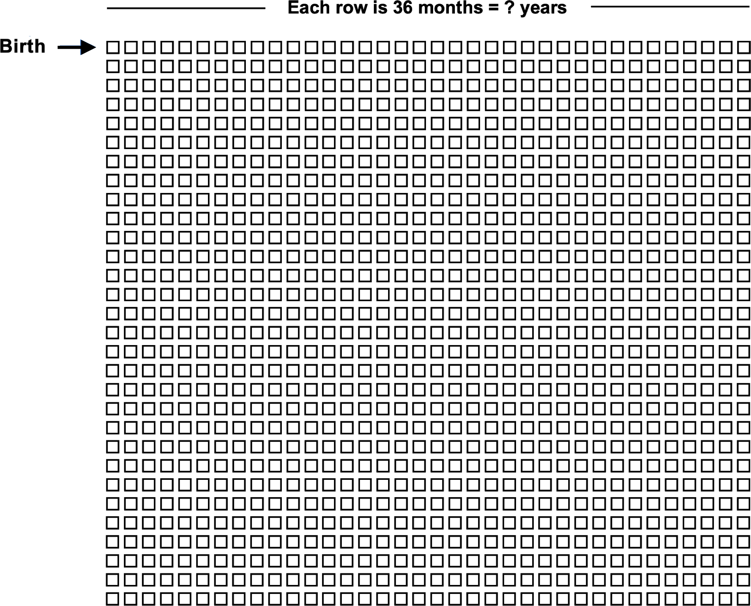

- How many years are in each row? Why do you think 36 months was chosen for the length of the row?
- Mark your birth month on the chart and add in the name of the month. Also mark the months of your 30th and 60th birthday.
- Find out when significant events in your early life occurred, such as first steps, first words, first tooth, and mark them on your chart. If these are not easily determined, estimate when you think they occurred.
- Shade in the months you have been attending school, using a different style or colour for the high school months.
- Label the chart with the average life expectancy for all men and women in Australia and then the average life expectancy for Indigenous men and women.

- Find out the average life expectancy for men and women in Sierra Leone and add this information to the chart.
- Identify what the average life expectancy for men and women was in Sierra Leone in 2000, each to one decimal place.
- A month still feels like quite a large unit of time to think about as part of your life. If you created a 90-year human life chart in weeks, how many weeks would you put in a row and how many rows would you need?

