Stage 5 Spanish
This unit starter can be modified to suit the needs of your learners, including adding your own resources, modifying content or duration and differentiating for learning needs and learner groups. There are suggested teaching and learning activities in the unit for the 3 learner groups – students learning Spanish as a second or additional language, students with prior learning and/or experience in Spanish and students with a background in Spanish. The learning, teaching and assessment strategies and assessment task are suggestions only.

Llevar una vida saludable – living a healthy life
Maintaining a healthy lifestyle is vital for individuals and the COVID-19 pandemic highlighted the importance of good health and wellbeing. In this unit, students learn to describe diet, exercise and daily routines. They will also identify and discuss physical, mental and emotional wellbeing issues, and give sound advice on healthy living choices.
(Note: In exploring some of the issues in this unit, teachers must consider the department’s policy: Controversial Issues in Schools and related procedures. The policy can be accessed on the department’s policy library.)

Duration
12-15 hours

Learning across the curriculum
- Critical and creative thinking (collaborative tasks and activities)
- Information and communication technology capability
- Intercultural understanding (value own and other cultures and beliefs)
- Literacy (types of texts, register)
- Difference and diversity

Vocabulary
Parts of the body | Healthy living and diet | Leisure activities | Visiting the doctor | Personal opinions and giving advice | Agreeing and disagreeing
cabeza  espalda  pierna  brazo  garganta  estómago  ojo(s)  oído(s)  dedo  pie(s)  corazón  pulmón  cuello  diente(s) | ¿Cómo llevar una vida sana?  ¿Qué haces en tu tiempo libre?  ¿Cuánto tiempo pasas en el internet?  ¿Cómo te cuidas?  régimen  saludable  dieta  alto en azúcar  bajo en grasas  prevención | ir al gimnasio  hacer deporte  actividad física  montar en bici  hacer footing  bailar  practicar yoga  jugar videojuegos | tengo una cita con el médico  ¿Tienes alergias?  ¿Cómo te sientes?  me duele la cabeza/garganta  tengo dolor de estómago/espalda  tengo tos/fiebre/gripe/un virus  estoy resfriado(a)/mareado(a)  me caí  ¡qué lástima!  saca la lengua  perdí el apetito  pastillas  inyección  vacuna | Pienso que debes descansar.  Tienes que descansar creo que quizás estás agotada.  Necesitas cuidarte.  Es necesario que…  Hay que comer bien. | Estoy de acuerdo(a).  Estoy de acuerdo(a)/no estoy de acuerdo(a).  Sí, eso es verdad. Por supuesto.  Comparto su/tu punto de vista/no comparto su/tu idea.  Pienso lo mismo/no pienso lo mismo.  Tiene(s) razón.  Desde mi punto de vista…  Me parece bien/estupendo…  Según yo  Según mi…

Structures
Conditional | Future tense | Verbs and imperatives | Questions in the past tense?
podría  debería  tendría  iría | voy a ir  iré  voy a comer  comeré  tomaré  haré | deber  tener (que)  tener dolor (de)  doler  creer  haber  sentir(se) | ¿Has ido…?  ¿Has hecho?  ¿Has comido?  ¿Has tomado?

Outcomes
Outcomes | Content
LSP5-1C | manipulates Spanish in sustained interactions to exchange information, ideas and opinions, and make plans and negotiate
LSP5-2C | identifies and interprets information in a range of texts
LSP5-3C | evaluates and responds to information, opinions and ideas in texts, using a range of formats for specific contexts, purposes and audiences
LSP5-4C | experiments with linguistic patterns and structures to compose texts in Spanish, using a range of formats for a variety of contexts, purposes and audiences
LSP5-5U | demonstrates how Spanish pronunciation and intonation are used to convey meaning
LSP5-6U | analyses the function of complex Spanish grammatical structures to extend meaning
LSP5-7U | analyses linguistic, structural and cultural features in a range of texts
LSP5-8U | explains and reflects on the interrelationship between language, culture and identity
All outcomes referred to in this unit starter come from the Spanish K-10 Syllabus © NSW Education Standards Authority (NESA) for and on behalf of the Crown in right of the State of New South Wales, 2018.

Suggested assessment of learning tasks
In this unit, there are 3 different suggested assessment of learning tasks to cater for the 3 learner pathways – students learning Spanish as a second or additional language, students with prior learning and/or experience in Spanish and students with a background in Spanish. You can access the full versions of these assessment tasks, with marking guidelines, on the Stages 4-5 Spanish section of the NSW Department of Education’s website. Please note, the example texts have been provided in both English and Spanish for teacher reference only. We suggest that the English translations not be given to students.

Students learning Spanish as a second or additional language
Part A – create a video for your YouTube wellbeing channel outlining 5 steps to a healthier lifestyle. For each step, expand on your ideas, give examples and provide reasons on why your steps are beneficial. LSP5-4C, LSP5-5U
Part B – you have received a comment on your channel from a viewer asking for advice on a related wellbeing/health issue. Respond in writing, offering helpful advice and solutions with justifications. LSP5-3C, LSP5-6U
As a suggestion in Part B, teachers can interact with the student by providing the wellbeing/health comment on the student’s video post for Part B. This could be a generic response for all students, for example:
Muchas gracias por tus consejos tan sensatos, me parecen muy útiles. Sin embargo, necesito algunos consejos específicos para mí. Soy una joven de 14 años y trabajo 3 tardes por semana, también estudio mucho y hago deberes en casa. No me queda mucho tiempo para hacer ejercicios todos los días, aunque de vez en cuando juego al tenis con unos amigos cuando tengo la energía y me da la gana. El problema es que no tengo motivación y ánimo… No tengo ganas de levantarme, vestirme y salir de la casa, y lo peor de todo ¡es que después me siento mal por no haber hecho ejercicio! ¿Qué puedo hacer para motivarme y hacer ejercicios? ¿Cómo logro tener un equilibrio en mi vida personal si estoy tan ocupada y cansada? Por favor ayúdame que me siento desequilibrada y ansiosa…
(Translation provided for teachers of other languages only – do not provide to students.)
Thank you very much for your sensible advice, I think it is useful. Anyway, I also need some advice for me. I’m a 14 year old girl and I work 3 afternoons per week. I study and do household chores as well. I don’t have much time to do exercise, although from time to time I play tennis with friends when I have the energy and feel like it. The problem is I lack motivation and energy … I don’t feel like getting up, getting dressed and getting out of the house. The worst part is, I feel bad for not having done exercise afterwards! What can I do to motivate myself and exercise? How can I find balance in my personal life if I’m so busy and tired? Please help, I feel off kilter and anxious …

Students with prior learning and/or experience in Spanish
Part A – create a podcast outlining 7 steps to a healthier lifestyle. For each step, expand on your ideas and provide compelling reasons on why your steps are beneficial. LSP5-4C, LSP5-5U
Part B – you have received a comment on your podcast channel from a listener asking for advice on a related wellbeing/health issue. Respond in writing, offering tailored advice and solutions, justifying your choices. LSP5-3C, LSP5-6U
As a suggestion in Part B, teachers can interact with the student by providing the wellbeing/health comment on the podcast channel for Part B. This could be a generic response for all students, for example:
Muchas gracias por tu podcast y los consejos. Ahora necesito algunos de tus consejos para mí. Soy un joven de 16 años y estudio mucho. De vez en cuando hago deberes en casa. Aun así, no me queda mucho tiempo para hacer ejercicios todos los días como mis compañeros deportivos, aunque de vez en cuando juego al tenis con unos amigos. El problema es que me falta motivación y ánimo… No tengo ganas de levantarme, vestirme y salir de la casa, y lo peor de todo ¡es que después me siento mal por no haber hecho ejercicio! ¿Qué puedo hacer para motivarme y hacer ejercicios? ¿Cómo logro tener un cuerpo esculpido y fuerte si estoy tan ocupado y cansado? Por favor ayúdame, quiero lucirme bien…
(Translation provided for teachers of other languages only – do not provide to students.)
Thank you very much for your podcast and the advice. I now need some advice for myself. I’m a 16 year old boy and I study a lot. Sometimes I do a bit of house work. Having said that, I don’t have much time to do exercise all day like my sporty friends, even though from time to time I do play tennis. The problem is I lack motivation and drive. I don’t feel like getting up, getting dressed and getting out of the house. The worst part is I feel bad for not having done exercise afterwards! What can I do to motivate myself and exercise? How can I have a strong and toned body if I’m so busy and tired? Please help, I want to look good …

Students with a background in Spanish
Part A – compose and perform a script for a radio segment on a wellbeing/health topic of your choice. Expand and explain your ideas, provide examples and personal anecdotes to engage your audience. LSP5-4C, LSP5-5U, LSP5-6U
Part B – you have received a message from an anonymous caller asking for advice on a related wellbeing/health issue. Listen to the message and respond to the listener as part of your radio segment, offering tailored advice and solutions, justifying your choices. LSP5-3C, LSP5-5U
As a suggestion, teachers may provide the recording as the anonymous caller with the wellbeing/health issue for Part B. This could be generic for all students, for example:
Anonymous caller: ¡Buenos días! Me encanta tu programa y me parecen muy útiles tus consejos. ¡Soy una fan de verdad! y quiero que me des algunos consejos. Me llamo Amelia y soy una joven de 14 años y trabajo 3 tardes por semana, también estudio mucho y hago deberes en casa. No me queda mucho tiempo para hacer ejercicios y además tengo problemas de cadera y no puedo correr. Me falta motivación y ánimo… No me dan ganas de levantarme, vestirme y salir de la casa, y lo peor de todo ¡es que después me siento mal por no haber hecho ejercicio! ¿Qué hago para superar mi debilidad y motivarme? ¿Cómo logro tener una vida más equilibrada? Por favor ayúdame ya que me siento ansiosa y triste…
(Translation provided for teachers of other languages only – do not provide to students.)
Good morning! I love your program and I think your advice is really useful! I’m a real fan and I would love some of your advice for myself. My name is Amelia and I’m 14 years old. I work 3 afternoons a week, I study a lot and do house chores as well. I don’t really have much time for exercise and I also have problems with my hip and I can’t run. I lack motivation and energy. I don’t feel like getting up, getting dressed and getting out of the house. The worst part is, I feel bad for not having done exercise afterwards! What can I do to overcome my weakness and motivate myself? How can I achieve a more balanced lifestyle? Please help, I feel anxious and sad …

Unit starter
Content | Teaching and learning strategies | Variation | Evidence of learning
LSP5-5U  understand the intonation and phrasing patterns of spoken Spanish | Students learn to talk about parts of the body with a Quizlet diagram to aid pronunciation and learn new language structures.  Students learn the song Las partes del cuerpo and complete worksheets to consolidate vocabulary and practise intonation. | Students with prior learning and/or experience  Students are provided with a diagram of the human body and label as many body parts as they are able to with a word bank.  Students with a background in Spanish  Students are provided with a diagram of the human body and label as many body parts as they are able to from prior knowledge, discussing any regional variations in vocabulary. | Students identify body parts vocabulary and say the words with correct pronunciation and intonation.  Students with prior learning and/or experience  Students correctly label the human diagram.  Students with a background in Spanish  Students correctly label the human diagram and record regional variations.
LSP5-1C  initiate and sustain interactions to share information, opinions and ideas  LSP5-2C  obtain and synthesise information and ideas from spoken, written, visual or multimodal texts  LSP5-4C  compose a range of informative and imaginative texts using a variety of formats for different contexts, purposes and audiences  LSP5-5U  understand the intonation and phrasing patterns of spoken Spanish  LSP5-6U  understand and use Spanish language and grammatical forms, and explore how to use/combine these elements to express complex ideas | As a hook, show students doctor/patient jokes to introduce language related to visiting the doctor. For example:  Patient: Doctor hace una semana que no como, no duermo y no tomo agua. ¿Qué cree que tengo?  Doctor: Pues, hambre, sueño y sed.  Introduce language related to visiting a doctor with the song Me duele to express ailments. Explain the expressions me duele/tengo dolor de… and their differences.  Provide students with a selection of dialogues on going to the doctor and read them aloud, modelling correct pronunciation, intonation and appropriate gestures. In pairs, students role play the dialogues and then answer the following questions.  - Describe the patient’s ailments and symptoms.  - What advice did the doctor give?  Ask students to categorise new medical vocabulary and the doctor’s advice to check for meaning.  Explicitly teach the expression Hay que, future and conditional tenses to build language in preparation for the final assessment of learning task.  Students write and simulate a conversation similar to the ones they have read incorporating newly learned structures and vocabulary. | Students with prior learning and/or experience  Students are provided with a diagram of the human body showing internal organs to be labelled using a word bank.  Students write the script of a dialogue and role play ‘at the doctor’, using a variety of vocabulary with explanation of their ailments. Students include 2-3 comprehension questions for the class to answer.  Students with a background in Spanish  Students are provided with a diagram of the human body showing internal organs to be labelled from their prior knowledge. Students research additional vocabulary if necessary.  Students write the script of a dialogue and role play ‘at the doctor’, using a range of verb tenses to talk about what happened, their symptoms and why they are at the doctors. Students can incorporate humour, gestures and creativity in their final performance. Students include 2-3 comprehension questions for the class to answer. | Students write and perform their dialogues in class.  Students use correct pronunciation and intonation patterns.  Students engage with the role plays presented by other students, answering comprehension questions.  Students with prior learning and/or experience and students with a background in Spanish  Students correctly label the human diagram including internal organs.  Students write and perform an engaging role play.
LSP5-2C  obtain and synthesise information and ideas from spoken, written, visual or multimodal texts  LSP5-5U  understand the intonation and phrasing patterns of spoken Spanish  LSP5-6U  understand and use Spanish language and grammatical forms, and explore how to use/combine these elements to express complex ideas  LSP5-7U  apply knowledge of the interrelationship between linguistic elements, structure, context, purpose and audience to a range of texts | Show the short COVID-19 video from UNICEF. Discuss what makes the video engaging for the target audience. Look at layout, composition, language use and style.  Ask students to find the following Spanish expressions and vocabulary appearing in the video transcript:  - a virus that has crowns  - the most famous villain in the world  - My mum teaches me how to wash my hands every day.  - I see my friends and my family through my phone or tablet.  - to fight “Corona virus” the villain, we must stay home.  Students may listen multiple times.  Discuss with students the issues that may have affected them during the COVID-19 pandemic. In your discussions, introduce the idea of mental health with the article Cuida tu salud mental. Read it with students, and ask what they can deduce from the text. Highlight cognates and the use of imperatives when giving advice.  Using the vocabulary and expressions from the article, further develop the idea and create a word cloud on how students cope with stress. Provide scaffolding when doing this activity and correct students where necessary.  Students complete the survey on page 11 of Guía para crear conciencia y tomar acción frente al COVID-19.  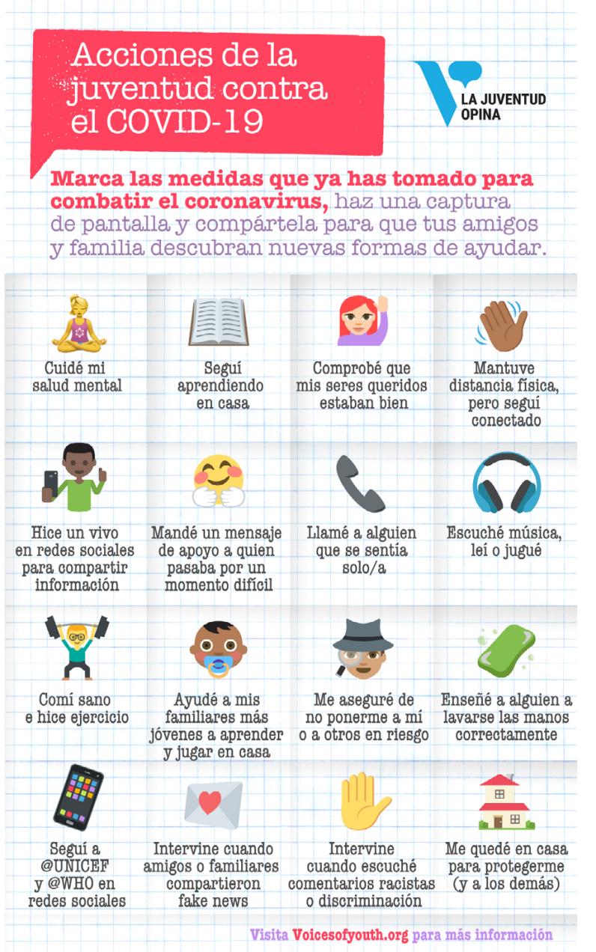  Students work with a partner to compare their answers.  Teach students how to convert statements into questions in the past tense based on the expressions and vocabulary from the survey. For example:  ¿Has cuidado tu salud mental?  ¿Has llamado a alguien que se sentía solo/a?  ¿Has comido sano/a? ¿Has hecho ejercicio?  ¿Has seguido aprendiendo en casa?  Students take notes and summarise their partner’s response in the third person. | Students with prior learning and/or experience  Students add their own strategies for coping with stress into the word cloud and when answering the survey.  When comparing answers, students respond to questions with reasons. Students summarise their partner’s response, adding explanations.  Students with a background in Spanish  Students develop their own personal list for coping with stress into their own word cloud.  When comparing answers, students elaborate on their responses by adding explanations, advice and reasons. Students summarise their partner’s response adding greater detail and explanations.  Students write a reflective piece of how they personally coped with the pandemic and how their families overseas were impacted. | Students create a word cloud with relevant expressions.  Students describe mental and physical health issues.  Students give advice on health issues.  Students turn statements into questions.  Students complete survey and compare answers with their peers.  Students write a summary in the third person.  Students discuss elements of an engaging video.  Students with a background in Spanish  Students write a reflective piece on the pandemic and its impacts.
LSP5-2C  obtain and synthesise information and ideas from spoken, written, visual or multimodal texts  LSP5-3C  evaluates and responds to information, opinions and ideas in texts, using a range of formats for specific contexts, purposes and audiences  LSP5-5U  understand the intonation and phrasing patterns of spoken Spanish  LSP5-7U  apply knowledge of the interrelationship between linguistic elements, structure, context, purpose and audience to a range of texts  LSP5-8U  understand that language, culture and communication are interrelated and shaped by each other | As a stimulus, show students the video Hábitos saludables.  As a class, brainstorm how to lead an active and healthy lifestyle in English. Set students on a dictionary skills hunt to look for expressions such as doing exercise, having a balanced diet and meditating. Students add these structures in their word cloud.  Show the video Cuerpo y mente saludable. Discuss what makes the video engaging for the audience. Look at layout, composition, language and style. Highlight the use of infinitives and imperatives in the texts when giving advice. Ask the students:  - What 3 things are you already doing to lead a healthy lifestyle?  - What things would you like to change or modify in your habits?  Read the article 6 simples hábitos para mantener una buena salud. Students complete the following:  - highlight the imperative verbs.  - What is the ideal portion of fruits and vegetables eaten to be healthy?  - How many hours of sleep is recommended daily and why?  - Why should we drink water?  - find the English equivalent of es mejor prevenir que lamentar (prevention is better than cure).  Provide a health conundrum and post it on Google Classroom. Students respond by commenting and giving advice. An example post could be:  Siempre estoy cansado y mi doctor me dice que tengo que dormir bien y tomar más agua y menos gaseosa. Pero soy un muchacho nocturno y odio tomar agua porque no tiene sabor. Además soy eternamente feliz cuando bebo cola porque me mantiene despierto. Si sigo su consejo voy a tener más energía, pero voy a ser infeliz. ¿Qué hago, elijo energía o felicidad?  Provide feedback on language and content to the students on their posts. | Students with prior learning and/or experience  Students share their word clouds with their peers and evaluate and modify according to their prior knowledge.  Students provide comments and advice outlining reasons in their posts.  Students with a background in Spanish  Students research and share a family custom or habit that they consider healthy, such as having a siesta.  Students provide detailed advice with explanations and justifications in their posts. | Students create and share their word clouds on the topic of healthy lifestyles.  Students identify key language and information from texts.  Students use correct pronunciation and intonation.  Students offer advice with appropriate structures and vocabulary.  Students with a background in Spanish  Students share a family custom which supports health.
LSP5-3C  respond in English or Spanish to information, ideas and opinions, using a variety of text types and formats according to context, purpose and audience  LSP5-4C  compose a range of informative and imaginative texts using a variety of formats for different contexts, purposes and audiences  LSP5-6U  understand and use Spanish language and grammatical forms, and explore how to use/combine these elements to express complex ideas  LSP5-8U  understand that language, culture and communication are interrelated and shaped by each other | Type “tips para comer saludable” into a Google image search and choose a poster appropriate for your class. Present it to your class and highlight parts of the visual text, such as the layout, font and pictures. Ask students to identify and write down cognates and new words with their best guess and then think-pair-share. In pairs, students then present the words they recognised and now understand, and say whether they agree or disagree with the advice using expressions such as:  Estoy de acuerdo(a)/no estoy de acuerdo(a)  Sí, eso es verdad. Por supuesto.  Comparto su punto de vista/no comparto su idea.  Pienso lo mismo/no pienso lo mismo.  Puede que tenga razón.  Show the class food and drink advertisements in Spanish and analyse the language used and product labelling in Spanish-speaking countries. After watching the advertisements, discuss the influence of advertising by asking the following questions:  What is the advertisement promoting?  Are there any hidden messages, if so what are they?  Would you buy these products? Explain.  Students create a bilingual poster encouraging healthy eating habits in adolescents. | Students with prior learning and/or experience  Students write an advertisement for a food or drink product which promotes health.  Students with a background in Spanish  Students research a typical food or drink from a Spanish-speaking country and write an advertisement for a billboard. Alternatively, students compose a script for a spoken advertisement promoting the product as a healthy life choice, to be shared with the class. | Students successfully identify key language and information from texts and express their opinions and justify these in classroom discussions.  Students interpret and respond to key language and information from visual texts.  Students create an engaging bilingual poster.  Students with prior learning and/or experience and students with a background in Spanish  Students produce an engaging advertisement.
LSP5-1C  initiate and sustain interactions to share information, opinions and ideas  LSP5-2C  obtain and synthesise information and ideas from spoken, written, visual or multimodal texts  LSP5-3C  respond in English or Spanish to information, ideas and opinions, using a variety of text types and formats according to context, purpose and audience | As a stimulus for a wellbeing issue, watch the award-winning short film El regalo. Discuss what makes the video engaging for the audience. Look at layout, composition, language and style. To build understanding and vocabulary students answer the following questions.  El chico está jugando con los _____ (videojuegos).  Su madre entró con un ________ (regalo).  En la caja, hay un ______ (perrito).  Al perrito le falta una _______ (pierna).  El chico se siente _______ (enojado/sorprendido).  El perrito le trae una _______ (pelota).  Al chico le falta una ______ (pierna) también.  Al fin, el chico y el perrito están jugando _____ (juntos).  Discuss the following questions with your students.  Why does the boy ignore his mother’s present in the beginning?  How has the boy’s wellbeing changed with the present?  How is physical activity connected with mental health?  Revise vocabulary for leisure activities and hobbies, and preferences.  Students complete survey/s prepared by students with prior knowledge and/or experience and/or background speakers.  Students negotiate and categorise these activities and hobbies into healthy and unhealthy pastimes and justify why.  Students discuss preferences with their classmates, asking them what they like and don’t like to do in their leisure time and why. | Students with prior learning and/or experience  Students screenshot 5 key scenes from the film and caption them. For example:  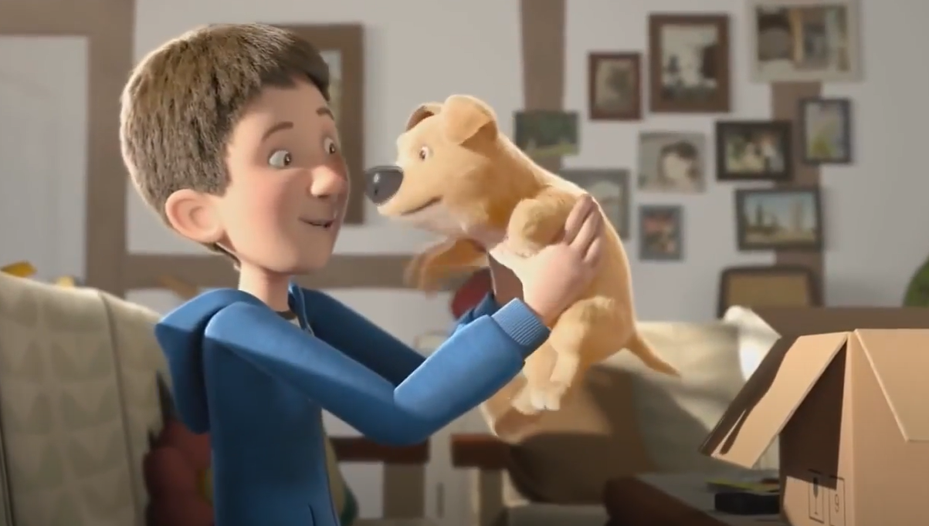  El niño abre su regalo y ve un perrito.  Students create a survey on leisure activities and give to classmates to complete. In Spanish, students write 3 statements or facts they have found in their data.  Students with a background in Spanish  Students write a summary of the film.  Students create a survey on leisure activities and give to classmates to complete. Students analyse the data from the survey and suggest generic changes to support physical and mental wellbeing. Students report findings and advice to the class. | Students express their opinions and justify these in small groups.  Students initiate and sustain a conversation about healthy and unhealthy choices and share information opinions and ideas.  Students with prior learning and/or experience  Students provide a visual summary of the film, with text and images.  Students create a survey and summarise the class data.  Students with a background in Spanish  Students provide a written summary of the film.  Students create a survey and analyse and present class data.
LSP5-3C  respond in English or Spanish to information, ideas and opinions, using a variety of text types and formats according to context, purpose and audience  LSP5-4C  compose a range of informative and imaginative texts using a variety of formats for different contexts, purposes and audiences  LSP5-6U  understand and use Spanish language and grammatical forms, and explore how to use/combine these elements to express complex ideas | Go through the assessment notification with your students and discuss any questions. Explain the marking guidelines and invite students to comment.  Read the article What makes a good video? and discuss the elements presented and how students can adapt these in their videos for Part A.  Revise structures for giving advice for Part B of the assessment task.  Allow some class time for planning and discussion and provide students with guidance as required. | Students with prior learning and or experience  Students read the article What makes a good podcast? 5 elements you should know Discuss the elements presented and encourage students to adapt 2-3 elements for their assessment of learning task.  Students create a podcast outlining 7 steps to a healthier lifestyle and offer written advice to a listener’s wellbeing/health issues.  Students with a background in Spanish  Students read 7 tips on how to present great radio. Discuss the elements presented and encourage students to pick 2-3 of these elements to include in their radio segment.  Students write and perform a script for a radio segment on wellbeing and offer spoken advice to a listener’s wellbeing/health issues. | Students create engaging content.  Students provide appropriate advice on a wellbeing/health issue.

Evaluation and variation
Record any variations you implemented, including extensions and adjustments for students with disability. The evaluation can include feedback from students.

Registration
Teacher name:
Teacher signature:
Date:

