Programming guidelines for classical languages 7-10
Note: This document provides advice only. It is the responsibility of individual school executive and teaching staff to ensure record keeping is compliant with both NSW Education Standards Authority (NESA) and departmental requirements and policies.

Introduction 2
Elements of a program 2
Scope and sequence 3
Units of work 3
Assessment 3
Assessment for learning 4
Assessment as learning 4
Assessment of learning 4
Register 5
Appendix 1 – scope and sequence checklist 6
Appendix 2 – unit of work checklist 7
Appendix 3 – assessment of learning checklist 8

Introduction
Programming is the process through which teachers select and sequence teaching, learning and assessment experiences which cater for the diversity of learners in a particular Stage/year. A program is all of the documents involved in the overall planning for each language and Stage/year that you teach.
Effective programs enable teachers to:
- plan for the delivery of syllabus outcomes and content
- improve student learning outcomes
- respond to student learning needs, school context, self-reflection and evaluation
- record planned learning experiences of how syllabus requirements are met.
A program is to be provided for each subject or course in each year of schooling in order to meet NESA school registration requirements.
The department also sets additional requirements, outlined in the Curriculum planning and programming, assessing and reporting to parents K-12 policy. (Note: If the link does not open, you can access via the policy library in the portal.)
A program allows for continuity of quality learning for students. Programs also allow other teachers to continue teaching your students if required, for example during periods of teacher absence.

Elements of a program
For each Stage/year and language, you need to have a program that includes the elements listed below.
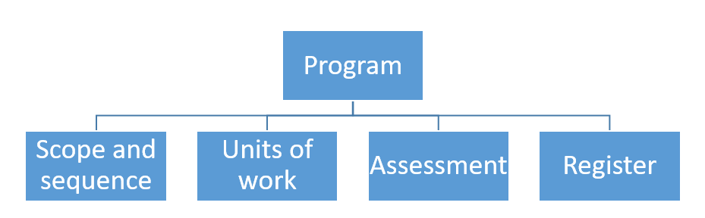

Scope and sequence
A scope and sequence summarises what is to be taught and the sequence in which it will be taught within a year or Stage. It includes the syllabus outcomes that each unit addresses.
See Appendix 1 for a detailed checklist to support you in developing your own scope and sequence documents.

Units of work
Units of work summarise the teaching and learning strategies, resources and assessment (both formal and informal) for a particular set of outcomes and content in the syllabus. They also include adjustments to meeting the learning needs of students, where required, and a section for reflection and evaluation.
When designing a unit of work, consider emphasising the equal significance and interdependence of the 3 objectives – Using language, Making linguistic connections and Moving between cultures.
The content in the syllabuses is expressed in the form of learn about and learn to statements connected to the course outcomes relating to each objective. The syllabus outcomes can be demonstrated through a range of contexts determined by the classroom teacher to take account of the needs, linguistic level of the students, resources and facilities of the school and its community.
See Appendix 2 for a detailed checklist to support you in developing your own units of work.

Assessment
NSW syllabuses and support materials promote an integrated approach to teaching, learning and assessment.
The purpose of assessment is to gather valid, reliable and useful information about student learning in order to:
- monitor student achievement in relation to outcomes
- guide future teaching and learning opportunities
- provide ongoing feedback to students to improve learning.
Students should be provided with opportunities to demonstrate their learning through a variety of assessment activities as part of an ongoing process. Whatever assessment strategies are used, it is important that activities are accessible to all students.
(Source: https://educationstandards.nsw.edu.au/wps/portal/nesa/k-10/understanding-the-curriculum/assessment/7-10-assessment-strategies)
Assessment for learning, assessment as learning and assessment of learning are 3 approaches to assessment that play an important role in teaching and learning.

Assessment for learning
Assessment for learning aims to close the gap between where a student is now and where they need to be, in order to successfully demonstrate their achievement of the outcomes. Teachers use evidence of students' knowledge, understanding and skills to inform their teaching and to provide feedback to students about their learning and how to improve.
It’s important to plan opportunities which allow for students to discover where there are now and enable them to plan how to move to the next stage of their learning.
For example:
- pre-testing for prior knowledge
- quizzes to monitor progress
- one-to-one feedback
- students plan own next steps to improve.
These activities are often teacher-driven, and have the aim of planning next steps to improve (also known as formative assessment).

Assessment as learning
Assessment as learning occurs when students are their own assessors. Students monitor their own progress, ask questions and practise skills. Students use self-assessment and teacher feedback to reflect on their learning, consolidate their understanding and work towards learning goals.
For example, students:
- provide feedback to peers
- complete online quizzes for immediate feedback
- compare own work against models and analyse differences.
These activities are often student-driven with the aim of planning next steps to improve (also known as formative assessment).

Assessment of learning
Assessment of learning allows teachers to gather evidence of achievement of learning goals and outcomes against standards, thus measuring student success – that is, summative assessment. We ask ourselves: Have the students demonstrated their achievement of the outcome/s and the learning goal?
We must ensure our assessment of learning task will generate the evidence of achieving the new outcomes.
See Appendix 3 for a detailed checklist to support you in developing effective assessment of learning tasks.

Register
A register is a document which tracks the progress of each unit of work, including any variations made, and allows for evaluation of the strategies and activities used. Teachers may approach this differently. For example, some teachers may annotate units of work, indicating when activities and tasks were completed by each class and noting any adjustments which were required, including a self-reflection. Other teachers may have their register as a separate document. It will depend on your school context.

Appendix 1 – scope and sequence checklist
- Does your scope and sequence contain all the necessary elements and fit on 1-2 A4 pages?
The necessary elements are:
- title of each unit
- sequence of each unit for the year/Stage
- duration of each unit
- syllabus outcomes included in each unit (as outcomes codes)
- final assessment of learning (summative assessment) task *
- additional information based on particular school requirements, if needed.
* This is not required by NESA for school registration but is recommended by the department as a key element to support planning.
- Which syllabus outcomes will you focus on in each unit?
You do not need to address every outcome in every unit of work, however it is important to ensure all outcomes are addressed across a Stage of learning.
- Do you want to base your units on topics, themes, key concepts or something else?
Remember to give equal emphasis to the significance and interdependence of the 3 objectives.
- In what order will you teach your units of work?
The acquisition of a language is a cumulative process therefore a continuous and sequenced approach is essential when developing your units of work. Use a spiral approach which gives students the chance to revisit what they have learned and use their language skills to participate in more complex situations. As a result, their knowledge is deepened and broadened, and they experience a feeling of success by building on prior learning.
- How many weeks will each unit take?
You can plan by weeks or by terms – this is up to you.
We also recommend you use “student-friendly” language in your scope and sequence and provide a copy to students at the start of the year. By addressing your students in your scope and sequence, you give students a sense of what they may be able to achieve by the end of each Stage/year, which can be motivating.

Appendix 2 – unit of work checklist
- Does your unit of work include all the elements required by NESA?
- unit description
- syllabus outcomes
- duration
- Stage or year
- range of relevant syllabus content
- integrated teaching, learning and assessment activities and tasks
- differentiation catering to the range of student abilities and interests
- opportunities to collect evidence of student achievement
- subject-specific requirements (not relevant for modern languages 7-10)
- resources
- reflection and evaluation
- adjustments for students with disability, where appropriate.
- Unit content
Have you:
- clearly described the teaching, learning and assessment activities, including differentiation, that will facilitate student attainment of the skills, knowledge and understanding to achieve the learning goal and successfully complete the assessment of learning task?
- incorporated students’ prior knowledge? (Ask: What do my students already know and what can they already do?) You can include pre-testing to determine the level of your students prior to starting a unit of work.
- included all the outcomes and learn about and learn to statements by the end of the Stage?
- considered equal emphasis to the significance and interdependence of the objectives?
- embedded learning across the curriculum content and key competencies where relevant?
- Outcomes
What is the evidence in the unit of work that the selected outcomes will be met?

Appendix 3 – assessment of learning checklist
- Have you listed the relevant syllabus outcomes?
- Does the task effectively allow students to demonstrate their achievement of the relevant outcomes?
- Does the task include explicit marking criteria so students know what aspects of learning are being assessed?
- Does the task include marking guidelines describing achievement across a range of marks/grades, to facilitate the provision of accurate information on each student’s achievement?
- Is the task inclusive of and accessible to all learners?
- Have you indicated how feedback will be provided?

