Stage 4 Korean – sample assessment task
Note to teacher: This is a sample only. Please modify according to student needs and your school context.

Unit – our top 10 favourite things to do

Outcomes
A student:
- LKO4-3C organises and responds to information and ideas in texts for different audiences
- LKO4-4C applies a range of linguistic structures to compose texts in Korean, using a range of formats for different audiences
- LKO4-6U demonstrates understanding of key aspects of Korean writing conventions
- LKO4-7U applies features of Korean grammatical structures and sentence patterns to convey information and ideas
All outcomes referred to in this unit come from Korean K-10 Syllabus © NSW Education Standards Authority (NESA) for and on behalf of the Crown in right of the State of New South Wales, 2018.

Assessment of learning task
Our school will be hosting 20 Korean students, and we need to start preparing our school community.

Part A
Design a bilingual infographic, in Korean and English, with our class’ top 10 favourite free time activities. Use an online infographic maker, for example Canva, Venngage, Piktochart, Visme, Infogram or Snappa – discuss with your teacher which option is best for you. (Note: If hyperlinks do not open, right-click and select copy, then paste the link into an internet browser tab.)

Part B
Read a short text about Korean teenagers’ free time interests. Then write a short article in English for your school’s newsletter, summarising the article for parents, and suggesting activities host families could try with the exchange students. Write approximately 150 words in English.

How you will be marked
In Part A, you will be marked on your ability to:
- write an informative infographic, presenting data through a visually engaging mixture of images and text, in English and Korean
- apply features of Korean writing conventions, grammatical structures and sentence patterns to convey information and ideas.
In Part B, you will be marked on your ability to:
- identify main ideas and information in the Korean text provided
- use this information to summarise key information in an article for parents in English.

Sample text for Part B
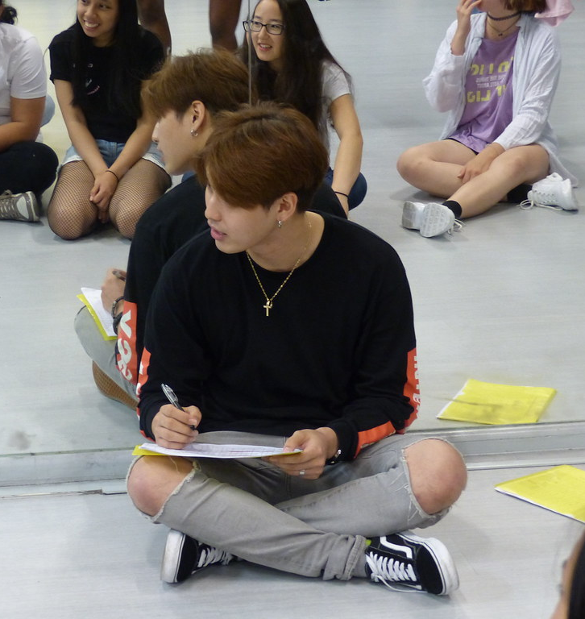
한국 학생들은 여가 시간에 뭐 해요?
무슨 여가 활동이 인기가 많아요?
여기 설문 조사 결과예요.
한국 학생들의 52%가 춤을 좋아해요.
케이팝 댄스가 제일 인기가 있어요.
많은 학생들이 댄스 스튜디오에서 춤을 배워요.
케이팝 스타일의 힙합 댄스가 유행이에요.
그리고 48% 학생들이 케이팝 노래 하기를 좋아해요.
케이팝은 신나요. 그리고 재미있어요.
36%의 학생들이 영화감상을 좋아해요.
학생들에게 액션 영화하고 판타지 영화는 인기가 많아요.
32%의 학생들이 온라인 컴퓨터 게임을 좋아해요.
많은 학생들이 온라인으로 스포츠 게임을 해요.
부모님들은 온라인 게임 중독을 걱정해요.
그 다음으로는 음악 감상(27%), 영화 만들기(23%), 사진 찍기(17%), 요리 하기(14%)가 인기가 있어요.
운동이 중요해요. 그런데 한국 고등학생에게 운동은 인기가 없어요.

Image source: KPop – "P1000259" by ericcooper3 licensed under CC BY-NC-SA 2.0

Marking guidelines – version A

Part A
Outcomes | A | B | C | D | E
LKO-4C | Creates a well-designed and visually engaging bilingual infographic with clear and accurate information on the class’ top 10 favourite free time activities. | Creates an organised bilingual infographic with clear information on the class’ top 10 favourite free time activities. | Creates a bilingual infographic with text and images, including information on the class’ top 10 favourite free time activities. | Submits an infographic with some bilingual text and/or images, including some information on the class’ top 10 favourite free time activities. | Submits some text in Korean and/or images. Attempts to include information on the class’ top 10 favourite free time activities.
LKO4-6U | Demonstrates extensive understanding of key aspects of Korean writing conventions. | Demonstrates thorough understanding of key aspects of Korean writing conventions, with minimal errors. | Demonstrates sound understanding of key aspects of Korean writing conventions, with some errors. | Demonstrates basic understanding of key aspects of Korean writing conventions, with errors which may hinder comprehension. | Demonstrates elementary understanding of key aspects of Korean writing conventions, with frequent errors which impact comprehension.
LKO4-7U | Applies an extensive range of grammatical structures and sentence patterns, with accuracy. | Applies a thorough range of grammatical structures and sentence patterns, with minimal errors. | Applies a sound range of grammatical structures and sentence patterns, with some errors. | Applies a basic range of grammatical structures and sentence patterns, with errors which may hinder understanding. | Applies an elementary range of grammatical structures and sentence patterns, with limited use of Korean.

Part B
LKO4-3C | Demonstrates extensive understanding of the text by writing an effective article of approximately 150 words in English for parents, including all of the following:  - a summary of the Korean teenagers’ free time interests, with reference to the text  - suggested activities host families could try with the exchange students, with reference to the text. | Demonstrates thorough understanding of the text by writing an engaging article of approximately 150 words in English for parents, including all of the following:  - a summary of the Korean teenagers’ free time interests, with reference to the text  - suggested activities host families could try with the exchange students, with reference to the text. | Demonstrates sound understanding of the text by writing an article of approximately 150 words in English for parents, including all of the following:  - a summary of the Korean teenagers’ free time interests, with reference to the text  - suggested activities host families could try with the exchange students, with reference to the text. | Demonstrates basic understanding of the text by writing text of 80-120 words in English for parents, including some of the following:  - a summary of the Korean teenagers’ free time interests, with reference to the text  - suggested activities host families could try with the exchange students, with reference to the text. | Demonstrates elementary understanding of the text by writing some text in English for parents, including some of the following:  - a summary of the Korean teenagers’ free time interests, with reference to the text  - suggested activities host families could try with the exchange students, with reference to the text.

Marking guidelines – version B

Part A
Criteria | Grade
- Creates a well-designed and visually engaging bilingual infographic with clear and accurate information on the class’ top 10 favourite free time activities.  - Demonstrates extensive understanding of key aspects of Korean writing conventions.  - Applies an extensive range of grammatical structures and sentence patterns, with accuracy. | A
- Creates an organised bilingual infographic with clear information on the class’ top 10 favourite free time activities.  - Demonstrates thorough understanding of key aspects of Korean writing conventions, with minimal errors.  - Applies a thorough range of grammatical structures and sentence patterns, with minimal errors. | B
- Creates a bilingual infographic with text and images, including information on the class’ top 10 favourite free time activities.  - Demonstrates sound understanding of key aspects of Korean writing conventions, with some errors.  - Applies a sound range of grammatical structures and sentence patterns, with some errors. | C
- Submits an infographic with some bilingual text and/or images, including some information on the class’ top 10 favourite free time activities.  - Demonstrates basic understanding of key aspects of Korean writing conventions, with errors which may hinder comprehension.  - Applies a basic range of grammatical structures and sentence patterns, with errors which may hinder understanding. | D
- Submits some text in Korean and/or images. Attempts to include information on the class’ top 10 favourite free time activities.  - Demonstrates elementary understanding of key aspects of Korean writing conventions, with frequent errors which impact comprehension.  - Applies an elementary range of grammatical structures and sentence patterns, with limited use of Korean. | E

Part B
Criteria | Grade
- Demonstrates extensive understanding of the text by writing an effective article of approximately 150 words in English for parents, including all of the following:  - a summary of the Korean teenagers’ free time interests, with reference to the text  - suggested activities host families could try with the exchange students, with reference to the text. | A
- Demonstrates thorough understanding of the text by writing an engaging article of approximately 150 words in English for parents, including all of the following:  - a summary of the Korean teenagers’ free time interests, with reference to the text  - suggested activities host families could try with the exchange students, with reference to the text. | B
- Demonstrates sound understanding of the text by writing an article of approximately 150 words in English for parents, including all of the following:  - a summary of the Korean teenagers’ free time interests, with reference to the text  - suggested activities host families could try with the exchange students, with reference to the text. | C
- Demonstrates basic understanding of the text by writing text of 80-120 words in English for parents, including some of the following:  - a summary of the Korean teenagers’ free time interests, with reference to the text  - suggested activities host families could try with the exchange students, with reference to the text. | D
- Demonstrates elementary understanding of the text by writing some text in English for parents, including some of the following:  - a summary of the Korean teenagers’ free time interests, with reference to the text  - suggested activities host families could try with the exchange students, with reference to the text. | E

