Stage 4 Italian – mandatory 100 hours (10 weeks)
This unit starter can be modified to suit the needs of your learners, including adding your own resources, modifying content or duration and differentiating for learning needs and learner groups. The learning, teaching and assessment strategies and assessment task are suggestions only.

Mangiamo! – Let’s eat!
Italians are deeply proud of their cuisine and food is an integral part of the Italian culture, going beyond nourishment. It’s about making connections – large extended family groups come together to eat as often as possible and enjoy eating out regularly. Italian cuisine also plays an important role in Australia. In this unit starter, students explore the world of Italian food, order food and drinks, express preferences, and understand Italian cuisine and the cultural role it plays in daily life.

Outcomes
- LIT4-1C – uses Italian to interact with others to exchange information, ideas, and opinions, and make plans
- LIT4-2C – identifies main ideas in, and obtains information from texts
- LIT4-3C – organises and responds to information and ideas in texts for different audiences
- LIT4-4C – applies a range of linguistic structures to compose texts in Italian, using a range of formats for different audiences
- LIT4-5U – applies Italian pronunciation and intonation patterns
- LIT4-6U – applies features of Italian grammatical structures and sentence patterns to convey information and ideas
- LIT4-7U – identifies variations in linguistic and structural features of texts
- LIT4-8U – identifies that language use reflects cultural ideas, values, and beliefs
All outcomes referred to in this unit starter come from the Italian K-10 Syllabus © NSW Education Standards Authority (NESA) for and on behalf of the Crown in right of the State of New South Wales, 2018.

Key inquiry questions | Learning across the curriculum
- What role does food (and coffee!) play in Italian cultures?  - How does this differ from our own cultures?  - What do you need to know when eating out in Italy?  - What are some of the typical dishes?  - How does Italian food vary from region to region?  - How do we express preferences and order food/drink? | - Critical and creative thinking (collaborative tasks and activities)  - Intercultural understanding (value own and other cultures and beliefs)  - Literacy (types of texts, register)  - Numeracy (working out costs and tips)

Vocabulary and structures
Dining venues | Interacting with friends – what you feel like eating/drinking and preferences | Ordering food | Menu items, food and drink (singular and plural) | Definite and indefinite articles | Adverbs and adjectives
- al ristorante  - al bar  - a casa  - in trattoria  - in pizzeria  - da un amico | - Ho fame/sete  - Ho una fame da lupo  - Buon appetito!  - Cosa prendi?  - Da bere/mangiare prendo...  - Cosa ti piace?  - Ti piace/piacciono…?  - Sì, mi piace/piacciono...  - No, non mi piace/piacciono...  - Quale preferisci?  - Preferisco/adoro/odio/detesto...  - Il mio cibo/piatto preferito è…  - Che schifo!  - Buonissimo! | - Desidera?  - Cosa vuole/prende Lei?  - Vorrei…  - Desidero…, per favore/per piacere  - Prego | - antipasti, primi, secondi, contorni, insalate, bevande  - favourite/least favourite foods (as identified by class)  - caffè, cappuccino, espresso, tè, cioccolata calda  - coca cola, limonata, aranciata, acqua minerale  - gelato (al cioccolato, al pistacchio, alla nocciola, alla vaniglia, alla fragola, al limone)  - pizza con funghi/prosciutto/salsiccia/  rucola/mozzarella/olive/  patate/carciofi | - l’, il, lo, la  - i, gli, le  - un, una, uno, un’ | - molto  - troppo  - buono  - bianco  - rosso  - grande  - piccolo  - caldo  - freddo  - dolce  - piccante

Final assessment task
Note: This assessment task, including marking guidelines, is available from the Stages 4 and 5 Italian section of our website.
In groups of 3-4, imagine you are planning a night in with friends and want to order pizzas. Using an Italian menu provided to you, discuss what to order with your group and why. Place your order. Film or present the interaction in a role play. (LIT4-1C, LIT4-3C, LIT4-5U, LIT4-6U)
Students with a background in Italian
In pairs, imagine you run a YouTube channel reviewing restaurants. Using an Italian menu provided to you, film your review of the pizzeria, recounting what you ate, what you enjoyed and didn’t enjoy. Rate the pizzeria. (Note: If you only have one background speaker in the class, the student can complete the task with you, or with a family member.)
(LIT4-1C, LIT4-3C, LIT4-5U, LIT4-6U)

Unit plan
Sequence | Outcome | Suggested strategies and assessment | Evidence of learning
Week 1 | LIT4-2C  Identifies main ideas in, and obtains information from texts  LIT4-7U  Identifies variations in linguistic and structural features of texts  LIT4-8U  Identifies that language use reflects cultural ideas, values and beliefs  Students with a background in Italian  LIT4-1C  Uses Italian to interact with others to exchange information, ideas and opinions, and make plans  LIT4-4C  Applies a range of linguistic structures to compose texts in Italian, using a range of formats for different audiences  LIT4-6U  Applies features of Italian grammatical structures and sentence patterns to convey information  LIT4-8U  Identifies that language use reflects cultural ideas, values and beliefs | To introduce the topic, use the lesson ideas – dinnertime around the world resource.  Display the menu explanation image to the class. Working in groups of 3-4, students deduce the meaning of each category by identifying key words. Allow 5-10 minutes (with no technology, just brains), then share findings.  Introduce food venues: Dove si mangia? Watch video on Eating out in Italy, then add images to a simple menu template according to categories – antipasti, primo, secondi, contorno, insalate, dolce, bevande. This could be created in Google Slides in grid view, for example:  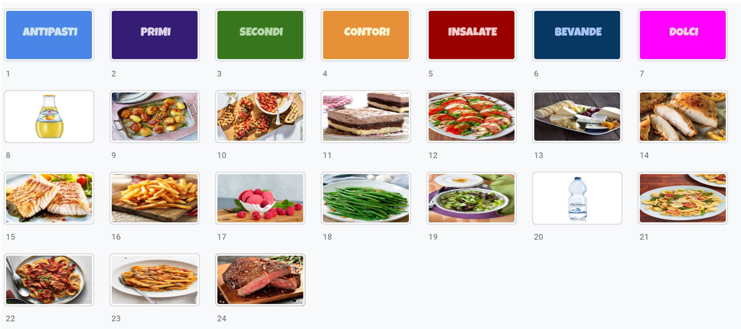  Alternatively, it could be provided as a cut-and-paste activity on a worksheet, for example:  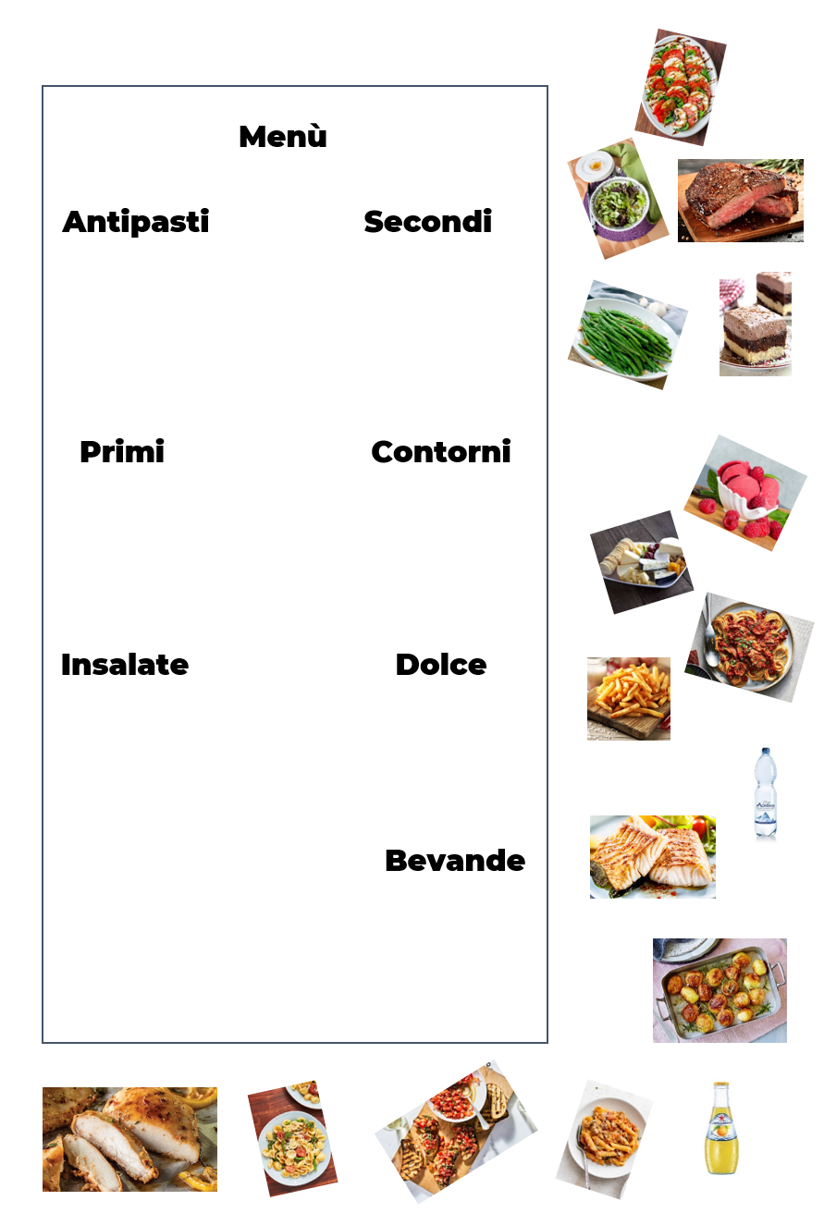  Discover what students know about Italian food. In small groups, students brainstorm the Italian foods they know or have tried. Each group presents their findings to class, with teacher elaboration/explanation, as required.  Final results are summarised, in categories such as entrees, mains, desserts, drinks, venues, meal times, food and ingredients, and so on. Headings are presented in English and Italian. Identify and discuss the impact Italian cuisine has had on our cultures.  Watch Jamie’s Great Italian Escape: Altamura on Italian school meals. Students complete a PMI (positive, minus, interesting) chart on the different eating habits and meal times between Australia and Italy.  Students with a background in Italian  Students design a online survey/Google Form, with images, to establish the favourite and least favourite foods of the class, for example:  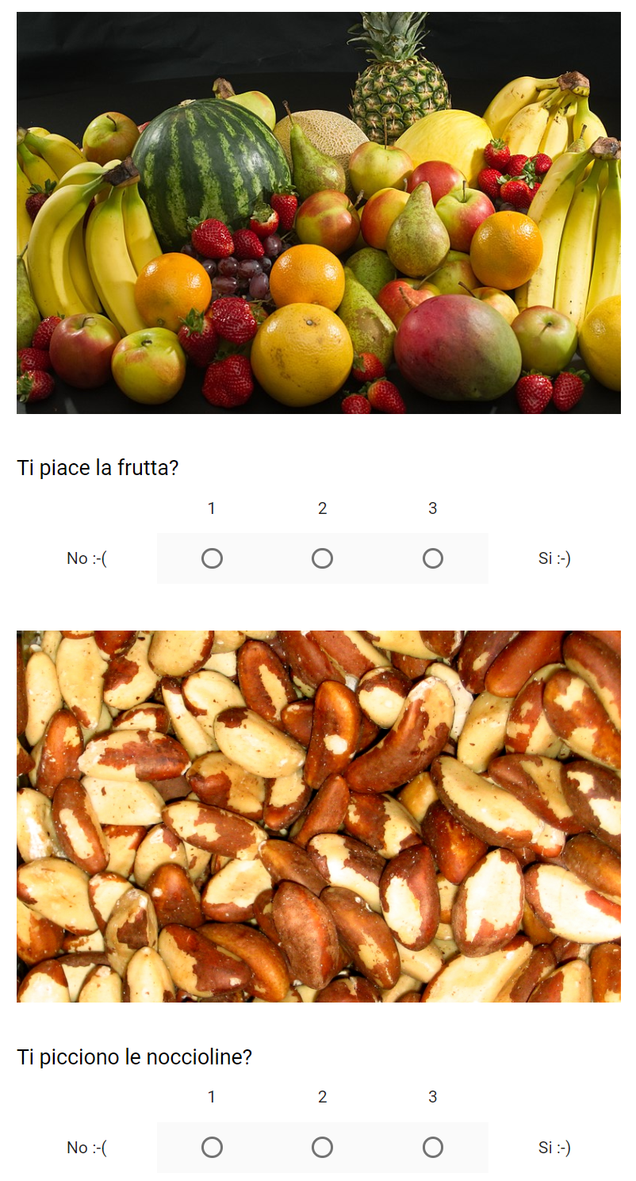  Students record interviews with their family members about favourite and least favourite foods and drinks (with reasons) and provide a transcript. | Participation in activities and discussions  Accurate completion of menu activity – food is added under the correct categories  Completion of PMI chart with clear and detailed cultural contrasts  Correct pronunciation  Students with a background in Italian  Participation in activities and discussions  Engaging survey for students with limited Italian  Recording of interview, including a range of structures relating to food preferences  Accurate grammar and spelling in transcription
Weeks 2-3 | LIT4-1C  Uses Italian to interact with others to exchange information, ideas and opinions, and make plans  LIT4-5U  Applies Italian pronunciation and intonation patterns  LIT4-6U  Applies features of Italian grammatical structures and sentence patterns to convey information  Students with a background in Italian  LIT4-1C  Uses Italian to interact with others to exchange information, ideas and opinions, and make plans  LIT4-4C  Applies a range of linguistic structures to compose texts in Italian, using a range of formats for different audiences  LIT4-5U  Applies Italian pronunciation and intonation patterns  LIT4-6U  Applies features of Italian grammatical structures and sentence patterns to convey information  LIT4-8U  Identifies that language use reflects cultural ideas, values and beliefs | Use key menu items to discuss/reinforce Italian pronunciation. Watch How to pronounce pasta in Italian.  Restaurant dash (pronunciation game): Divide students into 5-6 groups of 3 diners each, 5-6 wait staff (one for each group of diners) and 3-4 chefs. Using the food cards provided, ‘customers’ tell the ‘wait staff’ their order. The ‘wait staff’ then remember the words, and go to one of the ‘chefs’, who then finds the matching card to take back to the customer.  Discuss the different types of pasta and their translations, for example farfalle bow ties, penne pens. Discuss al dente. Practise pronunciation and intonation.  Complete the online survey designed by students with a background in Italian to identify the class’ likes and dislikes in relation to food.  Discuss survey findings and identify 10-12 vocabulary items which will form the basis of practising structures in this unit – include a range of feminine, masculine, singular and plural nouns.  Discuss/explain gender and definite articles using vocabulary, and reinforce with oral and written activities. Reinforce with Quizlet flashcard set developed by students with a background in Italian (see below).  Using visual aids, introduce preferences for singular and plural foods, for example Mi piace l’insalata, ma non mi piacciono gli spaghetti. Students practise in small groups, asking each other about likes and dislikes, with visual aids.  Using the likes-dislikes cards, students practise question/answer structure and definite articles.  Students with a background in Italian  Students create a Quizlet flashcard set for the class (based on the 10-12 vocabulary items), recording their pronunciation of vocabulary.  Students write a simple sentence for each eating venue, to describe the different types of eating venues (al ristorante, al bar, in trattoria, in pizzeria). Include the types of food and/or drink you may find there. For example, In trattoria, si mangia il cibo rustico per esempio la pasta.  In pairs, create and video a role play between a customer and wait staff, emphasising key words – Prendo…, Vorrei…, Desidero…, per favore? Prego?, Cosa vuole? Ecco…  Create a worksheet for classmates, in which they match key words to their English meanings. | Participation in activities and discussions  Correct pronunciation  Accurate completion of survey  Accurate responses to games  Students with a background in Italian  Participation in activities  Pronunciation for Quizlet is accurate  Accurate completion of written activities  Video includes a range of key vocabulary items relating to ordering food, reflected in the worksheet
Weeks 4-5 | LIT4-1C  Uses Italian to interact with others to exchange information, ideas and opinions, and make plans  LIT4-2C  Identifies main ideas in, and obtains information form texts  LIT4-5U  Applies Italian pronunciation and intonation patterns  LIT4-6U  Applies features of Italian grammatical structures and sentence patterns to convey information  LIT4-8U  Identifies that language use reflects cultural ideas, values and beliefs  Students with a background in Italian  LIT4-4C  Applies a range of linguistic structures to compose texts in Italian, using a range of formats for different audiences  LIT4-6U  Applies features of Italian grammatical structures and sentence patterns to convey information  LIT4-8U  Identifies that language use reflects cultural ideas, values and beliefs | Revise key vocabulary and preferences and reinforce using Quizlet/Duolingo/Kahoot games, including Quizlet flashcards created by students with a background.  Develop skills in expanding on likes and dislikes, using sentence builders (see sample below):  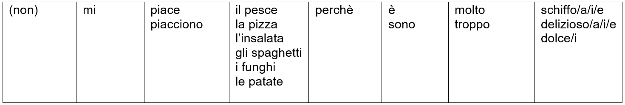  Delayed dictation activity: Say a sentence that students are familiar with (using the above sentence builders as a guide) and then count to 10 in Italian, before asking them to write down the sentence. Students then write the sentence down on their mini whiteboards/on paper (in large script) and show you.  Reinforce articles, gender and noun agreement through a range of oral and written activities. Introduce indefinite articles of known words through a memory game, for example matching una limonata to la limonata.  Introduce and practise a range of structures to support interactions relating to food, for example Ho fame/sete, Il mio cibo/piatto preferito è…, Preferisco, Detesto…  As a class, discuss places where students eat out, including when they may go to each place and what types of food and drink they enjoy there.  Read and discuss Italian eating venues (as prepared by students with a background) – what are the similarities and differences?  Students listen to the recordings prepared by the students with a background in Italian about family food preferences and identify key information.  Introduce gelato vocabulary (including flavours) in conjunction with likes/dislikes vocabulary (Quale gusto preferisci?, Ti piace …?)  Reinforce gelato vocabulary with song Vorrei un gelato.  Students watch video on ordering gelato and use it to practise pronunciation of vocabulary, with a focus on intonation and expression.  Introduce Prego? and Vorrei…  Students prepare a role play, between 2 customers and a gelateria server.  Students with a background in Italian  Interview an Italian speaker about popular dining venues and submit the transcript.  Create a video or infographic demonstrating how to make a regional dish of their choice in Italian, with subtitles in English, for display in the classroom/Google Classroom. | Participation in activities and discussions  Correct pronunciation of vocabulary  Accurate responses to games  Correct identification of food preferences when listening to texts  Confident and accurate interaction in spoken Italian, within the context  Accurate and detailed transcript of role-play  Students with a background in Italian  Participation in activities  Accurate and detailed transcript of interview  Accurate and engaging video/infographic
Weeks 6-7 | LIT4-7U  Identifies variations in linguistic and structural features of texts  LIT4-8U  Identifies that language use reflects cultural ideas, values and beliefs  Students with a background in Italian  LIT4-1C  Uses Italian to interact with others to exchange information, ideas and opinions, and make plans | Revise food preferences and gelato flavours.  Students design a menu for the class gelateria to be held the following week.  Watch video created by students with a background (in Weeks 2-3), introducing key phrases relating to ordering food, and complete worksheet.  Introduce al bar (café) vocabulary and revise ordering vocabulary, for example vorrei, desidera, prego.  Watch video on ordering coffee in Italy.  Students consolidate vocabulary using Quizlet/Duolingo/Kahoot games.  Discuss ‘social norms’ related to coffee drinking in Italy, for example no milk past 10am, paying before ordering, standing versus sitting. Intercultural discussion: What do these norms show us about Italian culture? How is this different and/or similar to Australian coffee culture?  Introduce Italian regional dishes by watching the short regional dishes video. Students research a recipe they’d like to make and contribute to a class recipe e-book, Cucina regionale, with ingredients listed in Italian and English and the method in English, for sharing with the school community.  Students with a background in Italian  Contribute to class discussion using their own experiences and knowledge of customs.  Students interview each other about the ‘social norms’ they have noticed about Australia’s coffee culture, and how it compares to Italy’s. | Participation in activities and discussions  Correct pronunciation of vocabulary  Accurate responses to games  Confident and accurate interaction in spoken Italian, within the context  Engaging and accurate contribution to e-book, following correct layout for a recipe  Students with a background in Italian  Participation in activities and discussions  Confident and accurate interaction in spoken Italian, using a range of vocabulary and sentence structures
Weeks 8-9 | LIT4-1C  Uses Italian to interact with others to exchange information, ideas and opinions, and make plans  LIT4-2C  Identifies main ideas in, and obtains information form texts  LIT4-5U  Applies Italian pronunciation and intonation patterns  Students with a background in Italian  LIT4-4C  Applies a range of linguistic structures to compose texts in Italian, using a range of formats for different audiences  LIT4-6U  Applies features of Italian grammatical structures and sentence patterns to convey information  LIT4-7U  Identifies variations in linguistic and structural features of texts | Students finalise their recipes for the e-book.  Students visit the class gelateria, run by the students with a background in Italian. Students order in Italian, and ‘pay’ with Euro.  Students look at a menu from an Italian pizzeria and identify key items. Discuss differences between Italian pizzas and Australian-style pizzas, including types and toppings, for example pizza rossa, pizza bianca, pizza napoletana, pizza romana, quattro stagioni.  Students complete a numeracy activity (see the German sample on the curriculum website, as a guide) to consolidate menu reading and calculate costs and tips.  Students with a background in Italian  Create a poster advertising an Italian dessert or design a competition (poster) inviting students to enter in a dessert making competition. Students could use Adobe Spark or Canva (aged 13+ years) to create their poster. Note: Canva requires Chrome to run, so right-click on the hyperlink, then copy the link and paste it into your Chrome internet browser. | Participation in activities and discussions  Correct pronunciation of vocabulary  Confident and accurate interaction in spoken Italian, within the context  Completion of numeracy activity, showing appropriate level of understanding  Students with a background in Italian  An engaging poster, using a range of vocabulary and grammatical structures
Week 10 | LIT4-1C  Uses Italian to interact with others to exchange information, ideas and opinions, and make plans  LIT4-3C  Organises and responds to information and ideas in texts for different audiences  LIT4-5U  Applies Italian pronunciation and intonation patterns  LIT4-6U  Applies features of Italian grammatical structures and sentence patterns to convey information | Revise vocabulary and structures through a range of activities in preparation for the assessment of learning task.  Assessment of learning  In groups of 3-4, imagine you are planning a night in with friends and want to order pizzas. Using an Italian menu provided to you, discuss what to order with your group and why. Place your order. Film or present the interaction in a role play.  Students with a background in Italian  In pairs, imagine that you run a YouTube channel reviewing restaurants. Using an Italian menu provided to you, film your review of the pizzeria, recounting what you ate, what you enjoyed and didn’t enjoy. Rate the pizzeria. (Note: If you only have one background speaker in the class, the student can complete the task with you, or with a family member.)  Celebrate the end of unit with a dessert competition. Invite the school executive and students with a background to judge. | Refer to marking guidelines

Evaluation and variation
Record any variations you implemented, including extensions and adjustments for students with special education needs. The evaluation can include feedback from students.

Registration
Teacher name:
Teacher signature:
Date:

