Stage 6 Chinese Extension – support materials

Introduction to the Chinese Extension course support materials 4
Structure of the Chinese Extension course 4
Prescribed issues 5
Objectives and outcomes 5
Familiarising students with the prescribed issues through related texts 6
Preparing students to present opinions and argue a case 7
Soapbox activity 7
Brainstorming and mind-mapping 8
Class discussions 12
Presenting a point of view 12
Developing skills for monologues and short essays 13
Developing knowledge of specialist vocabulary 14
Recording responses 14
Sample dot points from similar prescribed issues in other languages 15
HSC Standards Packages 15
Proformas for planning monologues and essay writing 16
Sample planning proforma 1 17
Sample planning proforma 2 18
Writing and speaking 19
Producing authentic texts 19
Glossary of key words for the HSC 21
Overview of syllabus text types 22
Suggestions for teaching film 26
The director 26
The cast 26
The screenplay 26
The production design 26
Film techniques 27
Other important elements 32
Film techniques template 34
Activities to develop global understanding of the film 36
Prescribed text 37
Background to the film 38
Extract 1 (5:45 to 11:00) 42
Extract 2 (15:45 to 21:00) 48
Extract 3 (1:03.16 to 1:07.22) 53
Extract 4 (1:19.03 to 1:23.26) 57
Sample analysis of text questions 60
Part A 60
Part B 60
Sample speaking and writing task 61
Additional resources 62

© State of New South Wales (Department of Education) 2019
These support materials were produced by the NSW Department of Education (the department). This publication is copyright to the department, however it may contain material from other sources that is not owned by the department.
Outcomes and other syllabus material referenced in this document are from the Chinese Extension Stage 6 Syllabus © NSW Education Standards Authority (NESA) for and on behalf of the Crown in right of the State of New South Wales, 2009.
Screenshots (or stills) from ‘Young style’ – English and Chinese, produced by CCTV Movie Channel, China Film Co. and Hubei Huanggang Radio and Television and Media Co., directed by Jie Liu and written by Shan Gao, Jie Liu, Xiaowei Tian and Zhu Zhu.

Disclaimer
The interpretation presented in these materials should not be regarded as definitive. Although the notes provide support to the Chinese Extension prescribed text, they are not to be considered authoritative.
Please note that this resource is intended only as an introduction to the study of the prescribed text and issues, and does not attempt to cover all aspects of the Chinese Extension course. It is envisaged that teachers will draw from these materials according to the needs of their students rather than using every item, and that they will supplement these notes with additional material.

Controversial issues in schools
In exploring the issues prescribed for the Chinese Extension course, teachers are to adhere to the department’s policy: Controversial Issues in Schools. The policy provides direction for management of controversial issues in schools, whether by the use of teaching and learning materials or views expressed by teachers or visiting speakers. The policy can be accessed on the department’s policy library.

Third party sites
This resource contains links to third party websites and resources. The department is not responsible for the condition or content of these sites or resources, as they are not under the control of the department.

Introduction to the Chinese Extension course support materials
These materials were prepared for teachers of the Chinese Extension course. They aim to support the teaching of the prescribed text and the prescribed issues, helping students achieve the outcomes of the Chinese Extension Stage 6 Syllabus. They have been designed to be used as introductory material to be further developed by the teacher as part of their lesson planning. In order to deliver lessons that are specifically tailored to the needs and interests of their own students, teachers may wish to use excerpts from these materials, in conjunction with their own related activities and texts.
The Chinese Extension course requires 60 indicative hours to complete, and the Chinese Continuers HSC course is a co-requisite.
Study of the text prescribed for any Year 12 course may not begin before the completion of the Year 11 course. This exclusion applies to study in the Year 11 Chinese Continuers course and to Year 11 courses in other subjects. It also applies to the study of a prescribed text in another medium, such as the film of a novel.

Structure of the Chinese Extension course
The organisational focus of the Chinese Extension course is the theme – the individual and contemporary society.
A number of issues that exemplify aspects of the theme are prescribed for study. Students engage with the issues through the study of a prescribed text and related texts.
Students need to be familiar with the whole prescribed text.
Students may benefit from reading the HSC examinations in Extension languages – advice to students, as they prepare for the HSC.

Exploring the prescribed issues through the prescribed texts
The study of the prescribed issues through the prescribed text will involve:
- exploring the relationship between the issues and the prescribed text
- creating original text in response to aspects of the prescribed text
- identifying meaning and how it is conveyed in the prescribed text
- evaluating linguistic and cultural features of the prescribed text
- analysing the sociocultural context of the prescribed text.

The study of the prescribed issues through related texts
Study of the themes and issues through other related texts will allow students to:
- read, view and/or listen to a range of texts
- further develop knowledge of Chinese-speaking communities
- evaluate how the issues are presented in these texts.

You can view the syllabus and the 2020-2024 course prescriptions on the NESA website.

Prescribed issues
Education | Relationships | Division in society
For example:  - role of education  - pressures and expectations  - personal goals | For example:  - family relationship  - the world of the young  - responsibility towards others | For example:  - poverty and wealth  - personal identity  - coping with reality
The prescribed issues are mandatory, the dot points are not. They are suggestions only and are included to give a sense of the scope of the prescribed issues.

Objectives and outcomes
Objectives | Outcomes
- Present and discuss opinions, ideas and points of view in Chinese | 1.1 discusses attitudes, opinions and ideas in Chinese  1.2 formulates and justifies a written or spoken argument in Chinese
- Evaluate, analyse and respond to the text that is in Chinese and that reflects the culture of Chinese-speaking communities | 2.1 evaluates and responds to text personally, creatively and critically  2.2 analyses how meaning is conveyed  2.3 analyses the social, political, cultural and/or literary contexts of text that is in Chinese

Familiarising students with the prescribed issues through related texts
Before you start the study of the prescribed text, spend some time familiarising students with the prescribed issues through related texts. You will continue to use related texts throughout the course, however it is important that students have a broader understanding of the issues before studying the prescribed text.
Students should engage with a variety of texts on the prescribed issues, discussing their ideas and opinions in class. This will give them an in-depth understanding from a number of perspectives and provide them with the vocabulary and range of ideas to assist in the oral and written sections of the Extension examination.
Reading and listening texts should be chosen which are appropriate to Extension level, but which also provide students with a range of vocabulary and linguistic structures to support them in expressing their own ideas in spoken and written form.
It is important to remember that the 3 prescribed issues can be studied from a number of perspectives, and that the sub-topics provided are suggestions only. There may be other sub-topics that can be explored through related texts and the prescribed text.
The benefit of using a wide range of texts is that students will gain an in-depth background from which to draw ideas, and will develop the tools (including a more sophisticated approach to the issues) to enable them to answer any question in the HSC examination.
The following steps may assist teachers in teaching the issues. Not all steps would need to be included, depending on the length and complexity of the text.
- Find a suitable text (written, aural or visual), which is interesting, accessible and contains relevant vocabulary.
- Brainstorm the topic beforehand, creating a mind-map in Chinese of the students’ thoughts, relevant vocabulary.
- Read, view or listen to the text. Ask questions in Chinese where appropriate, paraphrasing the text where necessary.
- Explore key vocabulary, grammar and sentence structures.
- Discuss the main points of the text, creating a bullet-point summary together.
- Analyse the purpose, context and audience of the text.
- Brainstorm possible side issues, identifying useful expressions.
- Allow students to formulate their own opinions about the issues raised in the text and express their ideas through speaking or writing.
- Compare and contrast between the way the issue(s) is explored in the related text and in the prescribed text.
- Create a task in which students are required to use new vocabulary and expressions in new contexts – for example, class debate, role-play or monologue.
- Ask students to research their own text and present it to the class, focusing on the issues discussed and the perspectives from which these issues are presented.

Preparing students to present opinions and argue a case
To achieve the outcomes of the Extension syllabus, students must be able to use the target language to discuss attitudes, opinions and ideas and to formulate and justify an argument.
To prepare students to respond capably to a broad range of questions, beyond just the sub-topics of the prescribed issues, teachers need to use strategies that encourage students to think in terms of opinions and arguments.
Emphasis needs to be placed on developing skills that can be applied to any content. Students should not attempt to fit a prepared response to a question, but rather use general structures and prepare a range of phrases that could be used to present any opinion and justify any argument. Students need to be exposed to a variety of topics and trained to quickly develop a logical argument with their own point of view embedded in the response.
Activities and resources that could be used to develop this include:
- soapbox activity
- brainstorming and mind-mapping
- class discussions
- presenting a point of view
- developing skills for monologues and short essays
- developing knowledge of specialist vocabulary
- recording responses
- sample dot points from similar prescribed issues in other languages
- HSC Standards Packages (2002).

Soapbox activity
A soapbox is an impromptu speech on a set topic. To familiarise students with current affairs and to encourage speaking, ask students to discuss something that has occurred in world current affairs that week that is of interest to them.
Consider doing soapbox initially in English, until students are familiar with the format. Once the students are ready to practise the activity in Chinese, limit the scope to the prescribed issues, discussing any relevant current news items, songs or TV programs that raise similar issues. To engage the whole class, have students complete a table, like the one below, while listening to their classmates speak. Review unfamiliar vocabulary before moving on to the next student.
Language structures used | Unfamiliar vocabulary

Brainstorming and mind-mapping
Have students brainstorm the prescribed issues and complete a mind-map to organise their thoughts. Students should think broadly about subjects that would relate to specific issues. Graphic organisers are useful tools to assist students in organising each prescribed issue into topics and sub-topics.
Useful graphic organisers include:
- placemat protocols
- plus/minus/interesting (PMI) charts
- affinity diagrams
- lotus diagrams.

Placemat protocols
These are useful for achieving breadth and depth in monologues and short essays on a topic. They can be used to:
- critically assess texts
- develop a comprehensive range of strategies and skills appropriate to the text being read
- justify a point of view.
Procedure
- Use a marker pen to divide an A3 sheet of paper into the format shown below.
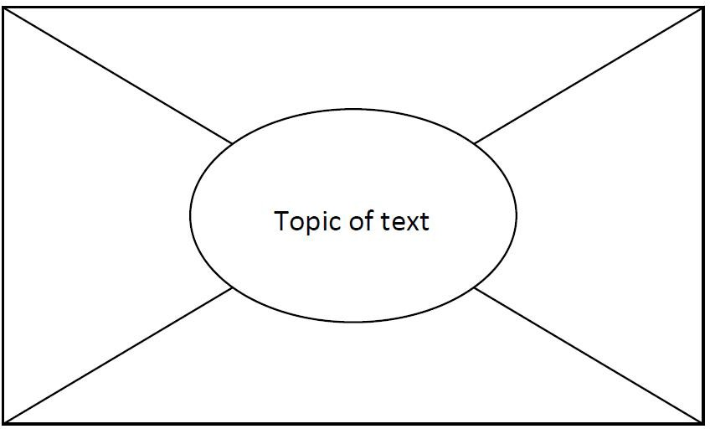
- Divide the class into groups of 4 and give each group 1 ‘placemat’ (A3 sheet).
- Nominate a group leader. The group leader cuts sections of the placemat and gives each student in the group one of the outside sections.
- Give students (including the group leader) a selected text to read individually.
- The group leader writes the topic of the text in the centre section of the placemat.
- After a predetermined period (the length of time will depend on the length and complexity of the text), ask students to summarise the most important points they have read in the text in dot point form on their section of the placemat.
- Reassemble the placemat.
- In the centre of the placemat, the group leader lists common points identified by all four students.
- When this is complete, give each student a specific period of uninterrupted time (for example 3 minutes) to justify orally the inclusion of individual points not listed by others (those that are not listed in the centre of the placemat).
- The group leader presents a summary of findings to the whole class.

Plus/minus/interesting (PMI) charts
These graphic organisers are useful for looking at both sides of an argument, or seeing things from a different perspective. The PMI chart is a creative thinking strategy used in Edward De Bono’s CoRT Thinking Program.
PMI charts help students to:
- see both sides of an argument
- view things from a different point of view
- think broadly about an issue
- suspend judgement
- make informed decisions
- work as individuals, in pairs or as members of a group.
Procedure
The strategy can be used in a range of classroom activities, including analysing texts and exploring issues. Give students a format for recording their ideas such as the table below.

Plus | Minus | Interesting
Individually, in pairs or in small groups, students apply 3 questions to a statement or task provided by the teacher:
- What are the positive ideas about this?
- What are the negative ideas about this?
- What is interesting about this?
Within a specified time limit, students brainstorm their responses, having appointed a recorder and a reporter. At the end of the designated time, the reporter reports back on the group’s most original or creative ideas from each of the categories.
It is useful to model the activity first, using as a topic a statement such as: The lifestyle of all countries is enriched by immigrant cultures or a recently shared text or experience.
PMI-based activities can support the development of a range of skills including:
- understanding and interpreting the topic, question or statement
- using strategies to assist or facilitate brainstorming
- contributing to discussion
- comprehending and explaining opinions and information
- evaluating a range of viewpoints and distinguishing them from their own
- applying the process of PMI to a range of situations.

Affinity diagrams
These are useful for brainstorming issue-related ideas and organising them into topics. The affinity diagram is an interactive data collection method that allows groups of people to identify and sort large quantities of ideas within a short time frame.
Procedure
- Clearly define and write the question or topic for the session at the top of a flip chart.
- All class members individually and without discussion, write their ideas on a separate sticky note and place these in front of them.
- Class members randomly place ideas on the topic flip chart.
- Class members, working as a group, silently place ideas into like categories.
- Label the idea for each category by writing it on the flip chart.

Lotus diagrams
This graphic organiser is useful for issues and sub-topics. The lotus diagram takes its name from the lotus flower, whose petals open in an overlapping way.
You can photocopy the diagram on to A3 paper, use colour-coded sticky notes on a display wall or use an online graphic organiser, for example Miro.
Procedure
- The diagram comprises 9 boxes, each made up of 9 squares. The main topic goes into the centre square of the centre box.
- Around the centre square of the centre box are 8 numbered squares. Students write up to 8 ideas about the central topic in each of the numbered squares.
- Each of the 8 squares then has a box of its own, with the corresponding number in the centre square. Students place the information from the square labelled 1 in the centre box into the centre square of box 1, and so on.
- In the outer squares of each box, students add more ideas to expand on each numbered idea.

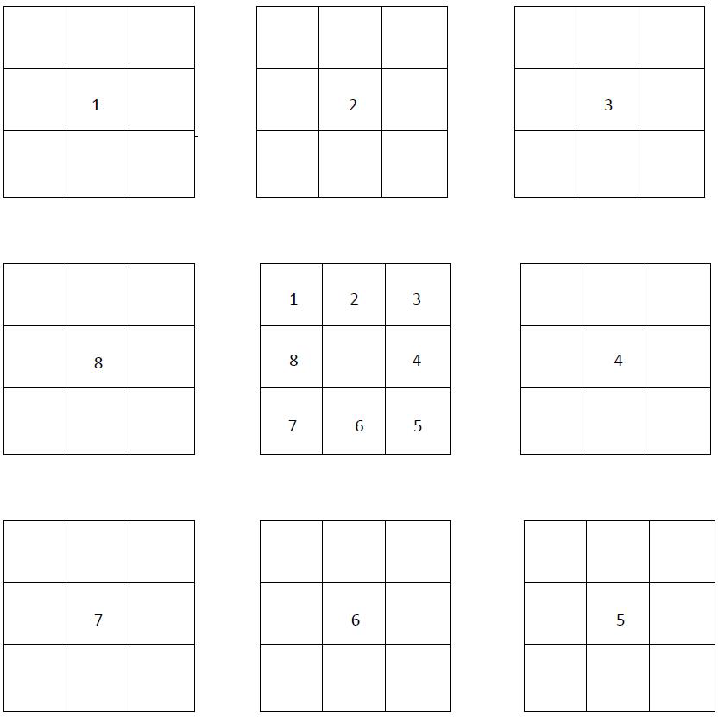

Class discussions
Use class discussions, in English or Chinese (depending on context), to gather ideas and debate pros and cons related to a particular topic or question. The results of the discussions can then be organised and used to formulate responses to particular topics and questions in Chinese.
Use material already published on the topic as a discussion starter – see the list below. Discussion could involve expanding ideas or identifying vocabulary, phrases and structures in the target language that will be useful in any response.
Useful resources include:
- articles in textbooks
- past HSC papers/questions
- a brainstormed list of possible prescribed issue-related topic questions
- news items and internet articles related to the prescribed issues.

Presenting a point of view
Encourage students to think about both sides of the argument for a given stimulus statement or question before deciding which stance they will take – for or against, or a more balanced approach.
Students should take the point of view they feel they are best equipped to argue.

Exercise 1
In order to practise presenting a point of view through classroom discussion, as described above, students formulate a response to a question in Chinese and then present a different point of view on the same topic.

Exercise 2
Students brainstorm HSC-style questions in pairs, based on sub-topics from their mind-maps.
- Give each pair a different topic.
- Ask one student to speak for the affirmative and one for the negative.
- Each pair prepares a 1.5-2 minute speech, initially in English. This is conducted as a debate, where the other students act as adjudicators after hearing each of the arguments. The other students must justify their decision based on the logic of the argument. This exercise can be done in Chinese when students become more confident.

Developing skills for monologues and short essays
Students should develop the skills necessary to prepare monologues and write short essays, as well as the ability to present and support a point of view or develop an argument in Chinese. These skills are necessary for the speaking and writing sections of the HSC examination. However, note that short essay writing is not the only text type specified for productive use in the Extension course.

Exercise
Give students a question/stimulus statement. For example: Self-acceptance is harder than accepting others. What is your opinion? Give reasons for your answer.
- As a class, brainstorm ideas and record them on the board.
- Organise points/ideas into ‘for’ and ‘against’ the argument.
- As a class, decide which side of the argument is easier to present.
- Using the ideas gathered, ask individual students to write their own response.
- Share the sample responses as a class.
- Deconstruct the sample responses and come up with a skeleton structure common to all good responses – introduction, main body and conclusion.
- Go through the sample response structure below.
- Joint construction – students create a group response in Chinese to the same question by fleshing out their argument using the sample structure. Working in pairs or groups of 3, students take an aspect of the structure and write a paragraph on it.
- When all students in the group have finished, put the paragraphs together to make a whole response. The opening statement, brief outline and concluding statements can be written at the same time. There may be some repetition through the argument, but students should gain confidence and the ability to put together a response before writing individual responses.
- Individual construction – students write their own response to the same question using ideas and skills gathered in this exercise.
Sample response structure
- Make an opening statement contextualising the question.
- State your argument/opinion on the question/stimulus – this may be for, or against, or a more balanced view.
- Provide point 1 related to your argument with 2 detailed examples.
- Provide point 2 related to your argument with 2 detailed examples.
- Draw your conclusion. Do not just reiterate the point that you made in your introduction. Provide some future advice/direction/suggestion related to your conclusion.

Developing knowledge of specialist vocabulary
Learning some commonly-used vocabulary and expressions related to the prescribed issues will help students respond to speaking and writing tasks.

Exercise 1
Cut up a mixture of specialist vocabulary or expressions – some in English and some in Chinese – and put them into a hat. Students then take turns drawing one out and translating it into the other language.

Exercise 2
Have students make a domino game where they have to match the Chinese vocabulary or expressions with the English equivalent. You can set up this activity as a group or individual activity (you will need several sets) and make it into a competition by timing students. This is useful as a revision activity.

Exercise 3
In order to develop students’ ability to express complex ideas in simple language rather than relying on a dictionary, put a list of difficult and hard to translate English words into a hat. Have students draw words one at a time and express them in Chinese they are already familiar with. You may need to rephrase some words in English before the students express them in Chinese.
This exercise is particularly relevant practice for the speaking exam where dictionaries are not permitted. However, even in writing tasks, students should try to avoid using unknown words from the dictionary as much as possible. Finding an alternative way of expressing an idea is an excellent skill to develop.

Recording responses
For the oral examination, students respond with a monologue on 1 question from a choice of 2. They are given 7 minutes to prepare their response and may make notes and refer to them during the examination. Students are expected to speak for approximately 3 minutes.
The monologues are recorded, therefore students need to become accustomed to having their speaking responses recorded. They also need to learn how to make effective use of the preparation time and be well-practised in planning and writing dot points for their monologues.

Exercise 1
Students take a question or stimulus statement out of a hat and give themselves 7 minutes preparation time. At the end of the 7 minutes they record their response. They should not stop the recording until they have completed their response. When finished, they play back the recording. This is an excellent exercise to help students become accustomed to forming ideas and developing a response within the time limit of the HSC oral examination.

Exercise 2
Have students record a monologue and bring it to school for peer assessment. This will help them to develop confidence in recording their voice and to become used to speaking clearly and at an even pace. Peer assessment is recommended for this exercise, as other students learn from their peers’ strengths and weaknesses.
The exercise should be used as a stimulus for a constructive discussion aimed at improving the performance of the whole class as well as that of the student whose performance is being assessed.
An explanation of the marking guidelines is necessary at this point so that students are made aware of the criteria examiners will apply.

Sample dot points from similar prescribed issues in other languages
Review the prescribed issues and suggested sub-topics for other languages from the NESA website. If they are similar to those set for Chinese Extension, use them as a source of ideas for practice speaking and writing questions.
Be aware that the sub-topics listed for any one prescribed issue are many and varied. They are not limited to the dot points in the syllabus nor to those that have been examined in previous HSC examinations.

HSC Standards Packages
It is important that students are familiar with the marking rubric and guidelines for each section of the HSC examination. HSC Standards Packages (2002) contain the marking guidelines as well as a sample examination paper, syllabus, answers and sample student responses at band cut-off points. The Standards Packages are a useful teaching and learning tool and are available on each language-specific page of the NESA website.

Exercise 1
Select a number of sample answers from the Standards Package speaking and writing sections and have students award marks to them by applying the marking guidelines. Students can discuss the marking criteria and justify their marks from an examiner’s perspective.

Exercise 2
Students listen to and read a number of speaking and writing samples from across the range of bands. They can use the exemplar samples as a model for their own monologues and writing.

Proformas for planning monologues and essay writing
In both the oral examination and the written examination, students are required to present and support a point of view in Chinese. Teachers will need to support their students in developing these skills. The following proformas have been designed to help students develop a structured approach to responding to monologue and short essay questions.
Depending on context, you may wish to introduce the proformas using English, moving to Chinese as students develop more confidence in planning monologues and essay writing. You can also adapt the proformas to meet the needs of your students.
In order to gain confidence and competence in these skills, students should write as many monologues and short essays as possible. Monologues can be recorded for practice. Please note that short essays are not the only text type prescribed in the Stage 6 Extension syllabus. Students also need to be familiar with the text types for productive use listed in the Stage 6 Continuers syllabus.

Sample planning proforma 1
Task | Answer
Question
(Write in the question with the stimulus statement)
Opening statement
(Make an opening statement contextualising the question; state your argument/opinion on the question/stimulus – this may be for, or against, or a more balanced view)
Introductory statement
(State why you have this argument/opinion and introduce the points you are going to discuss to support your argument)
First point
(Include 2 detailed examples)
Second point
(Include 2 detailed examples)
Concluding statement
(Draw your conclusion, but do not just reiterate the point that you made in your introduction – provide some future advice/direction/suggestion related to your conclusion)

Sample planning proforma 2
Task | Answer
Question
(Write in the question with the stimulus statement)
Opening statement
(Make an opening statement contextualising the question; state your argument/opinion on the question/stimulus – this may be for, or against, or a more balanced view)
Introductory statement
(State why you have this argument/opinion and introduce the points you are going to discuss to support your argument)
First point
(Include 1 detailed example)
Second point
(Include 1 detailed example)
Third point
(Include 1 detailed example)
Concluding statement
(Draw your conclusion, but do not just reiterate the point that you made in your introduction – provide some future advice/direction/suggestion related to your conclusion)

Writing and speaking

Producing authentic texts
Learning authentic phrases and expressions is a good way to build up vocabulary. However these phrases and expressions must be used in context. Students should be encouraged to keep a list of words and expressions they can use to build an argument or use in a discussion. They should write down one or more sentences in which these expressions could be used. Some phrases and expressions are set out below and require students and teachers to build meaningful sentences.

Starting a paragraph
- 在开始以前，我要……
- 我先要解释一下……
- 以我的意见……
- 差不多每天……
- 有人说……
- 很多人觉得……
- 这里有很多不同的……

Expressions to use within a paragraph to add structure
- 我们要很清楚……
- 一方面……，一方面……
- 不是……， 就是……
- 如果……
- 因为……， 所以……
- 因此……
- 不过……
- 虽然……，但是……
- 除了……以外……
- 不但……，而且……
- 要是……，就……

Giving examples or opinion
- 我的意见是……
- 我认为……
- 我同意……
- 我们常常会……
- 我觉得……

Ending a discussion
- 我觉得……
- 最后……
- 我想……
- 根据以上的讨论，我觉得……/我认为……

Glossary of key words for the HSC
The table below contains key words and their meanings in the context of HSC language courses. The table may help teachers and students understand how to respond to questions and tasks which use these terms.

Term | Description
Account | Account for, state reasons for, report on. Give an account of; narrate a series of events or transactions
Analyse | Identify components and the relationship between them; draw out and relate implications
Compare | Show how things are similar or different
Construct | Make, build; put together items or arguments
Contrast | Show how things are different or opposite
Critically analyse or evaluate | Add a degree or level of accuracy, depth, knowledge and understanding, logic, questioning, reflection and quality to analyse or evaluate
Define | State meaning and identify essential qualities
Demonstrate | Show by example
Describe | Provide characteristics and features
Discuss | Identify issues and provide points for and/or against
Evaluate | Make a judgement based on criteria; determine the value of
Explain | Relate cause and effect; make the relationships between things evident; say why and/or how
Explore | Examine or discuss (a subject, an option, an idea, a possibility)
Express | Put opinions, thoughts or views into words
Identify | Recognise and name
Interpret | Draw meaning from
Justify | Support an argument or conclusion
Outline | Sketch in general terms; indicate the main features of
Propose | Put forward (for example, a point of view, idea, argument, suggestion) for consideration or action
Recommend | Provide reasons in favour
Recount | Retell a series of events
Reflect | Think deeply or carefully about something
Summarise | Express, concisely, the relevant details
Adapted from A glossary of key words – NESA

Overview of syllabus text types
The text types listed in the Continuers Stage 6 syllabus are assumed knowledge for Extension students. Each Extension syllabus lists text types for production in the external examination. Below is an overview of some of the text types with which Extension students should be familiar. Refer to the Continuers and Extension syllabuses for complete lists.

Syllabus text type | Purpose | Structure | Language features
Article | - to sustain an argument  - to describe  - to inform, persuade, amuse or entertain | - titles or headings  - development of ideas or argument  - sequencing and linking of ideas  - statement of conclusion or advice | - range of tenses  - linking words  - language can be descriptive, factual, judgemental, emotive or persuasive, depending on context
Conversation | - to exchange information, opinions and experiences  - to maintain and sustain communication | - exchange of opening salutations  - question or statement followed by response  - 2-way interaction (sustained) | - question forms  - strategies to maintain conversation (fillers)  - interjections  - incomplete sentences  - language level depends on context and relationship between participants
Description | - to inform  - to entertain  - to describe  - to classify | - general statement or classification  - introduction and elaborated description of characteristic features | - specific details  - descriptive words  - range of tenses  - varied vocabulary  - comparative expressions  - literary devices (for example simile, imagery)
Diary or journal entry | - to record personal reflections or experiences | - chronological or stream of consciousness | - first person  - range of tenses  - sequencing (time) words  - abbreviated words or sentences  - subjective or informal language
Discussion | - to give different points of view  - to examine issues from more than one perspective  - to make recommendations based on evidence  - to sustain an argument | - presentation of main idea in introduction  - evidence or data to support main idea  - interaction between participants to clarify understandings  - conclusion or reiteration of main idea  - balanced | - linking words to sequence ideas logically  - qualifying words (for example, usually, probably)  - persuasive, descriptive, discursive or personal language, depending on context  - comparative expressions
Email or fax | - to use technology-based methods of communication  - to inform  - to seek a response | - conventions (for example subject line, email address)  - specific details without elaboration  - salutations and sign-offs | - abbreviated words and sentences  - simple language structures
Essay | - to discuss  - to analyse  - to assess  - to guide or teach | - orientation or introduction  - presentation of argument, judgement or evaluation  - conclusion or reiteration of main argument  - often has embedded description and/or explanation | - range of tenses  - formal, objective language  - linking words to sequence ideas and paragraphs  - qualifying words  - abstract nouns and concepts  - complex sentence structure  - evidence or examples included to support or enhance argument
Formal letter | - to communicate in writing in formal contexts  - to request information  - to lodge a complaint  - to express an opinion | - salutations and sign-offs  - letter conventions (for example layout, address, dates)  - logical and cohesive sequence of ideas | - use of full sentences and paragraphs  - more complex sentence structure  - objective language  - use of formulaic expressions
Informal letter | - to communicate in writing with acquaintances, friends, family  - to inform or amuse | - salutations and sign-offs  - letter conventions (for example layout, address, date) | - frequent colloquial language  - subjective language  - sentence structure often less complex than in formal letters
Interview | - to seek and convey information, views or opinions | - question and response format | - question words  - link words  - strategies to maintain communication
Invitation | - to invite in written form | - layout conventions  - statement of facts  - protocols | - abbreviated language  - formal or informal language  - expressions that tell when, where, with whom
Message or note | - to inform  - to request  - to instruct  - to remind | - general statement, description, procedure  - may be in point form | - succinct  - abbreviated words and sentences  - lack of descriptive detail  - use of colloquial language
Narrative account | - to entertain, amuse or instruct | - series of events presented in logical progression  - resolution or conclusion  - may contain a series of complications | - time words used to connect events  - use of action words  - descriptions of characters and settings
Personal profile | - to describe  - to outline personal details | - may be in point form (appropriate to situation)  - use of headings and subheadings | - factual  - descriptive language  - present tense  - simple phrases or sentences
Postcard | - to provide information  - to retell events | - salutations and sign-offs  - brief description or message | - descriptive language  - incomplete sentences  - abbreviated words  - colloquial expressions  - clichés  - personal impressions
Recount | - to retell what happened  - to tell a series of events | - introduction or orientation  - events sequenced in chronological order | - descriptive language  - past tense  - time words to connect events  - expressions that tell us when, where, with whom and how
Report | - to classify and/or describe  - to organise facts  - to draw conclusions | - general statement or classification  - description  - logical progression | - supporting evidence (for example statistics)  - factual  - usually present tense  - language specific to the topic  - objective language
Review | - to respond to a text or stimulus  - to summarise, analyse or interpret a text and to assess its value | - describe context of text or work  - describe the text or work  - judgement or evaluation of text or work | - descriptive language  - more complex structures with frequent abstract language  - words that express judgement  - possible comparisons  - expressions of aesthetic nature
Speech or talk (script) | - to communicate ideas, opinions and attitudes  - to entertain  - to persuade  - to welcome  - to thank | - introductory statement of purpose  - explanation or sequence of events or presentation of argument  - concluding remarks | - choice of expressions to engage the audience  - descriptive words  - a range of tenses  - subjective language  - consistent use of correct register depending on audience  - address audience throughout

Suggestions for teaching film
The tools of production are the director, the cast, the screenplay, the production design and the film techniques.
The tools of production are important in gaining an understanding of film. There are so many effects and subtle technical changes that add to the mood and meaning of the screenplay, creating a complete and new entity, sometimes even totally different to the original script.
Therefore it is important to go over these tools of production with students at an early stage of their study so that they may use the tools when focusing on the film as a whole, and more specifically within the chosen film extracts.
A film may gain meaning through the use of some or all of these means of production. Sometimes it can particularly gain meaning through leaving out an important tool during the film to create an effect. It is up to the teachers to guide the students to look for these effects and how the tools have been utilised in the film.

The director
The director is responsible for each and every scene shot, every effect and how every word is uttered in a film. He or she has poetic license to change the original screenplay to convey the meaning of the film, and works on the film with appropriate technical staff, from the conception stage to the finished product.

The cast
The cast are the actors chosen to play the various parts in the film and the right choice of cast can make or break a film. There are different styles of acting, and the cast must be able to fulfil the director’s vision for each role.

The screenplay
The screenplay is the script of the film with the addition of directions specifically for film, just as in a play there are directions for the characters on stage. The directions for a film may include information such as lighting, sound effects, music and camera angles.

The production design
Production design includes the exterior and interior location for the shots, the sets and colours used. The colour palette, for example, can reflect the mood, such as depressing, happy or exciting. Wardrobe, hair and make-up are also important in setting the scene, including the era.

Film techniques

Plot development and sequence of events
Film directors may present the plot and the subject matter in a chronological sequence of events.
Alternatively, the use of flashback and out-of-sequence narration may be used. This technique may enhance suspense and maintain a high level of interest and involvement by the audience. Such a structure allows for complication in the plot by offering a multi-layered interpretation of the story.
The plot may include events which foreshadow what is to come. Several plots may also run parallel in a film.

Setting
The setting is where and when the story takes place. It can incorporate location, weather conditions, time of day and the physical environment, for example natural or man-made.

Shot composition and framing
The shot composition consists of all the elements within a shot. It is a selective representation of reality, as seen within the confines of a frame. It is carefully thought through, very rarely the product of chance.
Framing refers to the placement of the subject matter within each shot. The subject may be placed centrally or at the side. A character may be seen in profile, from the back or from the front. The numbers of characters in each frame, how much of the background is included and for what purpose are also elements of framing.
The framing, and the way in which all the elements within it are placed, form the shot composition. By examining shot composition, students will be able to discern certain subtleties used by the director to manipulate the audience.

Type of shot and camera angle
A shot is all that is recorded on film from the time the clapboard has been shut to the time the director calls out ‘Cut!’. A lengthy shot (20 to 30 seconds) may convey a feeling of tranquillity, whereas a succession of short shots (1 to 5 seconds) may hasten the pace and movement. Film shots are taken from different distances to serve different purposes.

Long shot or wide shot
The long shot, also known as the wide shot, shows the entire object or character and places the object or character in its surroundings. With the camera shooting at a distance from the characters or the centre of the setting, long shots are commonly used as an introduction to grab the viewer’s attention and to invite involvement. A long shot is often used to anticipate the events that will follow or transport us to a different environment. In the scene in which Ju Ran is putting his things on to his desk while the classmates are cheering on some boys to eat cakes, the director uses long shots to introduce the new environment Ju Ran will be in and to invite involvement.
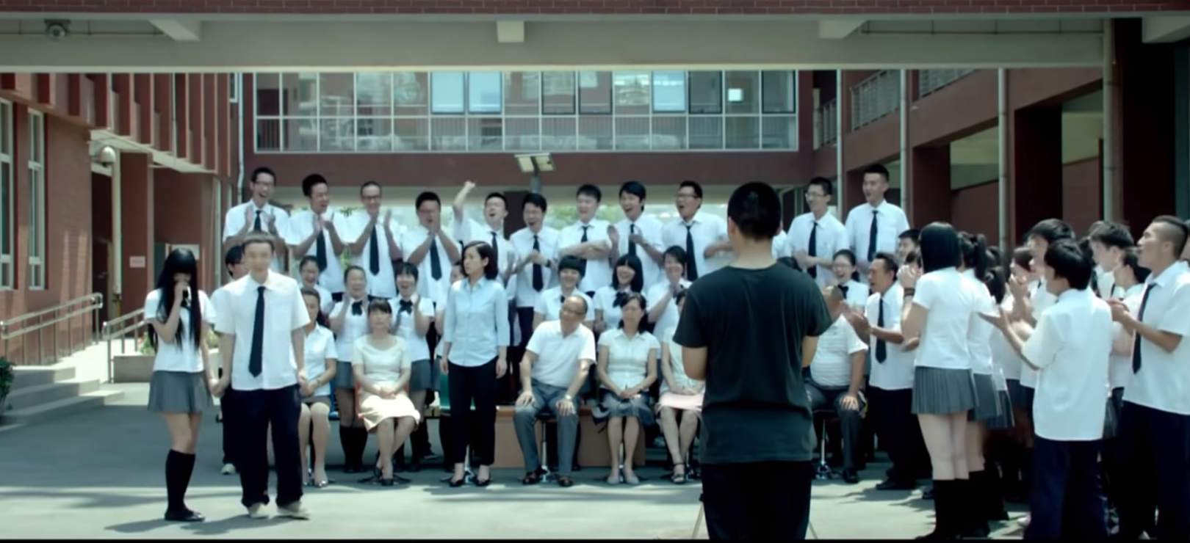
Young style CCTV Movie Channel/China Film Co/Hubei Huanggang Radio and Television and Media Co.

Medium shot
Medium shots are used to focus on the dialogue and the interaction between characters in a group.

Medium close-up
The medium close-up shot is generally used to reveal the psychological state of the characters rather than their actions. In the film, medium close-up shots are found in many scenes, including the shot of Wenli scolding Ju Ran in their apartment for getting involved with a girl 5 days before the Gaokao.

Close-up
Close-ups are often used to display the feelings and emotions of the characters and to gain an insight into their thoughts. Close-ups are dramatic and effective devices used to portray characters and character development. In the scene in which Ms Sa urges the class to open their eyes and get ready for the fight, the director uses the extreme close-up to emphasise that training for the Gaokao is very dramatic.
Close-ups of objects give significance to the object, directing the audience to an important element in the film.
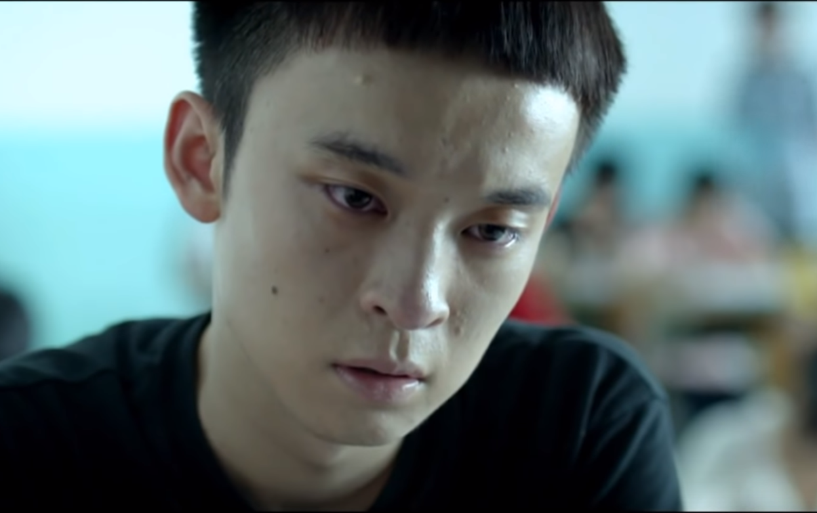
Young style CCTV Movie Channel/China Film Co/Hubei Huanggang Radio and Television and Media Co.

High-angle shot
The high-angle shot reduces the subject to lower proportions in relation to the surroundings. It is often used to indicate a feeling of vulnerability, powerlessness, helplessness, loneliness or isolation.
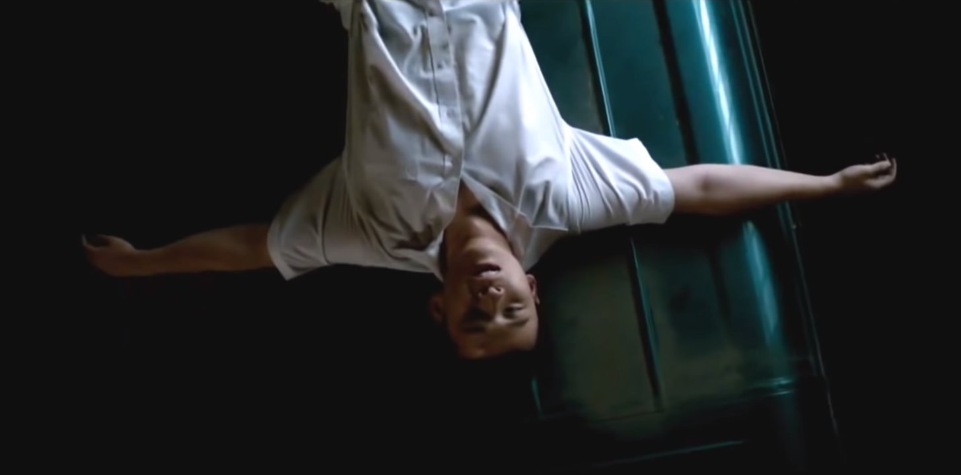
Young style CCTV Movie Channel/China Film Co/Hubei Huanggang Radio and Television and Media Co.

Low-angle shot
In a low-angle shot, the camera looks up at what is being filmed, increasing the sense of height or scope.
A low angle of a character can heighten their importance.
At the beginning of the film, the director uses a number of low angles to film Ju Ran climbing out the window, which in this case shows the height Ju Ran is at, indicating the risk he is prepared to take for love.
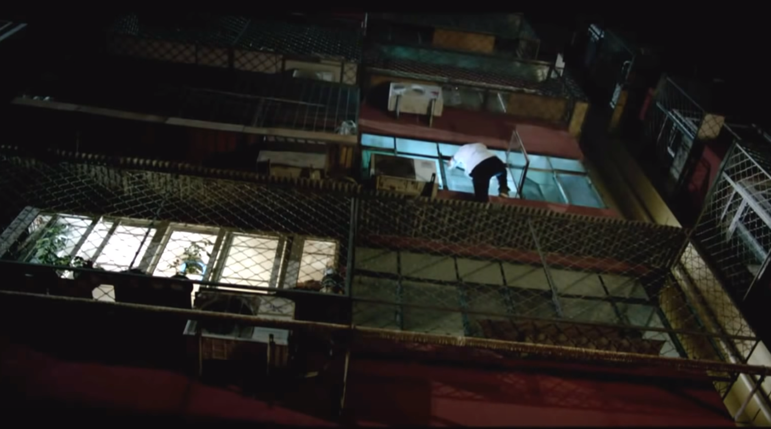
Young style CCTV Movie Channel/China Film Co/Hubei Huanggang Radio and Television and Media Co.

Straight-on angle shot
This is the most common angle used in filmmaking. Unlike the high and low angle shots mentioned above, it conveys objectivity.
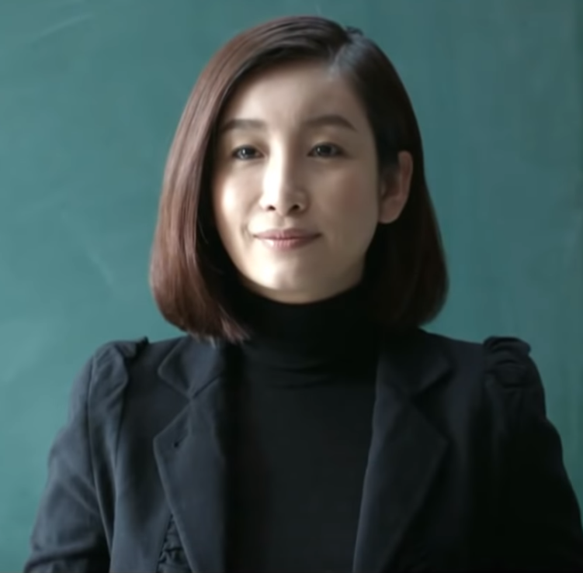
Young style CCTV Movie Channel/China Film Co/Hubei Huanggang Radio and Television and Media Co.

Over-the-shoulder shot
This shot contains 2 figures, one with part of his or her back to the camera while the other is facing the camera. This shot usually shows hostility, disagreement or a conflict of ideas between the characters involved. In the scene in which Ms Sa lectures Ju Ran in the corridor, the director uses over-the-shoulder shots to display the tension of the moment between them.
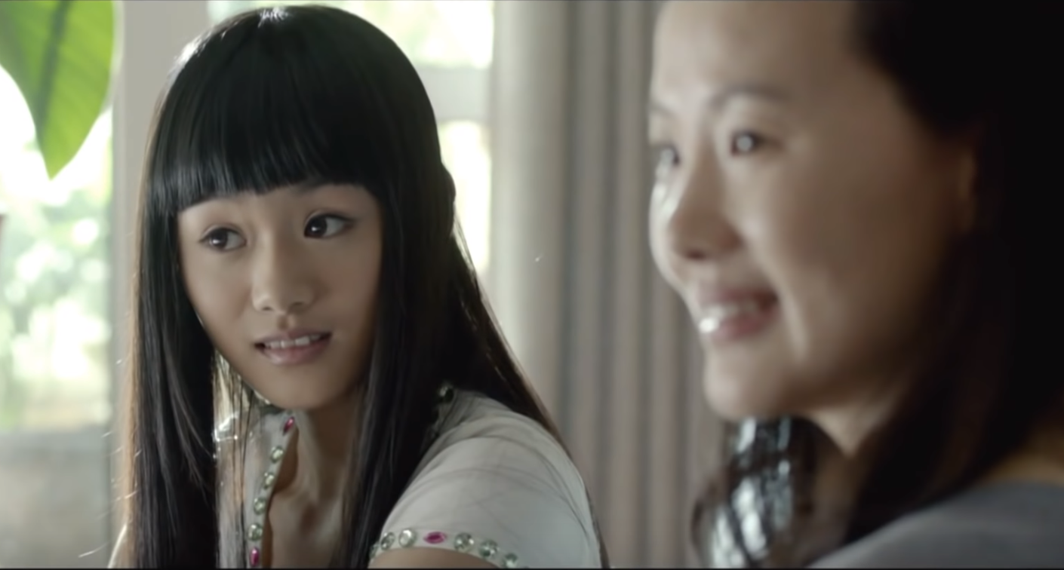
Young style CCTV Movie Channel/China Film Co/Hubei Huanggang Radio and Television and Media Co.

Flashback
The flashback is a shot or series of shots, a brief scene, or a sequence that interrupts a narrative to show earlier events. In the film, Ju Ran is recalling what Jingjing had said to him while the exam is in progress – a brief flashback of Jingjing talking appears and the present is momentarily suspended.

Colour and lighting
Colour and lighting (including the angle of lighting) are essential elements of cinematography. Colour visually stimulates the viewer’s senses and feelings in a most direct and physical manner. On an emotional level, lighting sets a mood, creates an atmosphere and invites an emotional and intellectual response from the viewer. Colour helps to convey meaning by visually expressing the characters’ moods and feelings.
It is important to locate the source of light in a shot composition. Is it natural or artificial lighting? Does it come from the side, the back, the front, the top, or from underneath? Is the light coming from outside the frame or from within it? Is it soft, diffused, strong or harsh?
Colour and lighting are not easily separable, as lighting will change the way an object looks regardless of its colour. Our personal response to a particular shot will often be subconsciously determined by the quality, depth and type of colour used. It is important to ask how the colour complements the theme both in the film as a whole and in particular shots.

Sound
Elements to consider with the soundtrack include:
- verbal exchanges
- sound effects
- music
- silence.
The physical presence or absence, and quality of, the verbal exchanges are important features in the overall effect of any film. Tone, pitch, speed and volume of dialogue all make a significant contribution to our perception of a character and the part he or she plays in a scene.
Scenes without any speaking may communicate their message via the visual elements combined with background music. The type of music used also plays an important part in the creation of the film; however, the director may choose to have no sound at various times throughout the film. This can be a powerful device, as the viewer has to rely on the visual elements only.
Music is added either as a complete soundtrack or as a series of songs played in certain scenes. Feelings of excitement, surprise, fear, love and hatred are evoked through the music.

Costuming and decor
Costuming and decor comprise the way people dress, interior decor and any other personal or collective look. This is done through the use of particular clothes and decorations that help to set the scene on a historical, social, personal and emotional level. Decor and costumes not only set a scene within its geographical and historical context, but they can also reveal the social status or personality of the characters.

Imagery
Imagery conveys meaning without words, and may include recurring symbols (including animals, objects or people), actions or colours.

Editing
Editing is the putting together, in a given order, of the thousands of shots that have been taken and to which the sound track will be added. This very complex task involves the selecting, deleting, clipping, lengthening and rearranging of shots before gaining the final stamp of approval from the director. Editing also involves the choice and order of opening and closing credits, sound effects and voice-overs.

Other important elements

Theme
The theme is the message the director wants the viewer to remember – what is the universal idea which shines through in the film? For example, the resilience of the human spirit. A film may have more than 1 theme.

Characterisation
Characterisation is how the director reveals the personality of each character and may also include the use of stereotypes.
Characterisation can include the way characters speak and interact, their appearance, mannerisms, thoughts and feelings, and their qualities.
Characters may remain static throughout a film, or they may develop.

Film techniques template
Extract: _________________________________

Before this extract | After this extract

Technique | Description
Setting
Camera angles and shots
Colour
Lighting
Sound
Costuming and decor
Imagery
Editing and transitions
Characterisation

Activities to develop global understanding of the film
The following are sample activities that may assist in providing a global understanding of the film. They can be used for the development of written and/or oral skills. Many are suitable for group work.
- Writing a review of the film.
- Creating a cloze test on a prescribed extract.
- Writing a report on an event from the film, for example who was there, what were they doing, why they were doing it, and so on.
- Organising a role-play based on a key scene. This may include improvised dramatisation and paraphrasing of the text.
- Taking key sentences from the film out of order and rearranging them in sequence.
- Summarising the plot in a number of sentences, mixing them up then arranging them in sequence.
- Drawing diagrams to show the structure behind what has happened. For example, timelines and graphic summaries. Students could consider whether the action is chronological or involves flashbacks, and could create diagrams of the relationships between the characters.
- Considering what the characters know about each other. Are the characters stereotypes or individuals?
- Holding a press conference for a character (interviewing a character, adopting the persona of the character and recording the interview).
- Writing a tag line for each of the key characters – one line to sum them up.
- Writing the history of a character. What is known about this person? Why is he/she now in this situation?
- Imagining yourself as a character and writing a letter explaining your actions.
- Writing the diary entry of a character for one day.
- Analysing significant character relationships in the film. Groups could consider specific quotations and show how language illuminates the changes in these relationships.
- Writing a letter to the editor of a newspaper, on behalf of a character, explaining what happened.
- Discussing the issues raised in the film – how do the issues unfold?
- Discussing whether the film offers new perspectives on the issues raised. Can it change perceptions? What does the viewer learn?
- Linking issues raised to students’ personal experiences or other texts studied.
- Discussing how viewing the film has widened the students’ experiences.
- Considering parallels and conflicts.
- Considering the setting. Is it integral to the whole story?
- Questioning whether the director is saying something new. Is it universal to the human condition?
- Considering how the level of language reflects the relationship between the characters.
- Identifying a social comment in the story and discussing the methods used to make the comment.

Prescribed text
Film – ‘Young style’, 青春派 directed by Liu Jie (2013)
There are 4 extracts prescribed for study.
- Extract 1 – 5.45 to 11.00 (approximately)
From the scene in which the mother starts to walk home with Ju Ran. “My mum is showing up from nowhere.”
Ju: 我妈神一样的速度出现。
To the scene in which the mother cries at the restaurant. “My mum’s dream is about to go up in flame.”
Ju: 我妈的梦想也要破灭了。
- Extract 2 – 15.45 to 21.00 (approximately)
From the scene in which Ju Ran returns to school to repeat the grade. “I am a superman.”
Ju: 全力以赴，我是超人。
To the scene in which the 3 students ask Ju Ran to join their group. “Nonsense!”
Ju: 无聊！
- Extract 3 – 1:03.16 to 1:07.22 (approximately)
From the scene in which the teacher lectures the class. “In the first mock test…”
Teacher Sa: 这次一模考试……
To the scene in which the students pour water over their heads. “Shoot me!”
Li Fei: 逼死我算了！
- Extract 4 – 1:19.03 to 1:23.26 (approximately)
From the scene in which Teacher Sa talks about her feeling for the class. “In the past fifty something days…”
Teacher Sa：在过去的这五十几天里面……
To the scene in which the whole class takes the graduation photo. “Three, two, one.”
Photographer: 来，三、二、一。
The prescribed text is available at Sale DVD.

Background to the film

The writers and directors
‘Young style’ was produced by CCTV Movie Channel, China Film Co. and Hubei Huanggang Radio and Television and Media Co. It was released in 2013 and directed by Jie Liu and written by Shan Gao, Jie Liu, Xiaowei Tian and Zhu Zhu.

Synopsis of the film
‘Young style’ is a heartfelt coming-of-age story. Just 5 days before sitting the Gaokao – the equivalent of the HSC in Australia – the protagonist Ju Ran openly announces his love for Huang Jingjing, whom he has quietly admired for 3 years. Their budding relationship is quickly stopped by his mother Wenli. Heartbroken and distracted, Ju Ran fails to pass his final exam, forcing him to repeat his senior year. For him, the second attempt at the Gaokao is a second chance to prove and better himself. During the gruelling preparation for the Gaokao, he comes to accept his mother’s expectations, see the challenges in his friends’ lives and understand his ‘mean’ teacher’s methods and tough love.

Main characters
Ju Ran
Ju Ran is a 16 year old high school student. During his first graduation group photo session, he declares his love for his ‘dream girl’ Huang Jingjing in front of his teachers and classmates. Ju Ran’s mother immediately stops their budding relationship, which tips Ju Ran over the edge. In his exam, he writes nothing and fails the Gaokao, forcing him to repeat his final year to get into university. While repeating his senior year again, he builds friendships with a group of boys who will eventually change his perspective in life. The boys see Ju Ran as their mentor and he becomes increasingly mature and recognises the importance of working hard for the Gaokao.
Ms Sa
Ms Sa is a highly experienced teacher who prepares graduating students for the Gaokao. She has maintained a track record of 100% university entry rate throughout her career as a teacher. She sees herself as socially responsible and target driven. She has high expectations for her students, expecting them to achieve the best results in the Gaokao. She becomes annoyed and upset when her students do not meet her standards as she knows how this can impact their future. Ms Sa appears to be a very strict teacher who is at times cold hearted towards her students. She does not show much sympathy even though it is clear that some of her students are disengaged and both mentally and physically exhausted. When she becomes sick, she is disappointed when none of her students comes to visit her in hospital. However, her gentle and loving nature is shown through her farewell speech to her students. At the end of the film, she wins the respect of her students when they realise how much Ms Sa has done for them.

Ju Ran’s parents
Ju Ran’s mother has high expectations for her son. She quits her job and rents an apartment near the high school for the sole purpose of helping Ju Ran prepare for the Gaokao. She stops Ju Ran’s relationship with Huang Jingjing and does not allow him to celebrate his graduation with his father, uncle and aunt. Everything she does is for the sake of the Gaokao. She becomes very emotional when she realises that Ju Ran has failed his Gaokao after so much preparation.
Unlike Ju Ran’s mother, Ju Ran’s father is very supportive and understanding. He stays with their family dog at home in the suburbs while Ju Ran and his mother stay at the rented place. He wants his son to have some relaxation time during the preparation for the Gaokao and is sympathetic towards his son.
With Ju Ran’s parents now living separately, their marital relationship also grows distant and there is talk of a possible divorce.
Qi Mingzhi
Qi Mingzhi is one of Ju Ran’s new friends, who comes from an ordinary family with little means, influence and power. Instead of focusing on his study, he spends time chasing Xiao Ci, so his academic results are poor. Ms Sa scolds him in front of the whole class for getting a poor mark in a mock examination. He is attached to his friends and does not worry too much about his future, even though all his friends have plans and ambitions.
Jia Di
Jia Di, one of Ju Ran’s new friends, is a boy who comes from an affluent family. He is also the leader of a group of 3 boys including Li Fei, Qi Ming Zhi and himself. He is not planning to sit the Gaokao as he has plans to go to the United States to further his higher education. His attitude towards school life is relaxed and he focuses on chasing girls instead.
Li Fei
Li Fei is one of Ju Ran’s new friends who is adorable and likes dancing and performing. His father is a high-ranking official in the military. He plans to take the entrance exam for art students which does not require him to have high marks to get into university.
Huang Jingjing
Huang Jingjing is Ju Ran’s ‘dream girl’ who he has secretly loved for 3 years. Jingjing is pretty and appears to be very sweet and does not refuse when Ju Ran asks her to be his girlfriend in front of everyone. However, she changes her mind and cools the relationship when Ju Ran does not speak up to defend her when she is confronted by Ju Ran’s mother. Jingjing is pragmatic, focused and cool headed. She knows that the priority for her as a high school graduate is to achieve good results in the Gaokao and to get into a reputable university. She focuses on her studies instead and gets into Fudan University.

Sun Xiaofan
Sun Xiaofan is a gentle, caring girl who does not hide her feelings for Ju Ran and supports him whenever she can. Although at times Ju Ran does not like it, Sun Xiaofan speaks to him honestly and advises him not to join the school soccer team as this may affect his studies. She is also a very sensible and diligent student at school. She is a top student in Ms Sa’s class, so when her mark in one of the tests falls below 90, Ms Sa is quite shocked.

Social context

Setting
The film is set at a high school in Beijing against the backdrop of the pressure of the Gaokao, which is the central theme of the film.
The life of Chinese young people is synonymous with the challenges required of them to pass the Gaokao, and the pressures of getting into a reputable university. The story starts 5 days before the Gaokao and, according to teachers and parents, these days should be spent cramming for the most important exam, not pursuing love interests. Passing a high pressure exam combined with a budding high school romance is not a new plot when it comes to films of this genre. The director tells a story of growing up using the Gaokao as the main theme and teenage romance as the catalyst for the character. As a result, the film is comical, touching and sensitive.

Education for Chinese people
“Only the learned rank high, all other trades are low” (Chinese saying). Chinese people have been deeply influenced by this traditional educational value and, since ancient times, highly regard education as a primary gateway to better social and economic status. This tradition was strengthened by the One-Child policy (c. 1978-2016) as parents usually have high expectations of their only child and are often willing to sacrifice everything to help them succeed. Nowadays, for those with poverty-stricken backgrounds, education is key to changing their destinies and breaking the cycle of poverty for their families.

The Gaokao
The Gaokao (高考), the National College Entrance Examination, is a high-stakes academic examination held annually in mainland China. This university entrance test can be traced back to the Keju (科举), its historical predecessor, which was abolished in 1905. The Gaokao was first held in 1952, 3 years after Mao Zedong declared the founding of the People’s Republic of China. It was halted during the Cultural Revolution (1966-1976) and resumed in 1977.
To date, millions of students have sat this challenging examination, with over 10 million students sitting the exam in 2019. For Chinese students, the Gaokao is an examination that can change the course of their lives, so students face enormous pressure and stress before the exam. The month of June is often referred to as ‘Black June’ by Chinese young people, as the exam takes place from 7-8 and/or 9 June every year. This exam-related stress has also resulted in an increase in mental health issues among students in recent years. For many Chinese parents, the Gaokao is seen as the only way to help their children secure a well-paid job and successful career in the future. Parents are willing to make any sacrifices and even forgo personal issues such as divorce plans or changing jobs to give their children emotional stability and complete support during this challenging time.

Teenage romance
Puberty is marked with psychological and emotional changes, including developing ‘crushes’ on others. However, in China, adolescent love is seen as something undesirable or a taboo by school authorities and parents. It is referred to as zao lian (早恋) which means ‘early/premature love’.
In order to ensure that students’ academic performance is not affected, schools and parents have come up with a variety of measures, from giving a light disciplinary talk to taking severe disciplinary action such as school suspension ‘to nip young love in the bud’. In recent years, new rules designed by some schools are very creative. For instance, boys and girls must sit in different areas at lunch; they must maintain a minimum distance of 50 centimetres from each other at all times; and they cannot walk around school premises in pairs.

Extract 1 (5:45 to 11:00)

Summary
Ju Ran’s mother Wenli appears from nowhere, just after he bravely announces his secret love to Huang Jingjing in front of the whole class and the teachers on the graduation photo day. Wenli brings Ju Ran back to their apartment, rented especially for his preparation for the Gaokao exam. She scolds Ju Ran for falling in love 5 days before the Gaokao instead of focusing on his studies. During this conversation, Ju Ran’s father and family come to take Ju Ran for a graduation celebration, but they are driven away by Ju Ran’s mother. Ju Ran cannot help but think of Huang Jingjing so he climbs out of the window and has a bad fall. Ju Ran fails the Gaokao because he is love-struck.

Script
居然（voice over): 我妈神一样的速度出现, 一定是有人告密。 还有，就是我妈辞了工作，租房就住在学校的对面。
(In their apartment)
妈：你想气死我， 离考试还有5天了， 你谈恋爱！还是那样的一个女孩， 你觉得她是个有教养的孩子吗？
居然：本来挺好的，还不是被你挤兑的。
妈：你说什么？
居然：我说离高考还有5天了。
居然（voice over): 我的救兵到了。
姑姑：然然，高考来了，滴答滴答，砰！
妈：别闹了！今天不去了，然然下午要做题。
爸爸：回来再做嘛，都定好了。
妈妈：必须做完了，你们定好了，你们去，就这样了……考完了再说！就这样了，好了……
居然（voice over): 看来今天没人能幸免。
妈妈：考完再说，就这样了！
姑姑：唉……嫂子……唉……
居然（voice over): 我已经记不清多久没见我爸了。
妈妈：做题去!
居然（voice over): 高三一年，我和我妈住在出租屋里，而我爸和狗住在郊区的家，心烦意乱的时候想想我爸，心里就平衡了很多，但此刻，我只想着黄晶晶。
(Text from mobile phone) 下一秒，我仍然勇敢。
妈妈：干什么呢你？
居然：查单词呢。
妈妈：手机拿出来！
居然：我查单词呢！
妈妈：手机拿出来！
(Ju Ran throws the mobile phone onto the desk)
妈妈：摔给谁看啊？还理直气壮的，我告诉你,交女朋友的事，想都别想！黄晶晶……
居然（voice over): 这就是故事的开始，没人能阻挡我去见她。
居然：大姐，大姐，大姐你听我说……
居然（voice over): 我要让她知道，我依然勇敢，只不过今天运气不好，更没想到所有的勇敢，换来的却是……啊……
(In the exam room)
男老师：这位同学，请坐下!
居然：老师，我尾巴骨折了，坐不下。
居然（voice over): 每个人对高考的记忆都各不相同。我的高考记忆是一片空白，因为 -- 我只想着她。
(Outside the exam room)
居然：黄晶晶……晶晶，你考怎么样啊？
黄晶晶：还不错，你呢？
居然：我不知道，我这几天一直在想你。不是，那天……那天事你别放在心上，我妈她就那样。
黄晶晶：你不需要跟我解释什么。因为你的懦弱，让你妈妈那么羞辱我，所以我对你很失望。这一秒， 咱们俩什么关系都没有。
居然：可为了你，我尾巴骨都摔折了。
黄晶晶：居然小朋友，好好考试吧，不然妈妈该担心了。
(Ju Ran is recalling what Jingjing said to him during the exam）
黄晶晶：我不是已经跟你说过了，咱俩什么关系都没有了！
居然（voice over): 如果今年的考题是关于黄晶晶的一切，我一定能拿满分。
(The bell rings)
男老师：考试已经结束，请同学停止答题!
居然（voice over): 高考过后，世界上只有两种人：一种是考上的， 一种是没考上的。我不知道自己属于哪一种。
(People from another table at the restaurant)
男：这一年啊，说实在的真不容易!您看，都给我们孙子都累瘦了。
女：可不是嘛，挺辛苦这一年。
居然（voice over): 我的初恋完了， 我妈的梦想也要破灭了。
(Ju Ran’s mother screams）

Vocabulary and expressions
Chinese | English
告密 | tell on
有教养的 | well-raised, well-mannered
挤兑 | ruin, screw up
高考 | university entrance examination
救兵 | rescuer
幸免 | escape by luck
郊区 | suburbs
心烦意乱 | worried and annoyed
平衡 | fair, balanced
勇敢 | brave
理直气壮 | self-righteous
阻挡 | stop somebody from doing
依然 | still
尾巴骨 | tail-bone
记忆 | memory
解释 | explain
懦弱 | coward
羞辱 | humiliation
失望 | disappointed
初恋 | first love

Prescribed issues
Issue | Description
Education | Role of education  In this extract, the importance of education in the Chinese culture is emphasised, however it is also explored as regimented and draconian. Qualifying for higher education is paramount in Chinese society, influencing the way parents bring up their children. Parents often put high expectations on their children and this is evident when Ju Ran’s mother Wenli quits her own job and rents an apartment near Ju Ran’s school in order to support and help him for his exam preparation. Like millions of other high school students, 16 year old Ju Ran faces enormous stress and gruelling preparation for the Gaokao exam.  Pressures and expectations  Ju Ran faces high expectations from his school and family. He is in a class in which every student works hard and aims to get into university, as expected by their teacher Ms Sa. At home, his mother Wenli expects him to get excellent results in the Gaokao and therefore puts added pressure on him as well. His mother berates him for getting a girlfriend and she does not allow him to go out for a graduation celebration with his father.  Personal goals  Ju Ran’s goal is to get into a prestigious university. However, he is distracted and decides to pursue his ‘dream girl’ Huang Jingjing. His mum tries to ‘help’ him get back on track by forcing him to study and grounds him at home.
Relationships | Family relationship  Chinese parents and teachers often hold objections to teenage romance. After Wenli is informed of Ju Ran’s ‘budding love,’ she is very upset and angry at Ju Ran. Wenli, like many Chinese parents, is very strict with her son. Ju Ran does not completely understand this and resents his mother for it.  The world of the young  According to many Chinese parents, young people should only focus on their studies. However, there is a shift in attitude with some Chinese young people as they combine the desire for having a relationship with studying. Against his parents’ expectations, Ju Ran falls in love with Huang Jingjing and openly declares his love for her at any cost.  Responsibility towards others  Traditionally, Chinese parents believe that it is their responsibility to ensure a supportive environment is available for their children so they excel in the Gaokao. Some parents even choose to live separately in order to better support their children’s study for the Gaokao. Ju Ran’s mother lives with him in a rented apartment near the school leaving his father at home with his dog in the suburbs. Achieving academic success is so important, that all other personal matters are superseded, even if it means postponing a divorce.  Teachers also believe that it is their responsibility to ensure a smooth learning journey before the Gaokao exams. Ms Sa notifies Ju Ran’s mother as soon as she finds out about Huang Jingjing and seeks her support because she is concerned that this may affect his results.
Division in society | Poverty and wealth/Coping with reality  Parents of rich families often can provide their children with better opportunities such as studying overseas, while parents of average families have no option but to use the Chinese education system available to them.  Personal identity  Like many working-class parents, Wenli has high expectations of her son Ju Ran and believes that her son’s education can change their family’s destiny and social standing.

Comprehension questions
- Why does Ju Ran live with his mother at a rented apartment?
- Describe Ju Ran’s reaction when his mother stops him from going out with his family.
- Why does Ju Ran send a text to Huang Jingjing saying that he will still be brave?
- Compare and contrast Ju Ran and Huang Jingjing’s personalities.
- Comment on the decision made by Ju Ran’s parents about living separately. Provide textual references.
- Do you think it is appropriate for Ju Ran and Huang Jingjing to have a romantic relationship? Give reasons for your response.
- Comment on Ju Ran’s attitude towards the Gaokao.
- Describe how Ju Ran’s mother felt when she found out Ju Ran did not pass the Gaokao. What film techniques did the director use?
- Do you think Ju Ran’s mother is a good mother? Support your answer with textual references.
- Identify the film techniques used to demonstrate the personalities of Ju Ran and his mother.

Extract 2 (15:45 to 21:00)

Summary
Ju Ran is forced to repeat his final year after failing the Gaokao. In this new graduating class, he meets a group of boys who like to get into mischief. Ms Sa, Ju Ran’s previous teacher, is asked to fix things up when the group has become a serious burden to the school’s academic reputation. She threatens to drive the disengaged boys in the class out the door and she also wants Ju Ran to realise that it is Zao Lian that caused him to fail the Gaokao.

Script
(Ju Ran walks to the classroom with a box)
全班同学：全力以赴，我是超人！全力以赴，我是超人!
贾迪：你们谁要是能在二十秒之钟内把这蛋糕给我吃了，这二十块钱就是谁的！
齐明智：太简单了。
全班同学：加油，加油！吃，吃，吃！
居然：哪个座位是空的？
贾迪：这不算，再来一个。
全班同学：十，十一，十二，十三，十四，十五，十六，十七……
贾迪：停，让他们接着吃。
(Jia Di walks to Ju Ran)
贾迪：唉，同学，我好像在哪儿见过你……被我说中了。你怎么会在这儿复读？不是官二代，就是交了很多钱吧？不对，你把书都卖了，你拿什么复习呢？
贾迪：唉，这是什么？（Jia Di picks up the ring cushion)
居然：放下！
贾迪：上面还有个嘴。
居然：叫你放下！
贾迪：是用来出气的还是用来放气的?
撒老师：从昨天接手你们这个班，我观察了你们一天，我现在终于明白，你们这个班的症结在哪里了？就是因为有几匹害群之马。我已经说过了，我是受命来整顿你们这个班的。本来我刚送走一个班，可以好好休息休息，开学的时候接一个新的高一的班，但是校长说了，你们这个班已经危及到了学校的名誉，所以既然我接了手，我就要尽到一个老师的本分。想学的，老师一定全心全力的帮助你们，至于那些不想学的，甚至是想捣乱的，我也绝对不会让你们在这里待下去。居然，介绍一下你自己吧
居然：我叫居然，撒老师班唯一的落榜生。
撒老师：说说为什么落榜。
居然：因为早恋。早恋害人，但是我不后悔。我落榜起码证明我是真心的。
(In the corridor)
撒老师：你知不知道我费了多大的力，才能让你复读，让你到我接的这个班去插班。
居然：是你给我妈打的电话？
撒老师：对，有错吗？
居然：那就是因为你我落的榜。
撒老师：我没这能力。
居然：你就是愧疚！
撒老师：幼稚 我有什么好愧疚的？读不读？早恋是不是错？
居然：你说是就是呗。
撒老师：就是！这都什么孩子？
贾迪：上……别挡我。
居然：有事儿吗？
贾迪：你说有事儿吗？
李飞：你打了我们老大，现在我们要还回来。
居然：就这货能当老大？
齐明智：我也这么认为，但是现在是三个打一个。
居然：有本事单挑，三个打一个算什么本事！
贾迪：听说你就是声震学校的毕业照情圣，够厉害，还是跳楼的勇士。我现在给你两个选择：第一，就是我们三个人揍你一顿。第二，就是你加入我们，做我们的军师，然后把我们三个人塑造成情仙，情神，情霸。
齐明智：哎……
贾迪：滚！
居然：无聊!

Vocabulary and expressions
Chinese | English
全力以赴 | try one’s best
说中 | say it right
复读 | repeat a school year
观察 | observe
症结 | sticking point/problem
害群之马 | an evil member of the herd, black sheep
受命 | be entrusted with
整顿 | rectify, set in order
危及 | threaten
名誉 | reputation
接了手 | took over
本分 | duty
全心全力 | whole heartedly
捣乱 | make trouble
落榜 | fail the exam
早恋 | puppy love, teenage romance
插班 | join a class in the middle of the course
愧疚 | feel guilty about
货 | piece (refers to a person)
老大 | leader
单挑 | one on one
本事 | ability, skills
声震学校 | well-known at school
毕业照 | graduation photo
军师 | adviser
塑造 | mould into
情圣 /情仙/ 情神 | love master

Prescribed issues
Issue | Description
Education | Role of education  Traditionally, Chinese people attach great importance to the role of education and believe that they can change their destiny through education. Today, for Chinese young people, the Gaokao has become the key gateway to find better jobs with high salaries. Therefore, repeating the final year of school is Ju Ran’s only choice after he fails the exam.  Pressures and expectations  While counting down to the Gaokao (330 days away), students shout slogans to motivate themselves to work harder towards their goal – passing the Gaokao and getting into university.  In order to top the rankings and become high achievers in the Gaokao, both schools and students experience high levels of academic stress. When this graduating class threatens to mar the fine academic reputation of the school, Ms Sa remedies the situation by providing rigorous training and revision. As for the ‘black sheep’ in the class, as Ms. Sa refers to her disengaged students, she threatens to kick them out. Ms Sa also wants Ju Ran to reflect on the reasons why he failed to get into university and urges him to change.  Personal goals  Ju Ran’s ‘dream girl,’ Jingjing, gets into the prestigious Fudan Univeristy in Shanghai. This motivates Ju Ran to return to school and repeat the final year, hoping to get accepted by the same university so that he can be near her.

Issue | Description
Relationships | The world of the young  The boys admire Ju Ran for his brave confession of love during the graduation photo session and his reckless act of plunging from the railing outside his window. They think he is a ‘love master’ and they too want to become ‘love masters’ like him.  Despite the intense pressure from teachers and parents, the students are still energetic, fun-loving, chasing girls and getting into mischief.  Responsibility towards others  In today’s China, teenage romance is seen as a taboo or a serious social problem that needs to be addressed in schools. To safeguard their children’s promising future, schools with the backing of the parents make rules that prevent students from having romantic relationships at school. School authorities see this as acting responsibly towards their students because their primary focus is academic excellence and not necessarily the welfare of their students.

Comprehension questions
- Explain the reason why Ju Ran repeats his final year.
- Why do the students shout the slogan “I am a superman!”?
- Explain the reasons why Ms Sa is asked to take over this class.
- What is your first impression of Ms Sa? Why?
- Why does Ms Sa want Ju Ran to tell the class the reason for his failure?
- Why do Qi Mingzhi and Li Fei clap for Ju Ran during his self-introduction?
- Is Ms Sa happy with Ju Ran’s reflection on his failure? Why or why not?
- Why does Ju Ran think that Ms Sa feels guilty?
- Explain the changes in Qi Mingzhi’s attitude towards Ju Ran.

Extract 3 (1:03.16 to 1:07.22)

Summary
Ms Sa addresses the class and expresses her concerns about the poor results of her students in a recent mock examination. In particular, she is upset about Qi Mingzhi’s unsatisfactory results. While some students do not take the Gaokao seriously enough, she warns the class that the Gaokao may be the only possible way that leads to success especially for students from families with no power, no wealth and no connections. Although the students know that they have to work hard, they find the pressure of the Gaokao overwhelming and do not want to face reality.

Script
撒老师： 这次一模考试，我们班的一本上线率，竟然不及百分之七十！
(Students are laughing)
撒老师：干嘛呀，干嘛呀都，很高兴吗？你们是怎么答应我的？更可笑的是……竟然还有一位大仙儿， 竟然连三本线都没过！……齐明智，我想请问你，你到底是怎么考的？为什么连三本线都没有过？
齐明智：啊……
撒老师：考试前让你请家长来，为什么不来？你爸的手机为什么永远打不通？
齐明智：可能您……您记错了吧！再说了，我考不考上大学是我的事，跟我爸有什么关系 (Pointing to Jia Di）他不也没过吗？
撒老师：你还跟他比呀？贾迪根本就不参加高考，他就在这儿混日子的！你想跟他比呀？可以呀！你有他们家有钱吗？你有他那样的老爸吗？你还想跟谁比？你们那团伙里还有谁？李飞，是吧？你有人家李飞可爱吗？他爸什么级别你知道吗你？还有谁？小雷是不是？他们家是中石化的，你不会不知道吧？你说说你，你说你拼爹拼不过，你还不拼你自己！你一个三无人员，无钱，无权，无势的，上个像样的大学，将来找个好工作，要不然你怎么办呢你？有什么好笑的？你要是不想好好学，你也不用在这个班里边待了！收拾东西，出去！滚出去！(Walks to Qi Mingzhi’s desk and forcefully throws his books to the floor) 滚出去！给我滚出去！
(In the boys’ dormitory)
居然：你们说你们是不是犯贱，就你们这几个货，小心点儿吧。要是哪天撒老师觉得你们考不上大学，怎么撵巴也把你们撵巴走了。要不然她每年百分之百升学率哪来的？
李飞：我不怕，我已经向撒老师请了假去参加艺考，分数很低哦！
贾迪：我也不怕，我又不参加高考，回头过两天哥就颠美国去喽！
齐明智：你们也太不够意思了吧……就剩下我一个了！
(In the classroom)
撒老师：醒醒，醒醒，醒醒，都给我打起精神来。两眼一睁，开始竞争！发卷子！不苦不累，高三无味！不拼不搏，等于白活！所以，就算拼个头破血流，也要给我冲进一本的大楼！提高一分，你就有可能干掉的是上万人，上万人！懂吗？扛得住给我扛，扛不住，给我死扛！我现在就是觉得时间不够用，你们的成绩都提高得太慢。你们要记住：累死你一个，幸福你一家！破釜沉舟，拼它个日出日落！背水一战，干它个无怨无悔！
(In the bathroom, the boys pour water on their heads)
贾迪：去它的托福！
齐明智：去它的清华！
小雷：去它的中石化！
居然：我去它的一本线！
男生们：去它的高考！
李飞：逼死我算了！

Vocabulary and expressions
Chinese | English
一模考试 | the first mock examination
一本上线率 | cut-off mark to tier 1 university
三本线 | cut-off mark to tier 3 university
混日子 | live one’s life aimlessly
中石化 | Sinopec – China Petroleum and Chemical Corporation – a giant multinational company in China
拼爹 | compare whose father is richer and more powerful
犯贱 | act stupidly
撵巴 | throw somebody out from a place
颠 | travel to, roam to
无味 | tasteless, meaningless
白活 | meaningless life
升学率 | entry rate to university
扛 | bear a burden
破釜沉舟 | determined to fight to death
背水一战 | fight to win or die

Prescribed issues
Issue | Description
Education | Role of education  The ultimate goal for students, schools and educators in China is to achieve well in the Gaokao. Ms Sa has a brilliant record of maintaining a 100% university entrance rate. Examination marks are the indicators of whether students are going to succeed. Therefore, Ms Sa is worried and angry when students have not done well in one of their mock examinations. In order to enhance their results, students practise numerous examination papers on a day-to-day basis. The main aim of education for the senior high school students is to enter a tier 1 university as this guarantees a promising future.  Pressures and expectations  The traditional Chinese belief that ‘only the learned rank high, all other trades are low’ is still true today. The pressure the Gaokao imposes is enormous, not only on students but on teachers and parents as well. It brings competitiveness, bitterness and mental fatigue for students. Therefore, the expectations of teachers and parents towards the students are high and not negotiable. The preparation for the Gaokao is described by Ms Sa as ‘getting ready to fight’, ‘sacrificing oneself to bring blessings to the whole family.’  Failure in the Gaokao means a bleak future for students and their families, so students cannot give up their studies or let their families down. Ju Ran has to repeat the Gaokao in order to get into university. Qi Mingzhi is from a family with ‘no money, no power, and no connection’ so excelling in the Gaokao and getting into a good university is the only way for him to have a bright future.  Personal goals  Young Chinese students are greatly influenced by their teachers and parents’ expectations when pursuing personal goals. For most of them, getting through the Gaokao and achieving good results is their ultimate goal at this stage of their life.  Family background and social status are decisive factors when young people set their personal goals. Jia Di is not attempting the Gaokao only because his father is rich enough to support him to study abroad in the US. Xiaofei does not need to achieve outstanding results as he is going to an Art Institute and his father comes from an influential family. Ju Ran has to repeat the Gaokao to secure his future as he is from an ordinary family.
Relationships | The world of the young  Apart from enormous pressure, the Gaokao causes time constraints for young people. They are trained to compete and to excel so students spend all their time revising and practising for the examination. This means that they have to stay up at night and wake up very early. Students have almost no social life or time to pursue personal relationships.  Responsibility towards others  Ms Sa is annoyed with the fact that Qi Mingzhi’s father has not been contactable and does not seem to care about his son’s study. Qi disagrees and believes that it is his own business to worry about whether or not he can get into university. Ms Sa, who is limited by her career and personal values, reminds students that getting good results in the Gaokao is a worthwhile personal sacrifice that brings a promising future for the whole family.
Division in society | Poverty and wealth/Personal identity  In this extract, the existing social hierarchy is explored. Getting into a prestigious high school in China requires power or money. With Ms Sa’s help, Ju Ran, a student from an ordinary family, gets a second opportunity to come back to the same school to repeat his final year. Jia Di is surprised about Ju Ran returning to their class for a second time. As a child of a wealthy family, he seems to be more carefree and pleasure-seeking.  Personal identity  Ms Sa believes that the pressure imposed on students to achieve academically is justifiable, worthwhile and meaningful. As a passionate educator, she is upset and worried when her students do not achieve as expected. She also wants her students to understand their identity and to work hard to overcome their limitations.  Coping with reality  All students find the pressure of studying quite unbearable. Even for Jia Di and Xiaofei, who do not need to achieve outstanding results in the Gaokao, the pressure is still huge and not easy to cope with. The students express their frustration and discontent by calling out ‘go away Gaokao’, ‘go away Qing Hua’, ‘go away TOEFL’, ‘go away Sinopec’ and pouring water on their heads as an act of protest.

Comprehension questions
- What concerns Ms Sa when returning the mock examination papers to her students?
- Why is Ms Sa angry with Qi Mingzhi?
- What is Ms. Sa’s purpose in comparing Jia Di, Xiaofei and Xiaolei’s fathers to Qi Mingzhi’s?
- How does Ms Sa describe Qi Mingzhi’s family background? What does this mean to Qi Mingzhi?
- How do the boys in the dormitory describe Ms Sa?
- According to Ms Sa, what is the right attitude for preparing for the Gaokao?
- What emotions are portrayed in the last scene when the boys all call out and pour water on to themselves?

Extract 4 (1:19.03 to 1:23.26)

Summary
Ms Sa shares her feelings with her students on their last day at school. Her only wish is for her students have a successful life. She also acknowledges that her students may have ‘hated’ her for being strict and having high expectations. During the class photo session, Ju Ran comes out to the front again and expresses his heartfelt thanks to Ms Sa. This scene is juxtaposed to the early scene in extract 1 when Ju Ran comes out of the front to declare his love for Huang Jingjing. This time, however, Ju Ran quotes words from the poet Tagore on behalf of the class and swears that the students love her and will never forget her.

Script
撒老师：在过去的这五十几天里面，我突然有时间想了很多事情。因为在我过去的十几年里面，除了高考，没有其他，所以我带给你们的也只有高考，只有压力。所以，在我生病的这段日子里面，你们没有一个同学来看我，可当你们真不出现的时候，我也真的很失落，但是我不后悔的。就算你们恨我怨我，甚至要在以后的日子里面忘记我，我也都可以接受，我希望你们每个人都可以有一个美好人生的开始，所以不管将来怎样，我爱你们！
摄影师： 看我这儿，三二一。好，我们再来一张，三二一。好，下一个班。
撒老师：快去坐吧。
摄影师：后面的同学再往中间站一点，好，看镜头啊，保持这样，喊茄子，三二……
居然：等一下！
(Ju Ran comes to the front)
撒老师：居然，有什么话一会儿再说吧。
居然：撒老师，这句话必须当您面说。老师，您陪我们度过了一个艰难、漫长而又短暂的一年。在这个即将要离别的时候，我们想对您说，我们忘不了您，因为我们真的恨你……但是我们也爱您！
撒老师：好！我以为你又要说泰戈尔。
居然：泰戈尔还说过，尽管走下去，不必逗留着，去采鲜花来保存，因为在这一路上，花自然会继续开放。
摄影师：不错，咱们再来一张，保持这样，来，三二一。

Vocabulary and expressions
Chinese | English
压力 | pressure
失落 | feeling lost
后悔 | regret
甚至 | even
美好 | beautiful
不管 | regardless of
艰难 | difficult
漫长 | long
短暂 | short
泰戈尔 | Rabindranath Tagore
逗留 | stay
继续 | continue, carry on

Prescribed issues
Issue | Description
Education | Pressures and expectations  Ms Sa realises that she has put her students under tremendous pressure and she feels disappointed because no student came to visit her when she was sick.  Personal goals  In the past decade, the Gaokao has been Ms Sa’s life and maintaining a 100% success rate has been her goal. She has no regrets for pushing her students too hard to excel in the Gaokao as she believes that this is the only way for them to secure a bright future.
Relationships | The world of the young  During the graduation photo session, Ju Ran recites a poem by Tagore to Ms Sa to thank her for accompanying them in this ‘hard, seemingly endless and yet short year’. It shows that Ju Ran has come to understand Ms Sa’s tough-love method. By the end of this extract, Ju Ran’s character experiences growth and is transformed into a mature young man.  Responsibility towards others  As a teacher, Ms Sa is concerned about her students, which is discernible in her farewell speech. She acknowledges that her way of training students may have been severe, but she does not regret it as she believes that students will have a solid start in life by doing exceptionally well in the Gaokao.

Comprehension questions
- What kind of life has Ms Sa had in the past decade?
- According to Ms Sa, what is the only thing she brings to students?
- Describe Ms Sa’s emotions when she fell ill.
- Why does Ms Sa not feel regretful about her training methods?
- Why does Ju Ran want to say something to Ms Sa during the photo taking session?
- How did Ju Ran used poetry to express his feelings?
- Describe Ms Sa’s psychological state in the close-up shots of her face.

Sample analysis of text questions

Part A
Read the extract from the film, then answer the following questions that follow.
撒老师：干嘛呀，干嘛呀都，很高兴吗？你们是怎么答应我的？更可笑的是……竟然还有一位大仙儿， 竟然连三本线都没过！……齐明智，我想请问你，你到底是怎么考的？为什么连三本线都没有过？
齐明智：啊……
撒老师：考试前让你请家长来，为什么不来？你爸的手机为什么永远打不通？
齐明智：可能您……您记错了吧！再说了，我考不考上大学是我的事，跟我爸有什么关系 (Pointing to Jia Di）他不也没过吗？
撒老师：你还跟他比呀？贾迪根本就不参加高考，他就在这儿混日子的！你想跟他比呀？可以呀！你有他们家有钱吗？你有他那样的老爸吗？你还想跟谁比？你们那团伙里还有谁？李飞，是吧？你有人家李飞可爱吗？他爸什么级别你知道吗你？还有谁？小雷是不是？他们家是中石化的，你不会不知道吧？你说说你，你说你拼爹拼不过，你还不拼你自己！你一个三无人员，无钱，无权，无势的，上个像样的大学，将来找个好工作，要不然你怎么办呢你？有什么好笑的？你要是不想好好学，你也不用在这个班里边待了！收拾东西，出去！滚出去！(Walks to Qi Mingzhi’s desk and forcefully throws his books to the floor) 滚出去！给我滚出去！
  - Why is Ms Sa angry with Qi Mingzhi?
  - What is “拼爹”? Why is it related to the Gaokao?
  - How does Ms Sa emphasise the importance of the Gaokao to students?
  - What aspects of Ms Sa’s personality can be reflected from this extract?

Part B
Read the extract below from the film, then answer the question that follows. Write approximately 250 characters in Chinese.
居然：我叫居然，撒老师班唯一的落榜生。
撒老师：说说为什么落榜.
居然：因为早恋。早恋害人，但是我不后悔。我落榜起码证明我是真心的。
假设你是居然，下课后写一篇日记，谈谈你对今天上课经历的感受。
Imagine you are Ju Ran. Write a diary entry reflecting your thoughts about your experiences in class today.

Sample speaking and writing task
‘现在的年轻人对家人都没有责任感。’ 你同意吗？
‘Today’s young people do not have any sense of responsibility towards their families.’ Do you agree?

Additional resources

Articles
- Shanghai Film Review – ‘Young style’
- Why Chinese schools are out to crush budding romances
- China schools seek to nip young love in the bud
- 如何正确引导青春期的孩子 (right-click to copy link into a new tab)

