Stage 6 languages – developing a notice of assessment

Contents

Introduction 2
What is a notice of assessment? 2
Elements of a notice of assessment 2
Task number, weighting and timing 3
Outcomes 3
Description of the task 4
Developing the task 4
Expectations 5
Sample task description 5
Marking criteria and marking guidelines 6
Marking criteria 6
Marking guidelines 6
Feedback 7
Providing feedback on the 4 macro skills 7
Sample assessment feedback template – writing 8
Sample assessment feedback template – speaking 9
Sample notices of assessment 10
Sample 1 10
Sample 2 12
Sample 3 14

Introduction
This guide has been developed by the Languages and Culture team in Curriculum Secondary Learners – Educational Standards Directorate for teachers of languages in Stage 6. It provides information on unpacking and developing a formal notice of assessment that provides an appropriate level of detail, is well-structured and complies with NESA requirements.
This guide provides information on the thinking, intentions and design that go into a notice of assessment. It highlights the importance of backward mapping and outlines suggested considerations which can impact planning, programming and assessment.
For further information regarding NESA requirements visit Stage 6 languages and choose the relevant syllabus to access language specific support and advice.

What is a notice of assessment?
A notice of assessment is the formal written advice you provide to your students about the assessment requirements of each assessment of learning task for their language course. It provides students with adequate written notification, typically 2 weeks in advance, of your intention to conduct a formal assessment task.
It is recommended that the assessment task, marking guidelines, and the notice of assessment are developed at the same time.

Elements of a notice of assessment
There are 5 elements to a formal notice of assessment. A notice of assessment should include:
- the task number, weighting and timing of the task
- the outcomes being assessed
- a description of the nature of the task
- the marking criteria
- information on the feedback you will provide to students.
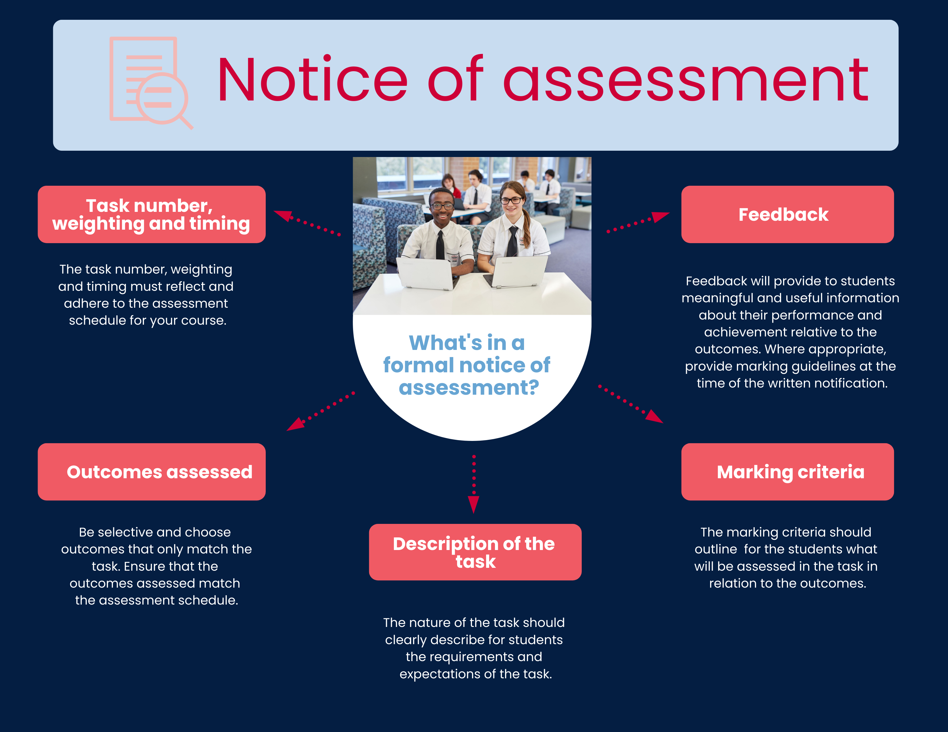
Figure 1: Notice of assessment and its 5 elements

Task number, weighting and timing
The task number, weighting and timing must reflect and adhere to the assessment schedule given to your students at the beginning of the course.

Outcomes
Outcomes represent knowledge, skills and understanding that students will achieve by the end of the HSC course. Consider the following when selecting the outcomes to be assessed through the task.
- Do your selected outcomes align with the task?
- Is the number of outcomes appropriate? Be selective – it's difficult to assess many outcomes effectively.
- Identify when outcomes are best assessed during the course, according to the schedule. For example, would it be best to assess in Continuers outcome 3.1 conveys the gist of, and identifies, specific information in texts in an earlier task? This outcome focuses on conveying and identifying information only.
- Choose outcomes to match the level of difficulty of the task and ensure you are assessing at the right level of complexity. Consider the differing complexities of these 2 examples in Beginners:
  - Question – tick the box that corresponds to the photo that is being looked at. Outcome 2.1 understands and interprets information in texts using a range of strategies
  - Question – how likely is it that Emily will join the karate club? Support your answer with reference to the text. Outcome 2.4 draws conclusions from or justifies an opinion about a text.

Description of the task
Consider the following when writing the description of the task:
- Use clear and concise language appropriate for your audience, the students. Address the students directly.
- Use headings to support communication.
- Describe what the students have to do to successfully complete the task.
- Use the correct terminology, including text types. For example, script of a speech, diary entry.
- Outline the macro skill/s to be assessed.

Developing the task
When designing a task, consider the following:
- the style/format of the task – providing a different style to the HSC so that a broader range of syllabus outcomes can be assessed to showcase students’ skills. Develop authentic tasks which connect to the world outside the classroom.
- the level of difficulty – does the task stretch students and provide them with opportunities to learn and showcase what they know?
- skills – do students have the necessary linguistic/research/ICT skills and equipment to successfully complete the task?
- the content of what is being assessed – was it covered in the course?
- the logistics of administering a language task – how will the integrity of the task be protected?
For further information on how to develop an assessment task visit NESA’s Principles of assessment.

Expectations
Be explicit – the more information you provide to students in advance, the better equipped they will be to complete the task successfully. Anticipate their questions, for example:
- What exactly is required for each section? (if the task has sections)
- Is it a take-home task or in-class task?
- Will it be administered under exam conditions?
- Are dictionaries allowed? If so, which ones?
- Are students aware of what a quality response looks like?
- Is it an individual or paired task?
- How will the task be submitted?

Sample task description
The following is a description of a sample task for Stage 6 Japanese. In this task, there are 3 components that assess 3 macro skills – reading, writing and speaking. Each part has explicit instructions, length of response, timing and submission.

Exchange program to Japan
You are considering applying for an exchange program to Japan. First, read the advertisement so you know exactly what exchange program is about.
You decide this would be an interesting experience so you start the application process by writing an email and recording a self-introduction, as requested in the application.

Part A – reading and responding
You will read a text in Japanese on an exchange program to Japan. You will answer questions in English. You will be given 30 minutes to respond to the questions.

Part B – writing
You will write an email in Japanese related to the exchange program from Part A. Your email should be approximately 150 ji in length. You will be given 30 minutes to write your email on grid paper provided.

Part C – speaking
You will submit a 2-3 minute introductory voice recording, talking about yourself. This component of the task will be completed at home and uploaded to Google Classroom by [date and time].

Marking criteria and marking guidelines
Marking criteria summarise for students what is expected of them in order to complete the task.
Marking guidelines are statements that describe student achievement for each criterion at different levels to award grades and/or marks.

Marking criteria
Marking criteria are mandatory in the notice of assessment.
Marking criteria:
- relate to the task description and outcomes being assessed
- ensure students know what is required of them to complete the task
- set the criteria for the development of the marking guidelines.

Marking guidelines
Marking guidelines are not mandatory in the assessment notification but are strongly recommended to better support students. They should be developed concurrently with the assessment task.
Consider the following when developing marking guidelines:
- Create guidelines that clearly describe the quality of each mark range in an appropriate hierarchy of achievement across each outcome being assessed.
- Ensure the guidelines allow for discrimination between the performances of individual students.
- Ensure mark ranges reflect the importance and difficulty of what students are expected to do.
- Compose a sample response and check them against the marking guidelines to ensure the guidelines are achievable.
- Ask a colleague to read over the task and see if it reads clearly – would they know what to do and what is expected, based on the marking criteria and guidelines?
- Use terminology students understand. For example, do students understand what is expected from terms such as extensive and thorough and how they relate to different outcomes?
- Consider if you will use HSC exam guidelines or adjust them to fit interrelated/non-HSC style tasks, and how this will be achieved.

Feedback
Feedback is one of the most powerful tools to support student learning and improvement. It provides students with positive feelings of self-efficacy, sustained motivation, and continued engagement (Centre for Education Statistics and Evaluation 2020b). Feedback enables students to close the gap between where they currently are in their learning and where they need to get to, as described in a unit of work’s learning intentions and success criteria.
Learning intentions and success criteria both form the basis of any feedback. Learning intentions ensure all students know what they are going to learn, and success criteria ensure all students know what the end goal for this learning is.
Feedback should:
- provide details on a student’s performance
- provide students with detailed personalised feedback on what they need to achieve to grow as a language learner
- encourage students to self-assess, reflecting on their own learning and identifying area for improvement
- be actionable by the student, providing advice on future learning
- provide a balance of more positive and less corrective feedback
- focus on the student’s process and ability.

Providing feedback on the 4 macro skills
Macro skill | Feedback considerations
Listening | Provide feedback on effective note taking when listening to texts.  Provide students with strategies to listen for the main points.  Link your feedback to the verbs in the question such as ‘recommend or ‘list’ so they understand what is required in their answers.
Speaking | During the task, avoid interrupting to provide feedback during the oral assessment. Instead, watch, listen and take notes to share with student afterwards.  Provide feedback according to the purpose of the speaking task, such as presentation, dialogue, and monologue.  Highlight accurate and appropriate language use rather than error correction.  Identify the place of fluency and accuracy within the context of the task and provide feedback.  Do not overcorrect. Focus on 1-2 areas for improvement.
Reading | Provide students with strategies to highlight the main points.  Provide feedback on how to identify and appropriately respond to key words in questions, for example ‘compare’ and ‘summarise’.  Provide feedback on textual clues, such as heading and images, which may support comprehension.  Provide feedback on how to identify inferences in texts.
Writing | Provide feedback on correctness and accuracy of effective writing, such as grammar, vocabulary, spelling, punctuation, script, layout, linking and style.  Consider using a feedback code where mistakes occur and get your students to self-correct.  If possible, provide feedback on your students’ drafts to support them to improve on their written responses.

Sample assessment feedback template – writing
This sample assessment feedback may be adapted for other macro skills.
Assessment task
Student name
Teacher
Subject
Assessment component and weighting
Mark
Strengths | For example ‘Your response was well-structured, with a clear introduction, body and conclusion’.
Areas for development | Considerations:  Does the writing contain a wide range of appropriate vocabulary?  Does the student use appropriate tenses and linking words to help the reader follow the text?  Do errors in grammar, vocabulary, punctuation or spelling impede comprehension?
Overall feedback | Write constructive feedback of one paragraph commenting on the student’s effort, process and approaches and an aspect for development.
Student reflection | Ask the student to write notes on:  What am I doing that is working well for me?  What are the focus areas in the feedback I need to work on?  How will I go about it?

Sample assessment feedback template – speaking
This sample assessment feedback maybe adapted for other macro skills.
Assessment task
Student name
Subject
Weighting and components
General feedback  (1 paragraph) | Write feedback about a student’s process or effort. For example ‘I can see you tried hard to improve X. The result is much better than last time because you did Y’.  Consider including feedback that also encourages students’ self-regulation. For example ‘You already know the key features of the opening of an argument. Check to see whether you have included them in your first paragraph’.
Strengths  What has the student done well? Mention at least 2  Be specific  Relate to success criteria | For example:  ‘You spoke fluently and coherently without too much hesitation or repetition’.  ‘You maintained the conversation through appropriate turn-taking (initiating and responding to utterances) and the use of a variety of speaking strategies’.  ‘You used a thorough range of discourse markers, including conjunctions, interjections, sentence starters’.
Opportunities for learning  Suggest 1-2 specific areas that the student can work on to achieve?  Where can the student improve?  Be specific  Relate to success criteria | Considerations:  How intelligible is the student? For example, do problems with sounds, stress or intonation impede comprehension?  Does the student have a wide enough range of vocabulary to express their ideas?  Does the student use grammar accurately enough to be comprehensible?
Assessment mark

Sample notices of assessment
These sample notices of assessment have been designed for particular languages and courses, but could be adapted for your context.

Sample 1
The following is an example of an Indonesian task for the HSC Beginners course.
Task 3 | Indonesian Beginners (HSC)
Due date | Term 2, Week 10 – Friday 25 June 2021
Weighting | 30% (Listening 10%, Writing 20%)
Topic | Holidays, travel and tourism
Outcomes | 2.1 understands and interprets information in texts using a range of strategies  2.2 conveys the gist of and identifies specific information in texts  2.4 draws conclusions from or justifies an opinion about a text  3.1 produces texts appropriate to audience, purpose and context  3.2 structures and sequences ideas and information  3.3 applies knowledge of diverse linguistic structures to convey information and express original ideas in Indonesian  3.4 applies knowledge of the culture of Indonesian-speaking communities to the production of texts.
Task description | You are preparing to go to Bali for a holiday. Part of the planning process is to hire a driver for your trip. You need to understand the information about Bali’s highlights in a video tour and answer specific questions relating to experiences in Bali. You need to decide your travel plans in Bali and write to the driver to secure them for your trip.  Listening – Part A (in-class task) 10%  You will be shown a video (approx. 3-5 mins) showcasing the tourist highlights of Bali. You will be given a range of questions in English about the video, to be answered in English. You will be able to view the video twice. You will be given 20 minutes to respond to the questions.  Writing – Part B (in-class task) 20%  Compose an email in Indonesian to a driver to enquire about your 5-day holiday in Bali based on the information shown in the video. You will have 30 mins to write your response. In your email you will need to:  - let the driver know your interests  - indicate your preferences of where you would like to go  - what you would like to do and timing of these  - ask for further advice or recommendations based on your interests  - establish a meeting time  - negotiate a price.
Marking criteria | You will be assessed on your ability to:  - convey specific information in the video, draw conclusions or justify an opinion  - structure information and ideas coherently about your travel plans  - use language features to enhance communication  - write text appropriate to context, purpose and audience  - demonstrate control of a range of language structures and vocabulary in Indonesian.

Marking guidelines – writing
(Note to teacher: Marking guidelines for the listening component would be developed according to the questions asked, and do not form part of this sample assessment notification.)
Grade | Marking guidelines – writing | Mark
A | Presents and develops original ideas, information, and/or opinions, with extensive reference to the video  Sequences and structures ideas and information coherently and effectively  Demonstrates an extensive range of vocabulary, language structures and features | 13-15
B | Presents and develops original ideas, information, and/or opinions, with thorough reference to the video  Sequences and structures ideas and information effectively  Demonstrates a thorough range of vocabulary, language structures and features | 10-12
C | Presents and develops ideas, information, and/or opinions, with sound reference to the video  Organises information and ideas coherently  Demonstrates some knowledge of vocabulary, language structures and features | 7-9
D | Presents some information relevant to the video  Organises some information and ideas  Demonstrates a basic knowledge of vocabulary and language structures | 4-6
E | Attempts to produce some comprehensible language related to isolated elements from the video  Attempts to organise information and ideas  Uses single words, set formulae and/or unrelated sentences to express information | 1-3

Feedback
Written feedback will be individually provided about aspects of the task that were performed well and need improvement. Whole course cohort discussion will also clarify areas for improvement and strategies to address these. Individual discussion may be requested.

Sample 2
The following is an example of a Japanese task for the HSC Continuers course.
Task 2 | Japanese Continuers (HSC)
Due date | Term 1, Week 9
Weighting | 30% (Reading 20% Writing 10%)
Time | 80 minutes
Topic | Living in Japan

Outcomes
A student:
- 2.1 applies knowledge of language structures to create original text
- 2.2 composes informative, descriptive, reflective, persuasive or evaluative texts appropriate to context, purpose and/or audience
- 2.3 structures and sequences ideas and information
- 3.4 draws conclusions from or justifies an opinion
- 3.5 interprets, analyses and evaluates information.

Task description
You live in Osaka and your ‘foodie’ cousin who lives in Hirosaki will be joining you for the summer festival and you want to showcase the best eateries Osaka has to offer. You need to know what is available around your city before you discuss these options with your cousin.

Part A – reading 20%
You will be provided with 4 texts on different places to eat. The texts will be in the form of reviews, blogs and/or articles. Three of these texts will be provided one week prior to the task, for you to explore at home. The remaining text will be provided in class on the day of your assessment. On the day of the assessment you will be given questions in English, to be answered in English, based on all 4 texts.
On the day of the assessment, you will be provided with fresh copies of the 3 texts you prepared at home – you will not be allowed to access your notes or annotated texts.

Part B – writing 10%
Using the texts as a stimulus, select 3 places you suggest to take your cousin to eat.
Write an email to your cousin explaining the possible places you could eat, making comparisons between the different options, which ones you would recommend and why.
Write approximately 400 ji in Japanese.

Marking criteria
Your answers will be assessed on how well you:
- understand and reference the reviews/blogs/articles
- write text appropriate to context, purpose and audience
- structure and sequence information, including recommendations and justifications
- use language features to enhance communication
- demonstrate control of a range of language structures and vocabulary in Japanese.

Marking guidelines – writing
(Note to teacher: Marking guidelines for Part A would be developed according to the questions asked, and do not form part of this sample assessment notification.)
Grade | Marking guidelines – Part B (writing) | Mark
A | Demonstrates an extensive level of accessing information to make clear and detailed comparisons and recommendation/s, with justification, on the places to eat  Manipulates language authentically and creatively, relevant to the purpose, context and audience  Sequences and structures ideas and information coherently and effectively | 17-20
B | Demonstrates a high level of accessing information to make clear comparisons and recommendation/s, with justification, on the places to eat  Manipulates language with some degree of authenticity and creativity, relevant to the purpose, context and audience  Sequences and structures ideas and information effectively | 13-16
C | Demonstrates a sound level of accessing information to make comparisons and recommendation/s, with justification, on the places to eat  Demonstrates a sound knowledge and understanding of vocabulary and language structures relevant to the purpose, context and audience  Organises information and ideas coherently | 9-12
D | Attempts to make comparisons and recommendations  Demonstrates a basic knowledge and understanding of vocabulary and language structures relevant to the purpose, context and audience  Organises some information and ideas | 5-8
E | Includes isolated elements from the text/s  Uses single words, set formulae and/or unrelated sentences to express information  Attempts to organise information and ideas | 1-4

Feedback
Written feedback will be individually provided about aspects of the task that were performed well and need improvement. Whole course cohort discussion will also clarify areas for improvement and strategies to address these. Individual discussion may be requested.

Sample 3
The following is an example of a Spanish task for the HSC Continuers course.
Task 3 | Spanish Continuers (HSC)
Due date | Term 2, Week 9
Weighting | 30% (Reading 10%, Writing 10%, Speaking 10%)
Topic | Arts and entertainment
Outcomes | 1.1 uses a range of strategies to maintain communication  - conveys information appropriate to context, purpose and audience  1.3 exchanges and justifies opinions and ideas  1.4 reflects on aspects of past, present and future experience  2.1 applies knowledge of language structures to create original text  2.2 composes informative, descriptive, reflective, persuasive or evaluative texts appropriate to context, purpose and/or audience  2.3 structures and sequences ideas and information  3.2 summarises the main ideas  3.4 draws conclusions from or justifies an opinion  3.5 interprets, analyses and evaluates information  3.6 infers points of view, attitudes or emotions from language and context  4.3 reflects upon significant aspects of language and culture
Task description | You will have 3 weeks to complete this task.  Part A – reading 10%  You will be provided with a short story written in Spanish with questions to be answered in English, including a brief summary.  Part B – writing 10%  Using the story from the reading section, write your own recount from the perspective of a different character of the story. Write approximately 300 words in Spanish.  Part C – speaking 10%  Using Flipgrid, you will create a 3-minute recording in Spanish based on your reflections about both stories and your reading habits. For example:  - Do you read often?  - What do you like to read?  - Is reading important to you?  - Do you read in English or Spanish? Why?  - Do you prefer reading or writing in Spanish? Why?  - What did you enjoy the most about the story you just read?  - Why did you choose that particular character for your recount?
Marking criteria | You will be assessed on your ability to:  - demonstrate understanding of the text  - summarise the short story  - structure your recount coherently to create an original text  - draw conclusions or justify an opinion  - use language features to enhance communication, such as intonation, pronunciation and fluency  - demonstrate control of a range of language structures and vocabulary in Spanish.

Marking guidelines
(Note to teacher: Marking guidelines for Part A would be developed according to the questions asked, and do not form part of this sample assessment notification.)

Writing
Grade | Marking guidelines – Part B (writing) | Mark
A | Demonstrates an extensive understanding of the story through the perspective of another character  Manipulates language structures authentically and creatively relevant to the task  Sequences and structures ideas and information coherently and effectively | 9-10
B | Demonstrates a thorough understanding of the story through the perspective of another character  Demonstrates an excellent understanding of language structures relevant to the task  Sequences and structures ideas and information effectively | 7-8
C | Demonstrates a sound understanding of the story through the perspective of another character  Demonstrates a good understanding of language structures relevant to the task  Organises some information and ideas | 5-6
D | Demonstrates a basic understanding of the story through the perspective of another character  Uses single words, set formulae and unrelated sentences to express information  Attempts to organise information and ideas | 3-4
E | Produces some comprehensible language relevant to the task | 1-2

Speaking
Grade | Marking guidelines – Part C (speaking) | Mark
A | Composes an engaging 3 minute recording on personal reading habits and insightful reflections on the story  Uses consistently appropriate language features to enhance communication, such as intonation, pronunciation and fluency  Manipulates language with a high level of grammatical accuracy  Demonstrates an excellent knowledge of vocabulary and language structures | 17-20
B | Composes a clear 3 minute recording on personal reading habits and reflections on the story with some depth  Uses appropriate language features to enhance communication, such as intonation, pronunciation and fluency  Manipulates language with grammatical accuracy  Demonstrates knowledge of a range of vocabulary and language structures | 13-16
C | Composes a 2-3 minute recording on personal reading habits and reflections on the story  Communicates with some degree of fluency but with possible repetition and inaccuracies in grammar and vocabulary  Demonstrates some ability to manipulate language  Demonstrates some knowledge of a range of vocabulary and language structures | 9-12
D | Composes a 1-2 minute recording on personal reading habits with limited reflections on the story  Communicates communication using simple structures and vocabulary with pauses and errors  Demonstrates basic knowledge of vocabulary and language structures | 5-8
E | Attempts to compose a recording on personal reading habits and reflections on the story  Demonstrates rudimentary knowledge of vocabulary and language structures  Communicates using single words and formulaic expressions | 1-4

Feedback
Written feedback will be individually provided about aspects of the task that were performed well and need improvement. Whole course cohort discussion will also clarify areas for improvement and strategies to address these. Individual discussion may be requested.

