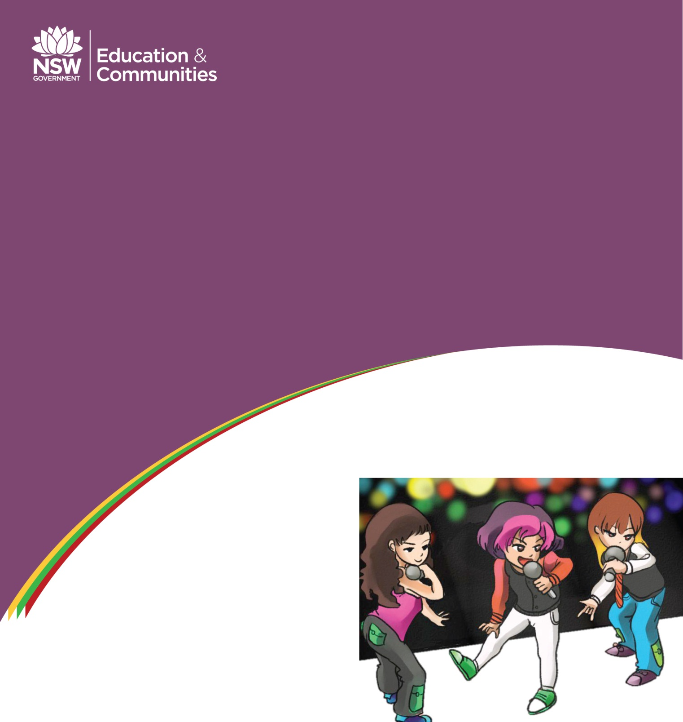

ARIRANG
Korean Songs for Beginners

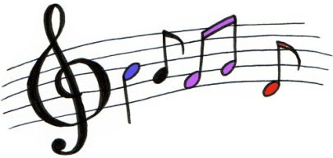

Contents

Vowel song …………………………………………………………………………………………………. 3
Greeting song ……………………………………………………………………………………………… 4
Ganada song I ……………………………………………………………………………………………… 5
Ganada song II …………………………………………………………………………………………….. 6
Colour song …………………………………………………………………………………………………. 7
Number song ………………………………………………………………………………………………. 8
Zoo song ……………………………………………………………………………………………………… 9
Days of the week song ………………………………………………………………………………… 10
Sport song …………………………………………………………………………………………………… 11
Food song ……………………………………………………………………………………………………. 12

Copyright
This resource contains information, data, documents, pages and images ('the material') prepared by the NSW Curriculum and Learning Innovation Centre (NSW CLIC). The material is subject to copyright under the Copyright Act 1968 (Cth), and it is owned by the State of New South Wales through the Department of Education and Communities although it may contain material that is owned by other parties.
The Department of Education and Communities encourages the availability, dissemination and exchange of public information. You may copy, distribute, display, download and otherwise freely deal with the material for any purpose, on the condition that you include the copyright notice '© State of New South Wales through the Department of Education and Communities' on all uses.
You must, however, obtain permission from the Department if you wish to:
- charge others for access to the work (other than at cost)
- include all or part of the work in advertising or a product for sale, or
- modify all or part of the work.
To obtain such permission please contact NSW CLIC Business Development at clic.marketing@det.nsw.edu.au
You may publish the material to another website, however if you publish an entire document or publication, we prefer you to make a direct link to this website to ensure that the latest version is always displayed.

Disclaimer
In compiling the information contained in and accessed through this website, NSW CLIC has used its best endeavours to ensure that the information is correct and current at the time of publication but takes no responsibility for any error, omission or defect therein.
To the extent permitted by law, the Department of Education and Communities and NSW CLIC, its employees, agents and consultants exclude all liability for any loss or damage (including indirect, special or consequential loss or damage) arising from the use of, or reliance on the information contained herein, whether caused or not by any negligent act or omission. If any law prohibits the exclusion of such liability, the Department and NSW CLIC limits their liability to the extent permitted by law, for the resupply of the information.

Third party sites
This website may contain links to third party websites and resources. Neither the Department nor NSW CLIC are responsible for the condition or content of these sites or resources as they are not under the control of the Department or NSW CLIC.
This material is licensed under the National Educational Access Licence for Schools (NEALS). Schools administered or represented by parties to NEALS may freely reproduce and/or make available online or electronically transmit this material in whole or part for educational uses.

The NSW Department of Education and Communities would like to acknowledge the following people and organisations who have contributed to the development of this resource and whose material has been used:
Illustrations: | Joanne Lee-Jung
Song composition: | Joo Yoon Lee & Sena Lee
Voices: | Sena Lee & Joo Yoon Lee

Vowel song

여우야 여우야 뭐하니? yeo-u-ya yeo-u-ya mwo-ha-ni?
아야어여 오요우유 으이 a-ya-eo-yeo o-yo-u-yu eu- i [repeat 4 times]
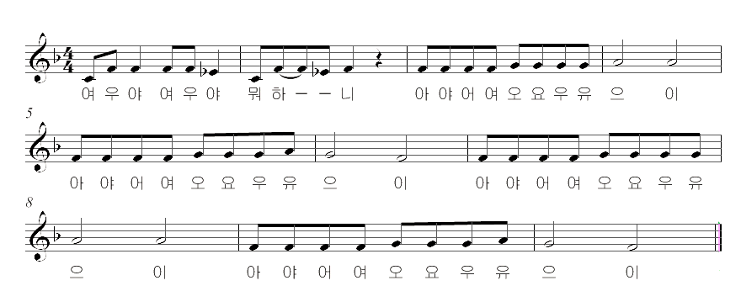

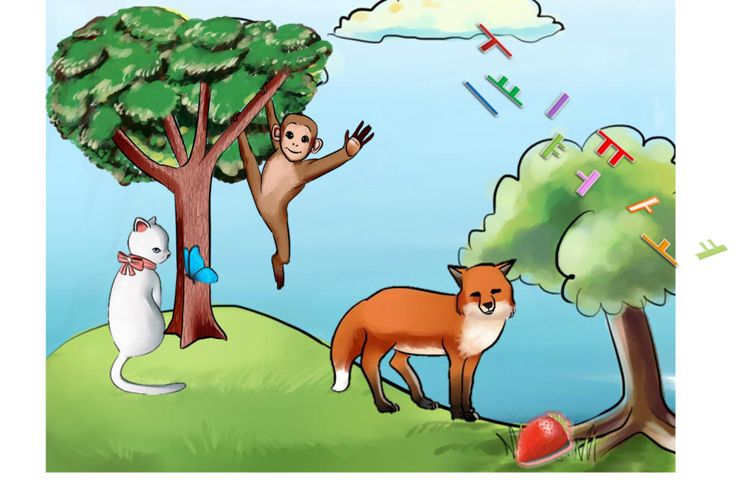
Greeting song

안녕, 안녕하세요 an-nyeong, an-nyeong-ha-se-yo
만나서 반가워요man-na-seo ban-ga-wa-yo
안녕, 안녕하세요an-nyeong, an-nyeong-ha-se-yo
저는 수지예요jeo-neun-susie-ye-yo
안녕, 안녕하세요an-nyeong, an-nyeong-ha-se-yo
만나서 반가워요 man-na-seo ban-ga-wa-yo
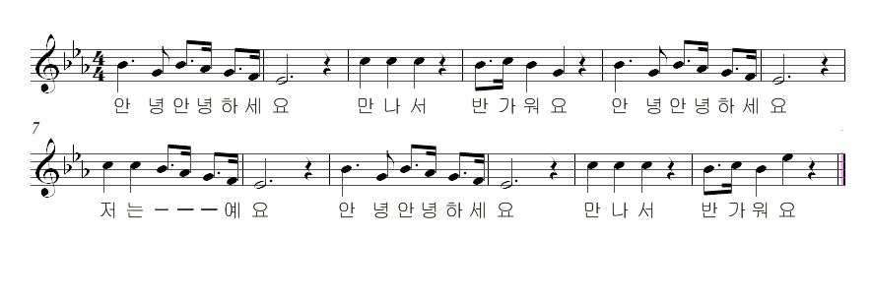

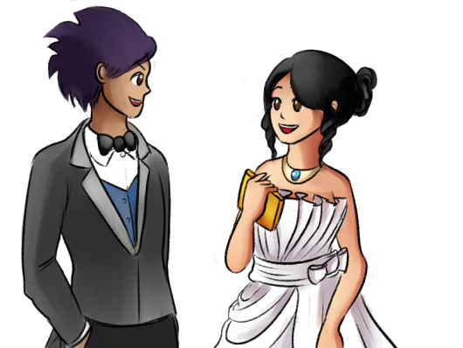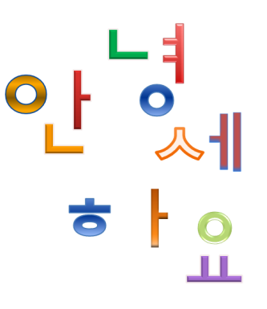

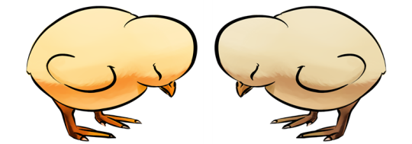

Ganada song I

가나다라마바사아자차카타파하ga-na-da-ra-ma-ba-sa-a-ja-cha-ka-ta-pa-ha
가나다라마바사아자차카타파하ga-na-da-ra-ma-ba-sa-a-ja-cha-ka-ta-pa-ha
가나 가나 가나 가나 가나다ga-na ga-na ga-na ga-na ga-na-da
가나다라마바사아ga-na-da-ra-ma-ba-sa-a
가나 가나 가나 가나 가나다ga-na ga-na ga-na ga-na ga-na-da
자 차 카 타 파 하 ja-cha-ka-ta-pa-ha

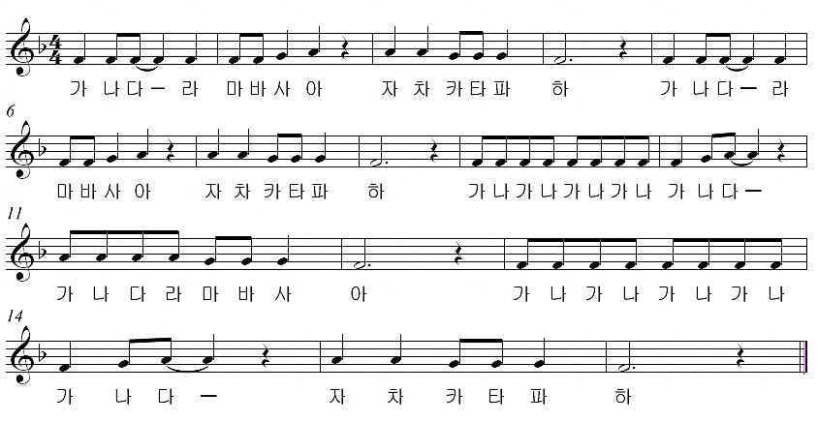

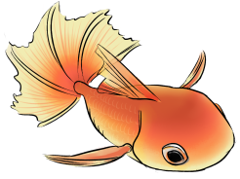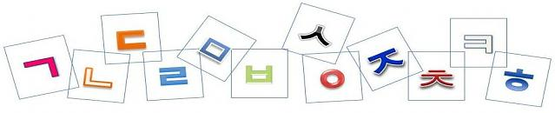
Ganada song II

가나다라마바사아자차카타파하ga-na-da-ra-ma-ba-sa-a-ja-cha-ka-ta-pa-ha
가나다라마바사아자차카타파하ga-na-da-ra-ma-ba-sa-a-ja-cha-ka-ta-pa-ha
가나다 가나다라마ga-na-da ga-na-da-ra-ma
가나다라마바사아ga-na-da-ra-ma-ba-sa-a
가나다 가나다라마ga-na-da-ga-na-da-ra-ma
가나다라마바사아자차카타파하ga-na-da-ra-ma-ba-sa-a-ja-cha-ka-ta-pa-ha

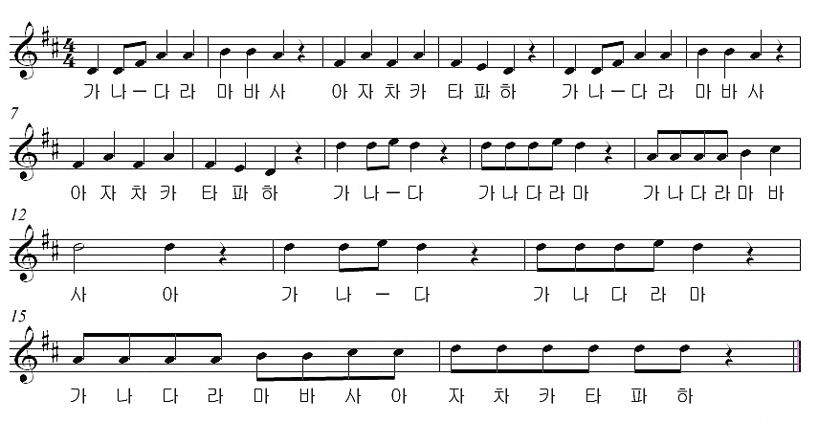

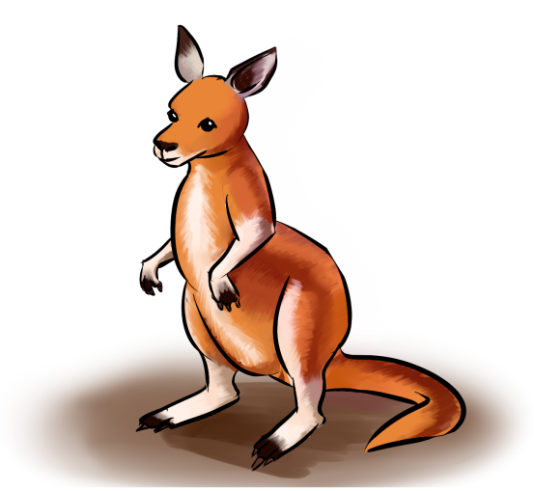
Colour song
빨간색 주황색 노란색 ppal-gan-saek juh-wang-saek no-ran-saek
초록색 파란색 남색 보라색 cho-rok-saek pa-ran-saek nam-saek bo-ra-saek
I can sing a 무지개, I can sing a mu-ji-gae,
Sing a 무지개, sing a 무지개 sing a mu-ji-gae, sing a mu-gi-gae.
빨 주 노 초 파 남 보ppal-ju-no-cho-pa-nam-bo
빨 주 노 초 파 남 보ppal-ju-no-cho-pa-nam-bo
빨 주 노 초 파 남 보ppal-ju-no-cho-pa-nam-bo
I can sing a 무지개, I can sing a mu-ji-gae,
Sing a 무지개, sing a 무지개 sing a mu-ji-gae, sing a mu-gi-gae.

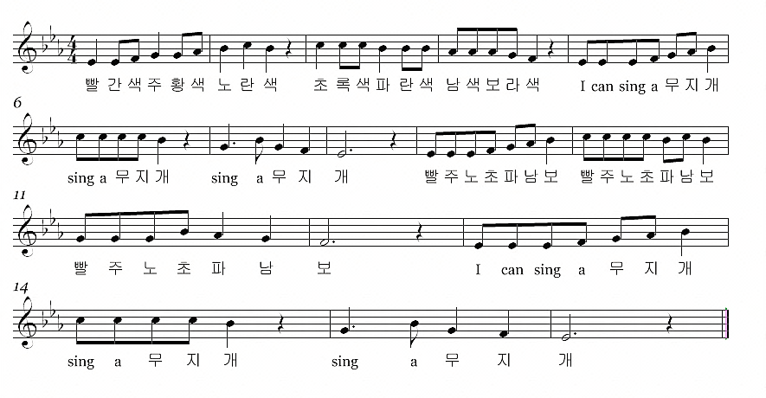

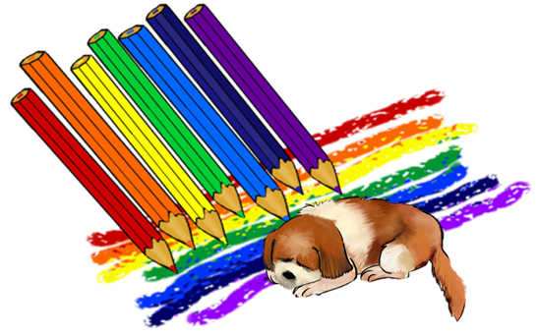
Number song

일은 하나 ir-eun ha-na  이는 둘 i-neun dul  삼은 셋 sam-eun set  사는 넷 sa-neun net  오는 다섯 o-neun da-seot  육은 여섯 yug-eun nyeo-seot  칠은 일곱 chi-reun il-gop  팔은 여덟 pa-reun nyeo-deol  구는 아홉 gu-neun a-hop  십은 열 sib-eun nyeol  I can count from one to ten. | 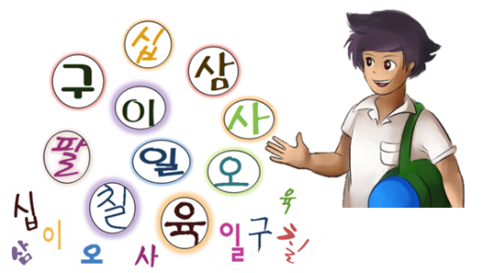
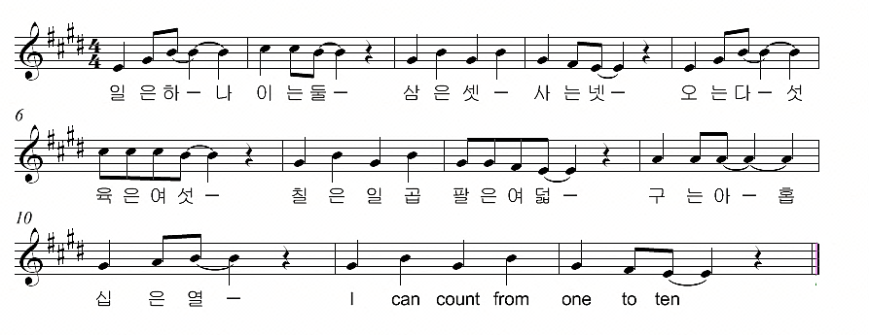

Zoo song

코끼리는 어디에 있어요? ko-kki-ri-neun eodie iseoyo?
코알라 앞에 있어요 ko-al-la ap-e i-seo-yo.
기린은 어디에 있어요? gi-rin-eun eo-di-e i-seo-yo?
코알라 옆에 있어요 ko-al-la yeop-e i-seo-yo.
앞에 앞에 앞에 앞으로ap-e ap-e ap-e ap-eu-ro
옆에 옆에 옆에 옆으로yeop-e yeop-e yeop-e yeop-eu-ro

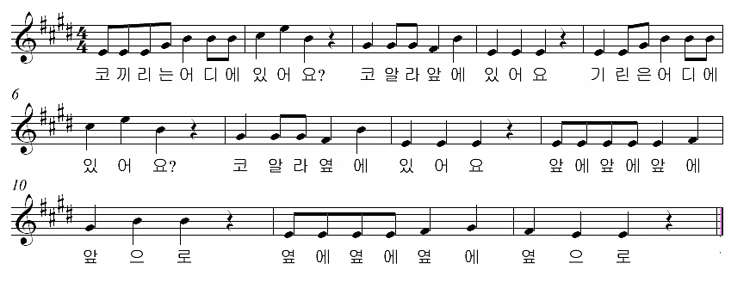
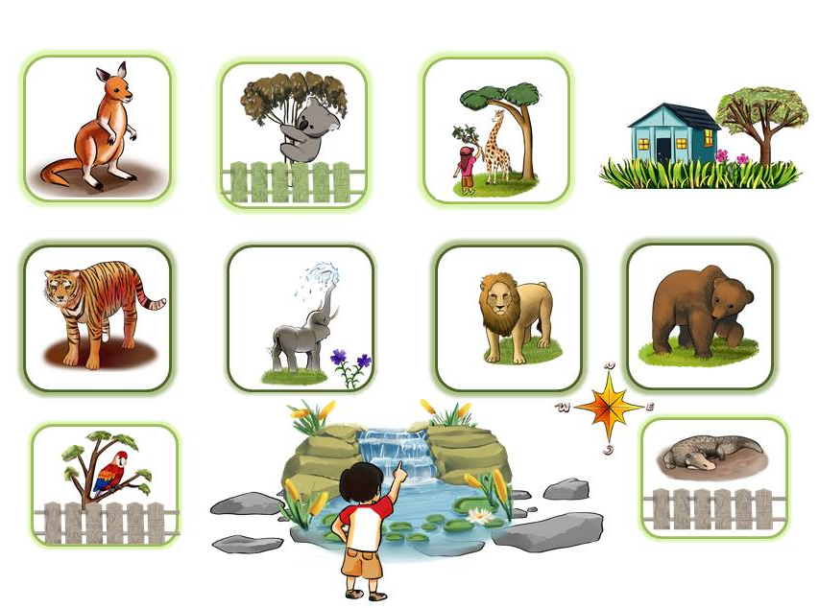

Days of the week song
[To the tune of ‘Old MacDonald had a farm’]

월 화 수 목 금 토 일 [그래 그래서] wol hwa su mog geum to il [geu-rae geu-rae-seo]
토요일에 태권도를 해 [그래 그래서] to-yo-il-e tae-kwon-do-reul hae [geurae geuraeseo]
예서 야! 야! 얍! ye-seo ya! ya! yap!
제서 야! 야! 얍! Je-seo ya! ya! yap!
예서 야! 제서 야! ye-seo ya! je-seo ya!
예서 야! 야! 얍! ye-seo ya! ya! yap!
월 화 수 목 금 토 일 [그래 그래서] wol hwa su mog geum to il [geu-rae geu-rae-seo]

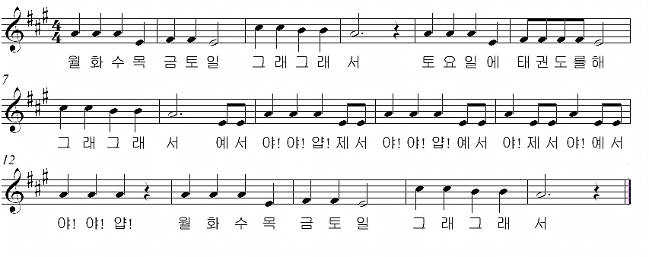

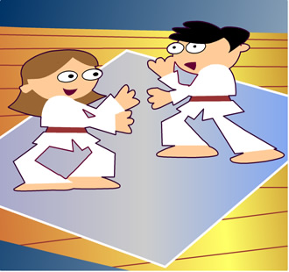
Sport song
[To the tune of ‘Incy Wincy Spider’]

축구 할 수 있어요 chuk-gu hal su i-seo-yo
농구 할 수 있어요 nong-gu hal su i-seo-yo
씨름 조금 할 수 있어요 ssi-reum jo-geum hal su i-seo-yo
하지만 수영, 수영은 못 해요 ha-ji-man su-yeong, su-yeong-eun mot hae-yo
축구 할 수 있어요 chuk-gu hal su i-seo-yo
농구 할 수 있어요 nong-gu hal su i-seo-yo

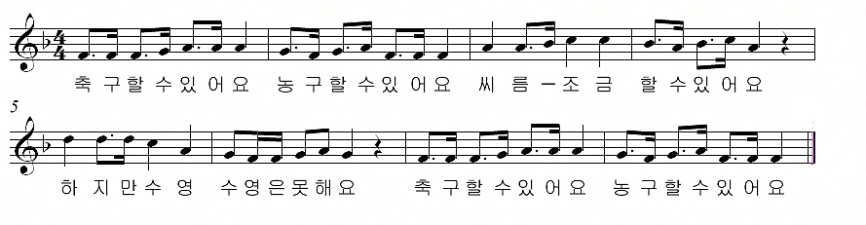

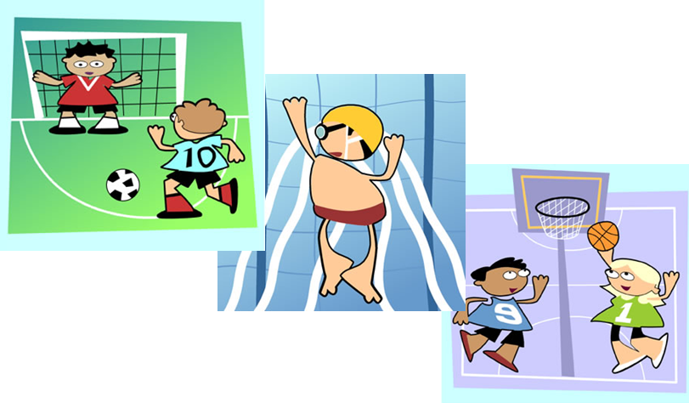
Food song

1
일 이 일 이 삼 사 il e il e sam sa
I want to eat something eat something eat something
먹어요 먹어요 불고기를 먹어요meo-geo-yo meo-geo-yo bul-go-gi-reul meo-geo-yo
오 륙 오 륙 칠 팔o ryuk o ryuk chil pal
I want to drink something drink something drink something
마셔요 마셔요 주스를 마셔요ma-syeo-yo ma-syeo-yo ju-seu-reul ma-syeo-yo
일이 일이 삼사 오륙 오륙 칠 팔il ri il ri sam sa oryuk oryuk chil pal
일 이 삼 사 오륙 칠 팔 구 십il ri sam sa oryuk chil pal gu sip

2
하나 둘 셋 넷 hana dul set net
아침에 무엇을 먹었어요 먹었어 achim-e mueoseul meogeo-seoyo meogeo-seo
밥하고 반찬을 먹었어요 먹었어 bapago banchan-eul meogeo-seoyo meogeo-seo
다섯 여섯 일곱 여덟 daseot yeoseot ilgop yeodeol
점심에 무엇을 마셨어요 마셨어 jeomsim-e mueoseul ma-syeo-seo-yo ma-syeo-seo
오렌지 주스를 마셨어요 마셨어 orenji juseu-reul ma-syeo-seo-yo ma-syeo-seo
하나 둘 셋 넷 다섯 여섯 일곱 여덟 hana dul set net daseot yeoseot ilgop yeodeol
일 이 삼 사 오륙 칠 팔 구 십 il ri sam sa oryuk chil pal gu sip

