Easy Hangeul
Consonant and vowel charts and picture flashcards
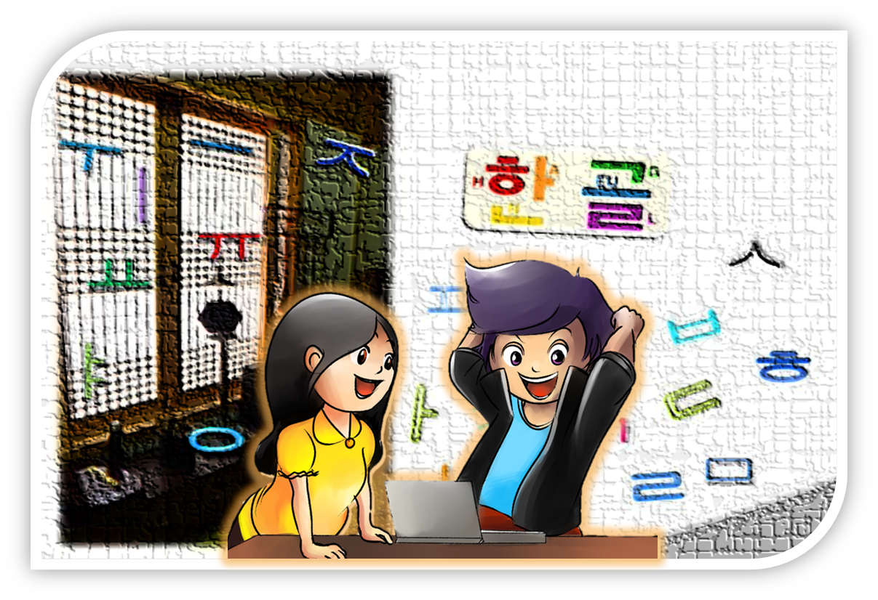
© State of New South Wales, Department of Education and Communities, 2012
www.clic.det.nsw.edu.au
NSW Curriculum and Learning Innovation Centre

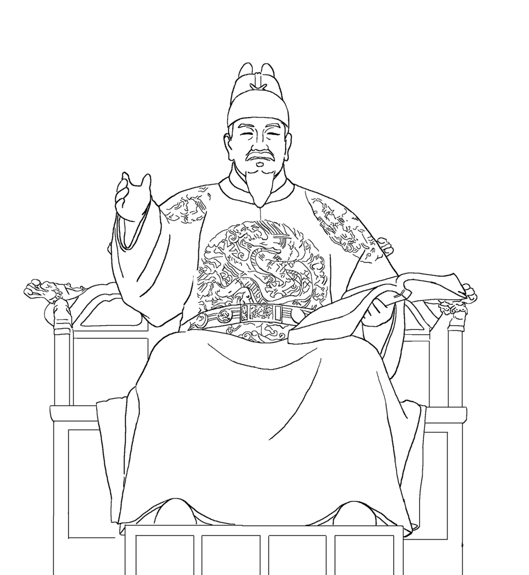
KING SEJONG, THE GREAT
Contents
Hangeul chart ………………………………………………..…………………… 4
Vowels ………………………………………………………………..……………. 5
Vowel song ………………………………………………………..………………. 6
Consonants ………………………………………………………..………………. 8
Ganada songs ……………………………………………………….……………. 9
Consonant flash cards with letters ………………………………………………11
Consonant flash card without letters …………………………………………….25

Copyright
This resource contains information, data, documents, pages and images ('the material') prepared by the NSW Curriculum and Learning Innovation Centre (NSW CLIC). The material is subject to copyright under the Copyright Act 1968 (Cth), and it is owned by the State of New South Wales through the Department of Education and Communities although it may contain material that is owned by other parties.
The Department of Education and Communities encourages the availability, dissemination and exchange of public information. You may copy, distribute, display, download and otherwise freely deal with the material for any purpose, on the condition that you include the copyright notice '© State of New South Wales through the Department of Education and Communities' on all uses.
You must, however, obtain permission from the Department if you wish to:
- charge others for access to the work (other than at cost)
- include all or part of the work in advertising or a product for sale, or
- modify all or part of the work.
To obtain such permission please contact NSW CLIC Business Development at clic.marketing@det.nsw.edu.au
You may publish the material to another website, however if you publish an entire document or publication, we prefer you to make a direct link to this website to ensure that the latest version is always displayed.

Disclaimer
In compiling the information contained in and accessed through this website, NSW CLIC has used its best endeavours to ensure that the information is correct and current at the time of publication but takes no responsibility for any error, omission or defect therein.
To the extent permitted by law, the Department of Education and Communities and NSW CLIC, its employees, agents and consultants exclude all liability for any loss or damage (including indirect, special or consequential loss or damage) arising from the use of, or reliance on the information contained herein, whether caused or not by any negligent act or omission. If any law prohibits the exclusion of such liability, the Department and NSW CLIC limits their liability to the extent permitted by law, for the resupply of the information.

Third party sites
This website may contain links to third party websites and resources. Neither the Department nor NSW CLIC are responsible for the condition or content of these sites or resources as they are not under the control of the Department or NSW CLIC.
This material is licensed under the National Educational Access Licence for Schools (NEALS). Schools administered or represented by parties to NEALS may freely reproduce and/or make available online or electronically transmit this material in whole or part for educational uses.
The NSW Department of Education and Communities would like to acknowledge the following people who have contributed to the development of this resource:
Illustrations: | Ga Hee Lee & Joanne Lee-Jung

Hangeul chart
 | ㅏ | ㅑ | ㅓ | ㅕ | ㅗ | ㅛ | ㅜ | ㅠ | ㅡ | ㅣ | ㅔ | ㅐ | ㅖ | ㅒ
ㄱ | 가 | 갸 | 거 | 겨 | 고 | 교 | 구 | 규 | 그 | 기 | 게 | 개 | 계 | 걔
ㄴ | 나 | 냐 | 너 | 녀 | 노 | 뇨 | 누 | 뉴 | 느 | 니 | 네 | 내 | 녜 | 냬
ㄷ | 다 | 댜 | 더 | 뎌 | 도 | 됴 | 두 | 듀 | 드 | 디 | 데 | 대 | 뎨 | 댸
ㄹ | 라 | 랴 | 러 | 려 | 로 | 료 | 루 | 류 | 르 | 리 | 레 | 래 | 례 | 럐
ㅁ | 마 | 먀 | 머 | 며 | 모 | 묘 | 무 | 뮤 | 므 | 미 | 메 | 매 | 몌 | 먜
ㅂ | 바 | 뱌 | 버 | 벼 | 보 | 뵤 | 부 | 뷰 | 브 | 비 | 베 | 배 | 볘 | 뱨
ㅅ | 사 | 샤 | 서 | 셔 | 소 | 쇼 | 수 | 슈 | 스 | 시 | 세 | 새 | 셰 | 섀
ㅇ | 아 | 야 | 어 | 여 | 오 | 요 | 우 | 유 | 으 | 이 | 에 | 애 | 예 | 얘
ㅈ | 자 | 쟈 | 저 | 져 | 조 | 죠 | 주 | 쥬 | 즈 | 지 | 제 | 재 | 졔 | 쟤
ㅊ | 차 | 챠 | 처 | 쳐 | 초 | 쵸 | 추 | 츄 | 츠 | 치 | 체 | 채 | 쳬 | 챼
ㅋ | 카 | 캬 | 커 | 켜 | 코 | 쿄 | 쿠 | 큐 | 크 | 키 | 케 | 캐 | 켸 | 컈
ㅌ | 타 | 탸 | 터 | 텨 | 토 | 툐 | 투 | 튜 | 트 | 티 | 테 | 태 | 톄 | 턔
ㅍ | 파 | 퍄 | 퍼 | 펴 | 포 | 표 | 푸 | 퓨 | 프 | 피 | 페 | 패 | 폐 | 퍠
ㅎ | 하 | 햐 | 허 | 혀 | 호 | 효 | 후 | 휴 | 흐 | 히 | 헤 | 해 | 혜 | 햬

Vowels
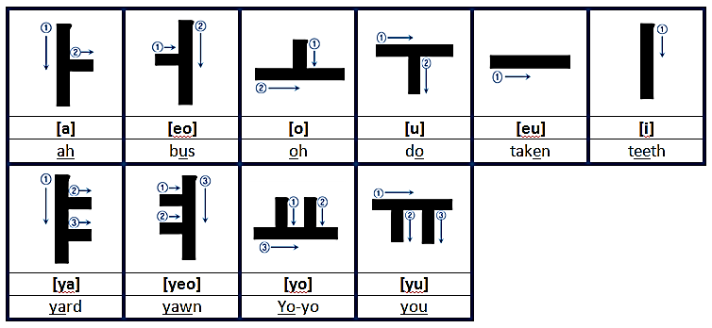

Vowel combinations
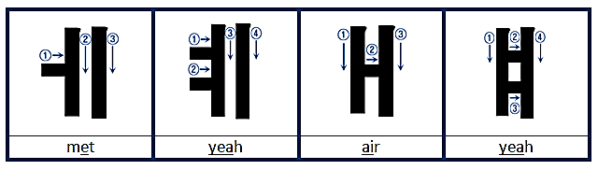
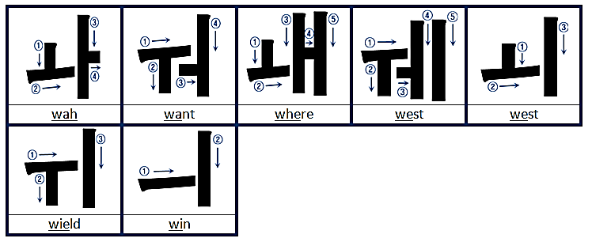

Vowel song
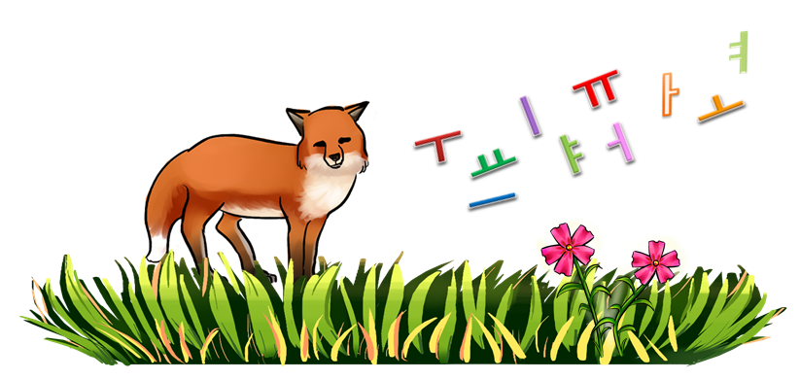

여우야 여우야 뭐하니? yeo-u-ya yeo-u-ya mwo-ha-ni
아야어여 오요우유 으이 a-ya-eo-yeo o-yo-u-yu eu- i [repeat 4 times]

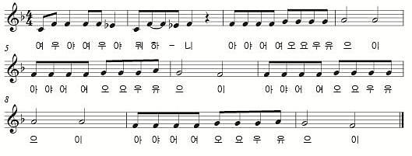
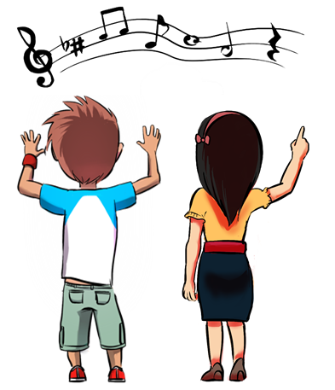
Consonants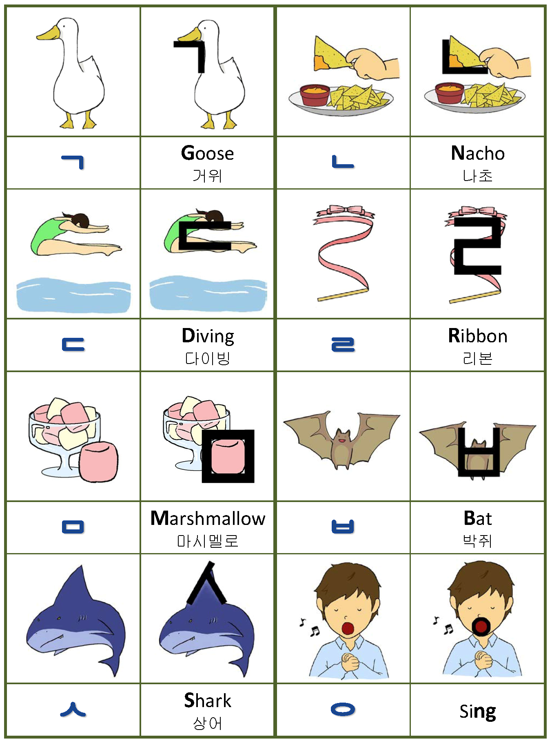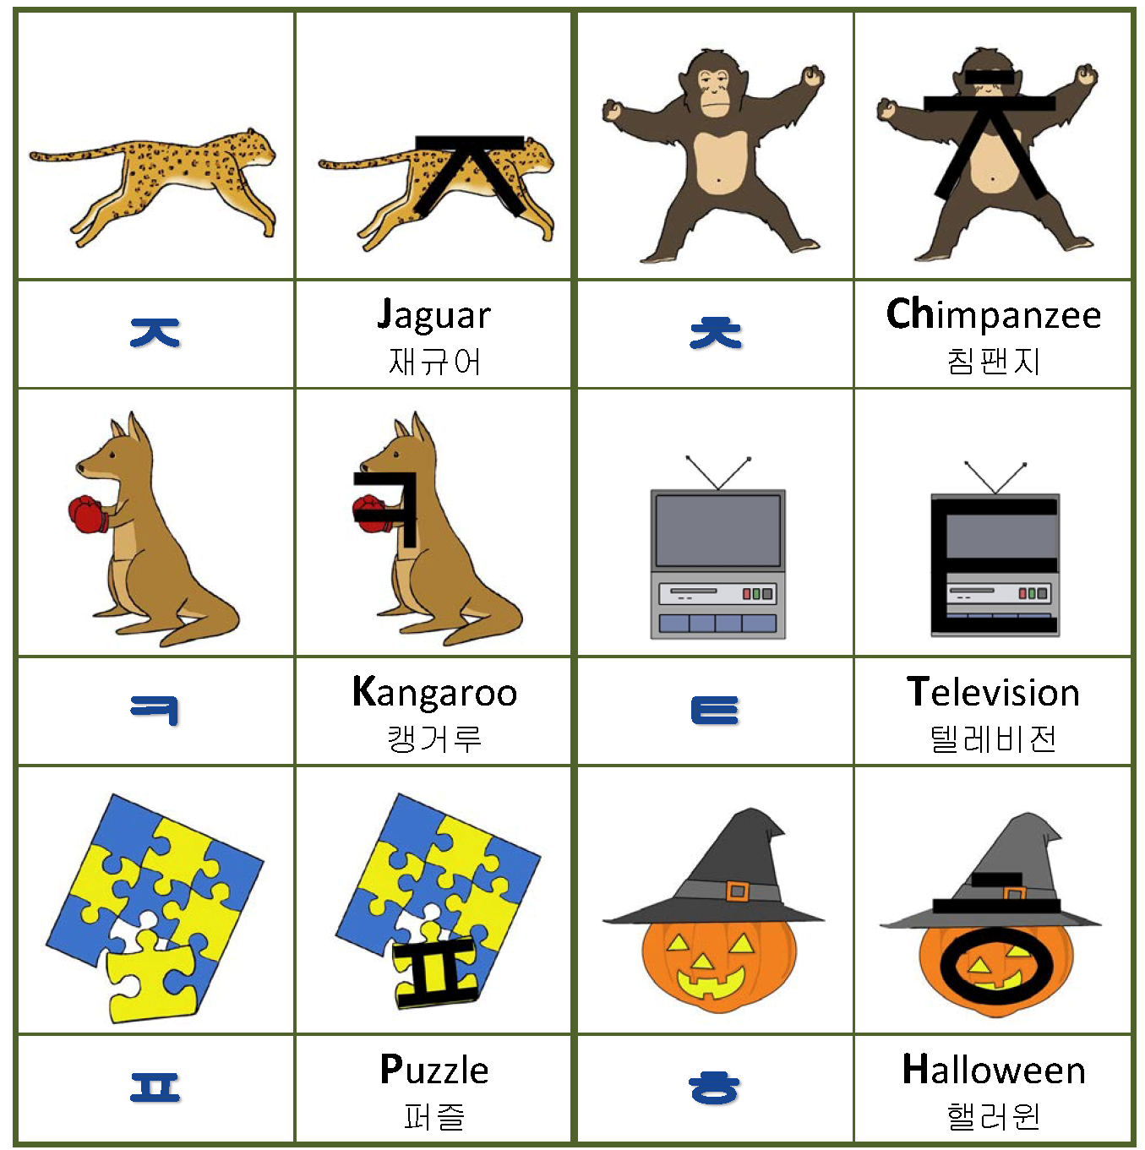

Ganada song I

가나다라마바사아자차카타파하ga-na-da-ra-ma-ba-sa-a-ja-cha-ka-ta-pa-ha
가나다라마바사아자차카타파하ga-na-da-ra-ma-ba-sa-a-ja-cha-ka-ta-pa-ha
가나 가나 가나 가나 가나다ga-na ga-na ga-na ga-na ga-na-da
가나다라마바사아ga-na-da-ra-ma-ba-sa-a
가나 가나 가나 가나 가나다ga-na ga-na ga-na ga-na ga-na-da
자 차 카 타 파 하 ja-cha-ka-ta-pa-ha

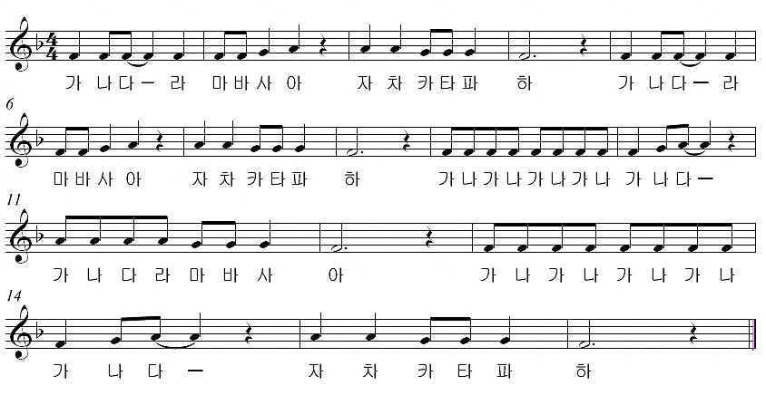

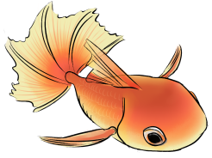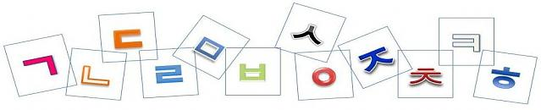

Ganada song II

가나다라마바사아자차카타파하ga-na-da-ra-ma-ba-sa-a-ja-cha-ka-ta-pa-ha
가나다라마바사아자차카타파하ga-na-da-ra-ma-ba-sa-a-ja-cha-ka-ta-pa-ha
가나다 가나다라마ga-na-da ga-na-da-ra-ma
가나다라마바사아ga-na-da-ra-ma-ba-sa-a
가나다 가나다라마ga-na-da-ga-na-da-ra-ma
가나다라마바사아자차카타파하ga-na-da-ra-ma-ba-sa-a-ja-cha-ka-ta-pa-ha
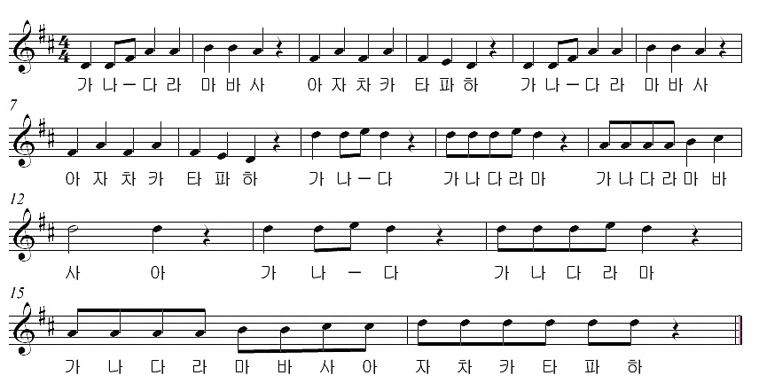
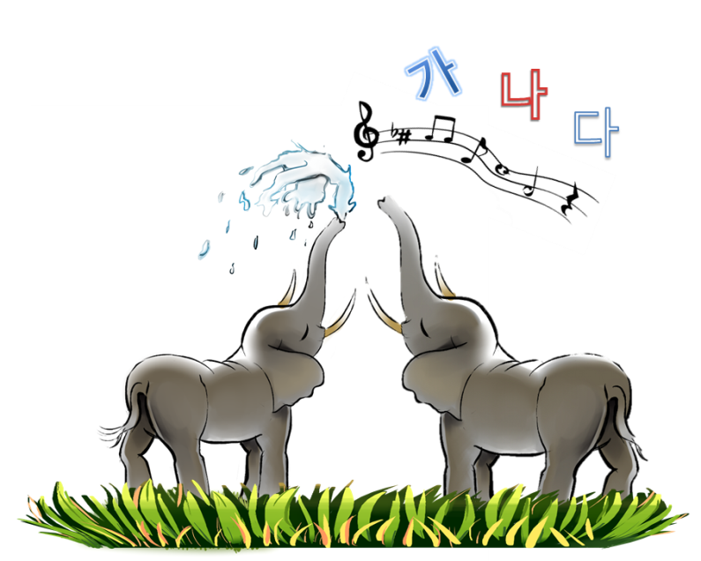
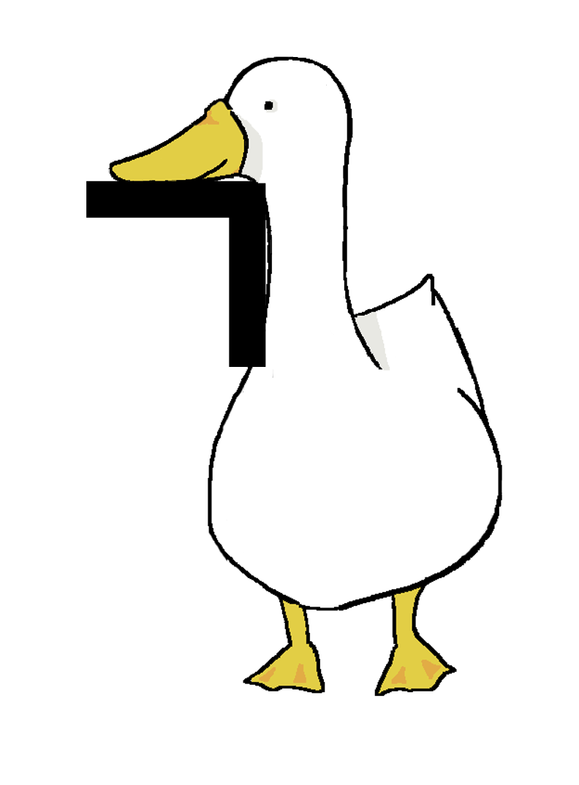*ㄱ