[Language] Early Stage 1 – My favourite toy 2 Student workbook
Name:
Class:

Overview
You will say and write words for different types of toys in [Language]. You will complete activities to demonstrate understanding of new vocabulary. You will practise saying and writing sentences before composing your own short text.

Resources
Lessons 1-2
- audio recording from teacher
- some playdough
- coloured pencils
- iPad, phone or a recording device to take photos and make audio recordings
Lessons 3-4
- audio recording from teacher
- coloured pencils
- lead pencil

Lesson 1
During this lesson you will learn to say and write words for types of toys in [Language].

Activity 1
You will listen to your teacher saying words for ‘doll’ and ‘ball’ and then practise saying those words.
Listen Speak 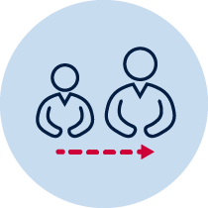 Adult support
Record Reflection
- Listen to the recording of your teacher saying ‘doll’ and ‘ball’.
- Imitate your teacher’s pronunciation and record yourself saying each word in [Language] 5 times.
- Listen to your recordings and decide which number sounds the best.
- Write that number for ‘doll’ here:
- Write that number for ‘ball’ here:

Students with prior learning and/or experience
- Also listen to the recording of your teacher saying ‘game’ and ‘puppet’ in addition to the words above.
- Imitate your teacher’s pronunciation and record yourself saying each word in [Language] 5 times.
- Listen to your recordings and decide which number sounds the best.
- Write that number for ‘game’ here:
- Write that number for ‘puppet’ here:

Activity 2
You will trace ‘doll’ in [Language].
Write Adult support
Using different coloured pencils, trace ‘doll’ in [Language] twice below.
doll
doll

Students with prior learning and/or experience
Using different coloured pencils, also trace ‘game’ in [Language] twice below.
game
game

Activity 3
You will trace ‘ball’ in [Language].
Write Adult support
- Using different coloured pencils, trace ‘ball’ in [Language] twice below.
ball
ball

Students with prior learning and/or experience
- Using different coloured pencils, also trace ‘puppet’ in [Language] twice below.

puppet

puppet

Activity 4
You will make ‘doll’ and ‘ball’ in [Language].
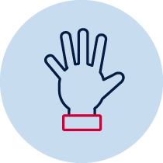 Hands on Adult support
- Using playdough, make the words ‘doll’ and ‘ball’ in [Language].
- Take photos of your work and send it to your teacher.

Students with prior learning and/or experience
- Using playdough, also make the words ‘game’ and ‘puppet’ in [Language].
- Take photos of your work and send it to your teacher.

Lesson 2
During this lesson you will learn to say and write words for types of toys in [Language]

Activity 1
You will listen to your teacher saying words for ‘teddy’ and ‘car’ and then practise saying those words.
Listen Speak Adult support
Record Reflection
- Listen to the recording of your teacher saying ‘teddy’ and ‘car’.
- Imitate your teacher’s pronunciation and record yourself saying each word in [Language] 5 times.
- Listen to your recordings and decide which number sounds the best.
- Write that number for ‘teddy’ here:
- Write that number for ‘car’ here:

Students with prior learning and/or experience
- Also listen to the recording of your teacher saying ‘dinosaur’, and ‘drum’ in addition to the words above.
- Imitate your teacher’s pronunciation and record yourself saying each word in [Language] 5 times.
- Listen to your recordings and decide which number sounds the best.
- Write that number for ‘dinosaur’ here:
- Write that number for ‘drum’ here:

Activity 2
You will trace ‘teddy’ in [Language].
Write Adult support
- Using different coloured pencils, trace ‘teddy’ in [Language] twice below.
teddy
teddy

Students with prior learning and/or experience
Using different coloured pencils, also trace ‘game’ in [Language] twice below.
dinosaur

dinosaur

Activity 3
You will trace ‘car’ in [Language].
Write Adult support
- Using different coloured pencils, trace ‘car’ in [Language] twice below.
car
car

Students with prior learning and/or experience
- Using different coloured pencils, also trace ‘drum’ in [Language] twice below.

drum

drum

Activity 4
You will make ‘teddy’ and ‘car’ in [Language].
Hands on Adult support
- Using pasta, make the words ‘teddy’ and ‘car’ in [Language].
- Take photos of your work and send it to your teacher.

Students with prior learning and/or experience
- Using pasta, also make the words ‘dinosaur’ and ‘drum’ in [Language].
- Take photos of your work and send it to your teacher.

Lesson 3
During this lesson you will show that you understand the words for types of toys.

Activity 1
You will say and write the words for types of toy in [Language].
Listen Speak Write Adult support
- Listen to the recording of your teacher saying each word from lessons 1 and 2.
- Your teacher will say a number and then a word. For example, ‘Number 1, ball’, ‘Number 2, doll’
- After listening to each number and word, repeat after your teacher.

Complete the table by writing the number your teacher said beside its matching toy.
Then write each word in the space provided.
Toy | Word | Number | My word
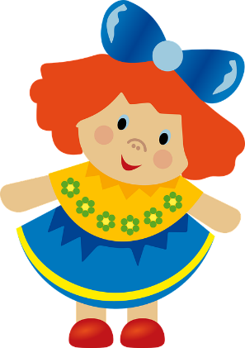 | doll
 | ball
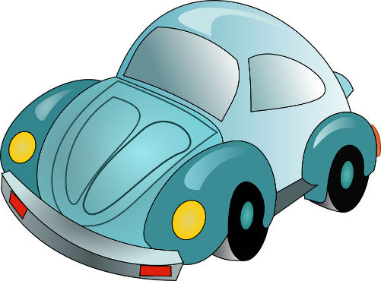 | car
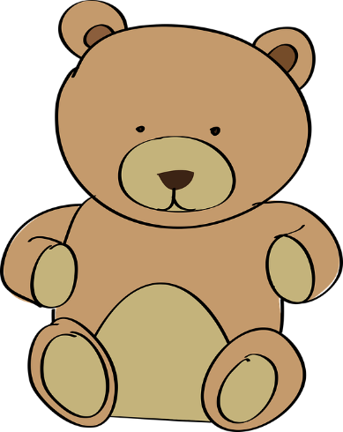 | teddy
"Baby-child-childhood-children-doll", football-ball-sport-soccer-round, Beetle-passenger-car-car-volkswagon and teddy-bear-toy-plush-cuddly by OpenClipart-Vectors is free for commercial use

Students with prior learning and/or experience
Complete both tables by writing the number your teacher said beside its matching toy.
Then write each word in the space provided.
Toy | Word | Number | My word
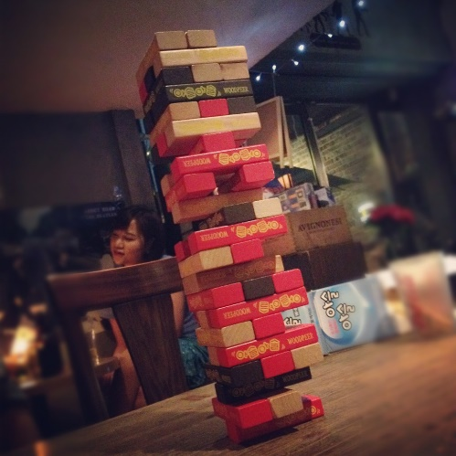 | game
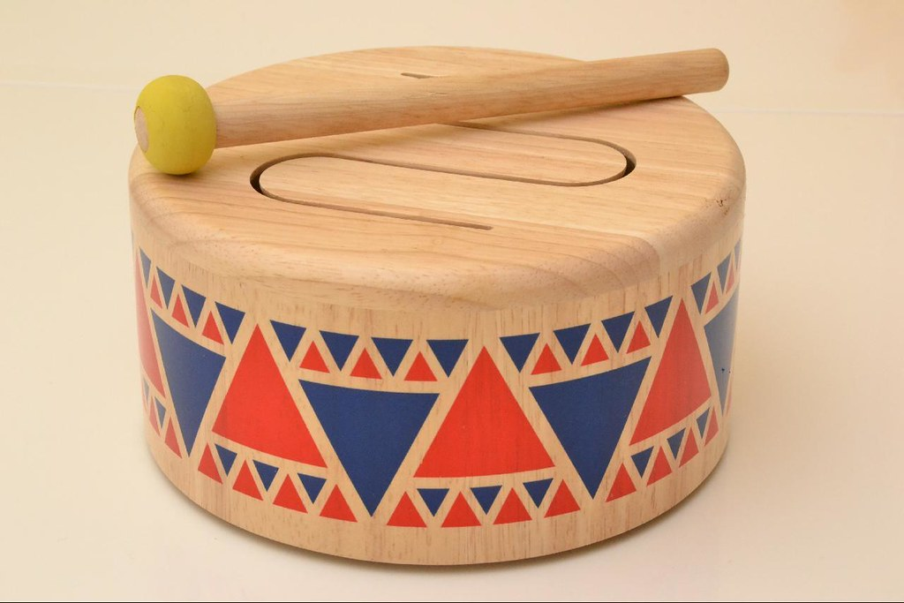 | drum
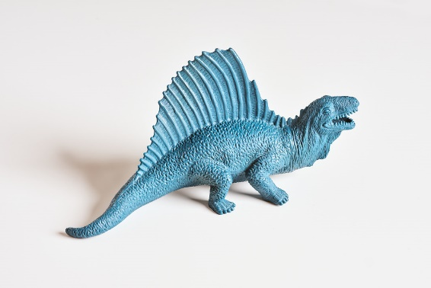 | dinosaur
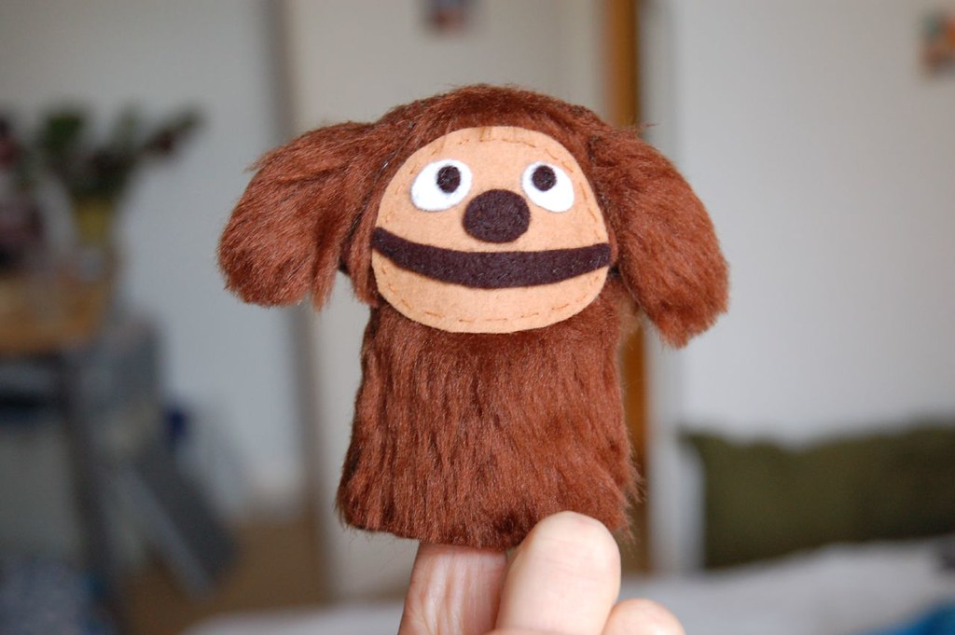 | puppet
"Board game time with Josh and Spenser" by seafaringwoman is licensed under CC BY 2.0
"Drum" by ThomasKohler is licensed under CC BY 2.0
"Toy Dinosaur" by danielfoster437 is licensed under CC BY-NC-SA 2.0
"Rowlf Muppet finger puppet" by Tarnie is licensed under CC BY-NC-ND 2.0

Activity 2
You will draw a picture of a toy and write the word in [Language].
Write Draw Adult support
- Choose one of the toys. Draw a picture of the toy and write the word in [Language] in the box below.

Lesson 4
During this lesson you will write a sentence in [Language]

Activity 1
You will listen to your teacher saying sentences and then practise saying those sentences.
Listen Speak Adult support
Record
- Listen to the recording of your teacher saying the following sentences:
  - I have a doll
  - I have a ball
  - I have a teddy
  - I have a car
- Imitate your teacher’s pronunciation and record yourself saying each sentence in [Language] 3 times.

Students with prior learning and/or experience
- Listen to the recording of your teacher saying the following sentences, in addition to the sentences above:
  - I have a game
  - I have a puppet
  - I have a dinosaur
  - I have a drum
- Imitate your teacher’s pronunciation and record yourself saying each word in [Language] 3 times.

Activity 2
You will write a sentence about a toy in [Language].
Write Adult support
- Choose a toy and trace the sentence about that toy.

I have a doll.
I have a ball.
I have a teddy.
I have a car.

Students with prior learning and/or experience

Choose another toy and trace the sentence about that toy.
. I have a game.
- I have a puppet.
- I have a dinosaur.
- I have a drum.

Activity 3
You will draw a picture of a toy and write the word in [Language].
Write Draw Adult support
- Choose one of the toys.
- Draw a picture of you and the toy.
- Write ‘I have a ________’ in [Language] in the box below.

Don’t forget to send your wonderful work to your teacher!
You could:
- Post your workbook to your school.
- Scan or take photos of your workbook and email them to your teacher or upload them to your class digital learning platform.
- Email your photos and recordings to your teacher or upload them to your class digital learning platform.

