Visible thinking in the languages classroom – building deeper understanding and student engagement
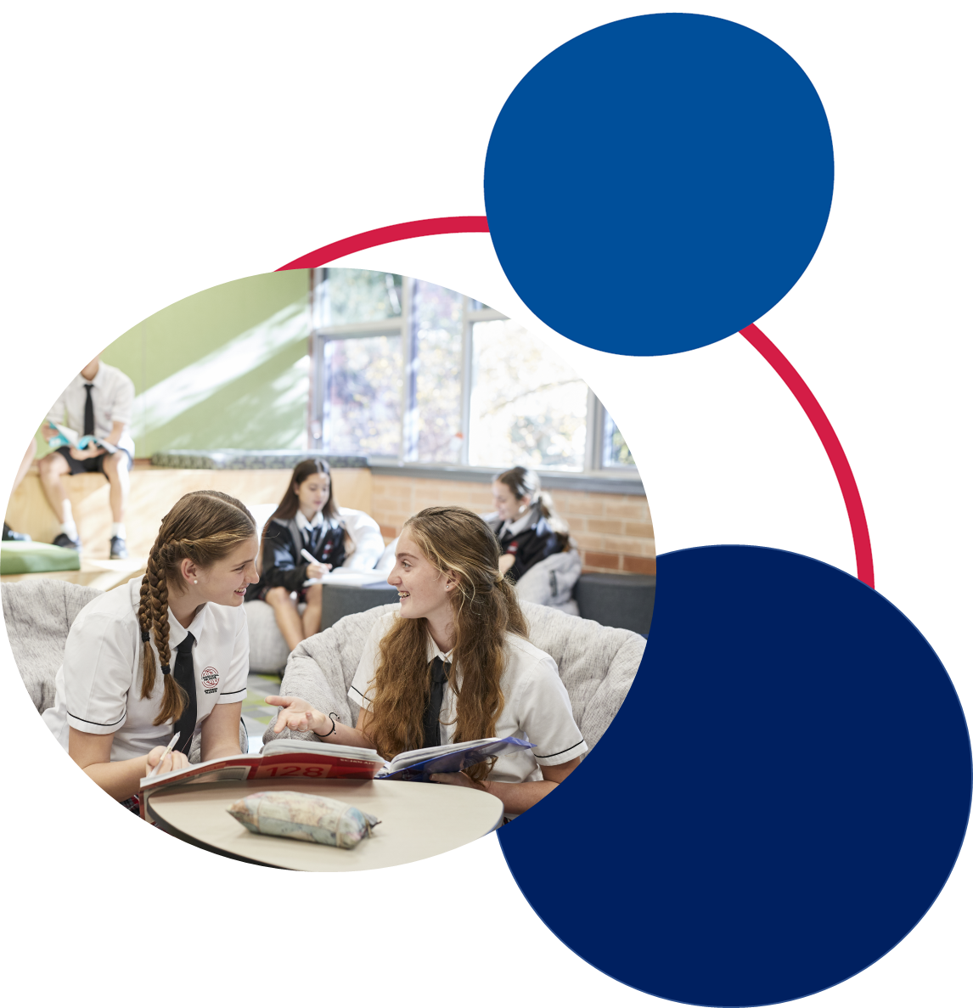

Table of contents

Introduction 2
6 benefits of critical thinking 3
5 expectations that help shape a culture of thinking 3
Focus on the learning versus the work 3
Teaching for understanding versus knowledge 3
Encourage deep versus surface learning strategies 3
Encourage independence versus dependence 4
Encourage a growth versus fixed mindset 4
8 cultural forces of a thinking classroom 4
Applying cultural forces in the language classroom 5
Time 5
Language 5
Expectations 7
Relationships 7
Routines 8
Modelling 8
Environment 9
Opportunities 9
Thinking routines 10
Applying thinking routines in the language classroom 10
See – think – wonder 10
5 whys 13
Peel the fruit 16
Jigsaw strategy 17
3-2-1 organiser 18
10 x 2 visual thinking strategy 19
Lenses 20
Hexagonal thinking 23
What tools can be used to support thinking routines? 24
Tools 24
Templates 25
Fishbone diagram 25
Concept maps 25
Connect – extend – challenge 26
Y chart 27
Modelled responses 27
Reflections 29
Roll the dice 29
Extra support 29

Introduction
This document has been developed to support our statewide staff meeting on ‘Thinking for deeper understanding and engagement in the languages classroom’, presented in 2021. You can access the recording on our YouTube channel.
The presentation was based on the work of Project Zero, an initiative from Harvard University that focuses on creating a culture of thinking in the classroom. This guide looks at some of the ideas and thinking tools from Project Zero, contextualised for the languages classroom. We’ll look at ways to make thinking visible, to value the thinking of all class members and how to advance the thinking of the group to deepen understanding.
Let’s take a moment to visualise a ‘thinking’ languages classroom. What sorts of things would we see, which are evidence that students are thinking about what they are learning and how they are learning? It could be activities, resources, actions or interactions.
Implementing a few of the ideas in this guide can quickly change the culture in your classroom, as routines for learning and thinking begin to replace routines regarding behaviour. You may find that classroom management issues decrease as students gain confidence in their learning and also become more independent and engaged learners. Their relationship with you, as their teacher, and with each other may also grow as a result. Student learning outcomes also improve as the class collectively moves from a fixed mindset to a growth mindset.
Learn more at the Project Zero website.
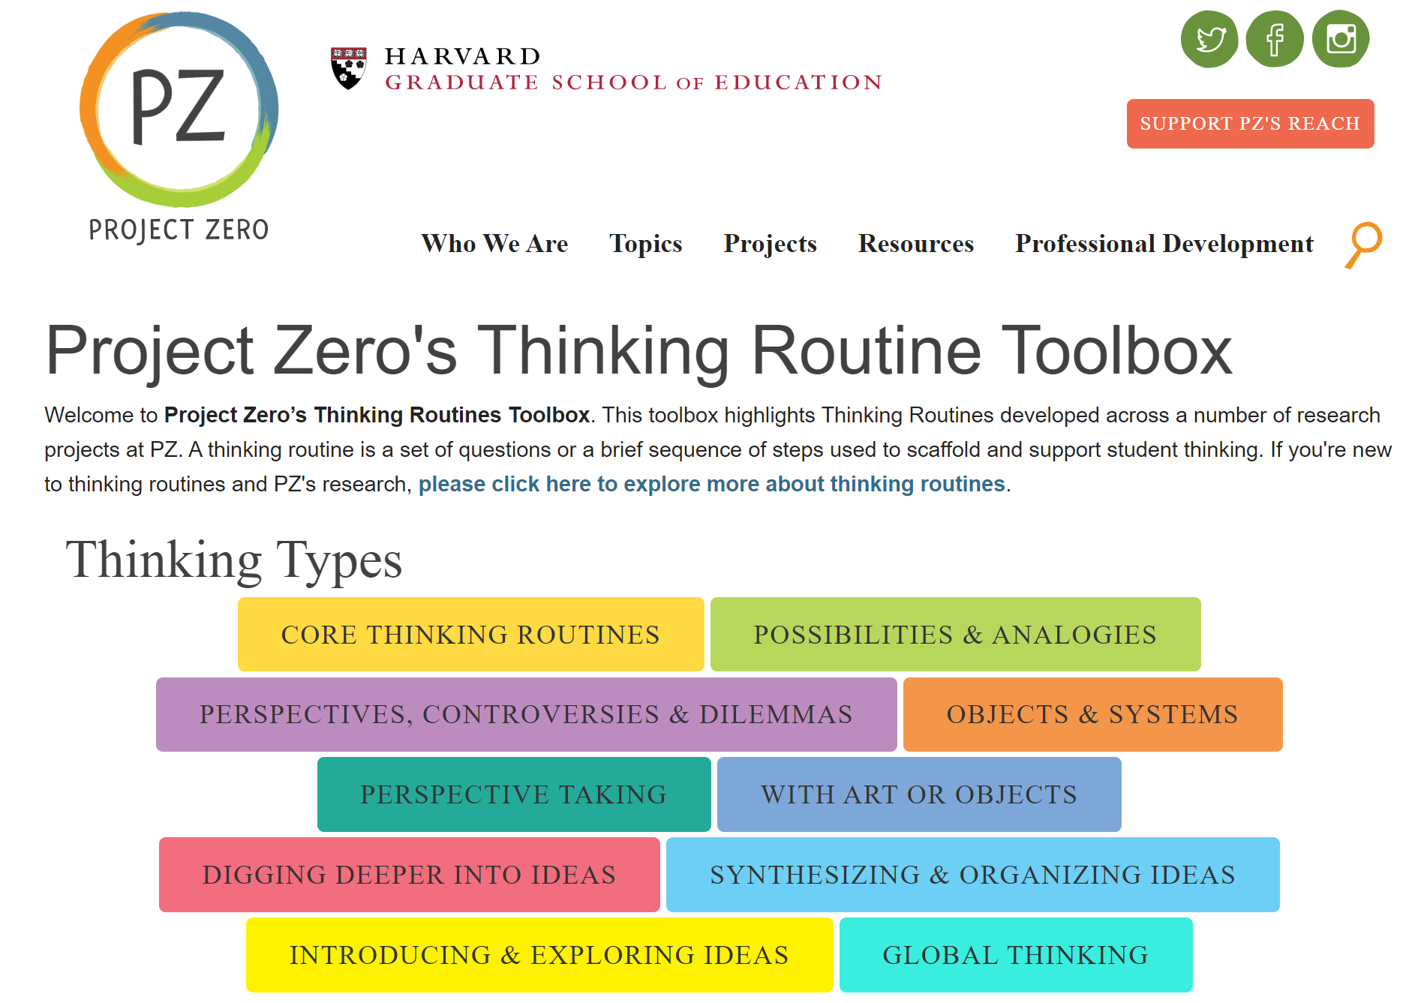

6 benefits of critical thinking
Wabisabi Learning identifies 6 benefits of critical thinking. Critical thinking:
- encourages curiosity
- enhances creativity
- reinforces problem solving ability
- is a multi-faceted practice promoting reasoning skills, evaluative skills, planning skills, language skills, self reflection and observation skills
- fosters independence
- is a skill for life, not just learning.

5 expectations that help shape a culture of thinking
Ron Ritchhart from Project Zero explains 5 expectations that help shape a culture of thinking.

Focus on the learning versus the work
The metaphor of work – learning as work, students as workers and classrooms as workplaces – is entrenched in our ideas of education. These metaphors organise our experience and create realities. So, how you frame a task is often what determines what you are likely to get out of it. When teachers and students focus their attention on learning as the priority, letting the work serve the learning, then work becomes a means to an end, not the end itself.

Teaching for understanding versus knowledge
Understanding goes beyond possessing a set of skills or a collection of facts; it requires knowledge to be woven together in a web of connections. This allows us to put ideas to use in unfamiliar situations. Teaching for understanding requires exploring a topic, and in our case language, from many angles, building connections, looking for applications and producing what is, for the student, a novel outcome.

Encourage deep versus surface learning strategies
Surface strategies focus on memory and knowledge gathering, whereas deep strategies help students develop understanding, through making connections and delving deeper into content.
As teachers, we ask our students to use certain modes of processing. These modes can be explicit, such as the thinking routines we will explore in this document, or implicit, when commonly used modes of processing have been established and are automatically used within the learning environment.
As we explore thinking routines, try to identify 1-2 routines you can use in your classroom for specific tasks such as a listening comprehension or extending on ideas or language to make more complex ones.

Encourage independence versus dependence
We want to develop independent learners, who are intrinsically motivated to be reflective, resourceful and effective in their learning efforts, even when challenges arise. We want students who are self-starters, can persevere and who work well both in groups and independently. However, often we inadvertently foster dependence by rescuing students and depriving them of the opportunity to develop initiative and resilience. Ask yourself: Who is doing the thinking in this encounter? The answer should be ‘the students’!

Encourage a growth versus fixed mindset
How we view intelligence, ability and talent often determines how we approach new learning situations. Do we view intelligence as a fixed entity that we are born with or as something that grows and develops over a lifetime through our efforts? Students with a growth mindset are often more likely to see challenges as opportunities to learn, whereas those with a fixed mindset tend to give up and be defeated by challenge. Mindsets develop based on feedback. Praise for effort can help develop a growth mindset, whereas praise for ability can foster a fixed mindset.

8 cultural forces of a thinking classroom
In addition to the expectations unpacked above, Project Zero identified 8 cultural forces to develop a culture of thinking in the classroom:
- time
- language
- expectations
- relationships
- routines
- modelling
- environment
- opportunities.

Applying cultural forces in the language classroom

Time
Allow your students time to explore ideas, and time to respond to questions asked. And remember a second wait time, allowing for students to reflect after a response is given.
You can also allow time to embed the following strategies:
- Rather than have quick, one-word answers, give students time to build on their responses. When a student responds, ask others to add to the response. Consider using mini whiteboards or a shared online document or platform, or students could work individually in their books or own documents.
- Ask students to consider a response more deeply or to apply it in other ways, linking the response to other learning or to real-life scenarios. For example, when drilling adjectives with flashcards, ask students to think of synonyms or antonyms, to use it in a sentence or question, or to join it with another adjective using a conjunction or connective. Ask students to write their best sentence using the adjective and share with someone.
To draw attention to thinking time, you could have a signal such as a push button light that shows it is thinking time, then turn it off for response time.
Thinking time is far more important than the amount of responses. It could include brainstorming, discussion, quiet time, feedback (self, teacher and peer) and self-reflection of their learning and setting learning goals

Language
Language in this context means the words you are using, not the language the students are learning, although in an immersion class, it could be the same.
Ron Ritchhart states that ‘Through language, teachers notice, name and highlight the activity, thinking and ideas that are important in the learning context, drawing students’ attention to these concepts and practices in the process. Often when you notice and name the students’ thinking and positive learning processes, the students exhibit more of those behaviours’.
Language of community – through using pronoun choices such as ‘we’, ‘us’ and ‘our’, we can create an inclusive and collaborative classroom for everyone. This gives the sense of everyone is in it together.
Language of identity – this involves students in the learning rather than being receivers of the information transmitted to them. In the languages classroom, students may be travellers, thinkers, writers, guides, linguists, reviewers, reporters, and so on. By seeing themselves in a role, students connect more deeply with the content.
Language of noticing and naming – naming the thinking that students are doing helps students identify, engage in and reflect upon thinking as part of the learning process and directs them to further their thinking processes. Some examples may be justifying, examining, questioning, agreeing, reasoning, connecting and brainstorming.
Language of initiative – to help students become independent, flexible learners, language is a powerful tool in fostering initiative. Through asking questions such as “Why did you use that grammatical structure?” or “What do you think you might add to your writing?”, students can see that ideas don’t just come to them, they can plan, and the learning is in their control. Using the words ‘could’ and ‘would’ can be helpful for thinking of alternatives.
Language of listening – discussing student ideas and progress with them through active listening, such as clarifying and extending questions, shows interest, builds positive relationships, makes you part of the learning process with the student and gives opportunity for feedback in an informal way. Being constantly mobile in the classroom as students create, develop and brainstorm allows for discussions with them. Engagement and behaviour may improve through these personalised, informal interactions giving your students a chance to share their learning. In the languages classroom, areas such as planning what content to review, how to extend sentences and discussing challenges are easily explored this way.
Language of knowing – trying to keep the language we use in the classroom to conditional rather than absolute forms keeps the discussions open and flexible and allows for more thinking time, different options and deeper understanding. In the languages classroom, using conditional language such as “How else could this structure be used?” or “Are there other ways we could express this?” shows the learning and communication are evolving. They are not absolute, and just one-word or one-structure answers can open up a world of possibility and peak curiosity in students. This helps students integrate their prior learning and understand new applications rather than just learn a word or structure.
Language of feedback and praise – being very specific about the language used in feedback in the classroom helps guide future learning. Sincere, descriptive, specific and action-orientated feedback helps students understand what they are able to do well and what they can action to develop further, fostering a growth mindset. Responding with “That was a great use of conjunctions” or “The ideas you came up with in your response will be really useful when travelling” will help students to specifically identify what they are able to do and link their learning to authentic situations.

Expectations
Share clear expectations for the level of thought required for a learning activity. Let students know that you are after their best understanding and application, not their fastest completion. It is better for students to gain a deeper understanding of how to create a few responses that may include a range of grammatical structures, conjunctions, sentence starter and opinions, rather than race to complete 10 questions from the workbook. Incomplete questions/activities are okay if the learning has been deep in other ways.
Remember, the focus is on the learning and not the work so try and remove the word ‘work’ from your classroom vocabulary. This can be hard at first as we often say “Do your work” or “Have you finished your work?”. Instead, try to say something like “I am looking forward to seeing the language and ideas you choose to include in your writing”. This puts the emphasis on the students’ effort and on their deep understanding of content, rather than on racing to complete the ‘work’.
Demonstrate to students what you expect in their responses and explore an example together. For example, making sentences more complex:
- I like Indonesian food.
- I like Indonesian food because it is delicious.
- I like Indonesian food because it is delicious and spicy.
- I like Indonesian food because it is delicious and spicy but I don’t like Klepon.
- I like Indonesian food because it is delicious and spicy but I don’t like Klepon. I think it is too sweet.
Show students how to demonstrate a deeper understanding and incorporate ideas. As you move through each step, you’ll notice there will be further opportunity to stop and think. Students could offer up alternative vocab or structures or create their own sentences, individually or in small groups.
Empower your students to meet expectations of deep understanding.

Relationships
Create a safe place for thinking and sharing, through collaborative inquiry and continual reaffirmation of the value of thinking.
Students and teachers can build positive relationships in the language classroom through:
- language game play
- group work on mini tasks
- peer assessment with feedback strategies, such as 2 stars and a wish or traffic lights
- creating a learning environment where everyone feels respected and heard. As you move around the classroom during thinking times you can include surrounding students, as appropriate, in discussions to model how we can positively discuss feedback and build a sense of community.

Routines
Use thinking routines, patterns of conversation and other tools to make student thinking visible. Over time, these routines can become habits that will stay with students for a lifetime of learning.
Thinking tools and activities create a sense of confidence, community and independence, as the students master the routines.
An example in a languages classroom might be that each time a new sentence structure is introduced, students use mini whiteboards in small groups to write their best sentence incorporating that structure. Students then swap the boards with another group to add to it, or give feedback. This allows students to build relationships, consider alternatives and engage in a thinking strategy that is easy to use on a regular basis.

Modelling
Model who you are as a thinker to your students. Share, discuss, and make your own thought process visible.
Openly discuss your thinking process with your students. Tell them why you make choices to add certain words or phrases, what your goals are for their learning and why, how you plan and organise your time and resources on your languages journey. This includes you in the ‘we’ of the learning.
When introducing a new task, take time to show students how you would go about planning for the task. Draw a planner on the board to brainstorm ideas for content and language, where you would go for help, context and audience alternatives and have your students join in with you. Encourage them to add a variety of vocabulary and structures to their planner for different parts so they can apply them to their own context.
Model different types of planners and reflection tools, share your own successes and challenges and how you faced them.

Environment
Arrange your classroom or learning space to facilitate thoughtful interactions. The way a room is set up can say a lot to our students about whose ideas are valued.
Everyone’s learning environment is very different but, with an open mind, even the smallest spaces can be a thinking hive. You could consider:
- a group of tables set up in your room
- online group work using Teams, Padlet, Flipgrid or other online collaborative spaces
- blended learning with workstations for students to rotate through on daily or weekly basis, including group work, pair work, independent work and teacher time
- alternative spaces for learning such as outside, computer rooms, virtual classrooms with another school
- your space in the classroom as a teacher. Do you stay out front or mostly at your desk? Do you even need a desk at the front? Interacting with the students during the lesson leads students to be more engaged, inquisitive, interactive and willing to take risks and ask questions. You can become better aware of students’ strengths, challenges, interests and preferred learning styles by spending more time with them. This will also allow you to become more involved in their thinking and learning process.

Opportunities
Create purposeful opportunities and activities to explore ideas and implement learning design that promotes inquiry. Students cannot deepen their thinking if they are only given shallow requests.
Think about the activities you do in your classroom – is it mostly textbook and workbook activities? Are the activities authentic? Do they challenge the students and offer opportunities for them to explore the language in areas of interest to them?
Backward mapping is the process of planning units of work by starting with the end goal – the assessment, which you should provide to students at the start of a unit, so they know where they are heading. Backward mapping enables you to plan mini tasks along the way, to build the language and skills students need to adapt to different audiences, contexts and purposes. Giving students choice in these mini tasks will peak curiosity and ensure they are using language in areas of interest to them. The same outcomes can be achieved even though the context, purpose or audience changes. These are also great for feedback opportunities and formative assessment.
Providing scaffolds and planners will assist students in making their thinking visible, set goals and gauge their progress and success.

Thinking routines
Thinking routines provide structures and scaffolds that must be deliberately activated, by the teacher at first and, over time, by the learner. They can be simple structures, for example a set of questions or a short sequence of steps. What makes them routines, as opposed to a strategy, is that they get used over and over again in the classroom so that they become ingrained and part of the classroom culture.
Thinking routines:
- help direct attention straight to the issue
- provide specific practices that can easily be employed
- make student thinking visible
- provide a good platform to show what students are capable of doing
- encourage action and discussion around thinking
- connect easily to the other cultural forces.
Ask yourself:
- What sort of thinking do I need students to do with this content?
- How can I best scaffold that thinking?

Applying thinking routines in the language classroom
In this next section, we’ll explore 8 thinking routines, linked to the sample units of work for Stages 4 and 5 on our website.

See – think – wonder
Let’s look at the see – think – wonder routine in relation to the Stage 5 unit ‘A sustainable future, making changes together’.
This is a generic unit which supports the cross-curriculum priorities of ‘Aboriginal and Torres Strait Islander histories and cultures’ and ‘Sustainability’. It includes an anchor text which has been translated into various languages on our website to support teachers to use this with their classes.
As part of this unit, students watch the YouTube clip ‘The land owns us’ to reflect and gain a deeper understanding of many Aboriginal peoples’ connection to land.
By using the see – think – wonder routine, students can gain a deeper understanding of this connection.
First, as a teacher, think of the language frames you might use, in order to direct your students’ thinking as they engage with the activity. Ask the students to consider these frames when watching the video and in discussion afterwards.
- What do you see/think/wonder?
- Why do you believe that … ?
- Where do you see … ?
- What do you mean when you say … ?
- That’s an interesting statement because …
- Could you repeat that?
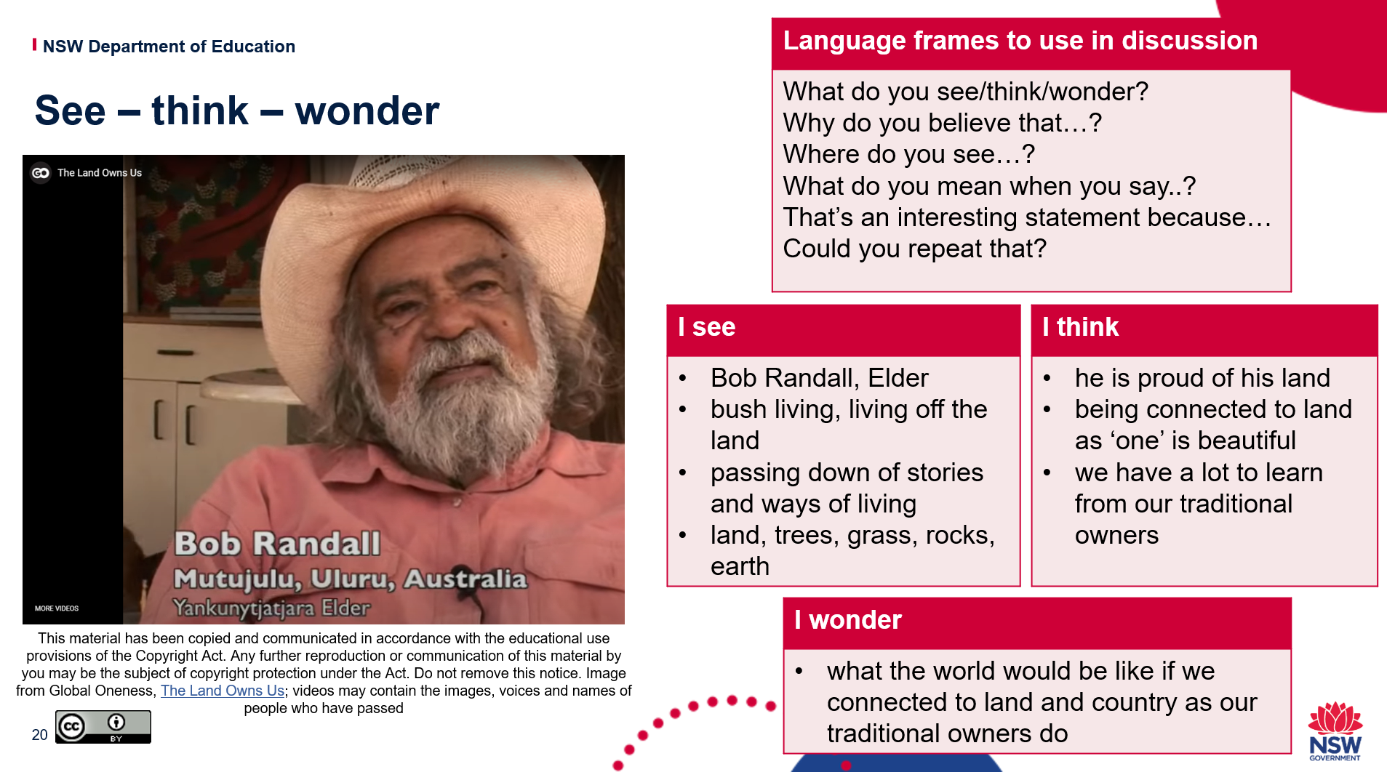
During the video, students write down what they see, for example:
- Bob Randall, Elder
- bush living, living off the land
- passing down of stories and ways of living
- land, trees, grass, rocks, earth.
After the video, students then reflect on their observations using the prompt I think, for example:
- he is proud of his Land
- being connected to Land as ‘one’ is beautiful
- we have a lot to learn from our traditional owners.
Next, students consider the prompt I wonder, for example:
- what the world would be like if we connected to Land and Country as our traditional owners do?
This can then be shared in pairs, groups or via a class discussion, using the language frames.
Students can use the see – think – wonder routine when completing reading and listening (I hear) activities, connecting to language they can identify and language they can develop to give deeper and extended responses.
Let’s take a look at an example.
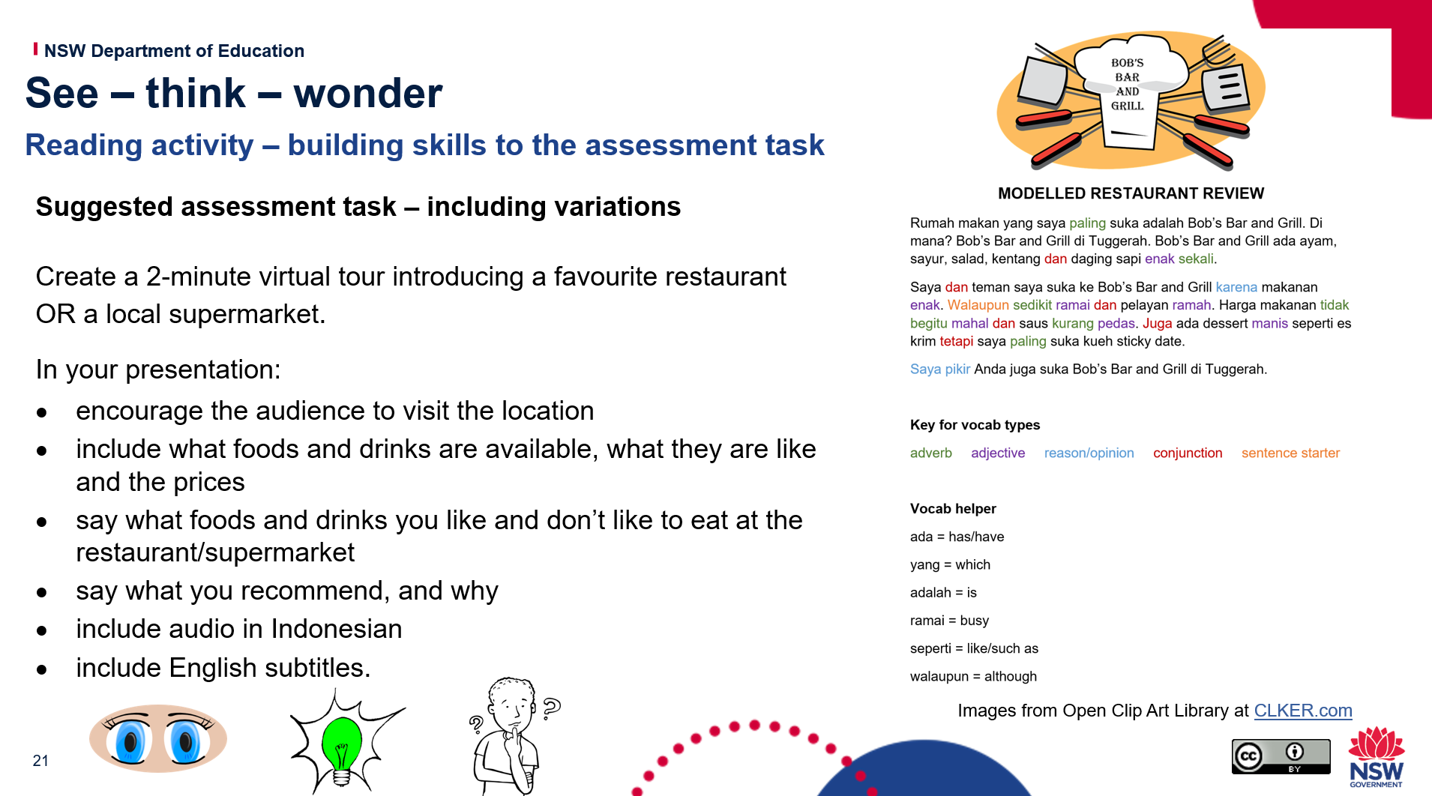
On the left, you’ll see the assessment of learning task from our Stage 4 Indonesian unit, ‘Dining out with friends’.
On the right is an assessment for learning task that builds to the final assessment task – it is a modelled restaurant review, colour coded to highlight adjectives, reasons/opinions, conjunctions and sentence starters.
In a backward mapping approach, provide students with the assessment of learning task at the start of a unit to know what they are working towards. When completing mini assessment for learning tasks, encourage students to make connections between prior and future learning.
Using the see – think – wonder technique can help.
See – what do you see when comparing the language of these two tasks side by side? How can the assessment for learning task language link to the assessment of learning task?
Assessment of learning task | Assessment for learning task
introduces favourite restaurant or supermarket | discusses a favourite restaurant
discusses food and drinks available | discusses food and drink at the restaurant, comments on their flavour
gives recommendations | gives an opinion, I think (you will also like) ….
subtitles | sentences and words to use in subtitles, colour coded to help see where to replace words
Think – what do you think when you look at these side by side?
- I can replace words from the modelled restaurant review with other words.
- I can use the structures and ideas here in the mini task in my assessment task.
Wonder – what other scenarios could I use these structures and vocabulary?
Movie reviews, accommodation reviews, discussing items when shopping, discussing things with friends.
Wonder – how can I build on, extend, manipulate the structures to add complexity to my virtual tour task? (check marking guidelines to see)

5 whys
The 5 whys routine is as simple as it seems… keep asking why!
You might not want to do 5, it could be 3 or any number you wish to extend as far as you wish.
For the purpose of building communication skills such as speaking and writing, this technique can help students go beyond a basic response.
In the example below, students are asked to write about “Why do I like to go to the beach?”.
You can see that by asking the students to ask ‘why’ at the end of each response, they are pushed to think more deeply about their answers. This takes them to hobbies, reasons, opinions, descriptions and future plans.
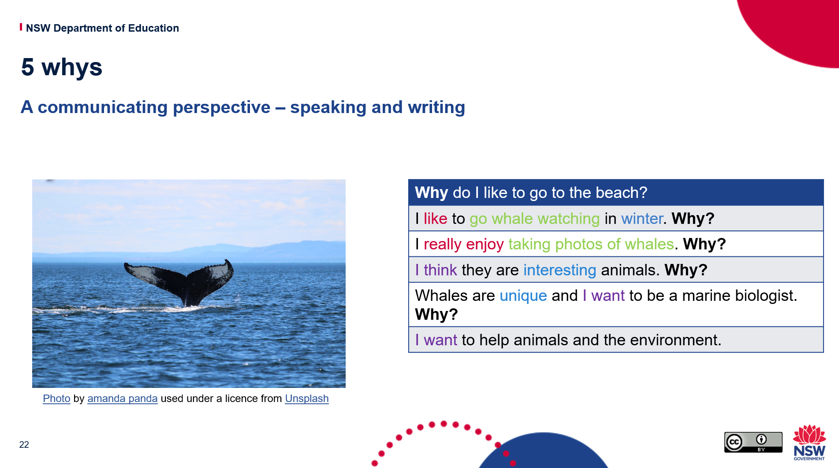
This routine can also be used to help students deepen their understanding of the target language by delving deeper into information given in texts.
This encourages students to consider different ideas, perspectives and justifications as they read or listen to texts.
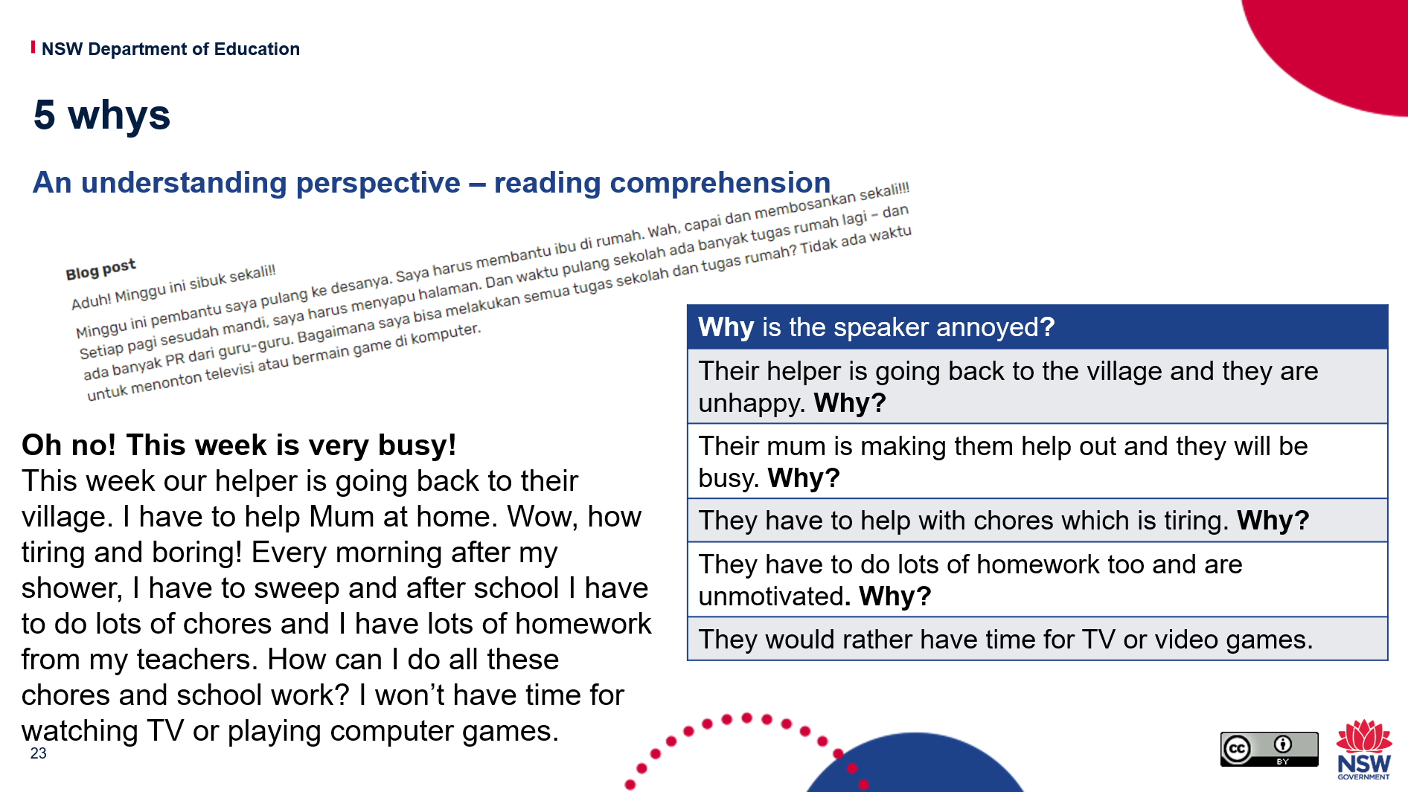
The example above is an activity from the Indonesian Stage 5 unit of work ‘Home sweet home!’. Students read the blog post (we have added the English, so everyone can read it here) and consider the question “Why is the speaker annoyed?”.
In the HSC examination, questions are assigned different marks according to the depth of the understanding expected. Through adding the ‘why’ questions, we require students to think about these basic initial responses more deeply, and even to evaluate and justify. This is good practice for all Stages and helps students to develop deep language skills on their journey.
Remember you don’t have to use 5! It can be any number.
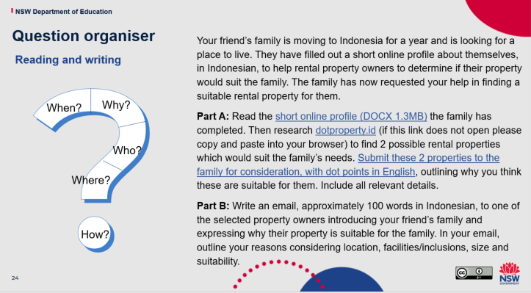
Building on the 5 whys, you may, as an adjustment, consider 5 question words rather than 5 whys … When? Why? Who? Where? How? (of course others like What? and Which? can be included in the 5), to change the thinking perspectives.
A graphic information organiser or table, with spaces for answers, can support students to scaffold their responses. A guide helps students to progressively delve deeper into a question or topic.
Consider the Stage 5 Indonesian sample assessment task from the ‘Home sweet home!’ unit on the slide above. How could we use this question organiser to support our students to plan their task?
When? We can assume sometime in the near future since they are looking for a home to live in so students should think about dates and seasons. Also, the email response will need to be written to include a date that is relevant to the imagined time frame of the task.
Why? To introduce a family to a property owner and justify why they are a good match. Students need to look at the profile of the family, choose an appropriate property and email the property owner to introduce the family and give reasoning/justification why their property is a good match for the family – location, facilities, inclusions.
Who? The audience of the email is the property owner and the language should be appropriate for this. The content of the email is in relation to the people in the family and their interests and needs.
Where? The location of the property is in Indonesia. Students may choose anywhere but they must consider the needs of the family in order to select a suitable location. They should indicate where the place is in their email and what is in that place that links to the family’s needs.
How? The students will communicate via email. Students should consider the language conventions that an email text type contains in Indonesian and include them. Date, subject line, to and from, an imagined email address in the address bar.

Peel the fruit
Peel the fruit can be used as a way to organise and map out deep understanding.
Starting with the peel which represents the surface ideas, students are asked to ‘get under the peel’ with deeper ideas regarding the topic/task. Students are then moved on to the flesh, the substance of the deeper idea, until finally they are asked to evaluate the idea at the core.
Let’s take a look at using this with the Stage 4 German task, ‘Harmony Day’.
It would be very easy in this task for students to give very basic responses, but even at early stages of learning we can encourage deeper thinking and engagement with the language.
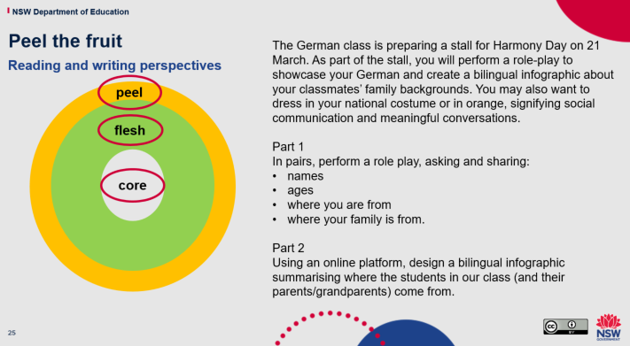
At the surface, the peel, students are asked to tell us facts about themselves and their family, such as names, ages and where they are from.
In the flesh, students are asked to provide a bit more detail. Perhaps they will manipulate learned language structures in a new way, maybe they will add further language details such as adjectives, conjunctions and sentence starters. Maybe in the infographic they will provide a range of cultural elements such as clothing, food, sports and hobbies, to broaden the content of their presentation.
At the core, we evaluate. This could be a reflection, an opinion or a reason. For example, I think Easter in Greece is fun because all of our family come together OR I love Balinese clothes because they are colourful OR I love my family’s city of Hiroshima because it is peaceful and beautiful.

Jigsaw strategy
The jigsaw strategy is achieved by forming groups with 5-6 students. Each student in their group has to investigate and learn about a different piece of the overall task (jigsaw). They become the expert of that piece. If you have multiple groups, the experts from each group focusing on the same piece, can join together in researching and attaining key insights, before returning to their group to share.
Use of this strategy ensures that all students contribute equally in a group that is inclusive of all. It gives individuals autonomy and responsibility as well as the opportunity to become an ‘expert’ while being supported and guided by those around them.
This routine is completed using the following steps:
- Students are placed into a group of 5-6.
- Individuals are each given an inquiry question (all groups are given the same set of questions).
- Students then find others from different jigsaw groups who have the same question. This is their expert group.
- In their expert group, students discuss the task. They should record prior knowledge and work together to plan and record the information required.
- When the time is up, students are to return to their jigsaw group with the information collected and present their puzzle piece to their group.
When all the puzzle pieces are put together students then can complete the task with a deep understanding. Students may complete the task individually or as a group, the point is the deep thinking and understanding they collaboratively gain.
Looking at the Stage 4 Spanish sample assessment task (below), ‘Let’s be friends!’, examples of puzzle pieces you may give to the students to collaboratively brainstorm for this task could be:
- personal details
- physical descriptions
- personality descriptions
- likes and dislikes with free time activities
- reasons for being friends with people.
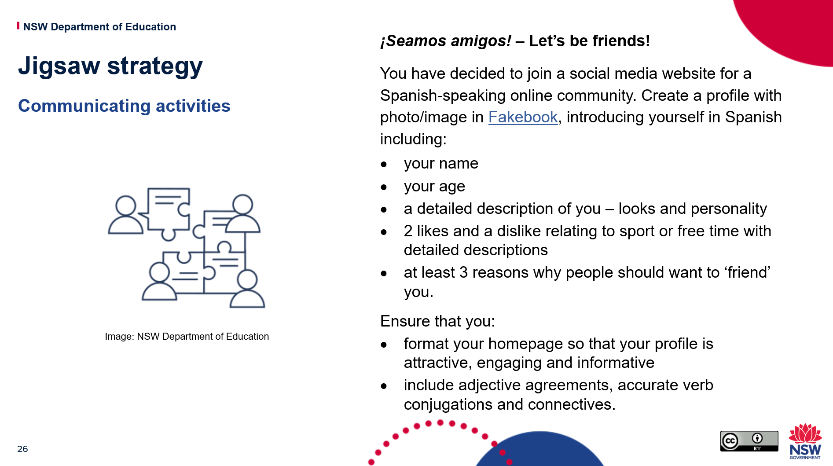
While brainstorming in their expert groups, students should consider a variety of vocabulary and grammatical structures that can be used, as well as content. Encourage students to think of how they could manipulate these further to produce more complex structures.

3-2-1 organiser
A 3-2-1 graphic organiser is used to help students summarise information when researching, by narrowing down the source to 3 things learned, 2 interesting facts and one new word. The process of narrowing down helps students in comprehending the source.
This graphic organiser can also ask students to locate many different words, facts or concepts, depending on the topic and what the teacher would like them to identify.
In the example below, students listen to the song ‘Let it go!’ from Frozen, in Italian You can view the song on YouTube. The 3 things you may ask students to look for could be:
- 3 new words
- 2 grammatical structures they know
- one question word they can use in the future.
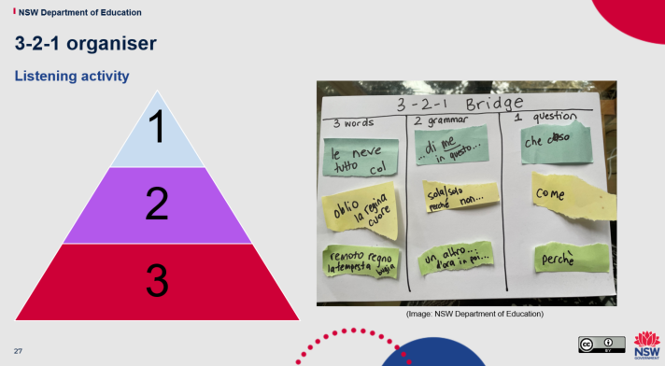
Once students have jotted down their 3-2-1 findings they can share them with the class.

10 x 2 visual thinking strategy
In the 10 x 2 visual thinking strategy, students are shown an image for 30 seconds and then asked to write down 10 words or phrases that come to mind regarding the picture. Once students have completed their 10 words/phrases, they repeat the activity, with another 30 seconds to relook at the image, and then record another 10 words or phrases, different from the first.
By using the 10 x 2 visual thinking strategy, students have the opportunity to slow down and make more detailed connections to language.
They use the graphic organiser provided to structure their thinking.
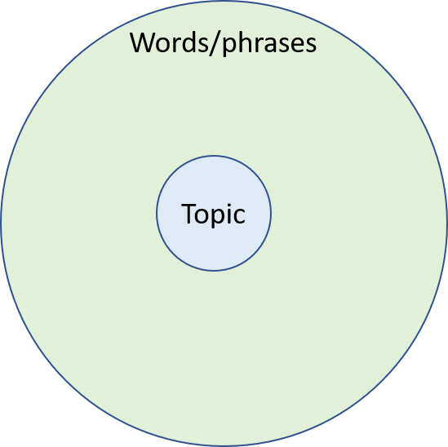
In our Stage 4 Chinese unit of work, ‘What do you recommend?’, students explore the movie ‘The Nightingale’ and then are asked to complete a film review for the final assessment of learning task.
At the start of the unit, to generate interest and develop learning goals, students could be given the image of a still from the movie and asked to write down words or phrases relating to what they see and think may be relevant to the movie they will watch this term. For example, granddaughter, care, grandfather, nature, family, respect, wise, kind, serious, love. On a second round they may add other things such as adverbs, verbs, sentence starters, characters.
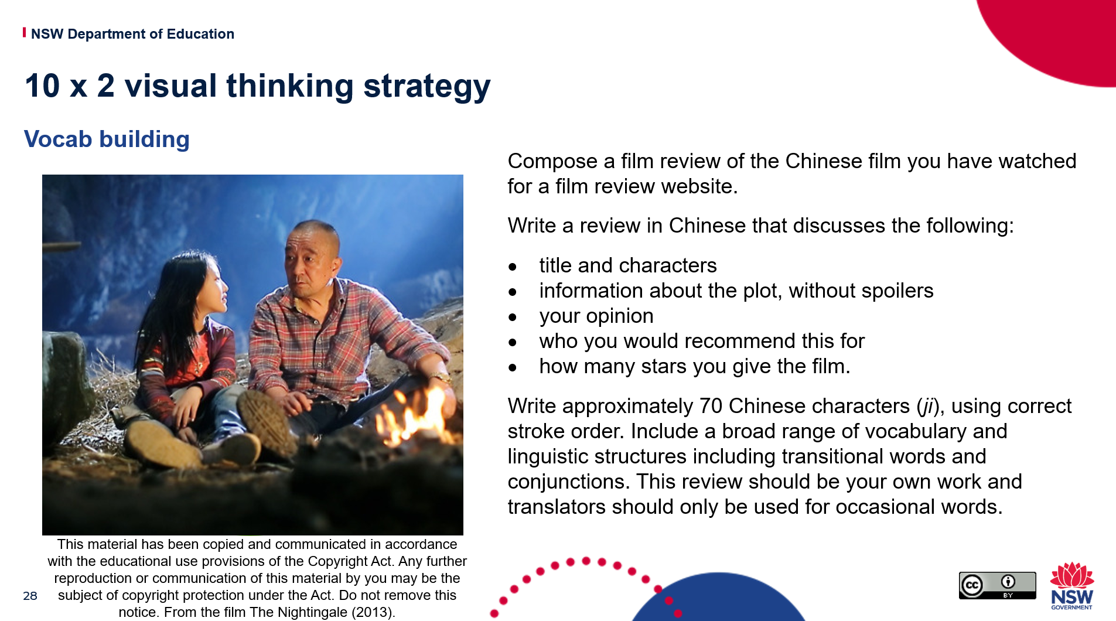
To support planning for the assessment task, you could show students the poster of the movie they have watched, as a stimulus and for reflection, and collaboratively write relevant Chinese words and phrases for content relating to the plot, describing characters and recommendations.
Even if the students complete these in English they will develop a broad range of ideas that take them from a basic, repetitive response and can use the dictionary to look them up later.

Lenses
Through encouraging students to look at the language options through different lenses, they are able to consider applying the language in new situations. Making this a thinking routine as a regular part of your lessons, whether it be asking students to consider it verbally, or taking time to brainstorm possibilities, will empower your students.
Looking through different lenses can also allow for student choice in assessment. The outcomes assessed can be the same even though students can choose the audience, context or purpose of the task.
Looking at this example from our ‘Assessment and reporting in languages 7-10’ workshop, let’s see how it can be open to choice or link to other situations.
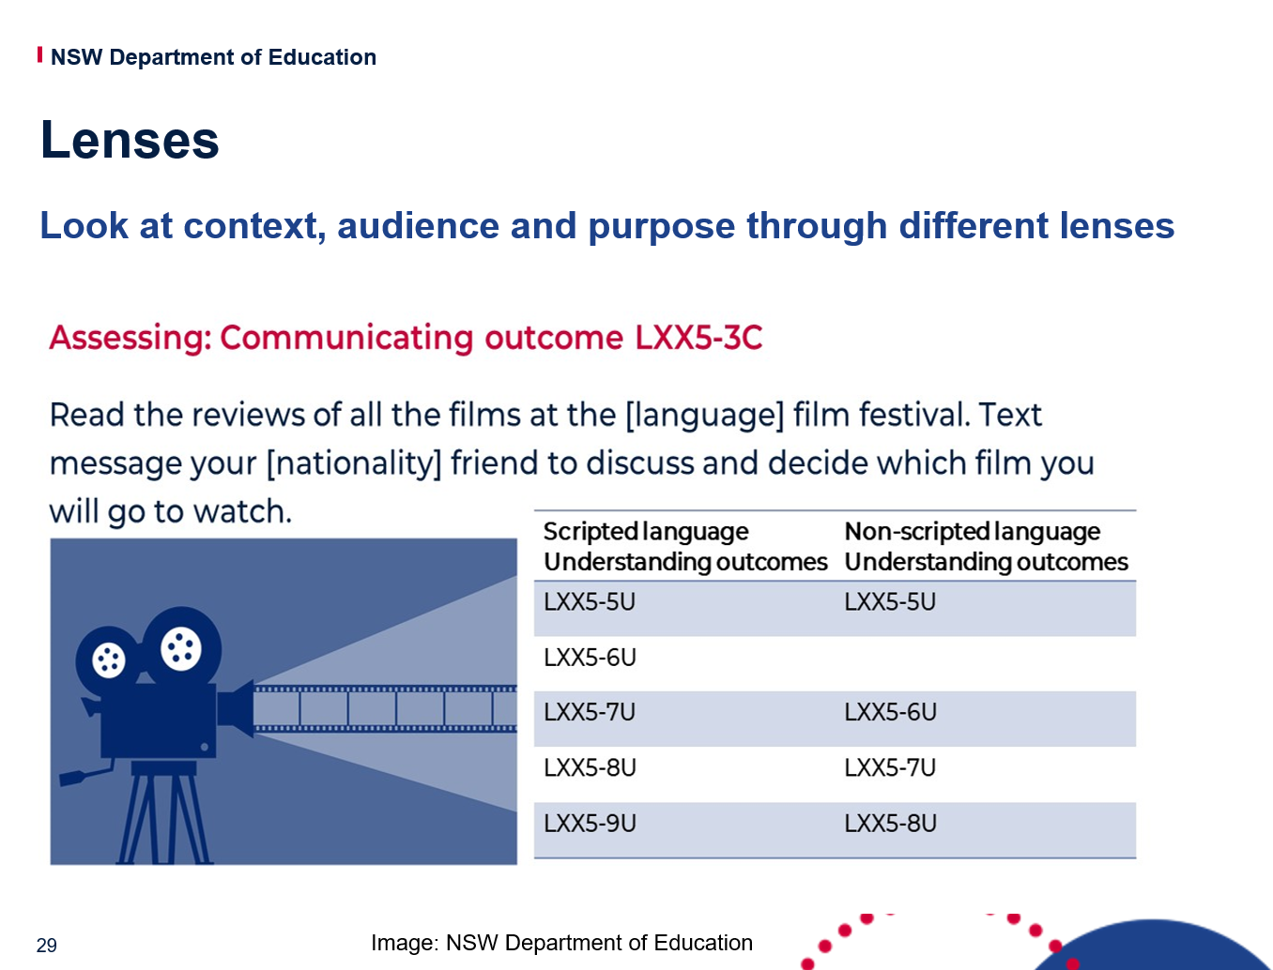
To support students to be able to respond in a broader range of situations, they can change the lens of the task. For example:
- changing the audience lens

- changing the context lens

- changing the purpose lens.

This increases engagement and gives students ownership of their learning. It can also help support differentiating for high potential and gifted students. The department’s differentiation adjustment tool is available to further support this.
When considering the Course Performance Descriptors and Common Grade Scale for languages, to achieve top bands students are required to demonstrate their language skills for a range of purposes, audiences and contexts – in other words, to look through different lenses.
Let’s look at this wording:
Course Performance Descriptors – A
-confidently manipulates [language] to convey meaning when exchanging information, ideas and opinions in a range of contexts
-demonstrates a very high level of skill in accessing and responding to information, and accurately interpreting and evaluating information in a range of texts
-applies extensive knowledge and understanding of grammatical and cultural features to compose texts for a range of purposes, audiences and contexts
Common Grade Scale – A
The student has an extensive knowledge and understanding of the content and can readily apply this knowledge. In addition, the student has achieved a very high level of competence in the processes and skills and can apply these skills to new situations.
Other lenses that students could consider in communicating tasks might include:
- tenses
- negative and positive
- singular and plural.

Hexagonal thinking
In the department’s Digital Learning Selector, you can find the hexagonal thinking templates.
In a hexagonal thinking exercise, students are given hexagonal tiles with ideas, questions or facts which they arrange so that related tiles are next to each other. With higher levels of understanding, students can explain the relationships between sets of tiles.
Hexagonal thinking can also be used to help plan a project or map out the problem-solving process. Students can fill in their own blank hexagons and arrange them to demonstrate their ideas. They could do this individually and then share with a group or the class, or do it as group work and go around and explore each others’ ideas. As the teacher, move around the room to discuss ideas and encourage students to expand and think through different perspectives.
Different coloured hexagons could be used for adjectives, verbs, nouns, structures, conjunctions.
This could be a great routine when planning communication tasks such as the Stage 4 Italian sample assessment task, ‘Mangiamo! – Let’s eat!’.
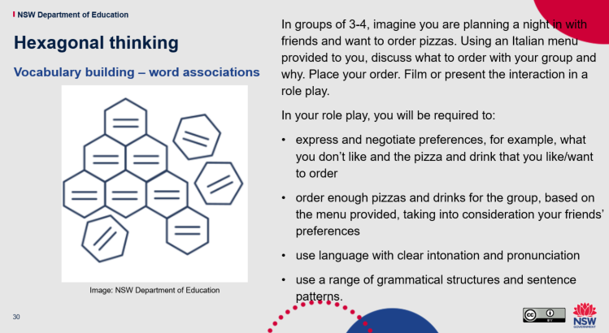
Students could brainstorm groups of words, using different colours for different groupings such as blue for adjectives and likes and dislikes, yellow for ordering food and pink for negotiating and reasoning. This could be done collectively or individually.
Encourage the students to share their ideas with others and see if they can add more. This could be used to create a class word bank on Quizlet, form vocabulary ladders, stimulate discussion and even become stimulus cards for an impromptu conversation to help develop their speaking skills.

What tools can be used to support thinking routines?

Tools
You can also use a range of tools to promote thinking, planning, deeper understanding and improved learning outcomes for students. These tools include:
- scaffolds
- templates
- modelled responses
- whiteboards
- sticky notes
- colour coding
- mind maps – digital and written
- discussion, probing questions, feedback.

Templates
Here are some templates which you may find useful.

Fishbone diagram
The head of the fish may be a main topic or task and branches of the skeleton can be used to plan different contexts and/or related language. For example, the main topic could be ‘my day’, and each branch of the skeleton could be for school, after school, on the weekends, household chores, eating and a general reflection on your daily life.
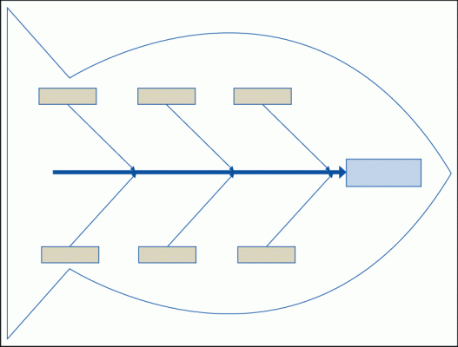

Concept maps
Concept maps are useful for planning tasks to ensure a broad range of content and structures are included. They can also be used for perspectives with a core element in the middle then other elements surrounding it like verb tenses, adjectives, conjunctions and questions.
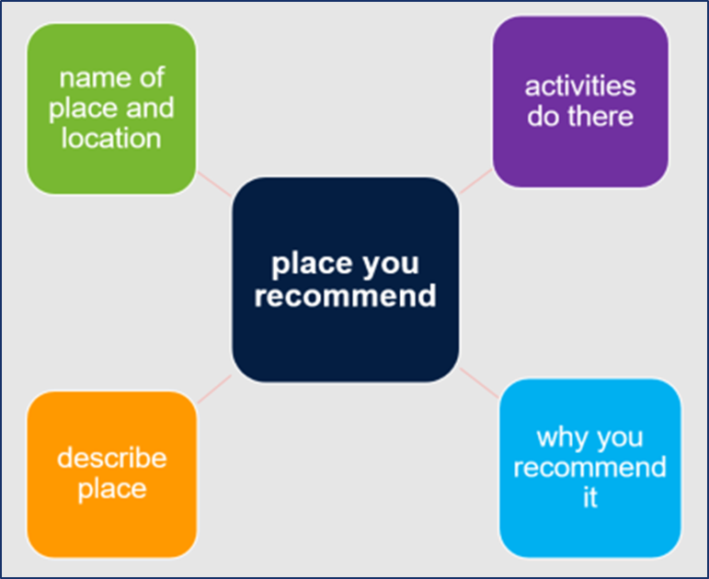

Connect – extend – challenge
To use the connect – extend – challenge template:
- connect – students list vocabulary and structures they know that connect to the topic or task
- extend – students are encouraged to manipulate these to include other language features
- challenge – students experiment, reflect and identify areas they might need help with, and plan how to overcome these challenges.
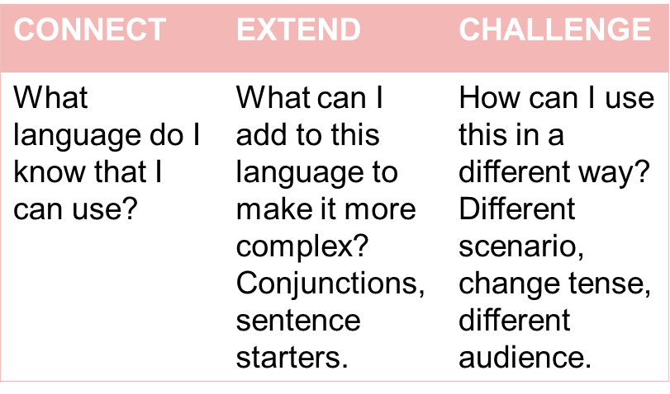

Y chart
In a Y chart, use any 3 headings to delve deeper into content.
For example:
- the topic may be ‘Technology in today’s world’ and you may have a student’s perspective, a teacher’s perspective and a grandparent’s perspective
- you could explore reviews, such as a food review, a movie review and a hotel review. This helps students make connections with their learning.
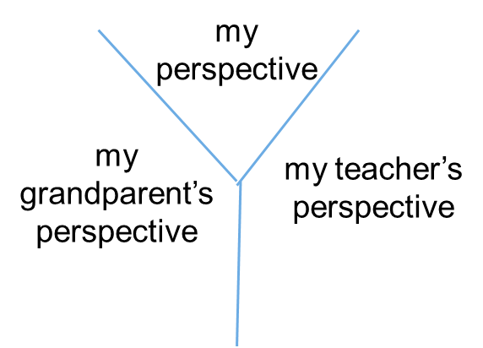

Modelled responses
Modelled responses support students by:
- giving a benchmark for excellence
- making success criteria concrete
- showing the thought processes of experts.
How do we do it?
There are 2 ways to approach modelling:
- Model the creation of products/procedures – show students how to produce a piece of writing, answer an exam question, make a product, make a simple sentence more complex.
- Deconstruct expert examples and use worked examples – start with the finished product and unpick with students why it is so good. What are the steps that they would have to go through to produce something similar?
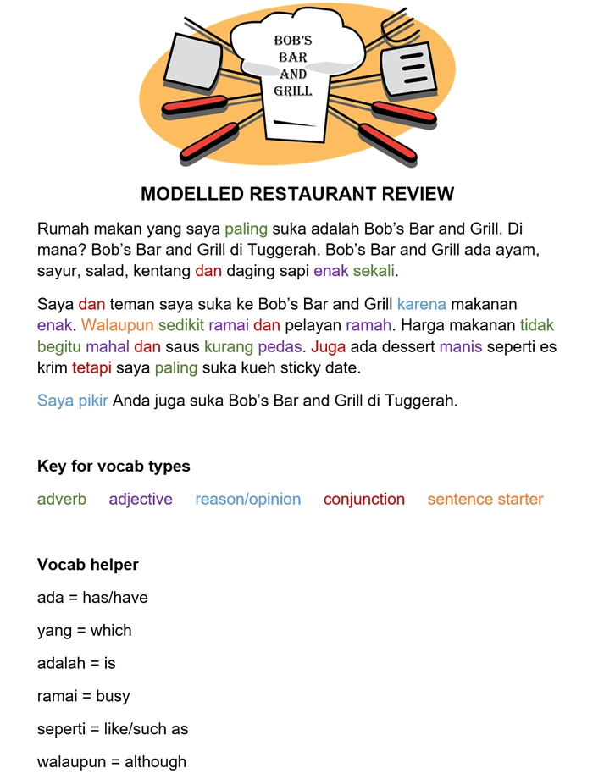
Some strategies for modelling include:
- Live modelling – start off by producing a product yourself on the board, describing each step you are taking (I do). Then do another example together – perhaps get students to come up to the board and do it with you, or just question them more to get their input (we do). Finally, get students to try it out on their own (you do).
- Comparative modelling – it’s much easier for students to pick out what is good about a piece of work, if they have something not so good to compare it to – so give them a good and a bad example.
- Student exemplars – these can sometimes be more powerful than using examples of ‘products’ that you have produced
A culture of thinking doesn’t develop spontaneously. It takes intentionality. (Tracy Ann Clark)

Reflections
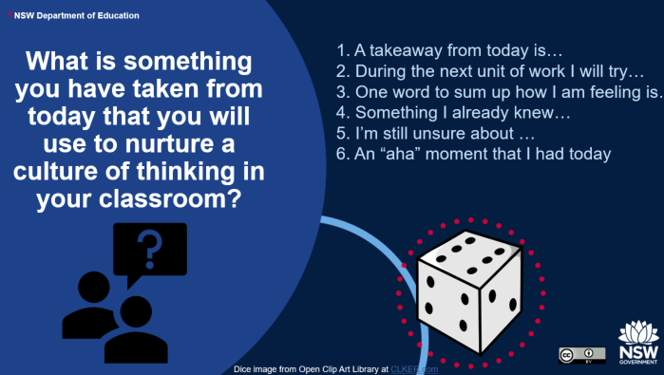
To reflect on what you’ve learned in this document, let’s use a thinking strategy you might like to try with your classes.

Roll the dice
In the classroom, put a 6-sided dice at each desk (or students can use an online dice roller). At the end of class, each student rolls and briefly answers aloud a question based on the number rolled.
For now, pick a number between 1 and 6 and consider your answer to the appropriate prompt.
If you choose 1 write, A takeaway from today is …
If you choose 2 write, During the next unit of work I will try …
Use this as a springboard to find 1-2 ways you can incorporate thinking routines into your lessons.

Extra support
Games, feedback and assessment for learning are all essential parts of creating a thinking classroom.
Our YouTube channel has recordings of previous statewide staff meetings, and you can see we have held sessions on games, feedback and assessment for learning.
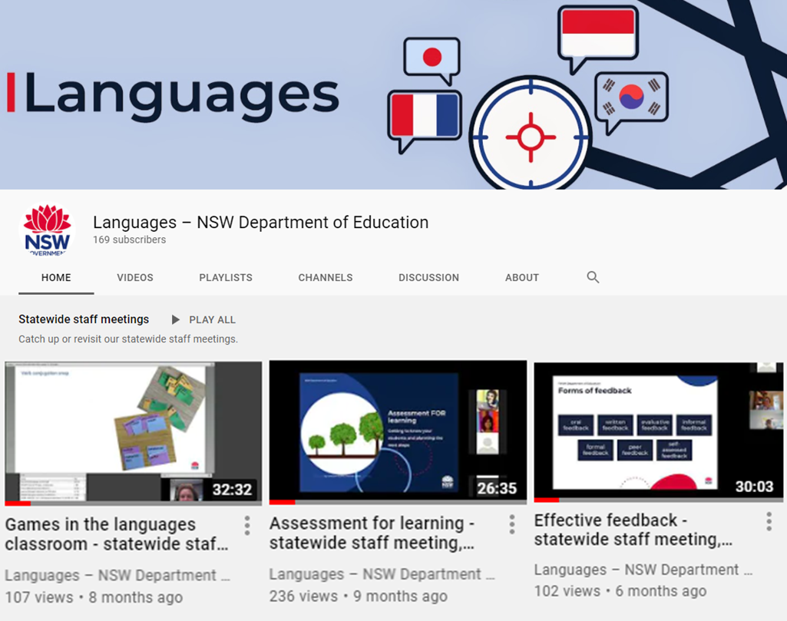
The units of work referenced in this document are on the department’s languages website. You’ll find them under support for Stages 4 and 5, together with assessment tasks (including marking guidelines) and sample scope and sequence documents.
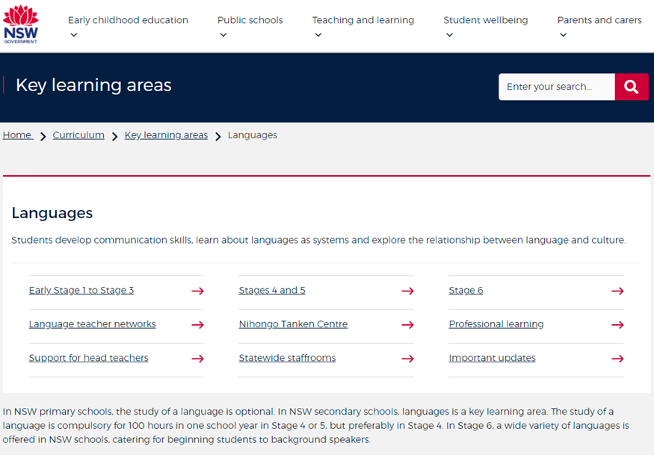
Finally, you can contact the Languages and Culture team if you still have questions – via the statewide staffroom, or by phone or email.

