Providing effective feedback – a guide for teachers
Feedback is one of the most powerful influences on student achievement. Feedback is designed to bring about an improvement in students' performance and can occur at any point during the teaching, learning and assessment cycle. Feedback enables students to close the gap between where they currently are in their learning and a unit of work’s learning intentions and success criteria.
Learning intentions and success criteria both form the basis of any feedback. Learning intentions ensure all students know what they are going to learn, and success criteria ensure all students know what the end goal for this learning is.
Feedback in the classroom should focus on students’ performance on specific tasks, clearly identifying for students where and why mistakes have been made and emphasising opportunities to learn and improve (What works best: 2020 update, Centre for Education Statistics and Evaluation, April 2020).

Effective feedback
Consider the following when providing feedback:
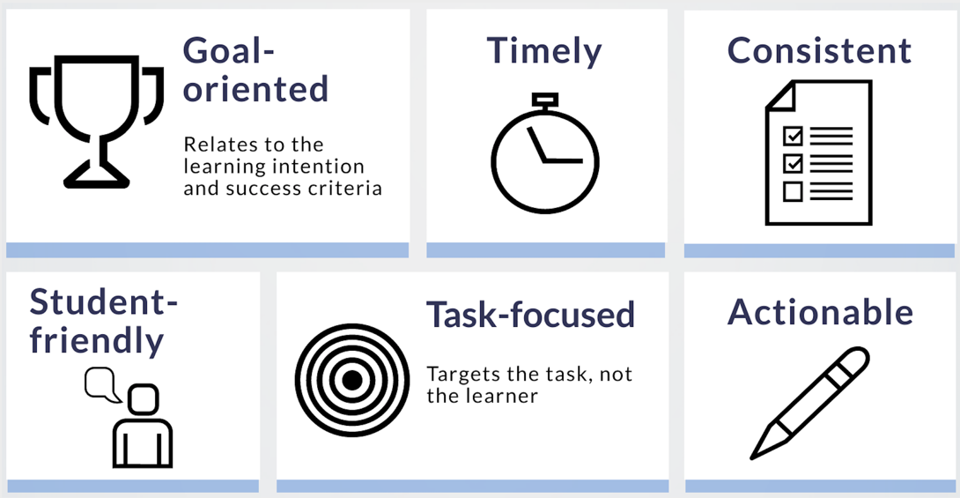

Goal-oriented
Effective feedback is goal-oriented. Linking your feedback to the learning intentions and success criteria supports students to have greater understanding of what they are learning, and the end goal for this learning. Focus on 3 key feedback questions:
- What are the goal/s?
- What progress are you making towards the goal/s?
- What do you need to do to make better progress?

Timely
Feedback is best given immediately, while there is still time for the student to act on it and adjust their learning. When students receive feedback while their efforts are still fresh in mind, it has its greatest impact.

Consistent
Be consistent by providing ample and regular opportunities for your students to use feedback, and provide feedback which is explicit, accurate and trustworthy.

Student-friendly
An encouraging, positive tone supports students to accept feedback and achieve their learning goals. Avoid using jargon or unnecessary technical language – feedback is not of much value if students cannot understand it or feel overwhelmed by it. Tailor your feedback to the individual student, including adjusting your feedback based on students' readiness. For example, an appropriate amount of feedback for one student might not be enough for another, and might overwhelm a third.

Task-focused
Effective feedback focuses on the task, not the student. Saying “Next time, try varying your sentence structure to add interest to your writing” is more supportive and explicit than telling a student to “Try harder”. By focusing on the work and not the student, students are more likely to be open to what you’re saying.

Actionable
Include clear and specific details in your feedback so that your students immediately know how to take action and how to better move toward the learning goal. Your comments should be balanced, and clearly identify their strengths and areas for improvement. This will help students see exactly what they've done well, repeat good habits in the future, and feel motivated and challenged to further develop their knowledge and skills. Ensure students not only understand the feedback and the steps they need to take moving forward, but are given time and opportunity to do so.

Keep it manageable
Giving feedback can take many forms including formal, informal, formative, summative, interactive, demonstrable, visual, written, verbal and non-verbal (What works best: 2020 update, Centre for Education Statistics and Evaluation, April 2020).
As well as spontaneous feedback, plan your feedback opportunities too so that they become part of your regular routine.
Consider opportunities such as:
- formal written feedback on set activities
- informal feedback, such as exit slips or check-ins against the learning intentions
- verbal feedback (including explicit feedback during class activities)
- digital feedback, through OneNote, O365, Google Classroom or interactive worksheets such as wizer.me. Tools such as Google Docs and OneNote allow you to provide suggestions to students. Similarly, verbal feedback can also be digitally recorded for students to listen to, action and then use as a checklist next time they complete a task
- whole class, small group or individual feedback.

Empower students to plan for their success
Effective feedback supports all students with the development of positive feelings of self-efficacy, providing motivation for continued effort and engagement (What works best: 2020 update, Centre for Education Statistics and Evaluation, April 2020). Support your students to plan for success by encouraging and scaffolding good learning habits.
For example:
- provide the marking guidelines for the final assessment of learning task at the start of the unit, for students to reference throughout their learning journey – this supports students to link class activities to the task
- provide model responses to students to compare with their own, so they can identify what they did well and areas for improvement. Alternatively, provide model responses for students to unpack and explore, identifying what makes them a good response (or not)
- create opportunities for peer feedback and provide templates to support the process
- encourage the use of student reflection journals – while student reflection journals are a way for students to monitor their own progress, they also provide you with a frame for providing regular written and/or oral feedback
- identify support and links you can share with students, for example Tips to help improve your listening skills
- support student goal setting. Students may find it challenging to articulate their learning goals, so provide guidance. For example:
  - vocab and structures they can use
  - how to break down text into smaller, more comprehensible chunks
  - techniques and applications to build skills, for example techniques for building confidence when speaking or ideas to memorise vocabulary.

More information on feedback
- Refer to our other support documents on our teaching tools page:
  - Supporting students to provide peer feedback
  - Learning journals – a guide for students.
- Teacher quality and accreditation – types of feedback
- AITSL – Improve practice – Feedback
- Teach Thought – 20 ways to provide effective feedback for learning

