Support for language teachers and head teachers supervising language teachers
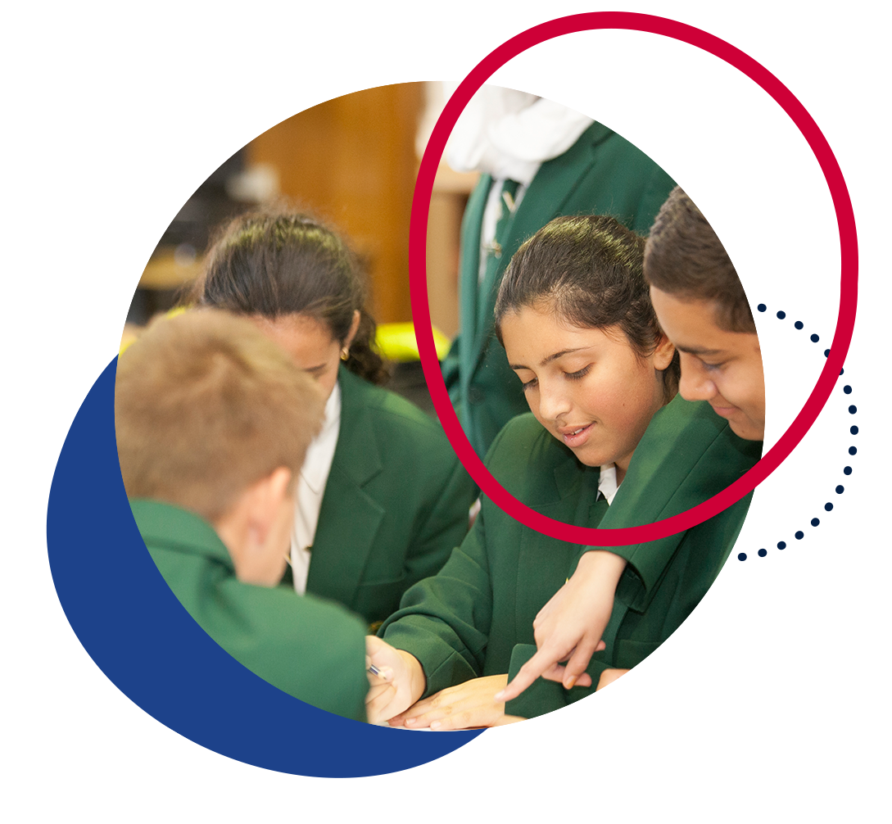

Contents
Introduction 4
Why is the study of a language important? 4
Advocating for languages 5
Resourcing 6
Additional considerations for modern languages 7
Additional considerations for classical languages 7
An overview of languages education in NSW 7
Languages K-6 8
Community languages program K-6 9
Bilingual Schools Program 9
Relief from face-to-face programs 10
Languages 7-10 10
Secondary College of Languages (Years 7-12) 10
NSW School of Languages (Years 9-12) 11
Distance education schools (Years 9-12) 11
Aurora College (rural and remote students only, Year 11-12) 11
Community Languages Schools Program 12
Supporting language pathways from Stage 4 to Stage 6 12
Curriculum structure K-10 14
Modern languages 14
Objectives and outcomes 15
Learner groups and differentiation in modern languages 7-10 20
Classical languages 21
Objectives and outcomes 22
Assessment and reporting in 7-10 25
Modern languages 25
Course performance descriptors 26
Classical languages 7-10 26
Course performance descriptors 27
Life Skills 27
Courses, curriculum structure and assessment in Stage 6 27
Modern languages 27
HSC courses 28
Eligibility 28
Assessment 29
Curriculum structure 30
Classical languages 35
HSC courses 35
Eligibility 35
Assessment 36
Curriculum structure 36
Support from the Languages and Culture team 40
Resources 40
Staying in touch and accessing direct support 41
Professional learning opportunities 41
Language teacher networks 41
Virtual Languages Mentoring Network 42
Nihongo Tanken Centre 42
Contacts 43

Introduction
In NSW public schools, the majority of language teachers 7-12 are supervised by a head teacher without a language-teaching background. Many language teachers are also the only language teacher at their school and so may not have a colleague with whom they can engage in professional dialogue relating to language teaching.
This guide has been developed by the Languages and Culture team (Curriculum Secondary Learners – Curriculum and Reform Directorate) for teachers of languages and for the head teachers or school executive members who supervise them.
The guide aims to:
- raise awareness of the importance of languages education
- provide an overview of language syllabuses K-10
- provide an overview of Stage 6 language syllabuses and eligibility requirements
- outline the support available to language teachers.
The information contained in this document is correct as at January 2022.

Why is the study of a language important?
Language study provides students with the opportunity to develop communication skills, learn about languages as systems and explore the relationship between language and culture. Students engage with the linguistic and cultural diversity of societies and reflect on their understanding of social interactions.
Students may benefit from learning additional language(s) by:
- being able to positively transfer literacy skills between languages, as they learn about grammatical structures and broaden their vocabulary
- improving communication skills
- developing more open and curious attitudes to other cultures.

Advocating for languages
A key component of growing a successful languages program at your school is building staff capacity to design and deliver engaging teaching and learning programs. This is especially critical if you supervise an individual or small group of language teachers, whose opportunities for collaboration and professional growth may be minimalised without a faculty of language-teaching colleagues.
There is a range of opportunities for building staff capacity, including:
- professional learning
- statewide staffroom interactions
- networks
- membership of language teacher associations, for example Modern Language Teachers Association NSW (MLTA NSW) and Classical Language Teachers Association (CLTA). Different languages may also have their own association. Associations may provide online resources and facilitate conferences and student events.
Figure 1 – your role in supporting languages
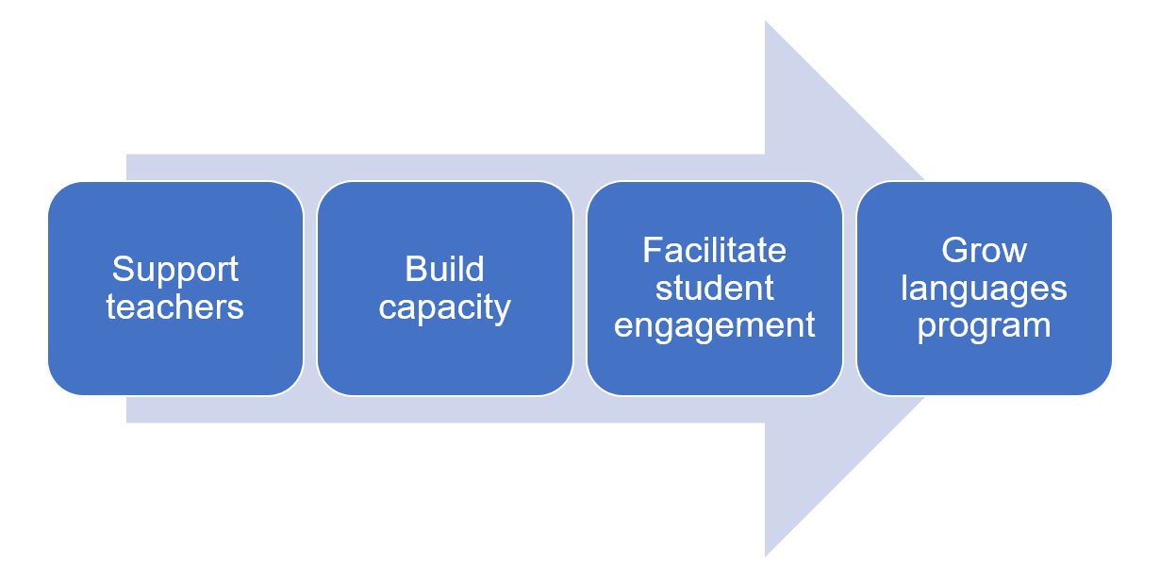
When timetabling occurs each year, keep in mind that for modern languages, the syllabuses state that the target language is used whenever possible as the primary medium of interaction. This is an important consideration if classes have to be split, as your languages teacher may need to develop lesson content even for the periods being taught by another teacher.
You can also help raise the profile of languages in your school, and grow community awareness of the benefits of language learning, with students, parents and other teachers. Suggestions include:
- including a languages section in the newsletter
- displaying student work in the front office
- ensuring languages curriculum information on your school’s website is up to date
- supporting a range of incursions and excursions, which can motivate and engage students.
If you are in a school with a large number of students from language backgrounds other than English, you can also advocate for the benefits of bilingualism and the impact it can have on student performance.

Resourcing
Your language teacher/s may need your support to ensure that they are resourced in a way that best meets the needs of the subject and the students.
Considerations include:
- High-quality texts provide stronger opportunities for student engagement.
- Language learning is often collaborative in nature. Classroom environments should allow enough space for students to move around.
- Access to appropriate technology and software can assist student engagement, particularly in activities supporting vocabulary learning and grammar drills. Technology can also support differentiated learning.
- Regular, reliable access to technology (computer labs, laptop trolleys or tablets) can increase the teacher’s ability to engage students in creative and productive language tasks, such as filmmaking or music making.

Additional considerations for modern languages
The K-10 modern languages syllabuses have a strong focus on intercultural language learning, in which students understand and reflect on the dynamic and interdependent nature of both language and culture.
As such, students need to engage with a wide range of authentic resources, including written and digital texts, audio texts, music, film and realia. Sourcing authentic resources may require funding – budget allowances for online subscriptions, magazines, books, films, posters and realia are an important support for teachers. If a teacher prefers to use a textbook, it will need to be regularly updated to ensure that content and cultural information are relevant and current.
Authentic communication is central to the K-10 modern languages syllabuses. Access to technology facilitates communication and collaboration with target-language speaking students from around the world, enabling meaningful communication.
Teachers may also require special equipment for assessing modern languages, including recording devices and audio-visual equipment.

Additional considerations for classical languages
‘New’ texts are rarely discovered in classical languages, and the texts which have been discovered are considered well above the reading level of students in all but Stage 6. As such, classical language students rely on readings written or adapted by educators rather than authentic materials from the culture being studied.

An overview of languages education in NSW
In primary schools, the study of a language is an optional component of the curriculum, and there is no Languages key learning area (KLA) in primary.
In secondary schools, there is a Languages KLA, with mandatory curriculum requirements. Please note that the KLA is ‘Languages’ (not ‘Languages Other Than English’, or ‘LOTE’, which are both outdated).
The study of a language is mandatory for 100 hours over a continuous 12-month period in Stage 4 or Stage 5, but preferably in Stage 4 (ACE manual 4007 – mandatory curriculum requirements for the Record of School Achievement).
Almost all schools offer the mandatory 100 hours in Stage 4, with the following options commonly-found in NSW public schools:
- a 100 hours course in Year 7 only
- a 100 hours course in Year 8 only
- a ‘taster’ course in Year 7, with a different language offered each term or semester, combined with the mandatory 100 hours in Year 8, in which students have the option to choose their language from those studied in Year 7.
Schools then offer elective language courses in Stage 5, which can be 100 hours or 200 hours in length. Keep in mind that students are better equipped to choose Continuers courses in Stage 6 if they have access to the full 200 hours in Stage 5.
In Stage 6, a wide variety of languages is offered in NSW schools, catering for beginning students to background speakers.
Local factors often determine the nature of language learning in schools. These factors relate to teachers’ qualifications, proficiency and passion; and schools’ support for languages, including high expectations and community engagement (Language participation in NSW secondary schools, CESE 2018).

Languages K-6
Approximately 17% of primary schools offer a languages program through government-funded initiatives or through individual school resources. As such, students enrolling at your school may or may not have had prior experience learning a language at primary school.
A summary of the types of language programs available for students K-6 is provided below.
High schools can develop close links with their community of feeder primary schools which offer languages and explore continuity pathways for language learners.
To support continuity, NSW has a modern Languages K-10 Framework from which each language-specific K-10 syllabus is developed. In Stages 4 and 5, the K-10 syllabuses include content for students with prior learning/experience in a language and for students with a background in a language, supporting teachers to program to meet the needs of their students.

Community languages program K-6
Primary schools with a significant number of students from a particular language background are allocated teachers to acquire, maintain and develop a community language, which is taught for a minimum of 2 hours per week in the course of the normal school day.
The program is delivered by specialist community language teachers through various modes including whole class groups and withdrawal.

Bilingual Schools Program
This program aims to achieve a greater level of fluency in priority Asian languages among a cohort of students at 4 government primary schools. The schools and their corresponding languages are:
- Campsie Public School – Korean
- Murray Farm Public School – Japanese
- Rouse Hill Public School – Chinese
- Scotts Head Public School – Indonesian.
Students experience immersion for up to 1.5 hours every school day through direct language teaching, and content and language integrated learning (CLIL).

Relief from face-to-face programs
Some primary schools offer a language program as part of the school’s relief from face-to-face (RFF) program. These programs typically run for between 30-120 minutes per week.
RFF programs provide an opportunity for flexibility in using staffing resources to best advantage the school and its students. The school may organise their RFF timetable around teachers with particular skills and interests in specialist areas of the curriculum, such as the community languages program, to teach across a grade or the whole school.

Languages 7-10
A range of languages is offered in NSW public secondary schools, dependent on staff availability and student numbers. The highest candidacy languages in Years 7-10 in NSW Department of Education schools, in order of enrolments, are:
- Japanese
- French
- Chinese (Mandarin)
- Italian
- Indonesian
- German
- Spanish.
There are other options available to study a language for NSW public school students, if it is not available for study in their local school. These are summarised below.

Secondary College of Languages (Years 7-12)
Secondary College of Languages, formerly known as Saturday School of Community Languages, offers students from government and non-government high schools the opportunity to study their background language if it is not available for study in their weekday school. Students follow NESA syllabuses in 26 languages. These languages are accessible as part of Stage 4, Stage 5 and Stage 6 studies. Some languages are also offered in Stage 3.
The college operates on Saturdays during the school term in 14 campuses located in Sydney, Wollongong and Newcastle, with approximately 3,000 students enrolled. The college also offers languages to a small number of rural and remote students in languages that are not accessible through any other distance education provider.

NSW School of Languages (Years 9-12)
NSW School of Languages is a distance education language specialist school, offering 106 courses in 12 languages. Subject to satisfying certain guidelines, students in NSW secondary and central schools may enrol to study a language course not available to them at their home school. Enrolment is available to both government and non-government school students. Face-to-face lessons are held once per term, and telephone or video lessons are held once per week. The students’ home schools must provide their students with the required resources such as phone, computer, internet and video conferencing access, as well as supervision and a safe learning space.

Distance education schools (Years 9-12)
Distance education is an equity program for geographically-isolated students or students whose circumstances prevent them from regularly attending school in NSW. Students can be enrolled full-time, or single and multiple course enrolments are also available for students in Years 9-12 when the home school cannot provide the required breadth and flexibility of curriculum.
Secondary distance education centres which offer languages are Camden Haven High School in Laurieton, Dubbo School of Distance Education in Dubbo, Finigan School of Distance Education in Queanbeyan and Southern Cross School of Distance Education in Ballina.

Aurora College (rural and remote students only, Year 11-12)
Aurora College is the state's virtual secondary school, and is academically selective in Stages 4 and 5 for high-potential rural and remote students. Aurora College offers classes in Stage 6 Italian Beginners, Japanese Beginners and Korean Beginners courses.

Community Languages Schools Program
The NSW Community Languages Schools Program offers classes in more than 60 different community languages. Classes are held outside normal school hours, usually at local government schools, and families may be asked to pay a small fee to enrol their child. They are open to any school-aged student attending a NSW government, Catholic or independent school who wishes to maintain their background or heritage language. Community languages schools are also open to students who wish to learn a language other than their heritage language. In NSW more than 36,000 students attend every year. Further information can be found on the Community Languages Schools website.

Supporting language pathways from Stage 4 to Stage 6
Schools need to consider the following in relation to their language’s programs.
- Careful planning is required to ensure a clear curriculum learning pathway is available for language learners from Stage 4 through to Stage 6.
- Offering fewer than the mandated 100 hours does not meet the mandatory curriculum requirements set for NESA for the Record of School Achievement (RoSA). This also impacts a student’s ability to succeed as a language learner.
- Offering more than 100 hours in the mandatory course will render students ineligible for the Stage 6 Beginners course in that language. However, it can provide a good foundation if learners continue the study of the language into Stage 5 and then into Stage 6 Continuers.
- The perceived value of language learning in a school context is enhanced by clear pathways to access Stage 5 electives and Stage 6 language courses.
- Not providing a clear learning pathway from Stage 4 onwards usually results in a school not being able to offer any languages at Continuers level in Stage 6.
For Stage 5 elective classes, the syllabuses provide the scope for students to continue their language studies as an elective in Years 9 and 10. Decisions made going into Stage 5 are crucial, as they determine the future language learning pathway for students. The availability of language electives in Stage 5 determines whether a school is able to offer Stage 6 Continuers courses.
Year 9 and or 10 electives courses can be either 100 or 200 hours, although 200 hours is a significantly better preparation for Continuers courses.

Curriculum structure K-10

Modern languages
The Languages K-10 Framework was released in 2016, and provides the structure for the learning of modern languages in NSW schools.
In 2017-2019, the following K-10 language syllabuses were developed from the framework:
- Arabic
- Chinese
- French
- German
- Hindi
- Indonesian
- Italian
- Japanese
- Korean
- Macedonian
- Modern Greek
- Persian
- Punjabi
- Spanish
- Tamil
- Turkish
- Vietnamese.
The framework ensures that students studying any of the 17 languages will work toward the same set of outcomes, and that similar sets of essential knowledge, understanding, skills, values and attitudes will be developed across all languages.

Objectives and outcomes
Note: The objectives and outcomes in this section are from Languages K-10 Framework 2018 © NSW Education Standards Authority.
The K-10 modern languages syllabuses are organised through two strands – communicating and understanding – each with related objectives and outcomes.
K-10 modern language syllabuses have either 8 or 9 outcomes, depending on the language’s writing system.
Figure 2 – organisation of content
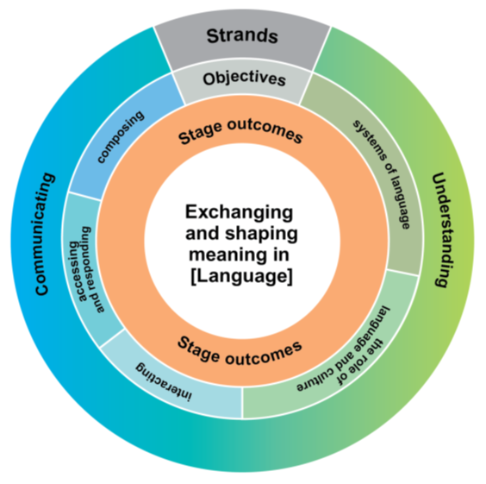

Communicating objectives
Students use language for communicative purposes by:
- interacting – exchanging information, ideas and opinions, and socialising, planning and negotiating
- accessing and responding – obtaining, processing and responding to information through a range of spoken, written, digital or multimedia texts
- composing – creating spoken, written, bilingual, digital or multimedia texts.

Understanding objectives
Students analyse and understand language and culture by:
- systems of language – understanding the languages system including sound, writing, grammar and text structure; and how language changes over time and place
- the role of language and culture – understanding and reflecting on the role of language and culture in the exchange of meaning, and considering how interaction shapes communication and identity.

Values and attitudes objectives
Learning a language helps students to:
- develop an interest in and enjoyment of language learning
- appreciate and value their own heritage, culture and identity
- appreciate and respect the culture, beliefs and values of others through language learning.
There are no outcomes associated with these objectives, so they are not assessable. However, the values and attitudes should underpin all teaching, learning and assessment activities and tasks to support student engagement.

Outcomes
In K-10 modern languages syllabuses, outcome codes identify the language, Stage, outcome number and strand.
Figure 3 – outcome codes
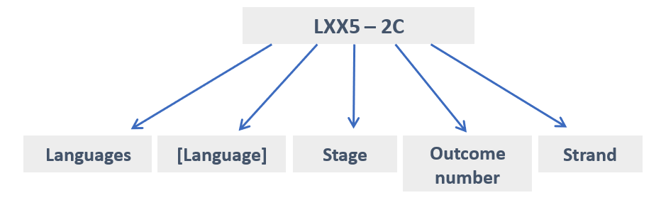
Table 1 – outcome codes and their meaning
Code | Meaning
LCH4-1C | Languages, Chinese, Stage 4, Outcome 1 (Communicating)
LJA5-7U | Languages, Japanese, Stage 5, Outcome 7 (Understanding)
LFRLS-2C | Languages, French, Life Skills, Outcome 2 (Communicating)
Non-scripted languages (French, German, Indonesian, Italian, Spanish, Turkish and Vietnamese) have 8 outcomes.
Scripted languages (Arabic, Chinese, Japanese, Korean and Modern Greek) have 9 outcomes. The additional outcome relates to the language’s writing systems.

Outcomes for scripted languages
For scripted languages (Arabic, Chinese, Hindi, Japanese, Korean, Macedonian, Modern Greek, Persian, Punjabi and Tamil), the outcomes for Stages 4 and 5 are as follows:
Table 2 – outcomes for scripted languages
Objective | Stage 4 outcomes | Stage 5 outcomes
Interacting | LXX4-1C uses [Language] to interact with others to exchange information, ideas and opinions, and make plans | LXX5-1C manipulates [Language] in sustained interactions to exchange information, ideas and opinions, and make plans and negotiate
Accessing and responding | LXX4-2C identifies main ideas in, and obtains information from texts  LXX4-3C organises and responds to information and ideas in texts for different audiences | LXX5-2C identifies and interprets information in a range of texts  LXX5-3C evaluates and responds to information, opinions and ideas in texts, using a range of formats for specific contexts, purposes and audiences
Composing | LXX4-4C applies a range of linguistic structures to compose texts in [Language], using a range of formats for different audiences | LXX5-4C experiments with linguistic patterns and structures to compose texts in [Language], using a range of formats for a variety of contexts, purposes and audiences
Systems of language | LXX4-5U applies [Language] pronunciation and intonation patterns  LXX4-6U demonstrates understanding of key aspects of [Language] writing conventions  LXX4-7U applies features of [Language] grammatical structures and sentence patterns to convey information and ideas  LXX4-8U identifies variations in linguistic and structural features of texts | LXX5-5U demonstrates how [Language] pronunciation and intonation are used to convey meaning  LXX5-6U demonstrates understanding of how [Language] writing conventions are used to convey meaning  LXX5-7U analyses the function of complex [Language] grammatical structures to extend meaning  LXX5-8U analyses linguistic, structural and cultural features in a range of texts
The role of language and culture | LXX4-9U identifies that language use reflects cultural ideas, values and beliefs | LXX5-9U explains and reflects on the interrelationship between language, culture and identity
For interacting and composing, students use the target language.
For accessing and responding, the response to texts may be in English or in the target language, depending on the outcome or content.
It is important to note that language and culture (outcome 9U) cannot be taught as 2 separate elements. Language and culture are linked through the outcome, and need to be taught together.

Outcomes for non-scripted languages
For non-scripted languages (French, German, Indonesian, Italian, Spanish, Turkish and Vietnamese), the outcomes for Stages 4 and 5 are as follows:
Table 3 – outcomes for non-scripted languages
Objectives | Stage 4 outcomes | Stage 5 outcomes
Interacting | LXX4-1C uses [Language] to interact with others to exchange information, ideas and opinions, and make plans | LXX5-1C manipulates [Language] in sustained interactions to exchange information, ideas and opinions, and make plans and negotiate
Accessing and responding | LXX4-2C identifies main ideas in, and obtains information from texts  LXX4-3C organises and responds to information and ideas in texts for different audiences | LXX5-2C identifies and interprets information in a range of texts  LXX5-3C evaluates and responds to information, opinions and ideas in texts, using a range of formats for specific contexts, purposes and audiences
Composing | LXX4-4C applies a range of linguistic structures to compose texts in [Language], using a range of formats for different audiences | LXX5-4C experiments with linguistic patterns and structures to compose texts in [Language], using a range of formats for a variety of contexts, purposes and audiences
Systems of language | LXX4-5U applies [Language] pronunciation and intonation patterns  LXX4-6U applies features of [Language] grammatical structures and sentence patterns to convey information and ideas  LXX4-7U identifies variations in linguistic and structural features of texts | LXX5-5U demonstrates how [Language] pronunciation and intonation are used to convey meaning  LXX5-6U analyses the function of complex [Language] grammatical structures to extend meaning  LXX5-7U analyses linguistic, structural and cultural features in a range of texts
The role of language and culture | LXX4-8U identifies that language use reflects cultural ideas, values and beliefs | LXX5-8U explains and reflects on the interrelationship between language, culture and identity
For interacting and composing, students use the target language.
For accessing and responding, the response to texts may be in English or in the target language, depending on the outcome or content.
It is important to note that language and culture (outcome 8U) cannot be taught as 2 separate elements. Language and culture are linked through the outcome, and need to be taught together.

Learner groups and differentiation in modern languages 7-10
The K-10 modern languages syllabuses acknowledge the diversity of students and their language capabilities. The syllabuses outline differentiated content for 3 broad learner groups:
- students learning the language as a second or additional language (for example, an English speaker learning Korean for the first time)
- content for students with prior learning and/or experience in the language (for example, a student who learnt the language in primary school)
- students with a background in the language (for example, a student who speaks the language at home).
The outcomes are the same for all 3 learner groups, it is the content which is differentiated.

It’s important to note that:
- teachers only program for the students in their class (for example, if they only have students learning the language for the very first time in Stage 4, they only program using the general content)
- individual student’s language skills may vary (for example, a student may be able to understand the spoken language well, but have difficulties with reading the language) – in these cases, teachers select the most appropriate content for each outcome.
Differentiation can be a challenge for teachers in every KLA. In languages, there is an additional layer – in modern languages, teachers program not only for students with a disability, EAL/D students, students experiencing difficulties with learning and gifted and high potential students, they may also need to differentiate for students with widely varying levels of competence in the target language. Even students with a background in the language may have varying skills varying, including:
- students who are completely literate in the language
- those who have strong oral skills but cannot read or write the language
- those who have some language skills across all 4 macro skills of reading, writing, listening and speaking.
For this reason, language teachers need to either create or access a very broad range of authentic target language resources.

Classical languages
Classical languages (Latin and Classical Greek) syllabuses were last revised in 2003. The structure of the syllabuses for Latin and Classical Greek broadly aligns, ensuring that students studying either or both languages will work toward the same set of outcomes, and that similar sets of essential knowledge, understanding, skills, key competencies and cross-curricular content will be developed.
Classical languages are no longer regularly spoken and are studied primarily to gain access to their literary products and, through those, to the culture, philosophy, religion, law and science of our own past.

Objectives and outcomes
While the modern languages objectives and outcomes are centred around communicative skills, the focus in classical languages is reading texts historically written in the language and understanding the linguistic, stylistic, and cultural environment of those texts as well as their connections to the modern world and their influences on them.
Classical languages organise their content around grammar (7.8) and vocabulary (7.9) with elaborate listings of linguistic details to be learned.
There are 3 objectives:
- using language
- making linguistic connections
- moving between cultures.
Figure 4 – interrelationship of 3 objectives in classical languages
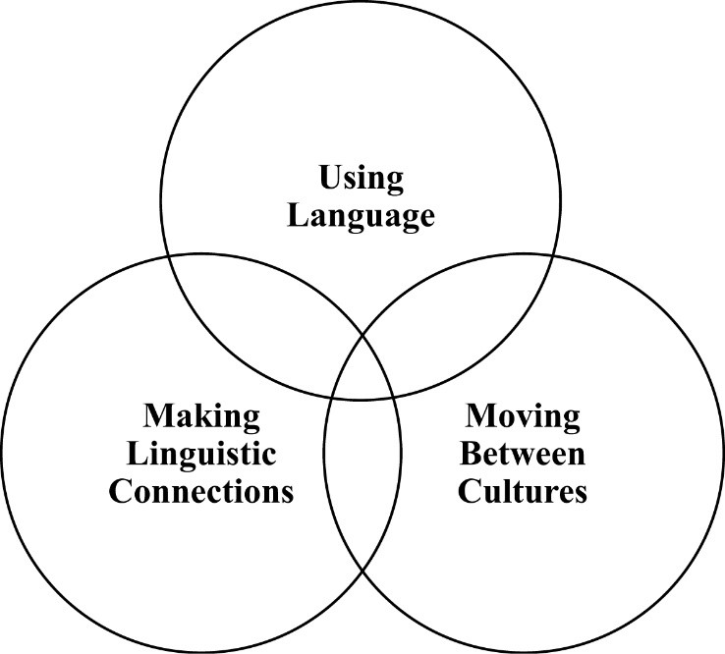
Each objective describes the active commitment students make to the acquisition of skills in reading, analysing and translating [classical language], and to the development of knowledge and understanding of the language and culture of the ancient world. The effective delivery of [classical language] emphasises the equal significance and interdependence of all objectives. However, depending on the stage of learning, one or more of the objectives may be emphasised at any given time.

Objective – using language
Students will develop knowledge, understanding and skills in reading, analysing and translating [classical language].

Objective – making linguistic connections
Students will explore the nature of languages as systems by making comparisons between [classical language] and English, developing an understanding of the correct application of linguistic structures and vocabulary.

Objective – moving between cultures
Students will develop knowledge of the culture of ancient civilisations and an understanding of the relationship of language and culture, thereby encouraging reflection upon their own cultural heritage and the influence of the classical world on the modern world.

Outcomes

Stage 4
The outcomes described for Stage 4 should be regarded as the basis for knowledge, understanding and skills in [classical language] in subsequent stages. The development outcomes for Stages 1–3 should be incorporated into the teaching and learning programs for students commencing their language study in Stage 4.

Stage 5
The outcomes described for Stage 5 should be regarded as the basis for the further development of knowledge, understanding and skills in Latin in Stage 6. The outcomes for Stages 1–4 should be incorporated into the teaching and learning programs for students commencing their language study in Stage 5.
Table 4 – outcomes for Stages 4 and 5 (classical languages)
Objective | Stage 4 outcomes | Stage 5 outcomes
Using language  Reading and responding  Analysing  Translating | 4.UL.1 reads passages of [classical language], recognising language structures  4.UL.2 analyses grammatical structures used in simple sentences in extended passages of [classical language]  4.UL.3 translates sentences in extended passages from [classical language] to fluent English | 5.UL.1 reads extended passages of [classical language], recognising language structures and overall meaning  5.UL.2 analyses familiar grammatical structures of complex sentences in extended passages of [classical language]  5.UL.3 translates passages of [classical language] into fluent and idiomatic English
Making linguistic connections | 4.LC.1 recognises the function of the relationship between words and structures  4.LC.2 explains the way in which meaning is conveyed by comparing and describing structures of [classical language] | 5.LC.1 demonstrates understanding of the nature of languages as systems by describing linguistic features  5.LC.2 demonstrates the ways in which meaning is conveyed by exploring features and structures of [classical language]
Moving between cultures | 4.MBC.1 demonstrates understanding of the interdependence of language and culture  4.MBC.2 demonstrates knowledge of key features of the culture of the ancient world [Roman/Greek] | 5.MBC.1 explores the relationship of language and culture, as manifested in a range of texts and contexts  5.MBC.2 identifies, explains and discusses references to cultural, social and historical features of the ancient world [Roman/Greek]

Stage 5 Extension
The outcomes described for Stage 5 Extension are for students who are able to achieve beyond Stage 5 outcomes.
Table 5 – Stage 5 Extension outcomes
Objective | Stage 5 outcomes
Using language  Reading and responding  Analysing  Translating | 5.UL.4 reads, analyses and evaluates extracts of original [classical language]  5.UL.5 demonstrates advanced skills in translating
Making linguistic connections | 5.LC.3 engages in discussion about linguistic issues  5.LC.4 analyses ways in which the structures and features of written [classical language] can be manipulated by authors for particular effect
Moving between cultures | 5.MBC.3 evaluates and demonstrates the importance of moving between cultures  5.MBC.4 evaluates expressions and representations of cultural, social and historical features of the ancient world in a range of texts [Roman/Greek]

Assessment and reporting in 7-10
Schools follow the department’s Curriculum planning and programming, assessing and reporting to parents K-12 policy for all subjects.

Modern languages
For modern languages, there are additional considerations when assessing students and reporting to parents:
- assessment of learning is task-based, so schools which hold a formal examination period in 7-10 may need to plan carefully to meet this requirement
- task-based assessment will cover a range of outcomes – at least one communicating and one understanding outcome, sometimes more, depending on the task
- teachers may wish to assess and report on different outcomes each semester
- teachers may combine syllabus outcomes when designing reporting outcomes. For example, if students are assessed on a speech they prepare and deliver for visiting exchange students, this would assess composing (4C), systems of language (5U, 6U in non-scripted; 5U, 7U in scripted) and the role of language and culture (8U in non-scripted; 9U in scripted)
- teachers should consider writing reporting outcomes which are in ‘parent-friendly’ language. Following on from the example above, this could be “prepares a culturally-appropriate speech for visiting exchange students, using correct pronunciation, intonation and grammatical structures”.

Course performance descriptors
The Course performance descriptors for [language] K-10 Syllabus (2017-2019) are designed for grading student achievement at the end of a Stage 5 course (100 or 200 hours), for the Record of School Achievement only.

Classical languages 7-10
For classical languages, assessment of students is more traditional, usually consisting of formal examinations rather than the task-based approach used for modern languages. NESA’s Advice on programming and assessment document for K-10 classical languages gives examples for both Latin and Classical Greek.
As with modern languages, teachers should consider writing reporting outcomes which are in ‘parent-friendly’ language.

Course performance descriptors
Unlike modern languages, classical languages have specific Latin course performance descriptors and Classical Greek course performance descriptors (which are very similar to each other) designed for grading student achievement at the end of a Stage 5 course (100 or 200 hours), for the Record of School Achievement only.

Life Skills
NESA recognises that a small percentage of students with special education needs may best fulfil the mandatory curriculum requirements for languages by undertaking Life Skills outcomes and content.
Life Skills outcomes for Years 7-10 are included in both modern and classical languages syllabuses.
Schools with eligible students can develop a school developed board endorsed course for a Stage 6 Life Skills course in any language. Applications for these courses are submitted to NESA via Schools Online.
For more details, including timelines for applications, refer to the NESA website.

Courses, curriculum structure and assessment in Stage 6

Modern languages
There are 55 modern language courses available as HSC subjects. The language(s) offered in each school is determined by the school’s priorities, staffing and student preferences. Some eligibility criteria apply for a number of courses.
In 2020, the highest candidacy languages for the HSC in NSW public schools were French, Japanese, Chinese (66% background speakers), Italian, Spanish and German (source: NESA).

HSC courses
There are 5 types of HSC modern languages courses:
- Beginners – for students with little or no prior language knowledge (for example no prior study or study of the mandatory 100 hours in Stage 4 only)
- Continuers – most commonly for students who have studied the language in Stage 5
- Extension – a course for students also studying the Continuers course, and who seek a high degree of language competence and fluency
- In some Asian languages, two additional courses are available, which affect eligibility rules:
  - [Language] in Context for heritage students
  - [Language] and Literature for students with a background in the language.

Eligibility
Eligibility criteria apply to the following courses:
- Beginners
- Continuers, where a [Language] in Context and/or a [Language] and Literature course exists
- [Language] in Context where a [Language] and Literature course exists.
Eligibility criteria do not apply to the following Year 11 and Year 12 courses:
- any course which is the highest proficiency level available
- Extension (these courses may only be studied concurrently with, or after completing, the Continuers course in the same language).
Students need to apply to their school principal for an eligibility determination, if possible during Term 3 of Year 10. To be deemed eligible for a course, a student must meet all of the eligibility criteria for that course at the time of entry to the course. The principal's eligibility determination should be provided to the student in writing at least 10 school weeks prior to the commencement of the course.
Eligibility forms, including a statutory declaration, are kept at the school. They do not have to be submitted to NESA but NESA officers may request copies of these forms.
For further information, refer to the eligibility for Stage 6 languages courses section on the NESA website and ACE manual 8008 – entry requirements for Stage 6 Languages courses where eligibility criteria apply.

Assessment
- New assessment and reporting guidelines for Stage 6 languages were released in July 2017 for implementation with Year 11 in 2018. These are available on the NESA website, under the relevant course. These include the mandatory components and weightings for school-based assessment in Year 11 and Year 12.
- Language courses must assess 4 macro skills: listening, speaking, reading and writing.
- School-based assessment requirements specify that tasks should assess macro skills in a holistic and authentic way, combining skills rather than testing them in isolation. As such, school-based assessment tasks should differ in structure and style to HSC examinations, which assess the 4 macro skills separately.
- Timetabling for in-school examinations must take into consideration the listening and oral component of languages examinations – they cannot run at the same time as other subjects or language levels.
- Teachers may require special equipment for language assessments, including recording devices and audio equipment.
- Unannotated monolingual or bilingual print dictionaries may be used in all Beginners, Continuers, [Language] in Context, [Language] and Literature and Extension HSC examinations. Digital dictionaries are not permitted. As such, schools should support students in understanding how to effectively use dictionaries.
- HSC oral examinations are held separately to the written examinations, usually in August or September. Oral examination centres vary from year to year, but are often centralised off-site due to the small number of candidates and availability of markers.
- The final written examination takes place on the date specified in the HSC written examinations timetable, at the student’s day school, regardless of where the language is studied.

Curriculum structure

Beginners courses
The aim of the Stage 6 Beginners modern language syllabuses is to enable students to develop:
- skills in effective communication
- knowledge of the nature of language
- understanding of the interdependence of language and culture.
Beginners courses are offered in Chinese, French, German, Indonesian, Italian, Japanese, Korean, Modern Greek and Spanish.
These courses are designed for students with little to no prior spoken or written knowledge or experience of the language and eligibility criteria apply.

Objectives
Objective 1: Interacting
Students will develop the linguistic and intercultural knowledge, understanding and skills to communicate actively in [Language] in interpersonal situations
Objective 2: Understanding texts
Students will interpret and respond to texts, applying their knowledge and understanding of language and culture.
Objective 3: Producing texts
Students will create and present texts in [Language] for specific audiences, purposes and contexts, incorporating their linguistic and intercultural knowledge, understanding and skills.

Content
The prescribed topics in Stage 6 Beginners courses should be studied from 2 interdependent perspectives:
- the personal world
- the [Language]-speaking communities.
These topics are taught across Year 11 and Year 12. In these 2 perspectives, the topics studied include:
- family life, home and neighbourhood
- people, places and communities
- education and work
- friends, recreation and pastimes
- holidays, travel and tourism
- future plans and aspirations.
The syllabus provides a comprehensive outline of the grammar knowledge required, which can be useful for program registration purposes.
There are no prescribed vocabulary lists – vocabulary is taught according to the topics studied, although it is generally expected that students will know the vocabulary used in the grammar outline. Some Asian languages have prescribed character lists.

Continuers courses
The aim of the Stage 6 Continuers modern language syllabuses is to develop students’:
- ability to use [Language] to communicate with others
- understanding and appreciation of the cultural contexts in which [Language] is used
- ability to reflect on their own culture(s) through the study of other cultures
- understanding of language as a system
- ability to make connections between [Language] and English and/or other languages
- cognitive, learning and social skills
- potential to apply [Language] to work, further study, training or leisure.
Continuers courses are generally designed for students who are learning the language as an additional language and eligibility criteria may apply. Typically, the students would have studied the language for 200-400 hours before starting the Stage 6 Continuers course.

Objectives
Objective 1 – exchange information, opinion and experiences in [Language]
Objective 2 – express ideas through the production of original texts in [Language]
Objective 3 – analyse, process and respond to texts that are in [Language]
Objective 4 – understand aspects of the language and culture of [Language]-speaking communities
Meeting these objectives will involve using the skills of listening, speaking, reading and writing, either individually or in combination, and being able to move between [Language] and English.

Content
Stage 6 Continuers courses focus on 3 prescribed themes:
- the individual
- the [Language]-speaking communities
- the changing world.
Each language has a list of prescribed topics and suggested sub-topics. These are listed in the individual syllabuses.
The syllabus provides a comprehensive outline of the grammar knowledge required, which can be useful for program registration purposes.
There are no prescribed vocabulary lists – vocabulary is taught according to the themes and topics prescribed in the syllabus. It is expected that students will be familiar with a range of vocabulary and idiomatic expressions.
Chinese and Japanese have prescribed character lists.

Extension courses
Extension modern language courses are available for study in Year 12 only and commence in Term 4.
Extension courses are available in the following languages:
- Arabic
- Chinese
- French
- German
- Indonesian
- Italian
- Japanese
- Modern Greek
- Spanish.
The Stage 6 Extension syllabuses aim to enhance students’ knowledge and understanding of a range of issues as reflected in contemporary target language texts.
The course extends their ability to use and appreciate the target language as a medium for communication, creative thought and expression.
Students engage with the theme ‘the individual and contemporary society’ through course prescriptions (study of a prescribed text, prescribed issues and a range of relevant related texts).
The course prescriptions change approximately every 5 years; new course prescriptions began in 2020.
The emphasis of assessment in Extension courses is productive language (speaking and writing) and text analysis.

[Language] in Context courses
[Language] in Context courses were previously known as Heritage courses. The courses are available in Chinese, Japanese and Korean.
[Language] in Context course aims to develop students’ ability to:
- use [Language] to communicate in a range of contexts
- understand how language works as a system
- appreciate their [Language] linguistic and cultural heritage
- understand how culture and identity are created and expressed through language
- make linguistic connections between [Language] and English, and/or other languages
- apply [Language] to work, further study, vocational training or leisure.
Most students undertaking these courses come from homes where the language is used, and have a connection to the culture. Typically, they have some understanding and knowledge of the language, although their spoken language is generally much stronger than their written language skills. These students have most likely completed the majority of their schooling in English. Eligibility criteria apply.
Students engage with themes from personal, community and international perspectives in the context of social and community settings, contemporary literature and the arts, and media. Students complete a Personal Investigation which allows students to reflect on their own personal and cultural identity by making links with their heritage.
The syllabuses provide extensive prescriptions for grammar, and character lists are provided for Chinese and Japanese.

[Language] and Literature courses
[Language] and Literature courses were previously known as Background Speaker courses.
The courses are available in Chinese, Japanese, Korean and Indonesian.
[Language] and Literature courses demand a higher level of language competence than [Language] in Context courses. Assessment emphasises written rather than oral language skills, with reading and writing being the most heavily weighted assessment components.
[Language] and Literature course aims to develop students’:
- ability to use [Language] to communicate with others
- understanding and appreciation of the cultural contexts in which [Language] is used
- ability to reflect on their own and other cultures
- understanding of language as a system
- opportunities to make connections between [Language] and English and or other languages
- cognitive, learning and social skills
- potential to apply [Language] to work, further study, training or leisure.
[Language] and Literature syllabuses are designed for students with a cultural and linguistic background in the language – students who are first-language speakers, or who have completed a significant part of their formal education in the target language. Eligibility criteria apply.
Students study 4 prescribed themes that are linked to contemporary issues and explored through a range of texts:
- prescribed texts change every 5 years; new course prescriptions began in 2019
- the syllabuses provide lists of text types plus extensive prescriptions for grammar.

Classical languages
Latin, Classical Greek and Classical Hebrew are available in Stage 6. The language(s) offered in each school is determined by the school’s priorities, staffing and student preferences.

HSC courses
There are 2 types of HSC classical languages courses:
- Continuers – for students who, typically, will have studied Latin for 400-500 hours at the completion of Year 12
- Extension – a course for students also studying the Continuers course, and who seek a high degree of language competence.

Eligibility
Eligibility criteria do not apply to classical language courses. However, it is strongly advised that students have a sound Stage 5 preparation in the classical language.

Assessment
Each classical language course has its own assessment and reporting requirements: Latin Continuers, Latin Extension, Classical Greek Continuers, Classical Greek Extension, Classical Hebrew Continuers and Classical Hebrew Extension although there are significant parallels between them.
- Unannotated monolingual and/or bilingual print dictionaries may be used in Latin exams. No dictionaries may be used in classical Greek or classical Hebrew exams. Digital dictionaries are not permitted.
- The final written examination takes place on the date specified in the HSC written examinations timetable, at the student’s day school, regardless of where the language is studied.

Curriculum structure

Continuers courses
The aim of the Stage 6 Continuers classical language syllabuses is to develop students’:
- ability to understand [classical language] texts
- ability to understand how language works, including at the grammatical level
- ability to recognise connections between [classical language] and English or other languages
- ability to recognise stylistic features of [classical language] texts and understand their literary effects
- ability to assimilate the ideas contained in a [classical language] text
- ability to explore the ideas of a [classical language] text in its social, cultural, historical and religious context
- ability to explore their own culture(s) through the study of the Ancient culture
- ability to recognise how ideas and beliefs of the classical period have influenced subsequent societies
- enjoyment of the study of [classical language] through the reading of [classical language] texts
- general cognitive, analytical and learning skills.

Target candidature
The Continuers level syllabus is designed for students who, typically, have studied [classical language] for 400–500 hours at the completion of Year 10.

Objectives
The students will achieve the following objectives:
Objective 1 – understand seen and unseen texts written in the original [classical language]
Objective 2 – understand the linguistic and stylistic features and the cultural references in prescribed [classical language] texts
Objective 3 – understand the prescribed text as a work of literature in terms of the author’s purpose.

Structure
Stage 6 Continuers is split into 2 year-long components:
1. Preliminary course (120 indicative hours)
The Preliminary course is structured to provide students with opportunities to read original [classical language] texts, developing the skills needed to study the prescribed texts for the HSC course and to translate unseen texts. Students extend their vocabulary, consolidate their language skills and study additional linguistic features not prescribed in the Years 7–10 syllabus. Students also begin to appreciate the purpose and point of view of different authors and their effective use of language.
It is a requirement that the Preliminary course not teach texts which will be prescribed for the following year in either the Continuers or Extension courses.
2. HSC course (120 indicative hours)
The HSC course is designed to allow students to apply and extend the knowledge and skills gained through a wider reading of authors in the Preliminary course to a detailed study and analysis of two prescribed texts, one verse and one prose. Students apply their linguistic skills and their familiarity with [classical language] literature in the independent translation of unseen passages of original [classical language] text.
The prescribed texts are found in the Course prescriptions for Latin Continuers, Course prescriptions for Classical Greek Continuers and Course prescriptions for Classical Hebrew Continuers. The texts are prescribed quite a long time in advance, and have overlapping time-frames which means a teacher should only need to prepare at most one new text per year across both Continuers and Extension courses in the language.

Assessment
Continuers course assessment requirements were updated and released in July 2017 and came into effect in Term 1 2018 (with Year 11). There are similar documents for each classical language: Assessment and reporting in Latin Continuers Course Stage 6, Assessment and reporting in Classical Greek Continuers Stage 6 and Assessment and reporting in Classical Hebrew Continuers Stage 6.

Extension courses
Extension classical language courses are available in Latin, Classical Greek and Classical Hebrew for study in Year 12 only and commence in Term 4.
The Extension syllabuses aim to increase students’ enjoyment and knowledge of classical literature, to develop students’ linguistic competence, to extend their analytical skills and to refine their ability to respond critically to literature.
The Extension course leads students into an area of classical literature that is not explored in the Continuers course.
For the Extension courses:
- the Preliminary course is a prerequisite
- the Continuers course is a co-requisite
- 60 indicative hours are required to complete the courses.

Assessment
Extension course assessment requirements were updated and released in July 2017 and came into effect in Term 4 2018. There are similar documents for each classical language: Assessment and reporting in Latin Extension Stage 6, Assessment and reporting in Classical Greek Extension Stage 6 and Assessment and reporting in Classical Hebrew Extension Stage 6.

Support from the Languages and Culture team
The Languages and Culture team offers a range of support to language teachers, coordinators and supervisors.
Our role is to support the effective implementation of language programs 7-12 in NSW public schools, including:
- designing and delivering relevant and innovative projects and professional learning
- providing expert curriculum advice and support related to syllabus implementation.

Resources
Our website is education.nsw.gov.au/languages
Our support includes:
- language-specific support across 10 modern languages in Stages 4 and 5, including sample scope and sequence documents, unit starters (units of work) and related assessment tasks, with marking guidelines
- Latin-specific support, including:
  - a sample scope and sequence for Stage 4, with a unit starter and sample assessment task, with marking guidelines
  - a sample unit of work and assessment task for Stage 6 Continuers
- advice on programming and assessment for Stages 4 and 5 modern languages, including programming guidelines with checklists to ensure your programs are compliant with both NSW Education Standards Authority (NESA) and departmental requirements and policies
- programming guidelines for quality programming in classical languages 7-10
- learning across the curriculum resources, including literacy and numeracy in languages
- advice documents for HSC students, across all 5 course levels
- practice speaking questions for Stage 6 Beginners and Continuers modern languages courses
- sample listening and reading resources for Stage 6 students.

Staying in touch and accessing direct support
Please ensure you and your language teacher(s) are:
- members of the Languages statewide staffroom in Microsoft Teams. To join, teachers complete a very short entry survey, which automatically adds them to the Team once completed – there are over 820 language teachers there, interacting with each other and with the Languages and Culture team. Teachers have also contributed more than 600 resources, for other teachers to use
- subscribed to our blog languagesnsw.com (to subscribe, fill in the RSS feed box on the News page and on any language-specific page/s relevant to your school’s context).

Professional learning opportunities
As all teachers are working towards their accreditation or maintenance of accreditation, there is a need for relevant, KLA-specific, professional learning.
The Languages and Culture team offers a range of professional learning opportunities for language teachers, including:
- statewide staff meetings in Week 4 and Week 7 each term
- eCourses
- face-to-face workshops
- online webinars.

Language teacher networks
There are 13 geographically-based language teacher networks operating across NSW, as well as a virtual network for language teachers who are geographically remote from their nearest network.
Networks offer targeted professional learning, tailored to meet local needs, and provide an invaluable opportunity for teachers to collaborate with other languages teachers.
View the full list of language teacher networks locations and contacts.

Virtual Languages Mentoring Network
The Virtual Languages Mentoring Network (VLMN) is a structured, 2-year mentoring program for beginning teachers of languages. A beginning teacher is one in their first 5 years of teaching languages.
Each participant (mentee) is assigned an experienced, language-specific teacher mentor. Each mentor works with up to 2 mentees, ensuring relationships are central to the mentoring journey.
The program includes face-to-face, whole group meetings, observation visits and virtual meetings via online platforms. All costs associated with the program, including the cost of relief, are met by the Languages and Culture team.

Nihongo Tanken Centre
If your school offers a Japanese program, you may consider accessing the support offered by the Nihongo Tanken Centre. The Nihongo Tanken Centre is a purpose-built Japanese immersion centre, located on the grounds of Kirrawee High School in southern Sydney.
Schools can:
- bring students for an immersion experience in the Japanese language and culture
- attend an online speaking session (subject to availability)
- access our virtual visit for Year 10 (available from Term 2 2022, for rural and remote students).
The centre also offers holiday workshops for Stage 6 students, which run online.

Contacts
Elisabeth Robertson
Coordinator, Languages and Culture
elisabeth.robertson@det.nsw.edu.au
Evia Kyriacou
Languages Advisor
evia.kyriacou@det.nsw.edu.au
Maxine Acosta-Ostrzycki
Language Officer
maxine.acosta4@det.nsw.edu.au
Coreena Allen
Language Officer
coreena.allen@det.nsw.edu.au
Ben Gibb
A/Language Officer
ben.gibb4@det.nsw.edu.au
Shanelle Ingram
Language Officer
shanelle.ingram@det.nsw.edu.au
Nada Gemayel
Languages Curriculum Implementation Officer 7-12
nada.gemayel-saliba@det.nsw.edu.au
Renetta Wolfe
Languages Curriculum Implementation Officer 7-12
renetta.wolfe@det.nsw.edu.au

