Using digital tools to enhance language learning
To develop speaking and listening skills
Name | url | Purpose
EDpuzzle | www.edpuzzle.com | Make any video your lesson  Choose a video, give it your magic touch and track your students' comprehension  Requires parental consent for children under 13 years old
Voki | www.voki.com | Voki is a fun tool that students can use for homework, classwork or projects
Audible | https://stories.audible.com/start-listen | Free for 2020  Stories to use as listening texts
Flipgrid | https://info.flipgrid.com/ | Present and collaborate through speaking about topics
Blabberize | https://blabberize.com | Create animations with own voice
To build vocabulary and script
Name | url | Purpose
Quizlet | https://quizlet.com/en-gb | Quizlet makes simple learning tools that let you study anything. Start learning today with flashcards, games and learning tools
Kahoot! | https://kahoot.com/ | Kahoot! is a free game-based learning platform that makes it fun to learn – any subject, in any language, on any device, for all ages!
Quizzizz | www.quizzizz.com | Gamified quizzes to play in class and at home  Can be used for practice or formative assessment
Gimkit | https://www.gimkit.com/ | Gimkit is a game show for the classroom that requires knowledge, collaboration, and strategy to win  Similar to Quizlet live
Lino | http://en.linoit.com/ | Lino is a free sticky and canvas service for sharing ideas and collaboration
Formative | https://goformative.com/ | Create engaging work for students
Quia | www.quia.com | Templates for creating online activities  Automatic grading and immediate feedback
Socrative | https://socrative.com/ | Teachers create a ‘room’ and students can login to that room to complete quizzes
Learn a language | https://www.learnalanguage.com/ | Vocabulary lists in a number of languages and topics
Wordwall | https://wordwall.net/ | Create interactive and printable activities
Flippity | https://flippity.net/ | Create activities from templates for students which can include audio
To develop writing skills
Name | url | Purpose
Animoto | www.animoto.com | Create and share videos for free with Animoto's video maker  Combine your photos and video clips with music to make professional videos
Powtoon | https://www.powtoon.com/ | Create animations
To develop reading skills
Name | url | Purpose
Chalk academy | https://chalkacademy.com/ | Multilingual books for children
Interactive worksheets
Name | url | Purpose
Wizer me | https://wizer.me/ | Build interactive, engaging worksheets
Live worksheets | https://www.liveworksheets.com/ | Transform your traditional worksheets into live, interacting exercises with self-correction
Other
Name | url | Purpose
Wakelet | https://wakelet.com/ | Capture, organise and share multi-media resources from across the web with students, teachers, and learning communities
ImmerseME | https://immerseme.co/ | Interactive website
National resources
Name | url | Purpose
Scootle | www.scootle.edu.au | National repository providing more than 20,000 digital resources aligned to the Australian Curriculum
Language learning space | www.lls.edu.au | Support for teachers and students of Chinese, Indonesian and Japanese languages in Australian schools
Languages online | https://www.education.vic.gov.au/languagesonline/ | Free resources for language teachers and students
Collaborative tools
Name | url | Purpose
Google Apps for Education | Access through the Portal
Microsoft 365 | Access through the Portal
Slidesmania | https://slidesmania.com/ | Free themes, templates, resources for Google Slides
Miro | https://miro.com/ | Online collaborative whiteboard platform to bring teams together, anytime, anywhere
Mindmeister | https://www.mindmeister.com/ | Brainstorm collaboratively
Whiteboards | https://whiteboard.fi/ | Online whiteboards for collaboration or games like Pictionary
Kapwing | https://www.kapwing.com | Students can create and edit videos collaboratively from different locations
Bubbl.us | https://bubbl.us/ | Brainstorm and create mind maps
Conceptboard | https://conceptboard.com/ | A visual collaboration space
Apps for language teachers
App icon | App description
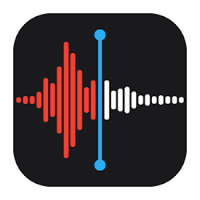 | Voice memos turns your iPhone, iPad, or Apple Watch into a portable audio recorder
Voice recorder Pro – best app for recording voice
Free for iPhone and iPad
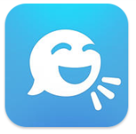 | Tellagami – talking full body avatar, choices for hair, skin, library of backgrounds or use own background image  Free for iPhone and iPad
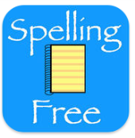 | Spelling notebook free – create word lists, record the clue (in language) and test themselves on vocab meanings  Free for iPhone and iPad
Quizlet – create or access study lists
Free for iPhone and iPad
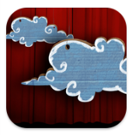 | Puppet Pals HD – create movies with animation and sound  Free for iPad
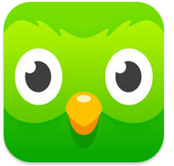 | Duolingo – learn languages for free  Free for iPhone and iPad
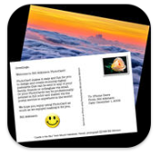 | Photocard by Bill Atkinson – personalised postcards  Free for iPhone and iPad
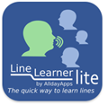 | LineLearner lite – to learn lines of a dialogue (5 lines each), good for independent practice of dialogue  Free for iPhone and iPad
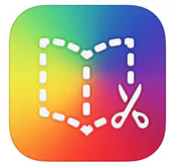 | Book creator for iPad – make books with photos, video and sound  $7.99 for iPad
 | Word clouds by ABCYa.com – allows you to create word clouds
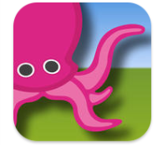 | Greenscreen by Do Ink – green screen, can put video in background  $7.99 for iPhone and iPad
Edmodo – collaborating tool for teachers and students
Free for iPhone and iPad
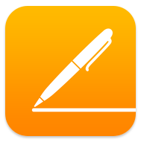 | Pages – word processor  Free for iPhone and iPad
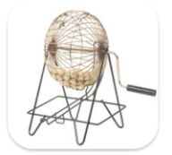 | Bingo Number Generator – a portable bingo cage  Free for iPhone and iPad
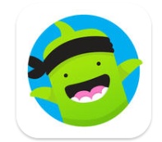 | ClassDojo – classroom management  Free for iPhone and iPad
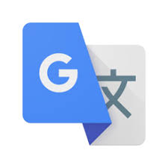 | Google Translate – translates blocks of text and text in images  Free for iPhone and iPad
 | Plickers – poll your class for free
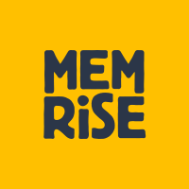 | MemRise – language learning app  Free for iPhone and iPad
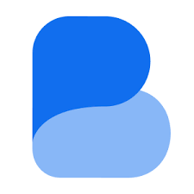 | Busuu – language learning app  Free for iPhone and iPad
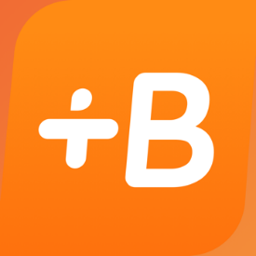 | Babbel – language learning app  Free for iPhone and iPad
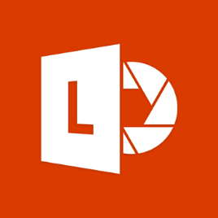 | Microsoft Office Lens – trims, enhances and makes pictures of whiteboards and documents readable
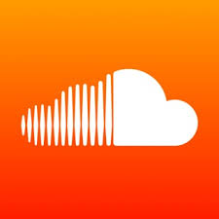 | SoundCloud – music and audio streaming platform

