Topic 1 – physical geography

Table of contents
Topic 1 – physical geography 1
Table of contents 2
Topic 1: Physical Geography 3
Outcomes 3
Learning sequence 1: Plate tectonics 4
Tectonic plates 4
Faulting, folding and plate movement 5
Learning sequence 2: Physical processes 6
Physical and chemical weathering 6
Learning sequence 3: Climate 8
Climate patterns and processes 8
Learning sequence 4: Weather 10
Factors affecting temperature 10
Learning sequence 5: Biogeography 13
Biogeography – Investigative study 13

The geographical processes that form and transform the physical world.
The content provides opportunities for students to investigate learning across the curriculum content including Aboriginal and Torres Strait Islander histories and cultures, Asia and Australia’s engagement with Asia, and Sustainability.

Outcomes
A student:
- GEE5-1 explains the diverse features and characteristics of a range of places, environments and activities
- GEE5-2 explains geographical processes and influences that form and transform places and environments
- GEE5-3 analyses patterns associated with natural phenomena and human activity at a range of scales
- GEE5-4 assesses the interactions and connections between people, places and environments that impact on sustainability
- GEE5-5 accounts for contemporary geographical issues and events that impact on places and environments
- GEE5-8 acquires and processes geographical information by selecting and using appropriate and relevant geographical tools for inquiry
- GEE5-9 communicates geographical information to a range of audiences using a variety of strategies and geographical tools
Related Stage 4 outcomes: GEE4-1, GEE4-2, GEE4-3, GEE4-4, GEE4-5, GEE4-8, GEE4-9
Outcomes referred to in this document are from Geography Elective Years 7-10 Syllabus © NSW Education Standards Authority (NESA) for and on behalf of the Crown in right of the State of New South Wales, 2019

Learning sequence 1: Plate tectonics
Students:
- investigate the processes involved in volcanic and earthquake activity, folding and faulting, for example:
  - location of major tectonic plates and their boundaries M ST
  - discussion of evidence of tectonic plate movement GS VR
  - explanation of the relationships between plate boundaries and major physical features VR

Tectonic plates
Teacher note: Tectonic plates are the large pieces of the Earth's crust which fit together and form part of the lithosphere. The plates sit on the mantle, which is molten material which can cause the plates to move over time. Geologically, the plates have moved significantly over time frames of millions of years to be in their current positions.
The balloon activity focuses on where plates are located on the Earth's surface and how they fit together. By completing this activity students will be able to show the size, shape and location of tectonic plates and where their boundaries are found. This activity will take more than one period and has resources listed below to make the paper mâché, the alternate could be to use balloons or paper lanterns.
Resources: Balloons, newspaper, glue, paint and permanent markers. Alternatively paper lanterns or balloons could be used instead of the papier mâché.
- Using a blank map, identify the name and location of the major tectonic plates. Students describe the features of convergent, divergent, and transform plate boundaries and research two examples of the different boundary types. They should show where these areas are and annotate the major types of convergent, divergent, and transform plate boundaries on their map.
- Blow up a balloon to a round shape and tie it off. Glue strips of newspaper to the balloon; several layers may be needed to form a strong paper mâché. Let the paper mâché dry overnight. When the paper mâché is dry, use paint to highlight the land (green) and oceans (blue). When the paint is dry, use a permanent marker to draw the tectonic plate boundaries. The tectonic plates jigsaw from Geoscience Australia can be used to help draw these on the globe or use the following Map of major tectonic plates In the world link. This globe can be used as a reference when looking at the locations of volcanic activity and earthquakes by either comparing to other maps or by also locating on the globe major hot spots of these hazards.

Faulting, folding and plate movement
Teacher note – Background information. Volcanoes and earthquakes are natural phenomenon that are unpredictable and can have devastating impacts on the built and natural environment. However, there is geological reasoning behind each event. Students will develop an understanding of the processes involved in volcanic and earthquake activity.
- Use the National Geographic images of volcanoes, fault lines and fold mountains to complete the following table:

Photo | Location of the photograph | Type of photograph (aerial, oblique or ground level) | Description

Learning sequence 2: Physical processes
Students:
- investigate the processes of weathering, erosion, deposition and mass movement, for example:
  - explanation of physical and chemical weathering processes and the role of weathering in shaping the landscape VR
  - description of types of mass movement VR
  - discussion of the role played by humans in mass movement
  - examination of erosion and deposition including the role of water, wind and ice in transforming the land F

Physical and chemical weathering
Teacher note – The following activity is a short in class method to simulate physical weathering of a fake rock. Students can complete this as an inquiry and use different types of rocks or rock like materials. Students should be encouraged to make predictions about what will happen to the rock through the experiment. The resources need for the activity are 15 small containers, 15 sugar cubes and water.
The erosion activity can be performed in one lesson and will use a desert sand dune as a landform which will be eroded by wind and water. Resources needed for activity is a small fans (electronic or hand held/homemade), sand (enough to make a small mound) and water.
- In pairs or small groups, collect the following equipment:
  - sugar cubes
  - small glass or plastic container
  - water or lemon juice
  - eye dropper or teaspoon
- Conduct a weathering experiment by following these steps:
- Place a sugar cube into the container
- Shake the container gently for one minute and then use the following table to record observations about the shape and structure of the sugar cube, including a sketch of the sugar cubes appearance.
- Repeat at 1 minute intervals for 5 minutes
Time | Start | 1 minute | 2 minutes | 3 minutes | 4 minutes | 5 minutes
Observation
- Repeat the above activity but include drops of water to the sugar cube, to demonstrate chemical weathering. A mild acid (lemon juice) could also be used to simulate chemical weathering.
- Write a structured response explaining the physical processes of the activity and how relates to real-world weathering of rocks
- Simulate the process of erosion by creating a small mound of sand in an open location. This would be best done outdoors or in a large plastic tub in the classroom. Use a fan, hand-held electronic or manual hand-held fan, and blow the sand from one direction. Make observations about the changing shape of the sand dune for two minutes and measure the length at which the sand grains have been transported. The activity could be continued until the entire sand dune has been transported and deposited to a new location. Answer the following questions:
  - Does wind or water have a greater impact on the sand dune landform?
  - How will this impact the sand dune over time?
- Conduct an experiment to show the effects of water movement on desert dunes. Build another mound of sand to represent the desert sand dune. Use water in a watering can or pour using a cup or jug in a steady stream. Observe the changes which take place to the dune for 2 minutes. Answer the following questions:
  - Does the transportation of the eroded sand move the grains in a similar way to the wind?
  - In which experiment did the landscape change the most?
  - Which agent (wind or water) is more likely to erode a desert sand dune?

Learning sequence 3: Climate
Students:
- investigate patterns and processes associated with climate, for example:
  - explanation of global atmospheric circulations: insolation, pressure, wind, temperature, precipitation M
  - description of global climatic patterns M
  - examination of factors affecting climate: latitude, altitude, maritime and continental influences F VR
  - explanation of issues resulting from climate change

Climate patterns and processes
Teachers note: Air circulates the globe moving from one area to another in large parcels. Air with similar characteristics will stick together and this helps to inform long term patterns. When air rises away from the general earth's surface this is known as a low-pressure system. When air is descending towards the earth's surface, this is known as a high-pressure system. When a high-pressure system descends it will be displaced and the air within it will move towards a low-pressure area – trying to balance the pressure between the two environments. This movement of air from high to low pressure area is called wind.
The circulation of air activity can be performed within one lesson and will cover the basic aspects of high and low pressure and the causes of wind. Balloons will be needed for to complete activity.
- Simulate the circulation of air by firstly observing the deflated balloon before it is blown up. The balloon has the same air pressure inside as the air pressure outside in the general atmosphere at ground level.
- Blow up a balloon, but do not tie the balloon – just hold the opening closed with fingers. As air is pushed inside the balloon the pressure inside is increasing compared to the air pressure outside. This is called a high-pressure environment and is a representation of high-pressure system that may be seen on a synoptic chart. This means that there are more air molecules in a small spaces. The air molecules in the general atmosphere have more space between them and more room to fly about. This is in comparison a low-pressure environment.
- Discuss what will happen when the balloon is released from our grip.
- Release the balloon and watch as the air inside escapes but be careful as the balloon may fly about. The air will always try and balance the pressure. When we let go of the balloon the high-pressure environment is trying to equalise itself to become the same pressure as the outside atmosphere.
- Discuss the process of the air moving from a high pressure environment to a low pressure environment is known as wind. This process (minus the plastic balloon) is what is creating the winds we feel each day and the dominant wind patterns – air moving from high to low pressure environments.
- Observe the following climate graphs for Canberra and Oslo. Make any initial observations and complete the following table using research
Factor | Canberra | Oslo
Latitude
Altitude
Distance from coastline
- Using the information from your research, complete the following questions, giving evidence to support your answers:
  - Which climatic factors do you think most influence the rainfall of these cities?
  - Which climatic factors do you think most influence the temperatures of these cities?

Learning sequence 4: Weather
Students:
- investigate patterns and processes associated with weather and weather events, for example:
  - discussion of factors affecting temperature and humidity GS VR
  - description of meteorological processes that produce different types of rainfall and extreme weather events: droughts, floods, storms M VR
  - assessment of the impact of an extreme weather event on a community
  - examination of Aboriginal, Torres Strait Islander and/or international Indigenous perspectives on patterns and processes associated with weather and climate

Factors affecting temperature
Teachers note: Air temperature is measured using a thermometer at or close to ground level. This is how we gather data on temperature each day and allows us to investigate trends over a long period of time. On a local scale temperatures can vary a lot due to factors such as time of day and aspect.
This activity can be completed in one lesson or extended across many lessons to gather data on temperature changes over a location and at different times. The focus is on how to gather and reasoning variations in temperatures in a school context. Thermometers will be needed for this activity and could be borrowed from the schools science department.

Terminology | Definitions
Aspect | The direction a slope faces.  This includes human and physical features such as buildings and the slope of a hill.
Microclimate | A climate of a very small area which is different to the surround area. This may be caused by factors including aspect.
Thermometer | A device used to measure air temperature in degrees Celsius.
- Brainstorm a variety locations in the school that would experience different temperatures and their causes.
- Draw a simple map of the school in the box below and identify 5 areas where the air temperature can be measured and answer the following questions:
  - Are there different locations in the school that would experience different temperatures?
  - What would cause different temperatures in the school?
- Using knowledge (or even a map) of the school identify five areas where the air temperature can be measured. Record the locations temperature by using a thermometer to measure the air temperature. Include observations that may impact climate in your log. This could be completed this multiple times throughout a day or weeks.

Location | Temperature  morning | Temperature  midday | Temperature  afternoon
Oval - grass | Observation - Is it shady or full sun | Observation - What aspect does the slope of building face? | Observation - What materials are any nearby buildings made of?
1
2
3
4
5
- Graph the results of the temperature reading by using different colours for each site. An example of a graph space is found below.

- Discuss the patterns that may be observed with the different times of day and complete the following questions –
  - Is there a time of day when temperatures were always high or low?
  - Was there a location that the temperature stayed the same all day?
  - Did shady areas have similar, higher or lower temperatures than the locations in full sun?
  - Did locations facing a particular direction (aspect) have a higher temperature?
  - Did any buildings nearby raise the temperature due to their materials e.g. metal siding?
- Make recommendations about what could be done to limit areas with extreme heat. For example, extra shade or trees, different building materials, zone off an area to limit sun exposure to students on breaks. Develop a diagram of the new area with recommendations.

Learning sequence 5: Biogeography
Students:
- investigate the biogeography of one vegetation community, for example:
  - identification of ways vegetation is classified VR
  - explanation of soil-forming processes and the relationship between soil and vegetation VR
  - examination of the spatial distribution and physical characteristics of one vegetation community M VR F
  - analysis of human impact on the selected vegetation community, including that of Aboriginal Peoples
- investigate at least one environment produced by biophysical processes and human interactions in a particular location, for example:
  - identification of the main biophysical processes in the selected study F VR
  - explanation of the processes that create the features of the environment
  - description of human interactions with the environment VR

Biogeography – Investigative study
Teachers’ note: Biogeography is the study of living things – plants and animals – over time. This could be the study of ecosystems in area and how changes in climate over thousands of years can contract vegetation. Another example might be to look at the similarities and differences between the animals and vegetation in southern African nations, Australia and South America and how changes have occurred since continental drift has moved these landmasses apart.
This activity focuses on investigating a vegetation community in a local school context using fieldwork and can be performed in one lesson or over many lessons depending on accessibility of resources. If using a plant identification app please consider downloading this prior. Resources needed for activites is a vegetation community (preferably native) on school grounds, plant identification app (optional) and a small container with water.

Terminology | Definitions
Biogeography | The study of living things, usually vegetation communities, in a location over time.
Organic matter | The living material, such as plants decomposing, within soil.
Sclerophyll characteristics | The characteristics of native plants to prevent water loss as adaptations to Australia's hot climate, which can include: Thick leathery leaves, short leaves, thick bark, leaves angled to face edge towards the hot sun.
Slake test | A test to measure the stability of soil using water.
Soil smear | A method of viewing the colour and texture of soils by spreading a small amount across paper.
Transect | A line or path across the Earth’s surface along which observations are made or measurements taken.
- Create an affinity diagram to represents the class output from a brainstorming session. The brainstormed ideas will be put into clusters or columns based on their natural relationships, affinity or similarity about the following question:
  - What is the biogeography (vegetation) of the local area and how is it being influenced?
- Find an area of the school which has vegetation (preferably native species). Investigate vegetation in an area of your school by observing any plants which have sclerophyll characteristics. To record this a leaf rubbing could be used which is labelled to show features of the leaf or plant. To help identify different plant types an app could be used, for examples apps for plant ID. The leaf rubbing can be annotated to show the length, species and any observable sclerophyll characteristics. A sample of a leaf rubbing is shown below:
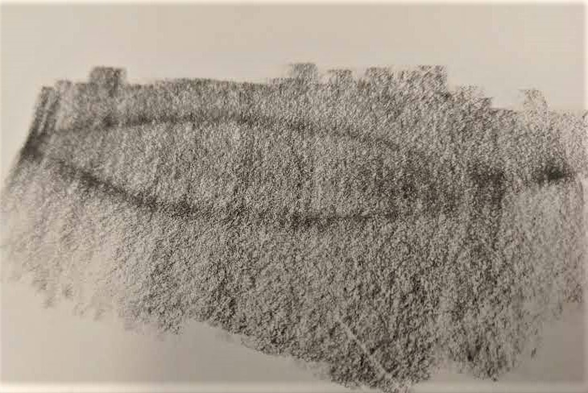
Image source - David Proctor
- Create a field sketch to record the types and plants of trees across a short transect. This can be performed by identifying different plants and recording their heights and spacing. A key can be used instead of true representations of the plants.
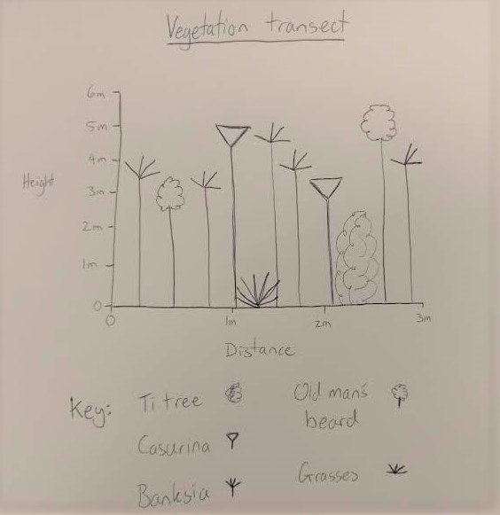
Image source - David Proctor.
Provided is a vegetation profile for using a short transect.
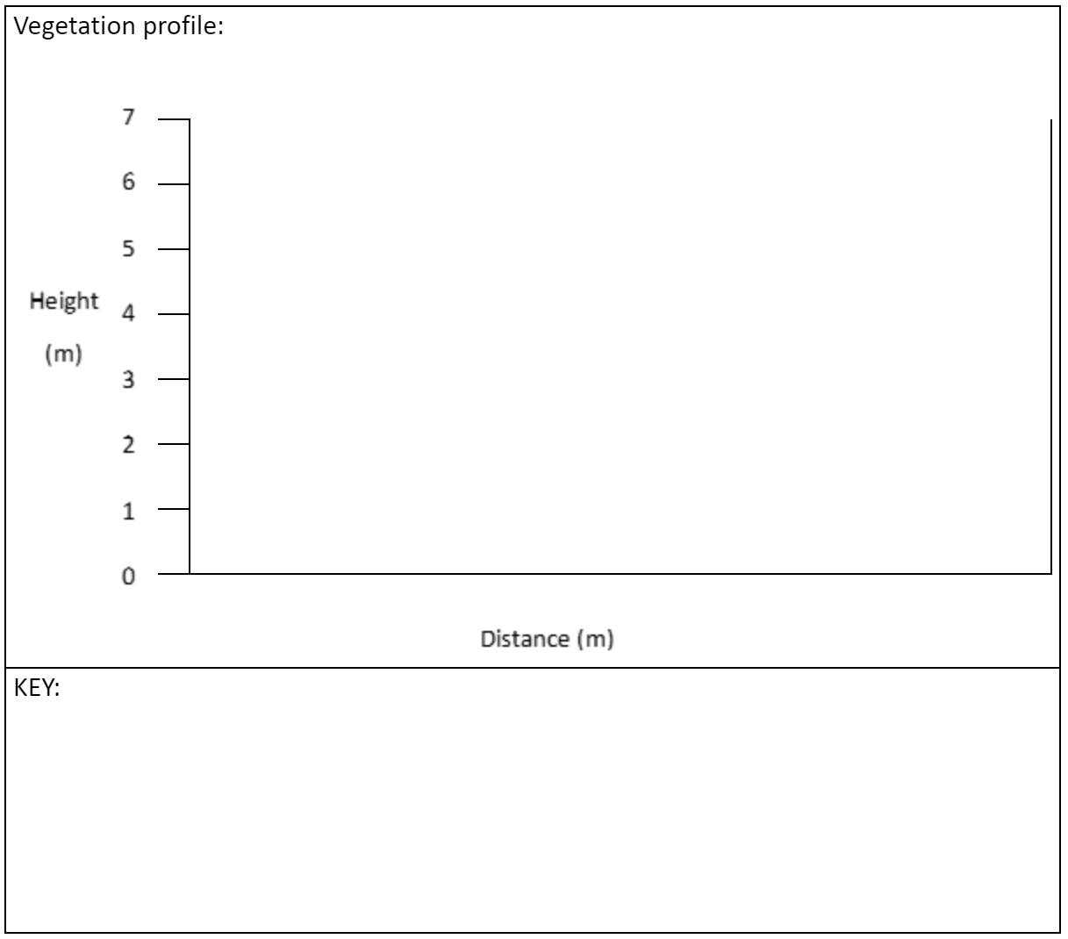
- Complete the following questions –
  - Are all the plants native?
  - If there are introduced species, why were they introduced?
  - What impact do these plants have on the local area - positive or negative?
  - Do you think this resembles the landcover or vegetation that was present before European settlement in Australia?
- Conduct a slake test (duration 1:13) to investigate the soil conditions in the local area. The soils organic matter and stability can be observed with a slake test which is where a clump of dry soil is lowered into water. If the soil clump quickly falls apart it is an indication of low organic matter and poor stability. This is often a sign that soil has been used extensively in the past for farming or gardening and the soil structure has been broken up and nutrients may have also been lost. If the soil clump mostly holds together, this is a sign of good soil stability with higher levels of organic matter present in the soil. Record the findings and create a visual representation of the findings.
- Conduct a soil smear which shows the materials that makes up the soil and the organic matter within them. A general rule is the darker the colour the more likely there is to be organic matter present in the soil. The grains felt in the soil while making the smear will indicate the parent material. For examples, the large grains, which may feel like sand, suggest a sandstone parent rocks and indicate the soils may not hold water very well on its own. Finer grains will indicate other soil is better able to hold water and could be a clay based soil. An example of a soil smear is shown below.
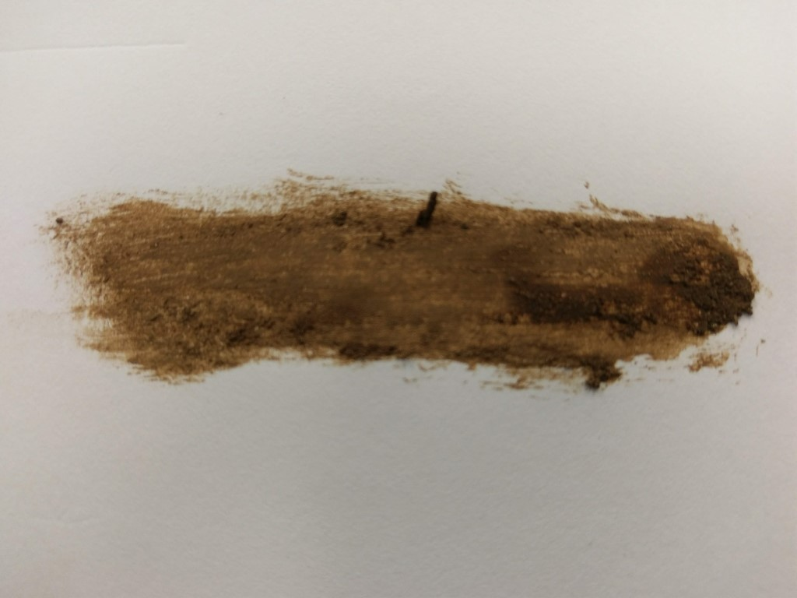
Image source - David Proctor
- Compile and document any influences on the vegetation within the study site. This may include:
  - native area or a garden
  - practices (such as adding fertilisers) could be affecting the growth and
  - types of species present,
  - litter or other pollution sources
  - exposure to the sun, wind and/or rain.
- Use the previous influences to write an explanation of the current vegetation patterns and soil conditions. Develop recommendations that could be made about what could be done to improve the vegetation.
- Use Google maps to find the following coordinates and complete the questions below about seagrasses. Seagrasses are an important marine species which exist all over the world. They are used by marine species as a source of food.
Coordinates: -33.801196, 151.285122
  - What location is shown at these coordinates?
  - Write these coordinates as latitude and longitude with degrees, minutes and seconds.
  - Switch to satellite view and draw a precis map of the area shown at the coordinates in the space below.

  - What is the issue being observed in the satellite image?
  - What evidence is there of this issue?

