Society and Culture – stage 6 – the social and cultural world
Note for teachers:
Students are guided in examining Australian and Amish communities and part of the Looking in/looking out: exploring the social and cultural world focus study. This lesson sequence is intended to cover 1 week of learning and includes a number of online and independent activities.
Worksheets and resources are found at the end of the learning sequence.
This document references the Geography K-10 Syllabus © 2015 Copyright NSW Education Standards Authority for and on behalf of the Crown in right of the State of New South Wales.

1.0 Focus study – Looking in looking out
Students gain an understanding of the social and cultural world through:
- A study from Australia or overseas, of a cultural group that is different from the student’s own in relation to two of the following
  - gender
  - identity
  - roles and status
  - conflict/cooperation
  - power, authority, influence and decision making
- Reflecting on their experience of their own society and culture and how this may be similar to, or different from, the cultural group in the focus study undertaken.

1.1 Understanding a different social or cultural group
Teachers’ note: this focus study examines the Amish community (chosen as there are very few Amish families in Australia). The focus study areas are gender and conflict/cooperation.

Activities:
- Using the BBC Amish communities resource, read the information about the characteristics of Amish communities and complete the following worksheet - 1.1 The Amish community
- Identify some of the key features of the Amish in relation to gender and conflict/cooperation. Relate those features to the fundamental, additional and related depth study concepts.
- Read the following articles and watch the video:
  - Meet the McCallums, one of Australia’s few Amish families
  - SBS Insight – Emma Gingerich (video duration 1:18)
  - SBS Insight (video duration 2:15)
- From the information in the articles and video, write a brief summary of the history of the Amish, including:
  - their origins
  - their world view
- Expand the information in you have written in worksheet 1.1 The Amish community with new or expanded information from the articles.

Worksheet 1.1 the Amish community
Feature of life | Amish view | How it reflects gender and/or conflict/cooperation | How it relates to depth study contents
Clothing | Plain clothes | Gender specific clothing. Eliminates a potential source of conflict (jealousy/envy) within the community. | Gender and reinforcement of gender roles within the community.
Technology
Gender roles – family life
Gender roles - community
Pacifists
Law
Insurance
Education
Discipline
Ethics
Conflict within the community
Ordnung
rumspringa
Dating

1.2 Comparison of the experience of adolescence
Teachers’ note: websites which may be used for further research are included on the final page of this document. The extended response should be used to provide feedback to the students on their capacity to identify and describe relationships within social groups.

Activities:
- Create a Venn diagram to examine the similarities and differences in attitudes to conflict/cooperation, and gender between your own culture and that of the Amish. Use worksheet 1.2 Comparison of Amish and Australian communities.
- Using the information collated in Worksheet 1.2, compare and contrast your experience of adolescence in contemporary Australian society with the experiences of an adolescent in the Amish community. This should be approximately 800 words long.

Worksheet 1.2 Comparison of Amish and Australian communities
Use the Venn diagram below to identify similarities and differences between Amish and Australian communities
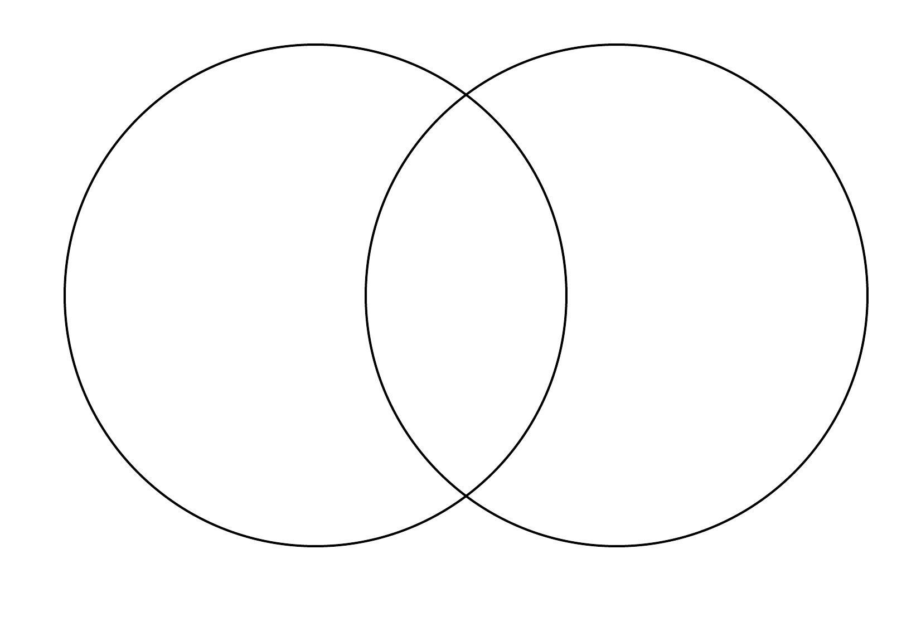

Resources
- BBC UK religion, The Amish
- Sydney Morning Herald – Meet the McCallums
- Lancaster Pennsylvania (The Amish) website
- Amish America
- Pennsylvania’s Amish Country (video duration 2:28)
- The Amish – The American Experience (video duration 12:30)
- Venn Diagram

