Business studies - stage 6 – business planning
Note for teachers:
Students are guided in completing an investigation into small to medium enterprises using real and hypothetical case studies. This sample virtual program is intended for two weeks of learning and includes several lessons and online resources.
Worksheets and resources are found at the end of the learning sequence.
This document references the Business Studies Stage 6 Syllabus © NSW Education Standards Authority for and on behalf of the Crown in right of the State of New South Wales 2010.

1.0 Small to medium enterprises
Students learn about:
Small to medium enterprises
- definition
- role
- economic contribution
- success and/or failure

1.1 Definition and role of small to medium enterprises
Teachers note - an understanding of business concept is essential for student learning. Students will need access to ICT throughout most of the activities, but alternatives have been suggested. Students will need prior knowledge and of the definitions for:
Economy - all activities undertaken for the purpose of production, distribution and consumption of goods and services in a region or country.
Enterprise - a project or undertaking that may relate to a business, organisation, community or government agency.
Entrepreneur - a person who sets out to build a successful business in a new field. An entrepreneur’s methods are sometimes regarded as innovative.
Markets - an exchange of goods, services or resources between buyers and sellers.

Activities:
- Students use the digital learning selector topic starter activity as an introduction to the business planning topic.
- Read the Parliament of Australia’s Definitions and data sources for small business in Australia and the Australian Small Business and Family Enterprise Ombudsman (ASBFEO) report on Small business counts (PDF 1Mb) on page 7. Using these definitions of SMEs, students develop their own definition and describe the features of SMEs in Australia. Student should include specific business terminology, concepts and examples in their response.
- Students complete the following table
Classification | Size (number of employees) | Definition | Role of the business
Micro business
Small business
Medium business
- Using your table and your knowledge from the previous business studies topics, develop a list of ten real life actual examples of micro, small and medium businesses. The business list should identify the industry and legal structure of each business example.
- Students read the SBS articles and watch the videos about Indigenous fashion designer making swimwear from recycled plastic (duration 4:51) and How a former power station worker turned his skills in a new direction (duration 4:17). Using the information from these articles, videos and prior knowledge, student explain the role and importance of SMEs in Australia.

1.2 Economic contributions of SMEs
- Choose any two articles from the SBS Small business secrets webpage and describe the economic contribution of the SMEs.
- Complete Worksheet 1 - Behind the news (BTN) report about SMEs economic contribution.
- Read the RBA’s publication The economic trends, challenges and behaviour of small businesses in Australia and answer the following questions -
  - Describe the economic trends of small businesses in Australia
  - Explain the varying challenges SMEs face in a competitive market. Use evidence from the statistics to support your response
  - Assess small businesses contribution to the Australian economy including the challenges in dealing with fluctuations in demand, the costs of doing business and financial issues.
- Read the World Bank Small and medium enterprises finance and APEC’s Small and medium enterprises factsheet. Using the previous articles and further research, develop a fact sheet about the international economic contribution of SMEs.

1.3 Success and/or failure of SMEs
- Students read the ABC article Business conditions worsen for small and medium enterprises. Identify each business in the article and explain the success and/or failures of each SME.
- Students complete the following table
Reasons for success of SMEs | Reasons for failure of SMEs
For example - Increased support from government funding | For example - Competitive market
- Read through ABS Counts of Australian businesses, including entries and exits and interpret the following graph. Write a short explanation of the entries and exits in Australian businesses.
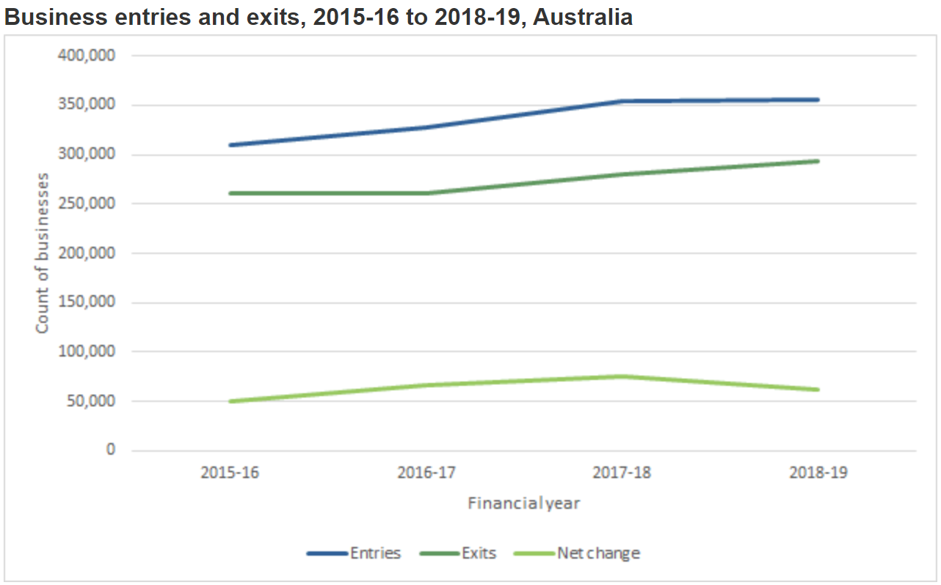
Image from ABS
- Using the previous activity, complete worksheet 2 – SMEs failure worksheet.
- Students complete a Misconception Check activity about the common misconception about the success and/or failure of SMEs. Students justify why they agree or disagree with the misconception.
- Students complete a short summary of each dot point completed. In the activity, students write a summary that answers the “who, what, where, when, why, how” about each dot point.

Worksheet 1 – Behind the news (BTN) report about SMEs economic contribution
ABC Business and Behind the news (BTN) has commissioned you to develop a news report for students about the economic contribution of SMEs. Your report must interpret chart 1 and explain the economic contribution of SMEs through further research. The report should include real or hypothetical business examples. The BTN report should use business terminology and concepts that clearly provides a definition of each term produced in your report.
It is important to have an understanding of the presentation method of BTN and therefore you should watch a business related video that is targeted towards students. If you do not have access to technology, you can develop BTN report script of your video. The script should include a description of images and clips that could be used in your report.
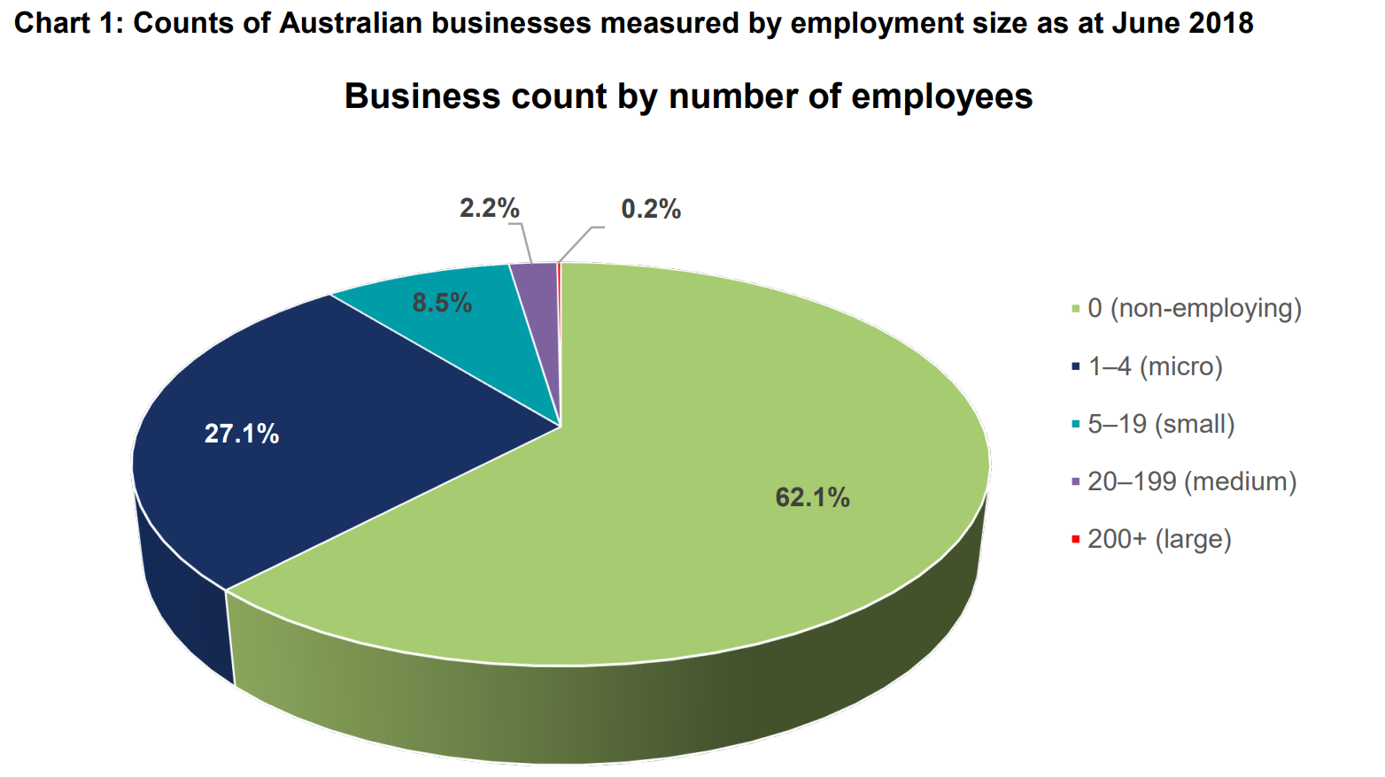
Image from the ASBFEO report (CC BY 3.0 AU) © Commonwealth of Australia 2019

Worksheet 2 – SMEs failure worksheet
Interpret the following charts from ASBFEO report on Small business counts (PDF 1Mb) and answer the following questions.
It is important to note that chart 2 refers turnover which means the income a business has generated in a particular period. Also, the ATO definition of a small business is turnover that is less than $10 million which accounts for 98.45% of all Australian businesses. The legend is identical for chart 2 and 3.
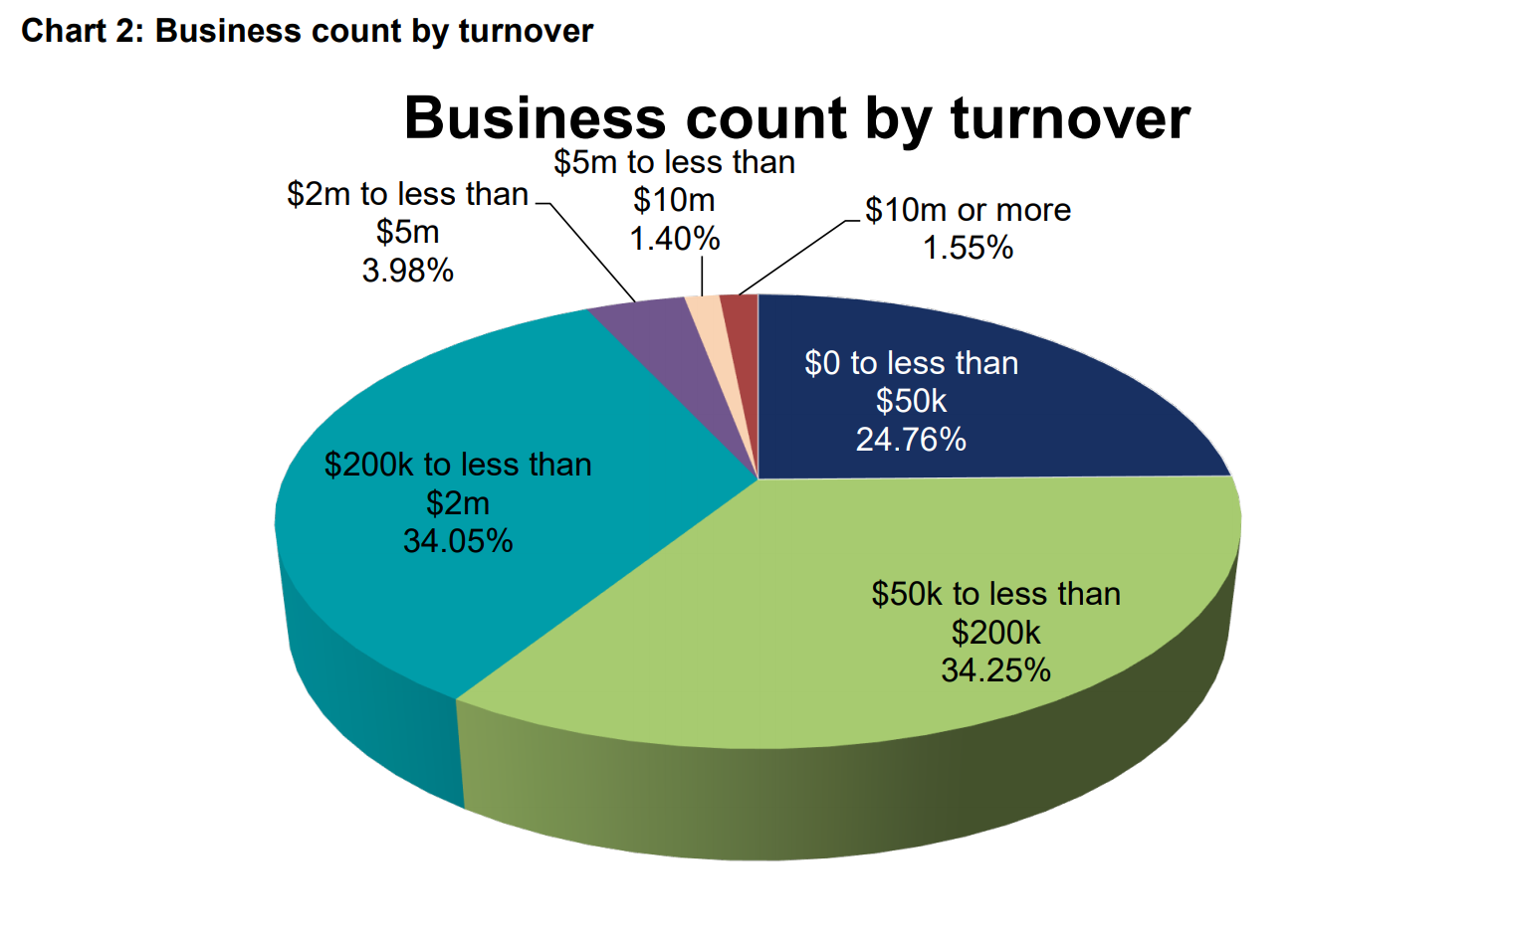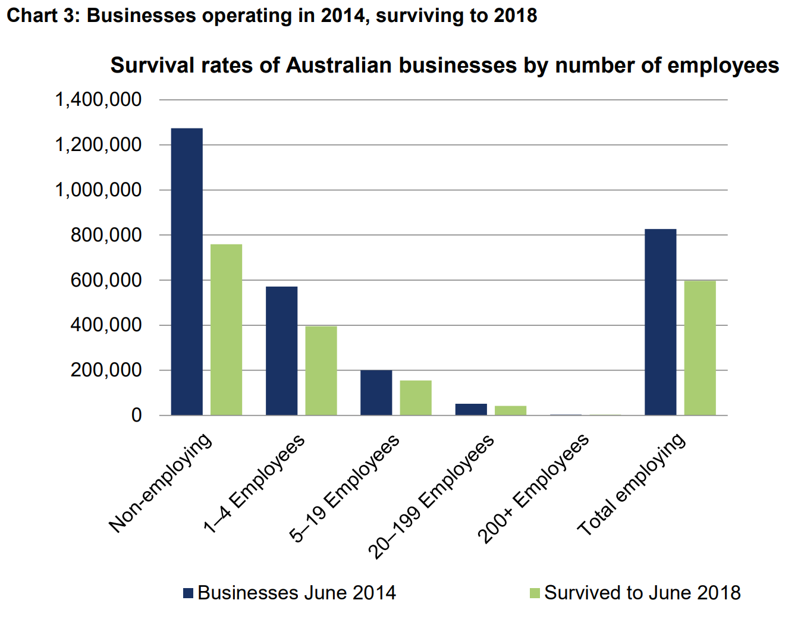
Image from the ASBFEO report (CC BY 3.0 AU) © Commonwealth of Australia 2019

Question 1
Describe each chart and use specific examples in your response.

Question 2
Explain how the charts relate to SMEs failure in the Australian economy.

Question 3
Using chart 3 and further research, assess the changing survival rates of SMEs from the period of 2014 to 2018

Provide three recommendations for government to decrease SME failures.
1.

2.

3.

Resources
- Digital learning selector app.education.nsw.gov.au/digital-learning-selector/LearningActivity/Card/605?clearCache=cb8c3d79-df2d-cfa0-59d0-47c5fb9d1ee6
- Parliament of Australia Definitions and data sources for small business in Australia aph.gov.au/about_parliament/parliamentary_departments/parliamentary_library/pubs/rp/rp1516/quick_guides/data
- Australian Small Business and Family Enterprise Ombudsman (ASBFEO) report on small business asbfeo.gov.au/sites/default/files/documents/ASBFEO-small-business-counts2019.pdf
- SBS Indigenous fashion designer making swimwear from recycled plastic sbs.com.au/news/small-business-secrets/article/2020/01/21/indigenous-fashion-designer-making-swimwear-recycled-plastic
- SBS How a former power station worker turned his skills in a new direction. sbs.com.au/news/sbs-small-business-secrets/article/2020/01/15/how-former-power-station-worker-turned-his-skills-new-direction
- SBS Small business secrets sbs.com.au/news/small-business-secrets
- RBA The Economic Trends, Challenges and Behaviour of Small Businesses in Australia rba.gov.au/publications/confs/2015/nicholls-orsmond.html
- World bank Small and medium enterprises finance worldbank.org/en/topic/smefinance
- APEC Small and medium enterprises apec.org/About-Us/About-APEC/Fact-Sheets/Small-and-Medium-Enterprises
- ABC Business conditions worsen for small and medium enterprises abc.net.au/news/2019-07-26/business-conditions-worsen-for-small-and-medium-enterprises/11346742
- ABS Counts of Australian businesses, including entries and exits www.abs.gov.au/ausstats/abs@.nsf/mf/8165.0
- Misconception Check rcsthinkfromthemiddle.com/misconception-check.html

