History K-10 – stage 5

Depth study 2a: making a nation
Note for teachers:
The following is a short, self-contained learning sequence for students studying federation and the development of Australian democracy in depth study 2a: making a nation. The activities have been designed to be incorporated into an asynchronous learning plan and can be completed using the internet or the non-internet based resources provided. The sequence should provide 2-3 hours of learning from home material for stage 5 students.
Outcomes and other elements of syllabus references in this document are from the History K-10 Syllabus © NSW Education Standards Authority (NESA) for and on behalf of the Crown in right of the State of New South Wales, 2012.

The development of Australian self-government and democracy
Key events and ideas in the development of Australian self-government and democracy, including women's voting rights (ACDSEH091)

Students:
- outline state and federal responsibilities under the Australian Constitution

1.1 What are the state and federal responsibilities under the Australian Constitution?
Teachers’ note:
Students can complete these activities with the support of online enabled devices or you can print the hard copy materials for them to complete if they have no access to internet/devices. Materials have been adapted from the Parliament of Australia website and the Parliamentary Education Office website.
Activities:
- Go to the federal, state and local interactive and complete the online game to determine which level of government is responsible for the various aspects of Australian life. Once you have completed the activity, make a list for each level of government with each of their responsibilities underneath.
- Read the factsheet (worksheet 1) and/or watch the video, three levels of government: governing Australia.
- Create an infographic/poster that explains the differences between local, state and federal governments in Australia. Your infographic/poster should include:
  - the three levels
  - the names of the state and territory parliaments
  - key responsibilities of each level of government
  - shared responsibilities
  - role of the Australian constitution
To complete this task, you should use the information in the factsheet and/or video, and any other information you have available. If you prefer the digital option, Canva is a useful tool.
- Extension – using the online version of the Australian Constitution, select a section of interest to read in depth. Write a short paragraph summarising the section and what it means in practice for Australian citizens.

Resource links (in case printing is preferable)
- Federal, state and local interactive - peo.gov.au/understand-our-parliament/how-parliament-works/three-levels-of-government/federal-state-and-local/
- Three levels of government: governing Australia (video) - peo.gov.au/understand-our-parliament/how-parliament-works/three-levels-of-government/three-levels-of-government-governing-australia/
- The Australian Constitution - aph.gov.au/about_parliament/senate/powers_practice_n_procedures/constitution
- For further information, see the extended depth paper, ‘the roles and responsibilities of the three levels of government’ - peo.gov.au/understand-our-parliament/how-parliament-works/three-levels-of-government/the-roles-and-responsibilities-of-the-three-levels-of-government/
- Additional resource, democracy matters video, booklet and poster - moadoph.gov.au/learning/classroom-resources/10-fast-facts-about-our-australian-democracy/

Worksheet 1– three levels of government factsheet
The Australian Constitution of 1901 established a federal system of government. Under this system, powers are distributed between:
- a national government (the Commonwealth)
- the six States (The Australian Capital Territory and the Northern Territory have self-government arrangements).
The Constitution defines the boundaries of law-making powers between the Commonwealth and the States/Territories.
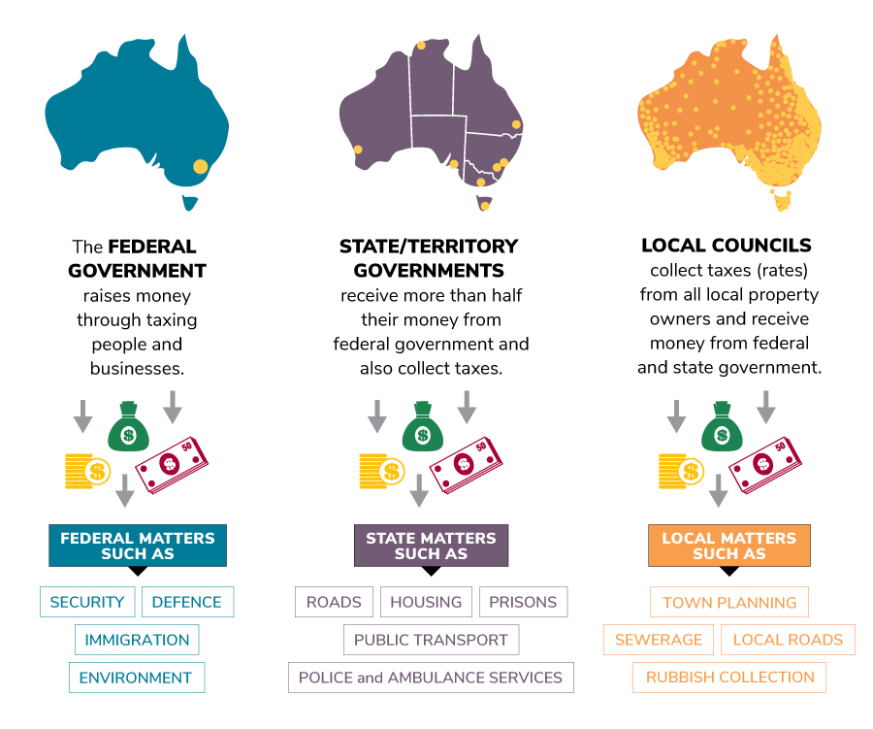
Figure 1 Parliamentary Education Office (PEO) 2019, three levels of government in Australia
Australia has three levels of law-making—often referred to as the three levels of government— that work together to provide us with the services we need.
The three levels are:
- federal—Australian—Parliament, in Canberra
- state and territory parliaments, in each state and territory capital city
- local councils—also called shires or municipalities—across Australia.
There are 6 state and territory parliaments. They are:
- ACT Legislative Assembly
- Legislative Assembly of the Northern Territory
- Parliament of New South Wales
- Parliament of Tasmania
- Parliament of South Australia
- Parliament of Victoria
- Parliament of Western Australia
- Queensland Parliament
There are over 500 local councils around Australia.

Responsibility
Representatives are elected to federal Parliament, state and territory parliaments, and local councils, so that all Australians have someone to represent them at each level of government. Parliaments and councils make laws; governments put these laws into action.
Some of the responsibilities of federal, state and territory, and local governments overlap, but generally each level of government provides different services to Australians:
- The federal government has broad national powers. Among other things, it administers— puts into action—laws in relation to national issues such as defence, immigration, foreign affairs, trade, postal services and taxation.
- State and territory governments have the power to look after areas not covered by the federal government: for instance, hospitals, schools, police and housing services.
- The powers of local councils are defined by Acts of Parliament passed by state parliaments and include responsibility for rubbish collection, local roads and pet control.
All levels of government raise money, through collecting taxes, to pay for services provided to Australians. Local councils also receive funding from the federal government and state governments.

Table 1 - levels of government and responsibility
Federal | State and territory | Local
The federal government raises money to run the country by collecting taxes on incomes, goods and services, and company profits, and spends it on national matters: for example, trade, defence, immigration and the environment. | State and territory governments also raise money from taxes but receive more than half their money from the federal government and spend it on state and territory matters: for example, schools, housing, hospitals, roads, railways, police and ambulance services. | Local councils collect taxes—rates—from all local property owners and receive grants from federal, state and territory governments, and spend this on local matters: for example, town planning, rubbish collection, water and sewerage, local roads and pet control.

Territories
Local councils in the Northern Territory (NT) are established by the NT Legislative Assembly under a local government law. The Australian Capital Territory (ACT) does not have local councils, as the ACT Legislative Assembly combines both state and local government functions.

The Australian Constitution
Section 51 of the Australian Constitution details the powers of the federal Parliament to make laws in relation to national matters. These laws are administered—put into action—by the Australian Government. Issues not listed in section 51 are the responsibility of state governments. Under section 109 of the Constitution, if a state Parliament and the federal Parliament pass conflicting laws on the same subject, then the federal law overrides the state law. Section 122 of the Constitution allows the federal Parliament to override a territory law at any time.
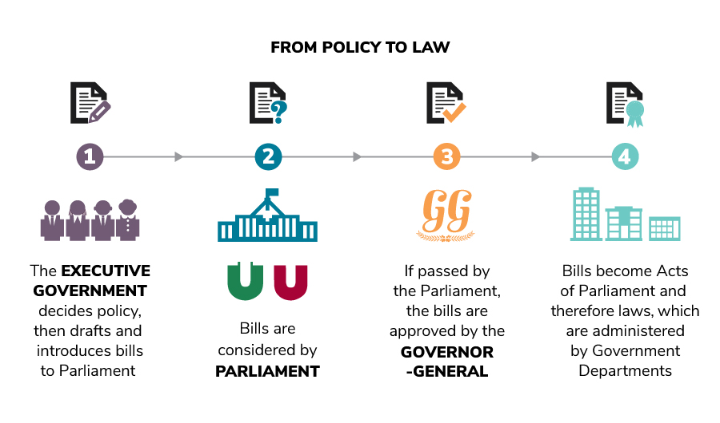
Figure 2 Parliamentary Education Office (PEO) 2019, From policy to law
Content for this factsheet has been adapted from Parliamentary Education Office (PEO) 2019, Three levels of government: governing Australia factsheet, accessed 18 March 2020

