History - stage 4 – ancient China
Note for teachers:
Students are guided in completing an investigation into the physical features of China and their effects on the development of ancient Chinese society.
All worksheets and resources are found at the end of the learning sequence.
This document references the History K-10 Syllabus © 2012 Copyright NSW Education Standards Authority for and on behalf of the Crown in right of the State of New South Wales.

1.0 Physical features
Students:
- describe the geographical setting and natural features of the ancient society

The physical features of China
Teacher note – students will need to access a map of China. This may be in an atlas or online, for example Google Maps. This is another example of a map of China. These may be printed for students who do not have access to the internet.
Activities:
- Complete Worksheet 1 – key terms to some of learn the terms most relevant to this topic. You should look for definitions in an online dictionary or a physical dictionary.
- Complete Worksheet 2 – map of China, locating and labelling the key geographic features listed on the sheet.
- Watch Geography of China (Duration11:02) and read the handout Worksheet 3 – geography of China. Take notes on the impact of geographical barriers on China as a developing society. Discuss as a class through an online learning platform (if possible). Consider the geography of Australia – what comparisons can be made to the geography of China regarding social development. Write a paragraph describing the differences and similarities between Australian and Chinese physical geography.

2.0 Research and writing task
Students:
- explain how the geographical setting and natural features influenced the development of the ancient society

2.1 Effect of geography on the development of Chinese civilisation
Teacher note – students will be building on the knowledge developed through the first set of activities to write an extended response. They will need to be given a scaffold for paragraph writing if they are not confident with this.
Activities:
- Using the information in your notes from the previous activities and the internet, research the impact of the land and water features of China on the development of ancient Chinese society.
- Complete worksheet 4 – impact of geography to organise your ideas.
- Compare the advantages and disadvantages of each physical feature for the development of ancient Chinese society. Fill in the table below:
Physical feature | Advantages | Disadvantages
Rivers
Ocean
Mountains
Deserts
Tibetan Plateau
- Write a 2-paragraph response to the question:
‘Explain the impact of the key geographical features on the development of society in Ancient China.’
Your response should include reference to the five features listed above and be written in a structured paragraph, as modelled by your teacher.
- Extension – research the Three Gorges Dam in China. Write a report on the impact of this dam and the controversy surrounding it in China and internationally.

Worksheet 1 – key terms
Look for definitions in an online dictionary or a physical dictionary of the following terms.
Key vocabulary term | Definition | Use the term in a sentence
Aristocrat
Artisan
Buddhism
Confucianism
Dynasty
Emperor
Empire
Eunuch
Mausoleum
Merchant
Middle kingdom
Qin Shi Huangdi
Silk Road
Taoism
Terracotta army
Tomb
Unify

Worksheet 2 - map of China
- Locate, mark and label the following geographic features:
  - Yellow Sea
  - East China Sea
  - South China Sea
  - Huang He River (Yellow River)
  - Yangtze River
- Shade the following areas, using a different colour for each feature:
  - Himalayas
  - Tibetan Plateau
  - Gobi Desert
  - Taklimakan Desert
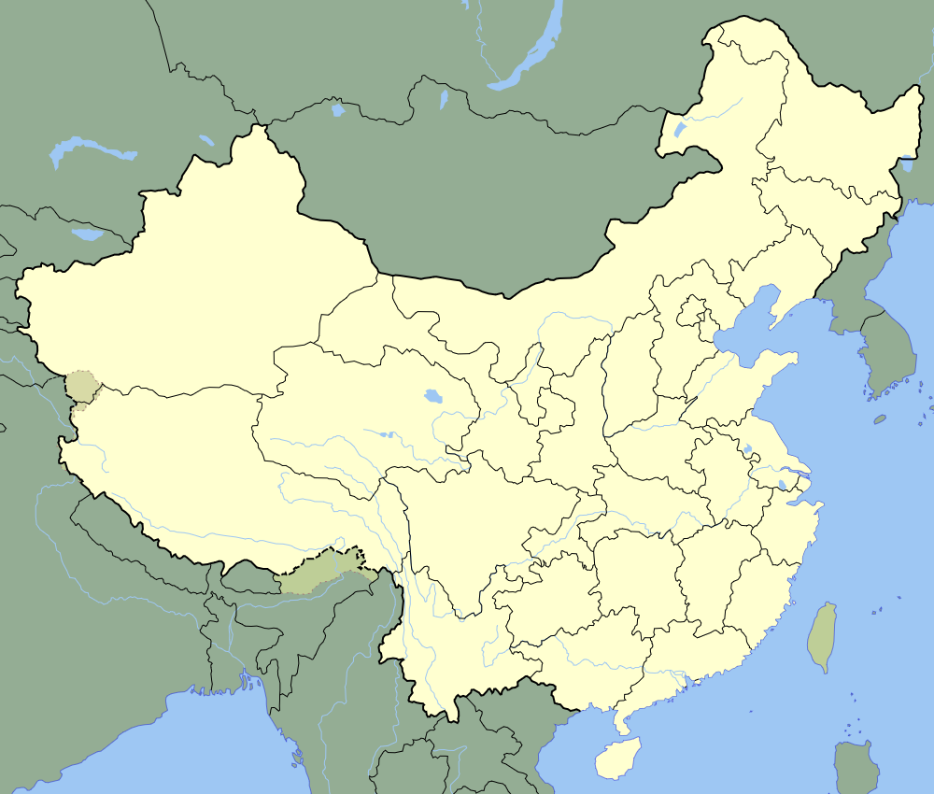
Figure 1 map of China with rivers from Wikimedia Commons (CC0)

Worksheet 3 – geography of China
The geography of China had a significant impact on the way ancient Chinese society developed. The key elements of the natural landscape that affected society were:
- rivers and ocean
- mountains and plateaus
- desert.

Rivers and seas
The two main rivers in China are the Huang He River (also known as the Yellow River) in the north of China and the Chang Jiang River (also known as the Yangtze River) in the south. Both rivers have carved valleys in the land, creating vast and fertile plains alongside. The soil by the Huang He River is made fertile by the yellow silt deposited there by the river. Both rivers also cause huge and devastating floods which impact on the communities that live nearby.
The eastern border of China is surrounded by the seas, including the Yellow Sea and the East China Sea, moving into the Pacific Ocean. This water border supported some parts of Chinese society to develop a fishing and coastal lifestyle.

Mountains and plateaus
China consists of many mountain ranges and plateaus. The most famous mountain range is the Himalayas, the highest mountains on Earth. The famous Mount Everest is one of the mountains in this range. North of the Himalayas is the Tibetan Plateau – a plateau is a flat, elevated landform that rises above the surrounding area. This terrain effectively separated the north of China from the bordering areas, created a natural barrier to people coming in or out.
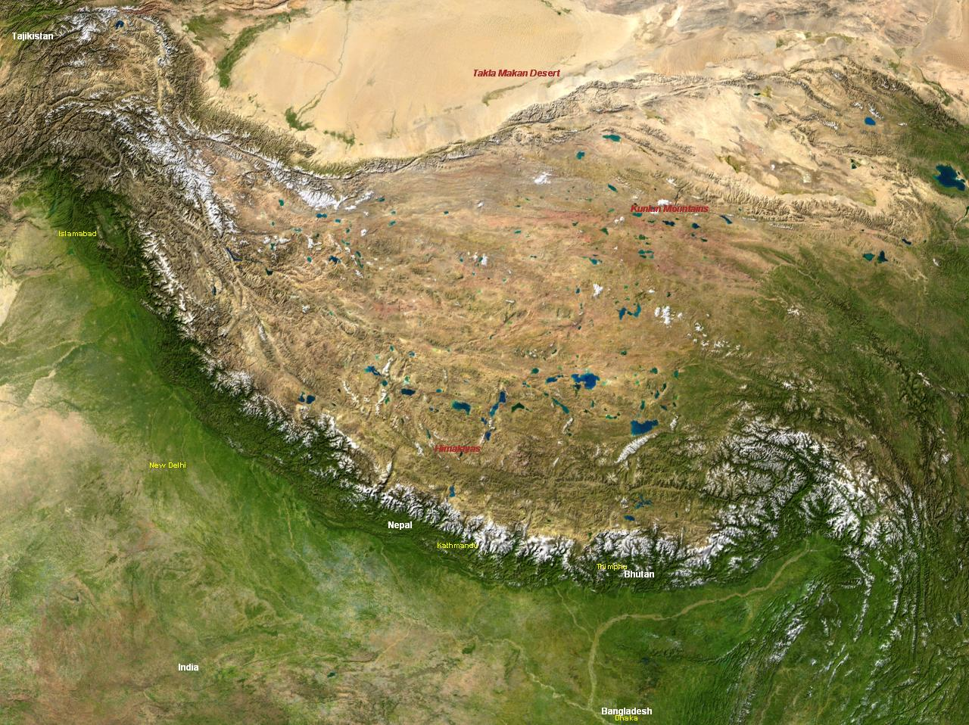
Figure 2 Himalayas and Tibetan Plateau by NASA, from Wikicommons (CC0)

Deserts
China’s climate is variable, with the northern parts of the country having cold, dry winters and warm rainy summers, while the southern part of the country is warmer and rainier through the year. This allows the southern provinces to have a longer growing season, especially for the staple crop, rice. Along the northern border with Mongolia lies the Gobi Desert. This desert is known for its vast dunes and mountains, as well as being home to many rare animals (such as snow leopards). Much of the desert is made up of rocks and, in current day China, can be driven across by car. The majority of the Gobi Desert is uninhabitable by large numbers of people, though there are some people on the Mongolian side of the border that call it home. The hostile nature of the desert acted as another natural barrier as the society of ancient China developed.
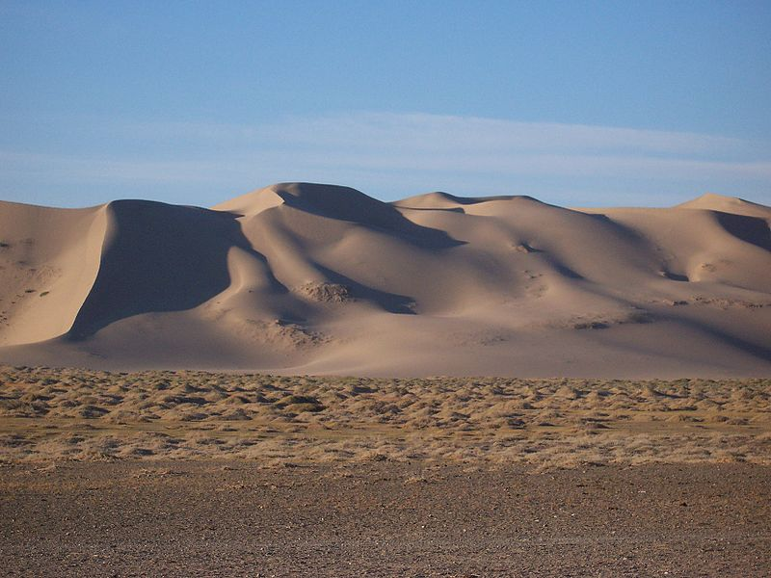
Figure 3 Gobi Desert, image from Wikicommons (CC BY-SA 3.0)

Worksheet 4 – impact of geography
Feature | Details and description | Effect on society
Rivers
Ocean
Mountains
Deserts
Tibetan Plateau

Resources
- Map of China google.com/maps/place/China
- Map of China ilibrarian.net/history/china_geography_map.jpg
- Chinese geography ducksters.com/history/china/geography_of_ancient_china.php
- Chinese geography easia.columbia.edu/china/geog/maps.htm#2a

