Notable colonials
Stage 3 history. This learning sequence comprises two short inquiries.

Topic – The Australian colonies
4 weeks – 90 minutes per week.

Key inquiry questions
- What do we know about the lives of people in Australia's colonial past and how do we know?
- What were the significant events and who were the significant people that shaped Australian colonies?

Overview
Inquiry 1 is a guided inquiry in which the students investigate the significance of colonial painter Tom Roberts. With strong links to visual arts, students reproduce part of a Tom Roberts painting and explain its significance.
Inquiry 2 is an independent inquiry into an individual who had a significant part in shaping the colony in the 1800s. They communicate this by taking on role as their notable colonial and telling their story in a ‘Night of the Notables’ event. In addition, students write a newspaper article outlining their notable colonial’s contributions.

Outcomes
A student:
- HT3-1 describes and explains the significance of people, groups, places and events to the development of Australia
- HT3-5 applies a variety of skills of historical inquiry and communication.

Content
The role that a significant individual or group played in shaping a colony; for example, explorers, farmers, entrepreneurs, artists, writers, humanitarians, religious and political leaders, and Aboriginal and/or Torres Strait Islander peoples (ACHHK097).
Students:
- use a range of sources to investigate the role of a particular man, woman or group and the contributions each made to the shaping of the colony.

Historical inquiry skills
- Comprehension: chronology, terms and concepts
  - respond, read and write to show understanding of historical matters
  - sequence historical people and events (ACHHS098, ACHHS117)
  - use historical terms and concepts (ACHHS099, ACHHS118)
- Analysis and use of sources
  - locate information relevant to inquiry questions in a range of sources (ACHHS102, ACHHS121)
  - compare information from a range of sources (ACHHS103, ACHHS122)
- Perspectives and interpretations
  - identify different points of view in the past and present (ACHHS104, ACHHS123)
- Empathetic understanding
  - explain why the behaviour and attitudes of people from the past may differ from today
- Research
  - identify and pose questions to inform an historical inquiry (ACHHS100, ACHHS119)
  - • identify and locate a range of relevant sources to support an historical inquiry (ACHHS101, ACHHS120)
- Explanation and communication
  - develop historical texts, particularly narratives and descriptions, which incorporate source material (ACHHS105, ACHHS124)
  - use a range of communication forms (oral, written, graphic) and digital technologies. (ACHHS106, ACHHS125)

Selected historical concepts
Cause and effect – events, decisions or developments in the past that produce later actions, results or effects, for example, events and other reasons that led to migration to Australia; reasons for the struggle for rights and freedoms for various groups in Australia.
Perspectives – people from the past will have different views and experiences, for example, differing attitudes of various groups to Federation or to granting rights and freedoms to women and Aboriginal peoples.
Empathetic understanding – an understanding of another's point of view, way of life and decisions made in a different time, for example, differing attitudes and experiences of living in an Australian colony; understanding the experiences of Aboriginal and Torres Strait Islanders, women and migrants throughout the twentieth century.
Significance – the importance of an event, development or individual/group, for example, determining the importance (significance) of various peoples' contributions to the development of a colony.

Assessment
All activities require students to demonstrate their learning. All are assessment for learning activities.

Vocabulary
Cause, effect, significance, perspective, empathy.
Observe, examine, summarise, record, sequence, infer, speculate, representation, conclude.
Colonial, colony, penal, settlement, establishment, settlement patterns, influence, factors, consequences, impacts.
Role, occupation, contribution, significance, influence, motivation, action, colony, challenge, criticism, success, legacy.

Teaching and learning activities
This learning sequence comprises two inquiries.

Inquiry 1 – guided inquiry into artist Tom Roberts
Students investigate the varying perspectives on the contribution of Tom Roberts to the colony. Students create a painting that reproduces part of a Tom Roberts painting and explain its significance.
Note – If students are competent in the historical inquiry process, inquiry 1 can be omitted, or used for students who need an inquiry scaffold.

Stimulus
Collectively examine source 1 and as a class, discuss first impressions of the painting and what it represents.
Play the video in source 2 to bring the painting to life, showing a reproduction colonial shearing shed in action.
Source 1 – ‘Shearing the rams’, Tom Roberts (1890).
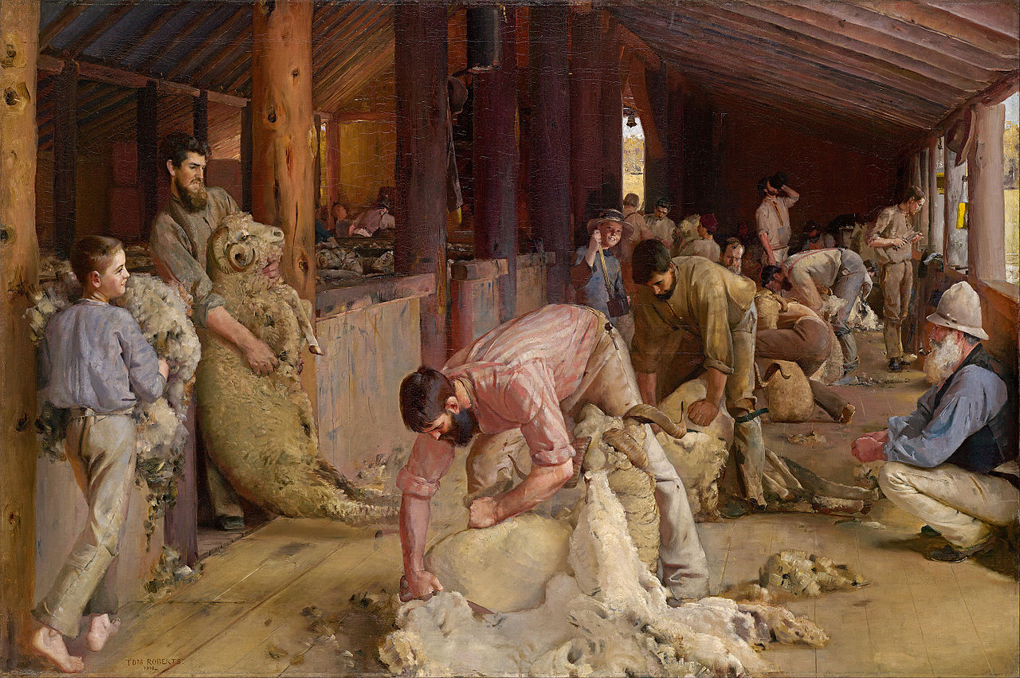
Tom Roberts (1890), Shearing the rams, oil on canvas on composition board, 122.4 x 183.3 cm, public domain courtesy of National Gallery of Victoria.
Source 2 – Outback House – last day of shearing (3:31), ABC, 2005.
As an optional activity, students use the zoom tools to examine the details of ‘Shearing the rams’ on the Google Arts and Culture website. Google Arts and Culture is an online gallery of high resolution images of artworks with zoom tools to enable close examination of details.
Students discuss the painting in source 1 using See-Think-Wonder prompts to guide their observations and inferences.
See–Think–Wonder prompts:
- See
  - What people are shown? What are they doing? What are their roles?
  - What objects are shown? How are they being used?
  - What is the physical setting? What building materials are evident?
  - What details can you see? Is there something unexpected?
- Think
  - Why was the painting made?
  - Is the painting a true representation? Why or why not?
  - What can you learn from examining this painting?
- Wonder
  - What else would you like to know?

Historical inquiry step 1 – question
With reference to the students’ See-Think-Wonder charts, formulate a set of inquiry questions relating to the role of Tom Roberts in shaping the colony.
Sample questions:
- Who is Tom Roberts?
- What was his role in the colony?
- How did Tom Roberts influence the colony?
- Why is Tom Roberts a significant person?
- What is his legacy?
Note – Inquiry questions may need to be redesigned through the historical inquiry process.

Historical inquiry steps 2 and 3 – research and analyse
Students use sources 3 to 7 to create a brief biography of Tom Roberts in table 1.
Source 3 – Tom Roberts: About, National Gallery of Australia.
Source 4 – Tom Roberts: Biography, Art Gallery of NSW.
Source 5 – Extract from Tom Roberts’ letter to the Editor, The Argus, Melbourne (4 July 1890).The article was written by Tom in response to comments on his painting, ‘Shearing of the rams’.
‘If I had been a poet instead of a worker with the brush, I should have described the scattered flocks on sunlit plains and gum-covered ranges, the coming of spring, the gradual massing of the sheep towards that one centre, the woolshed through which the accumulated growth and wealth of the year is carried; the shouts of the men, the galloping of horses and the barking of dogs as the thousands are driven, half seen, through the hot dust cloud, to the yards; then the final act, and the dispersion of the denuded sheep; but being circumscribed by my art it was only possible to take one view, to give expression to one portion of all this…’
‘…by making art the perfect expression of one time and one place, it becomes art for all times and all places.’
– Public domain courtesy of National Library of Australia.
Source 6 – ‘A break away!’ Tom Roberts (1891).
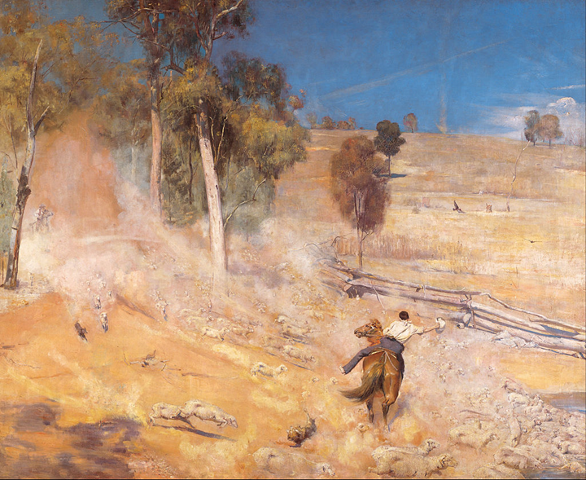
Tom Roberts (1891), A break away!, oil on canvas, 167.8 x 137.3 cm, public domain courtesy of Art Gallery of South Australia.
Source 7 – Article extract from Table Talk, Melbourne, ‘A break away! Mr Tom Roberts’ new picture’ (17 July 1891). This extract comments on Tom Roberts’ new painting shown in source 6.
‘Looking at the large canvas, one feels the story; its impression is conveyed to the eye by the painting; but, alas! here Mr. Roberts' art stops. He only conveys to the spectator the impression of what a noble picture could be made of the scene. The painting is incomplete; the technique is wanting. The dazzling blue sky is mere paint, from which the brush marks have not been stippled out; the tree foliage is an indistinct blotch; the weird dust column is a brush-streak of sandy-yellow colour; the dust cloud in the middle distance is as opaque as a white-washed wall.’
– Public domain courtesy of National Library of Australia.
Table 1 – Biography of Tom Roberts
Category | Key Information | How I know
Name
Date of birth and death
Place of birth and death
Occupation and role
Contribution to Australia
Significance to colony
Challenges and criticism
Legacy

Historical inquiry step 4 – evaluate
Guide the students in evaluating the reliability of the sources. Are there inconsistencies or contradictions between the sources? Do the inquiry questions need to be redesigned as a result of analysing and evaluating sources?

Historical inquiry step 5 – communicate
Reproducing a Tom Roberts’ colonial painting
- As a visual arts activity, students replicate the media and colour palette used by Tom Roberts to create a painting of a section of one of his paintings of rural colonial life.
- As an historical narrative activity, in role as Tom Roberts, students write a brief description of the artwork and its significance. They commence with Tom’s statement from Source 4: ‘By making art the perfect expression of one time and one place, it becomes art for all times and all places.’
Reflection
- Students reflect on the historical inquiry process, reflecting on what they learnt, how they learnt it and what else they would like to find out.

Inquiry 2 – student-led inquiry on a notable colonial
Students undertake a student-led inquiry into an individual or group who had a significant role in shaping the colony between 1800 and 1899. They communicate this by taking on the role of their significant individual, creating a costume and props, and telling their story in a ‘Night of the notables’ event. As an additional activity, or for assessment, students write a newspaper article about their notable colonial. A selection of significant colonial people is listed below.
Note – The student inquiry is intended to be a short research task. It could be undertaken concurrently with the guided class inquiry, or instead of the guided class inquiry.
List of some significant colonial people (not a definitive list):
Governors:
- Lachlan Macquarie
- Charles Augustus FitzRoy
- George Gipps
Explorers:
- Burke and Wills
- Blaxland, Lawson and Wentworth
- Hume and Hovell
- John McDouall Stuart
- Ludwig Leichhardt
Aboriginal warriors:
- Jandamarra
- Windradyne
- Calyute
- Yagan
- Musquito
- Tunnerminnerwait and Maulboyheenner
- Tarenorer
Women:
- Truganini
- Caroline Chisholm
- Louisa Lawson
- Mary Lee
- Mary Reiby
- Mary McKillop
- Rose Scott
Farmers and pastoralists:
- James Ruse
- John Macarthur
- Elizabeth Macarthur
- John Wyndham
- Alexander Berry
Artists, Illustrators and writers:
- John Glover
- Frederick McCubbin
- Tom Roberts
- Arthur Streeton
- Harriet and Helena Scott
- Louisa Atkinson
- Henry Lawson
- Andrew Barton (Banjo) Patterson
- Catherine Helen Smith
Architects:
- Francis Greenway
- James Barnet
- George Allen Mansfield

Historical inquiry step 1 – question
Students select a notable colonial and formulate a set of inquiry questions.
Sample questions:
- Who is (insert notable colonial’s name or names)?
- What was his, her or their role in the colony?
- How did he, she or they influence the colony?
- Why is the person significant?
- What is their legacy?
Note – Inquiry questions may need to be redesigned through the historical inquiry process.

Historical inquiry steps 2 and 3 – research and analysis
Students use table 2 to record information sourced from both primary and secondary sources. Sources could include colonial newspapers sourced through Trove, local colonial historical sites, journal or diary transcripts, paintings, photographs and biographies.
Table 2 – Biography of notable colonial
Category | Key Information | How I know
Name
Date of birth and death
Place of birth and death
Occupation and role
Contribution to Australia
Significance to colony
Challenges and criticism
Legacy

Historical inquiry step 4 – evaluate
During research and analysis, students evaluate the reliability of the sources. Are there inconsistencies or contradictions between the sources? Do the inquiry questions need to be redesigned as a result of analysing and evaluating sources?

Historical inquiry step 5 – communicate
Night of the notables – Students take on the role of their notable colonial and tell their story at a stall in a trade-show style of event. Students dress in appropriate costume and use props, oral telling, displays and reference to primary sources to communicate their role in shaping the colony. The varying perspectives on their role and contribution should be included.
Notable colonial newspaper article – Students write a newspaper article outlining the contribution to the colony of their notable colonial. Images can be included. All stories can be compiled and formatted into the style of a notable colonials feature spread in a colonial newspaper. To provide context and inspiration, play the video clip in source 8.
Source 8 – Outback House – school newspaper (2:38), ABC, 2005.
Reflection – Students reflect on the historical inquiry process, reflecting on what they learnt, how they learnt it and what else they would like to find out.

Additional resources
Books:
- ‘Inside the World of Tom Roberts’ by Mark Wilson (2012)
- ‘Meet…Banjo Paterson’ by Kristin Weidenbach (2015)
- ‘Meet…Mary MacKillop’ by Sally Murphy (2013)
- ‘Jandamarra’ by Mark Greenwood and Terry Denton (2013) – PRC 5–6 (note: some Stage 3 students may find this text disturbing)
- ‘Young Murphy: A Boy’s Adventure’ by Gary Crew and Mark Wilson (2005) – PRC 5–6
- ‘Mustara’ by Rosanne Hawke and Robert Ingpen (2006) – PRC 3–4
- ‘Sam, Grace and the Shipwreck’ by Michelle Gillespie (2011) – PRC 3–4
- ‘Kick it to Me’ by Neridah McMullin (2012) – PRC K–2
- ‘The Big Book of Australian History’ by Peter Macinnis (2013)
Resource:
- Guide to using picture books in history K–10, NSW Department of Education, 2017
Digital collections:
- Google art project
- National Gallery of Australia: Tom Roberts
- National Gallery of Victoria Shearing the rams
- Trove
- State Library of NSW

